Regresión logística

Código

Regresión logística

import matplotlib.pyplot as plt
import numpy as np
from pandas.io.parsers import read_csv
import scipy.optimize as opt

data = read_csv('p2/ex2data1.csv', header=None).values.astype(float)
x = data[:,:2]
y = data[:,2]
size = len(y)
positive = plt.scatter(x[np.where(y == 1), 0], x[np.where(y == 1), 1], marker='+', c='k')
negative = plt.scatter(x[np.where(y == 0), 0], x[np.where(y == 0), 1], marker='o', c='b')
plt.xlabel("Exam 1 score")
plt.ylabel("Exam 2 score")
plt.legend((positive, negative),('Admitted', 'Not admitted'))
plt.show()

X = np.ones((size,3))
X[:,1:] = x

theta = np.zeros((3, 1))

def sigmoid(x):
return 1.0 / (1.0 + np.exp(-x))

def cost_function(theta, x, y, m):
J = (-np.log(sigmoid(x.dot(theta)).T).dot(y) - np.log(1 - sigmoid(x.dot(theta)).T).dot(1 - y))/m
return J

def gradient_function(theta, x, y, m):
h = sigmoid(x.dot(theta)).reshape(-1, 1)
y = y.reshape(m, 1)
gradient = x.T.dot(h - y)/m
return gradient

print("Initial cost = " + str(cost_function(theta, X, y, size)))
print("Initial gradient = " + str(gradient_function(theta, X, y, size)))

result = opt.fmin_tnc(func=cost_function , x0=theta , fprime=gradient_function , args=(X, y, size))
theta_opt = result[0]
print("Optimal cost = " + str(cost_function(theta_opt, X, y, size)))
theta_opt = theta_opt.reshape((3,1))

linspace = np.linspace(30, 100, 1000)
boundary = -(theta_opt[0] + theta_opt[1]*linspace)/theta_opt[2]
positive = plt.scatter(x[np.where(y == 1), 0], x[np.where(y == 1), 1], marker='+', c='k')
negative = plt.scatter(x[np.where(y == 0), 0], x[np.where(y == 0), 1], marker='o', c='b')
plt.plot(linspace, boundary)
plt.xlabel("Exam 1 score")
plt.ylabel("Exam 2 score")
plt.legend((positive, negative),('Admitted', 'Not admitted'))
plt.show()

def accuracy(theta, x, y, m):
predictions = sigmoid(x.dot(theta))
predictions_corrected = [1 if pred >= 0.5 else 0 for pred in predictions]
number = np.sum(predictions_corrected == y)
return (float(number)/m)*100

print("Accuracy = " + str(accuracy(theta_opt, X, y, size)) +"%")

Regresión logística regularizada

import matplotlib.pyplot as plt
import numpy as np
from pandas.io.parsers import read_csv
import scipy.optimize as opt
from sklearn.preprocessing import PolynomialFeatures

data = read_csv('p2/ex2data2.csv', header=None).values.astype(float)
x = data[:,:2]
y = data[:,2]
size = len(y)
positive = plt.scatter(x[np.where(y == 1), 0], x[np.where(y == 1), 1], marker='+', c='k')
negative = plt.scatter(x[np.where(y == 0), 0], x[np.where(y == 0), 1], marker='o', c='b')
plt.xlabel("Microchip test 1")
plt.ylabel("Microchip test 2")
plt.legend((positive, negative),('Passed', 'Not passed'))
plt.show()

polynomial = PolynomialFeatures(6)
x_poly = polynomial.fit_transform(x)

theta = np.zeros((28, 1))
lambda_reg = 1

def sigmoid(x):
return 1.0 / (1.0 + np.exp(-x))

def cost_function(theta, x, y, m, lambda_reg):
J = (-np.log(sigmoid(x.dot(theta)).T).dot(y) - np.log(1 - sigmoid(x.dot(theta)).T).dot(1 - y))/m + lambda_reg*np.sum(np.square(theta))/(2*m)
return J

def gradient_function(theta, x, y, m, lambda_reg):
h = sigmoid(x.dot(theta)).reshape(-1, 1)
y = y.reshape(m, 1)
gradient = np.zeros((theta.shape[0], 1))
gradient = x.T.dot(h - y)/m
theta = theta.reshape((theta.shape[0], 1))
gradient[1:] = gradient[1:] + (lambda_reg/m)*theta[1:]
return gradient

print("Initial cost = " + str(cost_function(theta, x_poly, y, size, lambda_reg)))

result = opt.fmin_tnc(func=cost_function , x0=theta , fprime=gradient_function , args=(x_poly, y, size, lambda_reg))
theta_opt = result[0]

lin1 = np.linspace(-0.75, 1.00, 50)
lin2 = np.linspace(-0.75, 1.00, 50)
z = np.zeros((len(lin1), len(lin2)))

def plotting_preprocessing(lin1, lin2, theta_opt):
for i in range(len(lin1)):
for j in range(len(lin2)):
z[i,j] = np.dot(polynomial.fit_transform(np.column_stack((lin1[i], lin2[j]))), theta_opt)
return z

def accuracy(theta, x, y, m):
predictions = sigmoid(x.dot(theta))
predictions_corrected = [1 if pred >= 0.5 else 0 for pred in predictions]
number = np.sum(predictions_corrected == y)
return (float(number)/m)*100

positive = plt.scatter(x[np.where(y == 1), 0], x[np.where(y == 1), 1], marker='+', c='k')
negative = plt.scatter(x[np.where(y == 0), 0], x[np.where(y == 0), 1], marker='o', c='b')
plt.contour(lin1,lin2,plotting_preprocessing(lin1, lin2, theta_opt).T,0)
plt.xlabel("Microchip test 1")
plt.ylabel("Microchip test 2")
plt.legend((positive, negative),('Passed', 'Not passed'))
plt.title("Lambda = 1")
plt.show()

for lambda_reg in np.arange(0, 10, 0.5):
theta = np.zeros((28, 1))
result = opt.fmin_tnc(func=cost_function , x0=theta , fprime=gradient_function , args=(x_poly, y, size, lambda_reg))
theta_opt = result[0]

lin1 = np.linspace(-0.75, 1.00, 50)
lin2 = np.linspace(-0.75, 1.00, 50)
z = np.zeros((len(lin1), len(lin2)))

positive = plt.scatter(x[np.where(y == 1), 0], x[np.where(y == 1), 1], marker='+', c='k')
negative = plt.scatter(x[np.where(y == 0), 0], x[np.where(y == 0), 1], marker='o', c='b')
plt.contour(lin1,lin2,plotting_preprocessing(lin1, lin2, theta_opt).T,0)
plt.xlabel("Microchip test 1")
plt.ylabel("Microchip test 2")
plt.legend((positive, negative),('Passed', 'Not passed'))
plt.title("Lambda = " + str(lambda_reg))
plt.show()

print("Accuracy = " + str(accuracy(theta_opt, x_poly, y, size)) + "%")

Resultados

Regresión logística

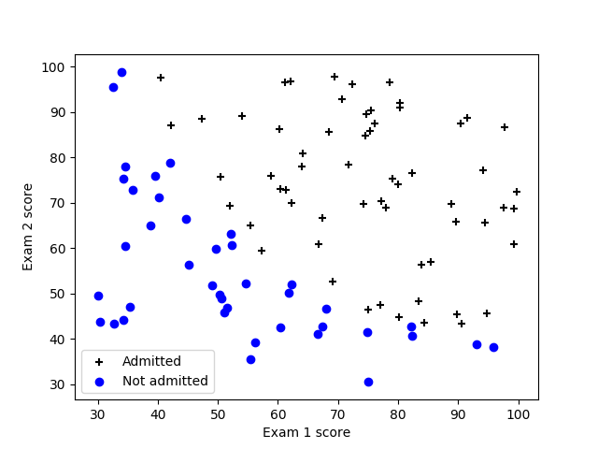

Initial cost = [0.69314718]
Initial gradient = [[-0.1]
[-12.00921659]
[-11.26284221]]
Optimal cost = 0.20349770158947517
Accuracy = 89.0%

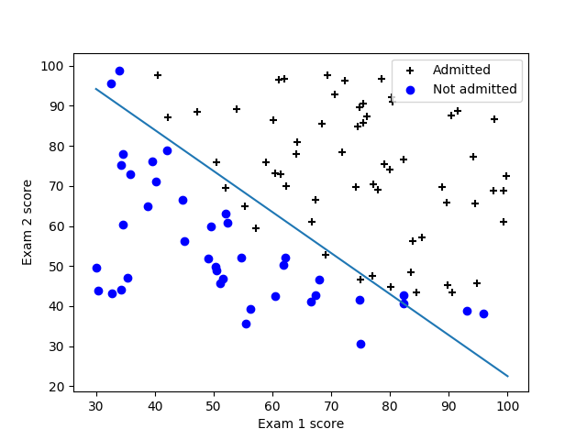

Regresión logística regularizada

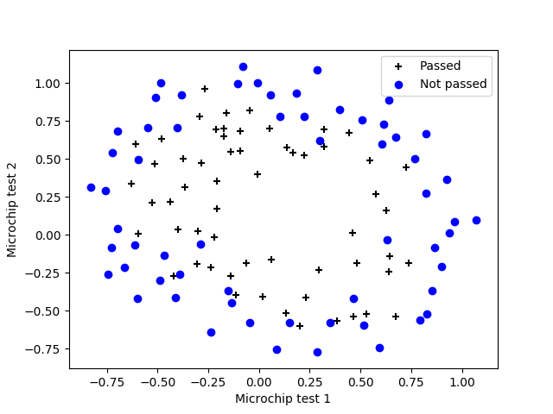
Initial cost = [0.69314718]

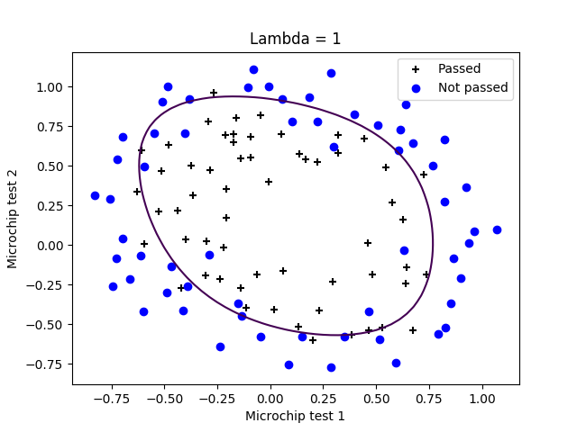
Accuracy = 83.0508474576%
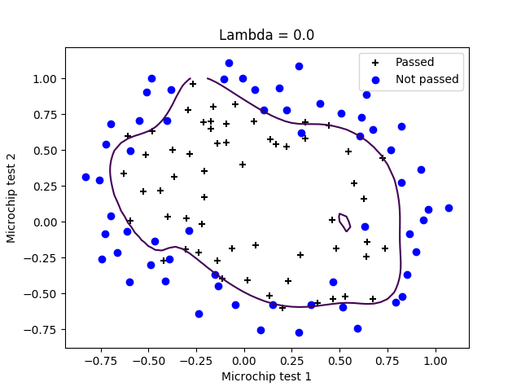
Accuracy = 88.1355932203%

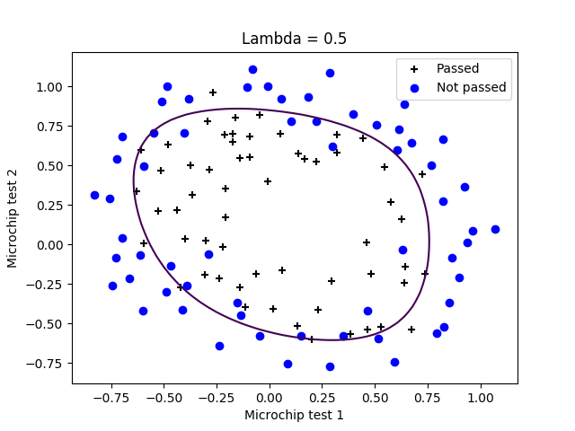

Accuracy = 82.2033898305%

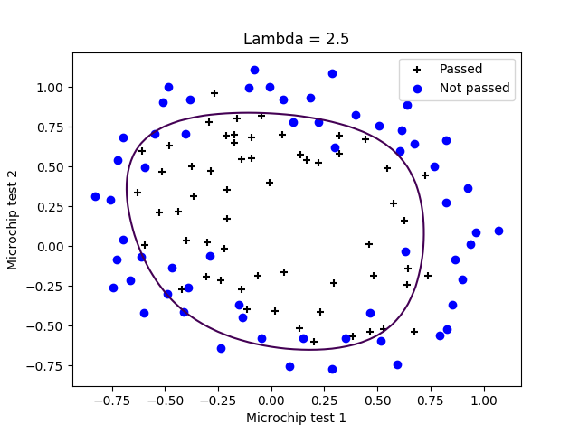
Accuracy = 82.2033898305%

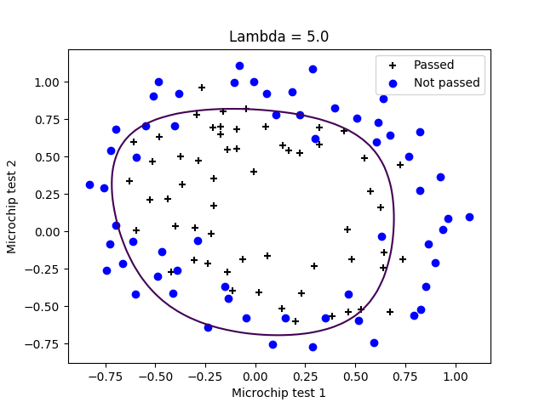
Accuracy = 81.3559322034%

Comentarios

Cuando lambda se aumenta, para pequeños valores de lambda el valor de accuracy es mejor, pero para los valores de lambda más grandes el valor de accuracy es peor. Para este conjunto de datos el valor optimal de lambda es entre lambda = 1 y lambda = 2. Para lambda = 0 el valor de accuracy es mejor debido a overfitting.

