Support Vector Machines

Código

SVM

from scipy.io import loadmat
import numpy as np
import matplotlib.pyplot as plt
import scipy.optimize as opt
from sklearn.svm import SVC

data1 = loadmat('p6/p6/ex6data1.mat')
y1 = data1['y']
X1 = data1['X']

data2 = loadmat('p6/p6/ex6data2.mat')
y2 = data2['y']
X2 = data2['X']

data3 = loadmat('p6/p6/ex6data3.mat')
y3 = data3['y']
X3 = data3['X']
yval3 = data3['yval']
Xval3 = data3['Xval']

for i in range(1, 120, 20):
svm = SVC(kernel='linear', C=i)
svm.fit(X1, y1)

positive = plt.scatter(X1[np.where(y1 == 1), 0], X1[np.where(y1 == 1), 1], marker='+', c='k')
negative = plt.scatter(X1[np.where(y1 == 0), 0], X1[np.where(y1 == 0), 1], marker='o', c='b')

ax = plt.gca()
xlim = ax.get_xlim()
ylim = ax.get_ylim()

xx = np.linspace(xlim[0], xlim[1], 30)
yy = np.linspace(ylim[0], ylim[1], 30)
YY, XX = np.meshgrid(yy, xx)
xy = np.vstack([XX.ravel(), YY.ravel()]).T
Z = svm.decision_function(xy).reshape(XX.shape)

ax.contour(XX, YY, Z, colors='k', levels=[-1, 0, 1], alpha=0.5,
linestyles=['--', '-', '--'])
plt.title('SVM with C = ' + str(i))
plt.show()

svm = SVC(kernel='rbf', C=1, gamma=1 / (2 * 0.1 ** 2))
svm.fit(X2, y2)

positive = plt.scatter(X2[np.where(y2 == 1), 0], X2[np.where(y2 == 1), 1], marker='+', c='k')
negative = plt.scatter(X2[np.where(y2 == 0), 0], X2[np.where(y2 == 0), 1], marker='o', c='b')

ax = plt.gca()
xlim = ax.get_xlim()
ylim = ax.get_ylim()

xx = np.linspace(xlim[0], xlim[1], 30)
yy = np.linspace(ylim[0], ylim[1], 30)
YY, XX = np.meshgrid(yy, xx)
xy = np.vstack([XX.ravel(), YY.ravel()]).T
Z = svm.decision_function(xy).reshape(XX.shape)

ax.contour(XX, YY, Z, colors='k', levels=[-1, 0, 1], alpha=0.5,
linestyles=['--', '-', '--'])
plt.title('SVM with gaussian kernel')
plt.show()

values = [0.01, 0.03, 0.1, 0.3, 1, 3, 10, 30]
for C in values:
for sigma in values:
svm = SVC(kernel='rbf', C=C, gamma=float(1)/(2 * sigma ** 2))
svm.fit(X3, y3)
predictions = svm.predict(Xval3)
number = 0
for i in range(len(yval3)):
if predictions[i] == yval3[i]:
number = number + 1
accuracy = (float(number)/len(yval3))*100
print("Accuracy for C = " + str(C) + " and sigma = " + str(sigma) + " = " + str(accuracy) + "%")

svm = SVC(kernel='rbf', C=1, gamma=float(1)/(2 * 0.1 ** 2))
svm.fit(X3, y3)

positive = plt.scatter(X3[np.where(y3 == 1), 0], X3[np.where(y3 == 1), 1], marker='+', c='k')
negative = plt.scatter(X3[np.where(y3 == 0), 0], X3[np.where(y3 == 0), 1], marker='o', c='b')

ax = plt.gca()
xlim = ax.get_xlim()
ylim = ax.get_ylim()

xx = np.linspace(xlim[0], xlim[1], 30)
yy = np.linspace(ylim[0], ylim[1], 30)
YY, XX = np.meshgrid(yy, xx)
xy = np.vstack([XX.ravel(), YY.ravel()]).T
Z = svm.decision_function(xy).reshape(XX.shape)

ax.contour(XX, YY, Z, colors='k', levels=[-1, 0, 1], alpha=0.5,
linestyles=['--', '-', '--'])
plt.title('SVM with best parameters')
plt.show()

Spam detection

import numpy as np
import matplotlib.pyplot as plt
from sklearn.svm import SVC
import re
import nltk
import nltk.stem.porter
import os
import io
from sklearn.model_selection import train_test_split

def preProcess(email):

hdrstart = email.find("\n\n")
if hdrstart != -1:
email = email[hdrstart:]

email = email.lower()
# Strip html tags. replace with a space
email = re.sub('<[^<>]+>', ' ', email)
# Any numbers get replaced with the string 'number'
email = re.sub('[0-9]+', 'number', email)
# Anything starting with http or https:// replaced with 'httpaddr'
email = re.sub('(http|https)://[^\s]*', 'httpaddr', email)
# Strings with "@" in the middle are considered emails --> 'emailaddr'
email = re.sub('[^\s]+@[^\s]+', 'emailaddr', email)
# The '$' sign gets replaced with 'dollar'
email = re.sub('[$]+', 'dollar', email)
return email

def email2TokenList(raw_email):
"""
Function that takes in a raw email, preprocesses it, tokenizes it,
stems each word, and returns a list of tokens in the e-mail
"""

stemmer = nltk.stem.porter.PorterStemmer()
email = preProcess(raw_email)

# Split the e-mail into individual words (tokens)
tokens = re.split('[ \@\$\/\#\.\-\:\&\*\+\=\[\]\?\!\(\)\{\}\,\'\"\>\_\<\;\%]',
email)

# Loop over each token and use a stemmer to shorten it
tokenlist = []
for token in tokens:

token = re.sub('[^a-zA-Z0-9]', '', token)
stemmed = stemmer.stem(token)
#Throw out empty tokens
if not len(token):
continue
# Store a list of all unique stemmed words
tokenlist.append(stemmed)

return tokenlist

def getVocabDict(reverse=False):
"""
Function to read in the supplied vocab list text file into a dictionary.
Dictionary key is the stemmed word, value is the index in the text file
If "reverse", the keys and values are switched.
"""
vocab_dict = {}
with open("p6/p6/vocab.txt") as f:
for line in f:
(val, key) = line.split()
if not reverse:
vocab_dict[key] = int(val)
else:
vocab_dict[int(val)] = key

return vocab_dict

spamFiles = []
for i in os.listdir('p6/p6/spam'):
spamFile = io.open('p6/p6/spam/' + str(i), mode='r', encoding='utf-8', errors='ignore').read()
spamFiles.append(email2TokenList(spamFile))

easyHamFiles = []
for i in os.listdir('p6/p6/easy_ham'):
easyHamFile = io.open('p6/p6/easy_ham/' + str(i), mode='r', encoding='utf-8', errors='ignore').read()
easyHamFiles.append(email2TokenList(easyHamFile))

hardHamFiles = []
for i in os.listdir('p6/p6/hard_ham'):
hardHamFile = io.open('p6/p6/hard_ham/' + str(i), mode='r', encoding='utf-8', errors='ignore').read()
hardHamFiles.append(email2TokenList(hardHamFile))

vocabDict = getVocabDict()

spamFilesEncoded = []
for email in spamFiles:
encoded = np.zeros((1, 1900))
for word in email:
if word in vocabDict:
encoded[0, vocabDict[word]] = 1
#Label (spam)
encoded[0, 0] = 1
spamFilesEncoded.append(encoded)

easyHamFilesEncoded = []
for email in easyHamFiles:
encoded = np.zeros((1, 1900))
for word in email:
if word in vocabDict:
encoded[0, vocabDict[word]] = 1
#Label (non-spam)
encoded[0, 0] = 0
easyHamFilesEncoded.append(encoded)

hardHamFilesEncoded = []
for email in hardHamFiles:
encoded = np.zeros((1, 1900))
for word in email:
if word in vocabDict:
encoded[0, vocabDict[word]] = 1
#Label (non-spam)
encoded[0, 0] = 0
hardHamFilesEncoded.append(encoded)

spamFilesEncoded = np.vstack(spamFilesEncoded)
easyHamFilesEncoded = np.vstack(easyHamFilesEncoded)
hardHamFilesEncoded = np.vstack(hardHamFilesEncoded)

data = np.vstack((spamFilesEncoded, easyHamFilesEncoded, hardHamFilesEncoded))
np.random.shuffle(data)

X = data[:, 1:]
y = data[:, 0]

X_train, X_val, y_train, y_val = train_test_split(X, y, test_size=0.2, random_state=1)

values = [0.01, 0.1, 1, 10]
for C in values:
for sigma in values:
svm = SVC(kernel='rbf', C=C, gamma=float(1) / (2 * sigma ** 2))
svm.fit(X_train, y_train)
predict = svm.predict(X_val)
number = 0
for i in range(len(y_val)):
if predict[i] == y_val[i]:
number = number + 1
accuracy = (float(number)/len(y_val))*100
print("Accuracy for C = " + str(C) + " and sigma = " + str(sigma) + " = " + str(accuracy) + "%")

Resultados

SVM

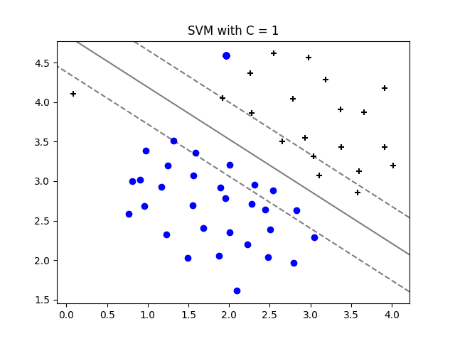

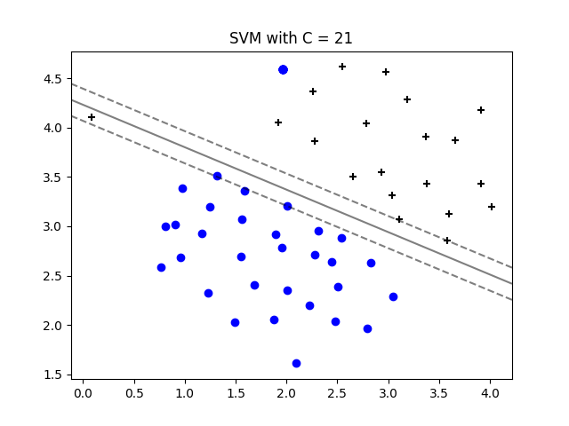
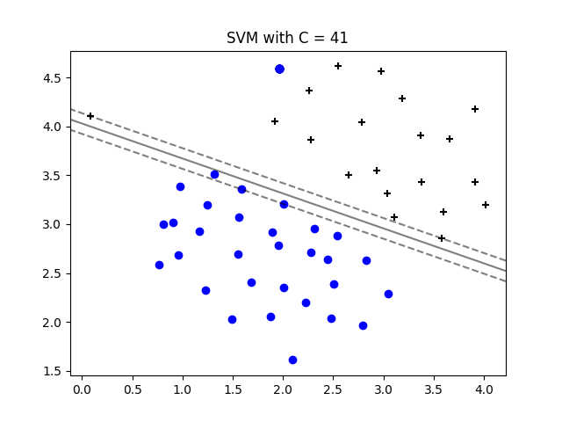
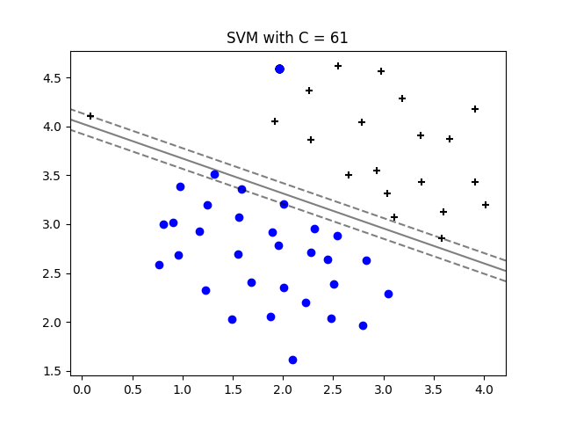
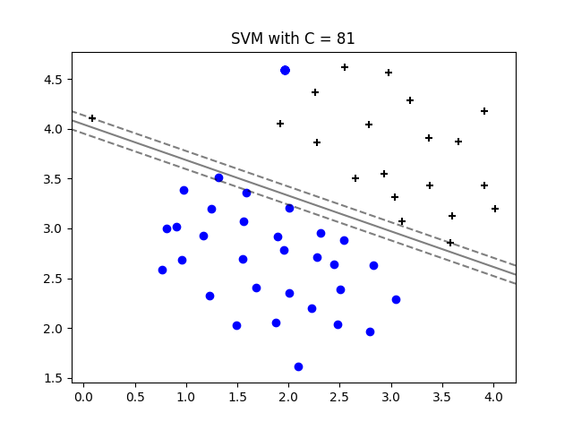
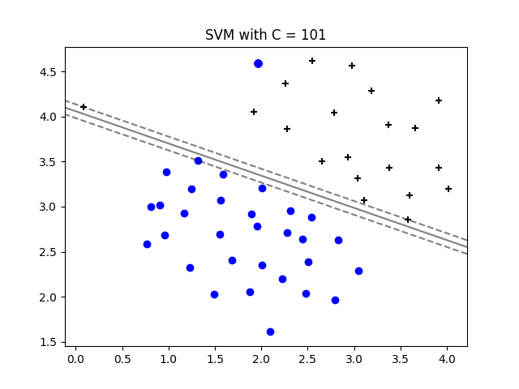
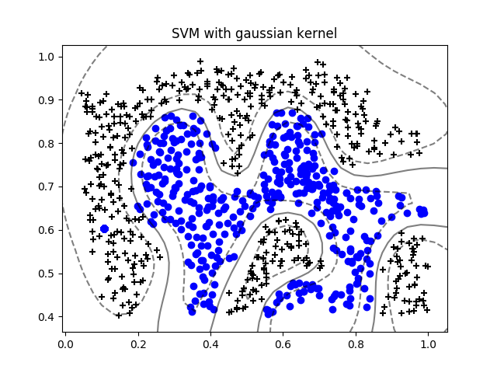
Accuracy for C = 0.01 and sigma = 0.01 = 43.5%
Accuracy for C = 0.01 and sigma = 0.03 = 43.5%
Accuracy for C = 0.01 and sigma = 0.1 = 43.5%
Accuracy for C = 0.01 and sigma = 0.3 = 43.5%
Accuracy for C = 0.01 and sigma = 1 = 43.5%
Accuracy for C = 0.01 and sigma = 3 = 43.5%
Accuracy for C = 0.01 and sigma = 10 = 43.5%
Accuracy for C = 0.01 and sigma = 30 = 43.5%
Accuracy for C = 0.03 and sigma = 0.01 = 43.5%
Accuracy for C = 0.03 and sigma = 0.03 = 43.5%
Accuracy for C = 0.03 and sigma = 0.1 = 45.0%
Accuracy for C = 0.03 and sigma = 0.3 = 86.0%
Accuracy for C = 0.03 and sigma = 1 = 62.0%
Accuracy for C = 0.03 and sigma = 3 = 43.5%
Accuracy for C = 0.03 and sigma = 10 = 43.5%
Accuracy for C = 0.03 and sigma = 30 = 43.5%
Accuracy for C = 0.1 and sigma = 0.01 = 43.5%
Accuracy for C = 0.1 and sigma = 0.03 = 43.5%
Accuracy for C = 0.1 and sigma = 0.1 = 94.5%
Accuracy for C = 0.1 and sigma = 0.3 = 91.0%
Accuracy for C = 0.1 and sigma = 1 = 82.5%
Accuracy for C = 0.1 and sigma = 3 = 43.5%
Accuracy for C = 0.1 and sigma = 10 = 43.5%
Accuracy for C = 0.1 and sigma = 30 = 43.5%
Accuracy for C = 0.3 and sigma = 0.01 = 43.5%
Accuracy for C = 0.3 and sigma = 0.03 = 75.5%
Accuracy for C = 0.3 and sigma = 0.1 = 96.0%
Accuracy for C = 0.3 and sigma = 0.3 = 92.5%
Accuracy for C = 0.3 and sigma = 1 = 89.0%
Accuracy for C = 0.3 and sigma = 3 = 74.0%
Accuracy for C = 0.3 and sigma = 10 = 43.5%
Accuracy for C = 0.3 and sigma = 30 = 43.5%
Accuracy for C = 1 and sigma = 0.01 = 60.5%
Accuracy for C = 1 and sigma = 0.03 = 90.5%
Accuracy for C = 1 and sigma = 0.1 = 96.5%
Accuracy for C = 1 and sigma = 0.3 = 96.5%
Accuracy for C = 1 and sigma = 1 = 92.5%
Accuracy for C = 1 and sigma = 3 = 84.5%
Accuracy for C = 1 and sigma = 10 = 43.5%
Accuracy for C = 1 and sigma = 30 = 43.5%
Accuracy for C = 3 and sigma = 0.01 = 62.0%
Accuracy for C = 3 and sigma = 0.03 = 89.0%
Accuracy for C = 3 and sigma = 0.1 = 96.5%
Accuracy for C = 3 and sigma = 0.3 = 94.5%
Accuracy for C = 3 and sigma = 1 = 93.0%
Accuracy for C = 3 and sigma = 3 = 89.0%
Accuracy for C = 3 and sigma = 10 = 72.0%
Accuracy for C = 3 and sigma = 30 = 43.5%
Accuracy for C = 10 and sigma = 0.01 = 62.0%
Accuracy for C = 10 and sigma = 0.03 = 89.0%
Accuracy for C = 10 and sigma = 0.1 = 94.0%
Accuracy for C = 10 and sigma = 0.3 = 95.5%
Accuracy for C = 10 and sigma = 1 = 93.5%
Accuracy for C = 10 and sigma = 3 = 92.0%
Accuracy for C = 10 and sigma = 10 = 84.5%
Accuracy for C = 10 and sigma = 30 = 43.5%
Accuracy for C = 30 and sigma = 0.01 = 62.0%
Accuracy for C = 30 and sigma = 0.03 = 89.0%
Accuracy for C = 30 and sigma = 0.1 = 94.0%
Accuracy for C = 30 and sigma = 0.3 = 96.0%
Accuracy for C = 30 and sigma = 1 = 92.5%
Accuracy for C = 30 and sigma = 3 = 92.5%
Accuracy for C = 30 and sigma = 10 = 89.0%
Accuracy for C = 30 and sigma = 30 = 74.0%

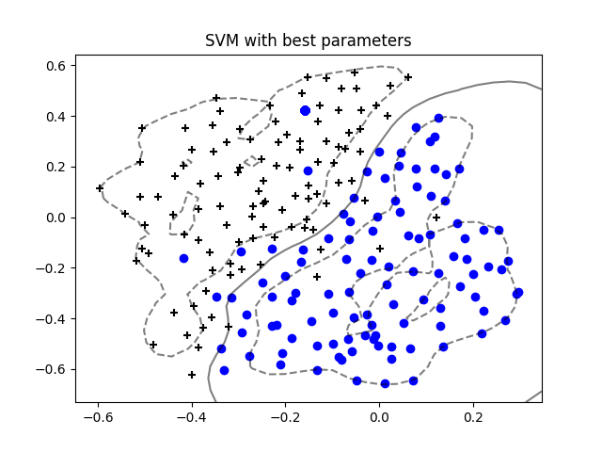
Spam detection

Accuracy for C = 0.01 and sigma = 0.01 = 85.4765506808%
Accuracy for C = 0.01 and sigma = 0.1 = 85.4765506808%
Accuracy for C = 0.01 and sigma = 1 = 85.4765506808%
Accuracy for C = 0.01 and sigma = 10 = 85.4765506808%
Accuracy for C = 0.1 and sigma = 0.01 = 85.4765506808%
Accuracy for C = 0.1 and sigma = 0.1 = 85.4765506808%
Accuracy for C = 0.1 and sigma = 1 = 85.4765506808%
Accuracy for C = 0.1 and sigma = 10 = 87.1406959153%
Accuracy for C = 1 and sigma = 0.01 = 90.9228441755%
Accuracy for C = 1 and sigma = 0.1 = 90.9228441755%
Accuracy for C = 1 and sigma = 1 = 90.9228441755%
Accuracy for C = 1 and sigma = 10 = 97.1255673222%
Accuracy for C = 10 and sigma = 0.01 = 90.9228441755%
Accuracy for C = 10 and sigma = 0.1 = 90.9228441755%
Accuracy for C = 10 and sigma = 1 = 92.1331316188%
Accuracy for C = 10 and sigma = 10 = 97.8819969743%

Comentarios

Cuando el valor de C se aumenta, el borde de SVM se disminuye para SVM con kernel lineal. Los mejores parámetros para la primera parte de la práctica son C = 1 y sigma = 0.1. Los mejores valores para C y sigma para spam detection son C = 10 y sigma = 10 con el valor de accuracy igual a casi 98%.

