LaTeX Template of VuV, date 31.05.2021

# # Most important notes:

Install a Latex distribution. I personally recommend TexMaker (<https://www.xm1math.net/texmaker/> ). If it does not compile an exemplary .tex document, you need to install MikTeX as well. See <https://miktex.org/howto/install-miktex> for explanations on the installation process.

The organisation of literature is well supported by Jabref. By \cite{your_Bibtextkey} the sources can automatically be inserted into the bibliography chapter. Further explanations and a download link can be found in <https://www.jabref.org/> .

If you have any questions, various forums on the internet usually offer valuable insights. Just google your problem or the error code provided by Latex.

# # How to get started:

Open the main .tex file like “bericht.tex” for the thesis template or “vorlage_memo.tex” for the memo template in TexMaker. This is the file that includes all necessary other files. Try to compile the document by pressing the left arrow (next to “Schnelles Übersetzen”) in TexMaker. After a short time the compiled document should either appear in a separate window or on the right in TexMaker (depending on the settings). Throughout this first compilation TexMaker asks for the permission to install the required packages. Now you should have a first compiled .pdf file of your .tex file. Congratulations 😉

In any case of difficulties, an error code appears in the “Messages/Log” window (look at the bottom of the TexMaker window). This error code helps to solve any occurring problems. If you do not understand it, just google it. There is a large community working with LaTeX, so many problems have known solutions for it.

Now you can start to insert your text in the chapters. Therefor see the respective .tex files in the same folder.

Take care that if you wrote in another than the main document and are trying to compile the document, it won’t work. You have to enable in “Optionen” the option “Aktuelle Datei zur ‘Masterdatei’ erklären” when you are in the main file. Or switch to the main file whenever you want to compile a new pdf version.

# # General notes:

1. Change language between German and English:

If you want to write in English: Nothing needs to be changed. The 18th and 19th line should look like this:



If you want to write in German: You have to change the language package to German by changing the 18th and 19th line to look like this: You comment out the English package and comment in the German one.



1. With/without indented pages for printing (eingerückte Seiten)

If you want indented pages, the 13th line needs to contain the word “twoside” like this (example from the thesis template):



Else, you use the keyword “oneside” like this (example from the memo template):



1. Table with automatic line break

To achieve automatic line breaks in a table, the respective, e.g. the last, column must be defined as “p{*width*}“ instead of an l (for left) or c (for centred) etc.

This change has to be applied to the start of the definition of a table: “\begin{tabular}[c]{l|l|l}“.

The width can be defined in centimetres or pixels or as a fraction of the textwidth, e.g. 0.3\textwidth if there are three columns.

# # Specifics on the THESIS template:

While working with the template, please insert your content in separate files and include them in the main file "bericht.tex". Thereby changes in form and style can be done without interfering with your text.

Attention: When switching to German, you have to include the German title page and declaration of autonomy instead of the English one. Therefor comment out or in the respective files in line 122/123 and in line 127/128 (_DE for German, _ENG for English) by inserting/ deleting a “%” at the beginning of the line.

# # Specifics on the MEMO template:

1. To exclude the header in the following picture, please comment out the following lines, found in the document from line 49 to line 67 by writing % in front of each line.

Header:



Code lines:

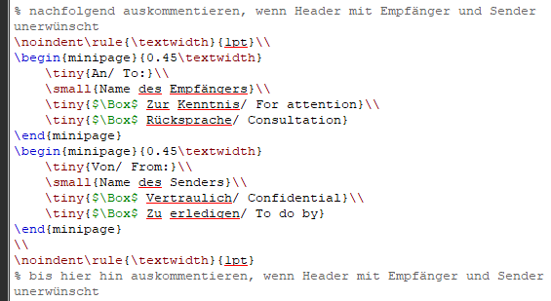

That should look like this:

