Project OS5

Shiwei Huang

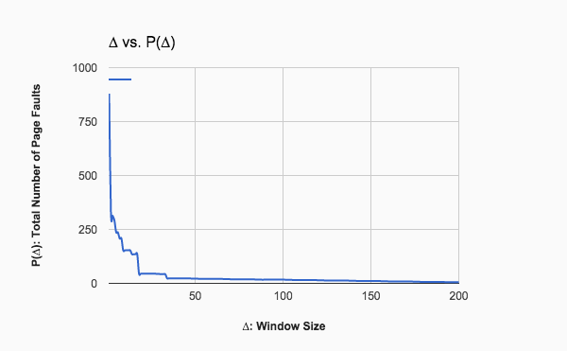

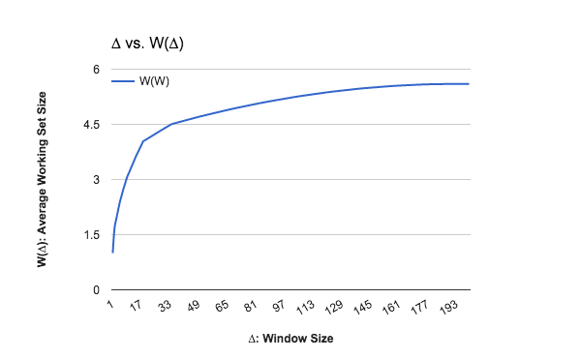

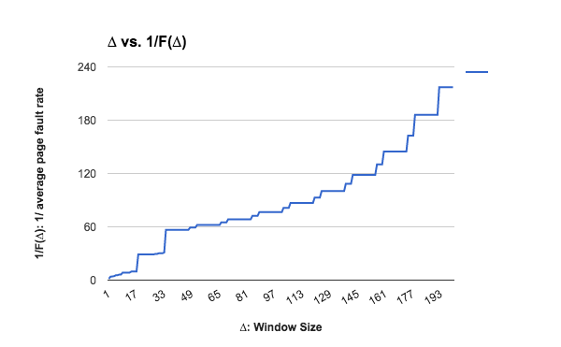

\*\*\*\*\*\*\*\*\*\*\*\*\*\*\*\*\*\*\*\*\*\*\*\*\*\*\*\*\*\*\*\*\*\*\*\*\*\*\*\*\*\*\*\*\*\*\*\*\*\*

W P(W) W(W) F(W) 1/F(W)

1 879 1.000 0.675 1.481

2 333 1.674 0.256 3.910

3 313 1.929 0.240 4.160

4 292 2.168 0.224 4.459

5 237 2.390 0.182 5.494

6 236 2.570 0.181 5.517

7 208 2.748 0.160 6.260

8 208 2.905 0.160 6.260

9 153 3.061 0.118 8.510

10 153 3.176 0.118 8.510

11 153 3.290 0.118 8.510

12 153 3.405 0.118 8.510

13 153 3.519 0.118 8.510

14 135 3.634 0.104 9.644

15 135 3.734 0.104 9.644

16 135 3.835 0.104 9.644

17 135 3.935 0.104 9.644

18 45 4.036 0.035 28.933

19 45 4.067 0.035 28.933

20 45 4.098 0.035 28.933

21 45 4.127 0.035 28.933

22 45 4.157 0.035 28.933

23 45 4.187 0.035 28.933

24 45 4.217 0.035 28.933

25 45 4.247 0.035 28.933

26 45 4.277 0.035 28.933

27 45 4.307 0.035 28.933

28 44 4.337 0.034 29.591

29 44 4.366 0.034 29.591

30 43 4.396 0.033 30.279

31 43 4.424 0.033 30.279

32 43 4.452 0.033 30.279

33 42 4.481 0.032 31.000

34 23 4.508 0.018 56.609

35 23 4.522 0.018 56.609

36 23 4.535 0.018 56.609

37 23 4.548 0.018 56.609

38 23 4.561 0.018 56.609

39 23 4.574 0.018 56.609

40 23 4.587 0.018 56.609

41 23 4.600 0.018 56.609

42 23 4.613 0.018 56.609

43 23 4.626 0.018 56.609

44 23 4.639 0.018 56.609

45 23 4.652 0.018 56.609

46 23 4.665 0.018 56.609

47 23 4.678 0.018 56.609

48 22 4.691 0.017 59.182

49 22 4.704 0.017 59.182

50 22 4.716 0.017 59.182

51 22 4.728 0.017 59.182

52 21 4.740 0.016 62.000

53 21 4.752 0.016 62.000

54 21 4.763 0.016 62.000

55 21 4.775 0.016 62.000

56 21 4.786 0.016 62.000

57 21 4.798 0.016 62.000

58 21 4.810 0.016 62.000

59 21 4.821 0.016 62.000

60 21 4.833 0.016 62.000

61 21 4.844 0.016 62.000

62 21 4.856 0.016 62.000

63 21 4.867 0.016 62.000

64 21 4.879 0.016 62.000

65 21 4.890 0.016 62.000

66 20 4.902 0.015 65.100

67 20 4.912 0.015 65.100

68 20 4.923 0.015 65.100

69 20 4.934 0.015 65.100

70 19 4.945 0.015 68.526

71 19 4.955 0.015 68.526

72 19 4.965 0.015 68.526

73 19 4.975 0.015 68.526

74 19 4.985 0.015 68.526

75 19 4.995 0.015 68.526

76 19 5.005 0.015 68.526

77 19 5.015 0.015 68.526

78 19 5.025 0.015 68.526

79 19 5.035 0.015 68.526

80 19 5.045 0.015 68.526

81 19 5.055 0.015 68.526

82 19 5.065 0.015 68.526

83 19 5.075 0.015 68.526

84 18 5.084 0.014 72.333

85 18 5.094 0.014 72.333

86 18 5.103 0.014 72.333

87 18 5.112 0.014 72.333

88 17 5.121 0.013 76.588

89 17 5.130 0.013 76.588

90 17 5.138 0.013 76.588

91 17 5.147 0.013 76.588

92 17 5.155 0.013 76.588

93 17 5.164 0.013 76.588

94 17 5.172 0.013 76.588

95 17 5.180 0.013 76.588

96 17 5.189 0.013 76.588

97 17 5.197 0.013 76.588

98 17 5.206 0.013 76.588

99 17 5.214 0.013 76.588

100 17 5.223 0.013 76.588

101 17 5.231 0.013 76.588

102 16 5.240 0.012 81.375

103 16 5.247 0.012 81.375

104 16 5.255 0.012 81.375

105 16 5.263 0.012 81.375

106 15 5.270 0.012 86.800

107 15 5.277 0.012 86.800

108 15 5.284 0.012 86.800

109 15 5.291 0.012 86.800

110 15 5.298 0.012 86.800

111 15 5.305 0.012 86.800

112 15 5.312 0.012 86.800

113 15 5.319 0.012 86.800

114 15 5.326 0.012 86.800

115 15 5.333 0.012 86.800

116 15 5.339 0.012 86.800

117 15 5.346 0.012 86.800

118 15 5.353 0.012 86.800

119 15 5.360 0.012 86.800

120 14 5.367 0.011 93.000

121 14 5.373 0.011 93.000

122 14 5.379 0.011 93.000

123 14 5.386 0.011 93.000

124 13 5.392 0.010 100.154

125 13 5.397 0.010 100.154

126 13 5.402 0.010 100.154

127 13 5.408 0.010 100.154

128 13 5.413 0.010 100.154

129 13 5.419 0.010 100.154

130 13 5.424 0.010 100.154

131 13 5.429 0.010 100.154

132 13 5.435 0.010 100.154

133 13 5.440 0.010 100.154

134 13 5.445 0.010 100.154

135 13 5.451 0.010 100.154

136 13 5.456 0.010 100.154

137 13 5.462 0.010 100.154

138 12 5.467 0.009 108.500

139 12 5.472 0.009 108.500

140 12 5.476 0.009 108.500

141 12 5.481 0.009 108.500

142 11 5.485 0.008 118.364

143 11 5.489 0.008 118.364

144 11 5.493 0.008 118.364

145 11 5.497 0.008 118.364

146 11 5.501 0.008 118.364

147 11 5.505 0.008 118.364

148 11 5.508 0.008 118.364

149 11 5.512 0.008 118.364

150 11 5.516 0.008 118.364

151 11 5.520 0.008 118.364

152 11 5.524 0.008 118.364

153 11 5.528 0.008 118.364

154 11 5.531 0.008 118.364

155 11 5.535 0.008 118.364

156 10 5.539 0.008 130.200

157 10 5.542 0.008 130.200

158 10 5.545 0.008 130.200

159 10 5.548 0.008 130.200

160 9 5.551 0.007 144.667

161 9 5.554 0.007 144.667

162 9 5.556 0.007 144.667

163 9 5.558 0.007 144.667

164 9 5.561 0.007 144.667

165 9 5.563 0.007 144.667

166 9 5.565 0.007 144.667

167 9 5.568 0.007 144.667

168 9 5.570 0.007 144.667

169 9 5.572 0.007 144.667

170 9 5.575 0.007 144.667

171 9 5.577 0.007 144.667

172 9 5.579 0.007 144.667

173 9 5.581 0.007 144.667

174 8 5.584 0.006 162.750

175 8 5.585 0.006 162.750

176 8 5.587 0.006 162.750

177 8 5.588 0.006 162.750

178 7 5.590 0.005 186.000

179 7 5.591 0.005 186.000

180 7 5.591 0.005 186.000

181 7 5.592 0.005 186.000

182 7 5.593 0.005 186.000

183 7 5.594 0.005 186.000

184 7 5.594 0.005 186.000

185 7 5.595 0.005 186.000

186 7 5.596 0.005 186.000

187 7 5.597 0.005 186.000

188 7 5.598 0.005 186.000

189 7 5.598 0.005 186.000

190 7 5.599 0.005 186.000

191 7 5.600 0.005 186.000

192 6 5.601 0.005 217.000

193 6 5.601 0.005 217.000

194 6 5.601 0.005 217.000

195 6 5.601 0.005 217.000

196 6 5.601 0.005 217.000

197 6 5.601 0.005 217.000

198 6 5.601 0.005 217.000

199 6 5.601 0.005 217.000

200 6 5.601 0.005 217.000

\*\*\*\*\*\*\*\*\*\*\*\*\*\*\*\*\*\*\*\*\*\*\*\*\*\*\*\*\*\*\*\*\*\*\*\*\*\*\*\*\*\*\*\*\*\*\*\*\*\*\*\*\*