LAB2 PART1

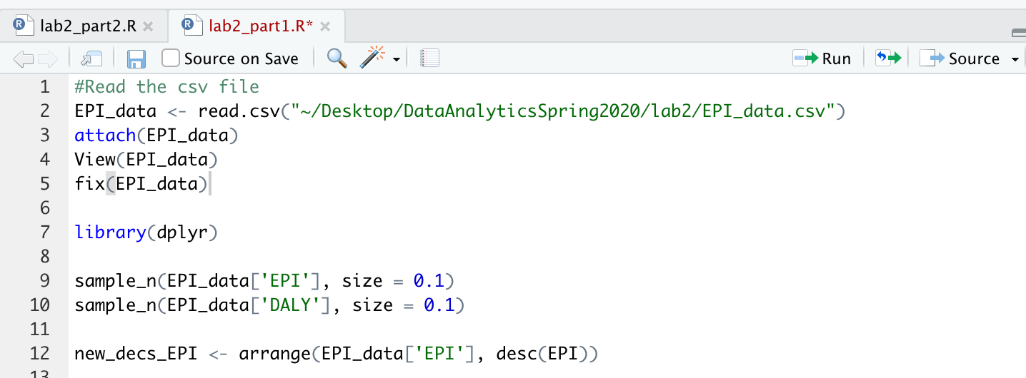

LAB2 PART2

Exercise1: Regression

* Retrieve this dataset: dataset_multipleRegression.csv
* A screenshot of a cell phone

  Description automatically generated
* A screenshot of a cell phone

  Description automatically generated
* Using the unemployment rate (UNEM) and number of spring high school graduates (HGRAD), predict the fall enrollment (ROLL) for this year by knowing that UNEM=7% and HGRAD=90,000.
* Repeat and add per capita income (INC) to the model. Predict ROLL if INC=$25,000
* A screenshot of a cell phone

  Description automatically generated

Exercise 2: Classification

* Retrieve the abalone.csv dataset
* Predicting the age of abalone from physical measurements.
* The age of abalone is determined by cutting the shell through the cone, staining it, and counting the number of rings through a microscope: a boring and time-consuming task.
* Other measurements, which are easier to obtain, are used to predict the age.
* Perform knn classification to get predictors for Age (Rings). Interpretation not required.

Exercise 3: Clustering

* The Iris dataset (in R use data(“iris”) to load it)
* The 5th column is the species and you want to find how many clusters without using that information
* Create a new data frame and remove the fifth column
* Apply kmeans (you choose k) with 1000 iterations
* Use table(iris[,5],<your clustering>) to assess your results

