META COURSE: INTRO TO FRONT END DEVELOPMENT

Capstone project demo: Little Lemon website
It includes the following elements:
- A home screen with information about the restaurant.
- A table reservation system.
- A profile screen for users to enter their personal details.
- Navigation that enables users to move between parts of the web app.
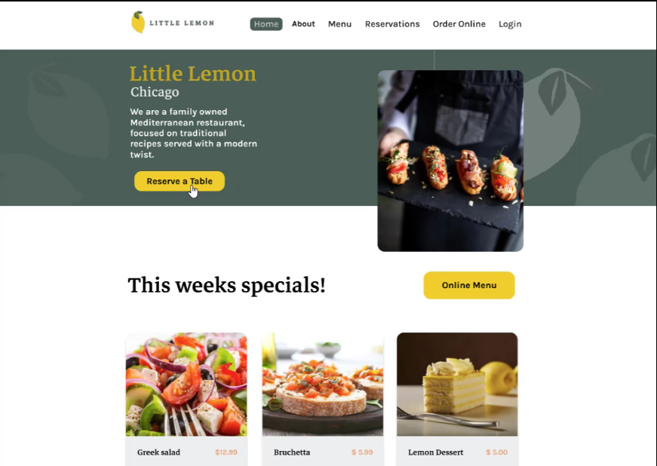
- DEMO VIDEO LINK: https://d3c33hcgiwev3.cloudfront.net/3dXEZfDfSbWCovIkF7sVdA_96918fa14c794472bc38c61045d614e1_FE-C8M4L1-Item-5---Solution-functionality-.mp4?Expires=1759881600&Signature=ibuUgVoBh1M0xcQ5ggI6-uiSnCc4VhvYxjZuZJafYES0I-QI3IAjduyEu~m19CBIXMxdjY-qE7Taim5mxfd8F7-BJkwr1DHonHqfv2W38KduoIlRJMT~j9iXRX1TnzDgC~TVkd8QWQz8v6YKaRW2O1KrODL5dJKdT11nkcRC4IA_&Key-Pair-Id=APKAJLTNE6QMUY6HBC5A
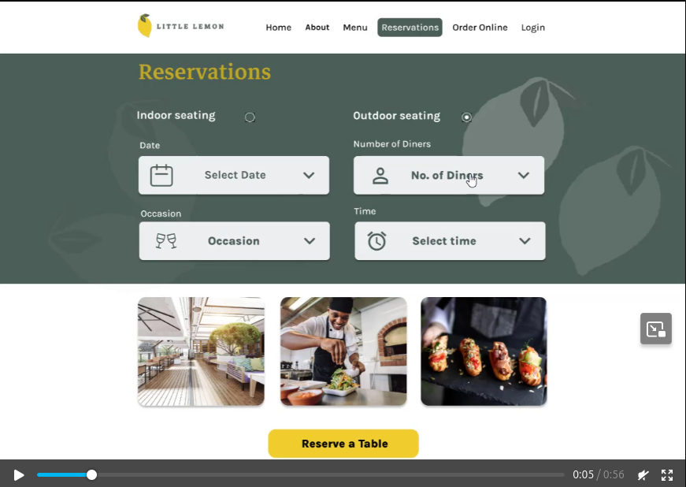
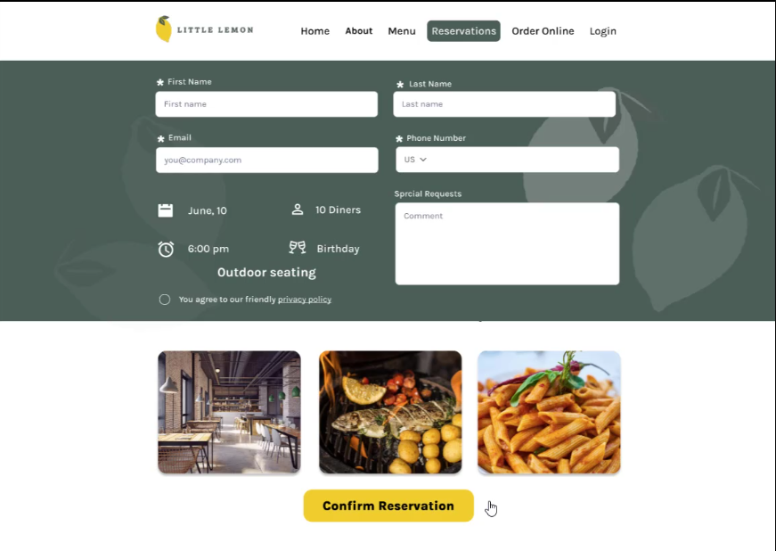
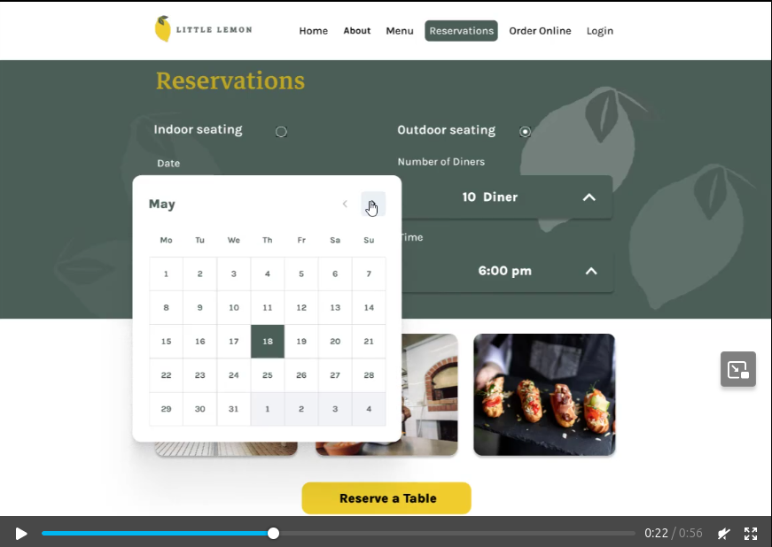

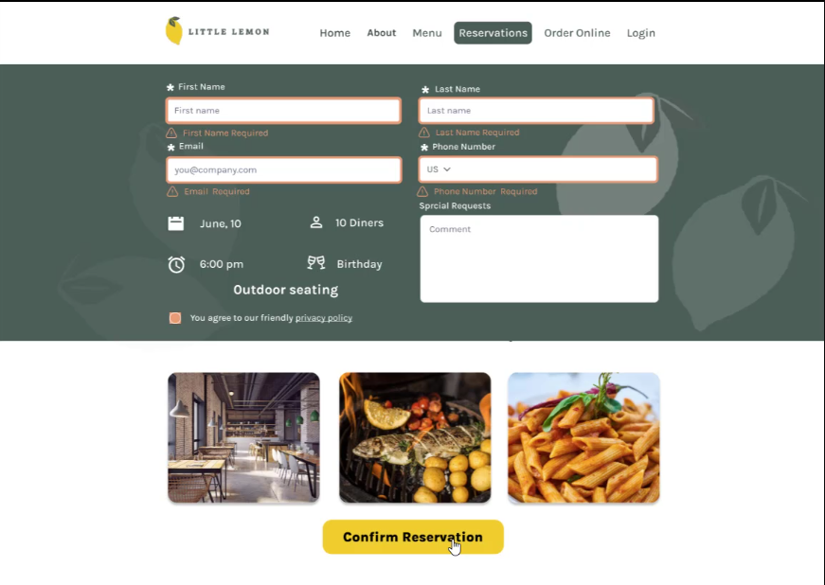
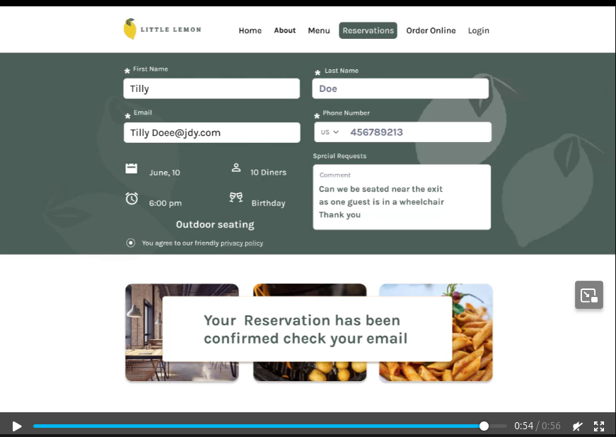

-------------------------------//------------------------------//-----------------------------
HOW THE INTERNET WORKS ??
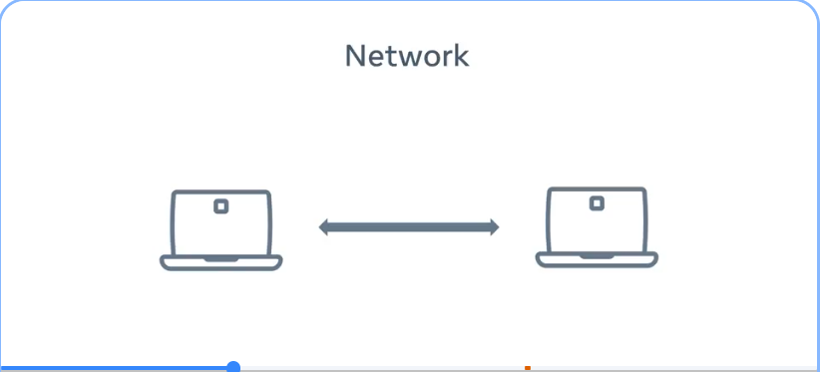
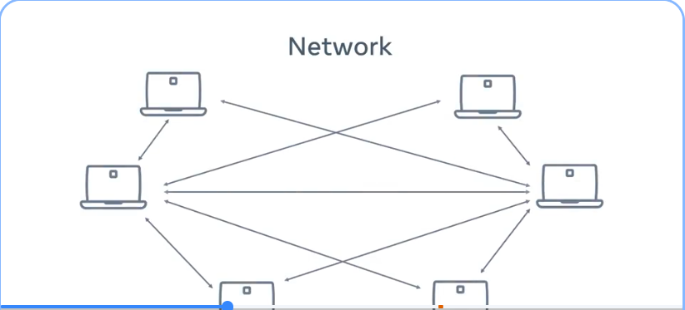

* When two devices connect and communicate via a wired or wireless connection, forming something called a network. You can connect multiple devices to this network. => But this becomes very complicated very quickly, as each device needs to connect to every other device to communicate effectively.

* This problem is solved by something called a network switch that connects multiple devices and allows them to communicate with each other. The network switch can connect to other network switches, and now two networks can connect.
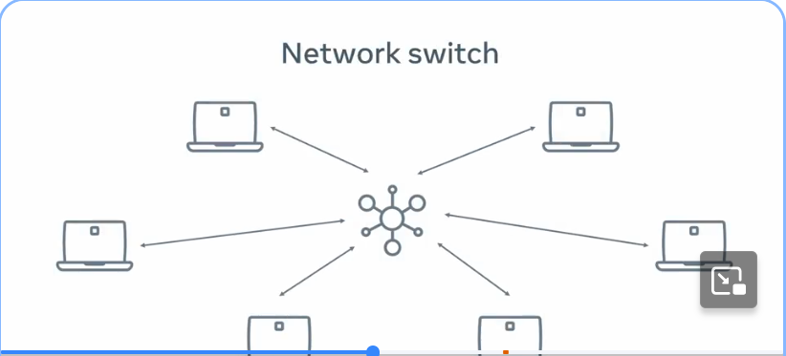
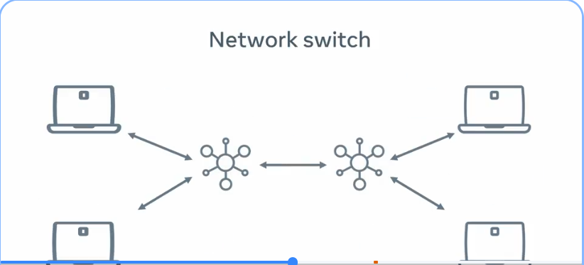

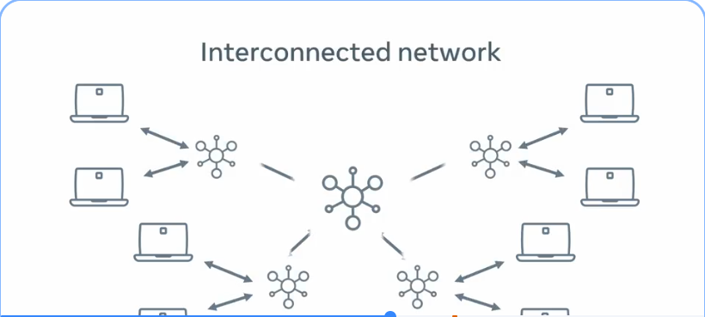
* These network switches then connect to more network switches until you have something called an interconnected network.
* This interconnected network has another name that you might be familiar with. It's called the Internet.

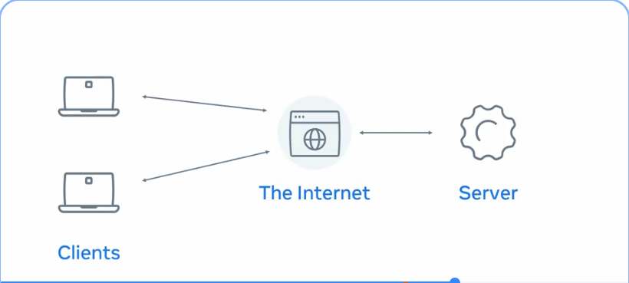
* When we use websites or video streaming services on the Internet, these are provided by computers called servers. Our devices are called clients. This is known as the client-server model. Internet connects the entire world.
--------------------------//----------------------------------//------------------------------
WHAT IS A WEB SERVER & HOW DOES IT WORK ??

* A server is a computer that runs applications and services ranging from websites to instant messaging.

* It's called a server because it provides a service to another computer and its user also known as the client. Is typically stored in something called a data center with hundreds or thousands of other servers, all running different services connected to the internet.

* There are many different systems in data centers to ensure that servers have continuous power, continuous internet connection and are kept called 24 hours per day.

* There are data centers located all around the world. Many websites use these to allow you to access your content quickly from the data center nearest to you.

* The data center servers are built based on the service purpose. For example:
1. If the server is only to be used for storing images, it might have a lot of hard drive space.
2. Whereas a server computing complex calculations might need a fast processor and a lot of memory.
=> This is usually referred to as a server hardware => The physical components of a server.

* Once the server hardware is installed in the data center, a piece of code can now run. The code that runs on the hardware is commonly known as software.

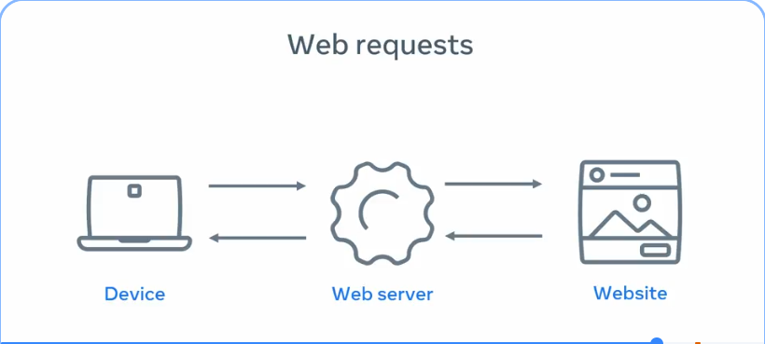
* A type of service software known as a web server. A web server has many functions which includes website storage and administration, data storage, security and managing email. Another primary function is to handle something known as a web request.

* When you open a browser on your device and type the name of the website, it's the job of the web server to send you back to that website's content. This process is known as the request response cycle .

------------//--------------------------------//------------------------------------//--------WHAT ARE WEBSITE AND WEBPAGES ????
* A web page is a document that displays images, texts, videos and other content in the web browser.

* A Website is a collection of webpages that link together.

* If you want to work with a webpage, you need to know about three technologies and understand how they interact, their HTML, CSS and JavaScript.

* HTML structures the content you see, CSS controls the colors and style and JavaScript is responsible for the user interaction.

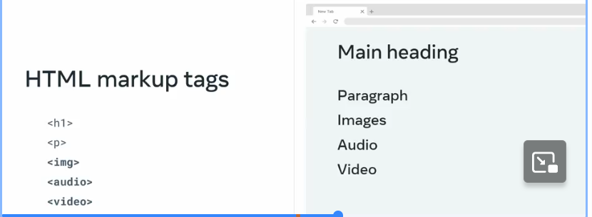
* HTML stands for hypertext markup language, it works by using something called markup tags. These tags describe the content that is displayed in the browser window, this content can be things like headings, paragraphs, images and even multimedia elements such as audio and video, the way html describes the content is known as markup.

* CSS is short for cascading style sheets and adds visual enhancements like colors and layout to the web page, this is commonly known as styling. It works by enhancing the HTML elements and telling them how to display.
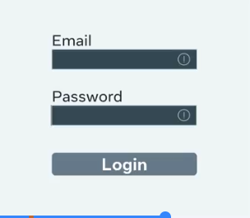

* The last technology is JavaScript, which is a programming language built into the browser. JavaScript provides web developers with tools for interactivity, data processing, control and action.
But how exactly does this code get translated to display the content that you see on your screen ??

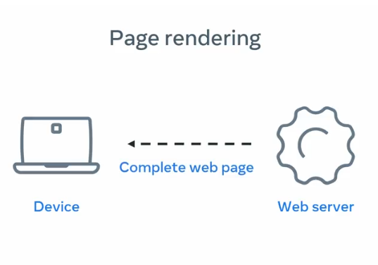
* When a copy of that webpage is sent from the web server to your browser, each line of code is processed in sequential order from first to last. As each line is interpreted, the browser creates the building blocks, which is the visual representation you see on the screen.
This creation process is known as page rendering
-------------//------------------------------------------//-----------------------------------

What is a web browser and how does it work ??
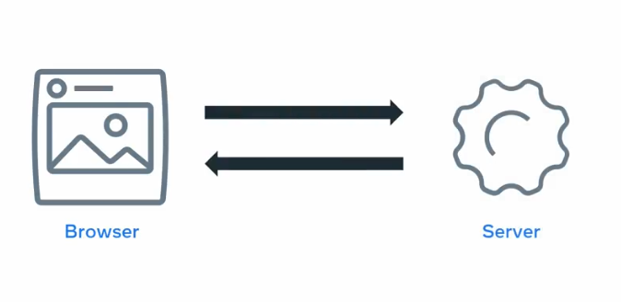
* A web browser, or browser for short, is a software application that you use to browse the World Wide Web. It works by sending a request to a web server and then receives a response containing the content that is to be displayed on the screen of your device.

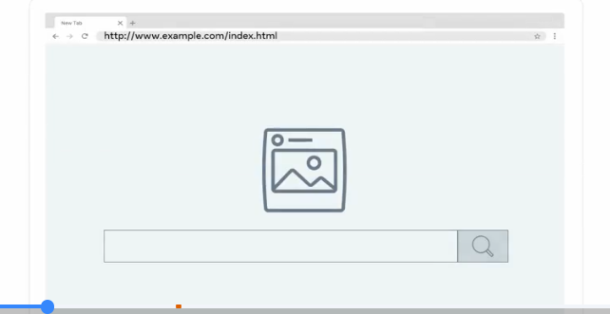
* Once the browser is open on your device, there is the address bar where you input the address of the website that you want to visit.
The address is commonly known as the Uniform Resource Locator or URL for short.

* The URL contains the protocol or the HTTP, the domain name, usually the name of the website, and the file path, or the path to the page that is displayed.

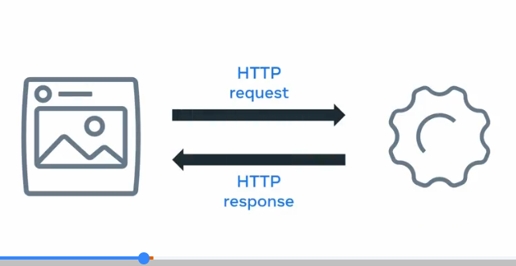
* When you make a request using this URL, the browser and server communicate using a protocol known as the Hypertext Transfer Protocol or HTTP.
=> Once the web browser receives the content, it displays it on the screen of your device. This exchange of information is made possible by something known as the request response cycle.

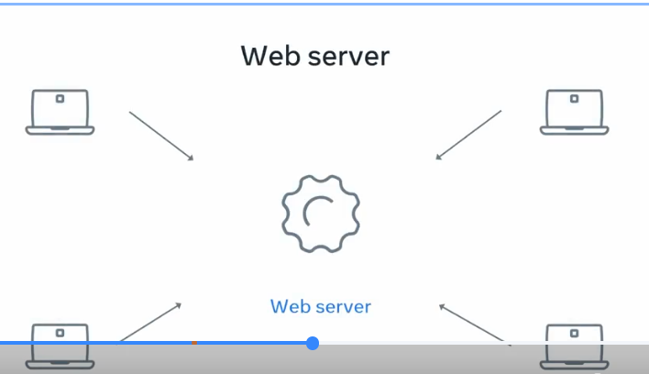
* The web server is a special type of computer that allows other computers to make requests for data. The web server responds by sending a webpage back to the browser.

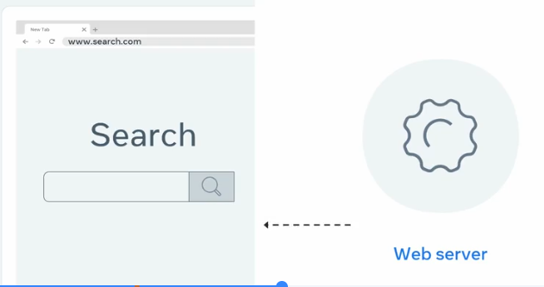
* Once the browser receives all the response information, the search engine webpage is made visible. The web page is a coded document that is rendered by the browser and then presented visually to you, the end-user.
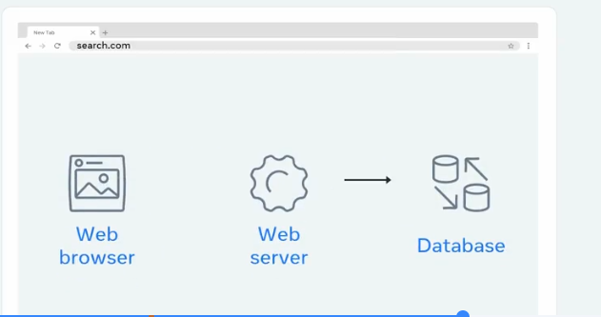
* The search engine web server processes the request by taking the keyword and using it to find the requested data. This data is stored in something called a database, which is connected to the web server. The web server then picks up that data and sends it back to the browser.

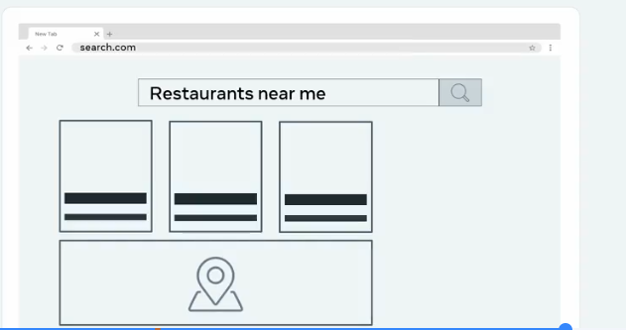
* When the web browser receives the full response from the web server, it again renders a visible webpage with links to some restaurants, a map showing nearby locations and more related information such as reviews, lists, and even reservations.

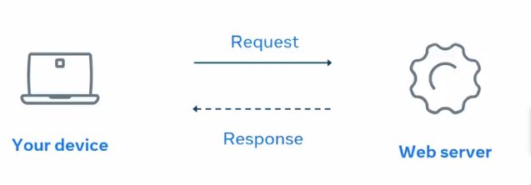

=> This how the request response cycle works.

-----------------//-----------------------------//----------------------//--------------------WEB HOSTING ????
what if you wanted to create your own website? Do you really need your own datacenter with specialized hardware and software?
* Thankfully, the answer is no.

Then how can you create your own website ??
* Developers can launch websites to the Internet using something known as web hosting. Web hosting is a service where you place your website and files on the hosting companies web server. You're essentially renting the space in return for stable and secure storage.

* The cheapest form of web hosting is known as shared hosting.
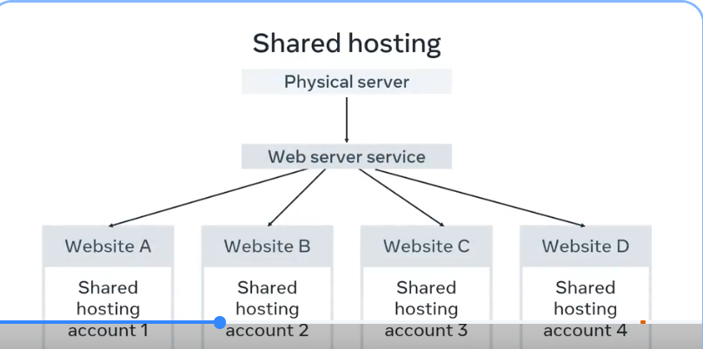
You pay for a location on a web server containing many web hosting accounts with shared hosting.
=>This means that you also share the service processing power, memory, and bandwidth with other websites that might slow your performance.

=> This option is best for a small website with a small number of visitors. Many developers also use this as a low-cost sandbox environment to practice deploying or hosting their personal websites.

* Sites with more considerable demands use virtual private surface or VPS.
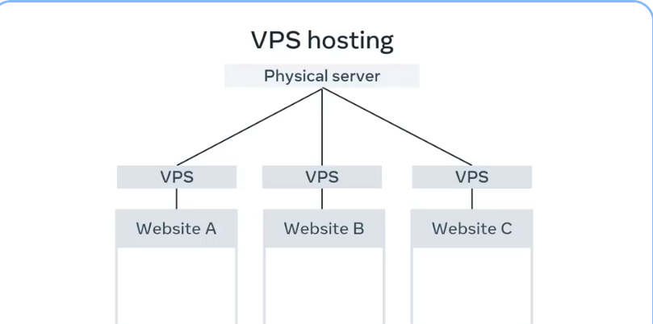
=> A VPS is a virtual server with dedicated CPU, memory, and bandwidth resources.

* It will be running on a hardware server with other VPS instances but as the resources are fixed per VPS instance, your website is unlikely to be impacted by the performance of other VPS instances. A VPS instance will be more expensive than shared hosting.

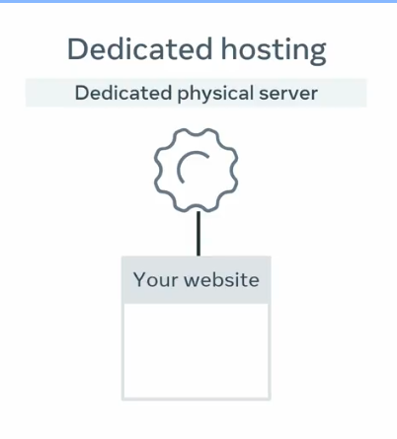
* The next option up is to use dedicated hosting.
* This will be a hardware server that is dedicated to you only. All hardware, CPU, memory, and bandwidth resources are yours to use. Generally, this option is more expensive than a VPS hosting.

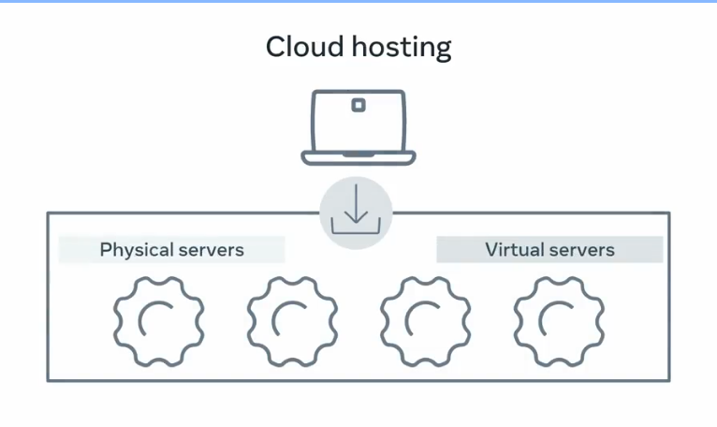
* The last type of web hosting is something you may have heard of.
Cloud hosting and the Cloud has grown in popularity over the last decade and is often mentioned in various news and services you use.

With Cloud hosting, your website is run in something called a Cloud environment, which spans across multiple physical and virtual servers.
=>If a physical or virtual server fails, your website will run on a different server and stay online.

* The main advantage of Cloud hosting is that you can use as many resources as you need without hardware limitations. However, you pay based on resource use.

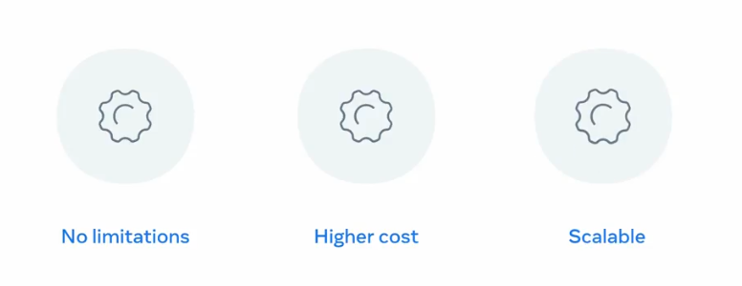
=> For example, if you transfer a file from the Cloud to a web browser, you'll pay for the bandwidth used for that transfer at a fractional cent cost per megabyte. While this can quickly become more expensive, is allows websites and web applications to scale their costs as popularity grows.

-----------//-------------------------------//---------------------------------------//-------
Introduction to internet protocols ????

* Email is a common communication method that we all know about.
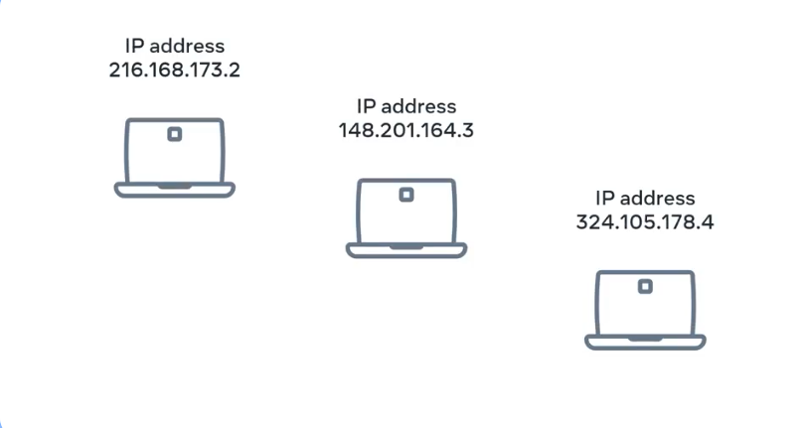
* Data sent across the Internet is quite an important part of our everyday lives, and it wouldn't be possible without Internet Protocol addresses or IP addresses.

* A useful way to think of IP addresses is that they function much like addresses in a postal system that make it possible for packets of information to be delivered to you. Like with the postal system, things can go wrong.
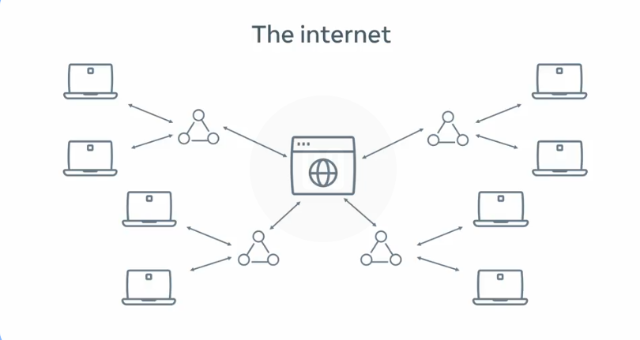
* A bit recap: You previously learned how computers connect to each other to form networks and how these networks connect to each other to form the Internet ??

* When you send data between computers across the Internet => A common way of understanding this is that the computers are the destinations that request and receive the data, and the networks are the routes that the data travels across.

* What makes that possible is the Internet Protocol. Version 4 and version 6 are currently the two most widely used standards of Internet Protocol.

* Every computer on a network is assigned an IP address. In protocol version 4, an IP address contains four octets separated by periods or dots. For example, 192.0.2.235.

* In protocol version 6, an IP address contains eight groups of hexadecimal digits separated by a colon.
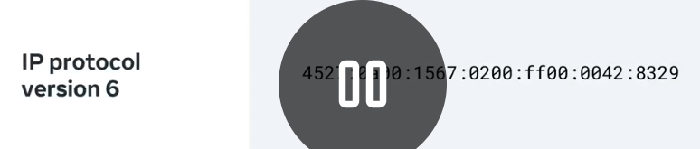
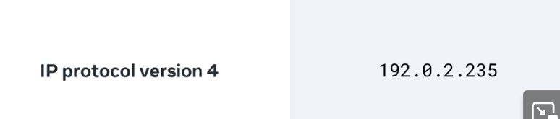

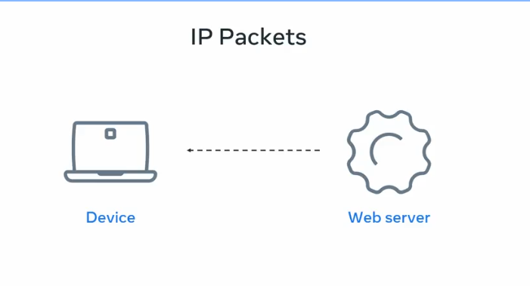
* When you send data across a network, you send the data as a series of messages called IP packets, also known as datagrams.

At a high level, IP packets contain a header and a payload, which is the data.

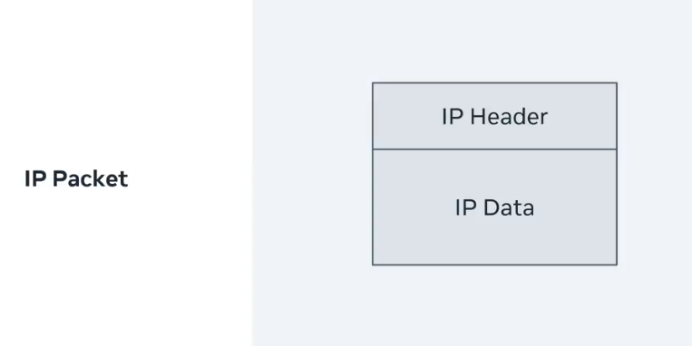
* IP packets are include the destination IP address and source IP address.
* These addresses are in the header along with some additional information to help deliver the packet.
* The payload contains the data of the packet and some of the other protocols.

When sending multiple data across the internet, it's possible that the IP packets may arrive out of order.
* They can arrive with damaged or corrupted during transit.
* Or be dropped or lost during transit.
=> To solve these problems, the payload part of the packets contains other protocols, too.

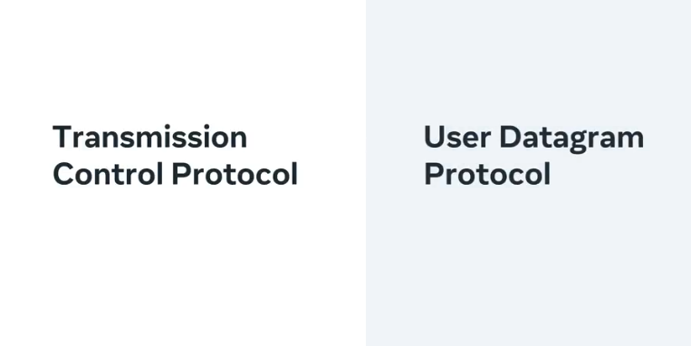
These 2 added protocols can be known as another message inside the payload of the IP packet.

* The two most common protocols are the Transmission Control Protocol, referred to as TCP, and the User Datagram Protocol, also known as UDP.

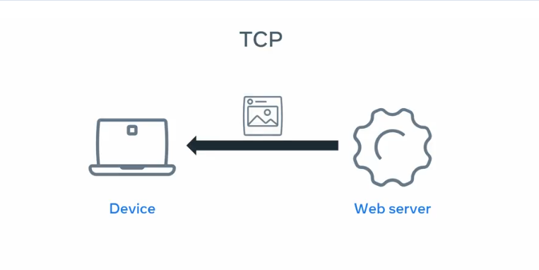
* TCP can solve all three of the previously mentioned issues, but at the cost of a small delay when sending the data.

* This protocol is used for sending the data that must arrive correctly and in order, such as a text or image files.
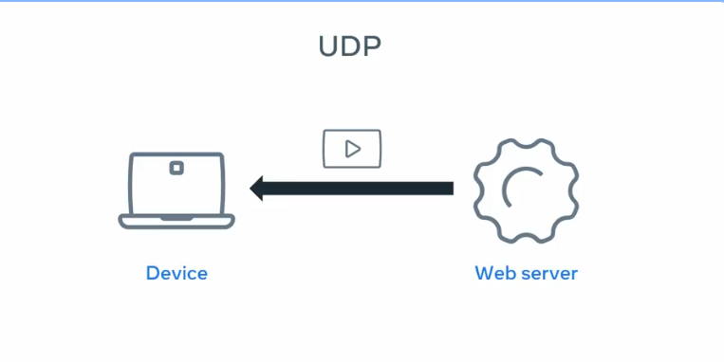

* UDP solves the corrupt packet issue, but packets can still arrive out of order or not arrive at all. This protocol is used for sending data that can tolerate some data loss, such as voice calls or live video streaming.

=> Both of these protocols contain payloads that contain further protocols inside of them.
=> These protocols can help to make sure that data arrives in order, does not become corrupted or lost or dropped during transit.

--------------------//-----------------------------//---------------------------------//------

Virtual Lab:
Picture 1: from a windows machine
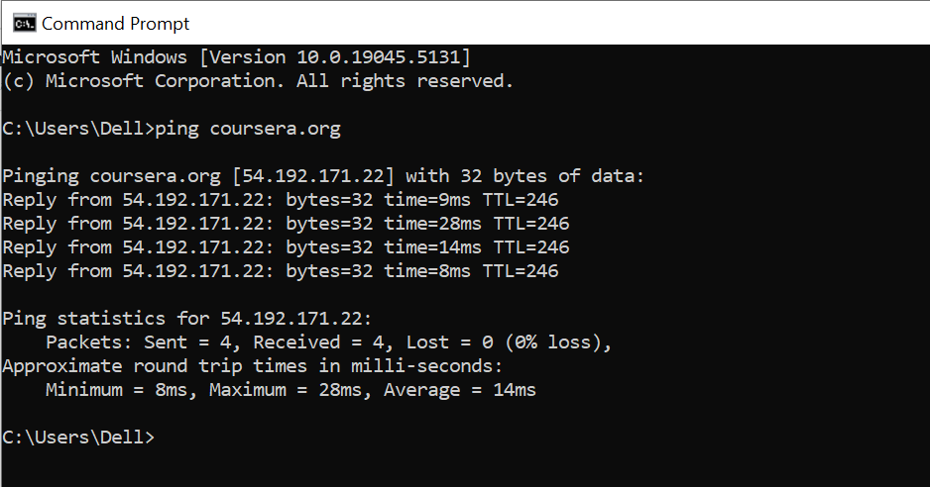
Analyze the output:
Output Details:
- DNS Resolution:
  - coursera.org [54.192.171.22]
    - The domain name coursera.org resolves to the IP address 54.192.171.22. This is the IP address of one of Coursera's servers.
- ICMP Packets:
  - Each line shows the details of the ICMP Echo Reply packets received:
    - bytes=32: The size of each ICMP packet sent and received is 32 bytes.
    - time=9ms, 28ms, 14ms, 8ms: These are the round-trip times (RTT) it took for the packet to travel from your computer to the server and back, measured in milliseconds.
    - TTL=246: The Time-to-Live value of the packet. This value decreases as the packet passes through network hops (routers). It gives an idea of the network's distance.
- Ping Statistics:
  - Packets:
    - Sent = 4, Received = 4, Lost = 0 (0% loss): Four packets were sent, and all four were received. There was no packet loss, indicating a stable connection to the server.
- Approximate Round Trip Times:
  - Minimum = 8ms: The fastest time for a packet to complete a round trip.
  - Maximum = 28ms: The slowest time for a round trip.
  - Average = 14ms: The average time of all four round trips.
Key Takeaways:
- The ping command is a simple yet powerful tool to explore Internet protocols.
- DNS resolution is crucial for converting user-friendly domain names into IP addresses.
- Packet statistics provide insight into network health and performance, such as latency and reliability.

Picture 2: from an Ubuntu machine
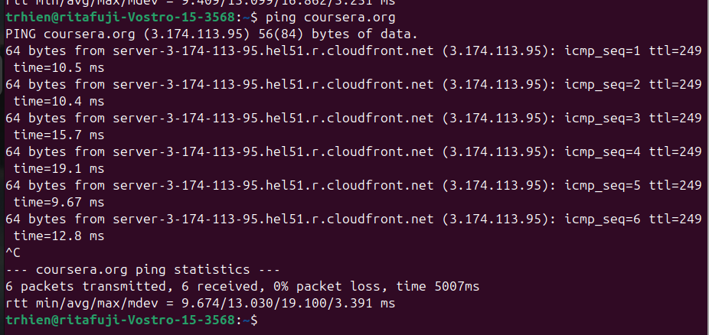
Analyze the output:
Output Details:
- DNS Resolution:
  - coursera.org [3.174.113.95]
    - The domain name coursera.org resolves to the IP address 3.174.113.95. This is the IP address of one of Coursera's servers.
ICMP Packets:
- Each line shows the details of the ICMP Echo Reply packets received:
  - bytes=64: Size of each ping reply (standard 64 bytes).
  - Time=10.5ms , 10.4ms , 15.7ms , 19.1ms , 9.67ms , 12.8 ms: The round-trip time (ping latency). Lower = faster connection.
  - TTL=249: “Time To Live” – indicates how many hops (routers) the packet traveled. Not super important for end users, just diagnostic.
  - Icmp_sep=1: Sequence number of the ping (goes up each time).
  - Icmp: Internet Control Message Protocol → the protocol used by ping.
  - From server-3-174-113-95.hel51.r.cloudfront.net (3.174.113.95) : Hostname and IP of Coursera’s server that replied.

How to interpret your result
- Ping time (avg = 13 ms) → Very fast. (Under 30 ms = excellent; 30–80 = good; 80+ = laggy)
- 0% packet loss → Stable connection.
- Low jitter (3.391 ms) → Consistent performance.
So in short:
🟢 Your network connection to Coursera is excellent — stable, low latency, and responsive.
--------------------//-----------------------------//---------------------------------//------
Introduction to HTTP ????
* HTTP is a core operational protocol of the world wide web.
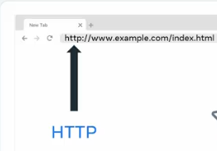
* HTTPS, the secure version of HTTP is being used.

=> It is what enables your web browser to communicate with a web server that hosts a website.

HTTP is the communication protocol you use whenever you browse the web.
HTTP stands for Hypertext Transfer Protocol.
It is a protocol used for transferring web resources such as HTML documents, images, styles, and other files.

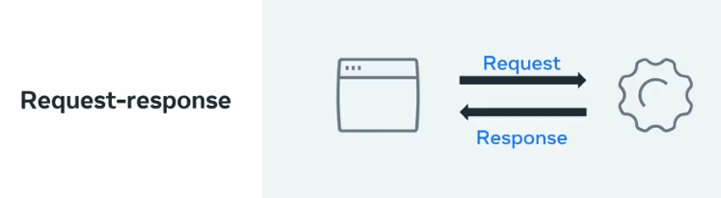
* HTTP is a request response based protocol. A web browser or client sends an HTTP request to a server and the web server sends the HTTP response back to the browser.
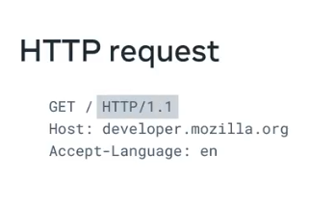
* An HTTP requests consists of a method, path, version and headers.

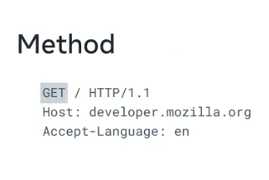
* The HTTP method describes the type of action that the client must performed.

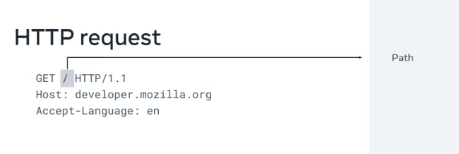
* The primary or the most commonly used HTTP methods are, GET, POST, PUT, and DELETE.
* The path is the representation of where the resource is stored on the web server.

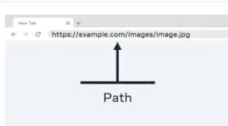
* For example, if you wanted to request an image from a page in a website, then the URL in the address bar would need to contain the full path to that particular file on the web server, such as: https://example.com/images/image.jpg

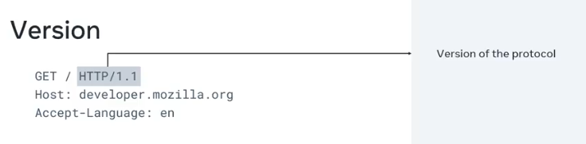
* There are multiple versions of the HTTP protocol., but Versions 1.1 and 2.0 are the most used among others.

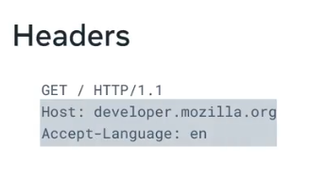
* Finally, there are the headers.
Headers contain additional information about the request and the client that is making the request.

* For certain requests methods, the request will also contain a body of content that the client is sending.

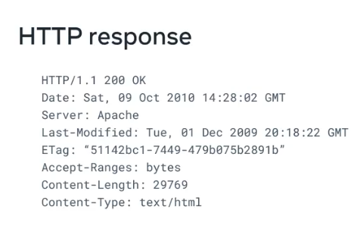
* HTTP responses follow a format similar to the request format.

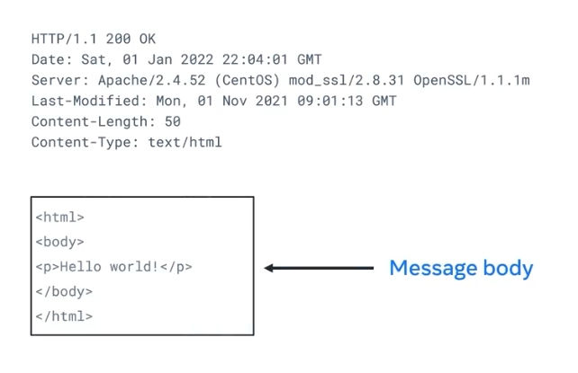

* Following the header, the response will optionally contain a message body consisting of the response contents such as the HTML document, the image file and so forth.

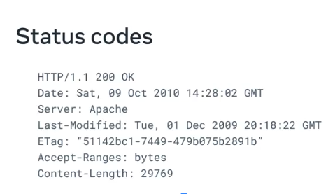

* HTTP status codes contained within the header indicate if the HTTP request successfully completed. The code values are in the range of 100-599 and are grouped by purpose.

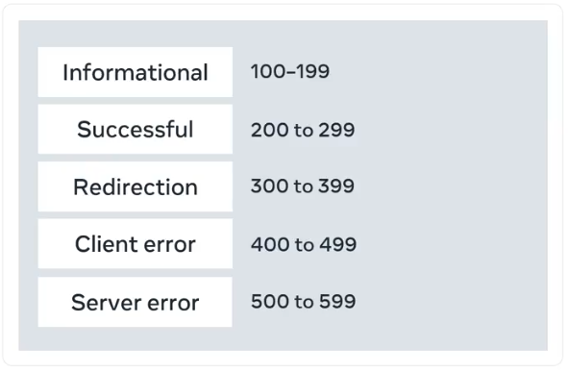
* Informational is grouped 100-199.
* Successful responses are grouped from 200-299.
* Redirection message are 300-399.
* Client error responses range from 400-499, and server error responses are 500-599.
* Information responses are provisional responses sent by the server. These responses are interim before the actual response.
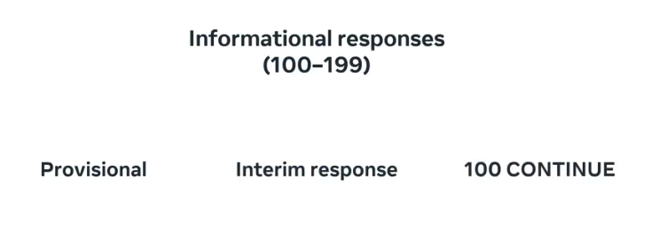
* The most common information response is 100 continue, which indicates that the web client should continue to request or ignore the response if the request is already finished.

* Successful responses (200 - 299) indicate that the request was successfully processed by the web server, with the most common success response being 200 OK.
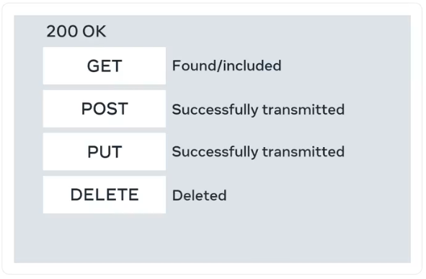
* The meaning of OK, depends on the HTTP method.
* If the method is GET, it means that the resource is found and is included in the body of the HTTP response.
* If it's POST, it means that the resource was successfully transmitted to the web server .
* If it's PUT, the resource was successfully transmitted to the web server.
* Finally, if the method is DELETE, it means the resource was deleted.

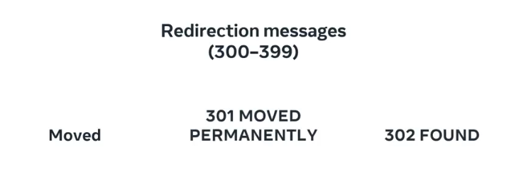
* Redirection responses indicate to the web client that the requested resource has been moved to a different path.

* The most common response codes used are 301 moved permanently and 302 found.

* The difference between the redirection messages 301 and 302 is that 302 indicates a temporary redirection. The resource has been temporarily moved.
=> When web browsers receive these responses, they will automatically submit the request for the resource at the new path.
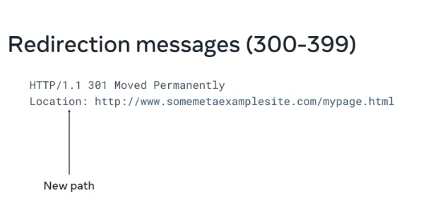
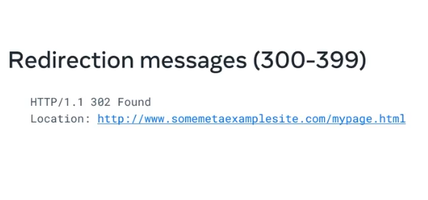

* Client error responses indicate that the requests contained bad syntax or content and cannot be processed by the web server.

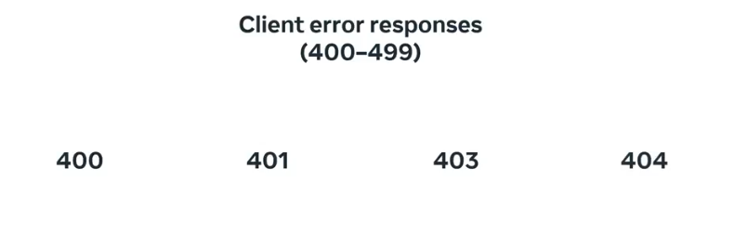
* The most common codes used are 400 is used when the web browser or client submitted bad data to the web server.

* 401 is used to indicate that the user must log into an account before the request can be processed.

* 403 is used to indicate the request was valid, but that the web server is refusing to process it. This is often used to indicate that a user does not have sufficient permissions to execute an action in a web application.

* 404 is used to indicate that the request resource was not found on the web server.
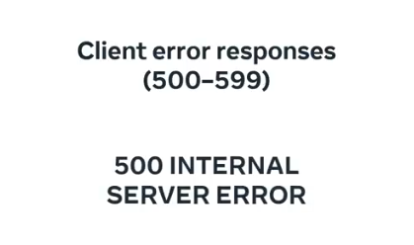
* Server error responses indicate that a failure occurred on the web server while trying to process the request.

* The most common code used is 500 internal server error, which is a generic error status indicating that the server failed to process the request.
------------//---------------//-----------------------//------------------------//------------
Why do we need HTTPS ??
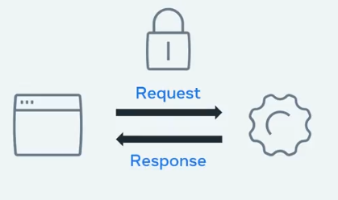
Now, have you ever bought something online and needed to enter your credit card information? You wouldn't want someone else to get this information from the HTTP request. =>

This is where HTTPS is involved. HTTPS is the secure version of HTTP. It is used for secure communication between two computers so that nobody else can see the information being sent and received. It does this by using something called encryption.
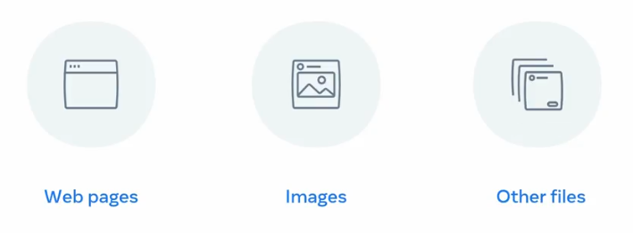
Like in HTTP, the requests and responses still behave in the same way and have the same content.

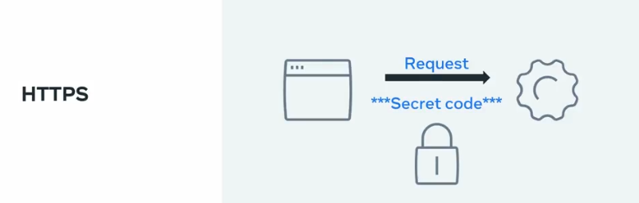
The big difference is that before the content is sent, it is turned into a secret code. Only the other computer can turn the secret code back into its original content.

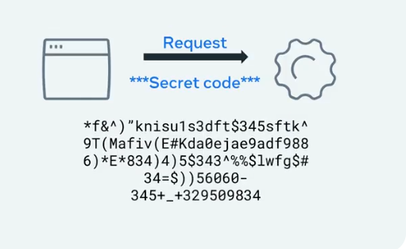
If someone else was to look at the code, it wouldn't be understandable.
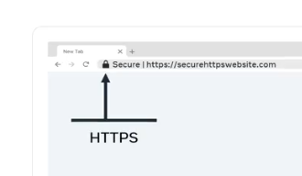

HTTPS icons

A brief summary of this lecture:
What is a HTTP ??
* It is a protocol used by web clients and web servers.
* It works to transfer web resources such as HTML files, and is the foundation of any data exchanges on the web.

What is a HTTPS ??
* Is an encryption version of HTTP used for secure protection.
* by using HTTPS, we send the information securely.

What is a Request ??
* Requests are sent by the client, usually a web browser, and the server replies with responses which may be the return of an image or an HTML page.

What does HTTP Request have ??
* HTTPS requests have a syntax that includes method, path, versions and headers.

What does HTTP Response have ??
* HTTP responses follow a similar format to the request.

What does HTTP status mean ??
* HTTP status codes indicate whether the HTTP requests successfully completed.
* The status code is a three-digit number that corresponds with groups representing different types of results.

Request Line
Every HTTP request begins with the request line.
This consists of the HTTP method, the requested resource and the HTTP protocol version.
GET /home.html HTTP/1.1
In this example, GET is the HTTP method, /home.html is the resource requested and HTTP 1.1 is the protocol used.

HTTP Methods
HTTP methods indicate the action that the client wishes to perform on the web server resource.
Common HTTP methods are:
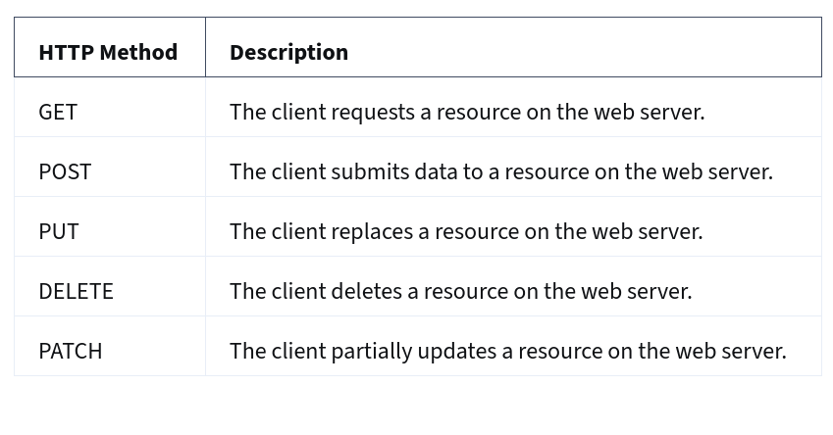
HTTP Request Headers
After the request line, the HTTP headers are followed by a line break.
There are various possibilities when including an HTTP header in the HTTP request. A header is a case-insensitive name followed by a: and then followed by a value.
Common headers are:
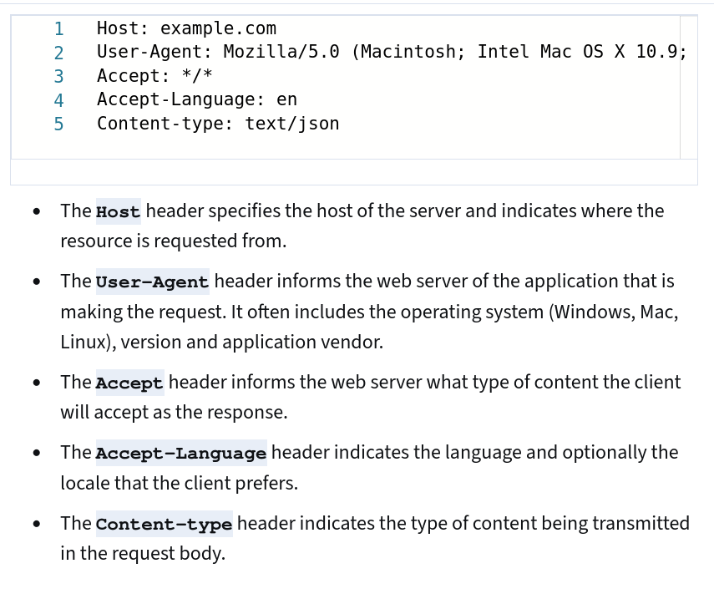

HTTP Request Body
HTTP requests can optionally include a request body. A request body is often included when using the HTTP POST and PUT methods to transmit data.
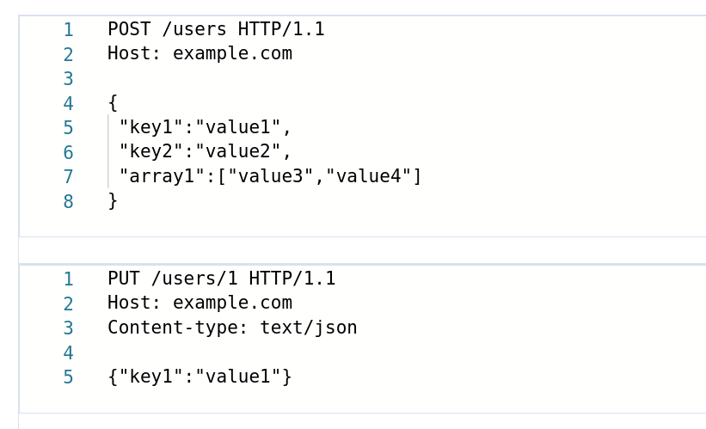

HTTP Responses
When the web server is finished processing the HTTP request, it will send back an HTTP response.
The first line of the response is the status line. This line shows the client if the request was successful or if an error occurred.

HTTP Status Codes
The first digit of an HTTP status code indicates the category of the response: Information, Successful, Redirection, Client Error or Server Error.
The common status codes you'll encounter for each category are:
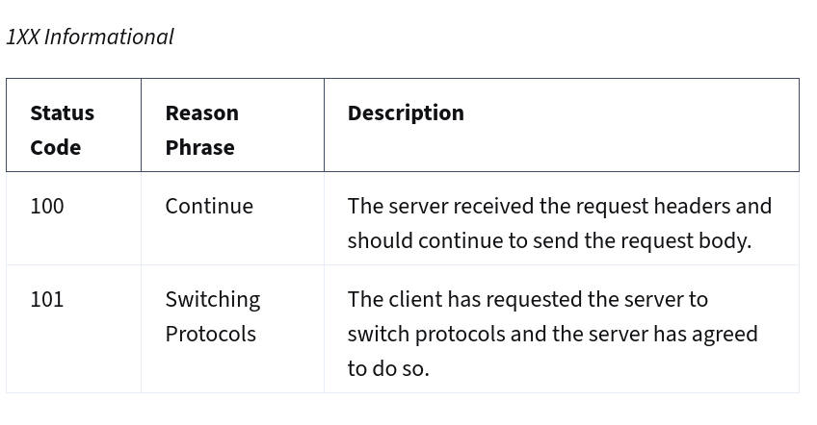
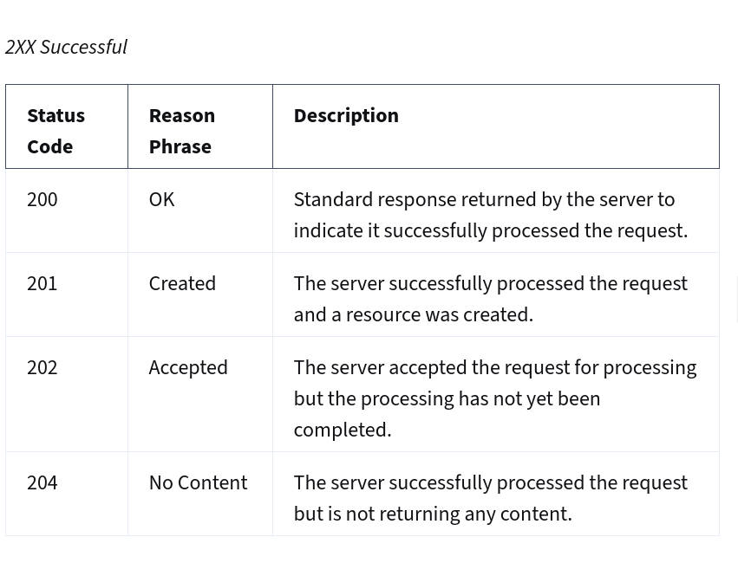
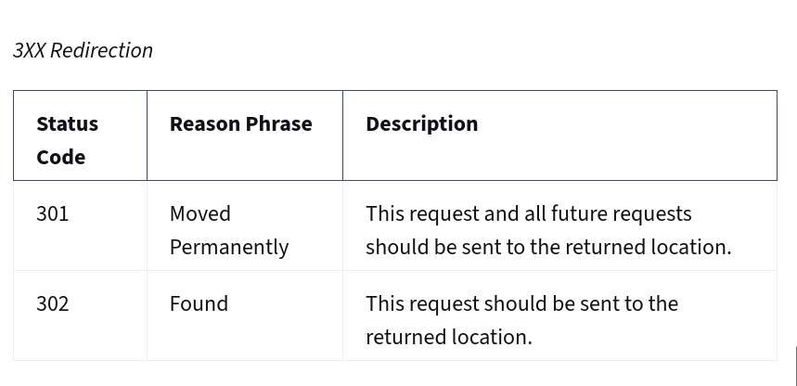
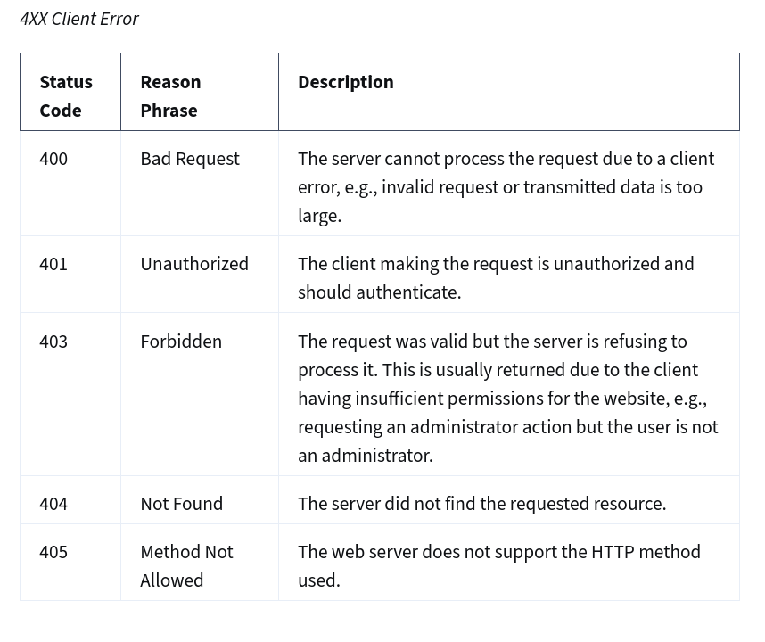
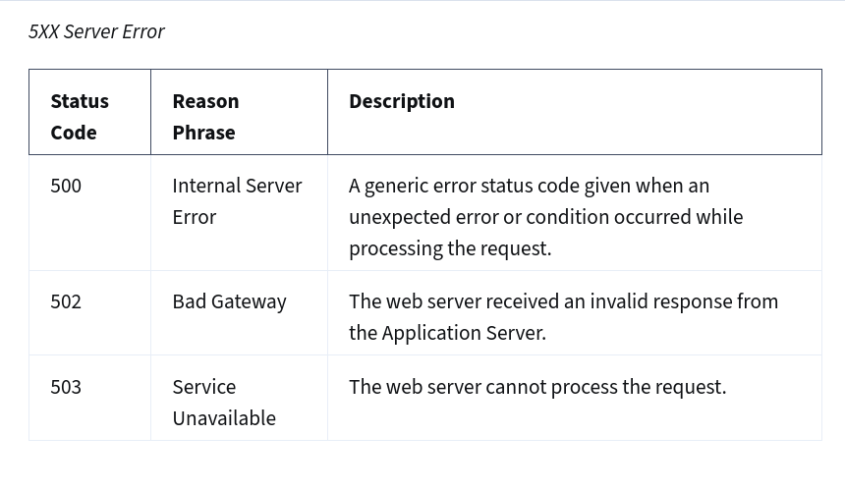

HTTP Response Headers
Following the status line, there are optional HTTP response headers followed by a line break.
Similar to the request headers, there are many possible HTTP headers that can be included in the HTTP response.
Common response headers are:

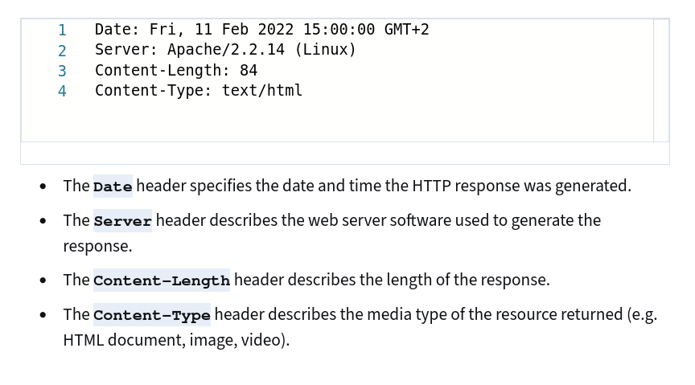
HTTP Response Body
Following the HTTP response headers is the HTTP response body. This is the main content of the HTTP response.
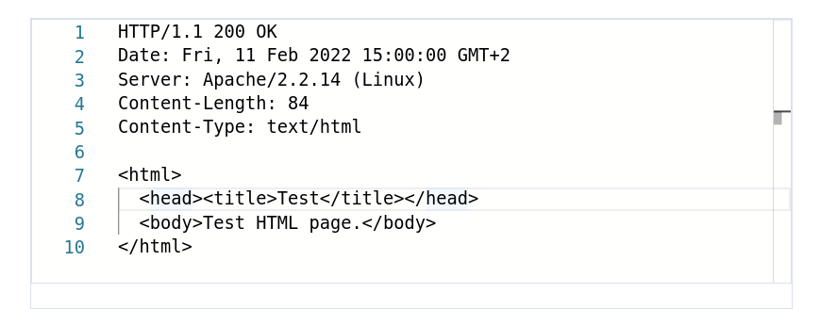
This can contain images, video, HTML documents and other media types.

Intro to HTML, CSS and Javascript
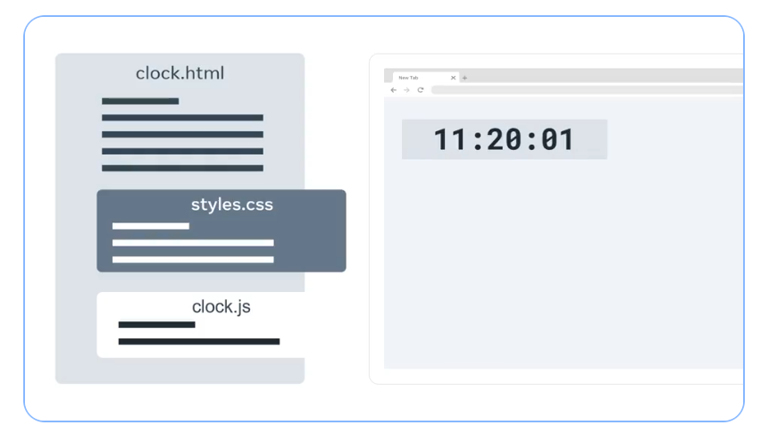
When building a web page that displays a digital clock. It shows the hour, minutes, and seconds.
* The time is updated every second. I will work with three files, an HTML, a CSS, and a JavaScript file
* To create the clock element, Let's first define our HTML code in a file called clock.html. The HTML code has an element that describes the content in hours, minutes, and seconds.
* To apply styles to the HTML element, the HTML code references a CSS file called styles.css. The web browser retrieves the styles.css file and processes it. The CSS code provides styling for the clock. It tells the browser the position, size, color, background, and font type, and size of each element on the screen.
* Finally, we need to ensure the clock updates with the correct time. This is where JavaScript comes in. The HTML references a JavaScript file called clock.js. The JavaScript file contains code that every second updates the content of the hour, minute, and second elements.
=> With the three files created and linked together, your clock is fully functional.

A Brieft summary of the lecture:
* The HTML file references the CSS and the JavaScript files.
* The CSS file is called on to format and style your application.
* The code in the JavaScript file implements the core functions of the app and user interactivity.
---------//-------------------------------------//-------------------------//-----------------

Other Internet Protocols
Hypertext Transfer Protocols (HTTP) are used on top of Transmission Control Protocol (TCP) to transfer webpages and other content from websites. This reading explores other protocols commonly used on the Internet.

Dynamic Host Configuration Protocol (DHCP)
You've learned that computers need IP addresses to communicate with each other. When your computer connects to a network, the Dynamic Host Configuration Protocol or DHCP as it is commonly known, is used to assign your computer an IP address. Your computer communicates over User Datagram Protocol (UDP) using the protocol with a type of server called a DHCP server. The server keeps track of computers on the network and their IP addresses. It will assign your computer an IP address and respond over the protocol to let it know which IP address to use. Once your computer has an IP address, it can communicate with other computers on the network.

Domain Name System Protocol (DNS)
Your computer needs a way to know with which IP address to communicate when you visit a website in your web browser, for example, meta.com. The Domain Name System Protocol, commonly known as DNS, provides this function. Your computer then checks with the DNS server associated with the domain name and then returns the correct IP address.

Internet Message Access Protocol (IMAP)
Do you check your emails on your mobile or tablet device? Or maybe you use an email application on your computer? Your device needs a way to download emails and manage your mailbox on the server storing your emails. This is the purpose of the Internet Message Access Protocol or IMAP.

Simple Mail Transfer Protocol (SMTP)
Now that your emails are on your device, you need a way to send emails. The Simple Mail Transfer Protocol, or SMTP, is used. It allows email clients to submit emails for sending via an SMTP server. You can also use it to receive emails from an email client, but IMAP is more commonly used.

Post Office Protocol (POP)
The Post Office Protocol (POP) is an older protocol used to download emails to an email client. The main difference in using POP instead of IMAP is that POP will delete the emails on the server once they have been downloaded to your local device. Although it is no longer commonly used in email clients, developers often use it to implement email automation as it is a more straightforward protocol than IMAP.

File Transfer Protocol (FTP)
When running your websites and web applications on the Internet, you'll need a way to transfer the files from your local computer to the server they'll run on. The standard protocol used for this is the File Transfer Protocol or FTP. FTP allows you to list, send, receive and delete files on a server. Your server must run an FTP Server and you will need an FTP Client on your local machine.

Secure Shell Protocol (SSH)
When you start working with servers, you'll also need a way to log in and interact with the computer remotely. The most common method of doing this is using the Secure Shell Protocol, commonly referred to as SSH. Using an SSH client allows you to connect to an SSH server running on a server to perform commands on the remote computer. All data sent over SSH is encrypted. This means that third parties cannot understand the data transmitted. Only the sending and receiving computers can understand the data.

Secure File Transfer Protocol (SFTP)
The data is transmitted insecurely when using the File Transfer Protocol. This means that third parties may understand the data that you are sending. This is not right if you transmit company files such as software and databases. To solve this, the SSH File Transfer Protocol, alternatively called the Secure File Transfer Protocol, can be used to transfer files over the SSH protocol. This ensures that the data is transmitted securely. Most FTP clients also support the SFTP protocol.
--------------------//-------------------------------------------//---------------------------
Webpages, Websites and Web Apps
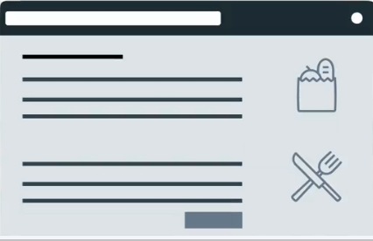
What is a Webpage ??
A typical web page is one single page that consists of HTML, CSS, and JavaScript. It displays images, text, videos, and other content in the web browser.

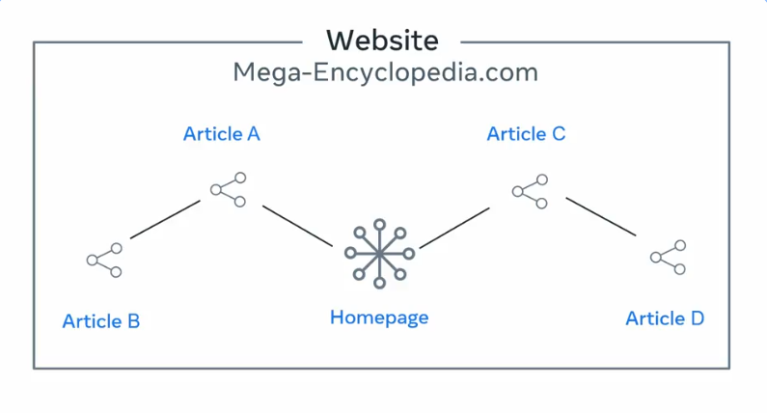
What is a Website ??
If a web page is one single page then a website is a collection of web pages that link together under one domain name.
when you visit your favorite encyclopedia website and the homepage has a lot of links to different articles, clicking on one of those links brings you to an article on a new web page, and that article links to more articles, and other web pages.

What is a Web Application ??
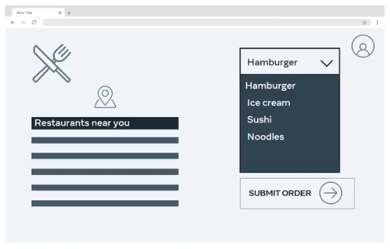
The key difference between a website, and web application is the level of interactivity, and dynamic content.
A website is more informative and a web application is more interactive.

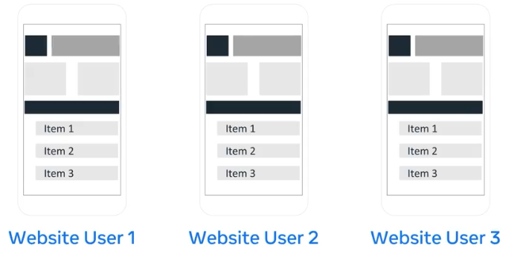
The web application displays different contents based on the user's input and interaction.
Whereas with the website, the user simply views the content and this content is the same for everyone who visits the website.
-----------------------------//------------------------------------//-------------------------Developer tools????
As a developer, there are several web browser developer tools available to you. For example, there is a console tab that outputs JavaScript logs and errors from a web application. The features might be:

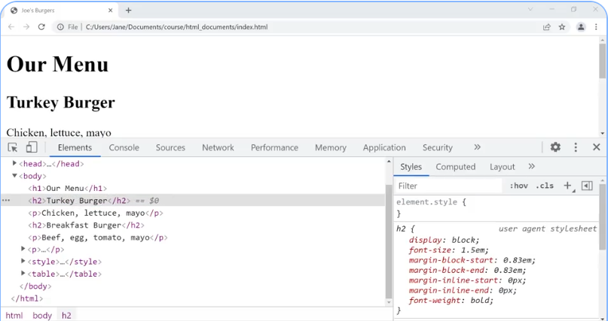
* The Sources tab shows all content resolved for the current page.
* The Network tab allows you to inspect the timeline and details of HTTP requests and responses for a webpage.
* The Memory tab displays the parts of your code that are consuming the most resources.
* The performance tab shows what the web browser is doing over time. It is useful if your web application is running slow because you can pinpoint the functions that are taking the most time.
-------------//------------------------//------------------------------//---------------------Frameworks and libraries ????
There are thousands of open source libraries and frameworks available or there might be proprietary, ones that are licensed or developed internally.
Understanding Libraries
- Libraries are reusable code pieces designed for specific functionalities, such as validating email addresses in an e-commerce application.
- They allow developers to save time by using pre-built solutions instead of creating everything from scratch.
Understanding Frameworks
- Frameworks provide a structured environment for developers to build applications.
- They handle common functionalities, like processing HTTP requests, while developers add their own code for specific features.
Comparison and Usage
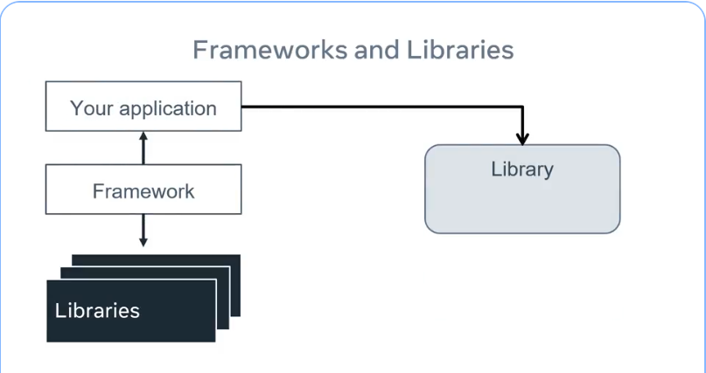
- Most frameworks use many libraries. The libraries that the framework uses can be used for your application. If you wish, your application can also use other libraries.

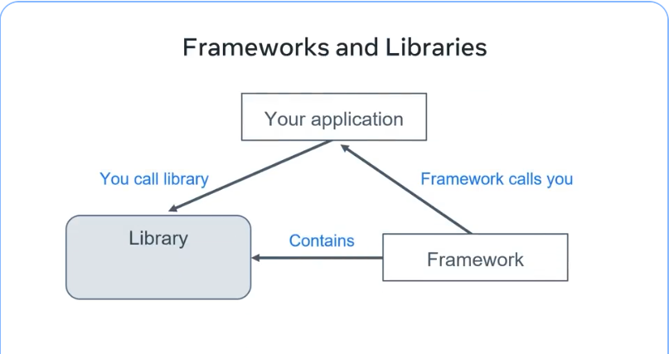
- Frameworks are more opinionated than libraries, meaning they enforce certain coding practices, which can streamline development but may also limit flexibility.

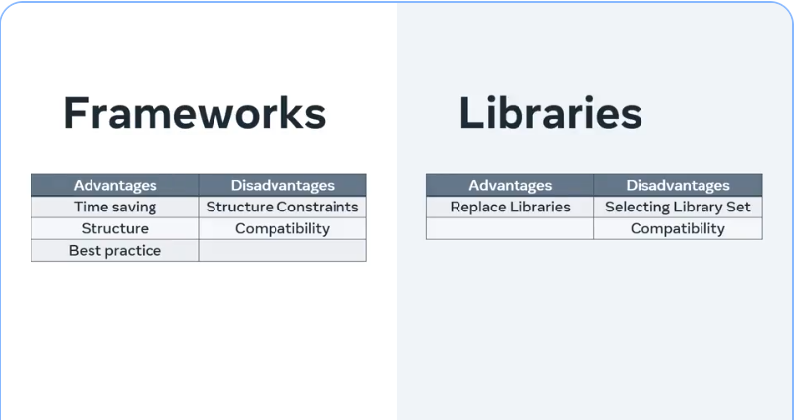
- Frameworks are a great way to reduce development time and to enforce a structure on how code is written. But sometimes you may find that some of the libraries the framework uses may conflict with a library that you are required to use and cause compatibility issues.
- Therefore, as if you choose to build an application without a framework, you will need to decide on the set of libraries you wish to use to achieve the functionality they must deliver. They will also need to take care that the selected libraries can work together. The upside to this is that you can always replace libraries as needed.

- Both frameworks and libraries help speed up development, reduce errors, and allow developers to focus on essential application features.
-----------------------//----------------------------------//-----------------------------//--
API & Services ????
What is API stand for ???
- API is the acronym for application programming interface. An API is a set of functions and procedures for creating applications that access the features or data of an operating system, application or other service.
- Probably use API's and as a web developer, you'll discover that API's developer friendly, easily accessible and a very valuable and useful development tool.
API & Web Developer???
- As a web developer, a lot of the day to day job involves working with API's.
- Some common API's that web developers work with include Browser API, API REST API and Sensor-Based API.
API in Software Development ???
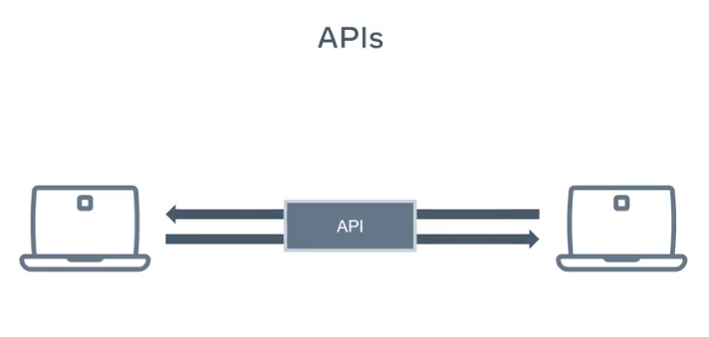
- In Software development, API's are often the bridge between different components or systems.
- This earns them names like gateway or middleware. The term is used widely to represent many different tools and systems.

Commons API use cases ???
- One common type of API, is Browser or Web APIs, which are built into the browser itself => They extend the functionality of the browser by adding new services and are designed to simplify complex functions and provide easy syntax for building advanced features.
1. A good Example for this case is DOM API => The DOM API turns the html document into a tree of nodes that are represented as JavaScript objects.
2. Another example, is the geolocation API that returns coordinates of where the browser is located.
3. There are also other API's available for fetching data known as Fetch API drawing, graphics or Canvas API keeping history or history API .
4. And other example is a client side storage also known as Web Storage API.

The most popular & critical type of API use cases ???
- For web development is the RESTful or REST API.
- This kind of API provides data for popular web and mobile apps. These are also known as web servers.
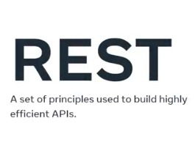
- REST is a set of principles that help build highly efficient API's.

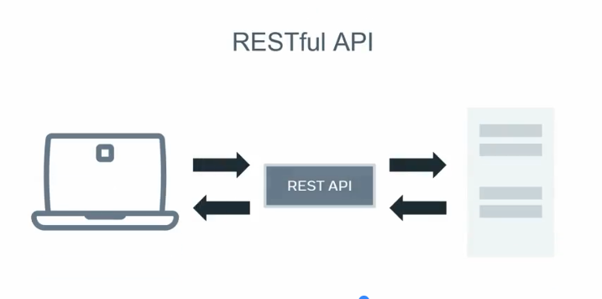
- One of the main responsibilities of these kinds of API's is sending and receiving data to and from a centralized database.

Then how can we query our REST API or 3rd party ones ???
- There is type of API, that you might encounter as a web developer is a Sensor-Based API. This is what the internet of things also known as IOT is based on.
- Then what is this ?? => These are actual physical senses that are interconnected with each other. The sensors can communicate through API and track and respond to physical data.
Example: Philips hue, smart lights and node bots.

As a developer the most commonly used data API is REST API.
What is this ???
- REST API which as you've learned is a web server that provides responses to requests.
- These API web servers are designed to provide the data backbone for a web client like a web page or mobile app.
- This means that these API's must be able to accomplish things like getting data or get, creating data. Also referred to as post updating data or put and deleting data or delete.
- API issues, REST principles and good design practices to create discoverable interfaces. => This helps us get the exact response expected.

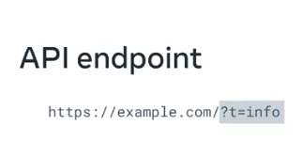
Then how does it work ???
- These API's use endpoints to specify how different resources can be accessed.
- The endpoint is built into the URL when accessing the API.
- Once the endpoint is hit, the API performs whatever service side processing is needed to build the response.
- The two common forms of response are:
1. Full web pages .
2. Data form based on JavaScript called JSON .
-----------------------//----------------------------------//-----------------------------//--
What is an IDE ????
Identify an IDE ???

- An integrated development environment or IDE is software for building applications.
- An IDE is just like a text editor except instead of writing documents you're writing code.
- There are many IDEs available, some are specific to one programming language while others support many languages in one IDE.
Benefits of an IDE ???
- IDEs have a feature called Error Highlighting. Just like checking spelling in a text document, IDEs can highlight mistakes you make in your code.
- Special keywords of the programming language are highlighted in different colors to make the code easier to read.
- Smart IDEs have a feature that can detect variables and functions and offer them as suggestions during autocomplete (They can not do autodelete). This feature is called IntelliSense.
- => They can offer a suggestion during auto-complete & re-factoring your code.
- They can help with detecting bugs when collaborate with other developers.
- Many even allow you to extend their functionality using plugins and extensions.
-----------------------//----------------------------------//-----------------------------//--
Module Summary - Get started with Web Development ????
The basics of how the web works ???
The basics of web pages ???
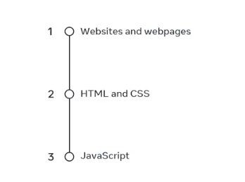
- In terms of web pages, you should now be able to, differentiate between a website and a web page by outlining the key elements of each.
- Outline the purpose of html and CSS and provide an explanation of how they work.
- Identify the benefits that Javascript provides to a web page like interactivity and data processing.

The basic of web servers ???
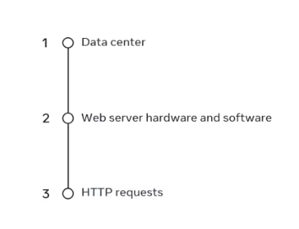
- In term of the basics of web servers, you should be able to explain how a data center provides storage and power for web servers.
- Differentiate between the key functions of web server hardware and software .
- Outline how a web server handles requests through HTTP or hypertext transfer protocol.

The basic of web browsers ???
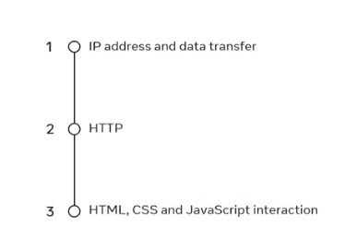
- The third key technology of the web, which is web browsers.
- After your study of how the web works, you investigated core internet technologies.
- You should now be able to explain the concept of IP addresses and how they facilitate the transfer of data across the internet.
- Demonstrate an understanding of how HTTP functions and identify common HTTP methods .
- Outline how HTMl, CSS and Javascript interact with one another.
Key concepts in core internet technologies ???


