
Ho Chi Minh City University of Science
Faculty of Information Technology
Software Engineering Department

Introduction to Software Engineering

Software Requirements Specification

CampusBorrow
Team T09 TetraBo

November 3rd, 2026
Table of Contents
1 Member Contribution Assessment 3
2 Introduction 4
2.1 Purpose and Scope 4
2.2 Glossary 5
3 Problem Statement 8
3.1 Business Context 8
3.2 Current Problems 8
3.3 Goals 9
3.4 Operating Environment 9
3.5 Design and Implementation Constraints 10
4 Stakeholders 11
5 Requirements 12
5.1 Functional Requirements 12
5.1.1 F01 – Authentication and role-based access control 12
5.1.2 F02 – Equipment and room catalog 13
5.1.3 F03 – Equipment requests and approval 15
5.1.4 F04 – Handover, return and overdue tracking 17
5.1.5 F05 – Room schedule view 18
5.1.6 F06 – Room booking requests 19
5.1.7 F07 – Room booking approval and cancellation 20
5.1.8 F08 – Request and resource-history tracking 22
5.1.9 F09 – Global administration 24
5.2 Non-Functional Requirements 26
5.3 Domain Requirements and Business Rules 28
5.3.1 Domain Requirements 28
5.3.2 Business Rules 29
5.4 Acceptance Criteria 40
5.4.1 F01 – Authentication and access 40
5.4.2 F02 – Equipment and room catalog 42
5.4.3 F03 – Equipment requests, decisions and cancellation 45
5.4.4 F04 – Handover, return and overdue 48
5.4.5 F05 – Room schedule 49
5.4.6 F06 – Room requests 50
5.4.7 F07 – Room decisions and cancellation 52
5.4.8 F08 – Business history 53
5.4.9 F09 – Account administration and controlled corrections 55
5.4.10 Room timetable boundary scenarios 57
6 Use Case Model 58
6.1 Use Case Diagram 58
6.1.1 Focused Views 60
6.1.2 Model Interpretation and Permission Exceptions 62
6.1.3 Use Case Relationships 62
6.2 Actors 63
6.3 Use Case List 64
6.3.1 Accounts and access 64
6.3.2 Equipment and room catalog 64
6.3.3 Equipment loan lifecycle 64
6.3.4 Room booking 65
6.3.5 History and controlled corrections 65
7 Use Case Specifications 67
7.1 UC-01 Sign in 67
7.2 UC-02 Sign out 68
7.3 UC-03 Create an account 69
7.4 UC-04 Change account status or role 70
7.5 UC-05 Reset a password manually 71
7.6 UC-06 Register a Borrower account 72
7.7 UC-07 Browse and search resources 73
7.8 UC-08 Create or update a catalog record 75
7.9 UC-09 Change visibility or operational status 76
7.10 UC-10 Submit equipment borrowing request 77
7.11 UC-11 Approve or reject an equipment request 79
7.12 UC-12 Change a pickup appointment 81
7.13 UC-13 Record equipment handover 82
7.14 UC-14 Record equipment return 83
7.15 UC-15 Cancel an equipment request 85
7.16 UC-16 View overdue loans 87
7.17 UC-17 View a room schedule 88
7.18 UC-18 Submit a room booking request 89
7.19 UC-19 Approve or reject a room booking 91
7.20 UC-20 Cancel a room booking 92
7.21 UC-21 View requests and business history 93
7.22 UC-22 Correct inconsistent resource and request states 95
8 Prototype / Mockups 97
9 Requirements Traceability Matrix 98
9.1 Domain Requirements Traceability 103
9.2 Business Rules Traceability 104
9.3 Non-Functional Requirements Traceability 105
10 Requirements Review 107
11 AI Usage Log 109

Member Contribution Assessment
ID | Name | Role(s) | Contribution (%) | Evidence
24127565 | Nguyễn Hoàng Mỹ Trang | Team Lead / PM | 30.2% | Issue #20 – §2 Purpose/Scope & Glossary, FR F07/F08 (WBS 2.1.1, 2.1.2, 2.2.7, 2.2.8)  Issue #26 – history & state-correction use-case specification (WBS 2.3.7)  Issue #29 – §10 Requirements Review and issue/resolution log (WBS 2.3.9)  Issue #30 – final SRS consolidation, §11 AI Usage Log & §1 Contribution Assessment (WBS 1.3.5, 1.3.6)  Issue #31 – task board closure, PDF export & submission (WBS 1.3.1, 1.3.3, 1.3.6)  GitHub Project task board
24127497 | Đoàn Hồng Phúc | Business Analyst | 27.9% | Issue #21 – §3 Problem Statement, §4 Stakeholders, FR F03/F04 (WBS 2.1.1, 2.2.3, 2.2.4)  Issue #24 – equipment request, approval, handover & return use-case specifications (WBS 2.3.4, 2.3.5)  GitHub Project task board
24127079 | Nguyễn Tiến Minh | Developer / Technical | 23.3% | Issue #22 – FR F05/F06 & §5.2 NFR (WBS 2.2.6, 2.2.9)  Issue #25 – room-booking use-case specifications, §8 wireframes & Figma prototype (WBS 2.3.6, 2.3.8)  PR #33 – F05/F06, NFR, room-booking use cases and wireframes (commits 93a4e8b, ea5932d, 33282c2)  PR #34 – PA2 AI usage log (merged)  GitHub Project task board
24127322 | Phan Nhật Ánh | QA / Tester | 18.6% | Issue #23 – §5.3 Business Rules: loan/return limits, overdue & 24h cancellation (WBS 2.2.3–2.2.5)  Issue #27 – §5.4 Acceptance Criteria, Given/When/Then for F01–F09 (WBS 2.2.1–2.2.8)  Issue #28 – §9 RTM with 100% FR↔UC↔Screen coverage (WBS 2.3.9)  GitHub Project task board

Introduction

Purpose and Scope
Purpose of this document. This Software Requirements Specification (SRS) defines the complete functional and non-functional requirements for CampusBorrow, a web-based resource-management system developed by Team T09 TetraBo as a course project for Introduction to Software Engineering at HCMUS. The document establishes a verified, agreed baseline for all subsequent design, implementation, and testing phases (PA3–PA5). It supersedes the preliminary scope in PA1 and incorporates clarifications agreed by the team during PA2 requirements analysis.
Product scope. CampusBorrow serves one simulated university unit and covers two resource types - shared equipment and classrooms. The system supports three roles: Borrower, Resource Manager, and Admin.
In-scope (Must-have, F01–F09):
Feature ID | Feature Name | Brief Description
F01 | Authentication & Role-Based Access Control | Login/logout, Borrower self-registration and server-side authorization for three roles. Admin creates privileged accounts.
F02 | Equipment & Room Catalog | Search and view resources, room capacity and operational status. Any active Resource Manager or Admin maintains all resources in the unit; there is no per-resource assignment.
F03 | Equipment Requests & Approval | One item per request with purpose, proposed pickup and return deadline. Approval reserves the item and confirms a pickup appointment. Borrowers may cancel before handover. Uncollected approvals expire at min(pickup + 24 h, return deadline).
F04 | Handover, Return & Overdue Tracking | Record actual handover and return times; update availability; list overdue loans. Return is mandatory after handover.
F05 | Room Schedule View | Display the configured periods and approved bookings for the selected room and day.
F06 | Room Booking Requests | Request one room on one day by selecting consecutive 45-minute periods, with purpose and headcount. Validate periods, future start, capacity and approved-booking overlap.
F07 | Room Booking Approval & Cancellation | Approve or reject room booking requests (rejection requires a reason); prevent overlapping approved bookings. Borrowers may cancel before the booking start. Hidden or Out of service rooms accept no new requests.
F08 | Request & Resource-History Tracking | Record business events and state changes with timestamp, actor, outcome, and reason. Access is role-scoped.
F09 | Global Administration & State Correction | Create, deactivate and reactivate accounts, change an account's single role and reset passwords manually. Correct inconsistent states with before/after records and written reasons.
Out of scope: The following items are explicitly excluded from CampusBorrow for PA5 delivery:
- Academic timetable integration, event management, and event registration.
- Recurring room bookings, and multiple items or rooms in one request.
- Advance equipment scheduling across future time slots and waiting lists.
- Repair workflows, maintenance work orders, and maintenance costs; only the operational status (In service / Out of service, with Under maintenance as a possible reason) is recorded.
- Automatic cancellation, room reassignment, or rescheduling of approved bookings after a room is subsequently set Out of service (for example, for maintenance); the unit handles these cases outside the application.
- Payments, deposits, and monetary penalties.
- Automated email/SMS notifications, single sign-on (SSO), real-time chat, multi-campus or multi-unit deployment, and native mobile applications.
- F10 (Usage statistics & CSV export) and F11 (In-application pickup-change requests) are classified as Could-have and will only be implemented after all F01–F09 Must-have features are complete and team capacity remains.
Intended readers: This document is intended for:
Team T09 TetraBo — as the authoritative requirements baseline for design (PA3), test planning (PA4), and implementation (PA5).
Lecturers and Teaching Assistants — for assessment of requirements quality, completeness, and consistency with PA1 scope.
Future reviewers — any party conducting change-impact analysis or extending the system beyond the current project scope.

Glossary

Term | Definition
Admin | The application role for account administration and global support. Admins create, deactivate and reactivate accounts, change an account's single role, reset passwords manually and perform controlled state corrections. They may also process requests and record handover and return, but cannot edit a confirmed pickup appointment or submit Borrower requests.
Approved booking | A room booking request that a Resource Manager or Admin has accepted. Once approved, the room is considered reserved for that time slot.
Approved request | An equipment loan request that a Resource Manager or Admin has accepted. The item is reserved for the Borrower until handover occurs or the request is cancelled/expired.
Borrower | The application role for students and club representatives who submit requests for equipment or rooms, track their own requests, and cancel before handover (equipment) or before the room start time (rooms).
Business event | An action recorded in the history log that changes the state of a resource or request, e.g., request submitted, approved, handed over, returned, cancelled. Routine page views and clicks are not logged.
Cancellation | The act of withdrawing a pending or approved equipment request before handover, or withdrawing a room booking before the booking start time. Cancellation releases any held reservation.
CampusBorrow | The web application developed by Team T09 for managing equipment lending and room booking within a simulated university unit.
CCU | Concurrent users. Used in NFR performance metrics (e.g., "200 CCU").
Equipment | A shared physical item (e.g., projector, microphone, camera) managed in the system and available for borrowing.
Erroneous state | An incorrect status applied to a resource, booking, or loan request due to a system error or data-entry mistake, which an Admin is authorized to correct.
Expiry (Collect before) | The time at which an approved but uncollected equipment request lapses: min(confirmed pickup + 24 hours, return deadline). Handover is allowed only before this time (BR-04).
Handover | The physical transfer of borrowed equipment from the Resource Manager (or Admin) to the Borrower, recorded in the system with the actual handover timestamp.
Headcount | The number of attendees stated when submitting a room booking request. The system checks that headcount does not exceed the room's capacity.
History log | The audit record of business events and state changes for resources and requests, including timestamp, actor, outcome, and reason (where applicable).
In service / Out of service | The operational status of a resource. In service means released for use; it does not guarantee that the resource is free at a given time. Out of service blocks new requests and must carry a reason (BR-13, BR-16).
Loan request | A request submitted by a Borrower to borrow one piece of equipment for a stated purpose and return deadline. Synonymous with "equipment request".
MoSCoW | A requirement prioritization scheme: Must-have, Should-have, Could-have, Won't-have.
Overdue loan | A loan whose return deadline has passed and for which the item has not yet been returned to the Resource Manager. Listed in the overdue report.
Period | One of eight fixed 45-minute room-booking units (P1–P8) in the daily timetable; a booking selects consecutive periods within one session (BR-03).
Pickup appointment | The agreed date and time at which the Borrower is expected to collect approved equipment from the Resource Manager. Only a Resource Manager may change a confirmed pickup appointment.
Reservation | The internal hold placed on an equipment item (or room time slot) when a request is approved, preventing it from being allocated to another request.
Resource | Any item managed by the system; either equipment or a room.
Resource Manager | The application role for unit staff who maintain the catalog, approve or reject requests, change pickup appointments, record handovers and returns and follow up overdue loans. All active Resource Managers have equal access to every resource and request in the unit; no assignment is required (BR-01).
Room | A bookable classroom or meeting space with a defined capacity, managed in the system.
Room booking | A Borrower's request to use one room on one day for one or more consecutive 45-minute periods within one session, with a stated purpose and headcount. The reserved interval runs from the start of the first selected period to the end of the last (BR-03).
SRS | Software Requirements Specification — this document.
State correction | An Admin action that changes the recorded status of a resource or request to the correct value, accompanied by a written reason, with the before-state and after-state both preserved in the history log.
Under maintenance | A possible reason for setting a resource Out of service; it is not a separate status (BR-13). While a room is Out of service, the booking action is disabled in the UI and new booking requests are rejected by the backend.
Visible / Hidden | The publication status of a resource. Hidden resources do not appear in Borrower search and cannot receive new requests, but existing records and history are kept (BR-13).
WBS | Work Breakdown Structure — the hierarchical decomposition of project work used to assign tasks and track progress.
WCAG AA | Web Content Accessibility Guidelines level AA — the accessibility standard targeted for CampusBorrow's UI.

Problem Statement

Business Context
CampusBorrow supports basic equipment lending and classroom booking within one simulated university unit. Students and student-club representatives need shared resources for academic and club activities. Resource-management staff review requests, coordinate collection and record physical equipment handover and return. An administrator manages accounts and access and provides authorized operational support.
For this simulation, the unit is assumed to receive requests through forms or messages and maintain resource information and usage records in spreadsheets. Equipment requests require an availability check, an approval decision, a confirmed pickup appointment and a specific return deadline. Room requests require a capacity check and comparison against approved bookings. Staff must distinguish a reservation from an actual equipment loan and an operationally usable room from a room that is free during a requested interval.
The project has not surveyed a real faculty, club or administrative office. The assumed workflow and potential problems below are modeling premises, not observed institutional practices. No actual resource inventory, transaction volume, staff workload or incident rate has been measured.

Current Problems
Separate messages and manually updated records may leave requesters and staff with different information about the same resource. Without consistent checks at the point of approval, two staff members may approve conflicting requests. A record marked as approved may also be mistaken for evidence that a borrower has already collected an item.
Assumed problem | Potential consequence | Need addressed by CampusBorrow
Catalog and request information are distributed across separate records. | Requesters repeatedly contact staff to identify resources and determine request outcomes. | A shared catalog and role-appropriate request views.
Equipment approvals and reservations are updated separately. | Competing requests may appear approved for the same item. | An exclusive reservation created consistently with approval.
Room bookings are checked manually. | Approved bookings may overlap or exceed room capacity. | Period-based requests and capacity/conflict checks before approval.
Approval, collection and return are not clearly distinguished. | Staff may release an item that remains with a borrower or report a reserved item as already collected. | Distinct request states and records of actual handover and return.
Approved equipment requests remain uncollected. | Items may remain reserved after the valid collection window. | Automatic expiry of eligible uncollected requests and release of their reservations.
Return deadlines and business events are difficult to trace. | Overdue loans may be missed and inconsistent records may be difficult to investigate. | Overdue views, retained business history and controlled state corrections.
These consequences are plausible risks within the simulated workflow. The project does not claim measured losses, time savings or demonstrated improvements at a real institution.

Goals
CampusBorrow aims to provide a consistent record of resource information, requests and processing outcomes for the simulated unit. Its goals are to:
- Help borrowers find visible equipment and rooms, understand their operational status and inspect approved room-booking intervals.
- Support equipment requests, approval, collection, return and overdue tracking without confusing an approval with a physical loan.
- Prevent conflicting equipment reservations and overlapping approved room bookings, including when staff process requests concurrently.
- Release reservations for approved equipment that is not collected within the valid pickup window, while preserving active physical loans until staff record return.
- Enforce account and role permissions and provide understandable validation and conflict feedback.
- Preserve request and resource-state history so authorized users can understand outcomes and staff can investigate or correct inconsistent records.
These goals are implemented through the F01–F09 Must-have scope. Their verification depends on the detailed FRs, acceptance criteria and subsequent tests; this document does not claim that implementation or testing is complete. Measurable performance, security, availability and usability targets are specified in NFR-01 to NFR-12 (§5.2).

Operating Environment
The planned product is a responsive web application accessed through a modern browser on a computer or smartphone with network access. A server-side API and a central PostgreSQL database support shared records for one unit. Equipment collection, identity checks and return take place physically; authorized staff record those events in the application. CampusBorrow does not directly observe physical possession.
Each account has exactly one role: Borrower, Resource Manager or Admin. Borrowers self-register and view their own requests. Resource Managers share unit-wide operational access without being assigned ownership of individual resources or requests; the staff member performing each business event is recorded. Admin manages accounts and supports permitted operations, while confirmed pickup-appointment changes remain restricted to Resource Managers.
Business times use UTC+7. Room bookings use one or more consecutive configured 45-minute periods on one day. Rooms operate Monday to Sunday in a morning session (07:30–11:00) and an afternoon session (13:30–17:00), with breaks at 09:00–09:30 and 15:00–15:30 (BR-03). Pickup-change requests are communicated outside the application; an authorized RM records an eligible appointment change. Existing approved room bookings affected by a later Out of service change are handled by the unit outside CampusBorrow.

Design and Implementation Constraints
Constraint | Implication
Course project with limited capacity | The four-member team plans 8–10 hours per member per week. Implementation prioritizes F01–F09; F10 usage statistics/CSV export and F11 in-application pickup-change requests remain deferred.
Agreed technical direction | The PA1 stack is React/Vite and TypeScript, NestJS on Node.js, Prisma and PostgreSQL on Supabase, with Vercel/Cloudflare and GitHub Actions supporting deployment and integration. These are planned implementation choices, not evidence of a working deployment.
Single-unit scope | Support equipment items and classrooms with the three defined account roles. Multi-unit operation, event management, academic timetable integration and native mobile applications are excluded.
Resource and booking boundaries | One equipment item or one room per request; no recurring room bookings, equipment waiting lists or advance equipment scheduling across future intervals. A pickup appointment coordinates collection of an already reserved item.
Operational status differs from visibility and occupancy | Visible/Hidden controls catalog exposure. In service/Out of service describes operational readiness. Neither In service nor visibility alone guarantees that an item or room interval can be reserved.
Current pickup-expiry rule | An approved, uncollected request expires at min(confirmed_pickup_at + 24 hours, return_due_at). Handover is allowed only from the confirmed pickup time until strictly before expiry. Collected equipment is not automatically released at its return deadline.
Account and integration boundaries | Only Admin performs manual password resets; email is unverified. Self-service password recovery, SSO, automated email/SMS notifications and real-time chat are excluded. No automatic borrowing quota is introduced.
Maintenance and financial boundaries | Resource status may indicate that an item or room is out of service. Repair workflows, maintenance costs, payments, deposits and monetary penalties are excluded.
History and privacy | Retain relevant business events, responsible actors and state changes within authorized access. General click/page-view tracking is excluded. Detailed permitted Admin corrections remain subject to specification.

Stakeholders
# | Stakeholder | Description | Interests / concerns
1 | Students and student-club representatives | Intended direct requesters, represented by the Borrower role. They request resources for academic and club activities and are responsible for collecting and returning borrowed equipment. | Clear resource information; understandable request outcomes, pickup windows and return deadlines; suitable room periods and capacity; permitted cancellation; protection of personal request information.
2 | Teaching staff and academic activity organizers | Indirect beneficiaries of equipment and classroom use in the simulation. Their inclusion identifies academic-use needs and does not introduce a lecturer role or a new staff-booking workflow. | Resources suitable for teaching and activities; dependable approved schedules; clear coordination with requesters and resource staff; minimal disruption from conflicting bookings or unavailable resources.
3 | Equipment-store and room-management staff | Direct operational users represented by Resource Manager. All RMs have equal access within the unit; responsibility for an action is recorded per event rather than through request ownership. | Accurate inventory and operational status; conflict-free approvals; clear reservation/loan distinction; efficient handover and return records; overdue visibility; protection against stale or concurrent updates.
4 | System administrator / IT support | Administrative user represented by Admin, responsible for account status, roles, manual password resets and authorized global support. | Server-enforced permissions; protection of privileged accounts; retained history; safe, attributable corrections; reliable operation and recovery from inconsistent records without bypassing business restrictions.
5 | Resource-owning unit and university management | Modeled organizational stakeholders responsible for shared-resource policies and oversight. University management represents an indirect governance interest, not an additional dashboard user or a confirmed project sponsor. | Accountable resource use; clear responsibilities and scope; reasonable maintenance and support effort; trustworthy records and manageable project cost. This interest does not add F10 analytics or financial workflows.
6 | T09 / TetraBo project team | Student team responsible for requirements, design, implementation, testing and documentation. | Feasible and consistent scope; unambiguous rules and acceptance criteria; traceable changes; reviewable deliverables and a maintainable implementation within course capacity.
7 | Course instructor and teaching assistants | Educational stakeholders who guide and assess the Introduction to Software Engineering project; distinct from teaching staff who benefit from resource use. | Alignment between requirements, design, tests and product; adherence to assignment templates; justified decisions; evidence of collaboration, review and transparent AI usage. They are not runtime application roles.

Requirements

Functional Requirements

F01 – Authentication and role-based access control

ID | Requirement | Feature | Priority | Source
FR-01-01 | The system shall authenticate an active account using its normalized username or email and exact password, applying its current single role. | F01 | Must | PA1 F01; G5; BR-02, BR-06; SH-1, 3, 4
FR-01-02 | The system shall revoke the current session on logout and deny subsequent protected calls using that session. | F01 | Must | PA1 F01; G5; BR-10; SH-1, 3, 4
FR-01-03 | The system shall enforce current role, session validity, account activation and Borrower ownership on every protected operation. | F01 | Must | PA1 F01; G5; BR-01, BR-05, BR-10; NFR-03; SH-1, 4
FR-01-04 | The system shall allow an unauthenticated person to register an active Borrower account with valid display name, unique username, unique email and matching password confirmation. | F01 | Must | PA1 F01; G5; BR-02, BR-06, BR-07; SH-1
FR-01-05 | The system shall validate and normalize account identifiers and display names according to BR-06 at account creation and apply the same identifier normalization at login. | F01 | Must | PA1 F01; G5; BR-06 (confirmed 1 Nov 2026); SH-1
FR-01-06 | The system shall apply the BR-07 password policy consistently to registration, Admin creation and reset without trimming or silent truncation. | F01 | Must | PA1 F01; G5; BR-07 (confirmed 1 Nov 2026); SH-1, 4
FR-01-07 | The system shall expire each session 24 hours after login and invalidate sessions on account-security changes according to BR-10. | F01 | Must | PA1 F01; G5; BR-10; SH-4

F02 – Equipment and room catalog

ID | Requirement | Feature | Priority | Source
FR-02-01 | The system shall maintain a stable identity and immutable resource code/type for each equipment item and room. | F02 | Must | PA1 F02; G1, G6; DR-01; BR-12, BR-18; SH-3
FR-02-02 | The system shall allow any active RM or Admin to create and update resources throughout the unit subject to validation and edit restrictions. | F02 | Must | PA1 F02; G1; BR-01, BR-12; SH-3, 4
FR-02-03 | The system shall provide role-scoped catalog search, filters, ordering and pagination according to BR-14. | F02 | Must | PA1 F02; G1; BR-14; SH-1
FR-02-04 | The system shall display catalog details with visibility, operational status and usage treated as distinct properties. | F02 | Must | PA1 F02; G1; DR-05; BR-13, BR-18; SH-1, 3
FR-02-05 | The system shall allow RM/Admin to change Visible/Hidden independently of operational status and occupancy. | F02 | Must | PA1 F02; G1; DR-05; BR-13; SH-3
FR-02-06 | The system shall enforce hidden-resource discovery and new-request restrictions on the server. | F02 | Must | PA1 F02; G1, G5; BR-05, BR-13; SH-1, 3
FR-02-07 | The system shall allow RM/Admin to change operational status using In service and Out of service with BR-16 reasons and notes. | F02 | Must | PA1 F02; G1; DR-05; BR-13, BR-16; SH-3
FR-02-08 | The system shall recheck catalog state and request eligibility consistently when new requests and approvals are processed. | F02 | Must | PA1 F02; G3; BR-05, BR-17; SH-3
FR-02-09 | The system shall preserve requests and permitted history when resources are hidden or taken Out of service. | F02 | Must | PA1 F02; G6; DR-08; BR-05, BR-18, BR-19; SH-1, 3
FR-02-10 | The system shall prevent catalog controls from bypassing physical handover/return, request lifecycle or controlled Admin correction rules. | F02 | Must | PA1 F02; G2, G6; DR-02, DR-05; BR-05, BR-20; SH-3, 4
FR-02-11 | The system shall validate catalog input according to BR-12 and enforce resource-code uniqueness across both types, including concurrent creation. | F02 | Must | PA1 F02; G5; DR-01; BR-12; SH-3
FR-02-12 | The system shall create each valid new resource as Hidden and Out of service with the initial readiness reason. | F02 | Must | PA1 F02; G1; BR-13; SH-3
FR-02-13 | The system shall block location/capacity changes while BR-15 obligations exist and preserve immutable code/type. | F02 | Must | PA1 F02; G3; BR-15; SH-3
FR-02-14 | The system shall reject stale catalog saves after another actor has updated the record and revalidate current dependencies. | F02 | Must | PA1 F02; G3; BR-17; SH-3
FR-02-15 | The system shall record catalog changes with actor/time and before/after values while restricting internal status reasons to RM/Admin. | F02 | Must | PA1 F02; G6; DR-08; BR-16, BR-19; SH-3, 4
FR-02-16 | The system shall preserve resource records and history by excluding permanent deletion from catalog operations. | F02 | Must | PA1 F02; G6; DR-01; BR-18; SH-4, 5

F03 – Equipment requests and approval

ID | Requirement | Feature | Priority | Source
FR-03-01 | The system shall allow an active authenticated Borrower to submit a Pending request for exactly one equipment item with a nonblank purpose, a future proposed pickup date-time and a specific return deadline. | F03 | Must | PA1 F03; G2; BR-05; SH-1
FR-03-02 | The system shall accept equipment requests only for a Visible, In service item not currently reserved or on loan. | F03 | Must | PA1 F03; G3, G5; BR-05, BR-13; SH-1
FR-03-03 | The system shall prevent duplicate active requests by the same Borrower for one item while permitting competing Pending requests from different Borrowers, without imposing automatic borrowing quotas or a maximum loan duration. | F03 | Must | PA1 F03; G3; BR-05; SH-1, 3
FR-03-04 | The system shall allow any active RM or Admin to review Pending equipment requests with submitted details and current item status and occupancy, enforcing role-based access without staff assignment. | F03 | Must | PA1 F03; G2; BR-01; SH-3
FR-03-05 | The system shall allow an active RM or Admin to approve an eligible Pending equipment request by confirming a future pickup before its existing return deadline and consistently creating its exclusive reservation and decision record. | F03 | Must | PA1 F03; G2, G3; DR-02; BR-01, BR-04, BR-05; SH-3
FR-03-06 | The system shall make equipment approval exclusive and consistently reject all competing Pending requests for that item with a system-generated reservation reason, including under concurrent processing. | F03 | Must | PA1 F03; G3; BR-01, BR-05; SH-3
FR-03-07 | The system shall allow any active RM or Admin to reject a Pending equipment request only with a nonblank reason, retaining the decision actor and time and showing the relevant decision reason to its Borrower. | F03 | Must | PA1 F03; G2, G5; BR-05; SH-1, 3
FR-03-08 | The system shall allow only an active RM to change an Approved, uncollected request’s confirmed pickup before its current expiry to a future time before the unchanged return deadline, retaining the reservation and recomputing expiry. | F03 | Must | PA1 F03; G2; BR-01, BR-04, BR-05; SH-1, 3
FR-03-09 | The system shall show authorized users current equipment request decisions, proposed or confirmed pickup, return deadline and the computed Collect before time, and report failed operations without false success. | F03 | Must | PA1 F03; G2, G5; BR-04; SH-1, 3
FR-03-10 | The system shall allow an active Borrower to cancel their own Pending or valid Approved equipment request before handover, with a mandatory reason and confirmation. | F03 | Must | PA1 F03; G2, G5; BR-05; SH-1, 3
FR-03-11 | The system shall allow any active RM or Admin to explicitly cancel an Approved, uncollected request when the item becomes damaged or out of service. | F03 | Must | PA1 F03; G2, G5; BR-05; SH-1, 3
FR-03-12 | The system shall release only the cancelled request's reservation, consistently with its state transition. | F03 | Must | PA1 F03; G2, G5; BR-05; SH-1, 3
FR-03-13 | The system shall automatically cancel Approved, uncollected equipment requests at the capped expiry threshold. | F03 | Must | PA1 F03; G4; DR-06; BR-04; SH-1, 3
FR-03-14 | The system shall use the latest valid appointment and current request state for expiry and dependent operations. | F03 | Must | PA1 F03; G4; DR-02, DR-06; BR-04; SH-3
FR-03-15 | The system shall enforce expiry in handover and appointment-change operations even when automatic cancellation processing is delayed. | F03 | Must | PA1 F03; G4; DR-02, DR-06; BR-04; SH-3

F04 – Handover, return and overdue tracking

ID | Requirement | Feature | Priority | Source
FR-04-01 | The system shall allow any active RM or Admin to record physical handover only for an Approved, reserved and uncollected request with an active Borrower and an In service item, within confirmed_pickup_at <= now < expiry_at. | F04 | Must | PA1 F04; G2; DR-02, DR-07; BR-04, BR-05; SH-3
FR-04-02 | The system shall consistently convert the request’s reservation into an active equipment loan on successful handover, recording the actual handover time and staff actor without duplicate or contradictory transitions. | F04 | Must | PA1 F04; G2; DR-02; BR-04; SH-3
FR-04-03 | The system shall allow any active RM or Admin to record confirmed physical receipt of an unreturned equipment loan, retaining the actual return time and actor and consistently closing the loan and clearing its occupancy. | F04 | Must | PA1 F04; G2; DR-03, DR-07; BR-04; SH-3
FR-04-04 | The system shall preserve independent catalog restrictions and historical records when recording return, making subsequent borrowing conditional on recorded receipt and all current eligibility checks. | F04 | Must | PA1 F04; G2, G6; DR-03, DR-05; BR-13; SH-3
FR-04-05 | The system shall identify an equipment loan as currently overdue only when handover is recorded, return is not recorded and system time is strictly later than its return deadline, without automatically releasing the item. | F04 | Must | PA1 F04; G2; DR-03, DR-06; BR-04; SH-3
FR-04-06 | The system shall allow active RMs and Admins to view and open current overdue loans for follow-up or return processing, while allowing Borrowers to see overdue status only within their own request records. | F04 | Must | PA1 F04; G2; DR-06; BR-01, BR-19; SH-1, 3

F05 – Room schedule view
ID | Requirement | Feature | Priority | Source
FR-05-01 | The system shall let a signed-in user with permitted access select a room and a date and display its schedule for that date. The default date shall be today in UTC+7. | F05 | Must | PA1 F05; G1; DR-04, DR-09; BR-03; SH-1, 2
FR-05-02 | The system shall list every approved booking of the selected room on the selected date in ascending order of start time, showing the start time and the end time of each. If there is none, the system shall state that the room has no approved bookings that day. | F05 | Must | PA1 F05; G1, G3; BR-03; SH-1, 2
FR-05-03 | The system shall show only approved bookings on the schedule. Pending, rejected and cancelled bookings shall not appear, and a booking cancelled before its start time shall disappear from the schedule at once. | F05 | Must | PA1 F05; G1; BR-03, BR-05; SH-1, 2
FR-05-04 | The system shall display the name, capacity and operational status of the selected room on the schedule page. | F05 | Must | PA1 F05; G1; BR-13, BR-18; SH-1
FR-05-05 | The system shall display the configured periods of the selected date and distinguish free periods, breaks and approved occupied intervals. Rooms operate every day under the fixed timetable in BR-03, so no closed days are shown. | F05 | Should | PA1 F05; G1; BR-03 (timetable confirmed 3 Nov 2026); SH-1, 2
FR-05-06 | The system shall not show other Borrowers’ names or purposes on the Borrower schedule. Showing requester names and purposes to all active Resource Managers and Admins remains an assumption pending confirmation of staff-visible fields. | F05 | Should | PA1 F05; G1, G5; BR-19; SH-1 (assumption, staff-visible fields pending)

F06 – Room booking requests
ID | Requirement | Feature | Priority | Source
FR-06-01 | The system shall let a Borrower request one room on one date by selecting one or more consecutive configured 45-minute periods and providing a purpose and headcount. It shall derive the start and end times from the selected periods. | F06 | Must | PA1 F06; G1; DR-04; BR-03; SH-1
FR-06-02 | The system shall reject selections containing invalid period identifiers, non-consecutive periods or periods outside configured operating hours for the selected room and date. Arbitrary time ranges are not accepted. Selection shall remain within one morning or afternoon session under BR-03; crossing lunch or selecting a break alone is rejected. | F06 | Must | PA1 F06; G5; BR-03; SH-1
FR-06-03 | The system shall reject a booking request whose start time is not later than the current time in UTC+7. | F06 | Must | PA1 F06; G5; DR-09; BR-03; SH-1
FR-06-04 | The system shall reject a booking request whose headcount is not a whole number of at least 1, or is greater than the capacity of the room. | F06 | Must | PA1 F06; G3; DR-04; BR-12; SH-1
FR-06-05 | The system shall reject a booking request whose time range overlaps an approved booking of the same room. Time ranges are half-open, so a booking that ends at the start time of another does not overlap it. Pending requests do not block each other; approval rechecks overlap (F07). For a selection spanning a break, overlap checks cover the entire derived interval including that break. | F06 | Must | PA1 F06; G3; DR-04; BR-03, BR-05; SH-1, 3
FR-06-06 | The system shall accept new booking requests only for a Visible, In service room. For a Hidden or Out of service room, the interface shall not offer an enabled booking action and the backend shall reject direct requests. Under maintenance is an Out of service reason. | F06 | Must | PA1 F06; G5; BR-05, BR-13; SH-1
FR-06-07 | The system shall save a valid booking request with status Pending, linked to the requester and the room, and show it to the requester and all active Resource Managers. | F06 | Must | PA1 F06; G1; BR-05; SH-1, 3
FR-06-08 | The system shall take the requester identity from the authenticated session and accept booking requests only from the Borrower role. | F06 | Must | PA1 F06; G5; §6.2 Actors; NFR-03; SH-1
FR-06-09 | When a booking request fails validation, the system shall show a message that names the field and the rule that failed, and shall keep the values the user entered. | F06 | Should | PA1 F06; G5; NFR-11, NFR-12; SH-1

F07 – Room booking approval and cancellation

ID | Requirement | Feature | Priority | Source
FR-07-01 | The system shall allow any active Resource Manager or Admin to approve a Pending room booking request after rechecking that its start is still in the future, its periods are valid, the room is Visible and In service, the headcount does not exceed capacity and no approved booking of the same room overlaps the derived interval. | F07 | Must | PA1 F07; G1, G3; DR-04; BR-01, BR-03, BR-05, BR-13; SH-1, 3
FR-07-02 | The system shall allow any active Resource Manager or Admin to reject a Pending room booking request only with a nonblank written reason, recording the decision actor and time, creating no reservation and showing the reason to the requesting Borrower. | F07 | Must | PA1 F07; G5, G6; BR-01, BR-05, BR-19; SH-1, 3
FR-07-03 | The system shall make room approval exclusive: when overlapping Pending requests for the same room are approved concurrently, at most one approval shall succeed and the others shall remain Pending. Intervals are half-open, so a booking that ends exactly when another starts does not overlap it. | F07 | Must | PA1 F07; G3; DR-04; BR-03, BR-05; NFR-09; SH-3
FR-07-04 | The system shall reject the approval of a request whose interval has become occupied, or whose room or request state has changed, since the review screen was loaded; it shall report the conflict and save neither the approval nor any partial occupancy. | F07 | Must | PA1 F07; G3, G5; BR-05, BR-17; SH-3
FR-07-05 | The system shall allow a Borrower to cancel their own Pending or Approved room booking only before its start time, after confirmation and with an optional reason, releasing an approved interval exactly once. Cancellation at or after the start, of another Borrower's booking or of a terminal record shall be rejected. | F07 | Must | PA1 F07; G1, G5; BR-03, BR-05; SH-1
FR-07-06 | The system shall apply the same eligibility, overlap and mandatory rejection-reason checks when an Admin approves or rejects a room booking request as when a Resource Manager does. | F07 | Must | PA1 F07, F09; G3, G5; BR-01, BR-05; SH-4
FR-07-07 | The system shall reject new room booking requests for a Hidden or Out of service room, whether submitted through the interface, a stale form or a direct API call, without creating a partial request or changing existing bookings. Under maintenance is recorded only as an Out of service reason. | F07 | Must | PA1 F07; G5; DR-05; BR-05, BR-13, BR-16; SH-1, 3
FR-07-08 | The system shall retain approved room bookings and their history when the room is later set Out of service, without automatically cancelling, reassigning or rescheduling them; the unit handles such cases outside the application. | F07 | Must | PA1 F07; G6; DR-05; BR-05, BR-13; SH-3, 5
FR-07-09 | The system shall record each room approval, rejection and cancellation with the actual actor, role, time, resulting state and applicable reason, and shall not record a duplicate successful event when a completed operation is repeated. | F07 | Must | PA1 F07; G6; DR-08; BR-19; SH-3, 4

F08 – Request and resource-history tracking
ID | Requirement | Feature | Priority | Source
FR-08-01 | The system shall record a history entry for every business event that changes the status of an equipment loan request or a room booking. Each entry shall include: (a) event type, (b) timestamp (UTC+7), (c) actor (user ID and role), (d) resource identifier, (e) previous state, (f) new state, and (g) reason/note where applicable. | F08 | Must | PA1 F08; G6; DR-08; BR-19; SH-3, 4, 5
FR-08-02 | The system shall not record history entries for routine page views, navigation actions, or non-state-changing user interactions (e.g., browsing the catalog, opening a form without submitting). | F08 | Must | PA1 F08; G6; BR-19; §3.5 History and privacy; SH-5
FR-08-03 | The system shall record history entries for the following equipment loan events (at minimum): request submitted, request approved, request rejected, pickup appointment set, pickup appointment changed by Resource Manager, request cancelled by Borrower, request auto-cancelled (24-hour expiry), handover recorded, return recorded, overdue status applied. | F08 | Must | PA1 F08; G6; DR-06, DR-08; BR-04, BR-19; SH-3
FR-08-04 | The system shall record history entries for the following room booking events (at minimum): booking submitted, booking approved, booking rejected, booking cancelled by Borrower, and room visibility or operational-status changes (In service / Out of service with the recorded reason, such as under maintenance). | F08 | Must | PA1 F08; G6; DR-08; BR-19; SH-3
FR-08-05 | The system shall allow a Borrower to view the history of their own equipment loan requests and their own room booking requests only. A Borrower shall not be able to view history entries belonging to other users. | F08 | Must | PA1 F08; G6; BR-19; SH-1
FR-08-06 | The system shall allow any active Resource Manager to view the history of all equipment loan requests and room bookings associated with all resources across the unit with equal operational visibility under BR-01. | F08 | Must | PA1 F08; G6; BR-01, BR-19; SH-3
FR-08-07 | The system shall allow an Admin to view the complete history log for all resources, requests, and state-change events across the entire system without scope restriction. | F08 | Must | PA1 F08; G6; BR-19; SH-4
FR-08-08 | The system shall preserve history entries indefinitely; deactivating a user account or removing a resource from active use shall not delete or hide associated history records. | F08 | Must | PA1 F08; G6; DR-08; BR-11, BR-19; SH-4, 5
FR-08-09 | The system shall display the history log in reverse-chronological order (most recent event first) by default, and shall allow filtering by resource, request ID, date range, and event type. | F08 | Should | PA1 F08; G6; SH-3, 4 (usability decision in PA2 analysis, no specific BR)

F09 – Global administration

ID | Requirement | Feature | Priority | Source
FR-09-01 | The system shall allow an active Admin to create an account with exactly one role and valid initial credentials. | F09 | Must | PA1 F09; G5; BR-02, BR-07, BR-11; SH-4
FR-09-02 | The system shall allow an active Admin to deactivate or reactivate another account subject to administrative safeguards. | F09 | Must | PA1 F09; G5; BR-05, BR-10, BR-11; SH-4
FR-09-03 | The system shall preserve requests, reservations, loan records and history when an account is deactivated. | F09 | Must | PA1 F09; G6; DR-08; BR-05, BR-11, BR-19; SH-4, 5
FR-09-04 | The system shall allow an active Admin to replace another account’s single role only after checking outstanding Borrower obligations and administrative safeguards. | F09 | Must | PA1 F09; G5; BR-08, BR-10, BR-11; SH-4
FR-09-05 | The system shall allow an active Admin to manually reset another account’s password after external identity verification and confirmation. | F09 | Must | PA1 F09; G5; DR-07; BR-07, BR-09, BR-10; SH-4
FR-09-06 | The system shall record account registration and administrative changes with target, event type, actual actor or setup origin, timestamp and relevant non-secret changes. | F09 | Must | PA1 F09; G6; DR-08; BR-02, BR-19; SH-4, 5
FR-09-07 | The system shall prevent Admin self-deactivation, Admin self-role changes and any operation that would leave no active Admin. | F09 | Must | PA1 F09; G5; BR-11; SH-4
FR-09-08 | The system shall support provisioning the first Admin during system setup without exposing privileged public registration. | F09 | Must | PA1 F09; G5; BR-02, BR-11; SH-4
FR-09-09 | The system shall allow only an active Admin to initiate controlled state corrections for inconsistent resource or request states strictly within the approved correction operations catalog, while denying non-Admin access. | F09 | Must | PA1 F09; G6; DR-08; BR-20; SH-4
FR-09-10 | The system shall require a nonblank justification reason of 1–500 characters and display a preview of current and proposed affected values before confirming an administrative state correction. | F09 | Must | PA1 F09; G6; DR-08; BR-20; SH-4
FR-09-11 | The system shall reject stale correction submissions upon detecting concurrent data modification, and shall reject proposed states that violate system invariants or attempt to bypass physical returns or appointment edit rules. | F09 | Must | PA1 F09; G6; DR-08; BR-20; SH-4
FR-09-12 | The system shall apply confirmed state corrections atomically to all affected records and append an immutable audit log entry containing before/after values, justification reason, Admin identity and timestamp while preserving previous history. | F09 | Must | PA1 F09; G6; DR-08; BR-20; SH-4

Non-Functional Requirements
ID | Category | Requirement (measurable) | How it will be verified
NFR-01 | Performance | Under 200 concurrent users on the reference data set (50 resources, 20 rooms, 5,000 loan and booking records), read operations (catalog search, room schedule, own request list) shall respond in ≤ 1.0 s at P95, measured at the API from one client on a stable broadband connection after a warm-up of 10 requests. (assumption: load and data set) | JMeter test plan with 200 threads, 2-minute ramp-up and 10-minute steady state against the staging deployment loaded with the reference data. Read P95 from the aggregate report. Run in WBS 6.1.6.
NFR-02 | Performance | Under 50 concurrent users, write operations (submit a loan or booking request, approve, cancel) shall respond in ≤ 2.0 s at P95, under the same data set and measurement conditions as NFR-01. (assumption) | JMeter mixed write scenario with 50 threads, 5-minute steady state, same environment as NFR-01. Read P95 per operation from the aggregate report.
NFR-03 | Security | The server shall check authentication, role and, for Borrower-owned data, record ownership on 100% of protected endpoints. All active Resource Managers have equal unit-wide operational access (BR-01); no assigned-resource scope applies. A request without a session shall get 401, and a request outside the role or ownership rules shall get 403. Hiding controls in the interface shall not be the only protection. | Automated authorization matrix test in CI using direct API calls for anonymous users, each role, active/inactive accounts and owning/non-owning Borrowers. Check equal RM access to multiple resources and the Admin pickup-edit exception against the permission table.
NFR-04 | Security | Passwords shall be stored only as bcrypt hashes with cost ≥ 10. The session token shall be a JWT in an HttpOnly and Secure cookie that expires within 24 h. No plaintext password or token shall appear in the database, in logs or in the repository. | Inspect stored credentials and cookie flags; test password boundaries including multibyte input, logout token reuse, expiration, deactivation, role change and manual reset. Record the credential/token implementation decision under I-05.
NFR-05 | Security | A deactivated account shall be rejected on its next request (401), even when its token has not expired. | E2E test: sign in, deactivate the account as Admin, repeat a protected call with the old cookie and expect 401.
NFR-06 | Security | All production traffic shall use HTTPS. The backend shall validate every input: invalid or oversized input shall get a 4xx response and never a 5xx response. An OWASP ZAP baseline scan of the staging deployment shall report 0 High-risk alerts. | OWASP ZAP baseline scan on staging before the PA5 release; negative API tests that send invalid, missing and oversized fields; check that HTTP is redirected to HTTPS.
NFR-07 | Availability, reliability | The system shall be available ≥ 99.0% of the time during working hours 07:00–22:00 UTC+7 over the period from first deployment to the PA5 demo, excluding maintenance announced at least 24 h ahead. (assumption: working hours, free-tier hosting) | External uptime monitor calling a health endpoint every 5 minutes. Uptime = successful checks ÷ all checks inside the working-hours window, taken from the monitor logs.
NFR-08 | Availability, reliability | The database shall be backed up at least daily. After a data loss, service shall be restored in ≤ 2 h (RTO) with at most 24 h of data lost (RPO). (assumption: the Supabase plan must allow backups; PA1 risk 8 requires them) | Restore a backup into a new database, measure the elapsed time and compare record counts with the source. Record the result and any plan limitation.
NFR-09 | Availability, reliability | When 20 concurrent approvals compete for the same room time slot, or for the same equipment item, at most one shall succeed; the others shall receive a conflict error and stay pending. After the test there shall be 0 overlapping approved bookings and 0 double-reserved items. | Concurrency test (WBS 6.1.4): run 20 parallel approval calls for each resource type, repeated 10 times. Check the winning reservation, each competing request’s final state and reason, and query for overlapping room bookings and double-reserved equipment.
NFR-10 | Usability | The interface shall work without horizontal scrolling from 360 px to 1920 px screen width, and in the latest two versions of Chrome, Edge, Firefox and Safari. | Checklist run on sign-in, catalog, room schedule, booking form and request list at 360, 768 and 1920 px in each browser.
NFR-11 | Usability | The key screens (sign-in, catalog, room schedule, booking form, request list) shall meet WCAG 2.1 AA basics: text contrast ≥ 4.5:1, a visible label on every field, all booking-form functions operable by keyboard in a logical Tab order, and error messages that name the field and the fix. | Lighthouse or axe accessibility score ≥ 90 on each key screen, a contrast check on mockup colours, and a manual keyboard-only walkthrough of the booking flow. Results go to the §8 accessibility audit. Automated scores are supporting checks, not proof of WCAG conformance; manually verify the stated contrast, labels, keyboard order and error feedback.
NFR-12 | Usability | At least 4 of 5 first-time Borrowers shall submit a valid equipment or room request within 3 minutes at the first attempt, without help. (assumption: participants are students who have not seen the system) | Moderated test with 5 students on the prototype (later the application): one scripted task, no hints, stopwatch time and success recorded per participant.

Domain Requirements and Business Rules

Domain Requirements
ID | Domain requirement | Description | Related requirements and rules
DR-01 | Resource identity | The system shall distinguish individually identifiable equipment from rooms and retain stable references for requests and history. | FR-02-01/04/11/16; BR-12/18
DR-02 | Reservation and physical loan | The system shall distinguish approved uncollected reservations from physical loans; approval does not prove handover. | FR-03-05; FR-04-01/02; BR-04/05
DR-03 | Actual return and occupancy | Equipment remains occupied until authorized staff record physical receipt. Passing a planned return deadline does not release a loan. | FR-04-03/04/05; BR-04
DR-04 | Room use and capacity | Room use concerns one room and one date with a selected set of periods, derived interval, purpose and headcount checked against room capacity. | FR-06-01/04/05; BR-03
DR-05 | Independent resource properties | The system shall represent visibility, operational readiness and reservation or loan occupancy separately. | FR-02-04/05/07/10; BR-13/18
DR-06 | Expiry and overdue | Uncollected reservation expiry and overdue physical loans are distinct domain conditions; neither is evidence of physical return. | FR-03-13/14/15; FR-04-05; BR-04
DR-07 | External physical activities | Collection, physical receipt and manual identity verification occur outside the application and are recorded by authorized staff. | FR-04-01/03; FR-09-05; BR-09
DR-08 | Business event evidence | The system shall retain resource/request relationships, actual actor or system origin, event time and relevant changes without replacing earlier evidence. | FR-08-01/03/04/08; FR-09-06
DR-09 | Consistent business time | The system shall use system-evaluated time for decisions and present business times consistently in UTC+7. | FR-06-03; BR-03/04/10

Business Rules
ID | Business rule | Policy | Source (policy, law, standard)
BR-01 | Equal RM Operational Access | All active Resource Managers have equal operational access to all resources and requests in the single simulated unit. No resource assignment, request ownership, primary/secondary manager, claim or transfer is required. One RM may approve and another may hand over or receive the same item. Each event records its actual actor and time.  Shared authority does not permit conflicting approvals or duplicate transitions. Approval and reservation remain consistent under concurrent operations; stale requests are rechecked before mutation. Borrower personal-data ownership still applies. Admin retains account administration, controlled state correction and global operational support, but cannot edit a confirmed pickup appointment. Any active RM may make that edit subject to BR-04. | PA1 roles (F02, F03, F09); team decision in PA2 requirements review (issue #5)
BR-02 | Borrower Registration and Login | An unauthenticated person may register with display name, unique username, unique required email and password. The server creates one Borrower role only; attempts to obtain RM/Admin through registration are rejected. Only Admin can grant privileged roles. Admin account provisioning remains available as a separate F09 operation.  Username or email plus password may authenticate the same active account. The identifier rules must prevent ambiguity between accounts. Identifier and password validation follow BR-06 and BR-07 below, confirmed on 1 November 2026.  Email verification, verification links and OTP are excluded. A stored email is unverified and is not evidence of email ownership or identity. Registration permits subsequent login without email confirmation. | PA1 F01;
BR-02 | Borrower Registration and Login | Password recovery remains manual Admin reset. Admin communicates replacement credentials outside the application; the old password stops authenticating and existing sessions are invalidated. Reset does not reactivate an inactive account or change its role. Password values never appear in logs/history. External identity checks follow BR-09; session effects follow BR-10. | PA1 F01;
BR-03 | Fixed Room Periods | A room booking selects one or more consecutive configured periods for one room on one day. Each period is exactly 45 minutes. The system derives start/end times from selected period identifiers; a duration divisible by 45 alone does not make arbitrary start/end times valid.  One, two and four periods contain 45, 90 and 180 minutes of use respectively. Same-day booking is allowed when the first selected period starts in the future. Selection must stay within configured operating hours and satisfy capacity, availability and conflict rules. No automatic maximum period count is added beyond the operating schedule. Approved adjacent bookings are allowed when one ends exactly when the next begins.
BR-03 | Fixed Room Periods | Confirmed by Phuc on 3 November 2026: Rooms operate Monday through Sunday, 07:30–11:00 and 13:30–17:00 UTC+7, with breaks at 09:00–09:30 and 15:00–15:30. Select consecutive 45-minute periods within one session. A booking spanning a break retains the room throughout that break; breaks cannot be booked alone. Crossing the lunch closure requires two requests. The timetable is fixed; runtime timetable editing is outside the current scope.  Period; Session; Start; End  P1; Morning; 07:30; 08:15  P2; Morning; 08:15; 09:00  P3; Morning; 09:30; 10:15  P4; Morning; 10:15; 11:00  P5; Afternoon; 13:30; 14:15  P6; Afternoon; 14:15; 15:00  P7; Afternoon; 15:30; 16:15  P8; Afternoon; 16:15; 17:00
BR-03 | Fixed Room Periods | The reserved interval is first selected period start, last selected period end), including any intervening break. Validate conflicts against this entire interval. Consecutiveness follows the configured order within a session, so P2–P3 is valid although separated by a break. P4–P5 is invalid in one request. No additional quota is imposed; four periods per session is a consequence of the timetable. Weekend room use does not add event-management features. Resource visibility, operational status, capacity and approved overlaps still restrict requests.  Scenario; Expected result  P1–P2; 90 minutes of use; reservation 07:30–09:00  P2–P3; 90 minutes of use; reservation 08:15–10:15 including the break  P1–P4; 180 minutes of use; reservation 07:30–11:00 (210 elapsed minutes)  P5–P8; 180 minutes of use; reservation 13:30–17:00 (210 elapsed minutes)  P1 and P3 without P2; Reject non-consecutive selection
BR-03 | Fixed Room Periods | Break-only, lunch-only or P4–P5 selection; Reject; two requests are needed to use both sessions  Sunday P3 with a future start; Accept if other eligibility checks pass  P1 ends 08:15 and next booking starts with P2 at 08:15; Adjacency alone does not overlap
BR-04 | Equipment Pickup Expiry | For an approved request that has not been handed over, define:  expiry_at = min(confirmed_pickup_at + 24 hours, return_due_at)  Both input values are specific date-times, interpreted consistently in UTC+7. The confirmed pickup must precede the return deadline. There is no requirement that pickup be at least 24 hours before return; short and same-day loans remain supported.  1. Handover is allowed only while confirmed_pickup_at <= now < expiry_at; early handover is prohibited, in addition to all other permission, account and resource checks.  2. At now >= expiry_at, an approved uncollected request is automatically cancelled and its reservation released. Equality is expired, not a final opportunity for handover.  3. An RM may edit a confirmed pickup only while now < current expiry_at. The replacement must be a future appointment before the existing return deadline. Recompute expiry using the replacement and the unchanged return deadline. | PA1 F03 (24-hour auto-cancel), refined by the team to cap expiry at the return deadline
BR-04 | Equipment Pickup Expiry | 4. A request that is already expired cannot be revived by changing its appointment, even if a background job has not yet changed its stored status. Create a new eligible request instead.  5. Handover, appointment editing and expiry must use current state consistently. Competing operations must not both cancel and hand over an item or release another request's reservation.  6. Once handover is recorded, this expiry rule no longer applies. The item remains on loan until authorized staff record physical return; if unreturned at now > return_due_at, it is overdue. No automatic release occurs at the planned return deadline.  7. Borrower/request views display Collect before using the computed expiry. Background-job delay does not authorize late handover or appointment edits; those endpoints independently enforce the cutoff. Maximum job delay is an open non-functional target.
BR-05 | Related Confirmed Rules | - Visibility is separate from operational status. Hidden resources are absent from Borrower catalog/search but retained in authorized personal history; all RMs/Admin retain management access.  - Borrowers propose a future pickup when requesting; RM/Admin confirm a future pickup on approval. If the proposed time has passed, approval requires a new future pickup before the existing return deadline. Only RMs edit a confirmed appointment afterward.  - No automatic borrowing quota or maximum loan duration is added. | PA1 F02–F07 scope; team-confirmed clarifications
BR-05 | Related Confirmed Rules | - Duplicate active requests by one Borrower for the same item are rejected. Requests for held/on-loan equipment and approved occupied room intervals are rejected; distinct pending requests may compete, with final conflict prevention on approval. For equipment, a successful approval automatically rejects all other Pending requests for that item with the system reason "Equipment has been reserved for another request". The approval/reservation/rejections are consistent under concurrency; rejected requests do not automatically reopen later.  - Account deactivation blocks login and protected actions while preserving records. Staff may approve a retained Pending request and receive returns, but cannot hand over equipment to an inactive Borrower. Approval while inactive does not pause expiry. Other active RMs continue processing without reassignment. | PA1 F02–F07 scope; team-confirmed clarifications
BR-05 | Related Confirmed Rules | - When approved uncollected equipment becomes damaged/out-of-service, any RM/Admin may explicitly cancel with a reason and release the reservation. Catalog edits alone do not cancel requests or fabricate a return.  - A Borrower may cancel pending/approved room requests only before start. Equipment cancellation is permitted before handover; afterward return is required.  - Reasons are required for rejection, manual out-of-service transition, staff cancellation and Admin correction. Borrower equipment cancellation also requires a nonblank reason. Borrower room cancellation requires confirmation; a cancellation reason is optional and is recorded when supplied.  - The last active Admin cannot be deactivated/demoted. Borrower role changes with outstanding obligations follow BR-08. Exact resource/request correction operations remain open.  - Existing approved room bookings affected by later maintenance are handled outside the application. F10/F11 remain deferred. | PA1 F02–F07 scope; team-confirmed clarifications
BR-06 | Account Identifiers | Trim leading/trailing whitespace from username, email and display name. Username has 3–30 ASCII letters, digits or underscores, excludes @, and is unique case-insensitively. Email is required, syntactically valid and unique case-insensitively by application policy; it remains unverified. Login applies the same identifier normalization. Display name has 1–100 characters after trimming, permits Vietnamese and need not be unique. Username cannot be mistaken for an email because it excludes @. | Team decision, confirmed 1 Nov 2026
BR-07 | Password Policy | Passwords have 15–64 characters, allow spaces and require no mandatory mix of uppercase, lowercase, digits or symbols. Do not trim or silently truncate passwords. Apply the same validation to registration, Admin creation and Admin reset. Registration requires matching password confirmation. No self-service password change/recovery or forced change at next login is included. Credential-storage mechanisms are deferred to security design; passwords never appear in history or readable logs. | NIST SP 800-63B (length-based passwords, no composition rules); team decision, confirmed 1 Nov 2026
BR-08 | Role Change with Outstanding Obligations | Block changing a Borrower to RM/Admin while equipment requests are Pending or valid Approved, any loan is unreturned (including overdue), room requests are Pending, or Approved room bookings have not ended. Cancelled/rejected/completed records and elapsed room bookings do not block the change. Recheck current effective states at mutation time, including expiry; do not rely on a stale screen. No automatic bulk cancellation is performed to enable a role change. Historical actor identities remain unchanged. RMs have no assignments to transfer. | PA1 F09; team decision (role-change safeguards)
BR-09 | Manual Password Reset Verification | Before resetting another account, Admin verifies the requester outside the application using a student/staff card or unit-maintained records and selects the matching account. A self-declared email alone is insufficient. No document upload is added and the application does not claim to verify identity automatically. Admin confirms that the external check occurred, supplies a valid replacement password and hands it over through the verified external channel. Reset invalidates all target-account sessions but changes neither role nor activation status. | Assumed unit identity-check practice (student/staff card); PA1 excludes email verification and SSO
BR-10 | Session Lifecycle | A session expires at 24 hours from successful login; at equality or later protected calls require a new login. There is no Remember me or automatic renewal. Logout revokes the current session on the server, including reuse of its token, while other sessions remain valid. Account deactivation, role change and Admin password reset invalidate all target-account sessions. Reactivation requires a new login and never restores old sessions. Protected calls enforce current activation, role and session validity; implementation choice is deferred to design. | OWASP Session Management guidance; team decision (24-hour session)
BR-11 | Administrative Account Boundaries | Admin may manage other accounts, including other Admins, but cannot deactivate or change the role of their own account. The last active Admin cannot be deactivated or demoted, including concurrent attempts. Preserve history; permanent account deletion, username/email editing and profile-editing screens are excluded. The first Admin is provisioned during system setup with the same account/password validation, not via public registration. Each account has exactly one role; public registration grants Borrower only. Existing RM and Admin operational exceptions remain in force. | PA1 F09; team decision (administrative safeguards)
BR-12 | Catalog Identity and Validation | One equipment record represents one individually identifiable item, not a stock quantity. RM/Admin enters a resource code unique across equipment and rooms, 3–30 ASCII letters/digits/hyphens/underscores, compared case-insensitively. Trim outer whitespace. Type is Equipment or Room. Name is required, 1–100 trimmed characters, permits Vietnamese and need not be unique. Location is required, 1–200 trimmed characters; for equipment it denotes storage/collection location. Description is optional, at most 2,000 trimmed characters. A room requires a positive integer capacity; capacity is not applicable to equipment. A stable internal identity preserves references. Code and type are immutable after creation, even if no request exists. | PA1 F02; team decision (catalog data rules)
BR-13 | Publication and Operational Status | Visibility has Visible/Hidden values. Operational status has In service/Out of service values. In service means released for operational use, not unreserved or free at a requested time. Under maintenance is a possible internal reason for Out of service, not a third operational state. New resources default to Hidden + Out of service with the system reason "Awaiting readiness confirmation". Staff must explicitly confirm readiness and change status/publication controls; creation does not publish an immediately requestable resource. | PA1 F02 and F07 (maintenance blocking)
BR-14 | Catalog Search and Filters | Authenticated users search by partial code or name without case sensitivity; accent-insensitive Vietnamese matching is not required. Empty search returns the filtered list. Filters include Equipment/Room and In service/Out of service; staff additionally filter Visible/Hidden. Borrower visibility restrictions apply before search and pagination, including counts. Sort by normalized code ascending and paginate 20 records per page. Operational-status filtering does not override loan occupancy or room schedule checks. | PA1 F02; team usability decision
BR-15 | Catalog Editing with Active Obligations | Code and type cannot change. Staff may edit name/description with actor/time and before/after values retained. Block equipment-location changes while any Pending/valid Approved equipment request or unreturned loan exists. Block room-location or room-capacity changes while any Pending room request or Approved booking not yet ended exists. Recheck current effective states, including expiry, at save time. Do not auto-cancel obligations to enable editing. These locks do not prohibit independent visibility/operational-status changes under their existing rules. Erroneous code/type is handled by hiding the old record and creating a correct one, without migrating or deleting history. | Team decision (data integrity of active obligations)
BR-16 | Status Reasons and Privacy | A manual transition to Out of service requires a nonblank reason of 1–500 trimmed characters. Transition to In service and visibility changes accept an optional note of at most 500 trimmed characters. Retain actor, timestamp and before/after state for each successful change. Borrowers see Out of service, not the internal reason; RM/Admin may inspect reasons and change history. On return to In service, clear the current out-of-service reason but retain it historically. The default creation reason in BR-13 is system-supplied. Distinguish private catalog reasons from relevant request approval/rejection/cancellation reasons; those request decisions follow their own visibility rules. | PA1 F07; team privacy decision
BR-17 | Concurrent Catalog Changes | If another actor saved the resource after the current edit was opened, reject the stale save rather than silently overwrite newer data. Show that the record changed, require reload and review before resubmission, and preserve the newer record. Apply to descriptive fields, visibility and operational status. Recheck relevant request/booking dependencies at save time even if the catalog itself was not edited. The implementation technique is a design decision. | Team decision (optimistic concurrency control)
BR-18 | Catalog Scope and Detail Views | No permanent resource deletion, image/upload, QR/barcode, import/export, category hierarchy or one-click history undo is included. Hide resources to withdraw them from Borrower discovery; maintain references in permitted personal history. Detail views show code, name, type, location, description and operational status; rooms also show capacity and access to the schedule. Equipment usage is separately Not reserved / Reserved / On loan. Borrowers must not see another Borrower’s identity through usage indicators. The fixed operating timetable is defined in BR-03; catalog editing does not expose timetable changes. | PA1 out-of-scope list
BR-19 | Business History and Disclosure | Retain business events and their actual actor or system origin, time, relevant before/after values and decision reasons. Preserve historical attribution after role changes, deactivation and resource withdrawal. General click/page-view tracking is excluded. Borrowers access their own records only; RM operational access is unit-wide, and Admin has global authorized access. Internal Out of service reasons remain staff-only. Additional calendar/history fields require I-02. No deletion workflow is introduced. Automatic expiry uses BR-04, not an unconditional 24-hour timer. | PA1 F08; Decree 13/2023/ND-CP on personal data protection (Vietnam)
BR-20 | Controlled Administrative Corrections | Only Admin may invoke a permitted resource/request correction, with a mandatory reason, affected-value preview, current-state validation and retained before/after evidence. Corrections must be consistent and must preserve historical events. They cannot bypass RM-only appointment edits or replace physical receipt with a time-based release. Unsupported and stale operations are rejected without partial changes. The catalog of allowed corrections, including erroneous handover/return records, is I-03. Account administration continues through its separate use cases. | PA1 F09 (state correction with before/after records)

Acceptance Criteria
Each acceptance criterion maps to the functional requirement with the same numeric suffix. These criteria specify expected outcomes for future PA4 tests; they do not record executed results. Current role, session, account activation and ownership checks apply to every protected operation. Test each listed invalid input, boundary and concurrent operation separately.

F01 – Authentication and access

AC-01-01
Requirement: FR-01-01 | Use case: UC-01
Given an active account
When either identifier and the correct password are supplied
Then a session starts with the current role. Invalid credentials or an inactive account issue no session; no email verification is required.

AC-01-02
Requirement: FR-01-02 | Use case: UC-02
Given two valid sessions
When one logs out
Then its token cannot authorize protected calls while the other session remains valid. An already ended session may return to the login screen without recreating a session.

AC-01-03
Requirement: FR-01-03 | Use case: UC-01, UC-03, UC-04, UC-05, UC-07, UC-11, UC-12, UC-19, UC-21
Given a direct API call
When the role, session or ownership check fails
Then access is denied without mutation or private-data disclosure. All RMs have equal operational access; Admin cannot edit confirmed pickup appointments.

AC-01-04
Requirement: FR-01-04 | Use case: UC-06
Given valid data
When registration succeeds
Then exactly one active Borrower is created and the person is directed to sign in. Duplicate identifiers, invalid fields, confirmation mismatch and requested privileged roles create no partial account, including concurrent submissions.

AC-01-05
Requirement: FR-01-05 | Use case: UC-01, UC-03, UC-06
Given Phuc01 and phuc01
When a second account is created
Then the username collision is rejected. Username containing @, fewer than 3 or more than 30 characters is rejected. Email duplicates differing only in case/outer whitespace are rejected. Vietnamese display names of 1–100 trimmed characters are allowed.

AC-01-06
Requirement: FR-01-06 | Use case: UC-03, UC-05, UC-06
Given a proposed password of 14 or 65 characters
When submitted
Then it is rejected. Lengths 15 and 64 are allowed if other checks pass; spaces are preserved and character-class combinations are not mandatory. Registration confirmation must match exactly.

AC-01-07
Requirement: FR-01-07 | Use case: UC-01, UC-02, UC-04, UC-05
Given login at time t
When now is at or after t + 24 hours
Then the session is rejected. Logout affects only its session; deactivation, role change or reset revokes all target sessions immediately for subsequent protected calls. Reactivation never revives them; no automatic renewal exists.

F02 – Equipment and room catalog

AC-02-01
Requirement: FR-02-01 | Use case: UC-08
Given an existing resource
When staff attempt to change code or type
Then reject the change and preserve all references. Duplicate names are allowed; duplicate codes are not.

AC-02-02
Requirement: FR-02-02 | Use case: UC-08
Given a resource created by RM A
When RM B makes a permitted valid edit
Then it succeeds without assignment. Borrower write attempts are rejected on the server.

AC-02-03
Requirement: FR-02-03 | Use case: UC-07
Given visible records
When a Borrower searches part of a code/name in different case
Then matching visible records are returned, ordered by normalized code with 20 per page. Empty search preserves filters; no match displays an empty result. Unaccented Vietnamese matching is not required. Hidden records never affect Borrower results or counts.

AC-02-04
Requirement: FR-02-04 | Use case: UC-07, UC-17
Given an In service item already on loan
When its detail is viewed
Then show In service and On loan separately and block a new request. For rooms show capacity and access to the schedule, not an unconditional free-room promise. Borrowers cannot see other requesters’ identities.

AC-02-05
Requirement: FR-02-05 | Use case: UC-09
Given an on-loan item
When hidden
Then it disappears from Borrower discovery but remains on loan and accessible to staff and permitted personal history. Showing it does not clear Out of service or existing occupancy.

AC-02-06
Requirement: FR-02-06 | Use case: UC-07, UC-10, UC-18
Given a known hidden code/ID
When a Borrower opens a general detail URL, searches it or submits a new request directly
Then access/submission is denied. Authorized personal-history references remain permitted.

AC-02-07
Requirement: FR-02-07 | Use case: UC-09, UC-10, UC-18
Given a manual Out of service transition
When the reason is blank or exceeds 500 trimmed characters
Then reject it. A valid transition blocks new requests. Switching to In service clears the current reason, preserves historical reasons and does not release a reservation/loan or override room conflicts.

AC-02-08
Requirement: FR-02-08 | Use case: UC-09, UC-10, UC-11, UC-18, UC-19
Given a stale Borrower screen
When staff have hidden or taken the resource Out of service
Then new submission is rejected. Approval repeats current catalog/occupancy checks; no conflicting approval or partial reservation may result.

AC-02-09
Requirement: FR-02-09 | Use case: UC-07, UC-09, UC-21
Given an existing request
When its resource becomes hidden or Out of service
Then the Borrower can identify it in their own history without gaining hidden-catalog or new-request access. Staff retain operational records. Catalog edits alone do not cancel requests.

AC-02-10
Requirement: FR-02-10 | Use case: UC-09, UC-14, UC-22
Given an item on loan
When it is hidden or set In service
Then it stays on loan until recorded return. Staff cancellation for approved uncollected out-of-service equipment remains an explicit reasoned operation. Room maintenance still leaves approved bookings for external handling.

AC-02-11
Requirement: FR-02-11 | Use case: UC-08
Given code EQ-001
When eq-001 is submitted for another equipment item or room
Then reject it. Require code length 3–30, name 1–100, location 1–200 and optional description at most 2,000 after trimming. Room capacity must be a positive integer. Invalid/concurrent duplicate creation leaves no partial resource.

AC-02-12
Requirement: FR-02-12 | Use case: UC-08, UC-09
Given successful creation
When the resource is inspected
Then it is Hidden + Out of service with reason Awaiting readiness confirmation. It cannot receive Borrower requests until explicitly published, put In service and otherwise eligible.

AC-02-13
Requirement: FR-02-13 | Use case: UC-08
Given Pending/valid Approved equipment requests or an unreturned loan
When equipment location changes
Then reject it. Given Pending room requests or Approved bookings not yet ended, when room location/capacity changes, then reject them. Name/description edits and permitted status changes remain possible; no auto-cancellation is performed.

AC-02-14
Requirement: FR-02-14 | Use case: UC-08, UC-09
Given two RMs editing the same version
When A saves then B saves
Then B is instructed to reload/review and cannot overwrite A’s data. Apply to information and status controls. Even without a resource edit, a newly created request/booking blocks a now-ineligible location/capacity change.

AC-02-15
Requirement: FR-02-15 | Use case: UC-07, UC-08, UC-09, UC-21
Given a successful catalog change
When staff inspect history
Then the actor/time and changed values are available. Borrower-facing catalog and personal-history responses do not leak the internal out-of-service reason. Clearing the current reason does not erase its history.

AC-02-16
Requirement: FR-02-16 | Use case: UC-08, UC-09
Given a resource no longer used
When staff withdraw it
Then they hide it rather than permanently delete it. No ordinary catalog UI/API may erase the resource or its historical references.

F03 – Equipment requests, decisions and cancellation

AC-03-01
Requirement: FR-03-01 | Use case: UC-10
Given An authenticated requester supplies equipment request data.
When The requester submits the request.
Then Reject missing purpose, invalid/missing date-times, multiple items, or pickup at/after return. A valid submission creates one identifiable Pending request owned by the authenticated Borrower and records submission time. It creates no reservation. At submission require proposed pickup > now. Equality or a past pickup is rejected; no additional minimum lead time is imposed.

AC-03-02
Requirement: FR-03-02 | Use case: UC-10
Given A request targets an item whose current catalog and occupancy states can be checked.
When Submission is attempted, including through a stale view or direct API call.
Then Hidden, out of service, reserved or on-loan items cannot receive a new request, including through a direct API call or stale page. A future planned return does not bypass current occupancy. Rejecting submission leaves no request/reservation partially created.

AC-03-03
Requirement: FR-03-03 | Use case: UC-10
Given One or more Borrowers request the same equipment item.
When Requests are submitted sequentially or concurrently.
Then Pending, valid Approved and On-loan requests count as active for duplicate prevention; overdue loans remain active. Repeated/concurrent submissions cannot create duplicate active requests. Pending requests by distinct Borrowers do not reserve the item. Terminal records do not by themselves prevent an otherwise eligible new request. No automatic quota or maximum loan duration is introduced.

AC-03-04
Requirement: FR-03-04 | Use case: UC-11
Given An account attempts to access a Pending equipment request.
When The account opens the staff review operation.
Then An RM can review any request regardless of which RM previously acted. Borrowers cannot invoke staff decisions. Private request access follows the role/ownership rules in FR-01-03.

AC-03-05
Requirement: FR-03-05 | Use case: UC-11
Given A Pending request is reviewed against current resource state and its existing return deadline.
When An active RM or Admin attempts approval with a confirmed pickup appointment.
Then Recheck Pending state, visible/in service item and absence of conflicting reservation/loan. At approval require confirmed pickup > now and confirmed pickup < return. If the proposed pickup has passed, staff must confirm a new future pickup before the existing return deadline; otherwise approval is rejected. The computed expiry must be in the future. Success stores Approved, the confirmed appointment, return deadline and actual decision actor/time with exactly one reservation. Failure leaves no partial approval or reservation. A deactivated Borrower's Pending request may be approved; handover remains prohibited until reactivation. Deactivation does not pause the pickup/expiry clock.

AC-03-06
Requirement: FR-03-06 | Use case: UC-11
Given Different Borrowers have Pending requests for the same item.
When Approval competes with another approval or a new submission.
Then At most one request becomes Approved. All other Pending requests for the same item become Rejected with the system-generated reason "Equipment has been reserved for another request", timestamp and system attribution linked to the winning approval. A losing/stale approval attempt reports the resulting state and creates no reservation. Concurrent new submissions cannot leave an eligible new Pending request for an already reserved item. Other equipment and non-Pending records remain unchanged. Failed approval causes no partial reservation or competing-request rejection. Later cancellation/return does not automatically reopen rejected requests; Borrowers may submit a new eligible request.

AC-03-07
Requirement: FR-03-07 | Use case: UC-11
Given A staff member reviews an equipment request.
When Rejection is attempted with a supplied reason.
Then Missing or whitespace-only reason is rejected. Successful rejection records actor/time and reason, exposes the relevant decision reason to the requester and creates no reservation. A stale request that is no longer Pending cannot be rejected through this operation.

AC-03-08
Requirement: FR-03-08 | Use case: UC-12
Given An Approved request has a current appointment, return deadline and computed expiry.
When An account attempts to replace the pickup appointment.
Then Borrower and Admin attempts are rejected. Require now < current expiry, replacement pickup > now and replacement pickup < existing return deadline. Preserve the deadline, recompute expiry, retain the reservation and record old/new appointment and actor/time. Reject changes after collection or cancellation and reject revival of an expired request even if its stored label is Approved. F11 is not required.

AC-03-09
Requirement: FR-03-09 | Use case: UC-10, UC-11, UC-12, UC-21
Given An account has access to a request under role and ownership rules.
When It views the request after a decision, appointment change or failed operation.
Then Borrower sees only personal requests; staff have authorized operational access. After approval or rescheduling, the view uses the latest confirmed appointment and expiry. A failed operation reports the relevant validation/conflict and current state without displaying a false success. Displayed controls do not replace server validation.

AC-03-10
Requirement: FR-03-10 | Use case: UC-15
Given an active Borrower and an equipment request
When the Borrower attempts cancellation with a reason and confirmation
Then Reject missing/whitespace-only reason, another Borrower's request or a collected/terminal request. Record successful cancellation with actor/time and reason. Once handed over, require physical return rather than cancellation. Already expired approvals follow automatic-expiry handling instead of being revived or treated as a fresh valid approval.

AC-03-11
Requirement: FR-03-11 | Use case: UC-15
Given an Approved uncollected request and equipment that became damaged or Out of service
When an active RM or Admin attempts exceptional staff cancellation
Then Require the stated exceptional condition and a nonblank reason; record actual staff actor/time. This is not unrestricted staff cancellation and does not permit cancellation of a handed-over item. Catalog changes alone do not cancel requests or fabricate returns.

AC-03-12
Requirement: FR-03-12 | Use case: UC-15
Given a Pending or Approved request and its reservation, if any
When cancellation is processed, including concurrently with handover
Then Pending cancellation releases no reservation. Approved cancellation releases its own reservation exactly once. Preserve other requests, active loans and visibility/availability restrictions. Concurrent cancellation and handover cannot both succeed with incompatible effects; refresh stale views to the resulting state.

AC-03-13
Requirement: FR-03-13 | Use case: Automatic system expiry; no actor-initiated UC
Given an Approved uncollected request with a confirmed pickup and return deadline
When the system evaluates missed-pickup expiry
Then Compute expiry_at = min(confirmed_pickup_at + 24 hours, return_due_at). Eligibility is now >= expiry_at. Record automatic cancellation time and a system cause distinguishable from a Borrower/staff reason; release its reservation consistently. Short same-day loans remain supported. The automatic process requires no human-entered cancellation reason.

AC-03-14
Requirement: FR-03-14 | Use case: UC-12, UC-13
Given a request whose appointment or physical collection state may have changed
When expiry or a dependent operation is evaluated against current records
Then A valid RM change recomputes expiry from the replacement appointment and unchanged deadline. Recheck after competing changes rather than using stale expiry data. A completed handover is never cancelled by missed-pickup expiry. Duplicate expiry evaluations have no additional release/event effects.

AC-03-15
Requirement: FR-03-15 | Use case: UC-12, UC-13
Given a stored Approved request and its current effective expiry
When handover or appointment editing is attempted, including while background cancellation is delayed
Then At now >= current expiry, reject handover and appointment change even if a stored Approved label remains. Never release an on-loan item merely because time passed. Maximum background-processing delay and scheduling mechanism remain subject to I-04 and later design.

F04 – Handover, return and overdue

AC-04-01
Requirement: FR-04-01 | Use case: UC-13
Given An approved request has a confirmed pickup and expiry threshold.
When Staff attempt physical handover, including at the time boundaries or after account/catalog changes.
Then Require an active Borrower, no earlier handover, the request's reservation and an operationally suitable item. Allow only confirmed_pickup_at <= now < expiry_at. Reject early collection, expired/cancelled requests and out-of-service items. Hidden status alone does not cancel an existing approval or prohibit otherwise eligible handover. Staff verify the person and item outside the application.

AC-04-02
Requirement: FR-04-02 | Use case: UC-13
Given An equipment request satisfies the handover conditions.
When Handover is recorded, repeated or competes with cancellation or expiry.
Then Record actual handover time and staff actor; update the request/item together without making the item available in between. Repeated handover or competing handover/cancellation/expiry operations produce no duplicate loan or contradictory transition. A second RM may perform handover even if another RM approved.

AC-04-03
Requirement: FR-04-03 | Use case: UC-14
Given An equipment request may or may not have an outstanding physical loan.
When Staff attempt to record physical return, including a duplicate attempt or return by an inactive Borrower.
Then Require a recorded handover and staff confirmation of physical receipt. Record actual return time and actor, close the loan and clear its occupancy consistently. Reject return before handover and duplicate return. An inactive Borrower does not prevent return processing.

AC-04-04
Requirement: FR-04-04 | Use case: UC-14
Given An item being returned has visibility, operational status and loan history.
When An authorized return clears its loan occupancy.
Then Returning an item does not automatically change Hidden to Visible or Out of service to In service. Subsequent borrowing is possible only after physical receipt is recorded and all catalog/occupancy checks pass. Request and event history remain available under existing access rules. No repair, cost or fine process is created.

AC-04-05
Requirement: FR-04-05 | Use case: UC-16
Given Requests have varying collection/return states and return deadlines.
When The system evaluates overdue status at or after a deadline.
Then A handed-over, unreturned item is overdue only when now > return_due_at. Equality alone is not overdue. Pending, rejected, cancelled, uncollected and returned requests are not current overdue loans. Crossing the deadline does not cancel the loan, fabricate receipt or release the item.

AC-04-06
Requirement: FR-04-06 | Use case: UC-16, UC-21
Given Current overdue loans and historical returned loans exist.
When Staff open the overdue view or a Borrower opens a request.
Then Display the relevant request/item, Borrower, return deadline and current loan status within staff permissions. A Borrower can see the overdue status of their own request but not other Borrowers' private records. After return the loan leaves the current overdue list; historical records remain. No automatic email, SMS or fine is implied.

F05 – Room schedule

AC-05-01
Requirement: FR-05-01 | Use case: UC-17
Given an authorized user
When a room is selected without a date
Then use today in UTC+7; changing the date loads that room/date without creating a booking.

AC-05-02
Requirement: FR-05-02 | Use case: UC-17
Given several Approved bookings entered out of order
When the schedule opens
Then show their exact start/end times in start-time order; an empty day explicitly has no Approved bookings.

AC-05-03
Requirement: FR-05-03 | Use case: UC-17
Given Pending, Rejected, Cancelled and Approved requests
When the calendar refreshes
Then only Approved intervals occupy it; cancelling an eligible Approved booking removes its interval.

AC-05-04
Requirement: FR-05-04 | Use case: UC-17
Given a selected room
When its schedule opens
Then show that room’s name, capacity and current In service/Out of service status, rather than inferring operational readiness from an empty calendar.

AC-05-05
Requirement: FR-05-05 | Use case: UC-17
Given Sunday and a P2–P3 Approved booking
When the schedule opens
Then display all eight configured periods, reserve 08:15–10:15 including the break and distinguish other free periods. No weekend closure is inferred.

AC-05-06
Requirement: FR-05-06 | Use case: UC-17
Given another Borrower’s booking
When a Borrower loads the calendar or calls its data endpoint
Then expose its occupied interval without the requester name or purpose. Additional staff fields depend on I-02.

F06 – Room requests

AC-06-01
Requirement: FR-06-01 | Use case: UC-18
Given an eligible Borrower and room
When valid purpose, headcount and P2–P3 are submitted
Then derive 08:15–10:15 for one room/day and create a Pending request, not a reservation.

AC-06-02
Requirement: FR-06-02 | Use case: UC-18
Given a booking form
When P1+P3 without P2, P4–P5, a break-only interval or unknown period IDs are submitted
Then reject without a request; consecutive P2–P3 is valid despite the break.

AC-06-03
Requirement: FR-06-03 | Use case: UC-18
Given the first selected period starts at t
When now >= t
Then reject; a same-day future first period remains eligible.

AC-06-04
Requirement: FR-06-04 | Use case: UC-18
Given capacity C
When headcount is 0, fractional or C+1
Then reject; positive integers up to C pass this check.

AC-06-05
Requirement: FR-06-05 | Use case: UC-18
Given an Approved P2–P3 booking
When a request overlaps any of its 08:15–10:15 interval
Then reject. Exact end/start adjacency passes the overlap check. Pending requests alone do not occupy the room.

AC-06-06
Requirement: FR-06-06 | Use case: UC-18
Given a Hidden or Out of service room
When the UI or a direct API attempts a new request
Then deny it. Visible and In service alone do not bypass capacity/time/overlap checks.

AC-06-07
Requirement: FR-06-07 | Use case: UC-18
Given valid request data
When submission succeeds
Then retain one Pending record linked to the room and session Borrower and make it accessible to that Borrower and every active RM.

AC-06-08
Requirement: FR-06-08 | Use case: UC-18
Given a submission with a forged Borrower ID or a staff session
When the endpoint checks authorization
Then reject impersonation/staff submission; use authenticated Borrower identity for valid requests.

AC-06-09
Requirement: FR-06-09 | Use case: UC-18
Given invalid form values
When submission fails
Then name the failing field/rule, retain the entered values and show no false success.

F07 – Room decisions and cancellation

AC-07-01
Requirement: FR-07-01 | Use case: UC-19
Given an eligible Pending room request
When any active RM approves it
Then recheck future start, periods, capacity, publication/status and overlap before recording one Approved reservation.

AC-07-02
Requirement: FR-07-02 | Use case: UC-19
Given a Pending request
When rejection has a whitespace-only reason
Then reject the operation; with a nonblank reason save Rejected with actual staff actor/time and no reservation.

AC-07-03
Requirement: FR-07-03 | Use case: UC-19
Given competing overlapping requests
When staff approve concurrently
Then at most one overlapping reservation exists and the loser stays Pending. End/start equality alone is not overlap.

AC-07-04
Requirement: FR-07-04 | Use case: UC-19
Given an interval reserved since the review screen loaded
When staff approve the stale request
Then report conflict and save neither approval nor partial occupancy.

AC-07-05
Requirement: FR-07-05 | Use case: UC-20
Given an owner’s Pending/Approved booking starting at t
When cancellation occurs before t
Then cancel and release its interval once; at or after t, for another owner or for a terminal record, reject. A cancellation reason is optional and is recorded when supplied.

AC-07-06
Requirement: FR-07-06 | Use case: UC-19
Given an active Admin
When approving/rejecting a Pending room request
Then apply the same eligibility, overlap and mandatory rejection-reason checks as for any RM.

AC-07-07
Requirement: FR-07-07 | Use case: UC-18; UC-19
Given a Hidden or Out of service room
When a new booking is attempted through the UI, a stale form or a direct API call
Then do not offer an enabled booking action and reject submission without a partial request or changing existing reservations. Under maintenance is an internal Out of service reason, not a separate status.

AC-07-08
Requirement: FR-07-08 | Use case: UC-19
Given a previously Approved booking
When the room becomes Out of service
Then retain its approval and history and do not automatically reassign/cancel it.

AC-07-09
Requirement: FR-07-09 | Use case: UC-19, UC-20
Given successful approval/rejection/cancellation
When history is opened
Then show the actual actor, time and resulting state plus the applicable reason. Repeating a completed operation creates no duplicate successful event.

F08 – Business history

AC-08-01
Requirement: FR-08-01 | Use case: UC-21
Given approval by RM A and handover by RM B
When history is inspected after either account changes
Then preserve both original actor identities/roles, times, resource/request references and relevant before/after values. Automatic events identify System.

AC-08-02
Requirement: FR-08-02 | Use case: UC-21
Given browsing and an unsubmitted form
When business history is inspected
Then no page-view or form-open event appears and no credentials, tokens or copied identity documents are disclosed.

AC-08-03
Requirement: FR-08-03 | Use case: UC-21
Given a loan lifecycle with pickup changes and capped expiry or physical collection/return
When history is inspected
Then retain the applicable equipment events and distinguish system expiry from human cancellation; derive overdue from the specific deadline and physical records.

AC-08-04
Requirement: FR-08-04 | Use case: UC-21
Given room lifecycle and status changes
When history is inspected
Then retain submission/decision/cancellation and visibility/operational changes; maintenance is a reason, not a third status.

AC-08-05
Requirement: FR-08-05 | Use case: UC-21
Given two Borrowers’ histories
When either requests the other’s records directly
Then deny access. Own decision reasons remain available; private catalog reasons and staff notes remain hidden. I-02 governs any additional fields.

AC-08-06
Requirement: FR-08-06 | Use case: UC-21
Given an RM who did not create or approve a request
When opening its operational history
Then allow unit-wide access without assignment checks.

AC-08-07
Requirement: FR-08-07 | Use case: UC-21
Given an Admin
When opening account, resource and request history
Then allow authorized global access while still excluding secrets.

AC-08-08
Requirement: FR-08-08 | Use case: UC-21
Given existing history
When its account is deactivated or resource hidden
Then preserve the records and their identities; normal ownership/access checks remain in force.

AC-08-09
Requirement: FR-08-09 | Use case: UC-21
Given permitted events across dates/types
When history is opened and filtered
Then default to newest first and apply resource/request/date/event-type filters without exposing unauthorized rows.

F09 – Account administration and controlled corrections

AC-09-01
Requirement: FR-09-01 | Use case: UC-03
Given an active Admin and valid unique account data
When creation is confirmed
Then one account is created with the selected role and no credential disclosure. Invalid/duplicate data creates no account.

AC-09-02
Requirement: FR-09-02 | Use case: UC-01, UC-04
Given an eligible target
When deactivation succeeds
Then all its sessions are revoked and login is blocked.
When reactivated, a new login is required; old sessions remain invalid. Self-deactivation and removal of the last active Admin are rejected.

AC-09-03
Requirement: FR-09-03 | Use case: UC-04, UC-14
Given a Borrower with outstanding work
When deactivated
Then no bulk cancellation or fabricated return occurs. Staff may approve retained Pending requests and receive returns, but handover is blocked until reactivation; expiry continues normally.

AC-09-04
Requirement: FR-09-04 | Use case: UC-04
Given a Borrower with any BR-08 blocker
When a role change is requested
Then it is rejected and obligations remain unchanged. With no blockers and valid safeguards, the role changes and all target sessions are revoked. Prior actors remain unchanged; RM transfer is not required.

AC-09-05
Requirement: FR-09-05 | Use case: UC-05
Given an externally verified target
When Admin confirms a valid replacement
Then the old password and all existing sessions become invalid. Role/status remain unchanged. Missing verification confirmation or invalid replacement causes no reset; no email/OTP is sent.

AC-09-06
Requirement: FR-09-06 | Use case: UC-03, UC-04, UC-05, UC-06, UC-21
Given a successful account change
When history is inspected
Then the event identifies the affected account and origin without passwords or copied identity documents. Historical request actors remain stable; no general clickstream logging is required.

AC-09-07
Requirement: FR-09-07 | Use case: UC-04
Given a direct or UI self-status/role request
When it would deactivate or change the Admin’s own role
Then reject it. Concurrent changes to different Admins cannot collectively remove the last active Admin. Other Admin accounts remain manageable subject to the same rules.

AC-09-08
Requirement: FR-09-08 | Use case: Setup prerequisite; UC-06 rejects public privileged registration
Given initial system setup
When the first Admin is provisioned
Then account/password validation applies and setup origin is identifiable without logging secrets. Public registration attempts to create RM/Admin are rejected; no public bootstrap screen is provided.

AC-09-09
Requirement: FR-09-09 | Use case: UC-22
Given a non-Admin or a correction outside the I-03 permitted catalog
When correction is attempted
Then deny it; ordinary account/reset operations remain separate.

AC-09-10
Requirement: FR-09-10 | Use case: UC-22
Given a permitted correction
When a blank reason is supplied
Then reject. With a reason, show current/proposed affected values and require confirmation before mutation.

AC-09-11
Requirement: FR-09-11 | Use case: UC-22
Given newer records or an invalid proposed state
When Admin confirms
Then reject without partial mutation, overlap, false physical return or unauthorized pickup edit.

AC-09-12
Requirement: FR-09-12 | Use case: UC-22
Given a permitted correction with current validated records
When Admin confirms
Then update affected records consistently and append before/after values, reason, actor and time while preserving older history.

Room timetable boundary scenarios
Scenario | Expected outcome | Criteria
P1-P2 | 90 minutes; reserve 07:30-09:00 | AC-06-01/02
P2-P3 | 90 minutes of use; reserve 08:15-10:15 including break | AC-06-01/02/05
P1-P4 or P5-P8 | 180 minutes of use; 210 elapsed minutes per full session | AC-06-01/02/05
P1 plus P3 without P2 | Reject non-consecutive selection | AC-06-02
P4-P5 or break/lunch alone | Reject; separate morning and afternoon requests | AC-06-02
Future Sunday P3 | Allow if other checks pass | AC-06-03
One approved booking ends when another starts | Allow exact adjacency | AC-06-05; AC-07-03

Use Case Model

Use Case Diagram
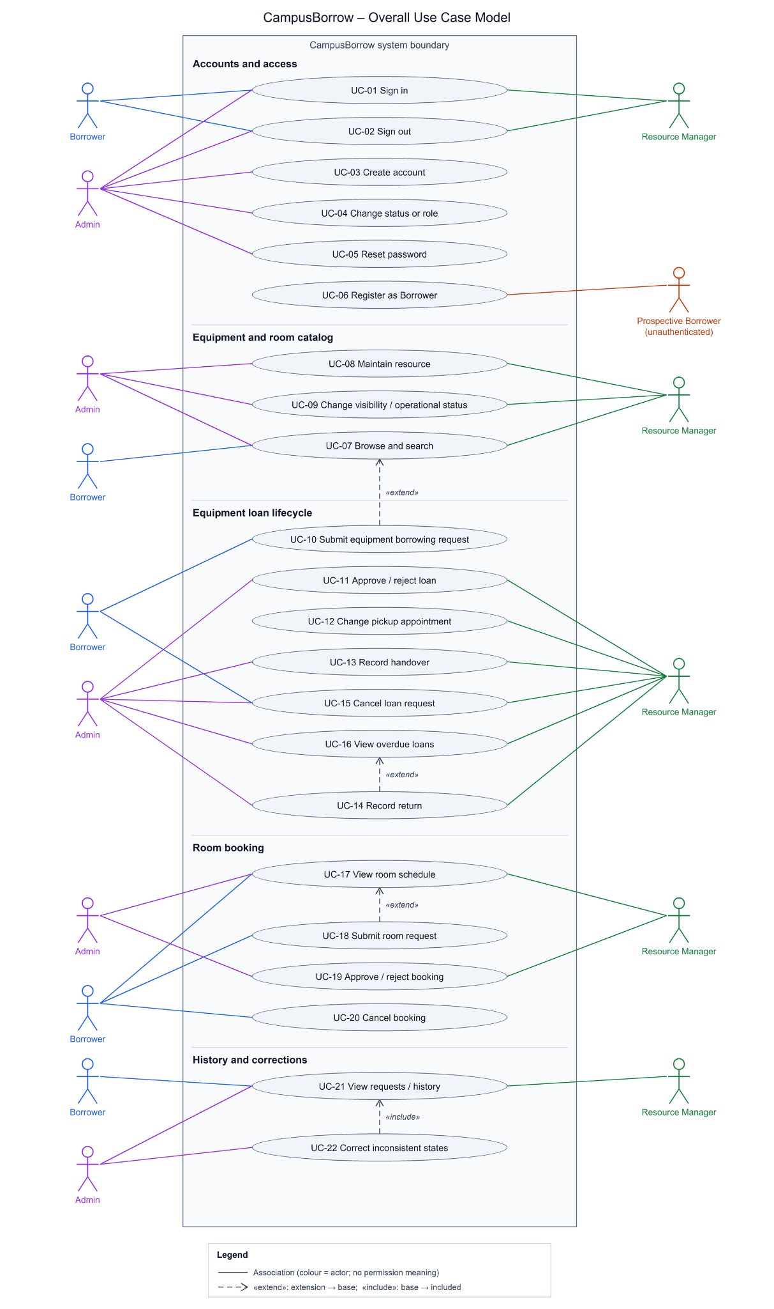
The overview places five functional groups inside one CampusBorrow system boundary. Borrower and Admin appear on the left; Resource Manager and Prospective Borrower appear on the right. Actors repeat beside each group to shorten connections; repeated symbols represent the same role, not additional roles. Every active use case appears once. Solid lines are associations coloured by actor (blue Borrower, green Resource Manager, purple Admin, orange Prospective Borrower); colours carry no permission meaning. Dashed arrows show the three «extend» relationships and one «include» relationship described in §6.1.3. The focused views below repeat each group at a larger scale.

Focused Views
View | Use cases covered | Outputs
Accounts and access | UC-01 – UC-06 | Source
Equipment and room catalog | UC-07 – UC-09 (UC-07 is the base of UC-10 «extend») | Source
Equipment loan lifecycle | UC-10 – UC-16, with UC-07 shown as the extended base use case | Source
Room booking | UC-17 – UC-20 | source
History and controlled corrections | UC-21 – UC-22 | Source
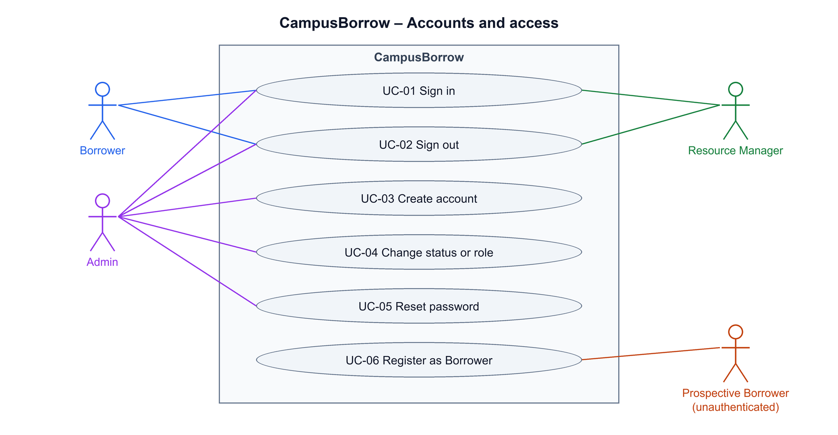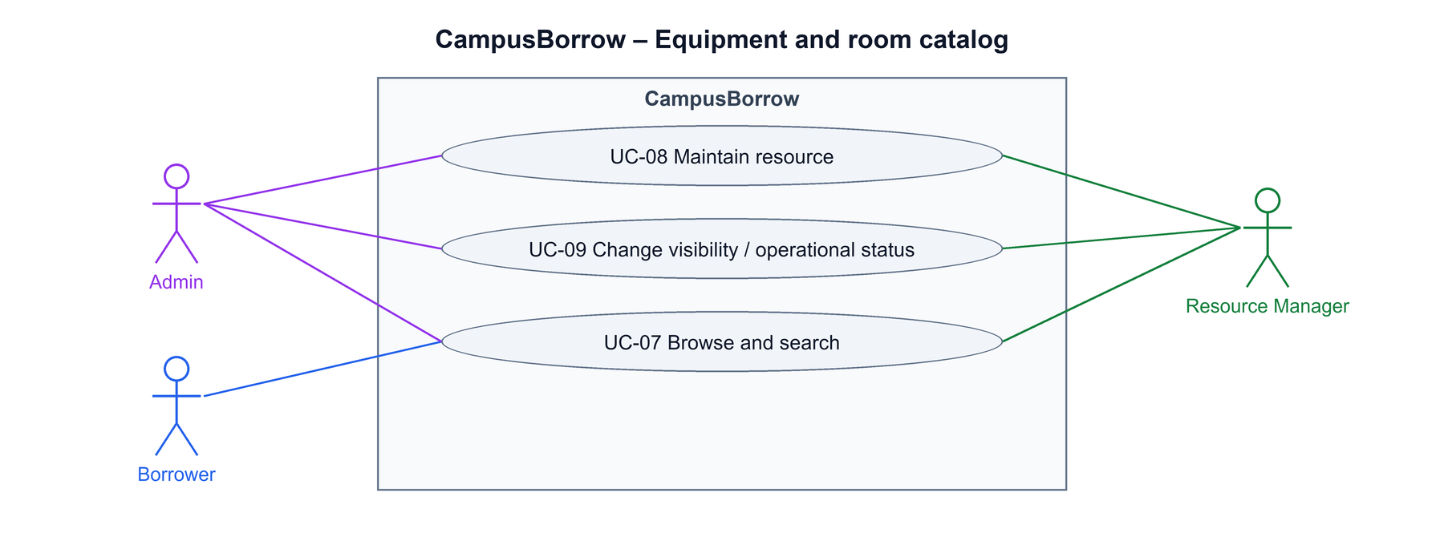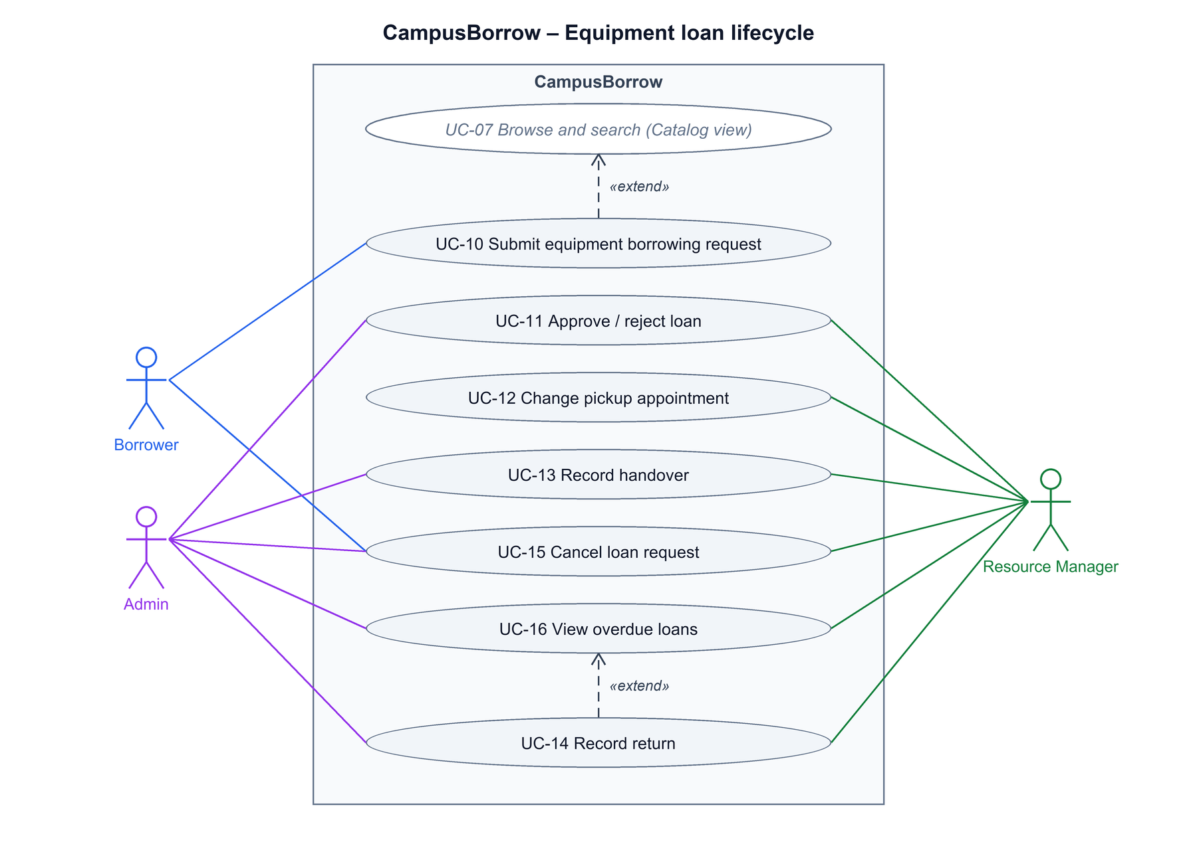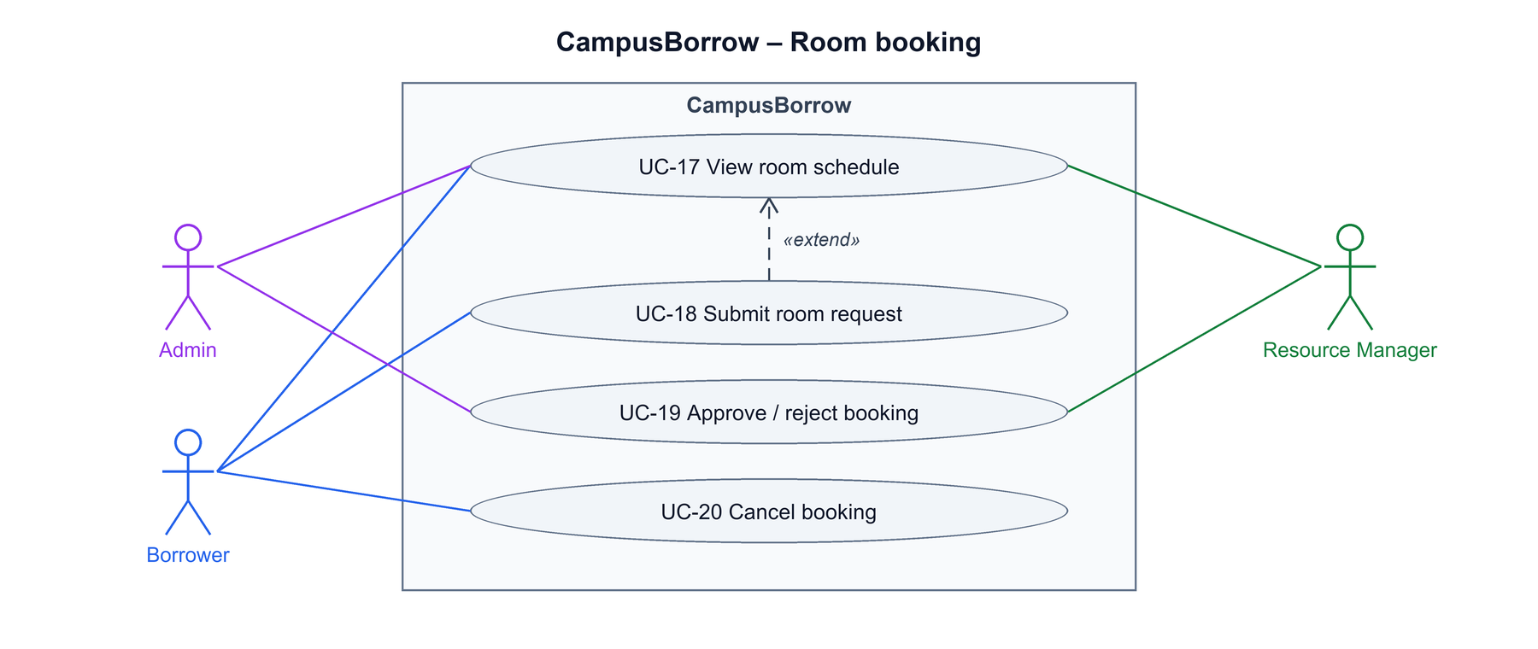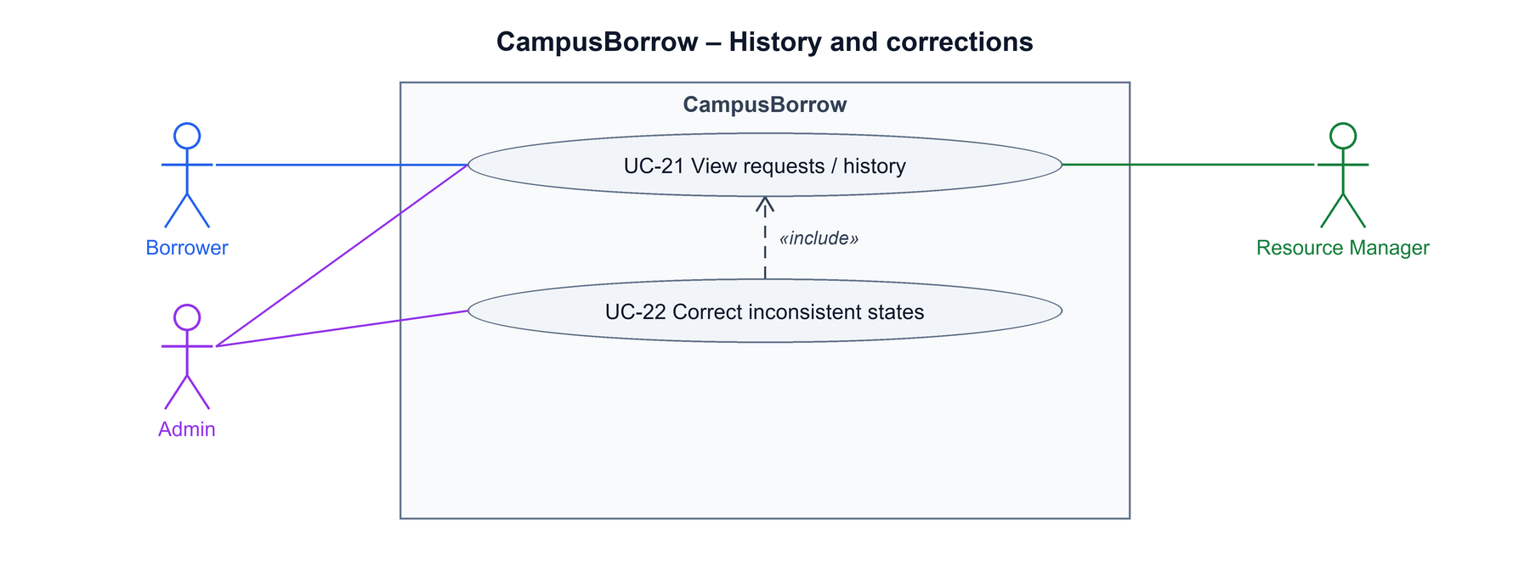

Model Interpretation and Permission Exceptions
- The CampusBorrow rectangle is the system boundary. Solid undirected associations identify interaction, not execution order or unrestricted authority. Preconditions, session/role checks and lifecycle guards in the specifications remain mandatory.
- «include» and «extend» are used only where one use case reuses another use case's behaviour or inserts optional behaviour at a named extension point (§6.1.3). Ordering dependencies, such as login before a protected operation or approval before handover, remain preconditions rather than include relationships. Conditional paths that do not form a separate actor goal remain alternative or exception flows in the specifications.
- No actor generalization is asserted. Admin does not inherit every RM capability: only RM may edit a confirmed pickup appointment (UC-12). Neither staff role automatically acquires Borrower request-submission rights.
- All RMs have equal operational permissions; there is no resource/request assignment or exclusive owner. Actual actors are recorded per event.
- UC-15 has a Borrower cancellation path and a narrowly scoped staff exception: approved uncollected equipment that becomes damaged/Out of service. It is not a blanket RM/Admin cancellation permission.
- Automatic missed-pickup expiry is not an actor-initiated use case and is omitted from the diagrams. FR-03-12, FR-03-13, FR-03-14, FR-03-15 retain expiry_at = min(confirmed_pickup_at + 24 hours, return_due_at), reservation release and concurrency safeguards. This rule never cancels an existing physical loan.
- In service / Out of service describe operational status; Visible / Hidden describe publication. Neither independently clears reservations or loans. New resources start Hidden + Out of service; reasons remain staff-only.
- Login and registration are pre-authentication interactions. Successful registration creates a Borrower only. There are three account roles, even though the diagram also shows the unauthenticated registration participant.
- FR-09-08 provisions the initial Admin during deployment/setup. It has no public use-case screen or public bootstrap actor; its deliberate UI exception is documented in traceability.
- F10/F11 have no active diagram nodes. The equal-RM model contains no assignment use case.

Use Case Relationships
The model uses three «extend» relationships and one «include» relationship. Each arrow is drawn from the extending use case to its base, or from the base to the included use case. The extending use cases can also be started on their own.
Relationship | Base use case | Extending / included use case | Extension point, condition and rationale
«extend» | UC-07 Browse and search resources | UC-10 Submit equipment borrowing request | Extension point Request equipment (UC-07 step 5, A5). Inserted only when a Borrower chooses to request an eligible item from its detail view.
«extend» | UC-16 View overdue loans | UC-14 Record equipment return | Extension point Record return (UC-16 step 5, A3). Inserted when staff receive an overdue item while following up from the overdue list.
«extend» | UC-17 View a room schedule | UC-18 Submit a room booking request | Extension point Request room (UC-17 A1). Inserted when an eligible Borrower chooses to request free periods shown on the schedule.
«include» | UC-22 Correct inconsistent resource and request states | UC-21 View requests and business history | UC-22 always reuses UC-21 at step 2 to display the target record's business history before a correction is proposed.

Actors
Actor | Description
Borrower | A person whose account has the Borrower role. Signs in/out, discovers visible resources, submits personal equipment/room requests, cancels under the applicable rules and reads personal request/history data. Cannot maintain the catalog, approve requests or manage accounts.
Resource Manager | An active staff account with unit-wide operational access: catalog maintenance, approvals, pickup edits, physical handover/return and operational history. No assignments are required. Cannot administer accounts or invoke Admin-only correction functions.
Admin | An administrative account that manages other accounts subject to self/last-Admin and outstanding-obligation safeguards; maintains catalog data, supports operational processing and performs controlled corrections. Cannot edit confirmed pickup appointments.
Prospective Borrower (unauthenticated) | A pre-registration participant interacting with UC-06; not a fourth account role. Provides registration data and receives a Borrower account only.

Use Case List

Accounts and access
ID | Use case | Primary actor | Priority | Related FR
UC-01 | Sign in | All three roles | Must | FR-01-01, FR-01-03, FR-09-02, FR-01-05, FR-01-07
UC-02 | Sign out | All three roles | Must | FR-01-02, FR-01-07
UC-03 | Create an account | Admin | Must | FR-09-01, FR-01-03, FR-09-06, FR-01-05, FR-01-06
UC-04 | Change account status or role | Admin | Must | FR-01-03, FR-09-02, FR-09-03, FR-09-04, FR-09-06, FR-01-07, FR-09-07
UC-05 | Reset a password manually | Admin | Must | FR-01-03, FR-09-05, FR-09-06, FR-01-06, FR-01-07
UC-06 | Register a Borrower account | Unauthenticated prospective Borrower | Must | FR-09-06, FR-01-04, FR-01-05, FR-01-06

Equipment and room catalog
ID | Use case | Primary actor | Priority | Related FR
UC-07 | Browse and search resources | All three roles | Must | FR-01-03, FR-02-03, FR-02-04, FR-02-06, FR-02-09, FR-02-15
UC-08 | Create or update a catalog record | RM, Admin | Must | FR-02-01, FR-02-02, FR-02-11, FR-02-12, FR-02-13, FR-02-14, FR-02-15, FR-02-16
UC-09 | Change visibility or operational status | RM, Admin | Must | FR-02-05, FR-02-07, FR-02-08, FR-02-09, FR-02-10, FR-02-12, FR-02-14, FR-02-15, FR-02-16

Equipment loan lifecycle
ID | Use case | Primary actor | Priority | Related FR
UC-10 | Submit equipment borrowing request | Borrower | Must | FR-02-06, FR-02-07, FR-02-08, FR-03-01, FR-03-02, FR-03-03, FR-03-09
UC-11 | Approve or reject an equipment request | Any RM, Admin | Must | FR-01-03, FR-02-08, FR-03-04, FR-03-05, FR-03-06, FR-03-07, FR-03-09
UC-12 | Change a pickup appointment | Any RM only | Must | FR-01-03, FR-03-14, FR-03-15, FR-03-08, FR-03-09
UC-13 | Record equipment handover | Any RM, Admin | Must | FR-03-14, FR-03-15, FR-04-01, FR-04-02
UC-14 | Record equipment return | Any RM, Admin | Must | FR-09-03, FR-02-10, FR-04-03, FR-04-04
UC-15 | Cancel an equipment request | Borrower; RM/Admin for the out-of-service equipment exception | Must | FR-03-10, FR-03-11, FR-03-12
UC-16 | View overdue loans | RM, Admin | Must | FR-04-05, FR-04-06

Room booking
ID | Use case | Primary actor | Priority | Related FR
UC-17 | View a room schedule | All three roles | Must | FR-02-04, FR-05-01 – FR-05-06
UC-18 | Submit a room booking request | Borrower | Must | FR-02-06, FR-02-07, FR-02-08, FR-06-01 – FR-06-09, FR-07-07
UC-19 | Approve or reject a room booking | Any RM, Admin | Must | FR-01-03, FR-02-08, FR-07-01 – FR-07-04, FR-07-06 – FR-07-09
UC-20 | Cancel a room booking | Borrower | Must | FR-07-05, FR-07-09

History and controlled corrections
ID | Use case | Primary actor | Priority | Related FR
UC-21 | View requests and business history | All three roles | Must | FR-01-03, FR-02-09, FR-02-15, FR-03-09, FR-04-06, FR-08-01 – FR-08-09, FR-09-06
UC-22 | Correct inconsistent resource and request states | Admin | Must | FR-01-03, FR-02-10, FR-08-01, FR-08-07, FR-09-09 – FR-09-12

Use Case Specifications

UC-01 Sign in
Field | Specification
Use case ID | UC-01
Use case name | Sign in
Brief description | Authenticate an active account by username or email.
Primary actor | Borrower, Resource Manager or Admin
Secondary actors | None; external identity checks/credential handoff, when applicable, are manual steps rather than an integrated service.
Priority | Must
Related requirements | FR-01-01, FR-01-03, FR-01-05, FR-01-07
Trigger | Valid credentials submitted.
Pre-conditions | An account exists; no authenticated session is required.
Post-conditions | An active account obtains a session using its current role. On failure no session is issued.
Main flow | 1. The user enters username or email and password.  2. The system trims/normalizes the identifier and checks the exact password and account activation.  3. The system creates a session expiring 24 hours after login and loads the current role.  4. The system opens the role-appropriate view.
Alternative flows | A1 (step 1): 1. The user supplies email instead of username. 2. The system resolves the same account using the email policy and continues at step 2.  A2 (step 2): 1. The identifier differs only in case or outer whitespace. 2. The system normalizes it; the password remains unchanged.
Exception flows | E1 (step 2): 1. Credentials are invalid or the account is inactive. 2. The system denies login without issuing a session.  E2 (step 3): 1. Session creation fails. 2. The system reports failure without displaying an authenticated success.
Business rules | BR-02, BR-06, BR-07, BR-10; see confirmed rules.
Non-functional constraints | Enforce authorization and applicable session revocation on the server; never expose passwords in logs/history. The confirmed 24-hour session limit follows BR-10. Measurable targets: NFR-03 (authorization), NFR-04 (credential storage and session), NFR-05 (deactivated accounts) and NFR-06 (input validation and HTTPS).

UC-02 Sign out
Field | Specification
Use case ID | UC-02
Use case name | Sign out
Brief description | End the current authenticated session.
Primary actor | Borrower, Resource Manager or Admin
Secondary actors | None; external identity checks/credential handoff, when applicable, are manual steps rather than an integrated service.
Priority | Must
Related requirements | FR-01-02, FR-01-07
Trigger | The user selects Sign out.
Pre-conditions | A current or previously issued session is presented.
Post-conditions | The current session cannot authorize further calls; other sessions are unchanged.
Main flow | 1. The user selects Sign out.  2. The system revokes the current session server-side.  3. The client clears its current authentication state.  4. The system displays the login screen.
Alternative flows | A1 (step 2): 1. The session has already expired or been revoked. 2. The system returns to login without recreating it.  A2 (step 2): 1. Other valid sessions exist for the account. 2. The system leaves them valid and continues at step 3.
Exception flows | E1 (step 2): 1. Server revocation cannot be confirmed because the service is unavailable. 2. The client may clear local state but must not claim server-side revocation succeeded; it reports failure and permits retry. The session remains subject to its expiry and other invalidation rules.
Business rules | BR-10; see confirmed rules.
Non-functional constraints | Enforce authorization and applicable session revocation on the server; never expose passwords in logs/history. The confirmed 24-hour session limit follows BR-10. Measurable targets: NFR-03 (authorization), NFR-04 (credential storage and session), NFR-05 (deactivated accounts) and NFR-06 (input validation and HTTPS).

UC-03 Create an account
Field | Specification
Use case ID | UC-03
Use case name | Create an account
Brief description | Provision another account through the Admin interface.
Primary actor | Admin
Secondary actors | None; external identity checks/credential handoff, when applicable, are manual steps rather than an integrated service.
Priority | Must
Related requirements | FR-09-01, FR-01-03, FR-09-06, FR-01-05, FR-01-06
Trigger | Admin selects Create account.
Pre-conditions | The actor is an active authenticated Admin.
Post-conditions | One account with the chosen single role exists; failure creates no partial account.
Main flow | 1. Admin opens account creation.  2. Admin enters display name, username, email, one role and an initial password.  3. The system validates identifiers, uniqueness, password and role.  4. Admin confirms; the system creates the account and records a non-secret event.  5. Admin conveys initial credentials outside the application.
Alternative flows | A1 (step 2): 1. Admin selects RM or Admin instead of Borrower. 2. The system grants exactly that one role after the same validation.  A2 (step 3): 1. Name/identifier input includes outer whitespace or mixed case. 2. The system applies BR-06 and continues validation.
Exception flows | E1 (step 3/4): 1. Data is invalid or a concurrent creation takes the same identifier. 2. The system rejects creation without a partial account.  E2 (step 4): 1. The actor session/role is no longer authorized. 2. The system denies creation.
Business rules | BR-06, BR-07, BR-11; see confirmed rules.
Non-functional constraints | Enforce authorization and applicable session revocation on the server; never expose passwords in logs/history. The confirmed 24-hour session limit follows BR-10. Measurable targets: NFR-03 (authorization), NFR-04 (credential storage and session), NFR-05 (deactivated accounts) and NFR-06 (input validation and HTTPS).

UC-04 Change account status or role
Field | Specification
Use case ID | UC-04
Use case name | Change account status or role
Brief description | Activate/deactivate another account or replace its single role.
Primary actor | Admin
Secondary actors | None; external identity checks/credential handoff, when applicable, are manual steps rather than an integrated service.
Priority | Must
Related requirements | FR-01-03, FR-09-02, FR-09-03, FR-09-04, FR-09-06, FR-01-07, FR-09-07
Trigger | Admin chooses a status or role change.
Pre-conditions | An active authenticated Admin selects an existing target account.
Post-conditions | The permitted change is recorded; deactivation/role change revokes all target sessions. History and obligations are preserved. A rejected change leaves state unchanged.
Main flow | 1. Admin opens the target account; the system shows current role/status and outstanding equipment/room obligations.  2. Admin chooses deactivation and confirms.  3. The system rechecks current authorization, target and self/last-active-Admin safeguards.  4. The system deactivates the target and revokes all its sessions consistently.  5. The system records the actor, target, timestamp and change without cancelling requests or fabricating returns.
Alternative flows | A1 (step 2): 1. Admin chooses reactivation. 2. After safeguards, the system activates the account and records the change. 3. The target must log in again; old sessions remain invalid.  A2 (step 2): 1. Admin chooses a different single role. 2. The system checks BR-08 obligations and BR-11 safeguards using current states. 3. If permitted, it replaces the role, revokes all target sessions and records the change.  A3 (step 3): 1. A Borrower being deactivated still has obligations. 2. Deactivation remains allowed; records and normal expiry are preserved, staff may approve Pending requests/receive returns, and new handover remains blocked.
Exception flows | E1 (A2): 1. The Borrower has a Pending/valid Approved equipment request, unreturned loan, Pending room request or Approved room booking not ended. 2. Reject role change and identify blocking obligations without auto-cancelling them.  E2 (step 3/A2): 1. Admin attempts self-deactivation/self-role change or removal of the last active Admin, including concurrent attempts. 2. Reject without partial changes.  E3 (step 3/4): 1. Authorization or relevant state changes concurrently. 2. Recheck and reject an invalid transition; do not preserve old privilege after a successful change.
Business rules | BR-05, BR-08, BR-10, BR-11; see confirmed rules.
Non-functional constraints | Enforce authorization and applicable session revocation on the server; never expose passwords in logs/history. The confirmed 24-hour session limit follows BR-10. Measurable targets: NFR-03 (authorization), NFR-04 (credential storage and session), NFR-05 (deactivated accounts) and NFR-06 (input validation and HTTPS).

UC-05 Reset a password manually
Field | Specification
Use case ID | UC-05
Use case name | Reset a password manually
Brief description | Replace another account’s password following external identity verification.
Primary actor | Admin
Secondary actors | None; external identity checks/credential handoff, when applicable, are manual steps rather than an integrated service.
Priority | Must
Related requirements | FR-01-03, FR-09-05, FR-09-06, FR-01-06, FR-01-07
Trigger | Admin selects Reset password for another account.
Pre-conditions | An active Admin receives a request outside the application; the target account exists.
Post-conditions | The replacement works only if the account is active; old password and all target sessions are invalid. Role/status stay unchanged.
Main flow | 1. Admin verifies identity externally using a student/staff card or unit-maintained records; email alone is insufficient.  2. Admin selects the matching account, confirms completion of the identity check and enters a replacement password.  3. The system rechecks Admin authority and validates the replacement.  4. The system replaces the credential and revokes all target sessions consistently; it records the event without passwords or identity-document copies.  5. Admin conveys the replacement through the verified external channel.
Alternative flows | A1 (step 3): 1. The target is inactive. 2. Reset may proceed but does not activate it; login remains blocked.  A2 (step 3): 1. The target is another Admin. 2. The same identity check, password policy and session revocation apply.
Exception flows | E1 (step 1/2): 1. Identity cannot be verified or verification confirmation is missing. 2. Do not reset; preserve credentials and sessions.  E2 (step 3): 1. The password is invalid or actor is not authorized. 2. Reject without partial reset.  E3 (step 5): 1. External handoff fails after a successful reset. 2. Report the operational issue; do not claim delivery or restore the old credential/session.
Business rules | BR-07, BR-09, BR-10; see confirmed rules.
Non-functional constraints | Enforce authorization and applicable session revocation on the server; never expose passwords in logs/history. The confirmed 24-hour session limit follows BR-10. Measurable targets: NFR-03 (authorization), NFR-04 (credential storage and session), NFR-05 (deactivated accounts) and NFR-06 (input validation and HTTPS).

UC-06 Register a Borrower account
Field | Specification
Use case ID | UC-06
Use case name | Register a Borrower account
Brief description | Create a personal Borrower account without Admin provisioning.
Primary actor | Unauthenticated prospective Borrower
Secondary actors | None; external identity checks/credential handoff, when applicable, are manual steps rather than an integrated service.
Priority | Must
Related requirements | FR-09-06, FR-01-04, FR-01-05, FR-01-06
Trigger | The person selects Register.
Pre-conditions | No authenticated session is required.
Post-conditions | One active Borrower exists and can sign in without email verification; failure creates no partial account.
Main flow | 1. The person enters display name, username, email, password and password confirmation.  2. The system normalizes name/identifiers and validates fields, identifier uniqueness and exact confirmation match.  3. The system creates exactly one active Borrower account and records registration without credentials.  4. The system confirms creation and directs the person to sign in; no verification email/OTP is sent.
Alternative flows | A1 (step 2): 1. Identifier input differs in case or includes outer whitespace. 2. The system applies BR-06 before checking uniqueness.  A2 (step 1/2): 1. The person supplies a Vietnamese display name or a password containing spaces. 2. The system permits them within length rules and preserves password spaces.
Exception flows | E1 (step 2/3): 1. A username/email already exists or is taken by a concurrent submission. 2. Reject without a duplicate/partial account.  E2 (step 2): 1. Input is invalid, password confirmation mismatches or RM/Admin is requested. 2. Reject and show relevant field errors without echoing passwords.
Business rules | BR-02, BR-06, BR-07, BR-11
Non-functional constraints | Enforce authorization and applicable session revocation on the server; never expose passwords in logs/history. The confirmed 24-hour session limit follows BR-10. Measurable targets: NFR-03 (authorization), NFR-04 (credential storage and session), NFR-05 (deactivated accounts) and NFR-06 (input validation and HTTPS).

UC-07 Browse and search resources
Field | Specification
Use case ID | UC-07
Use case name | Browse and search resources
Brief description | Find a resource and inspect permitted details without confusing operational status with occupancy.
Primary actor | Borrower, Resource Manager or Admin
Secondary actors | None; room schedule and request processing are linked application use cases, not external actors.
Priority | Must
Related requirements | FR-02-03, FR-02-04, FR-02-06, FR-02-09, FR-02-15
Trigger | The actor opens the catalog or submits search/filter input.
Pre-conditions | The actor has an active account and valid session.
Post-conditions | Authorized results/details are displayed; no records are changed or reserved.
Main flow | 1. The actor opens the catalog.  2. The actor enters an optional partial code/name and type/operational-status filters; staff may also filter visibility.  3. The system applies role visibility, case-insensitive matching and filters, then orders by normalized code and paginates 20 records per page.  4. The actor opens a result.  5. The system rechecks access and shows permitted fields, separate operational/usage labels, and room capacity/schedule access where applicable.
Alternative flows | A1 (step 2): 1. The actor leaves search blank. 2. The system returns the filtered, paginated list.  A2 (step 3): 1. An RM/Admin selects Hidden. 2. Matching hidden resources are shown to staff only.  A3 (step 5): 1. The resource is Out of service. 2. Borrower sees the status and disabled request action; staff can inspect the internal reason.  A4 (step 5): 1. Equipment is In service but Reserved/On loan, or a room has bookings. 2. Display usage/schedule separately and apply lifecycle eligibility checks.  A5 (step 5): 1. A Borrower selects Request equipment for an eligible item. 2. The system continues with UC-10 at extension point Request equipment (UC-10 «extend» UC-07).
Exception flows | E1 (step 3): 1. No records match. 2. Display an empty result with no hidden-record count leakage.  E2 (step 5): 1. A Borrower follows a hidden-resource URL or the record became hidden after search. 2. Deny general detail access; permitted own-history access remains separate.  E3 (step 3/5): 1. Retrieval fails or the session is invalid. 2. Report failure/require login rather than display fabricated availability.
Business rules | BR-13, BR-14, BR-16, BR-18; see business rules.
Non-functional constraints | Server-side authorization, current-state checks, non-disclosure of internal reasons and stale-save prevention are mandatory. Session rules BR-10 apply. Measurable targets: NFR-01 (search P95 ≤ 1.0 s), NFR-03, NFR-10 and NFR-11.

UC-08 Create or update a catalog record
Field | Specification
Use case ID | UC-08
Use case name | Create or update a catalog record
Brief description | Create a single equipment/room record or edit permitted descriptive fields.
Primary actor | Resource Manager or Admin
Secondary actors | None; room schedule and request processing are linked application use cases, not external actors.
Priority | Must
Related requirements | FR-02-01, FR-02-02, FR-02-11, FR-02-12, FR-02-13, FR-02-14, FR-02-15, FR-02-16
Trigger | The actor selects Add resource or Edit information.
Pre-conditions | The actor is an active authenticated RM/Admin; an existing resource is selected for edits.
Post-conditions | A valid resource is created Hidden + Out of service, or a permitted edit is saved with history; failures preserve prior records.
Main flow | 1. The actor selects Add resource and chooses Equipment or Room.  2. The actor enters code, name, location and optional description; Room also requires capacity.  3. The system validates required fields, lengths, type and case-insensitive code uniqueness across both resource types.  4. The actor confirms creation; the system rechecks authority/uniqueness and creates a stable record as Hidden + Out of service with reason Awaiting readiness confirmation.  5. The system records creation and displays the management detail; publication/readiness changes use UC-09.
Alternative flows | A1 (step 1): 1. The actor opens Edit information for an existing record. 2. Code/type are read-only. 3. The actor edits name/description or eligible location/capacity. 4. At save, the system checks current version and BR-15 obligations, saves permitted changes and records before/after values.  A2 (step 2): 1. Type is Equipment. 2. Capacity is not applicable and no stock-quantity field is added.  A3 (step 1): 1. Staff discover an incorrect immutable code/type. 2. They hide the old record using UC-09 and create a correctly identified record; prior history is not migrated or deleted.
Exception flows | E1 (step 3/4): 1. Input is invalid or another creation takes the same code. 2. Reject without a duplicate or partial record.  E2 (A1 save): 1. Pending/Approved/loan or room-booking obligations block a location/capacity edit. 2. Reject it without cancelling obligations.  E3 (A1 save): 1. Another actor saved since the edit opened. 2. Reject the stale save and require reload/review; preserve the newer version.  E4 (step 4/A1): 1. The actor lacks current authority or attempts a direct code/type change/deletion. 2. Deny the operation.
Business rules | BR-01, BR-12, BR-13, BR-15, BR-17, BR-18; see business rules.
Non-functional constraints | Server-side authorization, current-state checks, non-disclosure of internal reasons and stale-save prevention are mandatory. Session rules BR-10 apply. Measurable targets: NFR-01 (search P95 ≤ 1.0 s), NFR-03, NFR-10 and NFR-11.

UC-09 Change visibility or operational status
Field | Specification
Use case ID | UC-09
Use case name | Change visibility or operational status
Brief description | Publish/withdraw a resource or update its operational status without falsifying usage.
Primary actor | Resource Manager or Admin
Secondary actors | None; room schedule and request processing are linked application use cases, not external actors.
Priority | Must
Related requirements | FR-02-05, FR-02-07, FR-02-08, FR-02-09, FR-02-10, FR-02-14, FR-02-15
Trigger | The actor opens visibility/operational-status controls.
Pre-conditions | The actor is an active authenticated RM/Admin and selects an existing resource.
Post-conditions | The permitted state change and event are saved; occupancy and history remain valid. Failed/stale saves leave current state unchanged.
Main flow | 1. The system displays visibility, operational status, current usage and current internal reason separately.  2. The actor selects Out of service and enters a nonblank reason.  3. The system validates reason length, current authority, record version and lifecycle consistency.  4. The actor confirms; the system saves the status and current reason with actor/time and before/after values.  5. Borrower-facing access displays only the status and blocks new requests; staff retain access to the internal reason/history.
Alternative flows | A1 (step 2): 1. The actor selects In service and optionally adds a note. 2. The system applies the same validation/version checks, clears the current out-of-service reason and preserves it historically. 3. Existing reservation/loan/room conflicts still apply.  A2 (step 2): 1. The actor changes Visible/Hidden with an optional note. 2. The system changes visibility without resetting operational status or usage.  A3 (step 4): 1. Equipment has an Approved uncollected request. 2. Out of service blocks handover but does not automatically cancel; eligible staff cancellation remains UC-15.  A4 (step 4): 1. A room has existing Approved bookings. 2. The operational change is allowed; those bookings are handled outside the application without automatic cancellation.
Exception flows | E1 (step 3): 1. A required reason is blank or a reason/note exceeds 500 trimmed characters. 2. Reject and show the relevant error.  E2 (step 3/4): 1. Another actor saved a newer version. 2. Reject and require reload/review; no silent overwrite.  E3 (step 3): 1. The call lacks authority or attempts to erase loan occupancy through status changes. 2. Deny it and preserve the lifecycle records.
Business rules | BR-05, BR-13, BR-15, BR-16, BR-17, BR-18
Non-functional constraints | Server-side authorization, current-state checks, non-disclosure of internal reasons and stale-save prevention are mandatory. Session rules BR-10 apply. Measurable targets: NFR-01 (search P95 ≤ 1.0 s), NFR-03, NFR-10 and NFR-11.

UC-10 Submit equipment borrowing request
Field | Specification
Use case ID | UC-10
Use case name | Submit equipment borrowing request
Brief description | Submit a request for one equipment item without reserving it before approval.
Primary actor | Borrower
Secondary actors | None in the application interaction; physical participants and external contact do not introduce additional account roles.
Priority | Must
Related requirements | FR-02-06, FR-02-07, FR-02-08, FR-03-01, FR-03-02, FR-03-03, FR-03-09
Trigger | The Borrower selects Request equipment for a catalog item (UC-10 extends UC-07 at extension point Request equipment).
Pre-conditions | The Borrower has an active account and valid session. The selected item is visible, In service and not reserved or on loan; no duplicate active request by this Borrower exists. These conditions are rechecked at submission.
Post-conditions | Success: one Pending request owned by the authenticated Borrower is recorded with submission time; no reservation is created. Failure: no partial request or reservation is created; an existing duplicate remains unchanged.
Main flow | 1. The Borrower opens the request form for one equipment item.  2. The Borrower enters a nonblank purpose, proposed pickup date-time and specific return date-time.  3. The system checks required values and requires proposed pickup > now and proposed pickup < return_due_at.  4. The Borrower confirms submission.  5. The system rechecks current authorization, future pickup/return ordering, item visibility/readiness/occupancy and duplicate active requests, then creates one Pending request consistently.  6. The system displays the request ID, proposed pickup, return deadline and Pending status.
Alternative flows | A1 (step 5): 1. Other Borrowers have Pending requests for the same eligible item. 2. The system accepts this request without reserving the item; requests compete at approval.  A2 (step 5): 1. This Borrower has only terminal records for the item. 2. Those records do not prevent a new request if current checks pass.
Exception flows | E1 (step 3): 1. Purpose is blank, dates are invalid/missing, multiple items are supplied, pickup is not future or pickup is at/after return. 2. Reject the submission with the relevant validation message.  E2 (step 5): 1. The item became Hidden, Out of service, reserved or on loan. 2. Reject even from a stale screen/direct API call; planned future return does not override occupancy.  E3 (step 5): 1. A duplicate Pending, valid Approved or On-loan request exists, including an overdue loan or a concurrent submission. 2. Reject the duplicate; at most one active request is created for this Borrower/item.  E4 (step 5/6): 1. Authorization fails or the save/read fails. 2. Deny unauthorized access or report failure without false success; do not expose another Borrower’s records or create partial data.
Business rules | BR-01, BR-05, BR-13, BR-18; EQ-01 in the equipment specification. No automatic quota, maximum loan duration or RM selection applies. See business rules and equipment requirements.
Non-functional constraints | Enforce current authorization, session validity and record ownership on the server; preserve consistent state under concurrent/repeated operations and disclose only authorized data. Use system-evaluated time and consistent UTC+7 presentation. Measurable targets: NFR-02 (write P95 ≤ 2.0 s), NFR-03, NFR-07 and NFR-09; specification preparation is not evidence of executed tests.

UC-11 Approve or reject an equipment request
Field | Specification
Use case ID | UC-11
Use case name | Approve or reject an equipment request
Brief description | Decide a Pending request, reserving equipment on approval and resolving competing Pending requests consistently.
Primary actor | Resource Manager or Admin
Secondary actors | None in the application interaction; physical participants and external contact do not introduce additional account roles.
Priority | Must
Related requirements | FR-01-03, FR-02-08, FR-03-04, FR-03-05, FR-03-06, FR-03-07, FR-03-09
Trigger | An active RM/Admin opens a Pending request for a decision.
Pre-conditions | The actor has a valid staff session and operational permission. The request exists and is Pending; current eligibility is rechecked before the decision. Borrower inactivity does not itself prohibit approval.
Post-conditions | Approval: the request becomes Approved with one exclusive reservation, confirmed pickup, unchanged return deadline and actual decision actor/time; competing Pending requests for the item become Rejected. Rejection: the request becomes Rejected with actor/time/reason and creates no reservation. Failed/stale operations make no partial changes and preserve any competing operation’s committed result.
Main flow | 1. The actor opens the request; the system shows its submitted details, current item status and occupancy.  2. The actor selects Approve and confirms a future pickup appointment before the existing return deadline.  3. The system rechecks authority, Pending state, confirmed pickup > now and confirmed pickup < the unchanged return deadline, Visible + In service status and absence of a conflicting reservation or loan; it computes expiry_at.  4. The system consistently approves the request, reserves the item exclusively and records the confirmed appointment, deadline, decision actor and time.  5. As part of the same consistent decision, the system rejects all other Pending requests for that item with reason "Equipment has been reserved for another request", system attribution, timestamp and a reference to the winning approval.  6. The system displays the current decision and Collect before time to authorized users.
Alternative flows | A1 (step 2): 1. The actor chooses Reject and enters a nonblank reason. 2. The system rechecks authority/Pending state. 3. It saves rejection with actor/time/reason, makes the relevant reason visible to the requester and creates no reservation.  A2 (step 2): 1. The proposed pickup has passed. 2. Staff confirm a new future appointment before the unchanged return deadline. 3. Continue at step 3; Admin may set this initial confirmed time.  A3 (step 3): 1. The Borrower is inactive. 2. Approval may proceed if all other conditions pass. 3. Handover remains blocked until reactivation; expiry is not paused.
Exception flows | E1 (step 2/3): 1. No future pickup exists before the return deadline or the supplied appointment is invalid. 2. Reject approval without changing the deadline or creating a reservation.  E2 (A1): 1. The rejection reason is absent or whitespace-only. 2. Reject the decision and request a valid reason.  E3 (step 3–5/A1): 1. Another approval, rejection or cancellation changes the current state, or item eligibility is lost. 2. Reject the stale action and display the authorized current result; at most one approval reserves the item.  E4 (step 3–5): 1. Authorization or persistence fails. 2. Deny/report failure with no partial approval, reservation or competing-request rejections. Concurrent submission cannot leave a new eligible Pending request for the now-reserved item.
Business rules | BR-01, BR-04, BR-05, BR-13; EQ-01–03 in the equipment specification. Later cancellation/return never automatically reopens rejected requests. Initial appointment confirmation differs from RM-only UC-12. See business rules and equipment requirements.
Non-functional constraints | Enforce current authorization, session validity and record ownership on the server; preserve consistent state under concurrent/repeated operations and disclose only authorized data. Use system-evaluated time and consistent UTC+7 presentation. Measurable targets: NFR-02 (write P95 ≤ 2.0 s), NFR-03, NFR-07 and NFR-09; specification preparation is not evidence of executed tests.

UC-12 Change a pickup appointment
Field | Specification
Use case ID | UC-12
Use case name | Change a pickup appointment
Brief description | Replace a valid confirmed appointment after external contact, retaining the reservation and return deadline.
Primary actor | Resource Manager only
Secondary actors | None in the application interaction; physical participants and external contact do not introduce additional account roles.
Priority | Must
Related requirements | FR-01-03, FR-03-14, FR-03-15, FR-03-08, FR-03-09
Trigger | After a Borrower contacts the RM team outside the application, an RM opens the appointment-edit action.
Pre-conditions | The actor is an active authenticated RM. The request is Approved, uncollected and not expired; now < current expiry_at. No staff assignment is required.
Post-conditions | Success: the new appointment and recalculated expiry apply, the original return deadline and reservation remain, and old/new appointment values with actor/time are retained. Failure: no appointment or reservation change and no expired request revival.
Main flow | 1. The RM opens the request and reviews current pickup, return deadline and Collect before time.  2. The RM enters a future replacement pickup appointment.  3. The system checks RM authority, current Approved/uncollected state and now < current expiry_at; it requires replacement pickup > now and replacement pickup < existing return_due_at.  4. The RM confirms; the system rechecks current state and time, saves the replacement and recomputes expiry_at = min(replacement pickup + 24 hours, unchanged return_due_at).  5. The system records old/new appointment and actual RM/time, retains the reservation and shows the updated pickup window.
Alternative flows | A1 (step 3): 1. The old pickup has passed but the current expiry has not. 2. A future replacement before return may still be accepted.  A2 (step 4): 1. The return deadline is earlier than replacement pickup + 24 hours. 2. Use the return deadline as the new expiry.  A3 (step 4): 1. Replacement pickup + 24 hours is earlier than the return deadline. 2. Use that 24-hour threshold as the new expiry.
Exception flows | E1 (step 3/4): 1. Admin, Borrower or an invalid staff session attempts the edit. 2. Deny it; Admin operational support does not grant this permission.  E2 (step 3/4): 1. The replacement is past/present or at/after return. 2. Reject without changing the deadline.  E3 (step 3/4): 1. Current expiry has been reached, including with a stale Approved label, or collection/cancellation occurred. 2. Reject; expired requests cannot be revived by editing.  E4 (step 4): 1. A competing state change makes the edit invalid or persistence fails. 2. Report the current authorized result/failure, retain consistent state and avoid a partial edit.
Business rules | BR-01, BR-04, BR-05. F11 remains deferred: no in-app change-request or chat workflow. Handover must obey the replacement pickup window. See business rules and equipment requirements.
Non-functional constraints | Enforce current authorization, session validity and record ownership on the server; preserve consistent state under concurrent/repeated operations and disclose only authorized data. Use system-evaluated time and consistent UTC+7 presentation. Measurable targets: NFR-02 (write P95 ≤ 2.0 s), NFR-03, NFR-07 and NFR-09; specification preparation is not evidence of executed tests.

UC-13 Record equipment handover
Field | Specification
Use case ID | UC-13
Use case name | Record equipment handover
Brief description | Record physical collection and convert an equipment reservation into an active loan.
Primary actor | Resource Manager or Admin
Secondary actors | None in the application interaction; physical participants and external contact do not introduce additional account roles.
Priority | Must
Related requirements | FR-03-14, FR-03-15, FR-04-01, FR-04-02
Trigger | The Borrower arrives to collect equipment and staff open the handover action.
Pre-conditions | The staff actor is active and authenticated. The request is Approved, reserved for this request and uncollected; the Borrower is active, the item is In service and confirmed_pickup_at <= now < expiry_at. All conditions are rechecked at confirmation.
Post-conditions | Success: actual handover time and staff actor are recorded, request/item become On loan and the reservation is converted without a free-occupancy interval. Failure: no new handover or partial conversion is recorded; current records remain consistent.
Main flow | 1. The actor opens the approved request and checks the person and physical item outside the application.  2. The system displays current request, reservation, account status, pickup appointment and expiry.  3. The actor confirms physical handover.  4. The system rechecks current authority, active Borrower, operational readiness, reservation and pickup window.  5. The system consistently records handover time/actor and converts the reservation to an active loan.  6. The system displays the On-loan state and return deadline.
Alternative flows | A1 (step 4): 1. The item is Hidden but still In service with a valid reservation. 2. Hiding alone does not prohibit handover; proceed if all other checks pass.  A2 (step 4): 1. A different RM approved the request. 2. The current RM may hand over without reassignment.  A3 (step 4): 1. An inactive Borrower was reactivated before confirmation. 2. Proceed only if the current pickup window and all other conditions remain valid.
Exception flows | E1 (step 4): 1. now < confirmed_pickup_at or now >= expiry_at. 2. Reject early/expired handover, even if background expiry has not updated Approved.  E2 (step 4): 1. The Borrower is inactive, the item is Out of service or the required reservation is absent. 2. Reject handover; staff must not fabricate collection.  E3 (step 4/5): 1. A duplicate handover, cancellation, expiry or appointment edit wins a race. 2. Recheck the resulting state; no second loan or contradictory transition is allowed.  E4 (step 4/5): 1. Permission is lost or persistence fails. 2. Report failure with no partial loan or reservation release.
Business rules | BR-01, BR-04, BR-05, BR-13. Early handover is prohibited. At/after handover, use return rather than cancellation; expiry never cancels a completed physical loan. See business rules and equipment requirements.
Non-functional constraints | Enforce current authorization, session validity and record ownership on the server; preserve consistent state under concurrent/repeated operations and disclose only authorized data. Use system-evaluated time and consistent UTC+7 presentation. Measurable targets: NFR-02 (write P95 ≤ 2.0 s), NFR-03, NFR-07 and NFR-09; specification preparation is not evidence of executed tests.

UC-14 Record equipment return
Field | Specification
Use case ID | UC-14
Use case name | Record equipment return
Brief description | Record physical receipt, close an existing loan and preserve independent catalog restrictions.
Primary actor | Resource Manager or Admin
Secondary actors | None in the application interaction; physical participants and external contact do not introduce additional account roles.
Priority | Must
Related requirements | FR-09-03, FR-02-10, FR-04-03, FR-04-04
Trigger | Equipment is physically returned and staff open the return action, either directly or from the overdue list (UC-14 extends UC-16 at extension point Record return).
Pre-conditions | The actor is an active authenticated RM/Admin. A handover is recorded and no return is yet recorded. Staff verify physical receipt; Borrower inactivity does not block the operation.
Post-conditions | Success: actual return time and actor are retained, the request becomes Returned and loan occupancy is cleared consistently; visibility, operational status and history are preserved. The loan no longer appears as currently overdue. Failure: no duplicate return or partial occupancy release.
Main flow | 1. The actor opens the unreturned loan and verifies the returned equipment.  2. The actor confirms physical receipt.  3. The system rechecks staff authority and that handover exists with no recorded return.  4. The system records actual return time/actor, closes the loan and clears its occupancy consistently.  5. The system displays Returned; subsequent requests remain subject to current catalog/occupancy checks.
Alternative flows | A1 (step 3): 1. The Borrower is inactive. 2. Staff still record the physical return.  A2 (step 4): 1. The item is Hidden or Out of service. 2. Preserve those flags after clearing loan occupancy; separate catalog actions govern any later status change.  A3 (step 4): 1. The loan is overdue. 2. Record return without a fine, retain history and remove it from the current overdue list.
Exception flows | E1 (step 3): 1. There is no recorded handover or no physical receipt is confirmed. 2. Reject return; planned return time is not proof of receipt.  E2 (step 3/4): 1. Return has already been recorded, including by a concurrent staff action. 2. Reject the duplicate without releasing occupancy or recording an event twice.  E3 (step 3/4): 1. Authorization or persistence fails. 2. Report failure without partial closure/release or false success.
Business rules | BR-01, BR-04, BR-05, BR-13. A subsequent borrower must wait for recorded receipt, not merely the previous deadline. No repair/cost/penalty workflow or historical-event rewriting is added. See business rules and equipment requirements.
Non-functional constraints | Enforce current authorization, session validity and record ownership on the server; preserve consistent state under concurrent/repeated operations and disclose only authorized data. Use system-evaluated time and consistent UTC+7 presentation. Measurable targets: NFR-02 (write P95 ≤ 2.0 s), NFR-03, NFR-07 and NFR-09; specification preparation is not evidence of executed tests.

UC-15 Cancel an equipment request
Field | Specification
Use case ID | UC-15
Use case name | Cancel an equipment request
Brief description | Cancel an eligible uncollected request and release only its reservation, retaining the reason and history.
Primary actor | Borrower; Resource Manager or Admin only for the damaged/Out of service exception
Secondary actors | None in the application interaction; physical participants and external contact do not introduce additional account roles.
Priority | Must
Related requirements | FR-03-10, FR-03-11, FR-03-12
Trigger | A Borrower selects Cancel on a personal request, or authorized staff invoke the damaged/Out of service exception.
Pre-conditions | Borrower path: active authenticated owner; request is Pending or valid Approved and uncollected. Staff path: active authenticated RM/Admin; request is Approved and uncollected, and the equipment has become damaged/Out of service. Current expiry and state are checked before a human cancellation.
Post-conditions | Success: request is Cancelled with reason, actual actor and time; its reservation, if any, is released exactly once. Other requests, physical loans, visibility and operational restrictions are preserved. Failure: no new cancellation or duplicate release; a competing operation’s outcome is retained.
Main flow | 1. The Borrower opens a personal eligible request and chooses Cancel.  2. The system displays the current request and asks for a reason and confirmation.  3. The Borrower supplies a nonblank reason and confirms.  4. The system rechecks active session, ownership, reason, current state, absence of handover and approval expiry where applicable.  5. The system consistently records cancellation and releases only this request’s reservation, if present.  6. The system displays the cancellation outcome without reopening competing rejected requests.
Alternative flows | A1 (step 4/5): 1. The request is Pending. 2. Record cancellation without releasing a reservation, because this request holds none.  A2 (step 4/5): 1. The request is a valid Approved uncollected request. 2. Cancel and release its reservation consistently.  A3 (step 1): 1. An active RM/Admin identifies an Approved uncollected request whose item has become damaged/Out of service. 2. Staff enter a mandatory nonblank reason and confirm. 3. The system validates the specific exception, current state and expiry, then records the staff-attributed cancellation and releases its reservation. This is not unrestricted staff cancellation.
Exception flows | E1 (step 3/4 or A3): 1. The reason is absent or whitespace-only. 2. Reject without cancellation.  E2 (step 4): 1. The Borrower is not the owner, the account lacks authority, or staff do not meet the exception. 2. Deny access/action without disclosing another Borrower’s private records.  E3 (step 4/5): 1. Handover, rejection, cancellation or expiry has already occurred or wins a race. 2. Display the permitted current state without a second transition; handed-over items require UC-14.  E4 (step 4): 1. An approval has expired despite a stale Approved label. 2. Apply automatic-expiry rules rather than a new human cancellation; do not revive the approval.  E5 (step 5): 1. Persistence fails. 2. Report failure with no partial cancellation or release.
Business rules | BR-04, BR-05, BR-13. Equipment cancellation reasons are mandatory. Catalog status changes alone do not cancel requests. Automatic expiry is FR-03-13, FR-03-14, FR-03-15, not a separate actor-initiated use case; room cancellation rules are separate. See business rules and equipment requirements.
Non-functional constraints | Enforce current authorization, session validity and record ownership on the server; preserve consistent state under concurrent/repeated operations and disclose only authorized data. Use system-evaluated time and consistent UTC+7 presentation. Measurable targets: NFR-02 (write P95 ≤ 2.0 s), NFR-03, NFR-07 and NFR-09; specification preparation is not evidence of executed tests.

UC-16 View overdue loans
Field | Specification
Use case ID | UC-16
Use case name | View overdue loans
Brief description | Identify current overdue equipment loans and open a record for operational follow-up.
Primary actor | Resource Manager or Admin
Secondary actors | None in the application interaction; physical participants and external contact do not introduce additional account roles.
Priority | Must
Related requirements | FR-04-05, FR-04-06
Trigger | An active RM/Admin opens the overdue-loan view.
Pre-conditions | The actor has an active account, valid session and staff access to unit-wide operational records.
Post-conditions | The current authorized overdue results are shown; viewing changes no loan or catalog state. A return requires the separate UC-14 action. Failure displays no fabricated result or unauthorized private data.
Main flow | 1. The actor opens the overdue-loan view.  2. The system checks current staff permissions and evaluates system time against each relevant loan’s specific return deadline.  3. The system includes only loans with recorded handover, no recorded return and now > return_due_at.  4. The system displays request/item, Borrower, return deadline and current loan status within staff permissions.  5. The actor opens a record for follow-up or chooses the separate return action.
Alternative flows | A1 (step 3): 1. No loans meet the overdue condition. 2. Display an empty current-overdue list.  A2 (step 3): 1. now equals return_due_at. 2. Exclude that loan until time is strictly later; it remains on loan.  A3 (step 5): 1. Staff receive the item. 2. Continue through UC-14 (UC-14 «extend» UC-16 at extension point Record return), then refresh; the returned loan no longer belongs to the current overdue list while its history remains.
Exception flows | E1 (step 2/5): 1. The account is unauthorized or its session has expired. 2. Deny staff-list access. A Borrower may see only their own overdue status through the personal request view under UC-21.  E2 (step 5): 1. Another staff member has returned the item since the list loaded. 2. Show its current authorized state and do not permit a duplicate return.  E3 (step 2–4): 1. Retrieval fails. 2. Report the failure instead of presenting an empty list as a successful result.
Business rules | BR-01, BR-04, BR-05. Pending, rejected, cancelled, uncollected and returned requests are not current overdue loans. Crossing the deadline never fabricates receipt, cancels a physical loan or releases its item; no automatic notification or fine is generated. See business rules and equipment requirements.
Non-functional constraints | Enforce current authorization, session validity and record ownership on the server; preserve consistent state under concurrent/repeated operations and disclose only authorized data. Use system-evaluated time and consistent UTC+7 presentation. Measurable targets: NFR-02 (write P95 ≤ 2.0 s), NFR-03, NFR-07 and NFR-09; specification preparation is not evidence of executed tests.

UC-17 View a room schedule
Field | Content
Use case ID | UC-17
Use case name | View a room schedule
Brief description | An authorized user views configured periods and approved bookings for one room on one date.
Primary actor | User with permitted room access (Borrower, Resource Manager or Admin)
Secondary actors | None
Priority | Must
Related requirements | FR-05-01–FR-05-06; FR-02-04
Trigger | The user selects a room and date or opens its schedule from the catalog.
Pre-conditions | 1. The user is signed in and has permitted access to the room.
Post-conditions | The schedule is displayed; viewing it does not change a booking.
Main flow | 1. The user selects a room and date; the default date is today in UTC+7.  2. The system retrieves the room's capacity, operational status, configured periods and approved bookings.  3. The system displays free periods and approved occupied intervals, including their start and end times.  4. The user reviews the schedule.
Alternative flows | A1 (after step 3):  1. An eligible Borrower chooses to request the room.  2. The system continues with UC-18 at extension point Request room (UC-18 «extend» UC-17).  A2 (after step 3):  1. No approved bookings exist.  2. The system shows an empty-bookings message.
Exception flows | E1 (at step 2):  1. Access is not permitted or the session has expired.  2. The system denies access and saves no changes.  E2 (at step 2):  1. Schedule retrieval fails.  2. The system reports the error rather than displaying an empty schedule as a successful result  E3 (at step 3):  1. The room is Out of service.  2. A permitted schedule may be viewed, but new requests are disabled.
Business rules | BR-01, BR-03, BR-05, BR-13 and BR-19. Only approved bookings occupy the schedule; pending requests are not presented as approved. Hidden rooms are excluded from Borrower catalog navigation. Other Borrowers' names and purposes are not shown. Daily periods and breaks follow BR-03.
Non-functional constraints | Server-side authorization and privacy apply. Measurable targets: NFR-01 (read P95 ≤ 1.0 s), NFR-03, NFR-10 and NFR-11; no test pass is implied.

UC-18 Submit a room booking request
Field | Content
Use case ID | UC-18
Use case name | Submit a room booking request
Brief description | A Borrower requests one room for one date by selecting consecutive configured periods and providing purpose and headcount.
Primary actor | Borrower
Secondary actors | Resource Manager and Admin (subsequent processing)
Priority | Must
Related requirements | FR-06-01 – FR-06-09; FR-02-06 – FR-02-08; FR-07-07
Trigger | The Borrower chooses Request room from the room schedule (UC-18 extends UC-17 at extension point Request room).
Pre-conditions | 1. The Borrower is signed in and active.  2. The selected room is Visible and In service.
Post-conditions | A valid request is Pending, identified and visible to its Borrower and active Resource Managers. It does not reserve the room. A failed submission saves no request.
Main flow | 1. The Borrower selects a date and one or more consecutive configured 45-minute periods within one morning or afternoon session.  2. The Borrower enters purpose and headcount  3. The system derives and displays the start and end of the reservation.  4. The Borrower confirms the request.  5. The system validates the session, role, room, selected periods, future start, capacity and overlap with approved bookings.  6. The system saves the request as Pending and displays its identifier and status.
Alternative flows | A1 (before step 4):  1. The Borrower changes the date or selected periods.  2. The system updates the derived interval.  A2 (at step 1):  1. The Borrower selects periods across the break within one session.  2. The system includes the entire intervening break in the room reservation.
Exception flows | E1 (at step 5):  1. Periods are invalid, non-consecutive, outside operating hours, break-only or span both sessions.  2. The system identifies the error and rejects submission.  E2 (at step 5):  1. Start is at or before the current time, headcount is invalid or exceeds capacity, or a required field is missing.  2. The system identifies the field and retains entered values.  E3 (at step 5):  1. The selected interval overlaps an approved booking.  2. The system reports the conflict and retains entered values.  E4 (at step 5):  1. The room is Hidden or Out of service, or the user is unauthorized.  2. The system rejects submission  E5 (at step 6):  1. A system error occurs.  2. The system reports failure and saves no partial request.
Business rules | BR-01, BR-03, BR-05 and BR-13. One request covers one room and one day. Rooms operate daily 07:30–11:00 and 13:30–17:00 UTC+7; breaks are 09:00–09:30 and 15:00–15:30. A selection spanning a break holds the room throughout it. P4–P5 requires two requests. Pending requests do not block one another; approval rechecks overlap.
Non-functional constraints | The server validates role and all input. Measurable targets: NFR-02, NFR-03, NFR-06, NFR-10 and NFR-11.

UC-19 Approve or reject a room booking
Field | Content
Use case ID | UC-19
Use case name | Approve or reject a room booking
Brief description | An authorized RM or Admin decides a Pending room request; approval reserves the interval without overlap.
Primary actor | Resource Manager or Admin
Secondary actors | None; the requesting Borrower sees the outcome through UC-21.
Priority | Must
Related requirements | FR-01-03, FR-02-08, FR-07-01 – FR-07-04, FR-07-06 – FR-07-09; FR-05-03, FR-06-05, FR-06-06
Trigger | An active Resource Manager or Admin opens a Pending room request.
Pre-conditions | 1. The actor is signed in, active and authorized  2. The request is Pending.
Post-conditions | Approval reserves the interval and displays it as occupied; rejection does not reserve it. The decision, actor and time are recorded. Failed operations leave state unchanged.
Main flow | 1. The actor selects a Pending request.  2. The actor reviews the room, selected periods, derived interval, headcount, purpose and eligibility.  3. The actor chooses Approve.  4. The system rechecks status, future start, room eligibility, capacity and overlap consistently.  5. The system approves the request, records the decision, actor and time, and displays the interval as occupied.
Alternative flows | A1 (at step 3):  1. The actor chooses Reject.  2. The actor enters a nonblank reason.  3. The system records the rejection, reason, actor and time and makes the relevant reason available to the Borrower.
Exception flows | E1 (at step 4):  1. An approved interval overlaps.  2. The system rejects approval and leaves the request Pending.  E2 (at step 4):  1. The start has passed, the room is Out of service, capacity is invalid or the request is stale.  2. The system rejects approval without partial changes  E3 (at A1):  1. The rejection reason is blank.  2. The system requests a reason and leaves the request Pending.  E4 (at any step):  1. Access fails, another actor has processed the request or a system error occurs.  2. The system reports the problem without a duplicate transition.
Business rules | BR-01, BR-03, BR-05, BR-13, BR-17 and BR-19. Any active Resource Manager or Admin can process requests without assignment. Overlapping approved bookings are prohibited, while adjacent intervals are allowed. A nonblank rejection reason is mandatory. Approved bookings affected by a later Out of service change are retained and handled outside the system (FR-07-08).
Non-functional constraints | Authorization and consistent concurrent decisions are required. Measurable targets: NFR-02 (write P95 ≤ 2.0 s), NFR-03 and NFR-09 (at most one of 20 concurrent approvals succeeds).

UC-20 Cancel a room booking
Field | Content
Use case ID | UC-20
Use case name | Cancel a room booking
Brief description | A Borrower cancels their own eligible Pending or Approved room request before its start.
Primary actor | Borrower
Secondary actors | None
Priority | Must
Related requirements | FR-07-05, FR-07-09; FR-05-03
Trigger | The Borrower chooses Cancel on their own request.
Pre-conditions | 1. The Borrower is signed in and owns the request  2. The request is Pending or Approved and its start is in the future.
Post-conditions | The request is Cancelled; an approved interval is released and no longer appears occupied. The event is recorded. Failed cancellation changes nothing.
Main flow | 1. The Borrower opens their request.  2. The Borrower selects Cancel, optionally enters a reason and confirms the action  3. The system rechecks identity, ownership, status and start time.  4. The system records cancellation and releases any approved interval.  5. The system updates the personal request view and room schedule.
Alternative flows | A1 (at step 2):  1. The Borrower chooses to keep the request.  2. The system closes the confirmation without a state change.
Exception flows | E1 (at step 3):  1. The current time is at or after the start.  2. The system rejects cancellation  E2 (at step 3):  1. The request is already rejected, cancelled or changed concurrently.  2. The system reports the current state and makes no duplicate transition.  E3 (at any step):  1. Ownership or session validation fails or a system error occurs.  2. The system reports failure and saves no partial cancellation.
Business rules | BR-01, BR-03 and BR-05. Borrower cancellation requires confirmation and must occur before start. A later Out of service change does not automatically cancel approved bookings. A cancellation reason is optional and is recorded with the event when supplied (FR-07-09).
Non-functional constraints | Server-side ownership and concurrent-state checks are required. Measurable targets: NFR-02 and NFR-03.

UC-21 View requests and business history
Field | Specification
Use case ID | UC-21
Use case name | View requests and business history
Brief description | Retrieve, display, and filter lifecycle statuses, operational queues, and chronological immutable business audit events for equipment loan requests, room bookings, catalog updates, and administrative actions, strictly scoped according to the caller's authenticated role and ownership permissions.
Primary actor | Borrower, Resource Manager, Administrator (All three roles within respective permission boundaries).
Secondary actors | None in the application interaction; automated background tasks (e.g., automatic missed-pickup expiry) generate attributable system audit events with system origin, not external actor sessions.
Priority | Must (Core traceability, transparency, and operational governance requirement).
Related requirements | FR-01-03, FR-02-09, FR-02-15, FR-03-09, FR-04-06, FR-08-01 – FR-08-09, FR-09-06
Trigger | The actor navigates to the request or history view (Borrower: S10 My requests; RM/Admin: S12 Request history).
Pre-conditions | The actor has an active authenticated account with a valid session (≤ 24 hours, BR-10). Data access is scoped to the actor's current role.
Post-conditions | Authorized requests and chronological audit events are displayed in newest-first order without state mutation. Credentials, internal maintenance notes, and other Borrowers' private data are excluded.
Main flow | 1. The user navigates to the request/history view (Borrower: S10 My requests; RM/Admin: S12 Request history).  2. The system checks session validity and scopes data to the actor's role (Borrower: own records; RM: unit-wide operational scope; Admin: all global records).  3. The system derives dynamic statuses (overdue loans, expired collection windows) and displays records sorted newest-first.  4. The user optionally filters by resource code, request ID, date range or status, or selects a record to view details.  5. The system displays the authorized event progression with timestamps, actor roles/names, outcomes and non-confidential reasons.
Alternative flows | A1 (step 2): 1. A Borrower's past request references a resource now Hidden or Out of service. 2. Display the historical reference and status label without exposing internal maintenance notes or reopening catalog access.  A2 (step 3): 1. An RM inspects events processed by different staff members. 2. Display actual actor identities without requiring resource assignment or claiming (BR-01).  A3 (step 3): 1. An equipment request expired or was rejected due to a competing approval. 2. Display the event with System origin and the system-generated reason.  A4 (step 5): 1. A past actor account was deactivated or changed role. 2. Retain original actor identifier and event timestamp unchanged.  A5 (step 4): 1. Filter criteria match no records. 2. Display an empty list within caller scope without leaking out-of-scope record counts.
Exception flows | E1 (step 2): 1. Session is expired, invalid or revoked. 2. Deny access and redirect to Sign in (UC-01).  E2 (step 2/4): 1. A Borrower attempts direct URL access to another user's request. 2. Deny access (HTTP 403) with a generic error without confirming record existence.  E3 (step 2): 1. An RM attempts access to Admin audit logs or state corrections. 2. Deny access (HTTP 403); restrict strictly to operational scope.  E4 (step 4): 1. Filter parameters are invalid (e.g. start date > end date). 2. Reject input with validation message and keep current view.  E5 (step 3/5): 1. Database retrieval fails or times out. 2. Report failure and allow retry; do not display a false empty list.
Business rules | BR-01, BR-04, BR-05, BR-08, BR-10, BR-16, BR-19. All RMs share equal operational access without assignment. Borrowers access only their own records; internal maintenance reasons, telemetry and credentials are never exposed. Account changes preserve historical references. Overdue status is derived dynamically; UC-22 includes this use case to display the history of a correction target. See business rules.
Non-functional constraints | Enforce server-side authorization, role scoping and session validity (BR-10); never expose credentials in logs or responses. Display dates and times consistently in UTC+7. Pagination defaults to 20 records per page. Performance follows NFR-01 (P95 ≤ 1.0 s under 200 CCU) and accessibility follows NFR-11 (WCAG 2.1 AA).

UC-22 Correct inconsistent resource and request states
Field | Specification
Use case ID | UC-22
Use case name | Correct inconsistent resource and request states
Brief description | Investigate, validate, preview, and atomically rectify anomalous, desynchronized, or contradictory resource and request lifecycle states through an authorized, transactional, and fully audited administrative workflow strictly governed by the approved correction catalog.
Primary actor | Administrator (Admin role exclusively).
Secondary actors | None; reporting Borrowers or staff communicate suspected data discrepancies outside the application interaction.
Priority | Must (Data integrity, system stability, and exception governance requirement).
Related requirements | FR-01-03, FR-02-10, FR-08-01, FR-08-07, FR-09-09 – FR-09-12
Trigger | Admin investigates a reported anomaly or data inconsistency and opens State Correction (screen S13).
Pre-conditions | The actor is an active authenticated Admin with a valid session. Target records exist and the intended correction matches an operation in the approved catalog (BR-20).
Post-conditions | Target resource and linked request records are updated atomically to consistent states. An immutable correction event with Admin ID, UTC+7 timestamp, before/after values and mandatory reason is recorded. Historical physical event records remain unchanged. Failure leaves database state unmodified.
Main flow | 1. Admin opens the State Correction view (S13) and enters the target resource code or request ID.  2. The system verifies Admin authority, retrieves target entities and linked obligations, and displays current states; it includes UC-21 to show the target's business history.  3. Admin selects an operation from the approved catalog (BR-20) and enters a mandatory justification reason (1–500 trimmed characters).  4. The system validates invariants and displays a side-by-side preview of current (Before) and proposed (After) values.  5. Admin confirms; the system atomically updates all target records, inserts an immutable before/after audit event, and displays the result.
Alternative flows | A1 (step 4): 1. The correction affects multiple linked requests. 2. Preview and update all related records within the same atomic commit.  A2 (step 3): 1. Reason text contains outer whitespace. 2. Trim whitespace and validate length (1–500 characters).  A3 (step 4): 1. Admin cancels at preview. 2. Discard staged changes without modifying data or writing an audit log.
Exception flows | E1 (step 2): 1. Caller is not an active Admin. 2. Deny access (HTTP 403) without making changes.  E2 (step 3): 1. Operation is unapproved, unsupported or attempts raw SQL/DB editing. 2. Reject request under BR-20.  E3 (step 3): 1. Admin attempts to edit confirmed pickup appointments, simulate returns without physical receipt, or alter account roles. 2. Block action and direct Admin to regular workflows (UC-04, UC-12, or UC-14).  E4 (step 3): 1. Justification reason is blank, whitespace-only or exceeds 500 characters. 2. Reject submission and require valid reason.  E5 (step 4/5): 1. Proposed correction creates room schedule overlap or duplicate reservation. 2. Reject with conflict error and abort transaction.  E6 (step 5): 1. Concurrency conflict: records changed since preview was loaded. 2. Abort transaction, preserve current records, and require reload.  E7 (step 5): 1. Database transaction fails. 2. Roll back all changes completely; display error.
Business rules | BR-01, BR-04, BR-08, BR-10, BR-13, BR-15, BR-16, BR-19, BR-20. Corrections are restricted to Admin and approved catalog operations (BR-20). A nonblank reason (1–500 trimmed characters) and preview confirmation are mandatory. Invariants (no room overlap, no duplicate reservations) must hold. Corrections cannot bypass pickup edits (UC-12), physical returns (UC-14), or erase historical events. See business rules.
Non-functional constraints | Multi-entity state updates must execute in a single atomic database transaction (ACID) with optimistic concurrency locking. Append immutable before/after audit records with Admin attribution and reason. Server-side RBAC enforcement is mandatory; write performance follows NFR-02 (P95 ≤ 2.0 s).

Prototype / Mockups
Link prototype: Figma
Screen | Related use case(s) | Mockup / link
S01 Sign in | UC-01, UC-02 | Frame
S11 Borrower registration | UC-06 | Frame
S02 Accounts | UC-03, UC-04, UC-05 | Frame
S03 Catalogue | UC-07 | Frame
S14 Manage resources | UC-08–UC-09 | Frame
S04 Equipment request | UC-10 | Frame
S05 Equipment processing | UC-11–UC-12 | Frame
S06 Handover and return | UC-13–UC-14, UC-16 | Frame
S07 Room schedule | UC-17 | Frame
S07b Room out of service | UC-17–UC-18 | Frame
S08 Room booking | UC-18 | Frame
S09 Room requests | UC-19 | Frame
S10 My requests | UC-15, UC-20–UC-21 | Frame
S12 Request history | UC-21 | Frame
S13 State correction | UC-22 | Frame
S07 Room schedule mobile | UC-17 | Frame
S08 Room booking mobile | UC-18 | Frame
S01 Sign in (UC-01, UC-02)
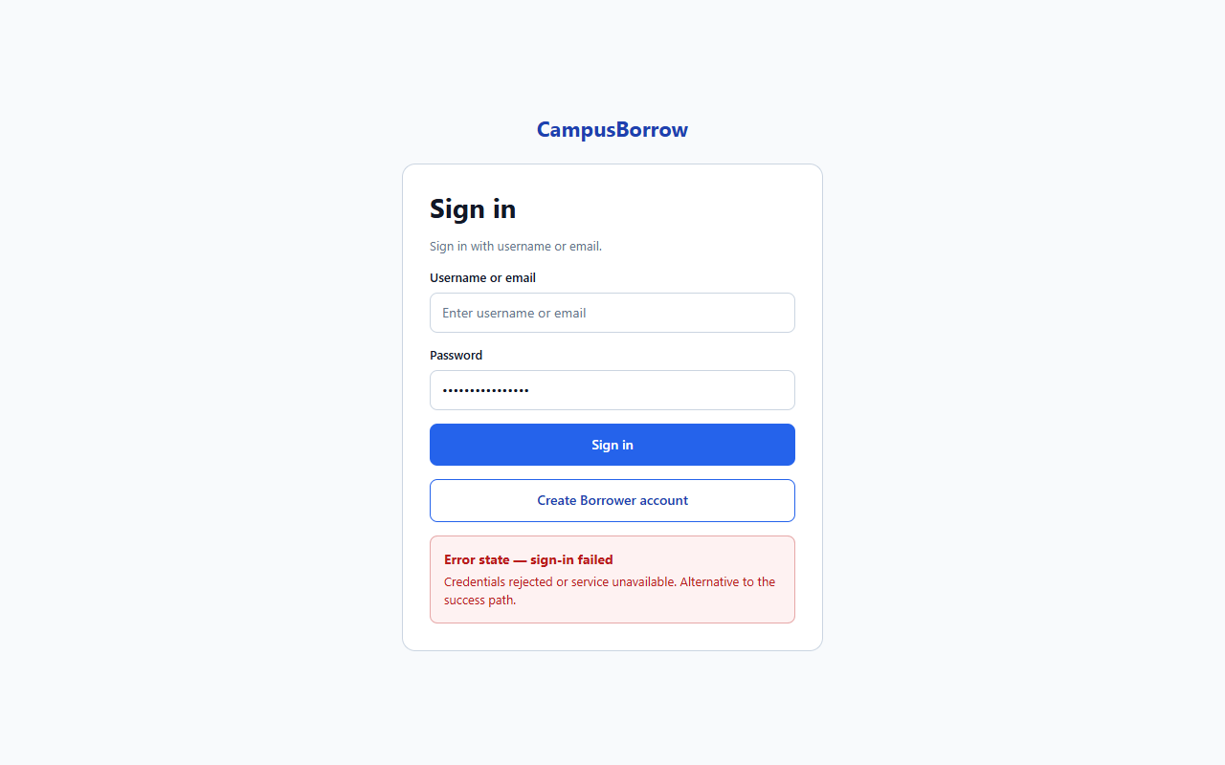
S11 Borrower registration (UC-06)
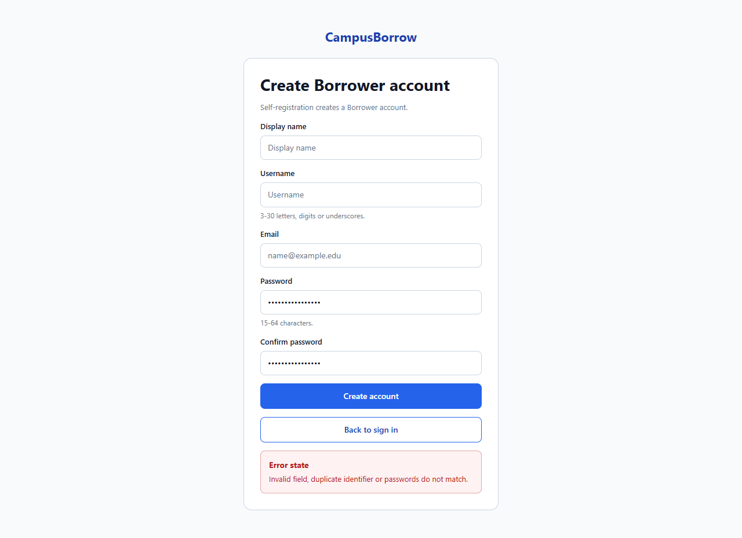
S02 Accounts (UC-03, UC-04, UC-05)
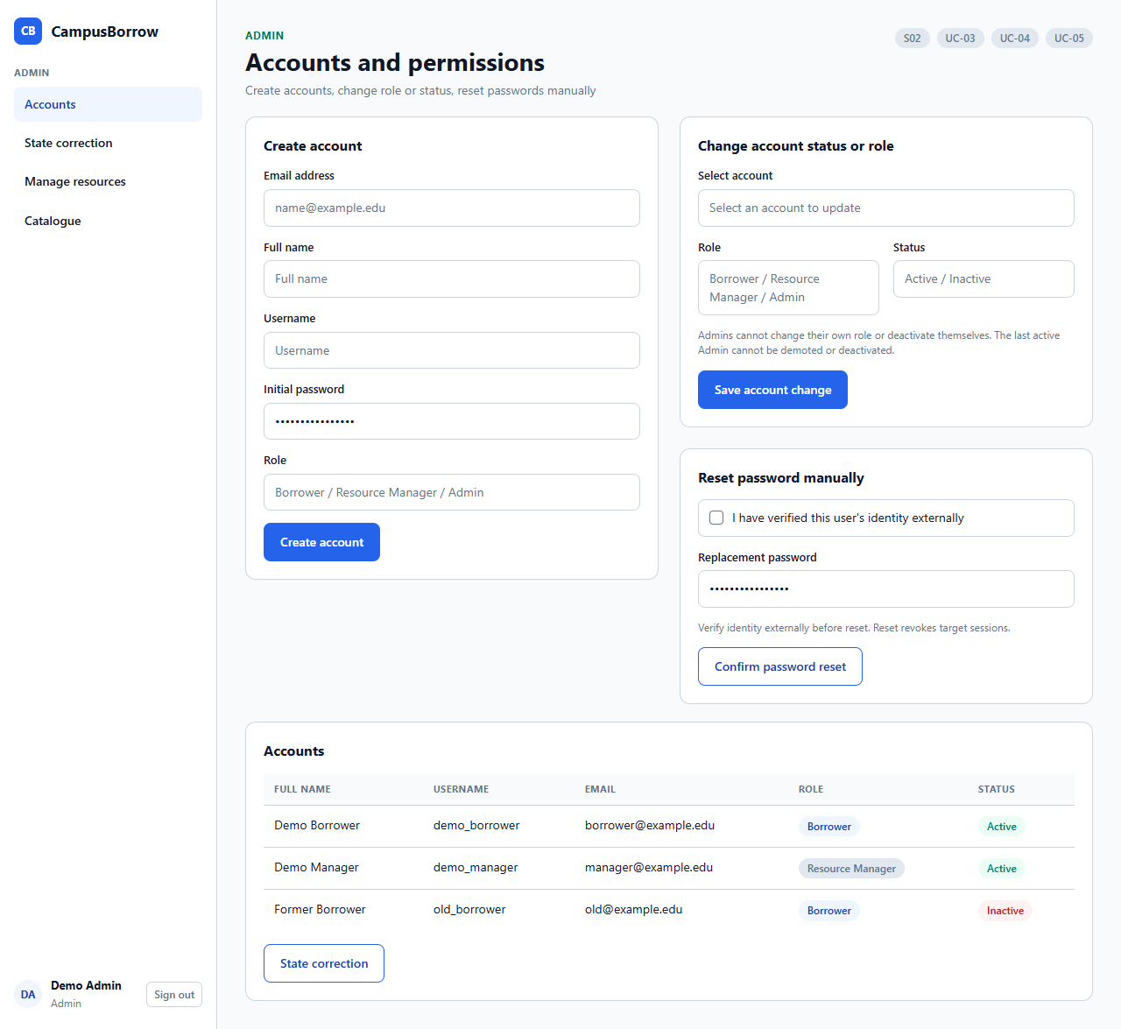
S03 Catalogue (UC-07)
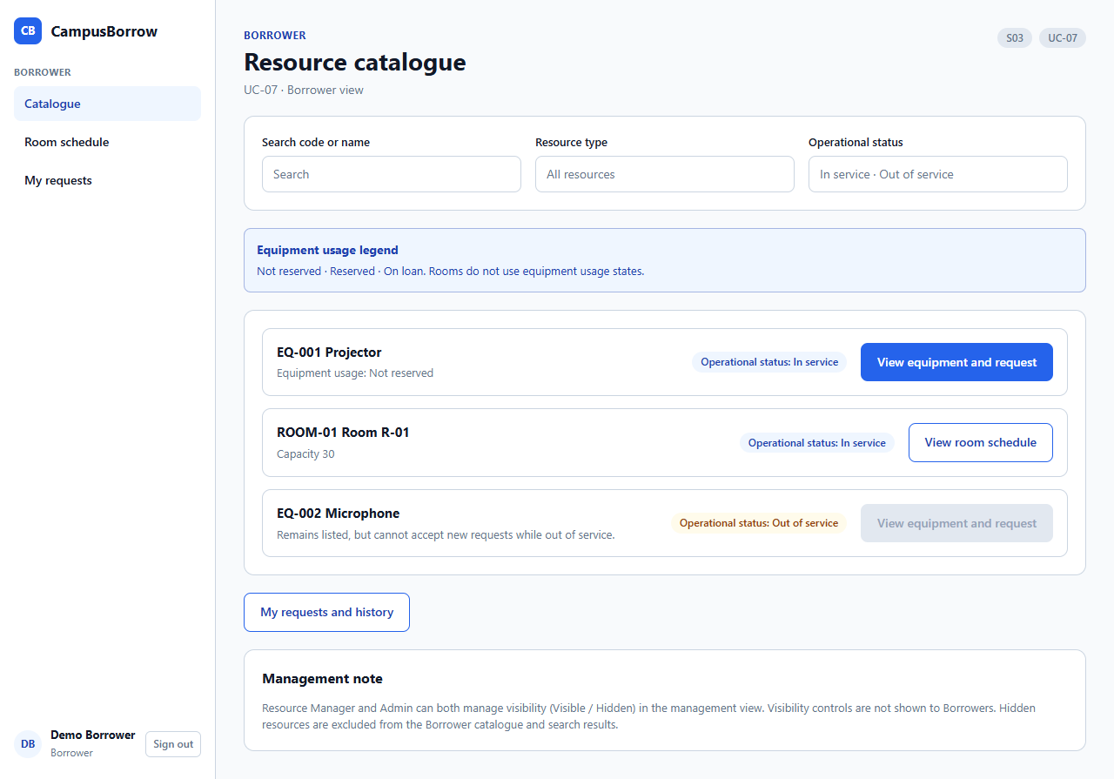
S14 Manage resources (UC-08–UC-09)
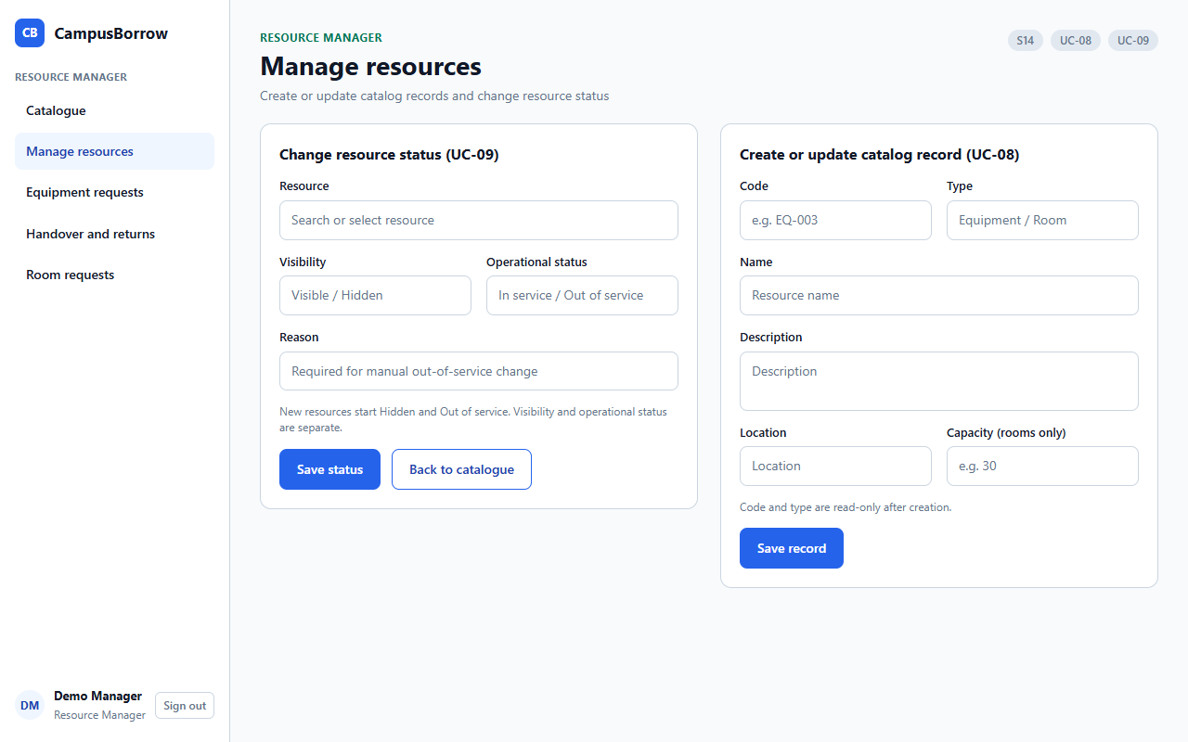
S04 Equipment request (UC-10)
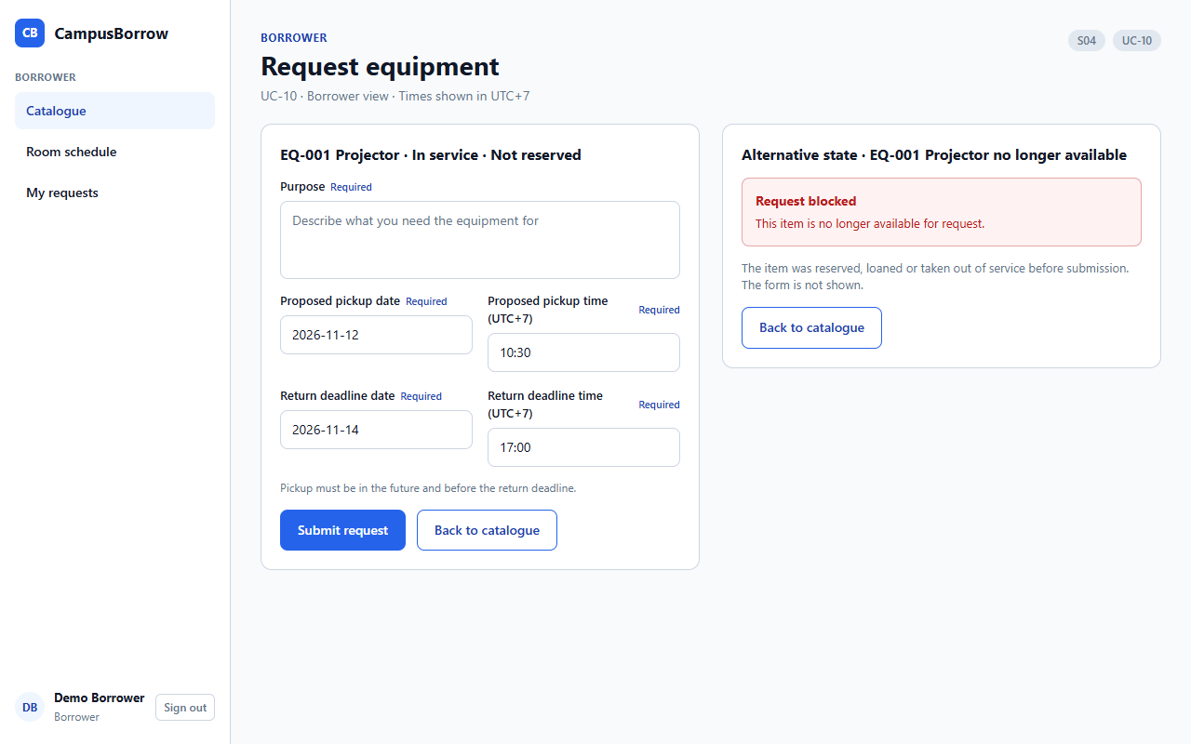
S05 Equipment processing (UC-11–UC-12)
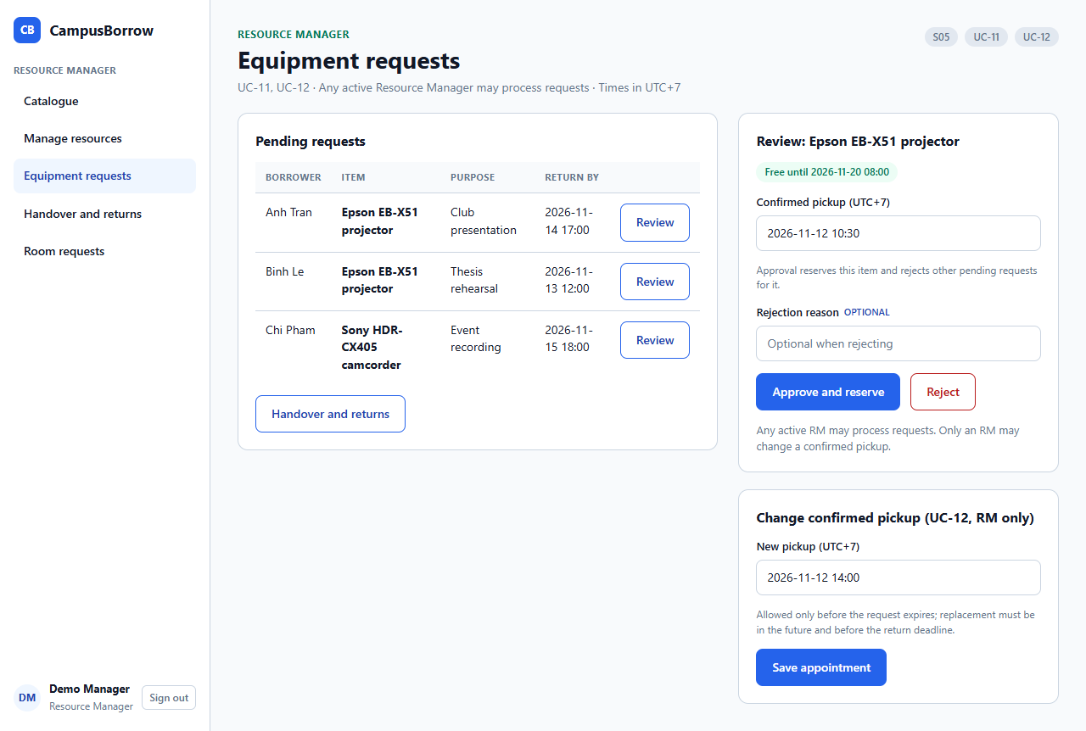
S06 Handover and return (UC-13–UC-14, UC-16)
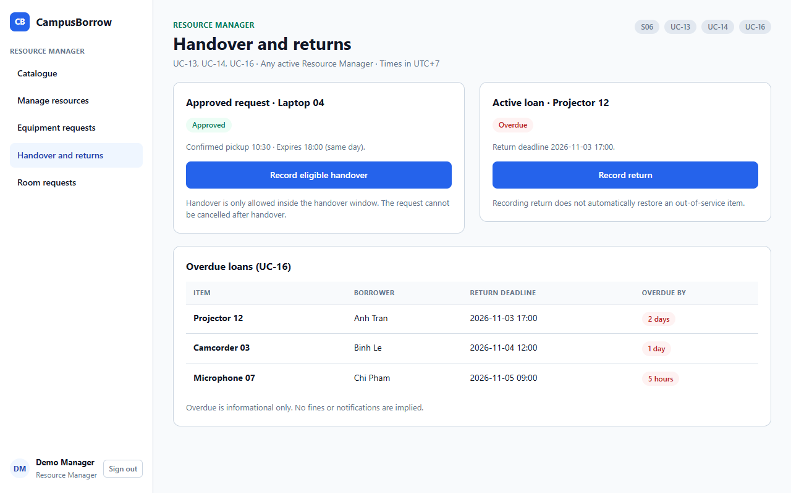
S07 Room schedule (UC-17)
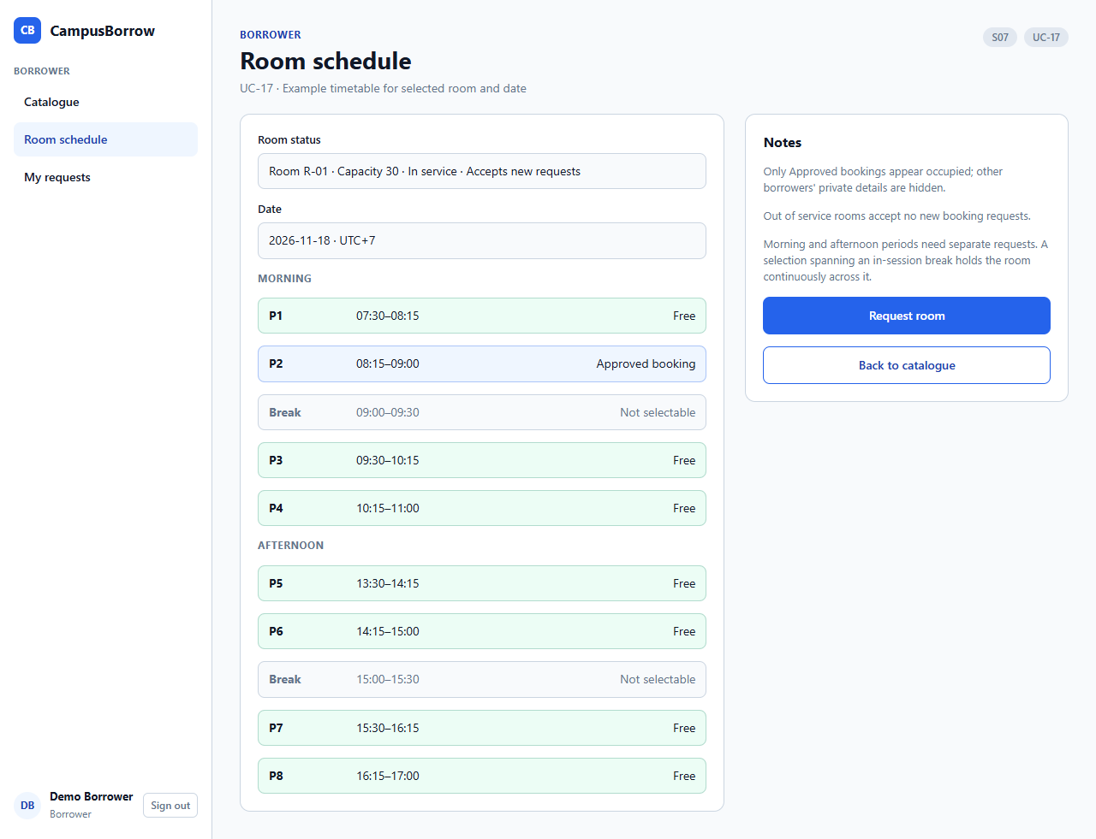
S07b Room out of service (UC-17–UC-18)
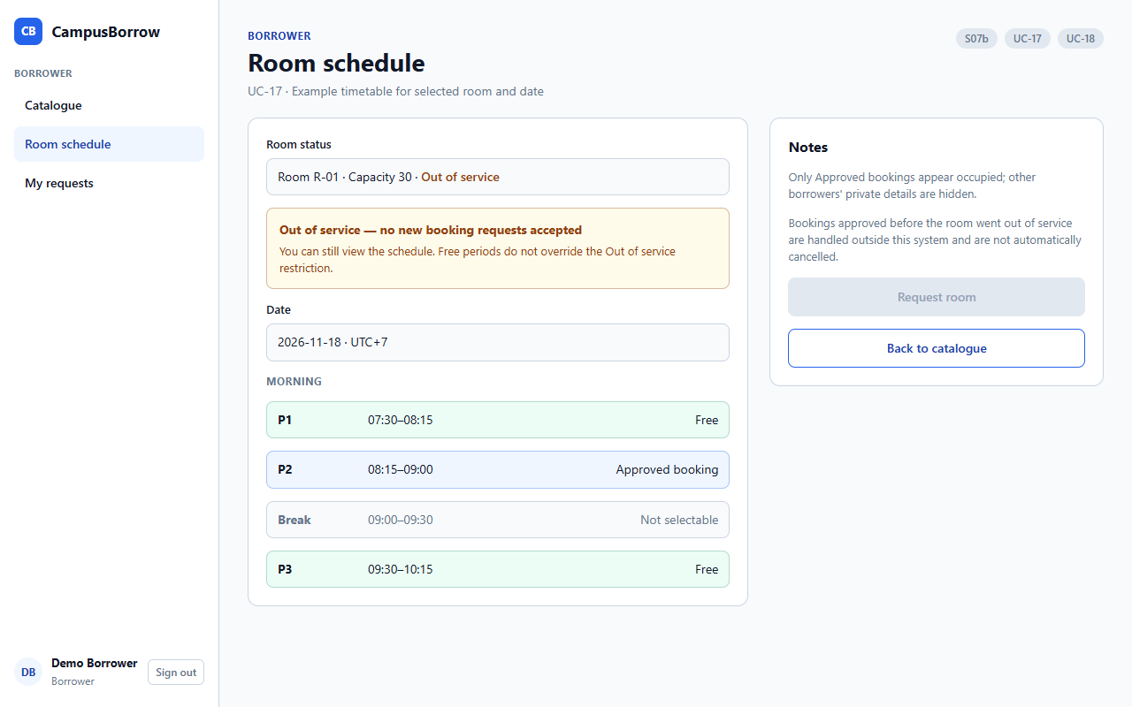
S08 Room booking (UC-18)
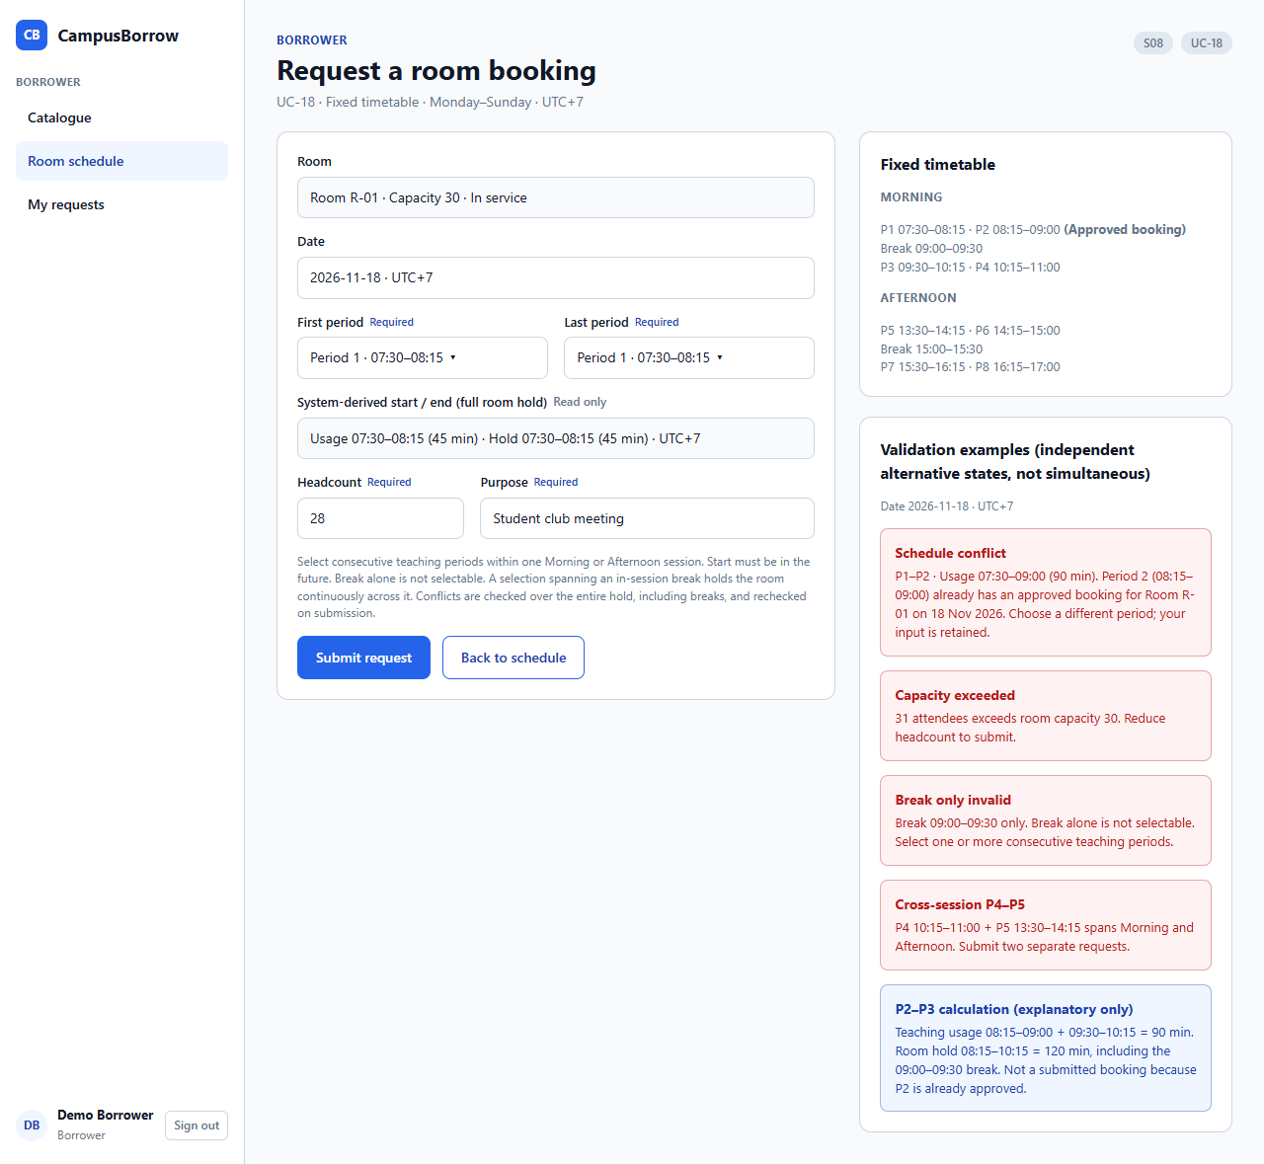
S09 Room requests (UC-19)
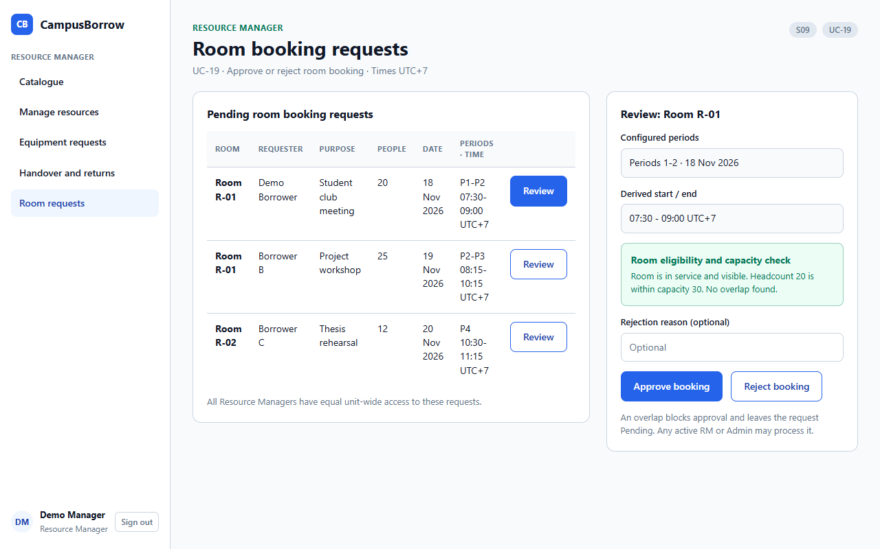
S10 My requests (UC-15, UC-20–UC-21)
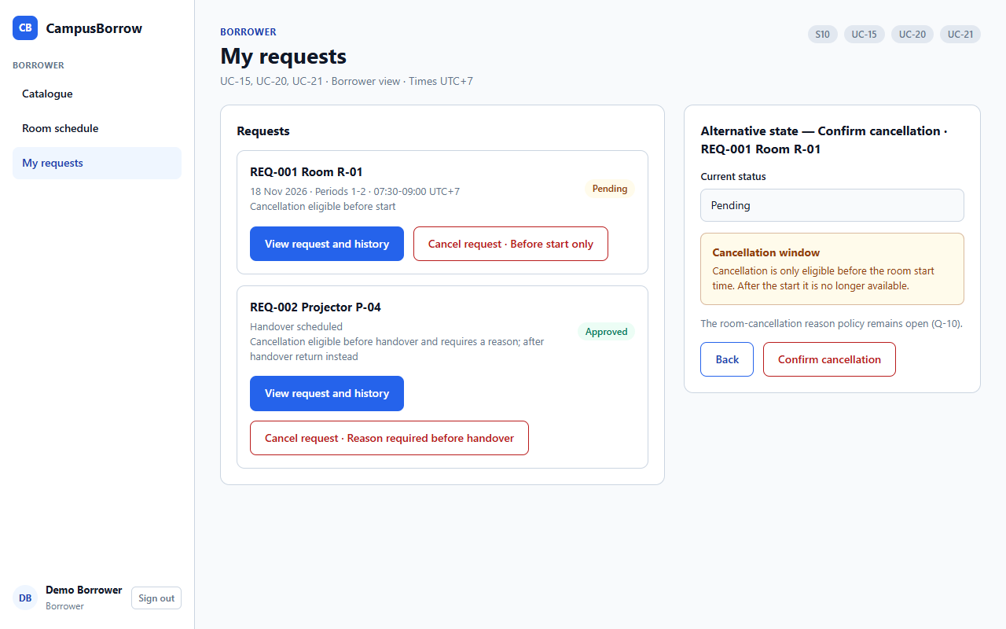
S12 Request history (UC-21)
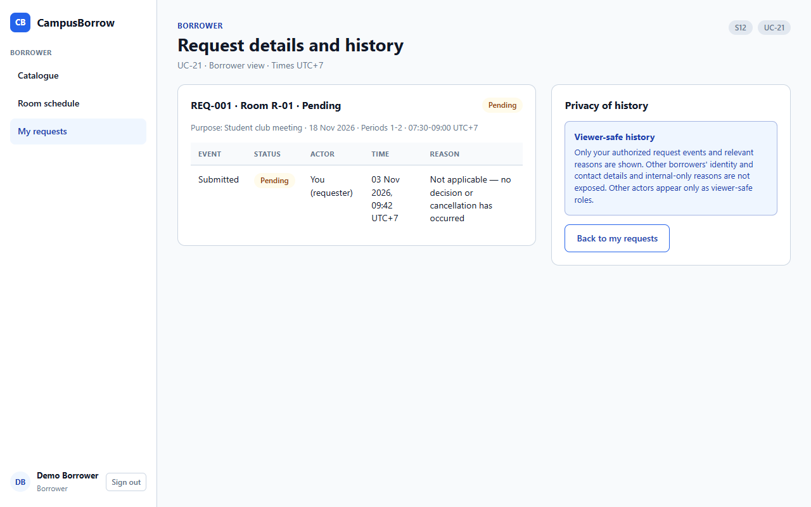
S13 State correction (UC-22)
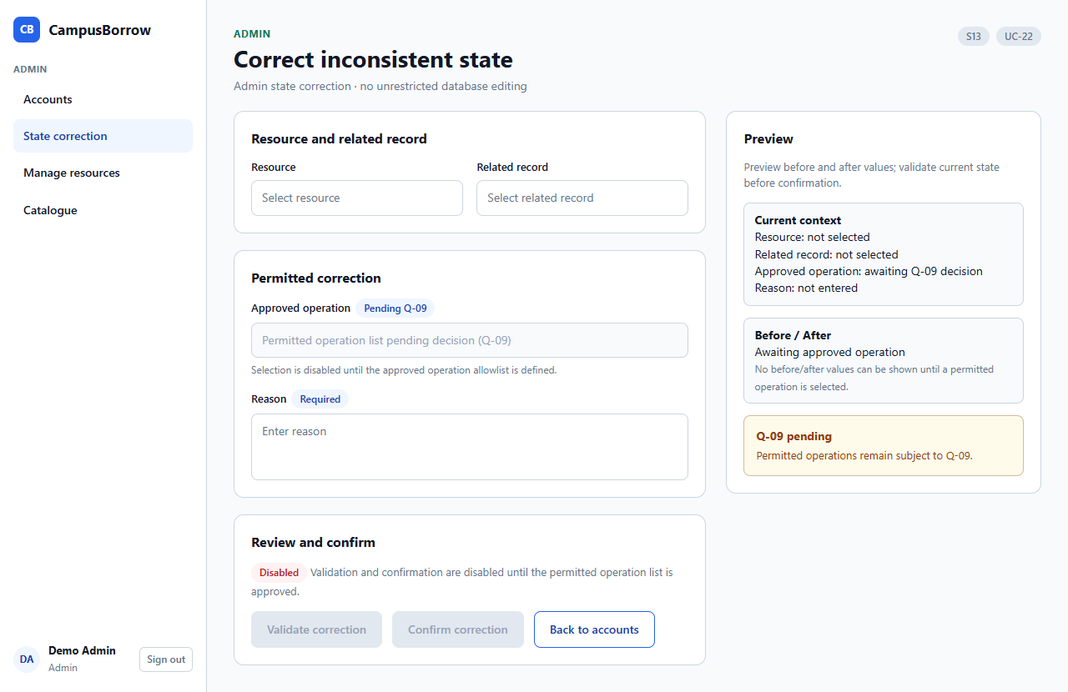
S07 Room schedule mobile (UC-17)
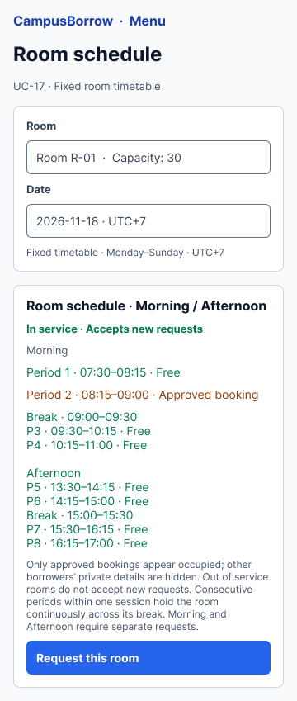
S08 Room booking mobile (UC-18)
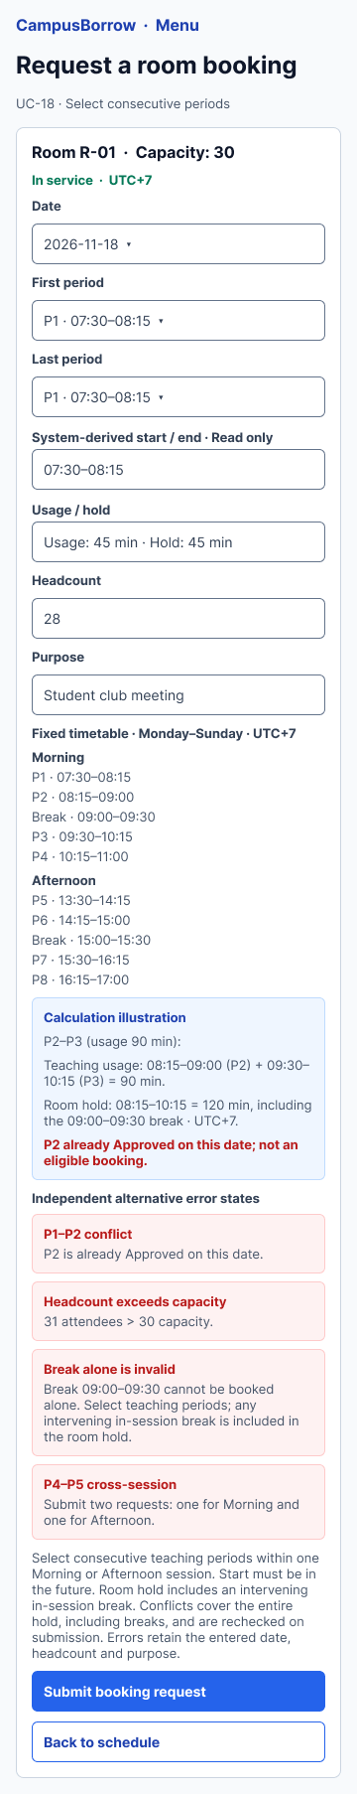

Requirements Traceability Matrix
All 89 current functional requirements have matching acceptance criteria and current use-case references or an explicit noninteractive exception. Screen identifiers follow Minh's S screen register and are linked by purpose; they are not assumed to be aliases of the consolidated edition's M identifiers. PA3 design and PA4 test-case identifiers remain pending. This matrix records specification coverage, not completed implementation or test execution.
Requirement | Use case | Screen | Acceptance criterion | Design | Test case
FR-01-01 | UC-01 | S01 | AC-01-01 | Pending PA3 | Pending PA4
FR-01-02 | UC-02 | S01 | AC-01-02 | Pending PA3 | Pending PA4
FR-01-03 | UC-01, UC-03, UC-04, UC-05, UC-07, UC-11, UC-12, UC-19, UC-21 | S01; S02; S03; S05; S09; S12; S10 | AC-01-03 | Pending PA3 | Pending PA4
FR-01-04 | UC-06 | S11 | AC-01-04 | Pending PA3 | Pending PA4
FR-01-05 | UC-01, UC-03, UC-06 | S01; S02; S11 | AC-01-05 | Pending PA3 | Pending PA4
FR-01-06 | UC-03, UC-05, UC-06 | S02; S11 | AC-01-06 | Pending PA3 | Pending PA4
FR-01-07 | UC-01, UC-02, UC-04, UC-05 | S01; S02 | AC-01-07 | Pending PA3 | Pending PA4
FR-02-01 | UC-08 | S14 | AC-02-01 | Pending PA3 | Pending PA4
FR-02-02 | UC-08 | S14 | AC-02-02 | Pending PA3 | Pending PA4
FR-02-03 | UC-07 | S03 | AC-02-03 | Pending PA3 | Pending PA4
FR-02-04 | UC-07, UC-17 | S03; S07; S07b | AC-02-04 | Pending PA3 | Pending PA4
FR-02-05 | UC-09 | S14 | AC-02-05 | Pending PA3 | Pending PA4
FR-02-06 | UC-07, UC-10, UC-18 | S03; S04; S08 | AC-02-06 | Pending PA3 | Pending PA4
FR-02-07 | UC-09, UC-10, UC-18 | S14; S04; S08 | AC-02-07 | Pending PA3 | Pending PA4
FR-02-08 | UC-09, UC-10, UC-11, UC-18, UC-19 | S14; S04; S05; S08; S09 | AC-02-08 | Pending PA3 | Pending PA4
FR-02-09 | UC-07, UC-09, UC-21 | S03; S14; S12; S10 | AC-02-09 | Pending PA3 | Pending PA4
FR-02-10 | UC-09, UC-14, UC-22 | S14; S06; S13 | AC-02-10 | Pending PA3 | Pending PA4
FR-02-11 | UC-08 | S14 | AC-02-11 | Pending PA3 | Pending PA4
FR-02-12 | UC-08, UC-09 | S14 | AC-02-12 | Pending PA3 | Pending PA4
FR-02-13 | UC-08 | S14 | AC-02-13 | Pending PA3 | Pending PA4
FR-02-14 | UC-08, UC-09 | S14 | AC-02-14 | Pending PA3 | Pending PA4
FR-02-15 | UC-07, UC-08, UC-09, UC-21 | S03; S14; S12; S10 | AC-02-15 | Pending PA3 | Pending PA4
FR-02-16 | UC-08, UC-09 | S14 | AC-02-16 | Pending PA3 | Pending PA4
FR-03-01 | UC-10 | S04 | AC-03-01 | Pending PA3 | Pending PA4
FR-03-02 | UC-10 | S04 | AC-03-02 | Pending PA3 | Pending PA4
FR-03-03 | UC-10 | S04 | AC-03-03 | Pending PA3 | Pending PA4
FR-03-04 | UC-11 | S05 | AC-03-04 | Pending PA3 | Pending PA4
FR-03-05 | UC-11 | S05 | AC-03-05 | Pending PA3 | Pending PA4
FR-03-06 | UC-11 | S05 | AC-03-06 | Pending PA3 | Pending PA4
FR-03-07 | UC-11 | S05 | AC-03-07 | Pending PA3 | Pending PA4
FR-03-08 | UC-12 | S05 | AC-03-08 | Pending PA3 | Pending PA4
FR-03-09 | UC-10, UC-11, UC-12, UC-21 | S04; S05; S12; S10 | AC-03-09 | Pending PA3 | Pending PA4
FR-03-10 | UC-15 | S10 | AC-03-10 | Pending PA3 | Pending PA4
FR-03-11 | UC-15 | S10 | AC-03-11 | Pending PA3 | Pending PA4
FR-03-12 | UC-15 | S10 | AC-03-12 | Pending PA3 | Pending PA4
FR-03-13 | Automatic system expiry; no actor-initiated UC | S10; S05 (expiry outcome only) | AC-03-13 | Pending PA3 | Pending PA4
FR-03-14 | UC-12, UC-13 | S05; S06 | AC-03-14 | Pending PA3 | Pending PA4
FR-03-15 | UC-12, UC-13 | S05; S06 | AC-03-15 | Pending PA3 | Pending PA4
FR-04-01 | UC-13 | S06 | AC-04-01 | Pending PA3 | Pending PA4
FR-04-02 | UC-13 | S06 | AC-04-02 | Pending PA3 | Pending PA4
FR-04-03 | UC-14 | S06 | AC-04-03 | Pending PA3 | Pending PA4
FR-04-04 | UC-14 | S06 | AC-04-04 | Pending PA3 | Pending PA4
FR-04-05 | UC-16 | S06 | AC-04-05 | Pending PA3 | Pending PA4
FR-04-06 | UC-16, UC-21 | S06; S12; S10 | AC-04-06 | Pending PA3 | Pending PA4
FR-05-01 | UC-17 | S07; S07b | AC-05-01 | Pending PA3 | Pending PA4
FR-05-02 | UC-17 | S07; S07b | AC-05-02 | Pending PA3 | Pending PA4
FR-05-03 | UC-17 | S07; S07b | AC-05-03 | Pending PA3 | Pending PA4
FR-05-04 | UC-17 | S07; S07b | AC-05-04 | Pending PA3 | Pending PA4
FR-05-05 | UC-17 | S07; S07b | AC-05-05 | Pending PA3 | Pending PA4
FR-05-06 | UC-17 | S07; S07b | AC-05-06 | Pending PA3 | Pending PA4
FR-06-01 | UC-18 | S08 | AC-06-01 | Pending PA3 | Pending PA4
FR-06-02 | UC-18 | S08 | AC-06-02 | Pending PA3 | Pending PA4
FR-06-03 | UC-18 | S08 | AC-06-03 | Pending PA3 | Pending PA4
FR-06-04 | UC-18 | S08 | AC-06-04 | Pending PA3 | Pending PA4
FR-06-05 | UC-18 | S08 | AC-06-05 | Pending PA3 | Pending PA4
FR-06-06 | UC-18 | S08 | AC-06-06 | Pending PA3 | Pending PA4
FR-06-07 | UC-18 | S08 | AC-06-07 | Pending PA3 | Pending PA4
FR-06-08 | UC-18 | S08 | AC-06-08 | Pending PA3 | Pending PA4
FR-06-09 | UC-18 | S08 | AC-06-09 | Pending PA3 | Pending PA4
FR-07-01 | UC-19 | S09 | AC-07-01 | Pending PA3 | Pending PA4
FR-07-02 | UC-19 | S09 | AC-07-02 | Pending PA3 | Pending PA4
FR-07-03 | UC-19 | S09 | AC-07-03 | Pending PA3 | Pending PA4
FR-07-04 | UC-19 | S09 | AC-07-04 | Pending PA3 | Pending PA4
FR-07-05 | UC-20 | S10 | AC-07-05 | Pending PA3 | Pending PA4
FR-07-06 | UC-19 | S09 | AC-07-06 | Pending PA3 | Pending PA4
FR-07-07 | UC-18; UC-19 | S08; S09 | AC-07-07 | Pending PA3 | Pending PA4
FR-07-08 | UC-19 | S09 | AC-07-08 | Pending PA3 | Pending PA4
FR-07-09 | UC-19, UC-20 | S09; S10 | AC-07-09 | Pending PA3 | Pending PA4
FR-08-01 | UC-21 | S12; S10 | AC-08-01 | Pending PA3 | Pending PA4
FR-08-02 | UC-21 | S12; S10 | AC-08-02 | Pending PA3 | Pending PA4
FR-08-03 | UC-21 | S12; S10 | AC-08-03 | Pending PA3 | Pending PA4
FR-08-04 | UC-21 | S12; S10 | AC-08-04 | Pending PA3 | Pending PA4
FR-08-05 | UC-21 | S12; S10 | AC-08-05 | Pending PA3 | Pending PA4
FR-08-06 | UC-21 | S12; S10 | AC-08-06 | Pending PA3 | Pending PA4
FR-08-07 | UC-21 | S12; S10 | AC-08-07 | Pending PA3 | Pending PA4
FR-08-08 | UC-21 | S12; S10 | AC-08-08 | Pending PA3 | Pending PA4
FR-08-09 | UC-21 | S12; S10 | AC-08-09 | Pending PA3 | Pending PA4
FR-09-01 | UC-03 | S02 | AC-09-01 | Pending PA3 | Pending PA4
FR-09-02 | UC-01, UC-04 | S01; S02 | AC-09-02 | Pending PA3 | Pending PA4
FR-09-03 | UC-04, UC-14 | S02; S06 | AC-09-03 | Pending PA3 | Pending PA4
FR-09-04 | UC-04 | S02 | AC-09-04 | Pending PA3 | Pending PA4
FR-09-05 | UC-05 | S02 | AC-09-05 | Pending PA3 | Pending PA4
FR-09-06 | UC-03, UC-04, UC-05, UC-06, UC-21 | S02; S11; S12; S10 | AC-09-06 | Pending PA3 | Pending PA4
FR-09-07 | UC-04 | S02 | AC-09-07 | Pending PA3 | Pending PA4
FR-09-08 | Setup prerequisite; UC-06 rejects public privileged registration | Setup process; no public screen | AC-09-08 | Pending PA3 | Pending PA4
FR-09-09 | UC-22 | S13 | AC-09-09 | Pending PA3 | Pending PA4
FR-09-10 | UC-22 | S13 | AC-09-10 | Pending PA3 | Pending PA4
FR-09-11 | UC-22 | S13 | AC-09-11 | Pending PA3 | Pending PA4
FR-09-12 | UC-22 | S13 | AC-09-12 | Pending PA3 | Pending PA4

Domain Requirements Traceability
Domain ID | FR and BR links | Acceptance basis
DR-01 | FR-02-01/04/11/16; BR-12/18 | AC-02-01/04/11/16
DR-02 | FR-03-05; FR-04-01/02; BR-04/05 | AC-03-05; AC-04-01/02
DR-03 | FR-04-03/04/05; BR-04 | AC-04-03/04/05
DR-04 | FR-06-01/04/05; BR-03 | AC-06-01/04/05
DR-05 | FR-02-04/05/07/10; BR-13/18 | AC-02-04/05/07/10
DR-06 | FR-03-13/14/15; FR-04-05; BR-04 | AC-03-13/14/15; AC-04-05
DR-07 | FR-04-01/03; FR-09-05; BR-09 | AC-04-01/03; AC-09-05
DR-08 | FR-08-01/03/04/08; FR-09-06 | AC-08-01/03/04/08; AC-09-06
DR-09 | FR-06-03; BR-03/04/10 | AC-06-03

Business Rules Traceability
Rule | Related requirements | Acceptance basis
BR-01 | FR-01-03; FR-02-02; FR-02-05; FR-03-04; FR-03-05; FR-03-06; FR-03-08; FR-04-01; FR-04-02; FR-04-03; FR-06-07; FR-07-01; FR-07-02; FR-07-03; FR-07-04; FR-07-06; FR-08-01; FR-08-06; FR-08-07; FR-09-06; FR-09-09; FR-09-10; FR-09-11; FR-09-12 | Matching AC IDs for the linked FRs
BR-02 | FR-01-01; FR-01-04; FR-06-08; FR-09-01; FR-09-05 | Matching AC IDs for the linked FRs
BR-03 | FR-05-01; FR-05-02; FR-05-03; FR-05-05; FR-06-01; FR-06-02; FR-06-03; FR-06-04; FR-06-05; FR-06-07; FR-06-09; FR-07-01; FR-07-03; FR-07-04; FR-07-05; FR-07-06 | Matching AC IDs for the linked FRs
BR-04 | FR-02-10; FR-03-01; FR-03-05; FR-03-08; FR-03-09; FR-03-12; FR-03-13; FR-03-14; FR-03-15; FR-04-01; FR-04-02; FR-04-03; FR-04-04; FR-04-05; FR-04-06; FR-08-03 | Matching AC IDs for the linked FRs
BR-05 | FR-01-03; FR-02-06; FR-02-08; FR-02-09; FR-02-10; FR-03-01; FR-03-02; FR-03-03; FR-03-05; FR-03-06; FR-03-07; FR-03-10; FR-03-11; FR-03-12; FR-04-01; FR-04-03; FR-05-02; FR-05-03; FR-06-05; FR-06-06; FR-07-01; FR-07-02; FR-07-05; FR-07-06; FR-07-07; FR-07-08; FR-07-09; FR-08-03; FR-09-02; FR-09-03 | Matching AC IDs for the linked FRs
BR-06 | FR-01-01; FR-01-04; FR-01-05; FR-09-01; FR-09-08 | Matching AC IDs for the linked FRs
BR-07 | FR-01-01; FR-01-04; FR-01-06; FR-09-01; FR-09-05; FR-09-08 | Matching AC IDs for the linked FRs
BR-08 | FR-09-03; FR-09-04 | Matching AC IDs for the linked FRs
BR-09 | FR-09-05 | Matching AC IDs for the linked FRs
BR-10 | FR-01-01; FR-01-02; FR-01-03; FR-01-07; FR-09-02; FR-09-04; FR-09-05 | Matching AC IDs for the linked FRs
BR-11 | FR-01-01; FR-01-03; FR-01-04; FR-06-08; FR-09-01; FR-09-02; FR-09-04; FR-09-07; FR-09-08 | Matching AC IDs for the linked FRs
BR-12 | FR-02-01; FR-02-02; FR-02-11; FR-02-13; FR-06-04 | Matching AC IDs for the linked FRs
BR-13 | FR-02-04; FR-02-05; FR-02-06; FR-02-07; FR-02-08; FR-02-12; FR-03-02; FR-04-04; FR-05-04; FR-06-06; FR-07-01; FR-07-07; FR-07-08; FR-08-04 | Matching AC IDs for the linked FRs
BR-14 | FR-02-03 | Matching AC IDs for the linked FRs
BR-15 | FR-02-02; FR-02-13 | Matching AC IDs for the linked FRs
BR-16 | FR-02-05; FR-02-07; FR-02-15; FR-05-06; FR-07-07; FR-08-04; FR-08-05 | Matching AC IDs for the linked FRs
BR-17 | FR-02-02; FR-02-08; FR-02-14; FR-07-04 | Matching AC IDs for the linked FRs
BR-18 | FR-02-04; FR-02-06; FR-02-09; FR-02-16; FR-05-01; FR-05-04; FR-08-08 | Matching AC IDs for the linked FRs
BR-19 | FR-02-09; FR-02-15; FR-02-16; FR-03-09; FR-04-02; FR-04-04; FR-04-06; FR-05-06; FR-07-09; FR-08-01; FR-08-02; FR-08-03; FR-08-04; FR-08-05; FR-08-06; FR-08-07; FR-08-08; FR-08-09; FR-09-06 | Matching AC IDs for the linked FRs
BR-20 | FR-02-10; FR-09-09; FR-09-10; FR-09-11; FR-09-12 | Matching AC IDs for the linked FRs

Non-Functional Requirements Traceability
Measurement conditions, workload and hosting assumptions still need the outcomes recorded under I-04. NFR-04 must preserve the full password and session-revocation policies; implementation compatibility is I-05. Verification methods are planned activities rather than completed checks.
ID | Relevant flows | Verification basis
NFR-01 | UC-07, UC-17, UC-21 (S03, S07, S10, S12) | Method stated in §5.2 (NFR-01); planned for PA4 test design and executed in PA5.
NFR-02 | UC-10, UC-11, UC-15, UC-18, UC-19, UC-20 (S04, S05, S08, S09, S10) | Method stated in §5.2 (NFR-02); planned for PA4 test design and executed in PA5.
NFR-03 | All protected use cases UC-01–UC-05, UC-07–UC-22 (all S screens) | Method stated in §5.2 (NFR-03); planned for PA4 test design and executed in PA5.
NFR-04 | UC-01–UC-06 (S01, S02, S11) | Method stated in §5.2 (NFR-04); planned for PA4 test design and executed in PA5.
NFR-05 | UC-01, UC-04 (S01, S02) | Method stated in §5.2 (NFR-05); planned for PA4 test design and executed in PA5.
NFR-06 | All use cases and API endpoints | Method stated in §5.2 (NFR-06); planned for PA4 test design and executed in PA5.
NFR-07 | All use cases (deployed system) | Method stated in §5.2 (NFR-07); planned for PA4 test design and executed in PA5.
NFR-08 | All stored records (database) | Method stated in §5.2 (NFR-08); planned for PA4 test design and executed in PA5.
NFR-09 | UC-11, UC-19 (S05, S09) | Method stated in §5.2 (NFR-09); planned for PA4 test design and executed in PA5.
NFR-10 | UC-01, UC-07, UC-17, UC-18, UC-21 (S01, S03, S07, S08, S10) | Method stated in §5.2 (NFR-10); planned for PA4 test design and executed in PA5.
NFR-11 | UC-01, UC-07, UC-17, UC-18, UC-21 (S01, S03, S07, S08, S10) | Method stated in §5.2 (NFR-11); planned for PA4 test design and executed in PA5.
NFR-12 | UC-10, UC-18 (S04, S08) | Method stated in §5.2 (NFR-12); planned for PA4 test design and executed in PA5.

Requirements Review
Review date: 2 November 2026
Participants: Nguyễn Hoàng Mỹ Trang (Team Lead / PM, review organizer), Đoàn Hồng Phúc (Business Analyst), Nguyễn Tiến Minh (Developer / Technical), Phan Nhật Ánh (QA / Tester). All four members were present.

# | Issue found | Requirement(s) | Resolution
1 | Some FR identifiers were incorrectly indexed (skipped, duplicated or out-of-sequence numbers). | FR-01, FR-02, FR-03, FR-04, FR-09 (affected groups) | Re-indexed the affected FRs using the FR-<group>-<sequence> convention, and updated all references in the use cases and the Traceability matrix accordingly.
2 | Use case specifications UC-06 (Register a Borrower account) and UC-16 (View overdue loans) were missing from the raw draft. | UC-06; UC-16; FR-01-04, FR-01-05, FR-01-06, FR-09-08; FR-04-05, FR-04-06 | Added the complete specifications for UC-06 and UC-16, and linked them to the related FRs, business rules and screens (S11, S06).
3 | Conflicts between the use case specifications and the prototype/mockups (flows, data fields and screen behavior were inconsistent). | Related use cases and corresponding screens | Cross-checked each use case against its mockup and resolved the conflicts by aligning the use cases and mockups with the team’s agreed decisions. Intentional exceptions are documented in the Traceability matrix.
4 | Traceability, Business Rules (BR), and Domain Requirements (DR) were incomplete. FR source metadata, priority columns, and key lifecycle/correction requirements were missing from §5.1 tables. | All FRs (FR-01 to FR-09, total 89 FRs); business rules (BR-01–BR-20); domain requirements (§5.3); Traceability matrix (§9) | Completed the Traceability matrix, BR, and DR linkages. Standardized the 4-part Source attribute (PA1 Fxx; G#; DR/BR; SH-#) and Priority across all FR tables in §5.1 with an explicit convention note. Restored missing functional requirements: FR-03-10 to FR-03-15 (equipment cancellation, staff cancellation, and capped auto-expiry under UC-15) and FR-09-09 to FR-09-12 (controlled administrative state corrections under UC-22 and BR-20), bringing §5.1 to exactly 89 FRs in full alignment with the Traceability Matrix and Acceptance Criteria.
5 | Conflicts between initial draft requirements (FR-07-01, FR-07-02, FR-07-06, FR-08-06, NFR-03) and confirmed operational business rules (BR-01, BR-05). | FR-07-01, FR-07-02, FR-07-06, FR-08-06; NFR-03; BR-01, BR-05; §6.2 Actors | Eliminated obsolete 'assigned scope' and staff assignment restrictions in FR-07-01, FR-07-02, FR-07-06, FR-08-06, and NFR-03 to align with BR-01 and §6.2 (all active Resource Managers share equal operational authority across the single simulated unit). Updated FR-07-02 to mandate a nonblank written reason for booking rejection rather than leaving it optional, strictly complying with BR-05.
6 | The use case model had no «include»/«extend» relationships, and the use case list, focused views and UC-19–UC-22 still carried draft notes ("pending", Q-10, M screen codes and undefined BR-22–BR-24). | UC-07, UC-10, UC-14, UC-16–UC-22; §6 | Added three «extend» relationships and one «include» relationship (§6.1.3) and redrew the diagrams. Aligned UC-19–UC-22 with the F07, F08 and F09 requirements and the S screen codes, and removed the draft notes.
7 | The glossary, the in-scope summary, §3.4, FR-05-05 and FR-08-04 still described per-resource RM assignment, "under maintenance" as a status and an unspecified room timetable. | Glossary; §1.1; §3.4; FR-05-05; FR-08-04 | Aligned the wording with BR-01 (equal RM access), BR-13 (Under maintenance is an Out of service reason) and BR-03 (fixed timetable). Added glossary entries for Expiry, In service / Out of service, Period and Visible / Hidden.
8 | Business rules had no source, and NFR verification methods appeared only in §9. | BR-01–BR-20; NFR-01–NFR-12 | Added a Source column to §5.3.2 and a verification column to §5.2. §9 now maps each NFR to concrete use cases and screens.
9 | The Borrower room-cancellation reason policy was left open. | FR-07-05; AC-07-05; BR-05; UC-20 | Decided that room cancellation requires confirmation and accepts an optional reason, which is recorded when supplied.

AI Usage Log

No. | Member | Tool | Task / Purpose | How the Output Was Verified and Changed
1 | Nguyen Hoang My Trang | Antigravity (Claude Sonnet 4.6 Thinking) | Refine detailed Use Case specification for UC-09, “View History & State Correction” (Section 7, Table 8). | Enforced the business rule requiring Admin to provide a mandatory justification (reason_for_change of at least 10 characters) with automated audit logging; rejected direct history overwrite. Cross-checked resource and request status transitions with UC-04/05/06 and UC-07/08.
2 | Nguyen Hoang My Trang | Antigravity (Claude Sonnet 4.6 Thinking and Gemini 3.8 Flash) | Prepare a checklist and log framework for the internal team Requirements Review meeting (Section 10, Table 11); cross-check member contributions. | Built review log Table 11 to track discrepancies across member drafts (Trang, Phuc, Minh, Nhat Anh). Verified that all flagged issues were resolved before baseline finalization.
3 | Nguyen Hoang My Trang | Antigravity (Claude Sonnet 4.6 Thinking) | Audit the final SRS master dossier (Sections 1–11) for consistency; prepare the Contribution Assessment (Table 0) and AI Usage Log (Table 12). | Verified all nine Must-have features (F01–F09) against the PA1 Vision, eliminating out-of-scope items F10, F11, and notifications.
4 | Nguyen Hoang My Trang | Antigravity (Claude Sonnet 4.6 Thinking and Gemini 3.8 Flash) | Draft the Week 05 Status Report (W05-status.md) for PA2 completion and establish the Week 06 Pre-PA3 preparation plan. | Recorded 100% completion across all 12 Week 05 tasks and documented the 02/11 meeting minutes with full team attendance (4/4). Simplified the Week 06 plan to about two high-level preparatory tasks per member (C4 Container sketch, initial ERD, overview diagrams, architecture ADR, and test strategy) to avoid wasted effort before official PA3 specifications were released.
5 | Nguyen Hoang My Trang | Antigravity (Gemini 3.8 Flash) | Compile, format, and export the personal PA2 AI Usage Log (ai-log-pa2.md) in accordance with the course GenAI Policy. | Reviewed all session transcripts (31/10–02/11), logging tools, prompts, and verification steps. Ensured compliance with the table format, WBS codes, and academic integrity disclosures. Confirmed that AI-generated content was critically reviewed, edited, or rewritten.
6 | Nguyen Tien Minh | Claude Code (Claude Sonnet 5.5) | Draft SRS Section 5.1 (F05 room schedule view and F06 room booking requests; WBS 2.2.6) and Section 5.2 non-functional requirements (WBS 2.2.9). | Rewrote the first draft into the PA2 template tables (Tables 3 and 4). Checked each row against the team-agreed PA1 final (Section 2.4 scope, Section 3.3 environment, Section 5 risks), WBS 2.2.6 and 2.2.9, and ADR-001 (half-open ranges, timestamptz, UTC+7). Used 360 px from PA1 instead of 375 px from the task list. Added no booking hours or duration limits because PA1 sets none. Marked figures from the task list and other unspecified values as assumptions for team confirmation.
7 | Nguyen Tien Minh | Claude Code (Claude Sonnet 5.5), Figma MCP server, and ui-ux-pro-max skill | Draft SRS Section 7 specifications for UC-07 and UC-08 (WBS 2.3.6); design the UI for UC-01 to UC-08, build it as HTML, push editable frames and prototype links into Figma, and run an accessibility audit (WBS 2.3.8). | Checked the flows against PA1 final F05–F08 and Section 5.1; marked cases PA1 does not decide as assumptions. Replaced a dark-glass design-system suggestion with the Calendar/Scheduling palette and Inter for the light admin app. Removed an AI-invented sign-in lockout rule. Axe-core found zero violations on 11 screens. Layout checks at 360, 768, and 1280 px identified and fixed a 360 px schedule-stats overflow and a 40 px skip link. Deleted an old-UI Figma capture and manually filled empty date, time, and password fields. Manual keyboard and screen-reader checks remain open.
8 | Nguyen Tien Minh | OpenAI Codex (tool confirmed by Minh; session history cleared) | Compare Minh’s room requirements, grouped use cases, and mockup notes with Phuc’s requirements, then assemble review packages and identify unresolved decisions. | Review notes record checks of use-case mapping, shared Resource Manager access, and room rules. The integrated package distinguishes confirmed requirements from open questions and does not claim an approved baseline. The original Phuc v2 archive was preserved. Minh confirmed Codex was used; the original session history is no longer available.
9 | Nguyen Tien Minh | OpenAI Codex with Figma MCP and Playwright | Review the existing mockups against Phuc’s use cases; create a separate Figma file, build or revise room mobile and representative desktop frames, and document prototype and accessibility limitations. | Compared requirements and exported screens; corrected use-case labels and a clipped S08 mobile field. Used Playwright to inspect frames and export PNGs. Some prototype navigation was created, but a complete end-to-end walkthrough and keyboard and screen-reader tests were not completed. Earlier axe results apply to the earlier HTML, not the revised Figma.
10 | Nguyen Tien Minh | Figma Agent, with prompts prepared by OpenAI Codex | Revise selected account, catalogue, equipment, room schedule, booking, history, and correction mockups, and adapt the room screens to the v4 timetable. | The user supplied Phuc’s v4 requirements and directed the changes. Codex compared the resulting frames visually, identified inconsistencies for correction, and checked exported room screens. Figma Agent did not complete prototype interactions.
11 | Nguyen Tien Minh | OpenAI Codex | Integrate Phuc’s requirements v4 into Minh’s SRS Section 5.1, grouped Section 7 room use cases, and Section 8 mockup links; add function names and checklists, and export current PNGs. | Compared v4 against the prior review package, kept F05/F06 and NFR approval status explicit, and identified conflicting UC-19/BR-05 wording. Checked 15 FR names/checklists and 17 PNGs and links, and fixed broken Markdown table spacing. Read requirements-v4.zip without modifying it. Full prototype and accessibility verification remains open.
12 | Phan Nhat Anh | ChatGPT (OpenAI) | Identify assigned PA2 tasks and draft the contribution using the team task list and available requirements. | Identified Nhat Anh’s task allocation and supplied the teammates’ work. Asked which tasks could be completed and whether they depended on other members. Focused on domain requirements, business rules, acceptance criteria, and traceability; use-case specifications remained with their assigned owners.
13 | Phan Nhat Anh | ChatGPT (OpenAI) | Draft and revise Section 5.3, separating domain requirements and business rules into tables. | Requested separate tables and preservation of Phuc’s and Minh’s shared rules. Questioned missing business-rule entries and requested comparison with the consolidated requirements. The revised contribution contains DR-01 to DR-09 and follows the consolidated BR-01 to BR-20 register; BR-19 concerns history and disclosure, and BR-20 concerns controlled corrections. Payments, deposits, and monetary penalties remain excluded.
14 | Phan Nhat Anh | ChatGPT (OpenAI) | Write and update Given / When / Then acceptance criteria for F01–F09. | Supplied updated team materials and requested criteria matching the new requirements. Added AC-09-09 to AC-09-12 and corrected AC-07-07 to test blocked room-booking submissions rather than staff approval. Automated document checks confirmed 89 uniquely numbered criteria with explicit Given, When, and Then clauses. These checks validate specification structure, not application behavior.
15 | Phan Nhat Anh | ChatGPT (OpenAI) | Build and update the Requirements Traceability Matrix. | Requested checks for missing requirements and mappings. The updated RTM links all 89 supplied FRs to matching acceptance criteria, current use-case references, and relevant screens, with documented exceptions for setup and automatic expiry. Automated checks confirmed one main RTM row per FR and four correction mappings to UC-22 and S13. PA3 design and PA4 test-case identifiers remain pending.
16 | Phan Nhat Anh | ChatGPT (OpenAI) | Compare the contribution with the SRS template and consolidated FR, AC, and UC content. | Requested a consistency review and then an update to the DOCX. The review identified outdated correction mappings, differing BR numbering, an AC-07-07 mismatch, and incomplete UC-21 sorting/filtering coverage. Synchronized the ACs and RTM with consolidated requirements. The UC-21 change remains an owner handoff; unresolved cancellation, disclosure, correction, and NFR decisions are recorded without claiming team approval.
17 | Phan Nhat Anh | ChatGPT (OpenAI) | Format and revise the Word contribution. | Requested removal of update labels and yellow highlighting, clarifying that only Section 5.3.3 should be deleted while acceptance-criteria use-case references and the RTM were retained. Rendered and visually inspected the DOCX layout. The contribution keeps separate domain and BR tables and excludes use-case specifications. No implementation, executed acceptance tests, or completed accessibility audit is claimed.
18 | Doan Hong Phuc | ChatGPT (confirm) | Structure the problem statement and clarify product scope for WBS 2.1.1 and 2.1.2. | Review to confirm: Compared the draft with PA1 and organized the problem statement into context, problems, goals, operating environment, and constraints. Distinguished simulated assumptions from observed institutional practices. Retained F01–F09 as the core scope, deferred F10/F11, and excluded payments, deposits, and monetary penalties.
19 | Doan Hong Phuc | ChatGPT (confirm) | Identify stakeholders and explain their roles and interests under WBS 2.1.1. | Review to confirm: Separated runtime actors from organizational stakeholders. Described Borrower, Resource Manager, and Admin responsibilities without granting extra application permissions to lecturers, university management, or course assessors. Removed wording that implied real interviews or sponsorship without evidence.
20 | Doan Hong Phuc | ChatGPT (confirm) | Draft account, authentication, and permission requirements for F01 and relevant F09 functions under WBS 2.2.1. | Review to confirm: Checked the requirements against the three-role model. Clarified Borrower-only self-registration, manual Admin password reset, session invalidation, account deactivation, and role-change safeguards. Replaced resource-assignment restrictions with equal unit-wide Resource Manager operational access while retaining Borrower ownership checks.
21 | Doan Hong Phuc | ChatGPT (confirm) | Refine equipment and room catalogue requirements under WBS 2.2.2. | Review to confirm: Distinguished Visible/Hidden publication, In service/Out of service readiness, and current occupancy. Checked resource-code uniqueness, required fields, room capacity, stale edits, and restrictions on location/capacity changes. Preserved historical references and prevented disclosure of internal status reasons to Borrowers.
22 | Doan Hong Phuc | ChatGPT (confirm) | Clarify equipment requests, decisions, handover, return, and overdue requirements under WBS 2.2.3 and 2.2.4. | Review to confirm: Checked one-item requests, future pickup, exclusive approval, and rejection of competing Pending equipment requests. Applied expiry = min(confirmed pickup + 24 hours, return deadline). Distinguished expired uncollected reservations from overdue physical loans; required recorded physical receipt before releasing a loan; restricted confirmed-pickup edits to Resource Managers.
23 | Doan Hong Phuc | ChatGPT (confirm) | Organize the use-case model, actors, and use-case list under WBS 2.3.1. | Review to confirm: Compared actor associations and feature coverage with F01–F09. Checked that shared Resource Manager access and Admin operational exceptions were reflected in the model. Kept initial Admin provisioning and automatic equipment expiry as documented noninteractive cases rather than inventing public setup or actor-initiated expiry use cases.
24 | Doan Hong Phuc | ChatGPT (confirm) | Structure detailed account, catalogue, and equipment use-case specifications under WBS 2.3.2–2.3.5. | Review to confirm: Checked the 15 required specification fields, numbered main flows, alternative paths, and exception flows. Compared role, state, timing, and concurrency conditions with related FRs and shared rules. Updated references to the current UC register and provided specifications for Nhat Anh’s separate AC and RTM work.

