
UNIVERSITY OF SCIENCE
VIETNAM NATIONAL UNIVERSITY, HCM CITY
INFORMATION TECHNOLOGY FALCULTY

INTRODUCTION TO SOFTWARE ENGINEERING
PA0 - Project idea & Team contract

Team ID: T09

Presented by | Lecturers
24127497 - Doan Hong Phuc  24127565 - Nguyen Hoang My Trang  24127079 - Nguyen Tien Minh  24127322 - Phan Nhat Anh | Nguyen Minh Huy  Nguyen Le Hoang Dung

August 21, 2026
1 Team Information
Item | Value
Team ID | T09
Team Name | TetraBo
Team Lead | Nguyen Hoang My Trang
Communication Channel | Discord

Student ID | Full Name | Email | Main Role | Backup Role
24127565 | Nguyen Hoang My Trang | nhmtrang2415@clc.fitus.edu.vn | Team Lead / PM | Developer
24127497 | Doan Hong Phuc | dhphuc2429@fitus.clc.edu.vn | BA / Designer | Team Lead / PM
24127079 | Nguyen Tien Minh | ntminh2435@clc.fitus.edu.vn | Developer | Database / CI
24127322 | Phan Nhat Anh | pnhatanh2437@clc.fitus.edu.vn | Tester | Developer

2 Project Idea Overview
2.1 Project Name and One-Sentence Pitch
CampusBorrow – a web application that lets students and club representatives submit equipment loan and room booking requests, while giving resource managers a single interface to approve, hand over, and record returns.
2.2 Problem and Motivation
Campus units currently manage equipment loans and room bookings through Google Forms, chat messages, and spreadsheets. This leads to:
- No real-time view of equipment availability or room schedules.
- Two students can request the same item simultaneously with no conflict check.
- Equipment status must be updated manually - prone to stale data and errors.
- Overdue loans surface only when a manager audits the spreadsheet.
- Approval history (who approved, when, why rejected) is not structured.
- Room double-bookings occur when requests come through separate channels.
CampusBorrow consolidates catalogue, request lifecycle, and history into one role-based system.
2.3 Target Users
User Group | What They Need from the System
Borrower (Student / Club Representative) | Browse equipment and room availability; submit, track, and cancel requests; view personal history.
Resource Manager | Process requests for assigned equipment/rooms; record hand-over and return; monitor overdue loans.
Admin | Create/deactivate accounts; assign roles and resources; view all requests and history unit-wide.

2.4 Main Features
Must-have features (F01–F09) must be fully implemented by PA5. F10 is a nice-to-have attempt only if scope is completed early.
# | Feature | Short Description | Must-have?
F01 | Authentication & RBAC | Three roles: Borrower, Resource Manager, Admin. Accounts created by Admin only; all permission checks on the server. | Yes
F02 | Equipment & Room Catalogue | Searchable list of equipment and rooms. Managers edit assigned resources; Admin manages all. Rooms show capacity and availability. | Yes
F03 | Equipment Borrow Request & Approval | One item per request; requester states purpose and return date. Manager approves or rejects; approval reserves the item atomically. | Yes
F04 | Hand-over, Return & Overdue | Manager records hand-over and return times; system updates availability. Loans past deadline appear in an overdue list. | Yes
F05 | Room Schedule View | Shows approved booking slots for a chosen room on a given day so requesters can find a free slot. | Yes
F06 | Room Booking Request | One room, one day; requester enters start/end time, purpose, and headcount. The system checks time order, future date, and capacity. | Yes
F07 | Room Booking Approval & Conflict Check | Manager approves or rejects; approval blocks if an approved slot overlaps. Requesters can cancel before start time. | Yes
F08 | Request & History Tracking | Borrowers see their own requests; Managers see their scope; Admin sees all. Every action logged with actor, outcome, reason, and time. | Yes
F09 | Global Administration | Admin creates/deactivates accounts, assigns roles, assigns resources to managers. Deactivation does not erase history. | Yes
F10 | Usage Statistics & CSV Export | Usage summary per resource; export borrow/booking list to CSV. | No – Nice-to-have

2.5 Similar Products
Snipe-IT (snipe-it.readme.io): Full IT-asset management with multi-location, depreciation, and LDAP. CampusBorrow is scoped to one unit, two resource types, and a simple three-role approval flow.
MRBS – Meeting Room Booking System (mrbs.sourceforge.io): Room-only scheduling, often self-service. CampusBorrow combines equipment and room booking under a manager-approval workflow suited to shared academic resources.
Google Forms + Spreadsheet: The current practice in most campus clubs. No real-time availability, no conflict prevention, no structured audit trail. CampusBorrow directly replaces this workflow.
2.6 Platform and Technology Ideas
Not final; to be confirmed at PA1.
- Platform: web application (responsive); no separate mobile app.
- Frontend: React.
- Backend: Node.js / Express (or equivalent).
- Database: PostgreSQL – transactions and conditional unique constraints for conflict prevention.
- Version control: Git / GitHub with pull requests and CI (GitHub Actions).
- Deployment: Render or Railway for the demo; finalised at PA1.
2.7 Feasibility, Scope and Open Questions
Feasibility: F01–F09 are primarily CRUD flows plus two state machines (equipment lifecycle, room booking lifecycle). The hardest part is the atomic approval-and-reserve step (F03/F07). With 4 members working 8–10 h/week over three coding weeks (Wk 8–10), the scope is feasible if the team finishes the core borrow/booking flow before auxiliary features.
Out of scope:
- academic timetable integration; event registration;
- recurring bookings;
- multiple items/rooms per request;
- advance equipment scheduling; waitlists;
- maintenance tracking; monetary transactions;
- automated email/SMS; SSO; multi-campus deployment;
- native mobile app.
Main risks:
- (1) two managers approving the same resource simultaneously → use DB transactions;
- (2) time-boundary edge cases → standardise on UTC+7, test all boundaries;
- (3) scope creep → freeze Must-have list after PA1.
Questions for the TA:
- To what extent is the team using AI tools (Copilot, Claude, Cursor...) to generate code? Are there any limits? How detailed do we need to record it in the AI Usage Log?

3 Team Contract
3.1 Goals and Expectations
- Proposed goal: get a project score of 10/10, complete all Must-have items, have a working deployed version, and be able to explain the group’s decisions. This is a goal, not a guarantee of the instructor’s grade.
- Each person is expected to spend 8–10 hours/week during the documentation phase, and 12 hours/week during the implementation and testing phase. The group will reconfirm this capacity at PA1.
- Members should inform early about weeks with exams, personal matters, or reduced time; the group will adjust tasks before it affects the deadline.
- Everyone must understand their own work and be able to explain other parts of the group’s work as required by the course.
- Contributions are recorded based on actual work and evidence; it is not assumed that everyone automatically gets 25%.
3.2 Communication
- Main channel for discussion: Discord.
- Expected response time: within 24 hours on weekdays.
- Decisions and files kept in: GitHub repository and GitHub Project task board.
3.3 Meetings
- Weekly TA status meeting: day and time to be confirmed with the TA at PA1 (online, ~15 min, every 9:00 am, Tuesday).
- Internal team meeting: every 09:00 am, Wednesday – review progress, blockers, decisions.
- Attendance rule: notify the team at least 12 hours in advance if unable to attend; absent members send a written update and read minutes within 24 hours. Missed meetings are recorded in the weekly status report.
- Weekly status report deadline: every Sunday at 22:00 pm – committed to repository.
3.4 Roles and Responsibilities
All members code, review, and test. Roles define primary accountability for non-code deliverables. Each backup reviews PRs for the primary so no one reviews their own work.
Role | Primary | Backup | Extra Responsibilities
Team Lead / PM | Nguyen Hoang My Trang | Doan Hong Phuc | Project plan, task board, meeting facilitation, weekly reports, PA coordination.
BA / Designer | Doan Hong Phuc | Nguyen Hoang My Trang | Stakeholder interviews, use cases, requirements, UI mockups, ERD.
Developer | Nguyen Tien Minh | Phan Nhat Anh | Project scaffolding, GitHub/CI setup, auth & access control backend, deployment.
Tester | Phan Nhat Anh | Nguyen Tien Minh | Test plan, test cases, automated test suite, defect log.

3.5 Work Standards
- Internal deadline: each member finishes their part 12 hours before the PA submission deadline.
- Quality: every document section and pull request is reviewed by at least one other member before submission.
- Tools: every task is on the task board with an owner and due date; code goes through pull requests.
3.6 Use of AI Tools
- Permitted tools: ChatGPT, GitHub Copilot, Claude, or equivalent – for drafting, explanation, code suggestion.
- Each member is responsible for reviewing and verifying any AI output before use in a deliverable.
- AI usage log: each member records their own usage.
- The course GenAI policy applies. Undisclosed AI use is an academic integrity violation.
3.7 Decision Making
- Default: consensus after all members discuss options and evidence.
- If no consensus: simple majority vote (3 of 4). In case of a tie, the PM decides and records the reason.
- Decisions on Must-have scope, PA deadlines, or baselines require all available members to review first.
3.8 Handling Conflicts and Missed Work
Step 1: Talk directly – clarify cause and impact, agree on a fix and a new date; PM monitors.
Step 2: Discuss in a team meeting – redistribute work if needed; record in the weekly status report.
Step 3: Inform the TA – PM provides evidence (tasks, PRs, commits); individual contribution factor adjustment is at the TA's / lecturer's discretion.
3.9 Signatures
By signing, each member agrees to follow this contract.
Student ID | Full Name | Signature | Date
24127565 | Nguyen Hoang My Trang |  | October 14th, 2026
24127497 | Doan Hong Phuc | 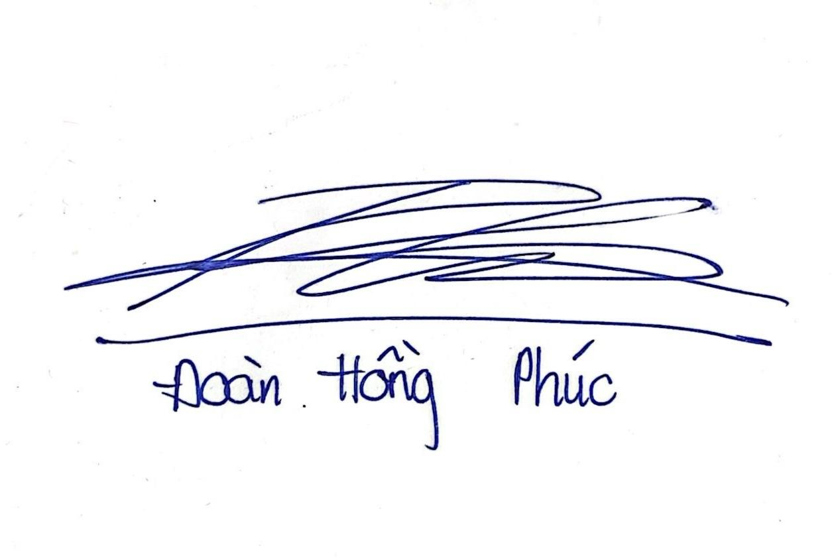 | October 14th, 2026
24127079 | Nguyen Tien Minh |  | October 14th, 2026
24127322 | Phan Nhat Anh |  | October 14th, 2026

4 AI Usage Log
[Required in every PA. List each significant use of AI tools. Write "No AI tools were used" if none. Undisclosed AI use is an academic integrity violation.]
# | Member | Tool | Task / Purpose | How Output Was Verified and Changed
1 | Nguyen Hoang My Trang | Claude (Anthropic) | Drafting PA0 – Project Idea and Team Contract sections. | The draft generated by AI has been read by the team and personal information has been added to the report, while also checking if the content matches the information the team had agreed on before.

