# To Run AHEF

Step 1. Get emissions profile from Jess (or you can alter an existing emission profile in one of the worksheets in Step 2)

Step 2. Run the emissions profile through ozone maker to go from ODS species to total column ozone (Dobson units)

* Open Ozone Maker in the “emission profile” directory
  + OzoneMaker_11_22-2014.xlsx (look in the worksheet entitled “TourGuide”)
    - Make sure ODS attributes is set up for WMO2010
    - Open a new worksheet, add the new emissions profile *(see “WMOA1_cut” as an example worksheet – same columns/years)*
    - In Emiss_Profile – call the new worksheet in cell A1

The spreadsheet should run through the steps & put new results into the “MakeOzoneFile” worksheet

* + - Save the “MakeOzoneFile” worksheet as a *.prn file
  + In the “input data” directory – switch the *.prn to *.OZN

Step 3. In AHEF, set up input files to call correct *.OZN file & run for each of the U.S. regions

[I have windows virtual pc: windows xp mode that can run DIGITAL Visual Fortran 6.0; then I open the Developer Studio & open the workspace in the specific region directory]

* In each of the regions (i.e. directories that start with “run group r*”):
  + Open “AHEF.Run”
    - Change an input file name to the *.OZN filename (e.g., WMOA1C.OZN is then WMOA1C) (note all text after * are ignored by AHEF)
  + In the “EXP_RUN.STD”
    - Choose which exposures you care about – skin cancer and/or cataract
  + In the “EFF_TRY.STD”
    - Make sure the exposure in exposure are included here
  + In your Fortran Compiler, open up “region 1.dsw”
    - Make sure all directory paths are up to date
      * “EFFECTS.FOR” Effects module has directory path calls, for example (just change the path to where you have it):

open(iunit, FILE = 'BAF.DAT',Defaultfile='\\tsclient\C\Users\18959\Desktop\AHEF_Runs_2014\ahef\input data)

* + - * “RD_LOOK.FOR”
      * “RD_OZONE.FOR”
      * “RD_WGHT.FOR”
    - Compile & run (may take 20-30 min to run, depending, some regions are bigger than others) – see below the red circle, click on the first icon to the left and then march forward – digital visual fortran will compile the files, link the files, and run the files

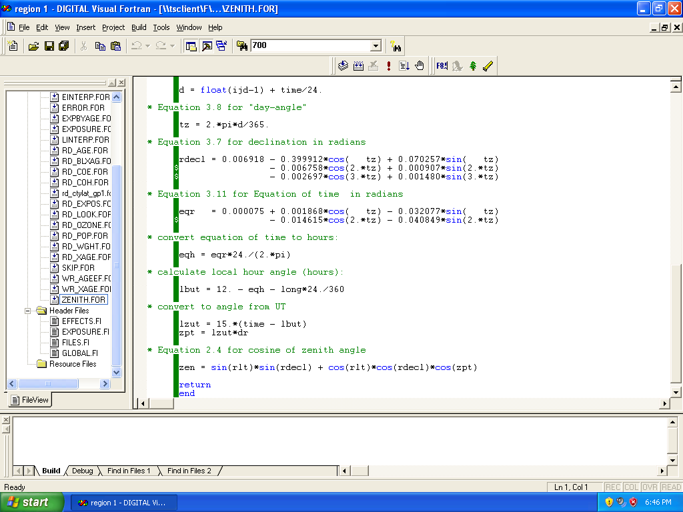

Step 4. Total results across regions in Excel

* I just open the files in Excel and add up em