

**USER**

**MANUAL**

*CAL Management System*

Ricardo Gomez, Roland Schiller, Alfonso Logroño, Julian Dasilva

Spring 2017

**USER'S MANUAL**

**TABLE OF CONTENTS**

Page #

1.1 Logging in 1

1.2 CAL Database Main Page 2

1.3 Creating a New Student 3

1.4 Creating a New Tutor 4

1.5 Updating a Student 5

1.6 Updating a Student’s Demographic Information 6

1.7 Updating a Student’s Academic Information 7

1.8 Updating a Student’s Accomdations Information 9

1.9 Updating a Student’s Enrollement Information 11

2.0 Updating a Student’s Enrollement Information 12

2.1 Updating a Student’s Clincial Record 13

2.2 Updating a Student’s Monthly Record 15

2.3 Reports 16

2.4 Logging Out 18

## 1.1 Logging in

Once you have clicked on the log in button, you should be redirected to this webpage. A “Sign In” box is shown prompting for an email and password. Please sign in with the credentials given to you by your supervisor or database administrator in order to enter the CAL database.

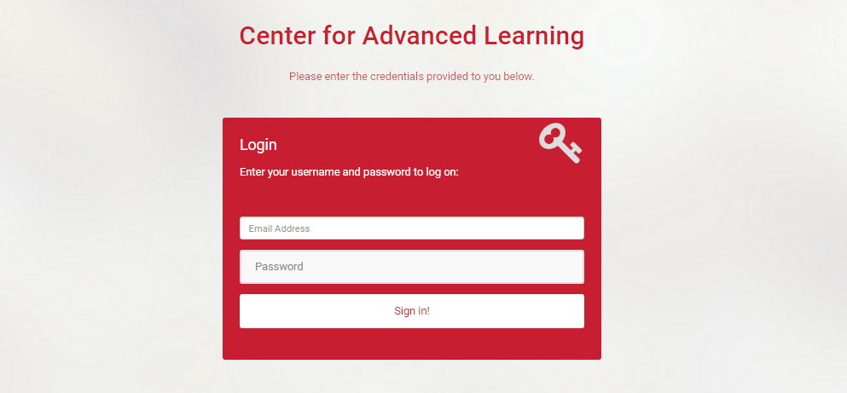

**1.2 CAL Database Main Page**

After logging in successfully, you will be redirected to this page. From here, you can create a new student record, create a new tutor, update student information, display student reports, or simply log out by clicking on the corresponding tab on the toolbar to the left of the screen; for logging out, click on the most upper-right button labeled with your email and click “Log Out”. This same toolbar will be accessible on all subsequent webpages.

**NOTE**: Only admin users may create a new tutor and access the Admin Dashboard

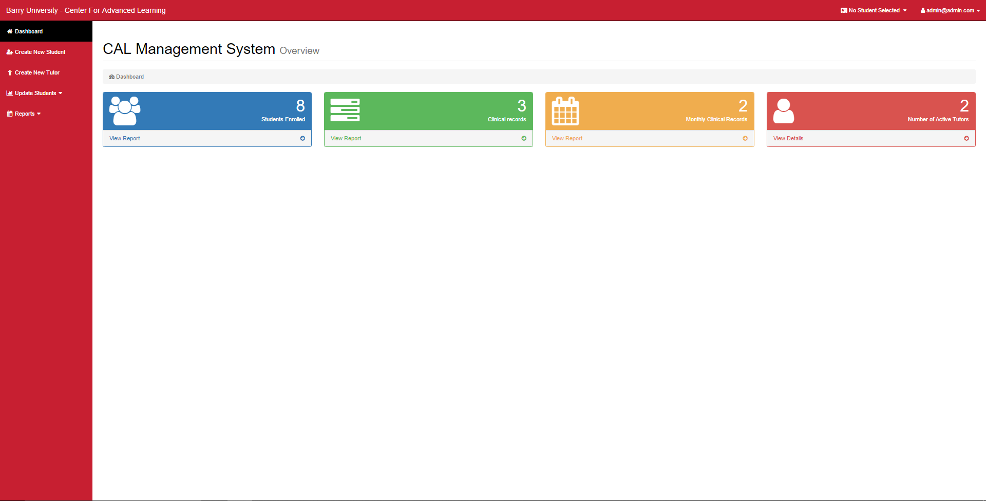

**NOTE**: Fields with an * indicate that you must fill in information for that field

**1.3 Creating a New Student**

To create a new student record, click on the “Create New Student” button on the toolbar. Doing so will redirect to this webpage on the next page. Prompts for entering a student’s id number, last name, first name, middle, date of birth, gender, living, and permanent residence are displayed. Fill in each field accordingly. For example, a student’s id number should be a 7-digit number to comply with Barry’s id system

Once you have finished entering a new student’s demographic information, click on the submit button. You will then be redirected to the main page of the database with this newly created student in session for updating.

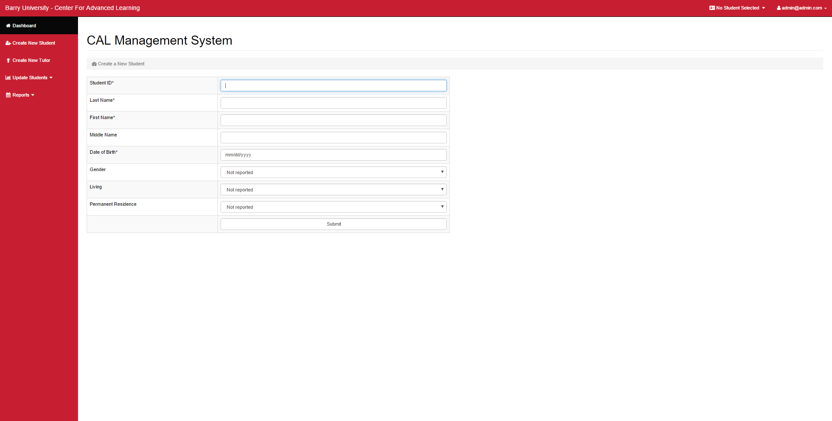

**1.4 Creating a New Tutor**

To create a new tutor record, click on the “Create New Tutor” tab on the toolbar. Doing so will redirect to this webpage below. Prompts for entering a tutor’s id number, last name, first name, email, login password, contact information, subject area, degree, and start and left dates are displayed. Fill in each field accordingly.

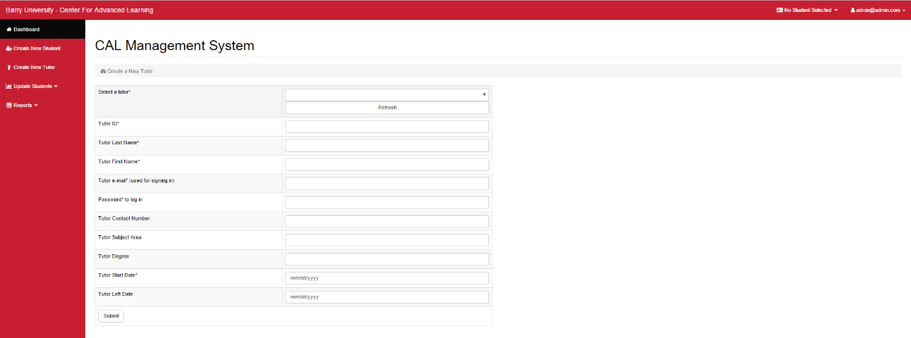

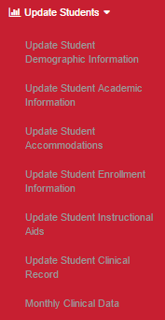**1.5 Updating a Student**

These options will be shown if the “Update Student” tab is clicked. Please note the information on the tab in the upper right corner and left of the current user tab. It indicates what student you are currently working. If the button is labeled “**No Student Selected**,” you will not have access to the update pages. However, there is an option of changing the current student. To do so, **click on the tab with the current student’s name, enter the student id number of the student you wish to work on under the field labeled “Student ID” and click the submit button**. Refer to the picture below.

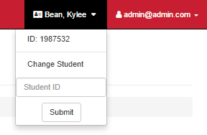

## 

## 1.6 Updating a Student’s Demographic Information

To update a student’s demographic information, please verify that you are in fact editing the desired student by referencing the current student tab in the upper-right corner.

Click on the “Update Student” tab and select the tab labeled “Update Student Demographic Information”. You will then be redirected to a familiar looking page. However, now, several fields should be filled with information. To update a student, click on a desired field(s) (i.e. Middle Name) and update the old information. Once finished, click submit.

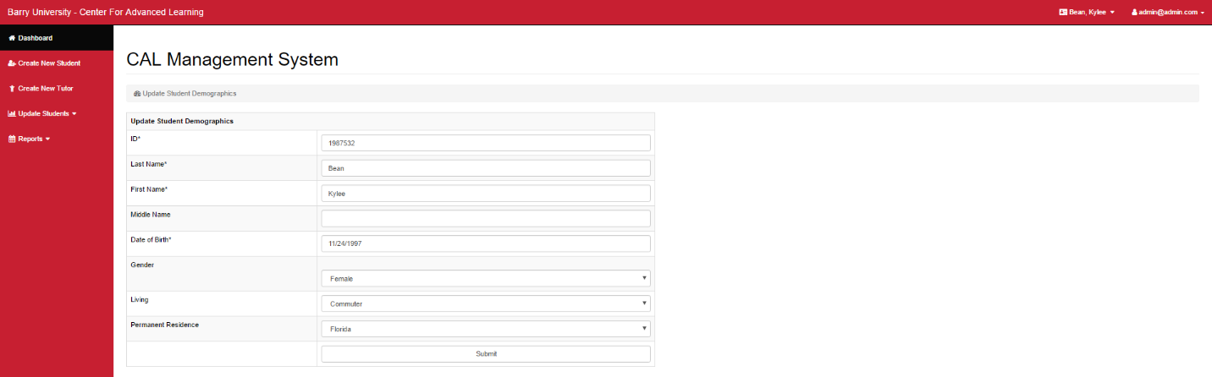*Example of occupied fields with pre-inputted data*

**Note**

Depending on whether you are inserting new information for a student you just created or updating an existing student within the CAL database, the fields within the academic information page and subsequent update pages will either be completely empty (for a new student) or have preexisting information (existing student). Each update section has a unique record based on an auto-incrementing id number behind the scenes. Auto-incrementing guarantees that each entry is unique. Also, Student id’s in each section cannot be edited. This was done to prevent a mistake on updating a different student or involuntarily changing the id number.

## 1.7 Updating a Student’s Academic Information

Click on the button labeled “Update Student Academic Information.” Within this page, you can create a new academic record or update a previous record for a student. One student can have multiple academic records since a student can have multiple majors.

To create a new academic record, click on the “Select an Academic Program” bar and select the “New Record” option. Once that is done, enter the select an academic program (whether it be a major or minor) from the list of programs that Barry University offers under “Academic Program (Major or Minor).” After making your selection, declare whether it is a major or minor under the “Academic Program Type.” Fill out the declare date of the current program as well as the student’s academic advisor. Once finished, click on the submit button. Once a record is created, a unique program record will be associated for that student. This program record will be used to update a student’s information.

To update a student’s academic record, click on the “Select an Academic Program” bar and select which of the student’s record you wish to update. For example, if you were to click on the “Select an Academic Program” bar for some student “Billy”, a set of options would appear. A “New Record” will always be an option; however, new options labeled “Major: Accounting” and “Major: Computer Science” will be available. If Billy decided he wanted to change his Computer Science major to a CS minor you

would select “Major: Computer Science” and click the refresh button next to the options bar. Information regarding Billy’s CS major program will now occupy the other fields such as the program type, the declare date of that major, and his advisor. These fields are now editable. Since Billy wanted to make CS his minor, you would click “Academic Program Type,” select “Minor” and click the submit button to successfully update this specific program record of Billy. The “Academic Program (Major or Minor)” itself is editable if a student decided to change their major/minor to a completely new one or dropping it altogether.

*New Record Screen with inputted information*

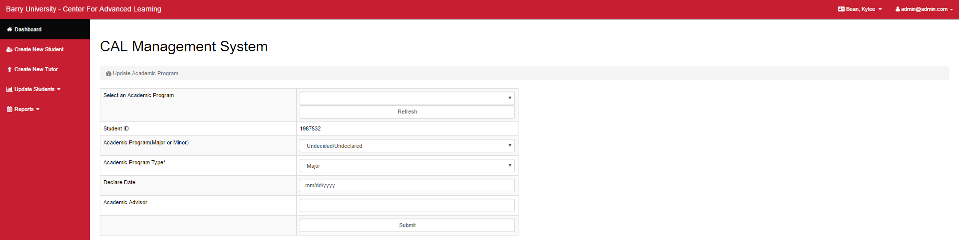

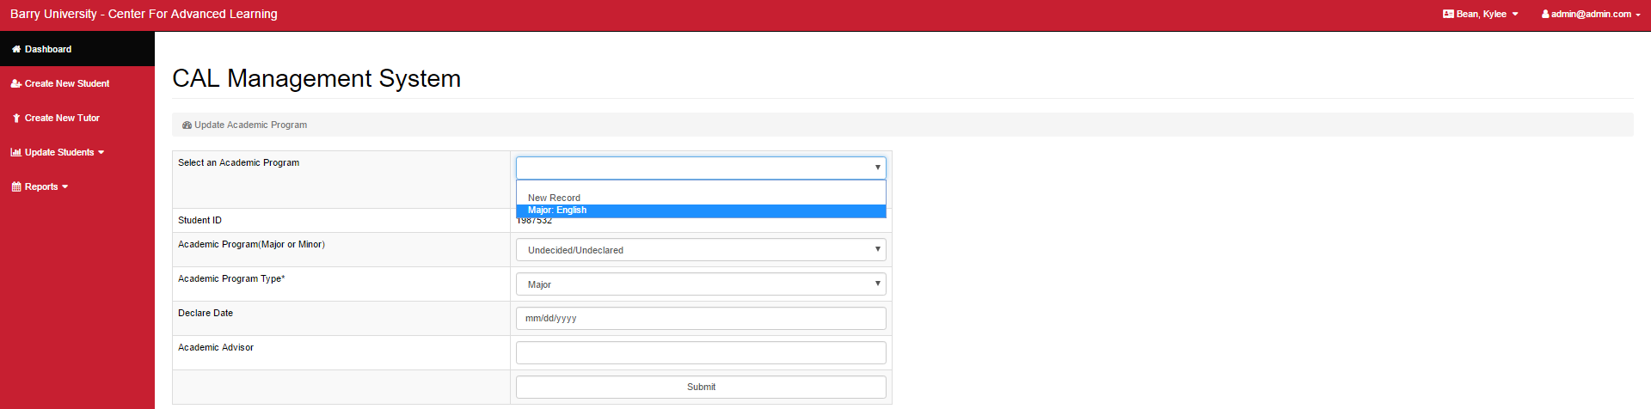*Selecting an existing academic record to update*

*After clicking refresh for a specific record*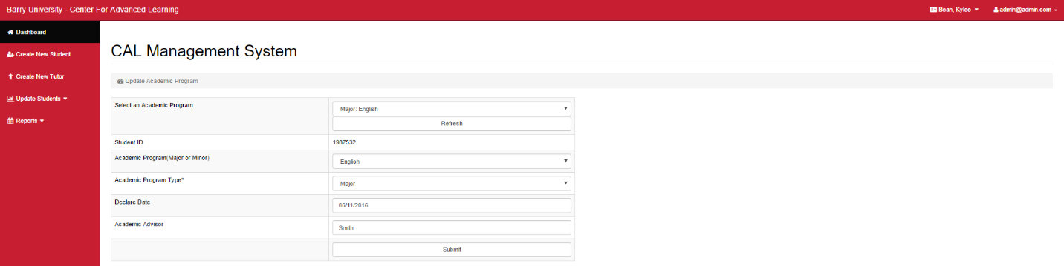

## 1.8 Updating a Student’s Accommodations Information

Under the “Update Students” tab, select the option labeled “Update Student Accommodations”. If you wish to create a new record, select the option “New Record” in the pull-down menu within the section labeled “Select Student Accommodation.” If a previous record exists, the pull-down menu will show also display the date the previous record was created alongside the “New Record” option. All the fields, other than the ones labeled “ADHD” and “Other Psychological Conditions,” are checkboxes. If a particular field applies to a student (i.e. Student takes medication), make sure a checkmark is displayed within the box for that field (“Medication”). “ADHD” and “Other Psychological Conditions” accept text as input. If these sections, or all sections for that matter, do not apply for a student, they can be left blank.

Refer to that section 1.7 for the process of updating an existing record.

*\*Example images on next page\**

*Example of a new record*

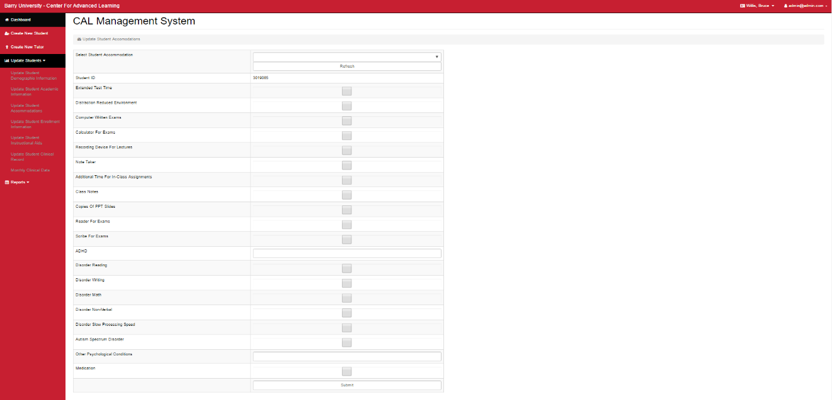

*Updating an existing accommodations record*

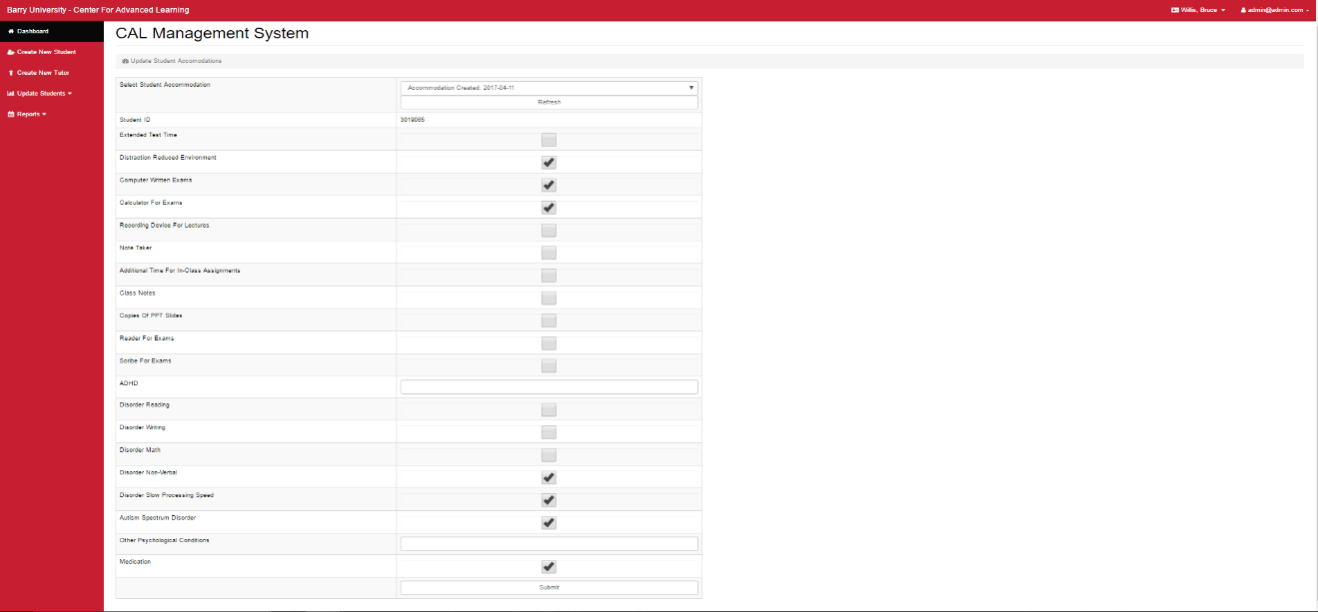

## 1.9 Updating a Student’s Enrollment Information

Click on the “Update Student Enrolment Information” tab under the “Update Students” tab. To create a new enrollment record, choose the “New Record” option under the “Enrollment ID” field. Under the fields “Semester/Year Entered Barry” and “Semester/Year Entered CAL”, follow the structure of the example provided alongside each field (E.G. 1704 (2017 FALL)). “Accepted” and “High Support” require simply a check mark to indicate whether this student was accepted and/or if s/he received support in high school. A check mark in this field will indicate a “yes” while leaving it blank will translate to a “no.” Fill out the “Date Left CAL” field with simply selecting the corresponding date or leaving it untouched. The last field “Reason Left CAL” can simply filled out with text.

Refer to that section 1.7 for the process of updating an existing record.

*Example of a new record*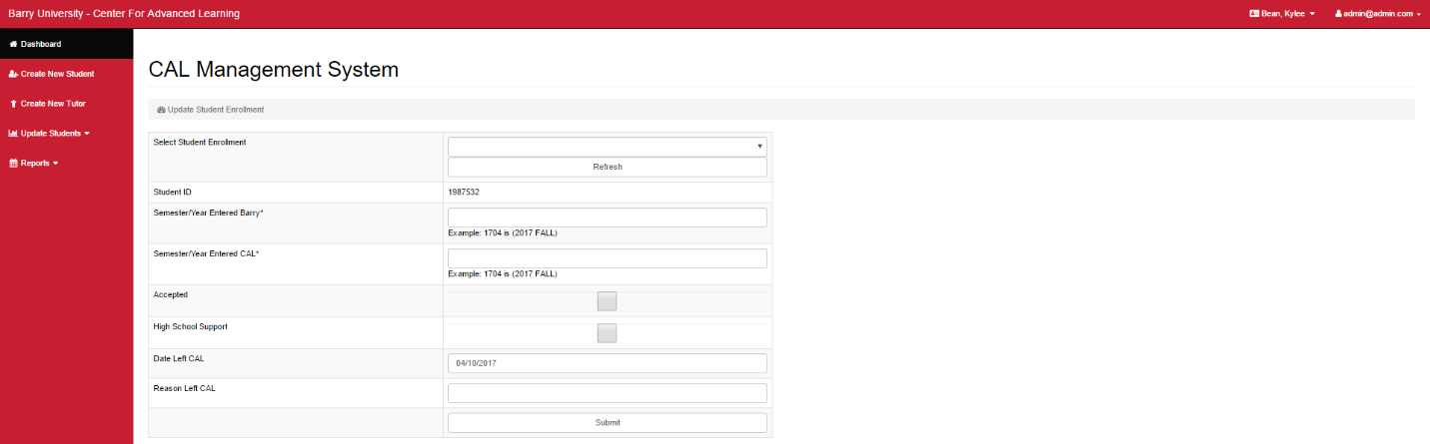

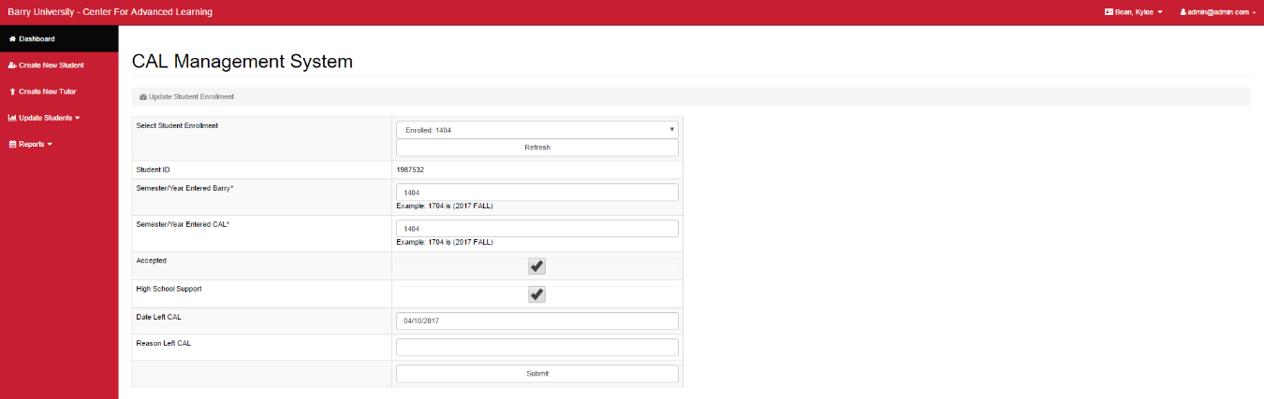*Updating an existing enrollment record*

## 2.0 Updating a Student’s Instructional Aids

Click on the “Update Student Instructional Aids Information” tab. To create a new instructional aids record, choose the “New Record” option under the “Instructional Aids ID” field. As you can see, all the fields (i.e. Smart Pen and Learning Ally) are checkboxes. Clicking on and check-marking a specific field box would translate to instructional aids the student is currently using. Leaving a box empty would indicate that the student does not use that exact aid. Once you filled out the fields accordingly, click the submit button to create the new record.

Refer to that section 1.7 for the process of updating an existing record.

*Example of a new record*

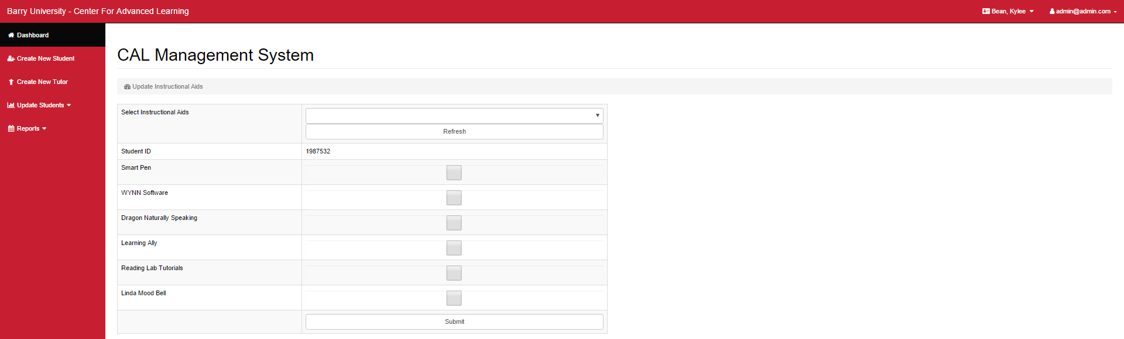

*Updating an existing instructional aids record*

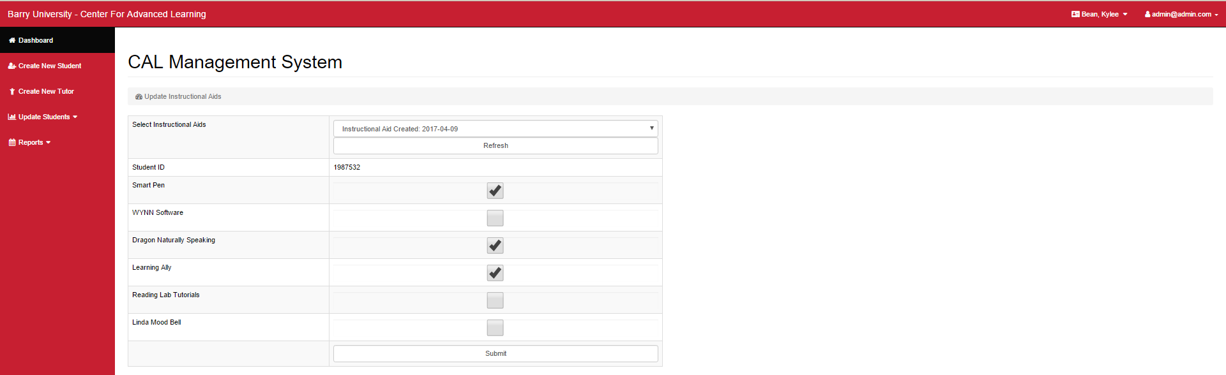

## 2.1 Updating a Student’s Clinical Record

As you can see, this informational page is far more extensive than the previous update pages. Nonetheless, creating a new record and the procedure for filling out fields with acceptable information remains the same. From the “Update Students” submenu, click on the “Update Student Clinical Record” tab. To create a new record, choose the “New Record” option under the “Clinical Record ID” field. Under the “Tutor” field, click from the list of documented tutors that assisted the student in a session. For the “Subject” field, type the subject(s) that were focused on during said session. The “Record Date” will be filled out in accordance the date of session. The “Time-In” and “Time out” fields should be inputted based on when the student started and finished a session. “Instructional Plan” accepts any form of text.

Under the “Instructional Intervention” subsection, check mark the corresponding boxes that correspond with the accomplished tasks performed during a session. An empty box indicates to an action not performed. The “Other,” “Observed Strengths,” “Areas for Improvement,” and “What Should Happen Next” all accept text as input and can be left empty if desired.

Under the “Instructional Outcomes” subsection is very similar to the previous subsection. Check mark the corresponding boxes that correspond with outcomes from a corresponding session. An empty box

translates to an outcome that did not result from this session. The “Other Outcome” accepts text as input and can be left empty.

Refer to that section 1.7 for the process of updating an existing record.

*\*Example image is on next page\**

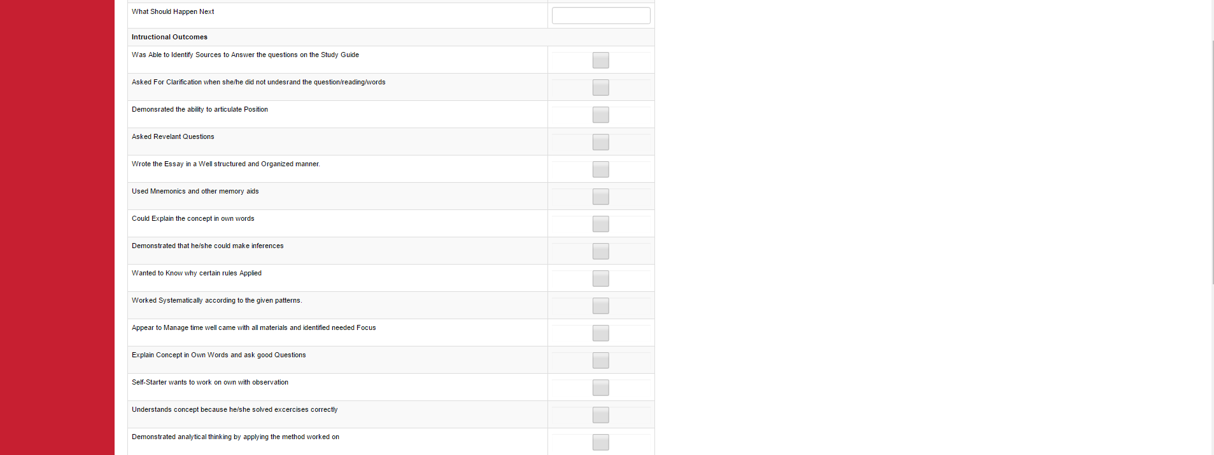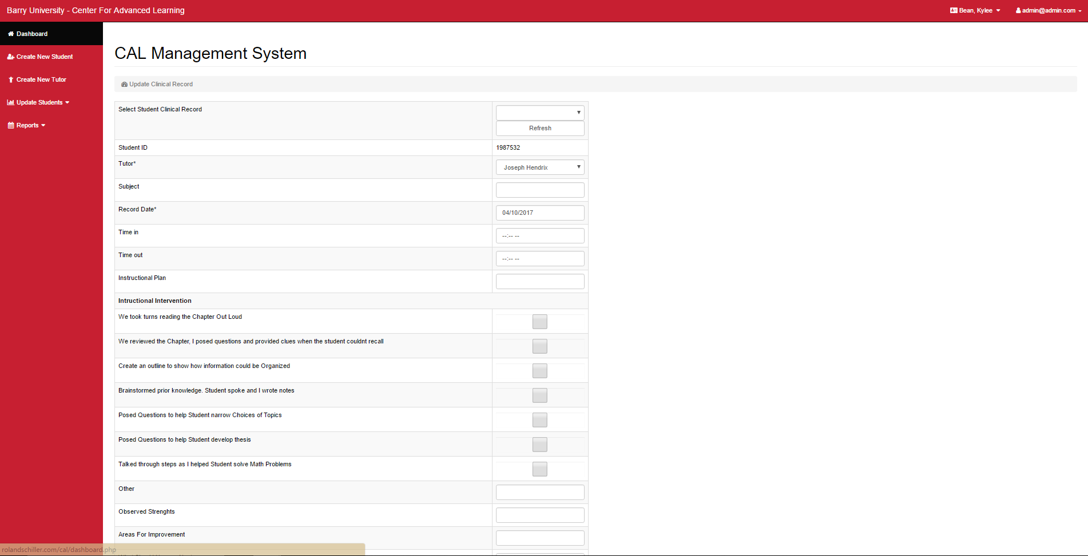*Example of a new record*

## 2.2 Updating a Student’s Monthly Record

As we all know by now, click on the “Monthly Clinical Data” tab. To create a new monthly clinical data record, choose the “New Record” option under the “Monthly Clinical Data ID” field. Based on who worked with the student for the month, select the corresponding tutors from the list of available instructors. “Tardies” and “Absences” can be documented based on the student’s attendance record for said month. These fields can only be whole numbers (0,1,2,3…); therefore, negative nor decimal values will be accepted. The final field, “Comments,” accepts text as an input, though it can be left empty. The remaining fields that I skipped over and are located between “Absences” and “Comments” vary slightly from what we have seen. Each field poses a question and selection bar that contains suitable responses for the aforementioned question. For example, the second field of the set, “Did the Student Complete the required reading/preparations to the tutorial sessions?” can be answered with:

1. No prior reading/preparation completed
2. Limited preparation (knows what to do, but not completed)
3. Started tasks/preparation
4. Completed all preparation

Select the response that best describes the student’s behavior for the month.

Refer to that section 1.7 for the process of updating an existing record.

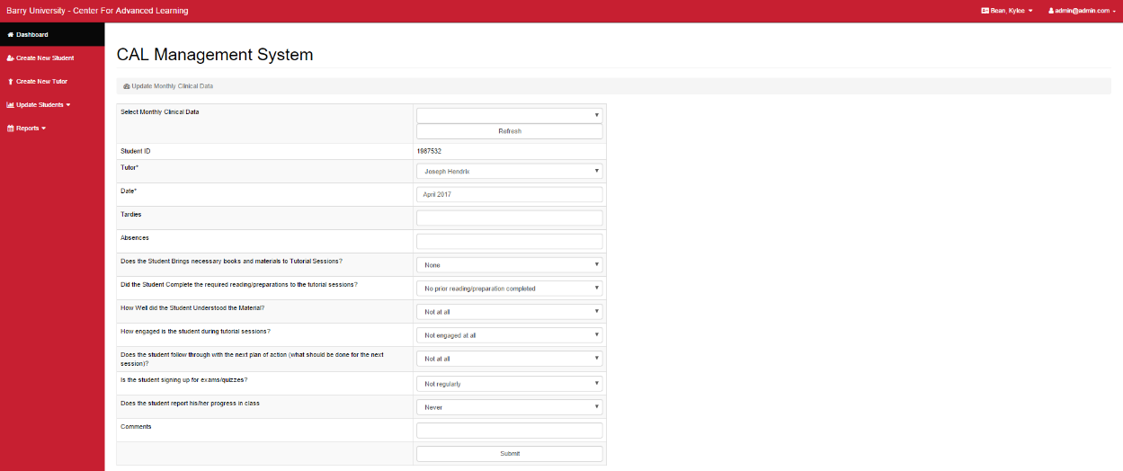*Example of new record*

**NOTE**: Dates shown as 0000-00-00 and other fields displayed as “N/A” signify that data was not inputted by the user for these fields.

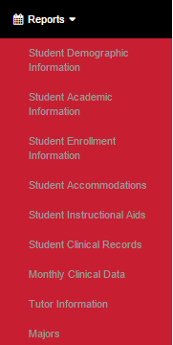**2.3 Reports**

Whether you are in the CAL database main page, the new student creation page, or one of the many update pages, the “Reports” tab is always accessible. To access report options, click on the “Reports” tab on the toolbar that always readily available on the left side of the webpage. Once you clicked on “Reports,” this submenu will appear **------------------------------------->**

Several options of various reports will appear. These include reports for all documented students’, within CAL, demographic information, academic information, enrollment information, instructional aids, clinical records, and monthly clinical data. Two additional reports are available: “Tutor Information” and “Majors.” Within the “Tutor Information” report, information regarding all verified tutors are displayed, including their tutor id number, first and last names, email address, subject area, date started and left CAL, and contact information. “Majors,” on the other hand, displays all unique major/minor id number and their corresponding program title. Choose the report you wish to view.

Within each report type, you can filter out information you wish to view. For example, if you were to click on the “Student Academic Information” report, you will notice several column names like student id and last name. Through the column names and corresponding values, we can filter information from the entire table. Within the student academic report page, you may notice a subsection labeled “Filter”. Under this subsection, there is a list of column names of the student academics table as well as an empty input box, where we will enter information to display the filtered records. Let us say you wished to view all students whose id number is 7306942. Within the “Filter: ” subsection, click on the list box and select “Student ID Number”. Following the selection, enter “7306942” within the empty box and click on “filter” (located under the input box). The table should now only display academic records of the student with an id number of 7306942. Important to note, your inputted data should be compatible with the column name you chose (i.e. Student ID Number should not be accompanied with a text filter since all student id numbers are evidently numbers). Such filters are available for all possible reports.

*Filtering example within Academic Information report*

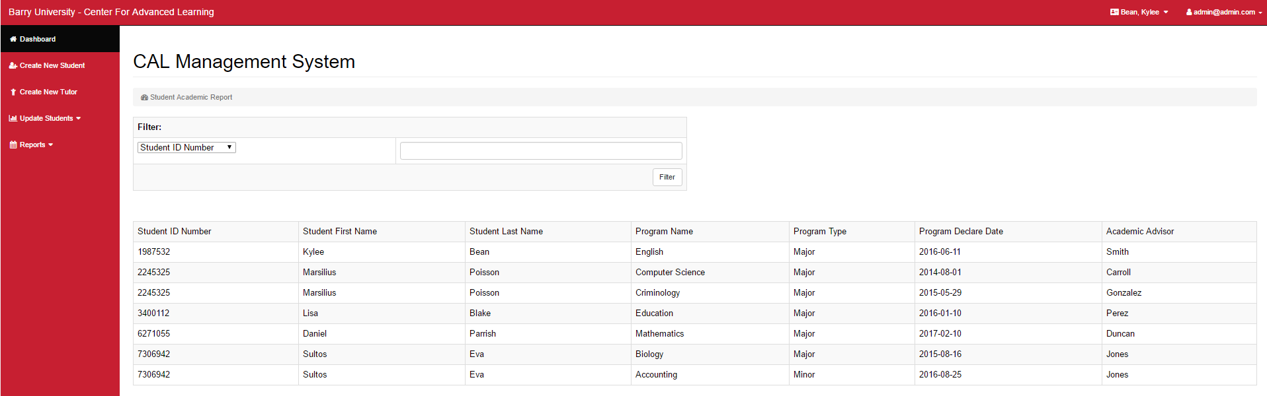***Before****:*

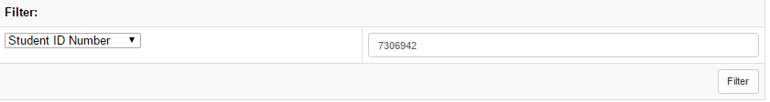

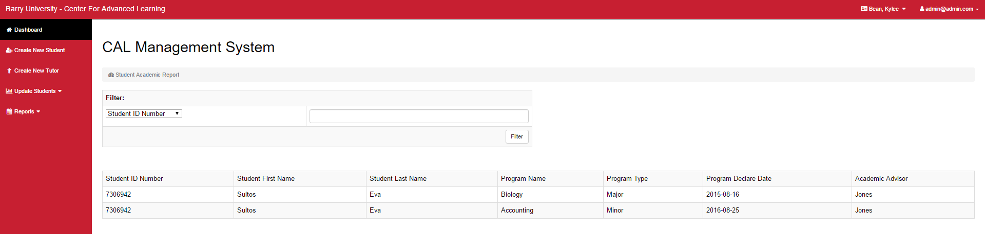***After***:

**2.4 Logging Out**

To log out, simply click on the tab labeled with your email login in the upper-right corner and click the “Log Out” button. You should then be redirected to the log in screen.

