1. On an audio CD, the audio voltage signal is typically sampled approximately 44,000 times per second, and the value of each sample is recorded on the surface of the CD as a binary number. In other words, each recorded binary number represents an individual voltage point in the audio signal's waveform:

(a) If the binary numbers are six bits long, how many distinct voltage values can be represented by a single binary number? Repeat for eight and ten bits.

(b) If ten-bit numbers are used, how many bits will be recorded on the CD in one second?

(c) If a CD can generally store 5 billion bits, how many seconds of audio can be recorded using ten bits?

1. In a 6 bit long binary there are $2^{6}$ values that can be represented, that mean there are a total of 64 distinct voltages points

In a 8 bit binary: $2^{8}$; 256 distinct voltages

In a 10 bit binary $2^{10}$; 1024 distinct voltages

2. A black-and-white digital camera places a fine grid over an image to measure and record a binary number representing the gray level seen in each grid cell. For example, if four-bit numbers are used, the value for black is set to 0000 and the value for white to 1111, and any gray level can have a value between 0000 and 1111. If six-bit numbers are used, black is 000000, and white is 111111, and all gray levels fall between these two values.

3. Suppose we want to differentiate between 254 gray levels within each grid cell. How many bits would we need to use to represent these gray levels?

4. Draw the output waveform for the OR gate in the figure.

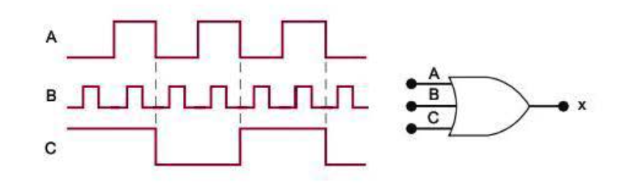

5. Read the following statements regarding an OR gate. At first, they may seem valid, but after analyzing them, you will realize that neither is always true. Demonstrate this with a specific example to refute each statement.

(a) If the output waveform of an OR gate is the same as the waveform on one of its inputs, the other input will remain permanently LOW.

(b) If the output waveform of an OR gate is always HIGH, one of its inputs will remain permanently HIGH.

|  |  |  |
| --- | --- | --- |
| a | b | OR |
| L | L | L |
| L | H | H |
| H | L | H |
| H | H | H |

1. False, if a=H and B=H then OR= H but none of the inputs are Low
2. True, if a=L and b=L then OR=L this is the only time when OR=L in the others one of the inputs is H