Pattern. **Weave-detail**

|  |
| --- |
|  |
|  |
| |  |  |  |  |  | | --- | --- | --- | --- | --- | | positons | | | |  | | beat | **A** | **B** | **C** | **D** | | 1 | 13 | 1 | 9 | 5 | | 2 | 13 | 2 | 10 | 6 | | 3 | 13 | 3 | 11 | 7 | | 4 | 13 | 4 | 12 | 8 | | 5 | 13 | 5 | 1 | 9 | | 6 | 13 | 6 | 2 | 10 | | 7 | 13 | 7 | 3 | 11 | | 8 | 13 | 8 | 4 | 12 | | 9 | 13 | 9 | 5 | 1 | | 10 | 13 | 10 | 6 | 2 | | 11 | 13 | 11 | 7 | 3 | | 12 | 13 | 12 | 8 | 4 | | |  |  |  |  |  | | --- | --- | --- | --- | --- | |  | passes | | | | |  | **A** | **B** | **C** | **D** | | 1 | B | A |  |  | | 2 | C |  | A |  | | 3 | D |  |  | A | | 4 | B | A |  |  | | 5 | C |  | A |  | | 6 | D |  |  | A | | 7 | B | A |  |  | | 8 | C |  | A |  | | 9 | D |  |  | A | | 10 | B | A |  |  | | 11 | C |  | A |  | | 12 | D |  |  | A | |
|
|
|  | |

Pattern: Windy 2-holer

|  |  |  |  |
| --- | --- | --- | --- |
|  | |  | |
|  | |  | |
| |  |  |  |  |  |  |  | | --- | --- | --- | --- | --- | --- | --- | | POSITIONS | | | |  |  |  | |  | **A** | **B** | **C** | **D** | **E** | **F** | | 1 | 7 | 6 | 5 | 3 | 1-2 | 4 | | 2 | 7-8 | 6 | 5 | 3 | 2 | 4 | | 3 | 8 | 6 | 5 | 3 | 2 | 4-1 | | 4 | 8 | 6-7 | 5 | 3 | 2 | 1 | | 5 | 8 | 7 | 5 | 3-4 | 2 | 1 | | 6 | 8 | 7 | 5-6 | 4 | 2 | 1 | | 7 | 8 | 7 | 6 | 4 | 2-3 | 1 | | 8 | 8-5 | 7 | 6 | 4 | 3 | 1 | | 9 | 5 | 7 | 6 | 4 | 3 | 1-2 | | 10 | 5 | 7-8 | 6 | 4 | 3 | 2 | | 11 | 5 | 8 | 6 | 4-1 | 3 | 2 | | 12 | 5 | 8 | 6-7 | 1 | 3 | 2 | | 13 | 5 | 8 | 7 | 1 | 3-4 | 2 | | 14 | 5-6 | 8 | 7 | 1 | 4 | 2 | | 15 | 6 | 8 | 7 | 1 | 4 | 2-3 | | 16 | 6 | 8-5 | 7 | 1 | 4 | 3 | | 17 | 6 | 5 | 7 | 1-2 | 4 | 3 | | 18 | 6 | 5 | 7-8 | 2 | 4 | 3 | | 19 | 6 | 5 | 8 | 2 | 4-1 | 3 | | 20 | 6-7 | 5 | 8 | 2 | 1 | 3 | | 21 | 7 | 5 | 8 | 2 | 1 | 3-4 | | 22 | 7 | 5-6 | 8 | 2 | 1 | 4 | | 23 | 7 | 6 | 8 | 2-3 | 1 | 4 | | 24 | 7 | 6 | 8-5 | 3 | 1 | 4 | | |  |  |  |  |  |  |  | | --- | --- | --- | --- | --- | --- | --- | | PASSES | | | |  |  |  | |  | **A** | **B** | **C** | **D** | **E** | **F** | | 1 | C | - | A | F | * | D | | 2 | * | C | B | - | F | E | | 3 | B | A | - | E | D | * | | 4 | C | * | A | F | - | D | | 5 | - | C | B | * | F | E | | 6 | B | A | * | E | D | - | | 7 | C | - | A | F | * | D | | 8 | * | C | B | - | F | E | | 9 | B | A | - | E | D | * | | 10 | C | * | A | F | - | D | | 11 | - | C | B | * | F | E | | 12 | B | A | * | E | D | - | | 13 | C | - | A | F | * | D | | 14 | * | C | B | - | F | E | | 15 | B | A | - | E | D | * | | 16 | C | * | A | F | - | D | | 17 | - | C | B | * | F | E | | 18 | B | A | * | E | D | - | | 19 | C | - | A | F | * | D | | 20 | * | C | B | - | F | E | | 21 | B | A | - | E | D | * | | 22 | C | * | A | F | - | D | | 23 | - | C | B | * | F | E | | 24 | B | A | * | E | D | - | | |  | |
|  | |  |  | |

D & G do 3-count; A & C chocolate bar; C,E, & F double 3-count; B does a tough 1-count (hard to do and hard to remember!).

|  |  |  |  |  |  |  |  |  |  |  |  |  |
| --- | --- | --- | --- | --- | --- | --- | --- | --- | --- | --- | --- | --- |
| 7 jugglers/  both hands counting | 1 | 2 | 3 | 4 | 5 | 6 | 7 | 8 | 9 | 10 | 11 | 12 |
| A | D | E |  |  | E | F |  |  | F | D |  |  |
| B | E | F | F | D | F | G | D | E | G | E | E | F |
| C |  |  | G | E |  |  | E | F |  |  | F | G |
| D | A |  |  | B |  |  | B |  |  | A |  |  |
| E | B | A |  | C | A |  | C | B |  | B | B |  |
| F |  | B | B |  | B | A |  | C | A |  | C | B |
| G |  |  | C |  |  | B |  |  | B |  |  | C |

First tried by MAJ, Sunday Aug 13, 2017

Pattern. **Up-Up-Over**

|  |
| --- |
| A |
| B C |

|  |  |  |  |  |  |  |
| --- | --- | --- | --- | --- | --- | --- |
|  | 1 | 2 | 3 | 4 | 5 | 6 |
| A | C |  |  | B |  |  |
| B | ↑ |  | A |  | ↑ |  |
| C |  | ↑ |  | ↑ |  | A |

First tried by Steve and Mike when Madfest was still at Memorial Union, in early 90’s

Pattern. **Up-Up-Over-5**

|  |
| --- |
| A B |
| C D E |

|  |  |  |  |  |  |  |
| --- | --- | --- | --- | --- | --- | --- |
|  | 1 | 2 | 3 | 4 | 5 | 6 |
| A | D |  |  | C |  |  |
| B | E |  |  | D |  |  |
| C | ↑ |  | A |  | ↑ |  |
| D |  | A |  |  | B |  |
| E |  | ↑ |  | ↑ |  | B |

Pattern. **feed**

|  |
| --- |
| **A** |
| **D C B** |

Pattern. **Foi Graham**

|  |
| --- |
| A B C |
| D E F |

|  |
| --- |
|  |
|  |
| |  |  |  |  |  |  |  | | --- | --- | --- | --- | --- | --- | --- | | positons | | | |  |  |  | |  | **A** | **B** | **C** | **D** | **E** | **F** | | 1 | 1 | 9 | 5 | 5’ | 9’ | 1’ | | 2 | 2 | 10 | 6 | 6’ | 10’ | 2’ | | 3 | 3 | 11 | 7 | 7’ | 11’ | 3’ | | 4 | 4 | 12 | 8 | 8’ | 12’ | 4’ | | 5 | 5 | 1 | 9 | 9’ | 1’ | 5’ | | 6 | 6 | 2 | 10 | 10’ | 2’ | 6’ | | 7 | 7 | 3 | 11 | 11’ | 3’ | 7’ | | 8 | 8 | 4 | 12 | 12’ | 4’ | 8’ | | 9 | 9 | 5 | 1 | 1’ | 5’ | 9’ | | 10 | 10 | 6 | 2 | 2’ | 6’ | 10’ | | 11 | 11 | 7 | 3 | 3’ | 7’ | 11’ | | 12 | 12 | 8 | 4 | 4’ | 8’ | 12’ | | |  |  |  |  |  |  |  | | --- | --- | --- | --- | --- | --- | --- | |  | passes | | | |  |  | |  | **A** | **B** | **C** | **D** | **E** | **F** | | 1 | F |  |  |  |  | A | | 2 |  | E |  |  | B |  | | 3 |  | D | E | B | C |  | | 4 | E | F |  |  | A | B | | 5 |  | E |  |  | B |  | | 6 |  |  | D | C |  |  | | 7 | D |  | F | A |  | C | | 8 |  | D | E | B | C |  | | 9 |  |  | D | C |  |  | | 10 | F |  |  |  |  | A | | 11 | E | F |  |  | A | B | | 12 | D |  | F | A |  | C | |
|

Pattern. **2 pi/3.** Three moving jugglers, A, B, and C; six passing beats (on count of choice; rows of tables) for full cycle. Everyone moves through the figure eight; in contrast to a Turbo or Bruno’s nightmare, there is not a feeder being swapped here; all folks are moving all the time. Four count is fun; three count is more fun. In any count, it’s pass-one, pass-the other, self. Whatever is the base count the pattern has a gap (in this layout, positions 2 and 5) where you can plug in any other juggler or pattern that matches that count (including three other jugglers doing a 2pi/3!). Looks like two pies when viewed from above, and it’s 3 jugglers. Plus, each circle in the layout is divided into 3, hence the name. Lots of 2pi/3 from summer 2017.

|  |  |  |  |  |  |  |  |  |  |  |  |  |  |  |  |  |  |  |  |  |  |  |  |  |  |  |  |  |  |  |  |  |  |  |  |  |  |  |  |  |  |  |  |  |  |  |  |  |  |  |  |  |  |  |  |  |  |  |  |  |  |  |  |  |  |  |
| --- | --- | --- | --- | --- | --- | --- | --- | --- | --- | --- | --- | --- | --- | --- | --- | --- | --- | --- | --- | --- | --- | --- | --- | --- | --- | --- | --- | --- | --- | --- | --- | --- | --- | --- | --- | --- | --- | --- | --- | --- | --- | --- | --- | --- | --- | --- | --- | --- | --- | --- | --- | --- | --- | --- | --- | --- | --- | --- | --- | --- | --- | --- | --- | --- | --- | --- |
| |  |  |  |  | | --- | --- | --- | --- | | positons | | | | |  | **A** | **B** | **C** | | 1 | 1 | 5 | 3 | | 2 | 2 | 6 | 4 | | 3 | 3 | 1 | 5 | | 4 | 4 | 2 | 6 | | 5 | 5 | 3 | 1 | | 6 | 6 | 4 | 2 | | |  |  |  |  | | --- | --- | --- | --- | | passes | | | | |  | **A** | **B** | **C** | | 1 | C |  | A | | 2 |  | C | B | | 3 | B | A |  | | 4 | C |  | A | | 5 |  | C | B | | 6 | B | A |  | | Layout |
| Passes |

*Variations*: add one feeder to fill the gap (4 jugglers); `mate` two 2pi/3’s to fill both gaps (6 jugglers); do that switching sides or not; slow to six count then add more passes (Tomify) by making each juggler do pass-pass-pass per row

Pattern. **Ivy pi (first tried Aug 27/17; Mike, Mel, Conor, Nick, Jason)**

|  |
| --- |
|  |
|  |
| |  |  |  |  |  |  | | --- | --- | --- | --- | --- | --- | | positons | | | |  |  | |  | **A** | **B** | **C** | **D** | **E** | | 1 | 1 | 3 | 5 | 7 | 9 | | 2 | 2 | 4 | 6 | 8 | 10 | | 3 | 3 | 5 | 7 | 9 | 1 | | 4 | 4 | 6 | 8 | 10 | 2 | | 5 | 5 | 7 | 9 | 1 | 3 | | 6 | 6 | 8 | 10 | 2 | 4 | | 7 | 7 | 9 | 1 | 3 | 5 | | 8 | 8 | 10 | 2 | 4 | 6 | | 9 | 9 | 1 | 3 | 5 | 7 | | 10 | 10 | 2 | 4 | 6 | 8 | | |  |  |  |  |  |  | | --- | --- | --- | --- | --- | --- | | passes | | | |  |  | |  | **A** | **B** | **C** | **D** | **E** | | 1 | D | E |  | A | B | | 2 | C | D | A | B |  | | 3 | D |  | E | A | C | | 4 | C | E | A |  | B | | 5 |  | D | E | B | C | | 6 | D | E |  | A | B | | 7 | C | D | A | B |  | | 8 | D |  | E | A | C | | 9 | C | E | A |  | B | | 10 |  | D | E | B | C | | Moves |
| Passes |

Pattern. **Apollo**

**A**

**B**

**C D E**

*Pattern. Chocolate feeds*

**E**

**A B D**

**C D E C**

**A B**

**standard wedge**

*Pattern. Theatre-style popcorn*

**A**

**B**

**C**

**D E F**

**3-5 Foie Graham**

From Video**,** A=Mark, B=Conner, C=Mel, D=Jeff, E=Chan, X=Graham, Y=Mike, Z=Peter; passers A-E do 4 of 10 rights; passers X-Z do 4 of 6 rights. The figure below shows all positions in the pattern (nodes) and 1-beat transitions (blue edges); the starting configuration is also shown; pink nodes indicate passing beats and yellow are self beats. Two pairs pass on every right-hand beat (e.g., starting Z-E and X-C). In the steady state A-E each do *pass-pass-self-self-pass-self-self-pass-self-self*; X-Z do *pass-pass-pass-pass-self-self*; all right-hand counting. Not counting selves, it’s also neat that each of A-E pass in sequence to X, Y, then Z; never in another order. There’s also a curious letter shuffling going on from the perspective of X,Y, and Z. Of all possible ordered sets of 4 from 5, only 5 appear as the passing sequences of X, Y, and Z. And they do them in the same order, but out-of-phase: EDBA-CEDB-ACED-BACE-DBAC, thanks to the dynamics of the two weaves. It’s interesting that to go from one to the next you append the non-passed-to juggler (prefix) to the first-three of four (suffix). E.g. EDBA goes to CEDB. Passing repeats after 30 right-hand beats (see table), but a full cycle is 60 right-hand beats to get back into the starting places! Notice also there are 20 positions in the 5-weave (5 positions on each of 4 loops), which makes it a slightly faster loop than a typical weave (which has 6 positions per loop and 3 loops).



|  |  |  |  |  |  |  |  |  |
| --- | --- | --- | --- | --- | --- | --- | --- | --- |
| PASSES | | | |  |  |  |  |  |
|  | **A** | **B** | **C** | **D** | **E** | **X** | **Y** | **Z** |
| 1 | - | - | X | - | Z | C | - | E |
| 2 | - | Y | - | Z | - | - | B | D |
| 3 | Y | Z | - | - | - | - | A | B |
| 4 | - | - | Y | - | X | E | C | - |
| 5 | - | - | - | X | Y | D | E | - |
| 6 | Z | X | - | - | - | B | - | A |
| 7 | X | - | Z | - | - | A | - | C |
| 8 | - | - | - | Y | Z | - | D | E |
| 9 | - | Y | - | Z | - | - | B | D |
| 10 | Y | - | X | - | - | C | A | - |
| 11 | - | - | Y | - | X | E | C | - |
| 12 | - | B | - | X | - | D | - | B |
| 13 | Z | X | - | - | - | B | - | A |
| 14 | - | - | Z | - | Y | - | E | C |
| 15 | - | - | - | Y | Z | - | D | E |
| 16 | X | Y | - | - | - | A | B | - |
| 17 | Y | - | X | - | - | C | A | - |
| 18 | - | - | - | Z | X | E | - | D |
| 19 | - | Z | - | X | - | D | - | B |
| 20 | Z | - | Y | - | - | - | C | A |
| 21 | - | - | Z | - | Y | - | E | C |
| 22 | - | X | - | Y | - | B | D | - |
| 23 | X | Y | - | - | - | A | B | - |
| 24 | - | - | X | - | Z | C | - | E |
| 25 | - | - | - | Z | X | E | - | D |
| 26 | Y | Z | - | - | - | - | A | B |
| 27 | Z | - | Y | - | - | - | C | A |
| 28 | - | - | - | X | Y | D | E | - |
| 29 | - | X | - | Y | - | B | D | - |
| 30 | X | - | Z | - | - | A | - | C |

*Pattern*: **Egg Beater switching handles** [5 jugglers]. (first done Nov 2, 17 by Graham=A, Mel=B, Mike=C, Jeff=D, Nick=E; nickname EggBeatOff) The table shows positions where each juggler (column) must be at that passing beat [right-hand counting in rows]. Only passes are indicated. So positions 1-2 exchange, similarly 3-8, 4-7, and 5-6. The first graph shows where each juggler moves; edge weights indicate number of right-hand counts up to next throw. Right graph shows passing events. Start with jugglers at 4, 7, near 1, 2, and on the edge moving towards 6. There are 30 right hand beats to get around, which seems excessive but doesn’t feel so bad when juggling, thanks to symmetries I guess.

|  |  |  |  |  |  |  |  |  |  |  |  |  |  |  |  |  |  |  |  |  |  |  |  |  |  |  |  |  |  |  |  |  |  |  |  |  |  |  |  |  |  |  |  |  |  |  |  |  |  |  |  |  |  |  |  |  |  |  |  |  |  |  |  |  |  |  |  |  |  |  |  |  |  |  |  |  |  |  |  |  |  |  |  |  |  |  |  |  |  |  |  |  |  |  |  |  |  |  |  |  |  |  |  |  |  |  |  |  |  |  |  |  |  |  |  |  |  |  |  |  |  |  |  |  |  |  |  |  |  |  |  |  |  |  |  |  |  |  |  |  |  |  |  |  |  |  |  |  |  |  |  |  |  |  |  |  |  |  |  |  |  |  |  |  |  |  |  |  |  |  |  |  |  |  |  |  |  |  |  |  |  |  |  |  |  |  |  |  |  |  |  |  |  |
| --- | --- | --- | --- | --- | --- | --- | --- | --- | --- | --- | --- | --- | --- | --- | --- | --- | --- | --- | --- | --- | --- | --- | --- | --- | --- | --- | --- | --- | --- | --- | --- | --- | --- | --- | --- | --- | --- | --- | --- | --- | --- | --- | --- | --- | --- | --- | --- | --- | --- | --- | --- | --- | --- | --- | --- | --- | --- | --- | --- | --- | --- | --- | --- | --- | --- | --- | --- | --- | --- | --- | --- | --- | --- | --- | --- | --- | --- | --- | --- | --- | --- | --- | --- | --- | --- | --- | --- | --- | --- | --- | --- | --- | --- | --- | --- | --- | --- | --- | --- | --- | --- | --- | --- | --- | --- | --- | --- | --- | --- | --- | --- | --- | --- | --- | --- | --- | --- | --- | --- | --- | --- | --- | --- | --- | --- | --- | --- | --- | --- | --- | --- | --- | --- | --- | --- | --- | --- | --- | --- | --- | --- | --- | --- | --- | --- | --- | --- | --- | --- | --- | --- | --- | --- | --- | --- | --- | --- | --- | --- | --- | --- | --- | --- | --- | --- | --- | --- | --- | --- | --- | --- | --- | --- | --- | --- | --- | --- | --- | --- | --- | --- | --- | --- | --- | --- | --- | --- | --- | --- | --- | --- | --- | --- |
| |  |  |  |  |  |  | | --- | --- | --- | --- | --- | --- | | Beat/Juggler | | | | | | |  | **A** | **B** | **C** | **D** | **E** | | 1 |  | 7 |  |  | 4 | | 2 | 2 |  | 1 |  |  | | 3 |  |  |  |  |  | | 4 | 3 | 8 |  |  |  | | 5 |  |  |  | 6 | 5 | | 6 |  |  |  |  |  | | 7 | 4 |  |  | 7 |  | | 8 |  | 1 | 2 |  |  | | 9 |  |  |  |  |  | | 10 |  |  | 3 | 8 |  | | 11 | 5 |  |  |  | 6 | | 12 |  |  |  |  |  | | 13 |  |  | 4 |  | 7 | | 14 |  | 2 |  | 1 |  | | 15 |  |  |  |  |  | | 16 |  | 3 |  |  | 8 | | 17 | 6 |  | 5 |  |  | | 18 |  |  |  |  |  | | 19 | 7 | 4 |  |  |  | | 20 |  |  |  | 2 | 1 | | 21 |  |  |  |  |  | | 22 | 8 |  |  | 3 |  | | 23 |  | 5 | 6 |  |  | | 24 |  |  |  |  |  | | 25 |  |  | 7 | 4 |  | | 26 | 1 |  |  |  | 2 | | 27 |  |  |  |  |  | | 28 |  |  | 8 |  | 3 | | 29 |  | 6 |  | 5 |  | | 30 |  |  |  |  |  | | Positions/movements    Start: A near 2; B at 4; C near 1;  D moving towards 6; E at 7  Table entries show position of receiver of  pass from juggler (column) |
| Passes |

Pattern.  **Mel’s 3-5 Foi-Graham (first tried Dec 1/17; Mike, Mel, Conor, Peter, Graham, Chan, Mark, Jeff )**

|  |
| --- |
| A B C  D E F G H |
|  |

Pattern. **feed**

|  |
| --- |
| A  B C D |

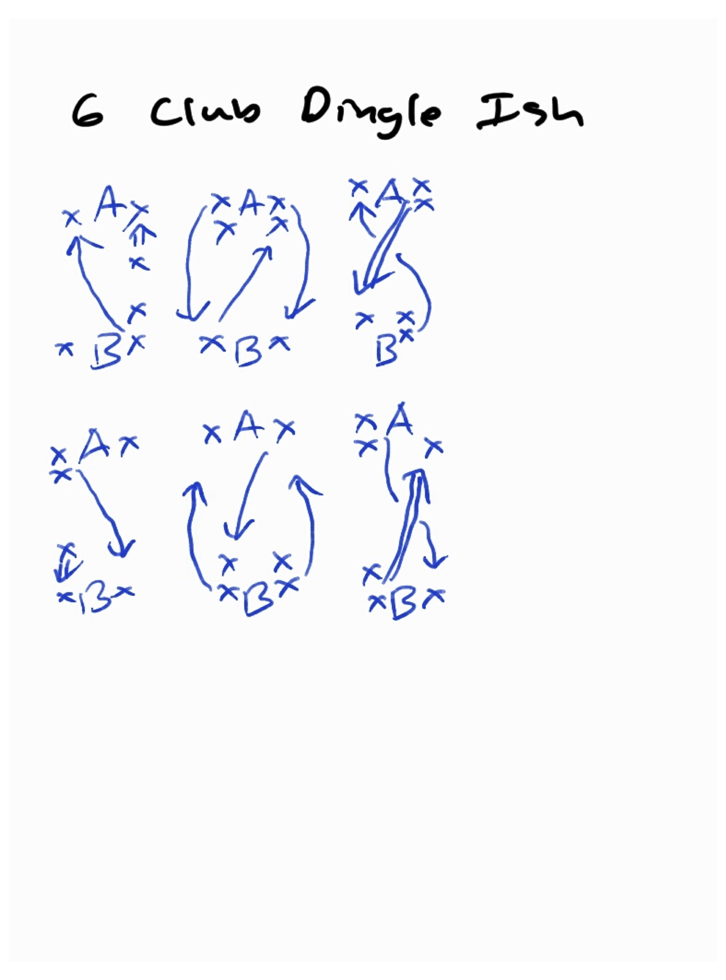

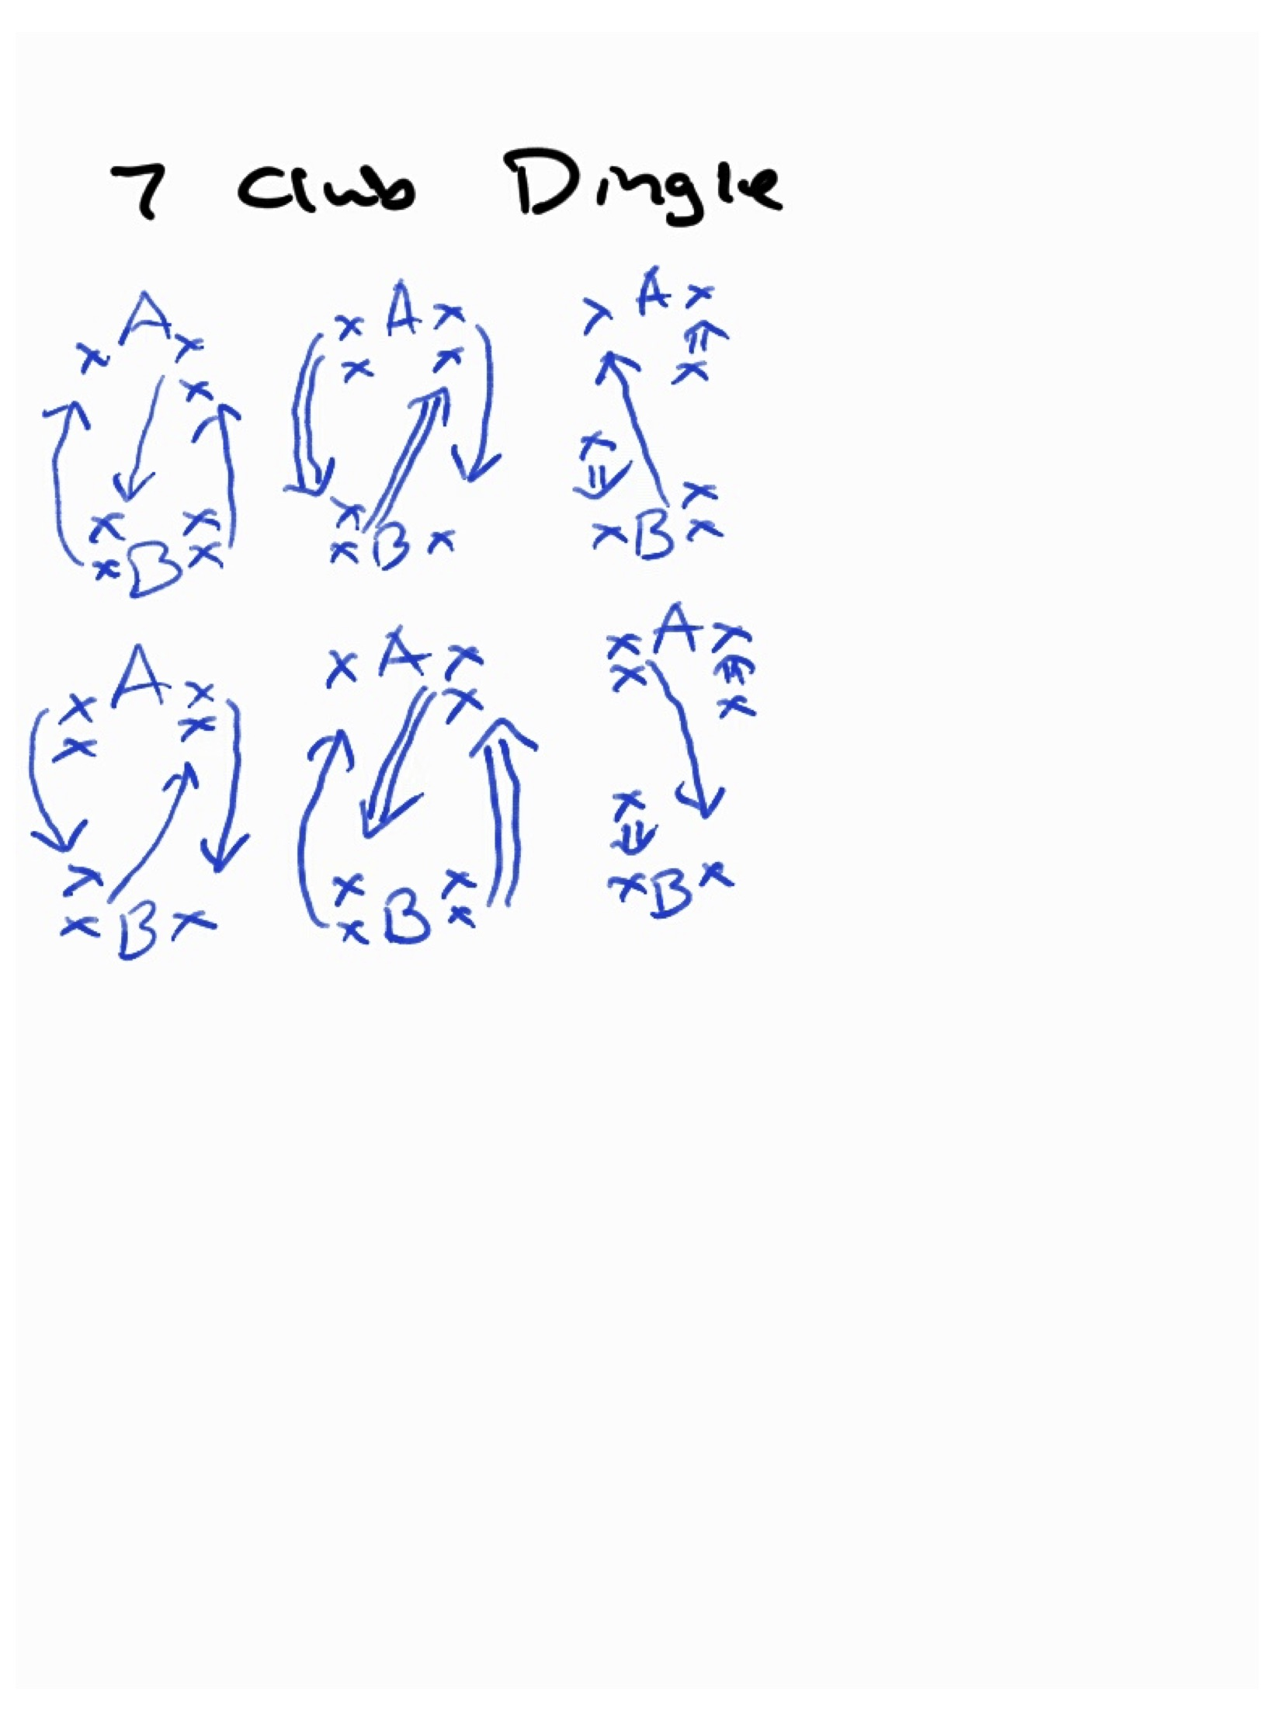

Pattern: It’s a good one. A feeder; B,C,D weaving; C starts in middle moving out to left

|  |  |  |  |  |  |  |  |  |  |  |  |  |
| --- | --- | --- | --- | --- | --- | --- | --- | --- | --- | --- | --- | --- |
| 4 jugglers/  both hands counting | 1 | 2 | 3 | 4 | 5 | 6 | 7 | 8 | 9 | 10 | 11 | 12 |
| A | C | - | C | - | B | - | B | - | D | - | D | - |
| B | - | D | - | - | A | - | A | - | - | C | - | - |
| C | A | - | A | - | - | D | - | - | - | B | - | - |
| D | - | B | - | - | - | C | - | - | A | - | A | - |

Pattern: Egg-Beater Twister



|  |  |  |  |  |  |  |  |  |
| --- | --- | --- | --- | --- | --- | --- | --- | --- |
| PASSES | | | |  |  |  |  |  |
|  | **A** | **B** | **C** | **D** | **E** | **F** | **G** | **H** |
| 1 | - | F | - | - | G | B | E | - |
| 2 | C |  | A |  | - | - | - | - |
| 3 | - |  | - | H | - | G | F | D |
| 4 | B | A | - | - | - | - | - | - |
| 5 | - | - | E | - | C | H | - | F |
| 6 | D |  | - | A | - | - | - | - |
| 7 | - | G | - | - | H | - | B | E |
| 8 | C | - | A | - | - | - | - | - |
| 9 | - |  | - | F | G | D | E | - |
| 10 | B | A | - | - | - | - | - | - |
| 11 | - | - | H | - | - | G | F | C |
| 12 | D |  | - | A | - | - | - | - |
| 13 | - | E | - | - | B | H | - | F |
| 14 | C | - | A | - | - | - | - | - |
| 15 | - | - | - | G | H | - | D | E |
| 16 | B | A | - | - | - | - | - | - |
| 17 | - | - | F | - | G | C | E | - |
| 18 | D | - | - | A | - | - | - | - |
| 19 | - | H | - | - | - | G | F | B |
| 20 | C | - | A | - | - | - | - | - |
| 21 | - | - | - | E | D | H | - | F |
| 22 | B | A | - | - | - | - | - | - |
| 23 | - |  | G | - | H | - | C | E |
| 24 | D | - | - | A | - | - | - | - |