# Project

You must create an e-market where subscribed users display used mobile phones available for sale.

|  |  |
| --- | --- |
| **Do Item** | **Done?** |
| 1. A new user is registered to the system (username, password, email) and then  logins. | 10 |
| 1. You should ask the user to activate his account be clicking on a link that you will send to his email after registration (you can skip activation if you find it hard). | 10 |
| 1. After login, land the registered user in his "own page" where he will be able to insert a single mobile phone details (insert mode), or view in a form the data he entered in the past and modify them (update mode). In update mode, provide a button to completely delete the mobile and its images (see #4). The fields to describe the mobile: brand, model, screen size, RAM size, storage size, color, price. | 10 |
| 1. All the form elements must be equipped with the right attributes (if possible) to help the user give proper input. Additionally a (simple) JavaScript form validator must be also implemented. | 10 |
| 1. The registered user should be able to upload as many photos of the phone as he likes (and delete any of them if he wants). | 10 |
| 1. The end user should be able to search for mobiles using a search form with at least 5 criteria (brand, model, RAM size, screen size, price range) – or less if you cannot do it like this! The user should be able to use any number of the available criteria (at least one). | 10 |
| 1. The search results should be displayed in HTML paginated with 4 results per page. You must have enough data in the database to demonstrate pagination. The user must be able to bookmark the results page, thus, creating pre-fabricated queries (see also #9 and #10). | 7 |
| 1. By clicking on a search result you should display the full phone details and images in a dedicated page. | 10 |
| 1. The home page must be the search page but should be enhanced with a few static and pre-fabricated queries, in the form of html links (like "Cheap iPhones", "For Gaming", etc). | 10 |
| 1. Modify the search mechanism to have an option for the type of the output. You must support three types of output: either “on screen / HTML” (default) or “XML” or “JSON”. For XML you should use the DOMDocument class of PHP. | Don’t do this! |

# Screenshots of the project with the required functions:

## Item 1: Signup functionality:



#

## Item 2: Login functionality:



## Item 2: Email to register with the verification code

This is the view of the database with a verification code and an timestamp when the email is verified. An automatic email is sent to the provided email address. For the verification and the automatic email that is sent, I used sendingBlue and their API. I had to remove my API-Key from the code because I have the project on Github.



This is the email that Is getting sent by the Webshop:

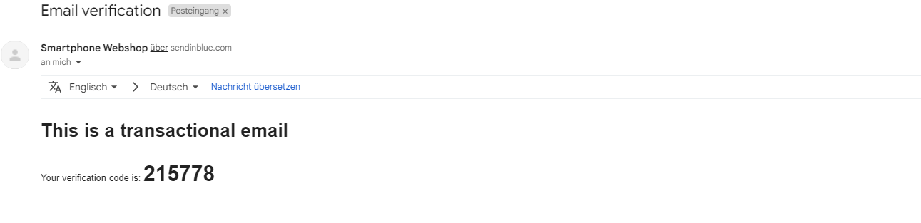

After that the registration is done and the user gets redirected to the login page and the database is setting a timestamp that the user is fully registered:

## Item 3: If the user is not logged in

Ein Bild, das Text enthält.

## Item 3: If the user is logged in

Ein Bild, das Text enthält.

## Item 3: Submenu upload your phone:

Ein Bild, das Text enthält.

## Item 3: Submenu View or Update Phone:

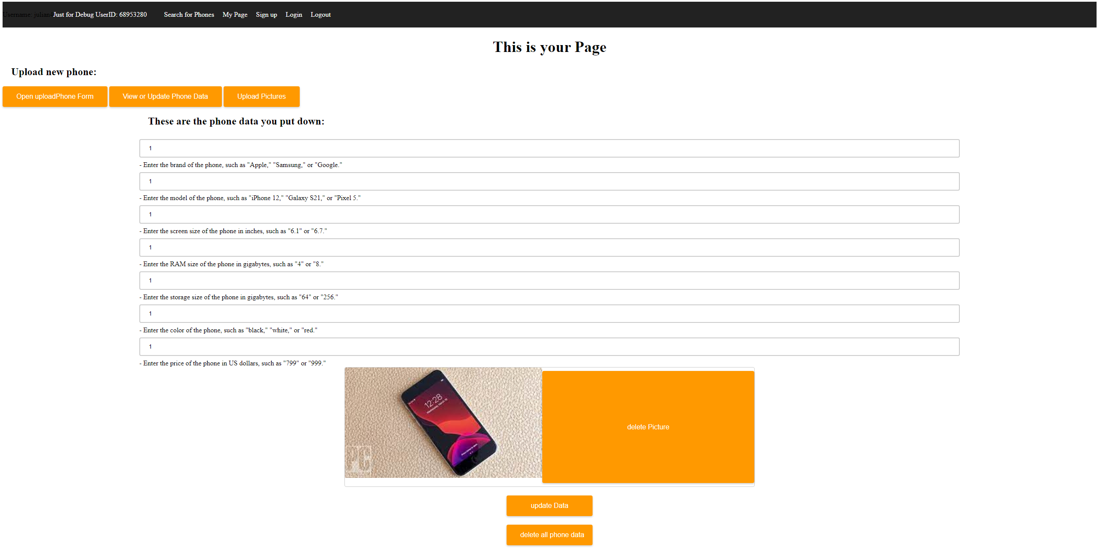

## Item 3: Upload Pictures:

Ein Bild, das Text enthält.

## Item 6: Search for Phones without search inputs:

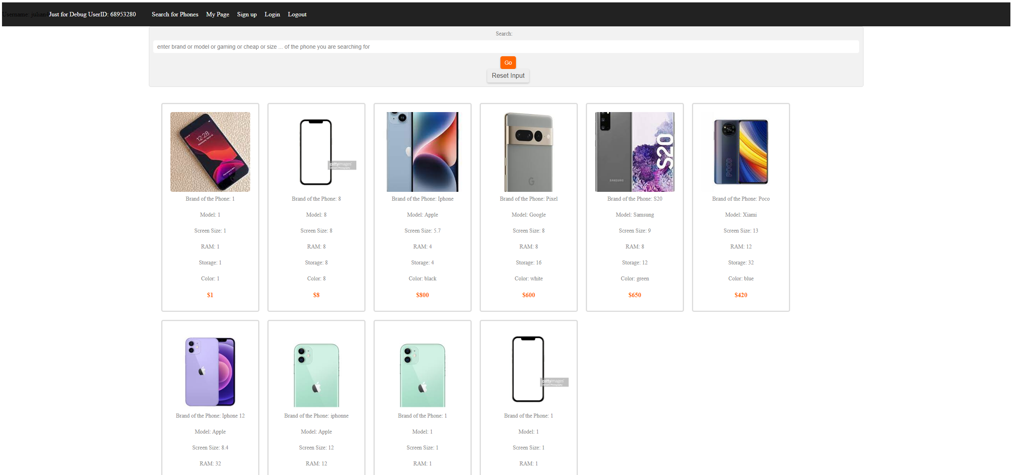

## Item 6: Search page with search input:

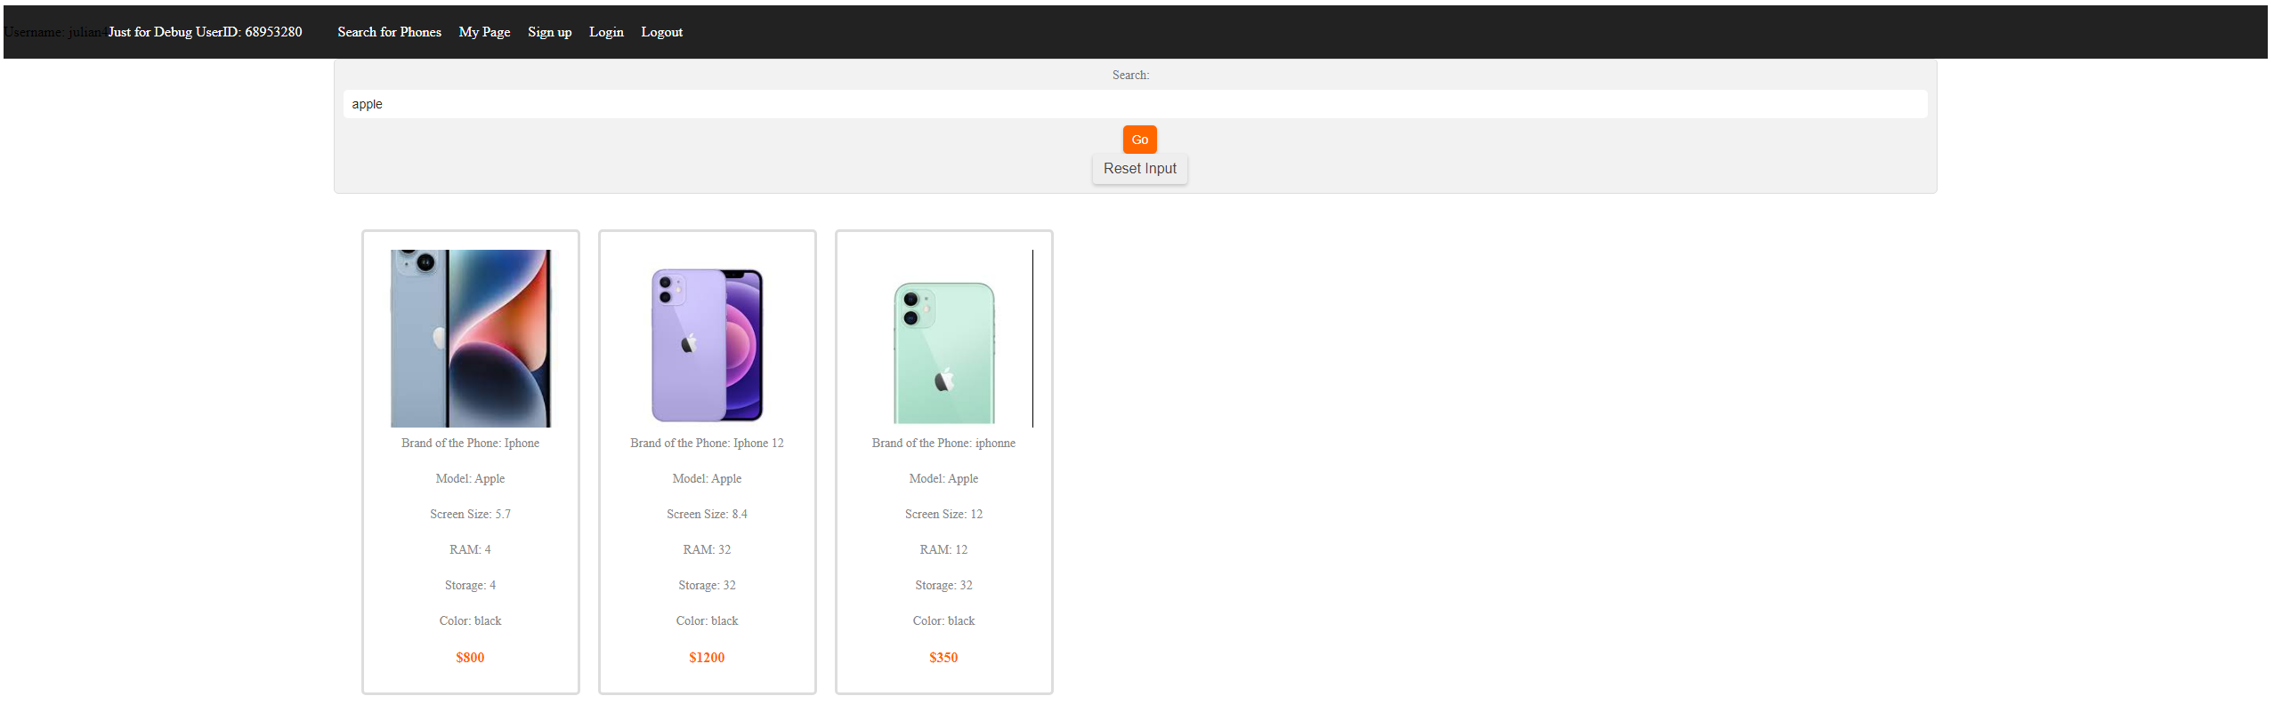

## Item 6/7: Search page with search input “gaming”:

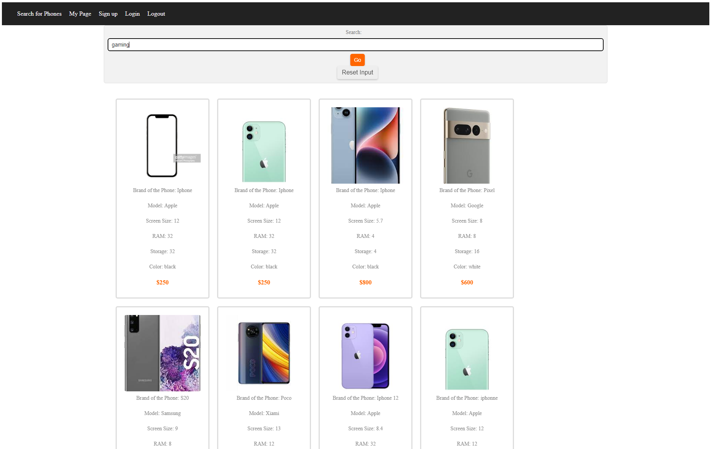

## Item 9: pre-fabricated queries in this example cheap or gaming:

