WEFESite Analyst Report: permontanha Case Study

WEFESiteAnalyst is an automatized remote data collection tool for the site-tailored planning of integrated Water-Energy-Food-Environment Systems (iWEFEs). This report presents findings and insights from the analysis of the case study for permontanha. The WEFESite Analyst tool aims to provide valuable information for decision-making and planning related to environmental factors, site suitability, and more. Thank you for using WEFESite Analyst for your case study analysis!

# Satellite Map

The map will be included once we figure out how to export it as an image.

# Terrain

This is an example of how the elevation layer can be exported. Note that the marked central point does not show up using this method.

**Elevation value at location:** 85 meters

# Landuse

The map will be included once we decide on which method to use.

**Cultivated Crops:** It says this gets inserted manually from interview results. Need to figure out how to present this then.

# Soil

|  |  |
| --- | --- |
| Parameter | Value |
| soil organic carbon [dg/kg] | 622.00 |
| bulk density [cg/cm³] | 139.00 |
| cation exchange capacity at pH 7 [mmol(c)/kg] | 187.00 |
| nitrogen content [cg/kg] | 3908.00 |

# Hydrology

The map will be included once the bug has been fixed

# Climate

## Solar Irradiance

**Total solar irradiance:** 1879.06 kWh/m^2/a

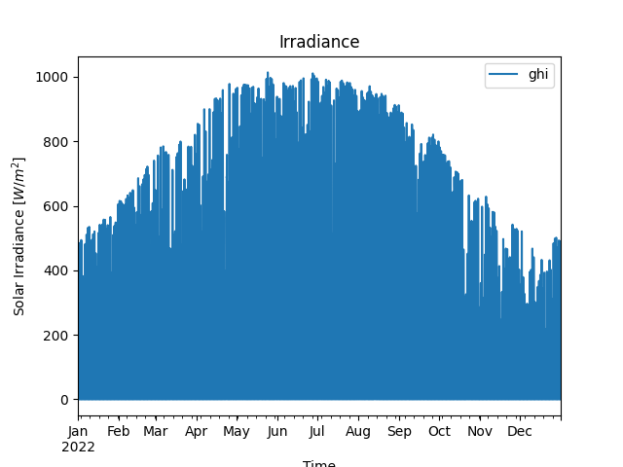

## Windspeed

**Average windspeed:** 3.96 m/s

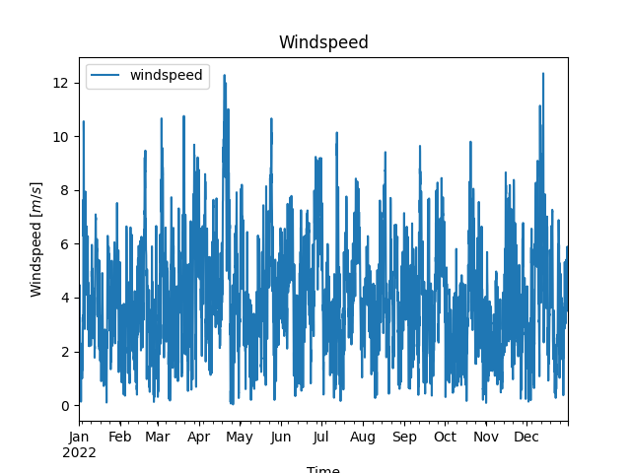

## Precipitation

**Total precipitation:** 474.27 mm

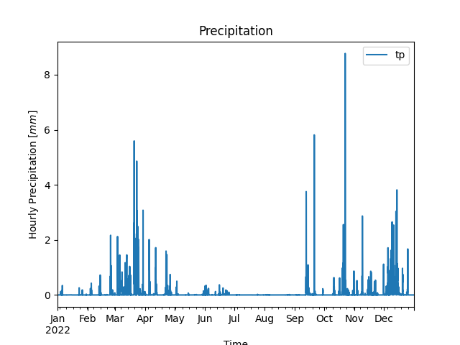

## Temperature

**Average temperature:** 17.36 °C

