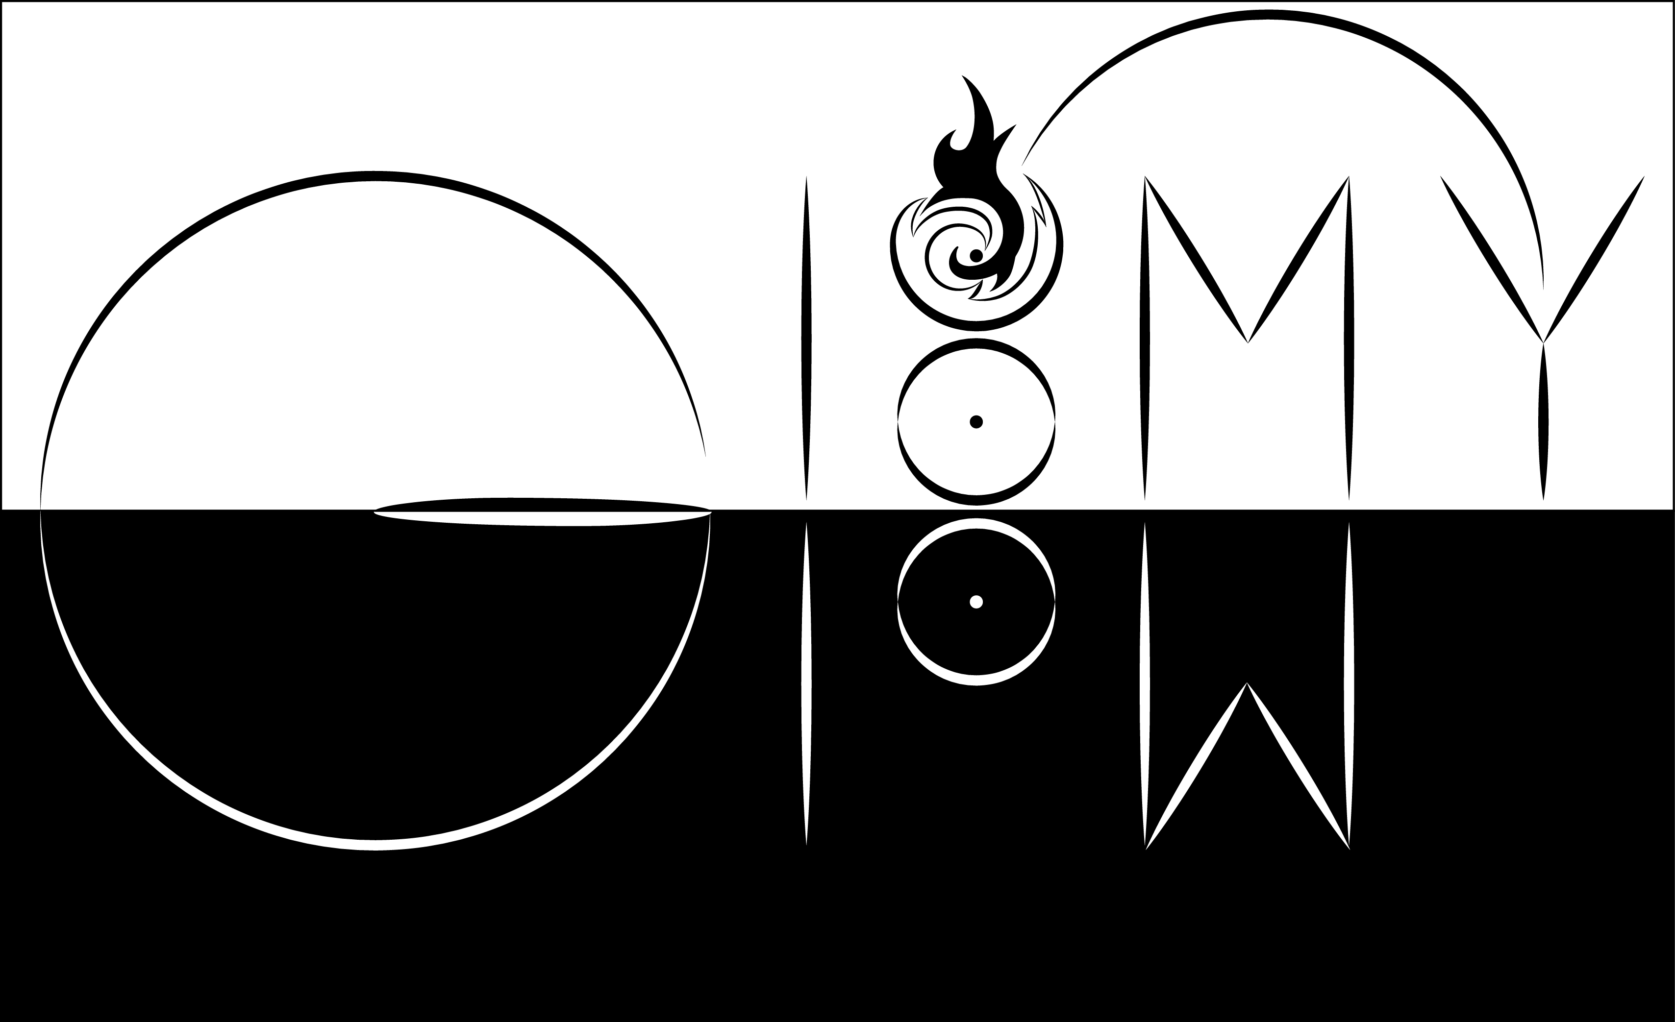

By Kayuzo

Gloomy Glow Studio

|  |  |  |
| --- | --- | --- |
|  |  |  |
|  |  |  |
|  |  |  |

Contents

Introduction 1

Description 2

Script 4

# Introduction



Hi, I'm a young developer whose the pseudo is *Kayuzo*. I have been working with Unity for 4 years. I have worked on many projects, and I’m embarking on a personal project. For this purpose, and to share my passion, I will put at the disposal the tools, scripts and other assets that I would have created for my video game **Gloomy Glow**.

This first tool is **Shadow Detect**. This is a easy way to detect that your character enters in a shadow. This script uses the raycasting system of Unity. This script is used to call event when a character enters (or exit) in a shadow, or detect the object which makes this shadow.

You can modify the **Shadow Detect** easily to evolve it. I’ll try to improve this script according to your comments. Do not hesitate if you have any questions or to give me any advices.

# Description

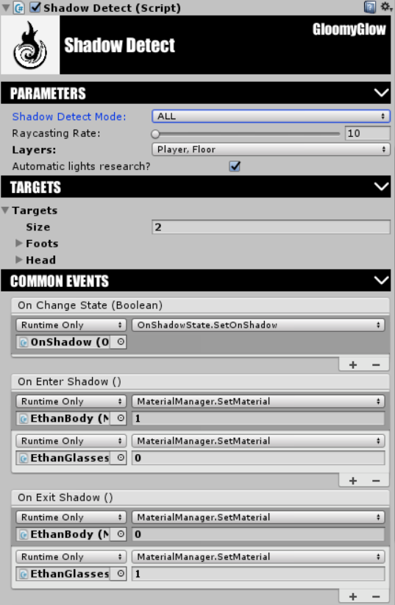

**Shadow Detect Mode** : This is the “mode” of detection. To call the events, it is necessary to be one of the targets in the shadow, or all the targets in the shadow.

**Raycasting rate** : This is the frequency to cast ray to detect object on shadow. Example : 10 means that the **Shadow detect tool** cast ray 10 times per seconds.

**Layers** : Choose the layers of GameObject which won’t hit by Raycast. It’s better to choose the layer of your character and the floor.

**Targets :** All targets used to detect if your GameObject is on shadow and call events per target if you want.

**On Change Event** : All function call when the GameObject enters or exits the shadow.

**On Enter Shadow** : All function call when the GameObject enters in the shadow.

**On Exit Shadow** : All function call when the GameObject exits the shadow.

**On Shadow** : All function call while the GameObject is in the shadow.

**Out Shadow** : All function call while the GameObject is out the shadow.

# Script

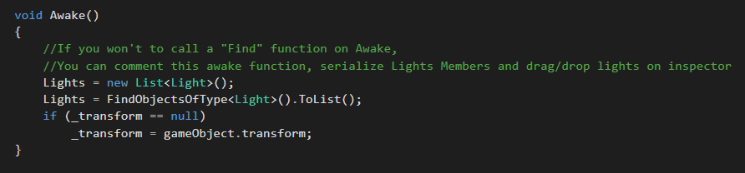

On awake, the script finds all light. You can also “comment” this part and set the member “Lights” public to set value of different light in inspector of Unity.

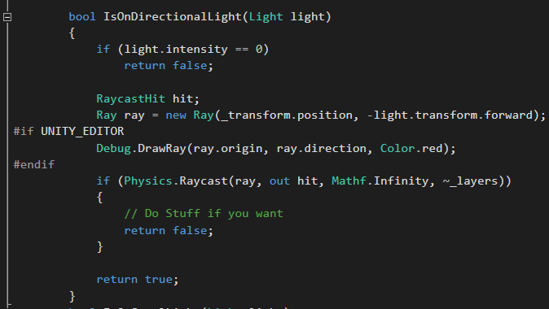

This function detects if a directional light hits your GameObject. You can modifiy this function on “if(Physics.Raycast…)” to know the object which makes the shadow.