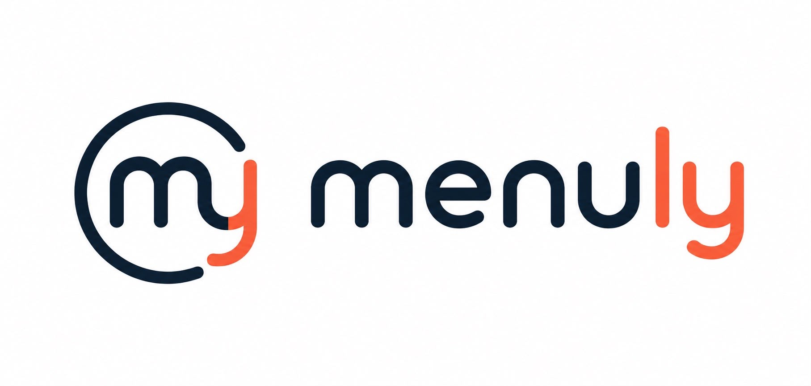
MENULY
BRAND BOOK
Identity system for interactive digital restaurant menus
Modern. Premium. Clear.

01

Brand essence
What Menuly should feel like at first glance
• A premium SaaS brand for restaurants that combines technology, elegance and speed.
• The identity should feel calm, modern and trustworthy, never loud or playful.
• The logo is the anchor: simple, memorable and easy to apply everywhere.

02

Logo system
Primary lockup, symbol and behavior
• Primary logo: horizontal lockup with symbol + wordmark.
• Secondary logo: symbol only for favicon, app icon and compact placements.
• Preferred background: white, ivory or very dark navy.
• Clear space: keep at least the height of the M around the logo on every side.
• Do not stretch, recolor or add effects.

Logo rules
Do | Dont
Use the horizontal mark on website headers, decks and emails.  Use the symbol alone in small spaces.  Keep generous breathing room. | Do not rotate.  Do not add shadows, bevels or gradients.  Do not place on busy photos.

03

Color
A restrained palette with one warm accent
Token | Role | HEX | Use
Navy | Primary ink | #0C1F30 | Wordmark, headings, dark UI
Coral | Accent | #F0643A | Details, highlights, CTA moments
Ivory | Base | #FBF8F3 | Backgrounds and premium fields
Slate | Secondary text | #64748B | Supporting copy and metadata

04

Typography
Editorial, legible and product-friendly
• Headline direction: elegant serif for premium brand moments.
• Body direction: clean sans serif for product, UI and explanations.
• Use the serif sparingly, mainly for the brand name and hero statements.
• Keep line lengths moderate and spacing calm.
Use | Recommended family | Fallback
Brand / headlines | Cormorant Garamond or Playfair Display | Georgia
Body / product | Arial or Inter | Segoe UI
UI labels | Arial Semibold or Inter Semibold | Arial Bold

05

Applications
How the system should appear in the real world
• Web header: use the horizontal logo on light backgrounds.
• App icon: use the symbol only, centered with generous padding.
• Sales deck: keep the cover simple and premium with a lot of negative space.
• Social avatars: use the symbol, never the full wordmark.
Brand voice: concise, polished and functional. The visual identity should make a restaurant feel modern without losing warmth.

06

Do not
Simple guardrails to protect the brand
• Do not use saturated colors outside the palette.
• Do not put the logo inside a badge, circle or container unless the use case requires it.
• Do not mix font styles randomly.
• Do not add illustrations that compete with the logo.

