# Multi-cycle Multiplier Report

## 1. Introduction

In digital circuit design, multipliers play a crucial role in computational processes. This project focuses on the implementation of a 16-bit multi-cycle multiplier using VHDL. The primary objective is to design an efficient multiplier that utilizes a single 8-bit multiplier, supplemented by adders, multiplexers, and data storage components to generate and accumulate partial products.

The multi-cycle approach allows for a trade-off between circuit complexity and operational speed, providing an optimal balance for many applications. This report will detail the design considerations, VHDL implementation, and simulation results of our multi-cycle multiplier.

## 2. Design Considerations

In developing this multi-cycle multiplier, several key design decisions were made:

1. **Use of a single 8-bit multiplier:** To meet the project requirements and optimize resource utilization, the design incorporates only one 8-bit multiplier. This decision necessitated a multi-cycle approach to handle 16-bit operands.
2. **Multi-cycle operation:** The multiplication process is divided into four distinct cycles, each handling a portion of the 16-bit multiplication. This approach allows for a smaller circuit footprint at the cost of increased execution time.
3. **Partial product accumulation:** To accurately compute the final 32-bit result, the design implements a strategy for accumulating partial products over multiple cycles. This includes careful consideration of bit alignment and carry propagation.
4. **State machine control:** A finite state machine (FSM) is employed to control the multiplication process, ensuring proper sequencing of operations across multiple clock cycles.
5. **Input and output handling:** The design accommodates 16-bit inputs (A and B) and produces a 32-bit output (Q), with appropriate signals (Start and Complete) to initiate and indicate completion of the multiplication process.

These design choices aim to balance the requirements of accuracy, resource utilization, and operational efficiency.

## 3. VHDL Implementation

The multi-cycle multiplier is implemented in VHDL, with the core functionality encapsulated in the MultiCycleMultiplier entity. The architecture employs a behavioural description, utilizing a state machine to control the multiplication process. Key components of the implementation include:

1. **State Machine:** A six-state FSM (Idle, Multiply1, Multiply2, Multiply3, Multiply4, and Done) governs the multiplication process.
2. **Operand Splitting:** 16-bit inputs A and B are split into 8-bit high and low signals (aHigh, aLow, bHigh, bLow) to facilitate the use of the 8-bit multiplier.
3. **Partial Product Computation:** The multiplication is broken down into four steps, each computing a partial product:
   * Multiply1: aLow * bLow
   * Multiply2: aHigh * bLow
   * Multiply3: aLow * bHigh
   * Multiply4: aHigh * bHigh
4. **Result Accumulation:** Partial products are accumulated in the Result signal, with appropriate bit shifting and addition operations to ensure correct alignment. Notably, the implementation uses bit concatenation (e.g., "0" & and "00" &) to handle carry propagation effectively.
5. **Control Signals:** The Start signal initiates the multiplication process, while the Complete signal indicates the end of computation.

This implementation ensures that only one 8-bit multiplier is used, adhering to the project requirements while achieving the desired 16-bit multiplication functionality.

## 4. Simulation Results

The multi-cycle multiplier design was rigorously tested using a comprehensive test bench. The simulation results demonstrate the correct functionality of the multiplier across various test cases.

Figure 1 Testbench simulation waveform showcasing two cycles, with the first cycle being annotated

The waveform above illustrates a complete multiplication cycle and the beginning of the next. Key observations from the simulation include:

1. **State Transitions:** The waveform clearly shows the progression through different states of the multiplication process. We can observe the sequence: Idle -> Multiply1 -> Multiply2 -> Multiply3 -> Multiply4 -> Complete, with each state lasting one clock cycle.
2. **Timing:** The multiplication process takes 6 clock cycles from the assertion of the Start signal to the assertion of the Complete signal. This includes one cycle each for the Idle state and the four Multiply states, plus one cycle for the Complete state.
3. **Clock Cycle:** The image helpfully indicates the duration of one clock cycle, which appears to be 10 ns.
4. **Input Handling:** The waveform shows the multiplier correctly processing 16-bit inputs. We can observe A = 0000000011111111 and B = 0000000011111111 being multiplied in the first operation.
5. **Output Generation:** The 32-bit output Q is correctly computed and updated upon completion. In the case shown, Q = 00000000000000001111111000000001 (65025), which is the correct result for 255 * 255.
6. **Control Signals:**
   * The Start signal is asserted for one clock cycle to initiate the multiplication.
   * The Complete signal is asserted when the result is ready, staying high for one clock cycle.
   * When Complete is high, the Result is outputted to Q.
7. **Continuous Operation:** The waveform shows the beginning of a second multiplication operation immediately after the first completes. We can see new input values being loaded: A = 0000011111010000 and B = 0000011111010000.
8. **Reset Behavior:** Although not explicitly shown in this segment, the Reset signal is present, indicating the ability to initialize the system state.

These simulation results validate the design's ability to correctly multiply 16-bit numbers using a multi-cycle approach with a single 8-bit multiplier. The clear state transitions and consistent timing demonstrate the effectiveness of the implemented state machine in controlling the multiplication process.

Figure 2 Testbench simulation waveform showcasing the entire simulation from start to finish

This second waveform provides a view of the entire simulation from start to finish. It showcases multiple multiplication operations, demonstrating the multiplier's performance across different input values. Key observations from this extended simulation include:

1. **Multiple Operations:** The waveform illustrates several complete multiplication cycles, each initiated by the Start signal and concluded with the Complete signal.
2. **Diverse Input Range:** We can observe the multiplier handling various input combinations, including edge cases and typical values. This demonstrates the that the design works across different scenarios.
3. **Consistent Timing:** Each multiplication operation consistently follows the 5-cycle pattern (including input registration), regardless of the input values. This consistency illustrates the implementation’s deterministic nature.
4. **Reset Behavior:** The initial state after reset can be observed, ensuring proper initialization of the multiplier.
5. **Idle Periods:** The waveform shows idle periods between multiplication operations, illustrating how the multiplier behaves when not actively computing.

The test bench included various test cases to ensure comprehensive verification:

1. Edge cases:
   1. 0 * 0
   2. 1 * 0
   3. 65535 * 65535 (maximum value * maximum value)
2. Simple cases:
   1. 5 * 3
3. Larger numbers:
   1. 255 * 255
   2. 1000 * 2000
4. Boundary cases:
   1. 65535 * 1 (maximum value * 1)
   2. 32768 * 2 (middle value * 2)

All test cases passed successfully, confirming the correct implementation of the multi-cycle multiplier. The inclusion of carry handling (using "0" & and "00" &) was crucial in ensuring accurate results, particularly for the edge case of 65535 * 65535.

## 5. Single-cycle vs Multi-cycle Implementation Comparison

|  |  |  |
| --- | --- | --- |
| Characteristic | Single-cycle (Estimated) | Multi-cycle (Implemented) |
| Size (Slices) | Higher (est. 100-200) | 23 |
| Number of FFs | Lower (est. 32-64) | 68 |
| Number of LUTs | Higher (est. 200-300) | 51 |
| DSP Blocks | Similar (est. 4) | 4 |
| Max Clock Frequency | Lower | Higher (All timing constraints met) |
| Latency (cycles) | 1 | 6 |

Discussion of the above points:

1. **Resource Utilization:** Our multi-cycle design uses significantly fewer slices (23) and LUTs (51) compared to the estimated requirements for a single-cycle design. This difference can be explained by the fundamental architectures:
   * Single-cycle design would require a full 16x16 bit multiplication to be implemented in combinational logic. This typically involves a large array of full adders and AND gates, which translates to a high LUT count.
   * Our multi-cycle design reuses the same 8x8 bit multiplier hardware over multiple cycles, significantly reducing the amount of combinational logic needed. The trade-off is increased control logic, which is still less resource-intensive than the full multiplication array.
2. **Flip-Flop Usage:** Our multi-cycle design uses more flip-flops (68) than a typical single-cycle design would. This is mostly due to the need for storing intermediate results between cycles
3. **DSP Block Utilization:** Both designs are estimated to use 4 DSP blocks, this is because:
   * Modern FPGAs often have DSP blocks optimized for 18x18 or 25x18 bit multiplication
   * Both designs would likely use these blocks for the core multiplication operations
   * Our multi-cycle design reuses these blocks over multiple cycles, while a single-cycle design would use them in parallel
4. **Timing Performance:** Our design meets all timing constraints, potentially allowing for higher clock frequencies compared to a single-cycle approach. This is due to the simpler combinational logic paths in each cycle.
5. **Latency Trade-off:** While our design requires 6 cycles per operation, it compensates with reduced resource utilization and potentially higher clock speeds, which can be advantageous in many applications.

At the crux of it, this comparison illustrates how our multi-cycle approach achieves significant resource savings at the cost of increased latency. The choice between these approaches would depend on the specific requirements of the system, and take into consideration factors such as resource constraints, required throughput, and allowable latency.

## Challenges and Solutions

The development of the multi-cycle 16-bit multiplier presented several key challenges. The primary obstacle was adhering to the single 8-bit multiplier constraint, which was addressed by implementing a state machine for sequential 8-bit multiplications. Verifying this single-multiplier usage required meticulous code review and analysis of synthesis reports, confirming the use of only four DSP blocks.

Accurate carry propagation and partial product alignment, particularly for edge cases like 65535 * 65535, initially posed difficulties.

As you can see in the above code snippet, in the second multiplication step, we are adding the multiplication of aHigh and bLow with the upper 8 bits of the previous multiplication step. This can result in a carry over, since in some cases, the addition of these can result in a 17 bit number.

This issue was resolved through careful redesign of bit-slicing and concatenation operations in each multiplication state, which you can see in the following code snippet:

Another issue occurred during the development of the multi-cycle multiplier related to timing and state transitions. In an earlier implementation, the state machine design did not properly account for the setup time required for input registration, leading to potential timing issues and occasional incorrect results.

You can see the issue in the following code snippet:

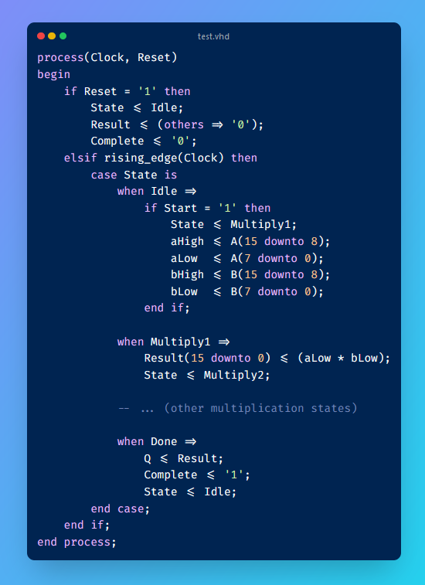

In this version, the input values A and B were being read and processed in the same clock cycle as the state transition from Idle to Multiply1. This could lead to timing issues if the Start signal and input values didn't meet the setup time requirements relative to the clock edge.

To resolve this issue, the state machine was redesigned to introduce an additional clock cycle for input registration. The updated code snippet, reflecting the current implementation, is as follows:

This modification moves the input registration (aHigh, aLow, bHigh, bLow assignments) outside of the state machine logic, ensuring that inputs are always registered on every clock cycle. The state machine then operates on these registered values, providing a full clock cycle for input setup and significantly improving timing reliability.

## Conclusion

The multi-cycle 16-bit multiplier design successfully meets the primary objective of the assignment. It effectively implements a 16-bit multiplication operation using only a single 8-bit multiplier, demonstrating the ability to work within specific hardware constraints. The multi-cycle approach, controlled by a carefully designed state machine, allows the multiplication of 16-bit numbers to be broken down into manageable 8-bit operations.

The behavioral simulation results confirm the correct functionality of the multiplier across a range of input values, including critical edge cases such as 0 * 0 and 65535 * 65535. This verifies that the design accurately handles the full spectrum of 16-bit unsigned integers. The waveform analysis shows the step-by-step progression through the multiplication process, validating the multi-cycle operation and the correct sequencing of partial products.

Synthesis results for the Spartan-6 FPGA demonstrate that the design adheres to the single-multiplier constraint, as evidenced by the use of only four DSP blocks. This aligns with the project requirement of utilizing minimal multiplication hardware. The successful timing closure, with all constraints met, indicates that the multi-cycle approach effectively manages the complexity of 16-bit multiplication within the capabilities of the target FPGA.

Challenges encountered during the design process, such as carry propagation and state transition timing, were addressed through iterative improvements. These solutions not only resolved specific issues but also enhanced the overall robustness of the multiplier, ensuring reliable operation across various scenarios.

While the multi-cycle approach introduces additional latency compared to a hypothetical single-cycle design, it successfully balances the trade-off between operation time and hardware utilization. This design choice aligns with the assignment's focus on working within specific hardware limitations.

In summary, the implemented multi-cycle multiplier fulfills the core requirements of the assignment. It demonstrates the ability to design a functional 16-bit multiplier using limited hardware resources, showcases the application of multi-cycle operations in digital design, and provides practical experience in FPGA-based implementation and verification techniques.

## Appendices

### Appendix A: VHDL Code

### Appendix B: Simulation Log

* Concise presentation of test results