Setup Python Development Environment

# Windows

## Install Python

1. Go to <https://www.python.org/downloads/>
2. Download Python 3.10.2
3. Click on the python-3.10.2-amd64.exe file to install Python
4. Accept the install default settings, click next until Python is installed.

## Install Visual Studio Code

1. Go to <https://code.visualstudio.com/download>
2. Download the Windows Version
3. Click on the VSCodeUserSetup-x64-1.63.2.exe file to install Visual Studio Code
4. Accept the default settings, click next until the installation is complete

## Install Visual Studio Code Python Extension

1. Open Visual Studio Code
2. Open the Extensions dialog: from the far left panel, click on the Extensions icon Application, icon

   Description automatically generated or type Ctl Shift X  
   Graphical user interface, text, application

   Description automatically generated
3. In the Search Extensions edit box type Python
4. Select the Microsoft Python extension  
   Graphical user interface, application

   Description automatically generated
5. Click on Install  
   Graphical user interface

   Description automatically generated

## Test the installation

1. From the menu create a new file: File->New File, name the file hello.
2. From the menu select File-Save As, file name hello, Save as type: Python  
   Graphical user interface, text, application, email

   Description automatically generated
3. Click Save
4. Type print(‘hello’) at the top of the file, Save your changes
5. From the upper right corner, run the program by clicking on the play button.  
   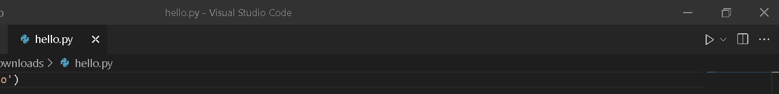



1. Hello displays in a terminal window at the bottom of the screen.  
   Text

   Description automatically generated

