**HOW TO MEASURE FOR VENETIAN BLINDS**

***RECESS MOUNT (Mounting on the inside of window)***

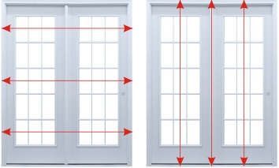

1. **Width –** Measure at three different locations (top, centre and bottom) on the inside of window from left to right. Measure to the closest millimetre. Deduct 7 to 10mm from the narrowest measurement. Round off to the closest 5mm and record this measurement as the Width.
2. **Height:** Measure at three different locations on the inside of window from top of the reveal to the window sill. Measure to the closest millimetre. Deduct 5mm from the shortest measurement. Round off to the closest 5mm and record this measurement as the Height.

***FACE FIX (Mounting on the outside of the window)***



1. **Width –** Measure at three different locations (top, centre and bottom) on the inside of window from left to right. Measure to the closest millimetre. We suggest an overlap of 100mm on either side for privacy and light control. Add the overlap measurement to the largest window width measurement. Round off to the closest 5mm and record this measurement as the Width.
2. **Height:** Measure at three different locations on the inside of window from top of the reveal to the window sill. Measure to the closest millimetre. We suggest an overlap of 100mm at the top and an additional 100mm at the bottom if required. Add the overlap measurement to the largest window height measurement. Round off to the closest 5mm and record this measurement as the Height.