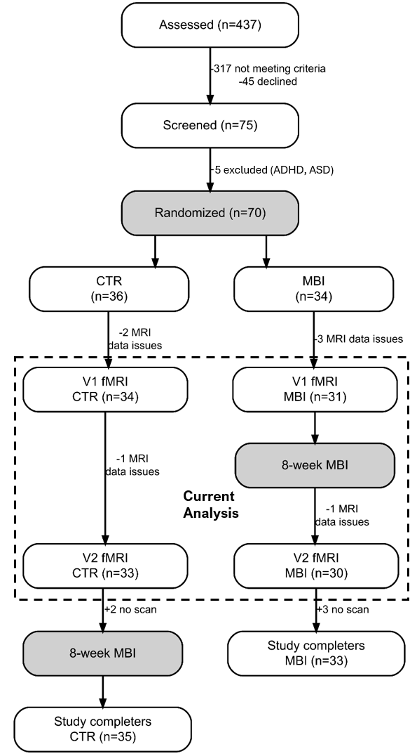

Figure 1: CONSORT flow diagram. ADHD, attention-deficit/hyperactivity disorder; ASD, autism spectrum disorder; MBI, mindfulness-based intervention. FMRI, functional magnetic resonance imaging.

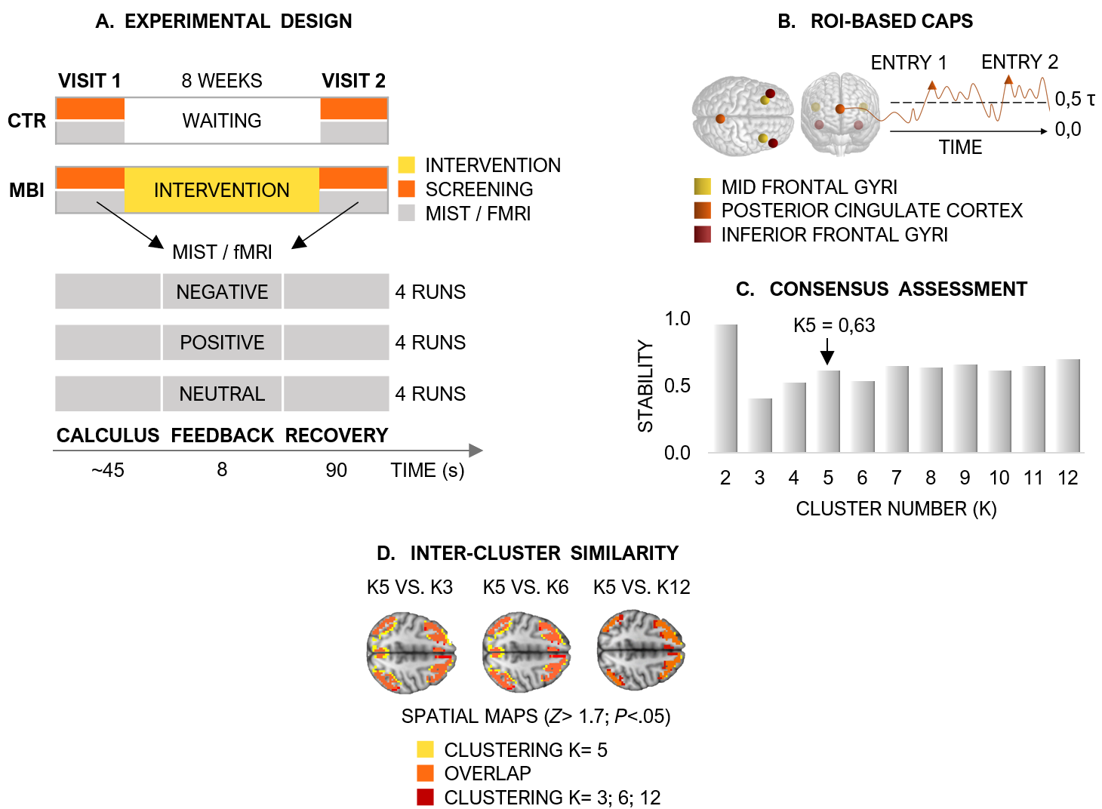
Figure 2. A. Experimental design. Longitudinal randomized controlled trial with two groups. MBI group: MIST/fMRI at Visit 1 (V1), 8-week MBI intervention, then MIST/fMRI at Visit 2 (V2). CTR group: MIST/fMRI at V1, 8-week waiting period (no intervention), then MIST/fMRI at V2. The Montreal Imaging Stress Task (MIST) included arithmetic calculations (max. 45 seconds), performance feedback (8 seconds), and a recovery resting-state period (90 seconds), with three types of affective feedback: negative, positive, and neutral; 4 runs each. The CAPs were computed on the recovery resting state period. B. ROI-based co-activation patterns. Six 6-mm spherical brain regions of interest (ROIs) were selected for CAP analysis: bilateral mid frontal gyri (yellow, MNI coordinates: -42, 34, 20/44, 36, 20), bilateral posterior cingulate gyri (orange, MNI coordinates: 1, -55, 17), and inferior frontal gyri (red, MNI: 32, 26, -14/38, 22, -10). Activity time courses from each seed were computed separately for each subject, and frames exceeding a positive threshold (seed > 0.5) were tagged. Entry rates quantified temporal expression over fMRI scanning. C. Consensus assessment. Stability plot indicates clustering quality at assessed k (k=2 to k=12), providing a quantitative metric suggesting k=5 as the optimal number of clusters for classifying the fMRI dataset. D. Intercluster similarity analysis. Spatial maps were compared to identify CAPs with the greatest consistency and reliability across different clustering scenarios (e.g., K=5 vs. K=3, K=6, K=12).

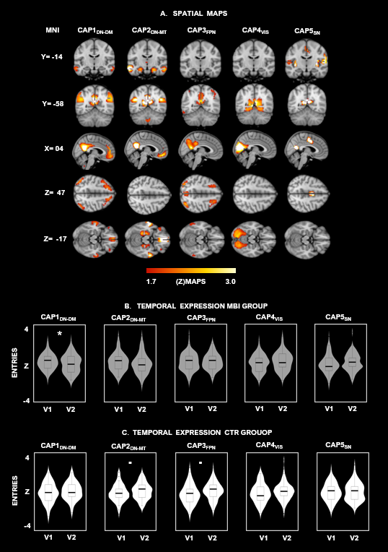

Figure 3. Brain maps depict the five co-activation patterns identified by the PCC-based co-activation patterns (CAPs) analysis. A. The spatial maps of each CAP are illustrated with a threshold of [z > 1.7 (p<.05); yellow color code]. Further anatomical information on peak regions is provided in Tables S3, S4, S5, S6, and S7, respectively. B, C. Violin plots depicting the median (horizontal black lines), the interquartile range (box markers), and the probability density (vertical histograms) of each CAP expression (entries) across groups [“MBI” (grey color), and “CTR” (white color)] and measurements collected before (V1) and following (V2) the mindfulness-based intervention (MBI) or waiting period. Inferential statistics on the temporal entry rates are reported in Table S1,S2. * p<0.05; . p<0.1.

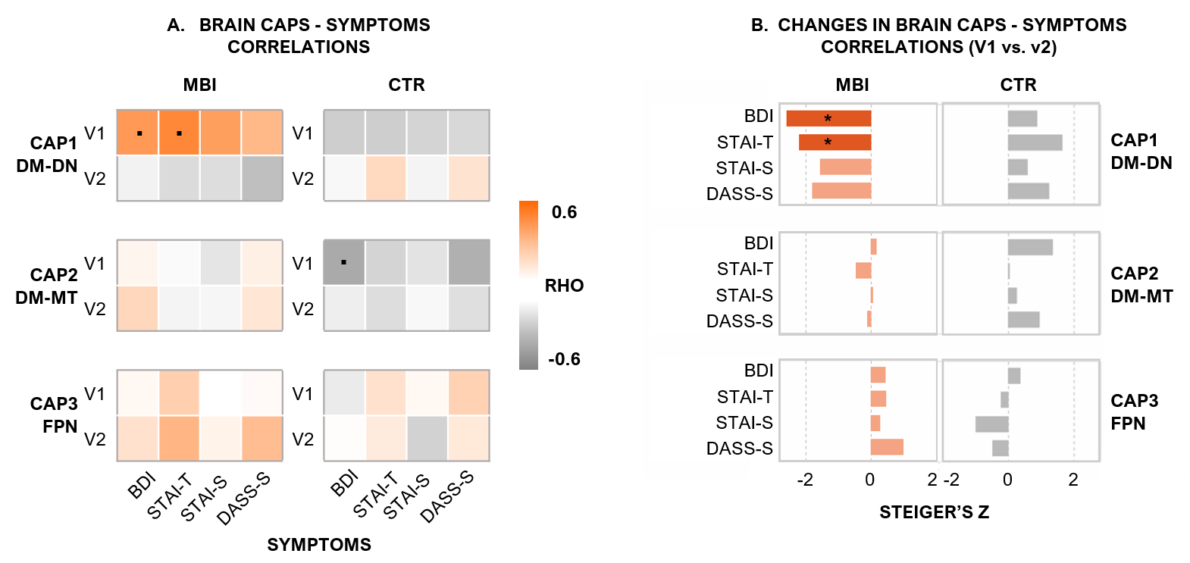

Figure 4. Brain CAP–symptom associations and their longitudinal changes. (A) Spearman correlations (RHO) between CAP entry rates and clinical symptoms at V1 and V2 for MBI (left) and CTR (right) groups. Color intensity reflects correlation magnitude (orange = positive, gray = negative). Dots indicate uncorrected p < .05. CAP1_{DM-DN} showed the strongest symptom associations at V1 in the MBI group, particularly with BDI and STAI-T. (B) Steiger's Z-tests quantifying V1→V2 changes in correlation strength. Dark bars denote significant changes (p < .05, FDR-corrected); light bars denote nonsignificant changes. Asterisks mark FDR-corrected significance. Only CAP1_{DM-DN} in the MBI group showed significant weakening of brain–symptom correlations from V1 to V2 (BDI: Z = −2.59; STAI-T: Z = −2.21), with no significant changes in CTR. BDI = Beck Depression Inventory; STAI-T = State-Trait Anxiety Inventory–Trait; STAI-S = State-Trait Anxiety Inventory–State; DASS-S = Depression Anxiety Stress Scale–Stress subscale.

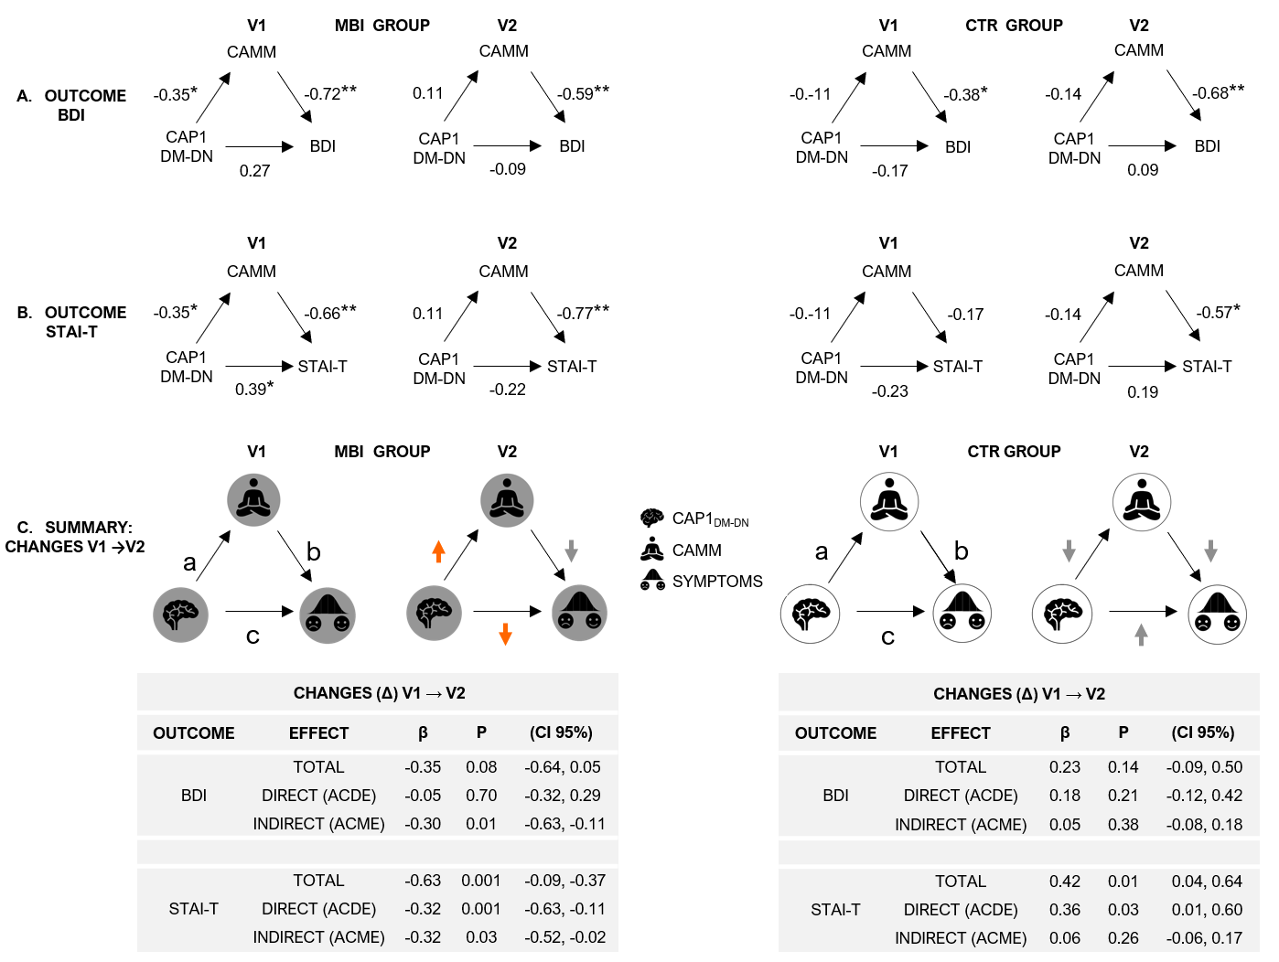

Figure 5. Mindfulness intervention effects on brain–symptom coupling and mediation mechanisms. A–B. Cross-sectional mediation at V1 and V2 for BDI (A) and STAI-T (B) in MBI (left) and CTR (right) groups. Path a: CAP1_{DM-DN} → CAMM; Path b: CAMM → Symptoms (controlling for CAP1_{DM-DN} ); Path c′: direct effect (CAP1_{DM-DN} → Symptoms, controlling for CAMM). Asterisks denote HC3-corrected significance (*p < .05, **p < .01). C. Summary of longitudinal mediation changes (V1→V2). Orange arrows indicate paths whose direction reversed post-MBI — notably Path a (negative → positive) and total effect Path c (positive → negative). Tables report longitudinal changes (Δ = V2 − V1) in total, direct (ACDE), and indirect (ACME) effects with standardized β, p-values, and 95% bootstrap CIs. Brain icon = CAP1_{DM-DN} ; meditation icon = CAMM; emotion icon = clinical symptoms (BDI, STAI-T). Full estimates in Tables S5–S6. p < .05 (FDR-corrected).

Tables

 | Mean (SE)
VARIABLE |  | All (70) | Treatments (33) | Controls (36) | Range
Age (years) |  | 14,30 (0,11) | 14,29 (0,15) | 14,30 (0,15) | 13,07 -16,01
Duration between scans |  | 99.81 (31.53) | 108.56 (28.95) | 92.03 (32.06) | 49-196
Gender (F/M) |  | 41/29 | 22/11 | 18/18 | -
Puberty (No/Yes) |  | 20/47 | 6/27 | 10/26 | -
Difficulties (KSADS) (No/Yes) |  | 56/13 | 29/4 | 27/9 | -
Social phobia (No/Yes) |  | 63/7 | 28/5 | 34/2 | -
GAD (No/Yes) |  | 69/9 | 27/6 | 33/3 | -
STAI-S |  | 36.46 (0.93) | 37.51 (1.49) | 35.56 (1.16) | -
STAI-T |  | 31.77 (0.71) | 31.34 (0.97) | 32.14 (1.02) | -
BDI |  | 9.91 (0.95) | 10.88 (1.61) | 9.09 (1.11) | -
DASS-A |  | 3.52 (0.44) | 3.55 (0.57) | 3.49 (0.67) | -
DASS-D |  | 4.54 (0.52) | 4.74 (0.91) | 4.36 (0.58) | -
DASS-S |  | 5.30 (0.53) | 5.51 (0.86) | 5.11 (0.67) | -
CAMM |  | 27.02 (0.94) | 26.6 (1.4) | 27.4 (1.2) | -

Table 1. Descriptive of the Mindfulteen Study sample. Abbreviations: MBI: Mindfulness-based intervention. GDA: generalized anxiety disorder. COVID: Coronavirus disease 2019. STAI: State/trait anxiety inventory. BDI: Beck depression inventory. DASS: Depression Anxiety Stress Scales. CAMM: Child and Adolescent Mindfulness Measure.

Brain | Coordinates | Reference related to
region of interest (ROI) | (MNI) | Stress | Anxiety | Depression
Middle Frontal Gyrus (L) | -42, 34, 20 | 38–40 | 41–43 | 44,45
Middle Frontal Gyrus (R) | 44, 36, 20 | 46,47 | 48–50 | 50–56
Inferior Frontal Gyrus (L) | -32, 26, -14 | 57,58 | 41,69–73 | 59,61–65
Inferior Frontal Gyrus (R) | 38, 22, -10 | 59,61–65 | 4,32–36 | 64,74,75
Precuneus (b) | 1, -55, 17 | 76,77 | 42,78–80 | 81–86
Table 2. Metanalytical assessment of the predefined ROIs. Brain regions of interest (ROIs) previously associated with the neural processing of stress, anxiety, and depressive symptoms. The reference numbers correspond to the bibliographical index for each study.

