# **ArrayLists Data Structure**

## **ArrayListPayRollProject**

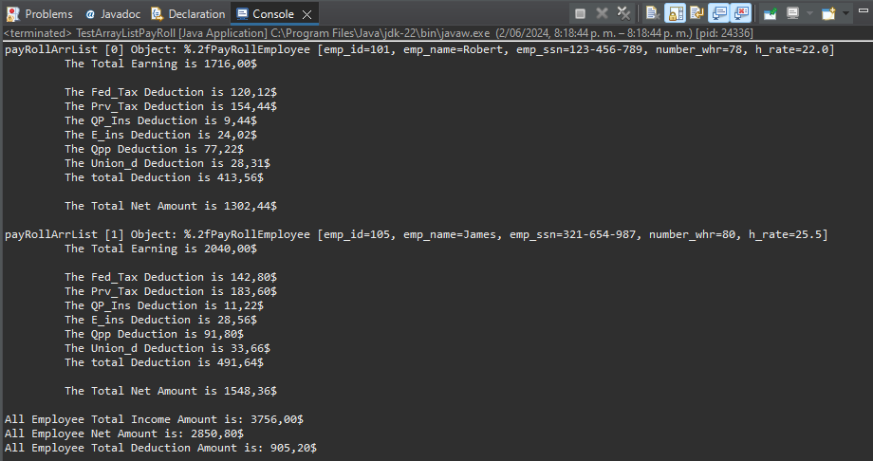

# **Linked List**

## **LinkedList1**

## **TestLinkedList2**

## **LinkedListCourseProject**

## **Linked List Project: ProjectThreeLinkedList**

