*Browser Testing*

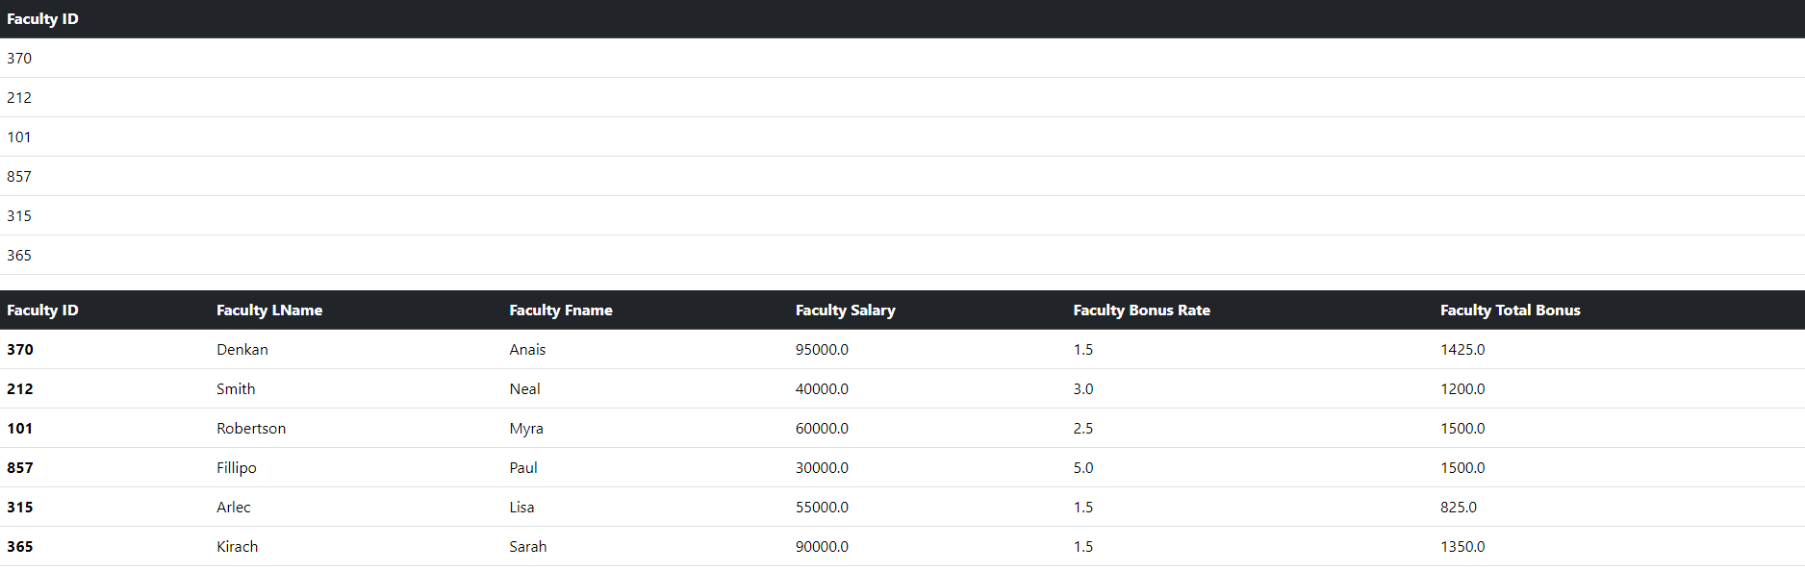

*Curl Testing*

*Postman Testing 1*

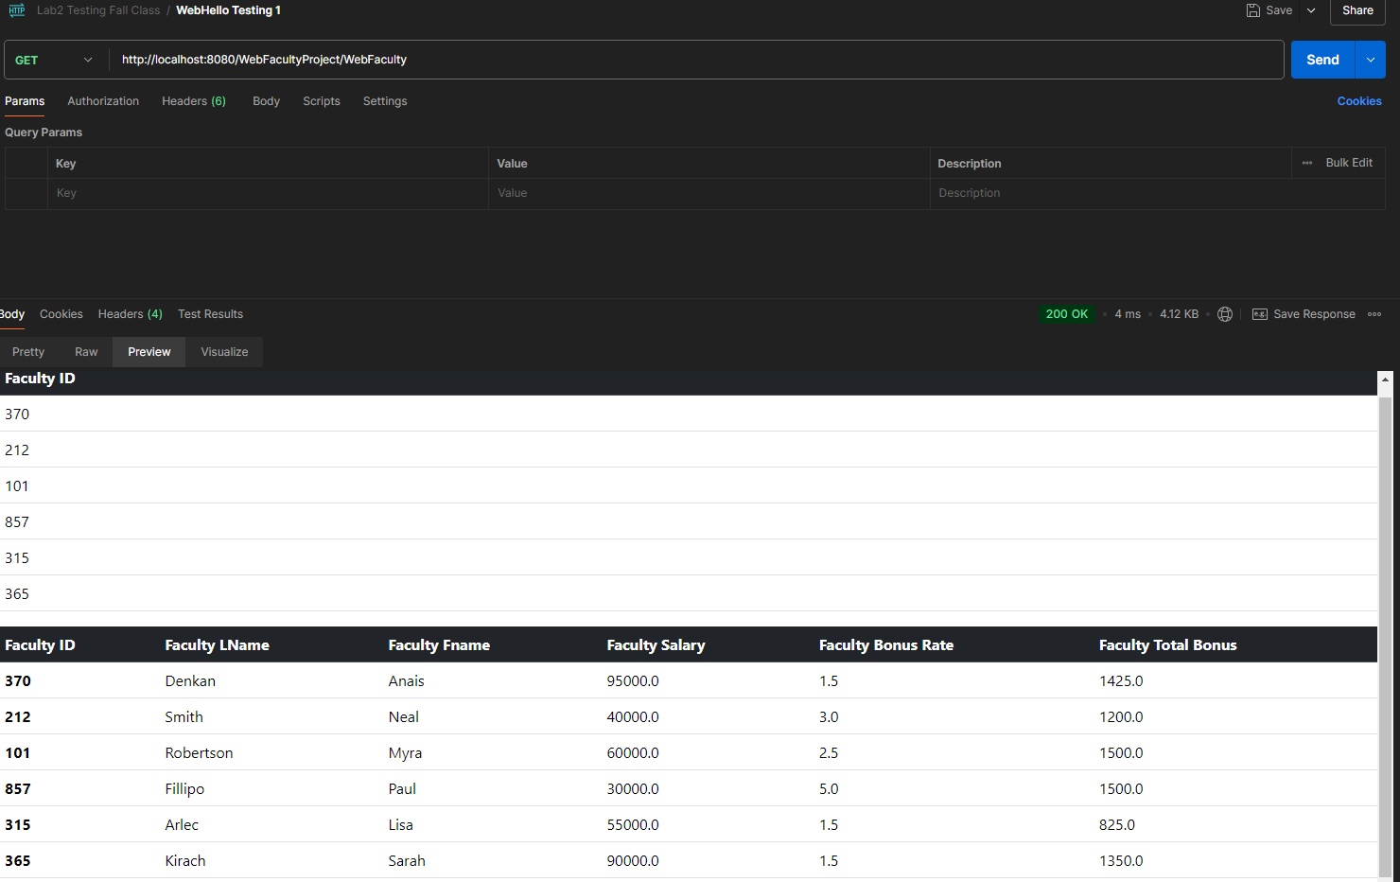

*Postman Testing 2 (REST)*

*Postman Testing 3 (REST)*

*Postman Testing 4 (REST)*

*Postman Testing 4 (SOAP)*

