**WebHelloRESTProject**

[*http://localhost:8080/WebHelloWorldRESTProject/rest/HiHi*](http://localhost:8080/WebHelloWorldRESTProject/rest/HiHi)

*Postman Text/Plain*

*Postman Text/HTML*

*Postman Application/Json*

[*http://localhost:8080/WebHelloWorldRESTProject/rest/HiHi/Specify/Julian*](http://localhost:8080/WebHelloWorldRESTProject/rest/HiHi/Specify/Julian)

[*http://localhost:8080/WebHelloWorldRESTProject/rest/HiHi/Employee/?EmpID=123&EmpName=John&EmpSalary=50000*](http://localhost:8080/WebHelloWorldRESTProject/rest/HiHi/Employee/?EmpID=123&EmpName=John&EmpSalary=50000)

**WebMathOperationsRESTProject**

*Postman*

<http://localhost:8080/WebMathOperationsRESTProject/rest/MathOp?x=1&y=2&z=3>

*Text/HTML*

*Application/Json*

<http://localhost:8080/WebMathOperationsRESTProject/rest/MathOp/listArray>

<http://localhost:8080/WebMathOperationsRESTProject/rest/MathOp/OpHashMap/4>

**WebCarRESTProject**

*Postman*

<http://localhost:8080/WebCarRESTProject/rest/WebCar>

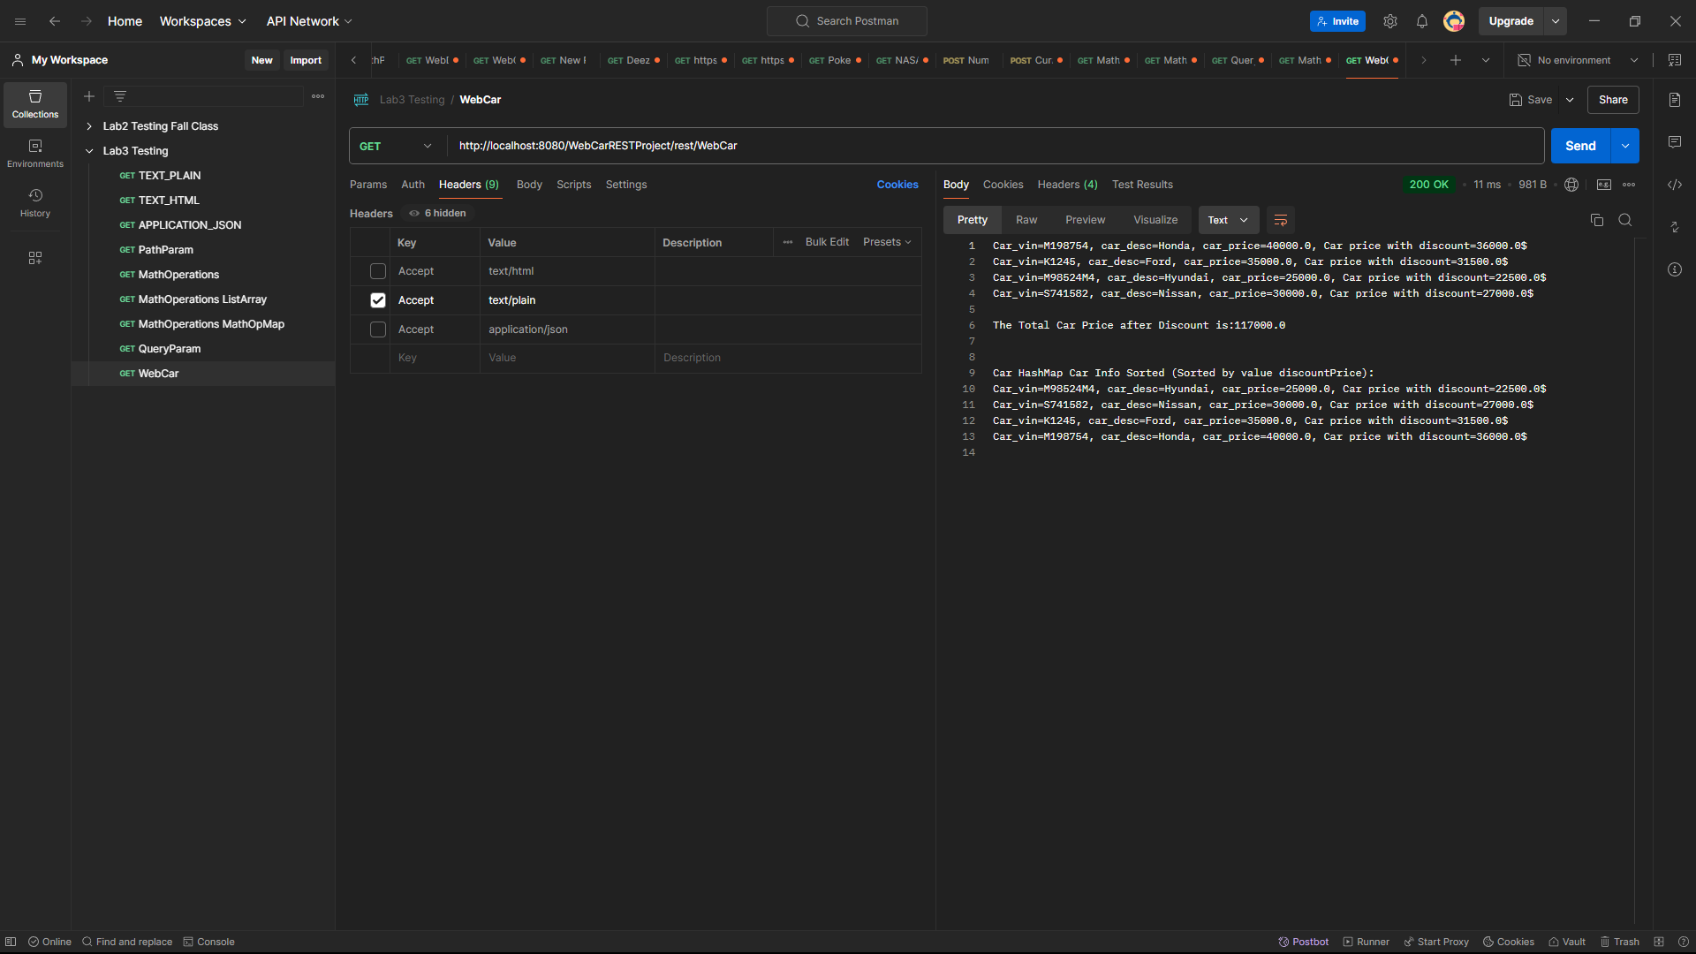

<http://localhost:8080/WebCarRESTProject/rest/WebCar/searchCar/K1245>

**WebBillingRESTProject**

*Postman*

<http://localhost:8080/WebBillingRESTProject/rest/WebBilling>

<http://localhost:8080/WebBillingRESTProject/rest/WebBilling/searchBilling/101>

**WebCourseRESTProject**

*Postman*

<http://localhost:8080/WebCourseRESTProject/rest/WebCourse>

[http://localhost:8080/WebCourseRESTProject/rest/WebCourse/searchCourse/MIS 441](http://localhost:8080/WebCourseRESTProject/rest/WebCourse/searchCourse/MIS%20441)

