**Creating Client Maven Project**

**Maven Project: ClientMathOperationsRESTProject**

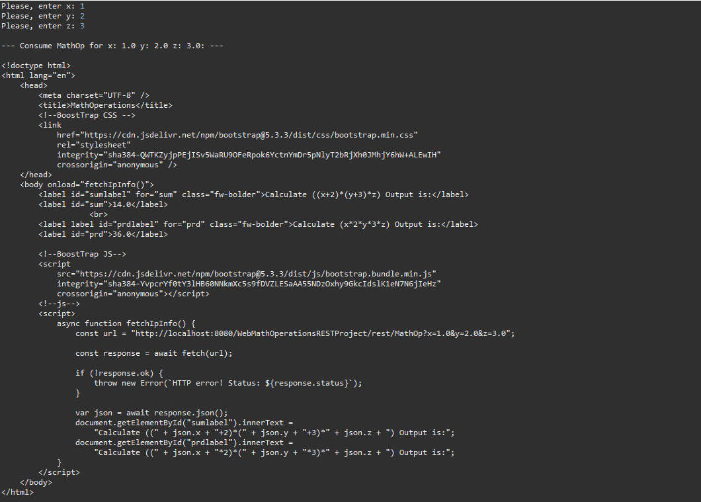

**Creating Graphical Client Maven Project**

**

**Maven Project: ClientCarRESTProject**

