Dear recipient of this message in a bottle,

this message in a bottle is an experiment of wodkafis.ch. We send messages in bottles and track their journey on our website.

It would be nice if you could either throw the bottle back into the river after reading it, so it can continue its journey, or, if the battery level is low (red light is blinking), charge the GPS transmitter beforehand.
The route of the bottle and our contact information can be found at the following address:

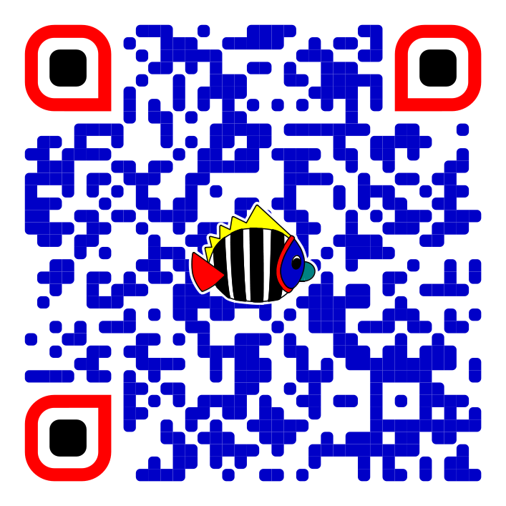

www.wodkafis.ch/flaschenpost

