

Drexel University
Electrical and Computer Engineering Department

ECEC 471
Introduction to VLSI Design

Lab Assignment 6
November 15th, 2013

Julian Kemmerer
jvk@drexel.edu
Lab 6 completes schematic and layout based simulations to characterize single bit full adder functionality. Special attention is paid to timing characteristics such as propagation delay and rise/fall time.

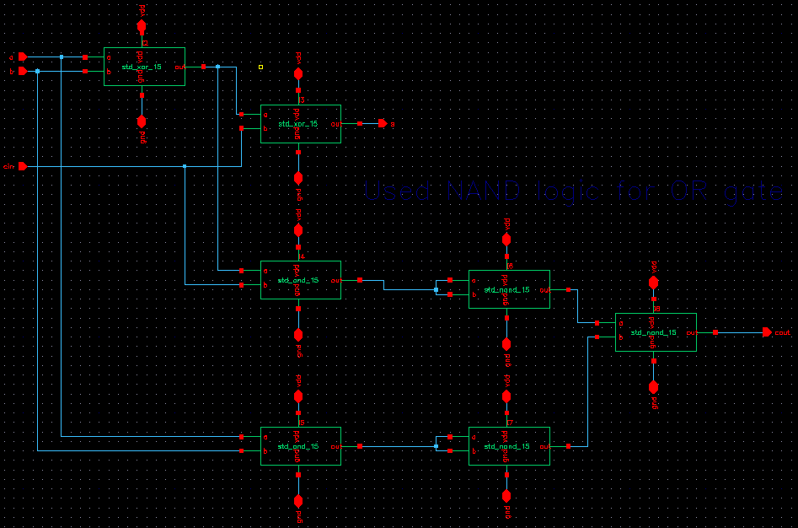
Fig. 1. Schematic view of the one-bit Full Adder .
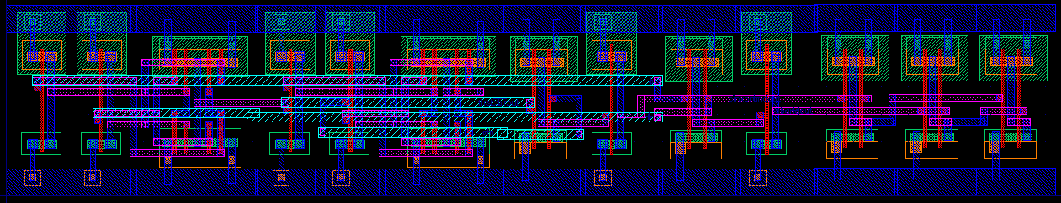
Fig. 2. Layout view of the one-bit Full Adder . (Full view)

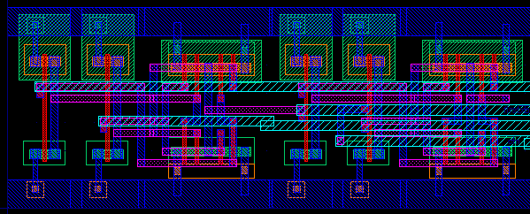
Fig. 3. Layout view of the one-bit Full Adder . (First half / left side view)

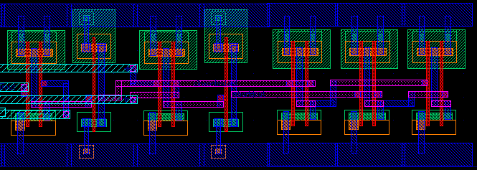
Fig. 4. Layout view of the one-bit Full Adder . (Second half / right side view)
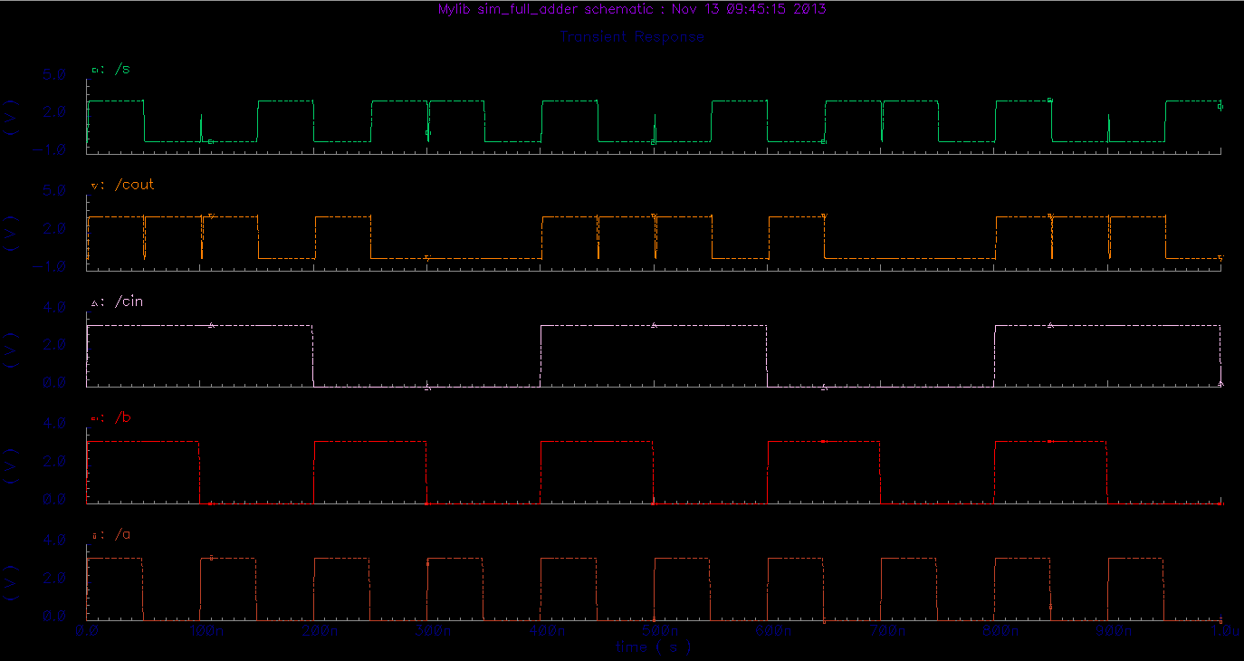
Fig. 5. Simulation results verifying the functionality of the one-bit Full Adder for schematic.

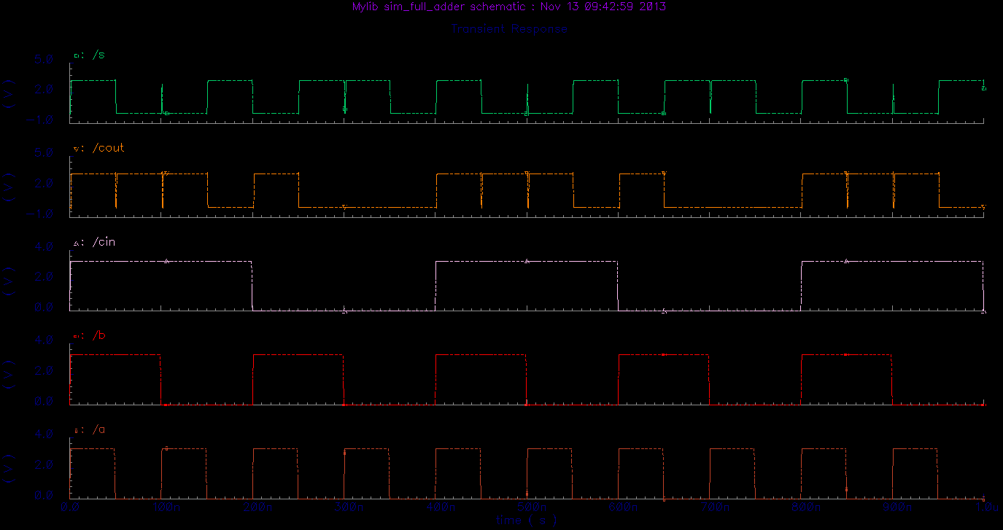
Fig. 6. Simulation results verifying the functionality of the one-bit Full Adder for layout.
Per Prof. Savidis, a subset of possible input patterns were examined. The table below contains the input patterns characterized and timing information. 'R' indicates a rising signal, 'H' a high signal, 'F' a falling signal, and 'L' a low signal. Zeros in the propagation delay columns indicate that the input signal specified was not switching at the time or was not critical to the propagation delay (i.e. output transition occurred before input transition).

Table. 1. Timing Information of the Adder
(Note: The period of signals A, B, and CIN, are 100ns, 200ns, 400ns respectively)

Table. 2. Timing Information of the Adder
(Note: The period of signals A, B, and CIN, are 400ns, 200ns, 100ns respectively)

