

Drexel University
Electrical and Computer Engineering Department

ECEC 471
Introduction to VLSI Design

Lab Assignment 6A
November 8th, 2013

Julian Kemmerer
jvk@drexel.edu
Lab 6A completes schematic and layout based simulations to characterize 2-to-1 MUX functionality. Special attention is paid to timing characteristics such as worst case propagation delay, and rise/fall time.

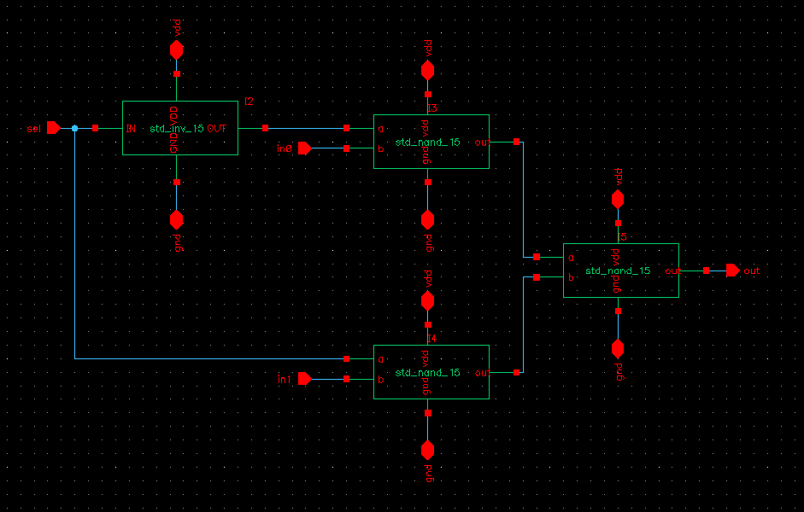
Fig. 1. Schematic view of 2-to-1 MUX.

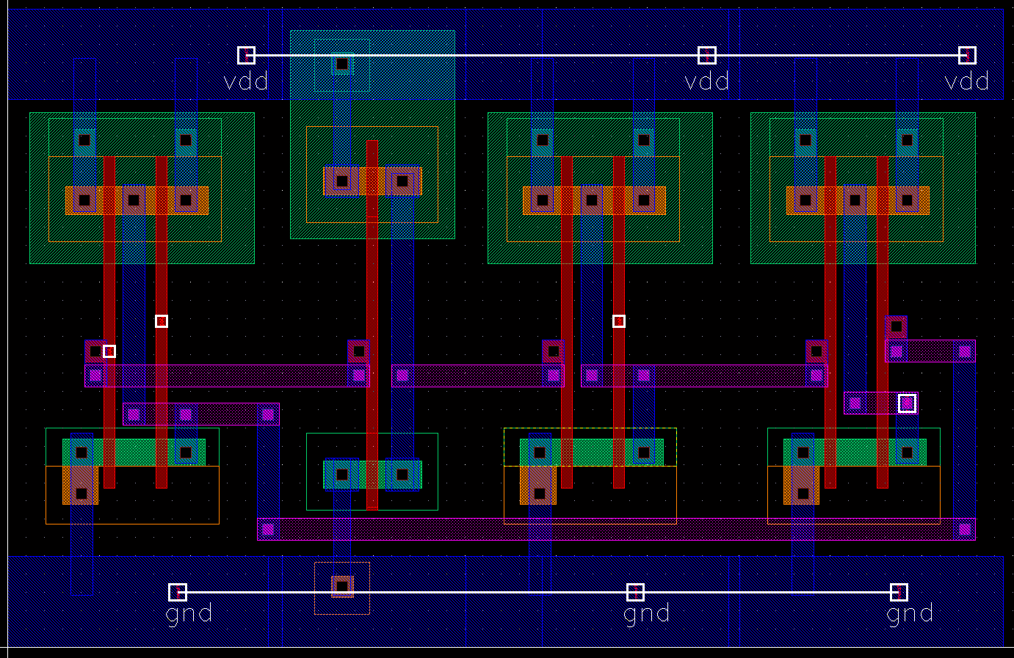
Fig. 2. Layout view of 2-to-1 MUX.

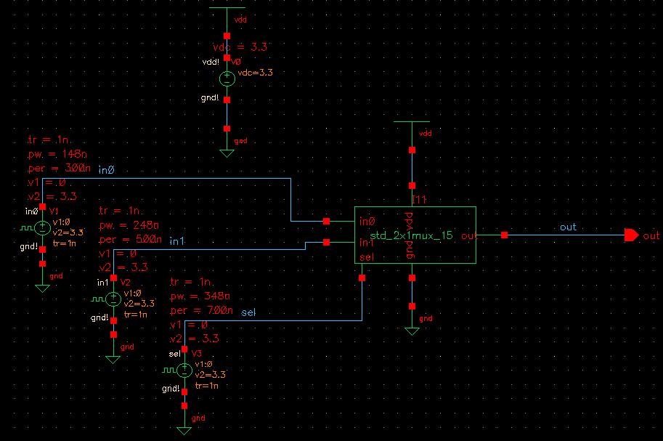
Fig. 3. Schematic view for simulation.

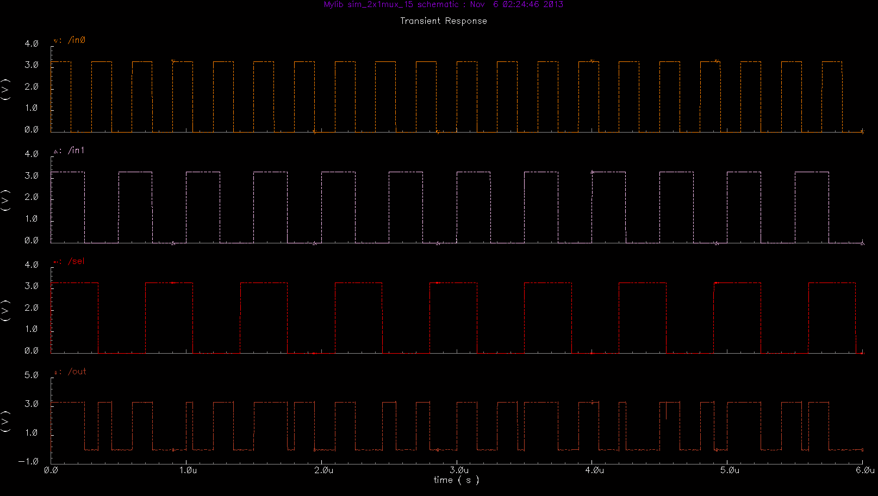
Fig. 4. Schematic based simulation verifying the functionality of the multiplexer .
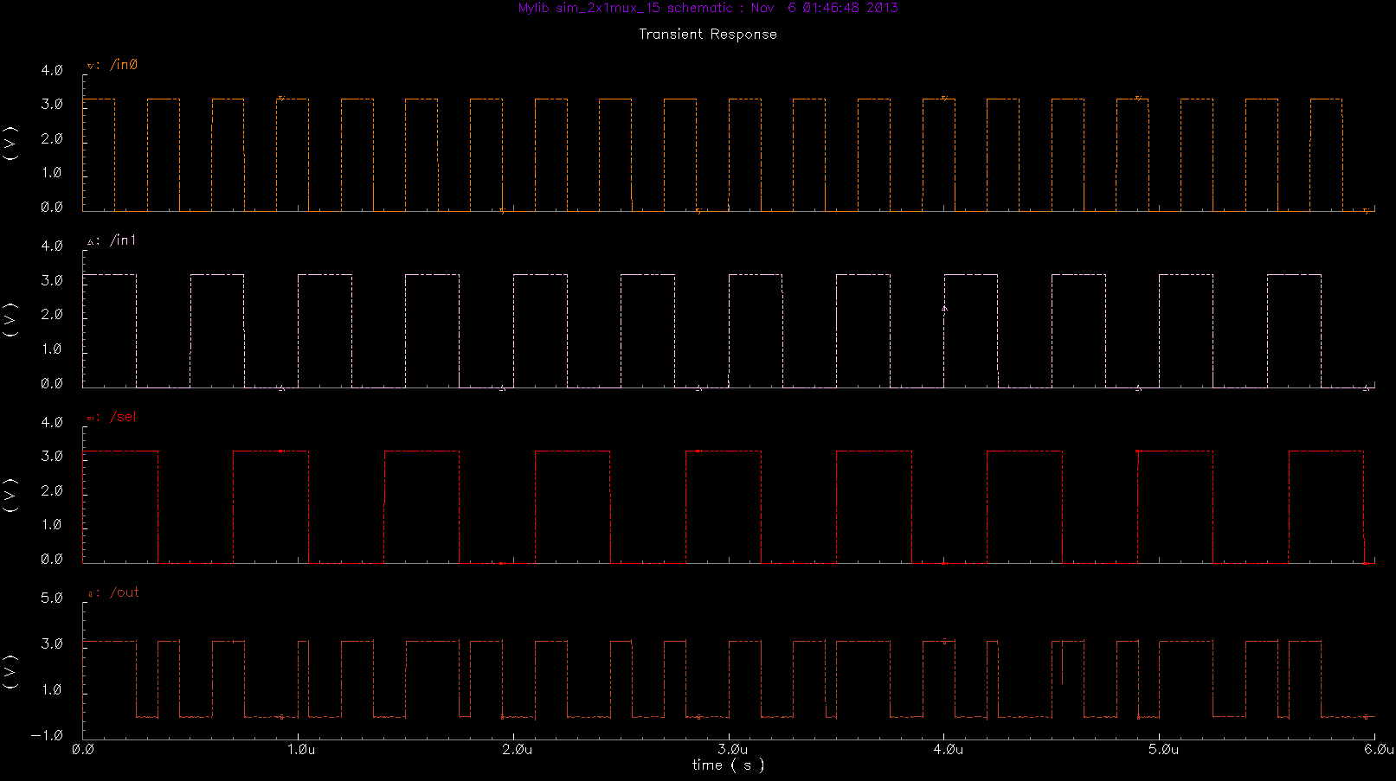
Fig. 5. Layout based simulation verifying the functionality of the multiplexer .

Per Prof. Savidis, a subset of possible input patterns were examined. The table below contains the input patterns characterized and timing information. 'R' indicates a rising signal, 'H' a high signal, 'F' a falling signal, and 'L' a low signal. Zeros in the propagation delay columns indicate that the input signal specified was not switching at the time or was not critical to the propagation delay (i.e. output transition occurred before input transition).

Table. 1. Worst case schematic based timing information.

Table. 2. Worst case layout/extracted based timing information.

Table. 3. Worst case timing information summary.

