

Drexel University
Electrical and Computer Engineering Department

ECEC 471
Introduction to VLSI Design

Lab Assignment 7
November 22nd, 2013

Julian Kemmerer
jvk@drexel.edu
Lab 7 completes schematic and layout based simulations to characterize D-flip-flop functionality. Special attention is paid to timing characteristics such as setup time, hold time, propagation delay and rise/fall time.

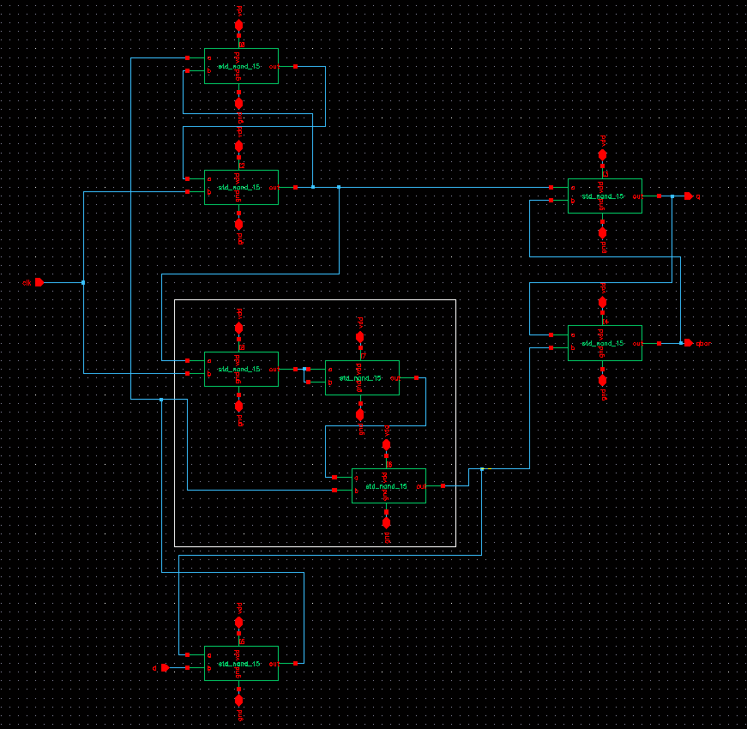
Fig. 1. Schematic view of DFF.
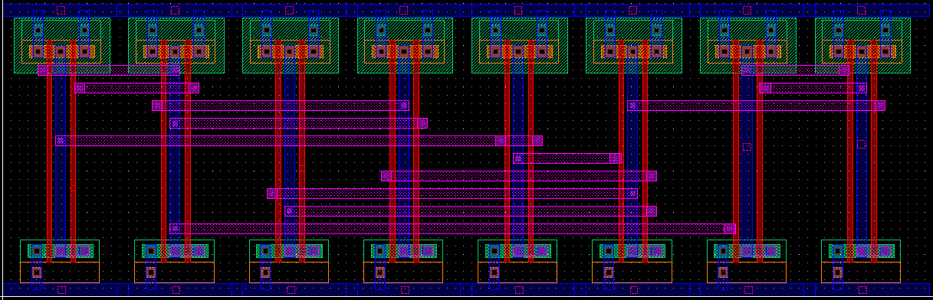
Fig. 2. Layout view of DFF.

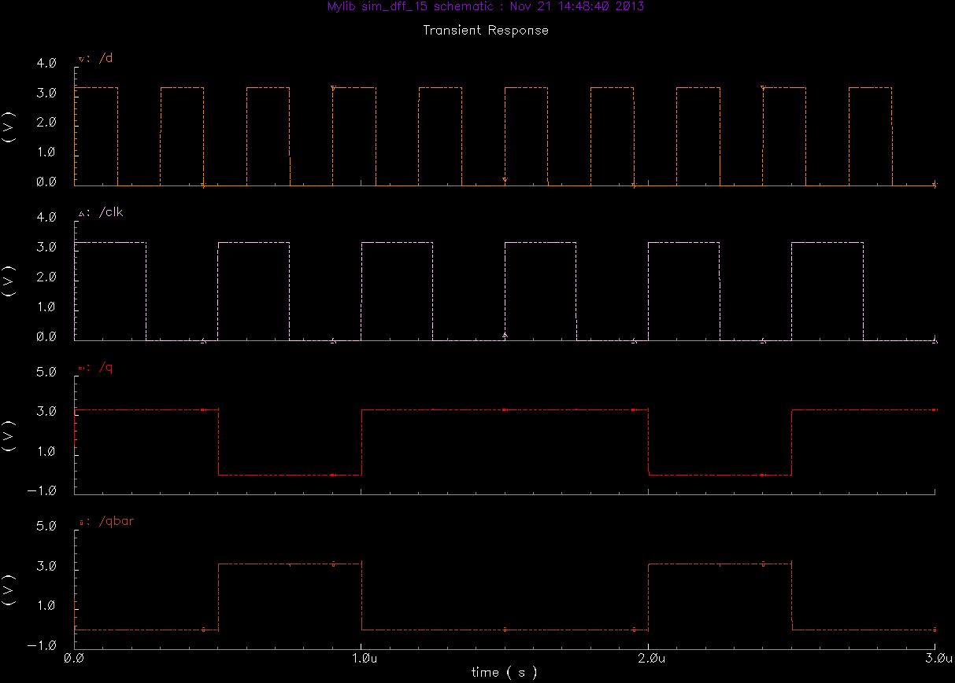
Fig. 3. Simulation results verifying the functionality of the flip-flop schematic view.

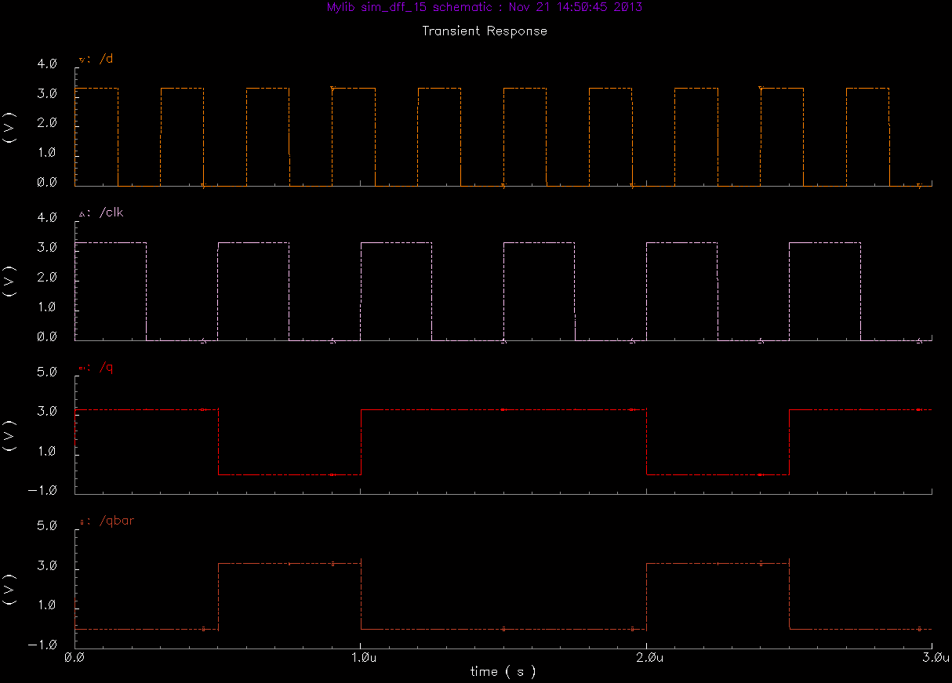
Fig. 4. Simulation results verifying the functionality of the flip-flop layout view.
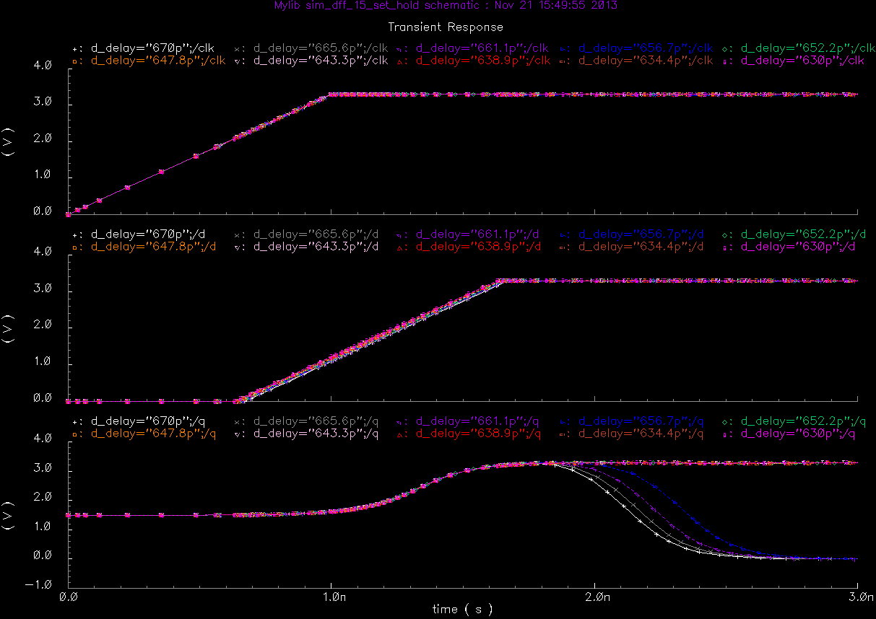
Fig. 5. Setup time simulation results for schematic view.
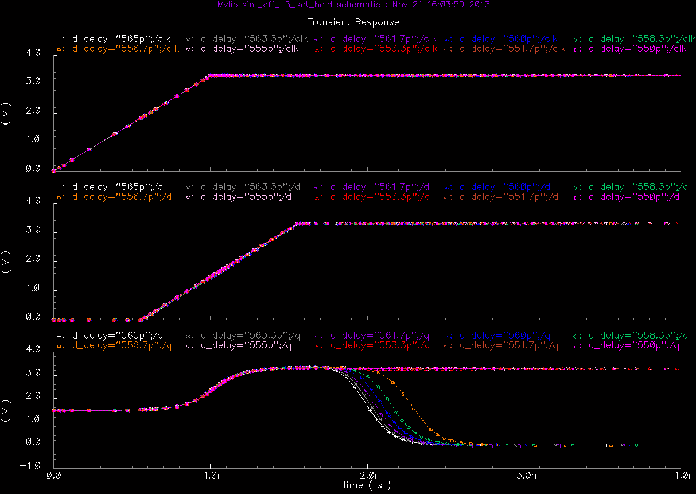
Fig. 6. Setup time simulation results for layout view.

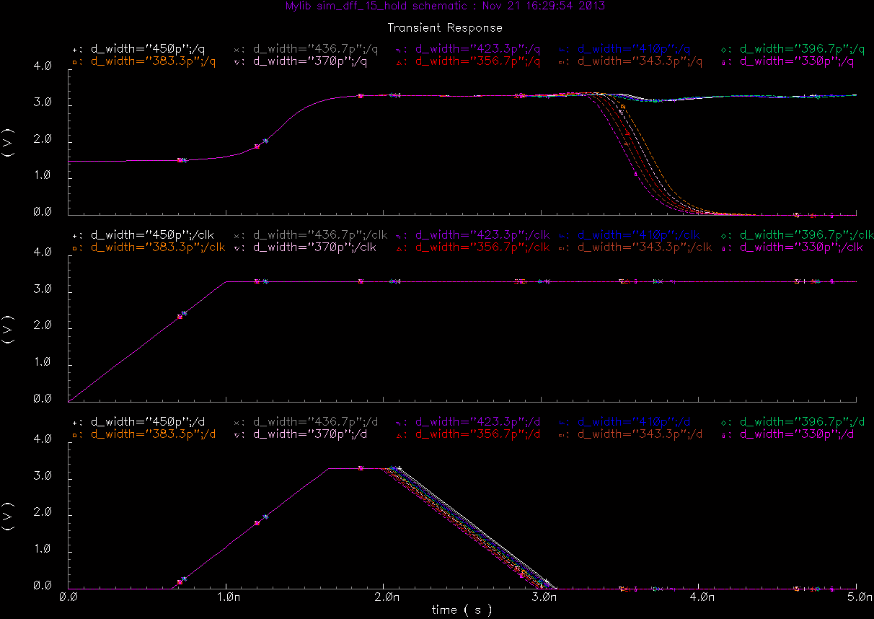
Fig. 7. Hold time simulation results for schematic view.

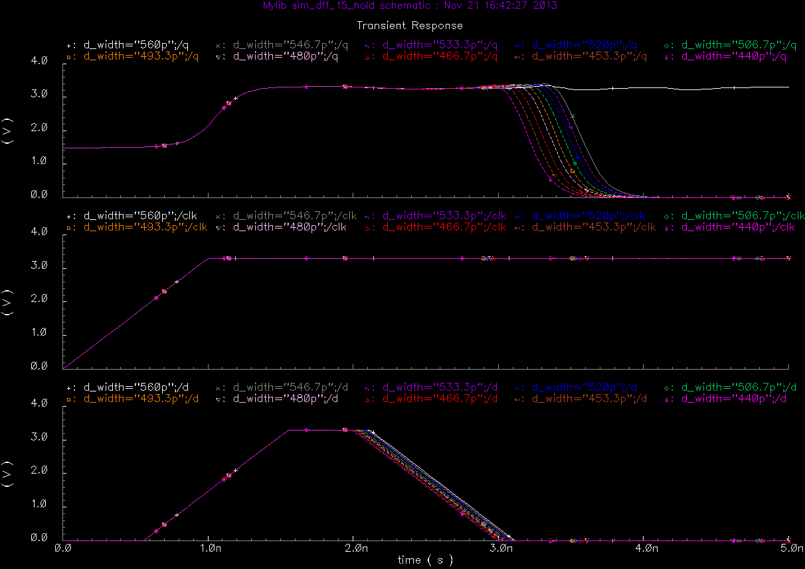
Fig. 8. Hold time simulation results for layout view.

Table 1. Summary of timing information of DFF.

