SYSC 4005 L2

Discrete Simulation/Modelling

Winter 2021

Milestone #2

Group Members: Julian Mendoza (101067270)

Hamna Nimra Manzoor (101057437)

Colin Wallace (100872525)

Due: March 14th, 2021

**TABLE OF CONTENTS**

**Deliverable 2 3-20**

Sample Calculations 3-5

Input Modelling 5-19

* Inspector 1 – component 1 5-7
* Inspector 2 – component 2 8-10
* Inspector 2 – component 3 10-12
* Workstation 1 12-14
* workstation 2 14-16
* Workstation 3 17-19

data input generation 19-20

**Sample Calculations**

Since we repeat the process seven times, we will show sample calculations to determine the data generated for each table. These sample calculations are specifically for the **first or second row of table 1**.

**Sample Mean ($\overline{X}$)**

$$=\frac{\sum_{i=1}^{N}{X_{i}}}{N}$$

Where $X_{i}$ is a data point in the sample

Where N is the sample size

**Bin Size:**

$$=\sqrt{N}$$

$$=\sqrt{300}$$

$$≈17$$

(Applies to all models)

**Frequency:**

$$=\frac{Max-min}{bin size}$$

$$=\frac{76.284-0.087}{17}$$

$$≈4.4822$$

**Bin Low:**

$$=prev bin high OR\min{value for bin=1}$$

Ex. Bin Low bin=2

$$=prev bin high (bin high=1)$$

$$=4.5692$$

**Bin High:**

$$=bin low+freq$$

$$=0.087+4.4822$$

$$≈4.5692$$

**Occurrences (Oi)**

$$=\# values that fall inbetween bin low \left(inclusive\right) and bin high (exclusive)$$

$$=\# values between 0.0870-4.5692$$

$$=94$$

**Cumulative Density function (CDF)**

In this report, we noticed that the histograms looked like exponential distributions.

$$=1-e^{-λx}$$

We will explain later in this report but, we can use our estimator $\hat{λ}=\frac{1}{\overline{X}}$

The CDF low corresponds to the CDF of the lower bin and the CDF high corresponds to the CDF of the higher bin.

Ex. CDF low

$$=1-e^{-λx}$$

$$=1-e^{-\left(\frac{1}{x}\right)*0.087}$$

$$≈0.08364$$

**Probability (Pi)**

We use Pi to denote the probability that the distribution falls under the two bin ranges (bin low and bin high)

$$=cdf high-cdf low$$

$$=0.35669-0.008364$$

$$≈0.348326$$

**Expected Frequency (Ei)**

$$={⌈P}_{i}*N⌉$$

$$=⌈0.348326*300⌉$$

$$=105$$

**Null hypothesis for chi-square test**

To compute the null hypothesis for chi-square, we take the partial value of each row:

$${X_{0}}^{2}=\sum_{i=1}^{Bin Size}{\frac{{(O_{i}-E_{i})}^{2}}{E_{i}}}$$

Sample $\frac{{(O_{i}-E_{i})}^{2}}{E_{i}}$

$$=\frac{{(104-94)}^{2}}{104}$$

$$≈1.15238$$

**Input Modelling**

**Inspector 1 – Component 1**

Using the sample data, we computed a frequency of 4.4821. With a bin size of 17, we generated the following histogram:

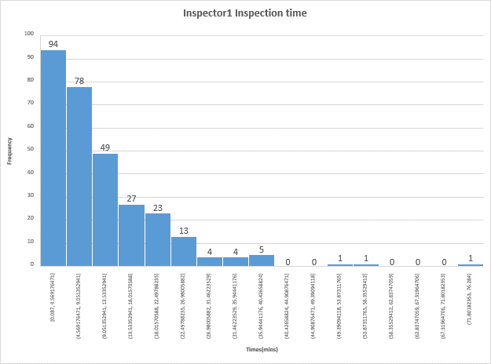*Figure 1: Histogram of Inspector 1's Inspection time*

From this histogram, we guessed that the distribution looks exponential.

We need to generate a Q-Q plot to verify this hypothesis.

CDF exponential: $F\left(x\right)=1-e^{-λx}$

$$x=1-e^{-λy}$$

$$(-x+1)=e^{-λy}$$

$$ln\left(-x+1\right)=-λy$$

$$F^{-1}\left(x\right)=\frac{-ln(-x+1)}{λ}$$

We have to use an appropriate estimator for this distribution:

$$\overline{X}=10.35791$$

$$\hat{λ}=\frac{1}{\overline{X}} \\ \hat{λ}=0.09654$$

We can substitute $\frac{1}{\hat{λ}}$ with $\overline{X}$ to get the inverse function:

$$F^{-1}\left(x\right)=-ln\left(-x+1\right)*\overline{X}$$

We plot $Y_{j}$ vs $F^{-1}\left(\frac{j-0.5}{300}\right)$

We can determine the line of best fit using linear regression:

*Figure 2: Q-Q Plot of Yj and the inverse function*

Since the slope is approximately 1. The fit is appropriate.

|  |  |  |  |  |  |  |  |
| --- | --- | --- | --- | --- | --- | --- | --- |
| Bin Low | Bin High | Oi | CDF low | CDF HIGH | Pi | Ei | (Oi-Ei)^2/Ei |
| 0.0870 | 4.5692 | 94 | 0.008364 | 0.35669 | 0.348326 | 105 | 1.152381 |
| 4.5692 | 9.0514 | 78 | 0.35669 | 0.582662 | 0.225972 | 68 | 1.470588 |
| 9.0514 | 13.5335 | 49 | 0.582662 | 0.729258 | 0.146596 | 44 | 0.568182 |
| 13.5335 | 18.0157 | 27 | 0.729258 | 0.82436 | 0.095102 | 29 | 0.137931 |
| 18.0157 | 22.4979 | 23 | 0.82436 | 0.886056 | 0.061696 | 19 | 0.842105 |
| 22.4979 | 26.9801 | 13 | 0.886056 | 0.92608 | 0.040024 | 13 | 0 |
| 26.9801 | 31.4622 | 4 | 0.92608 | 0.952046 | 0.025965 | 8 | 2 |
| 31.4622 | 35.9444 | 4 | 0.952046 | 0.96889 | 0.016845 | 6 | 0.666667 |
| 35.9444 | 40.4266 | 5 | 0.96889 | 0.979818 | 0.010928 | 4 | 0.25 |
| 40.4266 | 44.9088 | 0 | 0.979818 | 0.986907 | 0.007089 | 3 | 3 |
| 44.9088 | 49.3909 | 0 | 0.986907 | 0.991506 | 0.004599 | 2 | 2 |
| 49.3909 | 53.8731 | 1 | 0.991506 | 0.99449 | 0.002984 | 1 | 0 |
| 53.8731 | 58.3553 | 1 | 0.99449 | 0.996425 | 0.001936 | 1 | 0 |
| 58.3553 | 62.8375 | 0 | 0.996425 | 0.997681 | 0.001256 | 1 | 1 |
| 62.8375 | 67.3196 | 0 | 0.997681 | 0.998496 | 0.000815 | 1 | 1 |
| 67.3196 | 71.8018 | 0 | 0.998496 | 0.999024 | 0.000528 | 1 | 1 |
| 71.8018 | 76.2840 | 1 | 0.999024 | 0.999367 | 0.000343 | 1 | 0 |

*Table 1: Required values to compute Chi-Squared test.*

**Chi Square test**

We know that K=17 since it is our bin size.

P=17-1-1 = 15 degrees of freedom

Using a significance level of 0.05, from the chi-squared table,

Since our test statistics from the observations is less than the chi-square value, our null hypothesis is accepted, and we can claim that the exponential distribution is a good fit.

**Inspector 2 - Component 2**

Using the sample data, we computed a frequency of 6.723294. With a bin size of 17, we generated the following histogram:

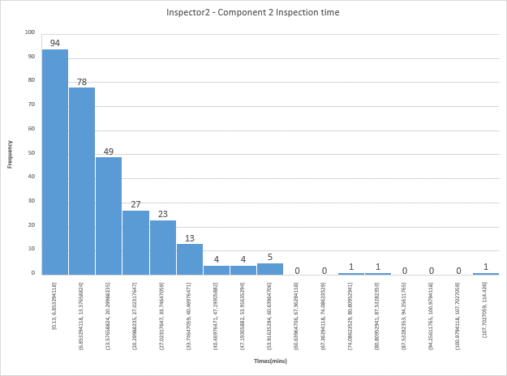*Figure 3: Histogram of Inspector 2's Inspection time of component 2*

From this histogram, we guessed that the distribution looks exponential.

**Q-Q Plot**

Using the exact same process as in Inspector 1,

With $\overline{X}=15.53690333$

We plot $Y_{j}$ vs $F^{-1}\left(\frac{j-0.5}{300}\right)$

We can determine the line of best fit using linear regression:

*Figure 4: Q-Q Plot of Yj and the inverse function*

Since the slope is approximately 1. The fit is appropriate.

|  |  |  |  |  |  |  |  |
| --- | --- | --- | --- | --- | --- | --- | --- |
| Bin Low | Bin High | Oi | CDF low | CDF HIGH | Pi | Ei | (Oi-Ei)^2/Ei |
| 0.1300 | 6.8533 | 94 | 0.008332 | 0.35667 | 0.348338 | 105 | 1.152381 |
| 6.8533 | 13.5766 | 78 | 0.35667 | 0.582649 | 0.225979 | 68 | 1.470588 |
| 13.5766 | 20.2999 | 49 | 0.582649 | 0.72925 | 0.146601 | 44 | 0.568182 |
| 20.2999 | 27.0232 | 27 | 0.72925 | 0.824355 | 0.095105 | 29 | 0.137931 |
| 27.0232 | 33.7465 | 23 | 0.824355 | 0.886053 | 0.061698 | 19 | 0.842105 |
| 33.7465 | 40.4698 | 13 | 0.886053 | 0.926078 | 0.040026 | 13 | 0 |
| 40.4698 | 47.1931 | 4 | 0.926078 | 0.952044 | 0.025966 | 8 | 2 |
| 47.1931 | 53.9164 | 4 | 0.952044 | 0.96889 | 0.016845 | 6 | 0.666667 |
| 53.9164 | 60.6396 | 5 | 0.96889 | 0.979818 | 0.010928 | 4 | 0.25 |
| 60.6396 | 67.3629 | 0 | 0.979818 | 0.986907 | 0.007089 | 3 | 3 |
| 67.3629 | 74.0862 | 0 | 0.986907 | 0.991506 | 0.004599 | 2 | 2 |
| 74.0862 | 80.8095 | 1 | 0.991506 | 0.99449 | 0.002984 | 1 | 0 |
| 80.8095 | 87.5328 | 1 | 0.99449 | 0.996425 | 0.001936 | 1 | 0 |
| 87.5328 | 94.2561 | 0 | 0.996425 | 0.997681 | 0.001256 | 1 | 1 |
| 94.2561 | 100.9794 | 0 | 0.997681 | 0.998496 | 0.000815 | 1 | 1 |
| 100.9794 | 107.7027 | 0 | 0.998496 | 0.999024 | 0.000528 | 1 | 1 |
| 107.7027 | 114.4260 | 1 | 0.999024 | 0.999367 | 0.000343 | 1 | 0 |

*Table 2: Required values to compute Chi-Squared test.*

**Chi Square test**

We know that K=17 since it is our bin size.

P=17-1-1 = 15 degrees of freedom

Using a significance level of 0.05, from the chi-squared table,

Since our test statistics from the observations is less than the chi-square value, our null hypothesis is accepted, and we can claim that the exponential distribution is a good fit.

**Inspector 2 – Component 3**

Using the sample data, we computed a frequency of 6.11694. With a bin size of 17, we generated the following histogram:

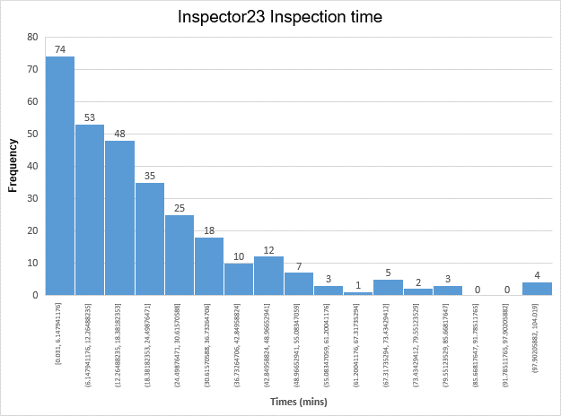*Figure 5: Histogram of Inspector 2's Inspection time of component 3*

From this histogram, we guessed that the distribution looks exponential.

**Q-Q Plot**

Using the exact same process as in Inspector 1,

With $\overline{X}=20.63275667$

We plot $Y_{j}$ vs $F^{-1}\left(\frac{j-0.5}{300}\right)$

We can determine the line of best fit using linear regression:

*Figure 6: Q-Q Plot of Yj and the inverse function*

Since the slope is approximately 1. The fit is appropriate.

|  |  |  |  |  |  |  |  |
| --- | --- | --- | --- | --- | --- | --- | --- |
| Bin Low | Bin High | Oi | CDF low | CDF HIGH | Pi | Ei | (Oi-Ei)^2/Ei |
| 0.0310 | 6.1479 | 74 | 0.001501 | 0.257676 | 0.256175 | 77 | 0.116883 |
| 6.1479 | 12.2649 | 53 | 0.257676 | 0.448127 | 0.190451 | 58 | 0.431034 |
| 12.2649 | 18.3818 | 48 | 0.448127 | 0.589716 | 0.141589 | 43 | 0.581395 |
| 18.3818 | 24.4988 | 35 | 0.589716 | 0.694978 | 0.105263 | 32 | 0.28125 |
| 24.4988 | 30.6157 | 25 | 0.694978 | 0.773235 | 0.078256 | 24 | 0.041667 |
| 30.6157 | 36.7326 | 18 | 0.773235 | 0.831414 | 0.058179 | 18 | 0 |
| 36.7326 | 42.8496 | 10 | 0.831414 | 0.874666 | 0.043253 | 13 | 0.692308 |
| 42.8496 | 48.9665 | 12 | 0.874666 | 0.906822 | 0.032156 | 10 | 0.4 |
| 48.9665 | 55.0835 | 7 | 0.906822 | 0.930728 | 0.023906 | 8 | 0.125 |
| 55.0835 | 61.2004 | 3 | 0.930728 | 0.9485 | 0.017773 | 6 | 1.5 |
| 61.2004 | 67.3174 | 1 | 0.9485 | 0.961713 | 0.013213 | 4 | 2.25 |
| 67.3174 | 73.4343 | 5 | 0.961713 | 0.971536 | 0.009823 | 3 | 1.333333 |
| 73.4343 | 79.5512 | 2 | 0.971536 | 0.978839 | 0.007303 | 3 | 0.333333 |
| 79.5512 | 85.6682 | 3 | 0.978839 | 0.984268 | 0.005429 | 2 | 0.5 |
| 85.6682 | 91.7851 | 0 | 0.984268 | 0.988304 | 0.004036 | 2 | 2 |
| 91.7851 | 97.9021 | 0 | 0.988304 | 0.991305 | 0.003001 | 1 | 1 |
| 97.9021 | 104.0190 | 4 | 0.991305 | 0.993536 | 0.002231 | 1 | 9 |

*Table 3: Required values to compute Chi-Squared test.*

**Chi Square test**

We know that K=17 since it is our bin size.

P=17-1-1 = 15 degrees of freedom

Using a significance level of 0.05, from the chi-squared table,

Since our test statistics from the observations is less than the chi-square value, our null hypothesis is accepted, and we can claim that the exponential distribution is a good fit for Inspector 2 component 3.

**Workstation 1**

Using the sample data, we computed a frequency of 1.727529. With a bin size of 17, we generated the following histogram:

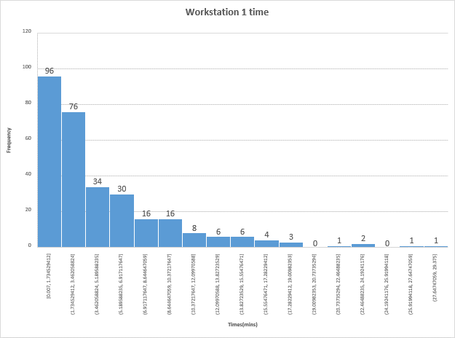*Figure 7: Histogram of Workstation 1's Production time*

**Q-Q Plot**

Using the exact same process as in Inspector 1,

With $\overline{X}=4.604416667$

We plot $Y_{j}$ vs $F^{-1}\left(\frac{j-0.5}{300}\right)$

We can determine the line of best fit using linear regression:

*Figure 8: Q-Q Plot of Yj and the inverse function*

Since the slope is approximately 1. The fit is appropriate.

|  |  |  |  |  |  |  |  |
| --- | --- | --- | --- | --- | --- | --- | --- |
| Bin Low | Bin High | Oi | CDF low | CDF HIGH | Pi | Ei | (Oi-Ei)^2/Ei |
| 0.0070 | 1.7345 | 96 | 0.001519 | 0.313885 | 0.312366 | 94 | 0.042553 |
| 1.7345 | 3.4621 | 76 | 0.313885 | 0.52853 | 0.214645 | 65 | 1.861538 |
| 3.4621 | 5.1896 | 34 | 0.52853 | 0.676025 | 0.147495 | 45 | 2.688889 |
| 5.1896 | 6.9171 | 30 | 0.676025 | 0.777378 | 0.101353 | 31 | 0.032258 |
| 6.9171 | 8.6446 | 16 | 0.777378 | 0.847023 | 0.069645 | 21 | 1.190476 |
| 8.6446 | 10.3722 | 16 | 0.847023 | 0.894881 | 0.047857 | 15 | 0.066667 |
| 10.3722 | 12.0997 | 8 | 0.894881 | 0.927766 | 0.032886 | 10 | 0.4 |
| 12.0997 | 13.8272 | 6 | 0.927766 | 0.950364 | 0.022598 | 7 | 0.142857 |
| 13.8272 | 15.5548 | 6 | 0.950364 | 0.965892 | 0.015528 | 5 | 0.2 |
| 15.5548 | 17.2823 | 4 | 0.965892 | 0.976562 | 0.01067 | 4 | 0 |
| 17.2823 | 19.0098 | 3 | 0.976562 | 0.983895 | 0.007332 | 3 | 0 |
| 19.0098 | 20.7374 | 0 | 0.983895 | 0.988933 | 0.005038 | 2 | 2 |
| 20.7374 | 22.4649 | 1 | 0.988933 | 0.992395 | 0.003462 | 2 | 0.5 |
| 22.4649 | 24.1924 | 2 | 0.992395 | 0.994774 | 0.002379 | 1 | 1 |
| 24.1924 | 25.9199 | 0 | 0.994774 | 0.996409 | 0.001635 | 1 | 1 |
| 25.9199 | 27.6475 | 1 | 0.996409 | 0.997533 | 0.001123 | 1 | 0 |
| 27.6475 | 29.3750 | 1 | 0.997533 | 0.998304 | 0.000772 | 1 | 0 |

*Table 4: Required values to compute Chi-Squared test.*

**Chi Square test**

We know that K=17 since it is our bin size.

P=17-1-1 = 15 degrees of freedom

Using a significance level of 0.05, from the chi-squared table,

Since our test statistics from the observations is less than the chi-square value, our null hypothesis is accepted, and we can claim that the exponential distribution is a good fit for workstation 1.

**Workstation 2**

Using the sample data, we computed a frequency of 3.4698. With a bin size of 17, we generated the following histogram:

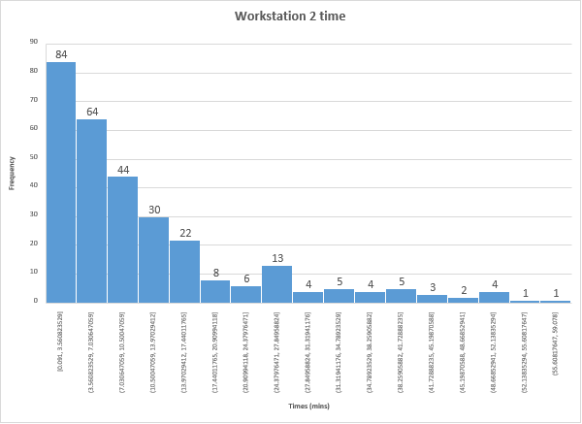*Figure 9: Histogram of Workstation 2's production time*

From this histogram, we guessed that the distribution looks exponential.

**Q-Q Plot**

Using the exact same process as in Inspector 1,

With $\overline{X}=11.09260667$

We plot $Y_{j}$ vs $F^{-1}\left(\frac{j-0.5}{300}\right)$

We can determine the line of best fit using linear regression:

*Figure 10: Q-Q Plot of Yj and the inverse function*

Since the slope is approximately 1. The fit is appropriate.

|  |  |  |  |  |  |  |  |
| --- | --- | --- | --- | --- | --- | --- | --- |
| Bin Low | Bin High | Oi | CDF low | CDF HIGH | Pi | Ei | (Oi-Ei)^2/Ei |
| 0.0910 | 3.5608 | 84 | 0.00817 | 0.274583 | 0.266413 | 80 | 0.2 |
| 3.5608 | 7.0306 | 64 | 0.274583 | 0.469436 | 0.194852 | 59 | 0.423729 |
| 7.0306 | 10.5005 | 44 | 0.469436 | 0.611949 | 0.142514 | 43 | 0.023256 |
| 10.5005 | 13.9703 | 30 | 0.611949 | 0.716183 | 0.104233 | 32 | 0.125 |
| 13.9703 | 17.4401 | 22 | 0.716183 | 0.792418 | 0.076236 | 23 | 0.043478 |
| 17.4401 | 20.9099 | 8 | 0.792418 | 0.848176 | 0.055758 | 17 | 4.764706 |
| 20.9099 | 24.3798 | 6 | 0.848176 | 0.888957 | 0.040781 | 13 | 3.769231 |
| 24.3798 | 27.8496 | 13 | 0.888957 | 0.918784 | 0.029827 | 9 | 1.777778 |
| 27.8496 | 31.3194 | 4 | 0.918784 | 0.940599 | 0.021815 | 7 | 1.285714 |
| 31.3194 | 34.7892 | 5 | 0.940599 | 0.956555 | 0.015955 | 5 | 0 |
| 34.7892 | 38.2591 | 4 | 0.956555 | 0.968224 | 0.01167 | 4 | 0 |
| 38.2591 | 41.7289 | 5 | 0.968224 | 0.97676 | 0.008535 | 3 | 1.333333 |
| 41.7289 | 45.1987 | 3 | 0.97676 | 0.983002 | 0.006243 | 2 | 0.5 |
| 45.1987 | 48.6685 | 2 | 0.983002 | 0.987568 | 0.004566 | 2 | 0 |
| 48.6685 | 52.1384 | 4 | 0.987568 | 0.990907 | 0.003339 | 2 | 2 |
| 52.1384 | 55.6082 | 1 | 0.990907 | 0.99335 | 0.002442 | 1 | 0 |
| 55.6082 | 59.0780 | 1 | 0.99335 | 0.995136 | 0.001786 | 1 | 0 |

*Table 5: Required values to compute Chi-Squared test.*

**Chi Square test**

We know that K=17 since it is our bin size.

P=17-1-1 = 15 degrees of freedom

Using a significance level of 0.05, from the chi-squared table,

Since our test statistics from the observations is less than the chi-square value, our null hypothesis is accepted, and we can claim that the exponential distribution is a good fit for workstation 2.

**Workstation 3**

Using the sample data, we computed a frequency of 3.0185. With a bin size of 17, we generated the following histogram:

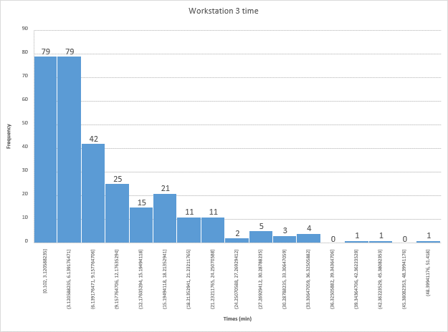*Figure 11: Histogram of Workstation 3's production time*

From this histogram, we guessed that the distribution looks exponential.

**Q-Q Plot**

Using the exact same process as in Inspector 1,

With $\overline{X}=8.79558$

We plot $Y_{j}$ vs $F^{-1}\left(\frac{j-0.5}{300}\right)$

We can determine the line of best fit using linear regression:

*Figure 12: Q-Q Plot of Yj and the inverse function*

Since the slope is approximately 1. The fit is appropriate.

|  |  |  |  |  |  |  |  |
| --- | --- | --- | --- | --- | --- | --- | --- |
| Bin Low | Bin High | Oi | CDF low | CDF HIGH | Pi | Ei | (Oi-Ei)^2/Ei |
| 0.1020 | 3.1206 | 79 | 0.01153 | 0.29868 | 0.28715 | 87 | 0.735632 |
| 3.1206 | 6.1392 | 79 | 0.29868 | 0.502413 | 0.203733 | 62 | 4.66129 |
| 6.1392 | 9.1578 | 42 | 0.502413 | 0.646961 | 0.144549 | 44 | 0.090909 |
| 9.1578 | 12.1764 | 25 | 0.646961 | 0.749519 | 0.102557 | 31 | 1.16129 |
| 12.1764 | 15.1949 | 15 | 0.749519 | 0.822283 | 0.072765 | 22 | 2.227273 |
| 15.1949 | 18.2135 | 21 | 0.822283 | 0.87391 | 0.051627 | 16 | 1.5625 |
| 18.2135 | 21.2321 | 11 | 0.87391 | 0.910539 | 0.036629 | 11 | 0 |
| 21.2321 | 24.2507 | 11 | 0.910539 | 0.936527 | 0.025988 | 8 | 1.125 |
| 24.2507 | 27.2693 | 2 | 0.936527 | 0.954966 | 0.018439 | 6 | 2.666667 |
| 27.2693 | 30.2879 | 5 | 0.954966 | 0.968048 | 0.013082 | 4 | 0.25 |
| 30.2879 | 33.3065 | 3 | 0.968048 | 0.97733 | 0.009282 | 3 | 0 |
| 33.3065 | 36.3251 | 4 | 0.97733 | 0.983916 | 0.006586 | 2 | 2 |
| 36.3251 | 39.3436 | 0 | 0.983916 | 0.988588 | 0.004672 | 2 | 2 |
| 39.3436 | 42.3622 | 1 | 0.988588 | 0.991903 | 0.003315 | 1 | 0 |
| 42.3622 | 45.3808 | 1 | 0.991903 | 0.994255 | 0.002352 | 1 | 0 |
| 45.3808 | 48.3994 | 0 | 0.994255 | 0.995924 | 0.001669 | 1 | 1 |
| 48.3994 | 51.4180 | 1 | 0.990651 | 0.997108 | 0.006457 | 2 | 0.5 |

*Table 6: Required values to compute Chi-Squared test.*

**Chi Square test**

We know that K=17 since it is our bin size.

P=17-1-1 = 15 degrees of freedom

Using a significance level of 0.05, from the chi-squared table,

Since our test statistics from the observations is less than the chi-square value, our null hypothesis is accepted, and we can claim that the exponential distribution is a good fit for workstation 3.

**Data Input Generation**

Now that we know that our models can fit our hypothesis model, we can use these models to generate our input. To do this, we need to create a random number generator to produce random variates. We used Java’s Random library to generate a sequence of random numbers between the range 0 to 1 exclusively. These numbers will be used in our model’s respective inverse CDF to produce a random input.

To ensure that our random input stream is valid, we will use a frequency test between the random numbers generated to compare the distribution set of numbers generated to a uniform distribution.

Using the Chi-Square Test with sample size 300, we will validate the randomness in the number generation for seed 111 for inspector 1.

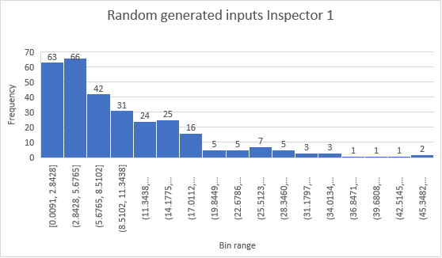

*Figure 13: Histogram of Randomly generated inputs for inspector 1*

|  |  |  |  |  |  |  |  |
| --- | --- | --- | --- | --- | --- | --- | --- |
| Bin Low | Bin High | OI | CDF LOW | CDF HIGH | PI | EI | (Oi-Ei)^2/Ei |
| 0.009 | 2.842 | 63 | 0.000869 | 0.239957 | 0.239088 | 72 | 1.125 |
| 2.842 | 5.675 | 66 | 0.239957 | 0.421832 | 0.181875 | 55 | 2.2 |
| 5.675 | 8.508 | 42 | 0.421832 | 0.560185 | 0.138353 | 42 | 0 |
| 8.508 | 11.341 | 31 | 0.560185 | 0.665431 | 0.105246 | 32 | 0.03125 |
| 11.341 | 14.174 | 24 | 0.665431 | 0.745492 | 0.080061 | 25 | 0.04 |
| 14.174 | 17.007 | 25 | 0.745492 | 0.806395 | 0.060903 | 19 | 1.894737 |
| 17.007 | 19.84 | 16 | 0.806395 | 0.852724 | 0.046329 | 14 | 0.285714 |
| 19.84 | 22.673 | 5 | 0.852724 | 0.887966 | 0.035243 | 11 | 3.272727 |
| 22.673 | 25.506 | 5 | 0.887966 | 0.914775 | 0.026809 | 9 | 1.777778 |
| 25.506 | 28.339 | 7 | 0.914775 | 0.935169 | 0.020394 | 7 | 0 |
| 28.339 | 31.172 | 5 | 0.935169 | 0.950683 | 0.015514 | 5 | 0 |
| 31.172 | 34.005 | 3 | 0.950683 | 0.962484 | 0.011801 | 4 | 0.25 |
| 34.005 | 36.838 | 3 | 0.962484 | 0.971462 | 0.008977 | 3 | 0 |
| 36.838 | 39.671 | 1 | 0.971462 | 0.978291 | 0.006829 | 3 | 1.333333 |
| 39.671 | 42.504 | 1 | 0.978291 | 0.983486 | 0.005195 | 2 | 0.5 |
| 42.504 | 45.337 | 1 | 0.983486 | 0.987438 | 0.003952 | 2 | 0.5 |
| 45.337 | 48.17 | 2 | 0.987438 | 0.990444 | 0.003006 | 1 | 1 |

*Table 7: Required values to compute Chi-Squared test.*

$${X_{0}}^{2}=14.2105$$

$${X_{0.05,15}}^{2}=25.0$$

Since our null hypothesis of random inputs is less than the chi-square value, we can accept the random number stream and say that the stream is acceptable.