Lecture 3:

Describing Distributions -Cont’d (Section 1.3, page 24)

Continuous Distributions – Cont’d

In our last lecture, I introduced density functions of continuous variables. We were able to

- verify a valid density function
- Find the proportion of x between two numbers a and b

Let’s do another example!

Example: Suppose that the probability density function of the amount of milk deposited in a milk container is
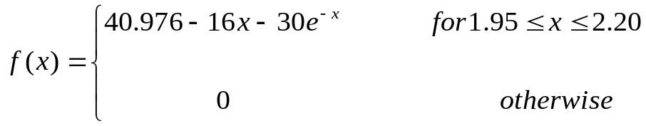

- Verify this is a valid probability density (pdf) function and plot the function in maple.

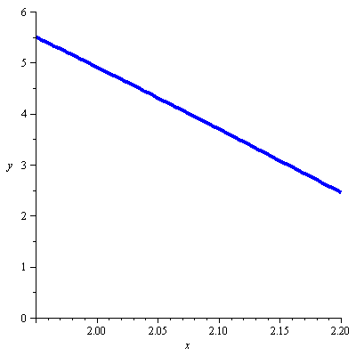
How do we verify that this is a valid pdf?

- The investigators are interested in whether the actual amount of milk is less than the advertised 2.00 liters. Find the proportion.

- Find the probability that the amount of milk is at least 2.0 liters.

Exercise to try at home: Find the probability that the amount of milk is at most 2.1 liters.

EXPONENTIAL DISTRIBUTION
Definition
A variable
is said to have an exponential distribution with parameter
if the density function for
is

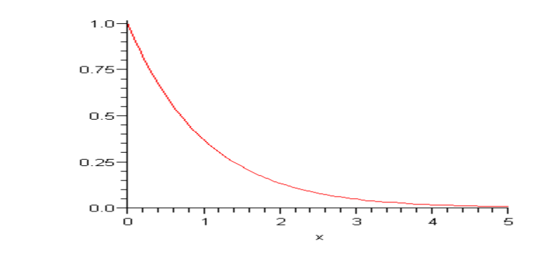

Example: The response time (sec) at a certain on-line computer has an exponential distribution with 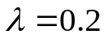.

- What proportion of response times are at least 10 seconds?

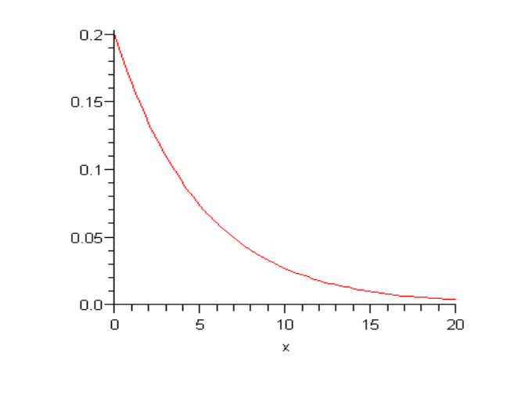

- What proportion of response times are less than 5 seconds?

- What proportion of response times are at most 5 seconds?

- What proportion of response times are between 5 seconds and 10 seconds?

DISCRETE DISTRIBUTIONS

Definition
A population or process distribution for a discrete variable
is specified by a mass function
satisfying

and
;

where the summation is over all possible
values. Other interesting proportions can be obtained by adding various
values. In particular if
and
are integers with
, then

proportion of
values
between
and
(inclusive)

Example: The following table contains the probability distribution of the number of traffic accidents daily in a small city:

x: 0 1 2 3 4 5
p(x): .10 .20 .45 .15 ? ?

- (i)In the long run, what proportion of the time will there be at most three traffic accidents? (ii)Fewer than three accidents?

- In the long run, what proportion of the time will there be at least four traffic accidents?

- In the long run, what proportion of the time will there be between one and three traffic accidents, inclusive?

Have you been paying attention????

1. A random variable r has a probability distribution as follows:
r | 0 1 2 3
P(r) | 2k 3k 13k 2k
Then the probability that P(r < 2) is equal to

(a) .90
(b) .25
(c) .65
(d) .15
2. For what constant k is 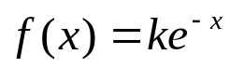 a probability density function on [0,1]?
(a) 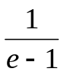 (b) 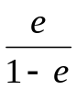 (c) 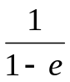 (d) 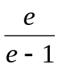

NOTE: If you’ve answered number 1 wrong, you need to review your discrete probability mass functions. If you’ve answered number 2 wrong, you need to review your continuous probability density functions.

