Aplicación 2.3. Curva de Engel para el gasto en alimentos

J. Ramajo

2020

En esta aplicación se estimarán curvas de Engel para el gasto en alimentos.

## 1. Lectura de datos y análisis exploratorio básico

library(readr)  
ENGEL_ALIM_2 <- read_csv("ENGEL_ALIM_2.csv")

## Parsed with column specification:  
## cols(  
## GALIM = col_double(),  
## GTOTAL = col_double()  
## )

attach(ENGEL_ALIM_2)  
WALIM <- GALIM/GTOTAL  
plot(GTOTAL, WALIM)

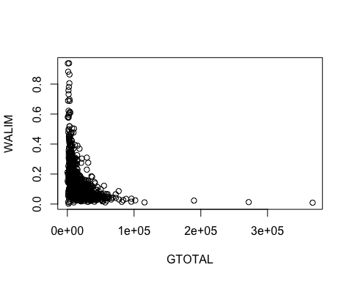

## 2. Análisis econométrico

library(car)

## Loading required package: carData

#  
# Curva de Engel lineal   
#  
S(lm_lin <- lm(WALIM ~ GTOTAL))

## Call: lm(formula = WALIM ~ GTOTAL)  
##   
## Coefficients:  
## Estimate Std. Error t value Pr(>|t|)   
## (Intercept) 1.642e-01 2.849e-03 57.62 <2e-16 ***  
## GTOTAL -2.243e-06 1.267e-07 -17.70 <2e-16 ***  
## ---  
## Signif. codes: 0 '***' 0.001 '**' 0.01 '*' 0.05 '.' 0.1 ' ' 1  
##   
## Residual standard deviation: 0.09035 on 2039 degrees of freedom  
## Multiple R-squared: 0.1332  
## F-statistic: 313.2 on 1 and 2039 DF, p-value: < 2.2e-16   
## AIC BIC   
## -4017.43 -4000.57

#  
# Curva de Engel inversa   
#  
S(lm_inv <- lm(WALIM ~ I(1/GTOTAL)))

## Call: lm(formula = WALIM ~ I(1/GTOTAL))  
##   
## Coefficients:  
## Estimate Std. Error t value Pr(>|t|)   
## (Intercept) 9.201e-02 2.416e-03 38.08 <2e-16 ***  
## I(1/GTOTAL) 3.320e+02 1.374e+01 24.17 <2e-16 ***  
## ---  
## Signif. codes: 0 '***' 0.001 '**' 0.01 '*' 0.05 '.' 0.1 ' ' 1  
##   
## Residual standard deviation: 0.08555 on 2039 degrees of freedom  
## Multiple R-squared: 0.2227  
## F-statistic: 584.2 on 1 and 2039 DF, p-value: < 2.2e-16   
## AIC BIC   
## -4239.92 -4223.05

#  
# Curva de Engel semi-logarítmica  
#  
S(lm_semilog <- lm(WALIM ~ log(GTOTAL)))

## Call: lm(formula = WALIM ~ log(GTOTAL))  
##   
## Coefficients:  
## Estimate Std. Error t value Pr(>|t|)   
## (Intercept) 0.881651 0.022359 39.43 <2e-16 ***  
## log(GTOTAL) -0.079994 0.002367 -33.80 <2e-16 ***  
## ---  
## Signif. codes: 0 '***' 0.001 '**' 0.01 '*' 0.05 '.' 0.1 ' ' 1  
##   
## Residual standard deviation: 0.07769 on 2039 degrees of freedom  
## Multiple R-squared: 0.359  
## F-statistic: 1142 on 1 and 2039 DF, p-value: < 2.2e-16   
## AIC BIC   
## -4633.54 -4616.68

#  
# Curva de Engel Box-Tidwell   
#  
t_BT <- boxTidwell(WALIM ~ GTOTAL)  
print(t_BT)

## MLE of lambda Score Statistic (z) Pr(>|z|)   
## -0.30684 20.295 < 2.2e-16 ***  
## ---  
## Signif. codes: 0 '***' 0.001 '**' 0.01 '*' 0.05 '.' 0.1 ' ' 1  
##   
## iterations = 9

S(lm_BT <- lm(WALIM ~ basicPower(GTOTAL, -0.307)))

## Call: lm(formula = WALIM ~ basicPower(GTOTAL, -0.307))  
##   
## Coefficients:  
## Estimate Std. Error t value Pr(>|t|)   
## (Intercept) -0.125470 0.007356 -17.06 <2e-16 ***  
## basicPower(GTOTAL, -0.307) 4.456994 0.125752 35.44 <2e-16 ***  
## ---  
## Signif. codes: 0 '***' 0.001 '**' 0.01 '*' 0.05 '.' 0.1 ' ' 1  
##   
## Residual standard deviation: 0.07633 on 2039 degrees of freedom  
## Multiple R-squared: 0.3812  
## F-statistic: 1256 on 1 and 2039 DF, p-value: < 2.2e-16   
## AIC BIC   
## -4705.44 -4688.58