Datos financieros: modelos ARCH/GARCH y generalizaciones

J. Ramajo

2020

library("AER")

library("tseries")

library("ggplot2")  
library("imputeTS")

library("fGarch")

#  
# EURUSD <- get.hist.quote("EURUSD=X", start = "2004-01-01", end = "2020-06-30")  
# plot(EURUSD)  
# autoplot(EURUSD$Close) + facet_free()  
# statsNA(EURUSD$Close)  
# EurUsd <- na.approx(EURUSD$Close)  
# autoplot(cbind(EURUSD$Close, EurUsd)) + facet_free()  
# write.zoo(EurUsd, "FIN_EURUSD.CSV", index.name = "Index")  
#  
EurUsd <- read.zoo("FIN_EURUSD.CSV", header = FALSE, sep = " ", format = "%Y-%m-%d")  
plot(EurUsd)

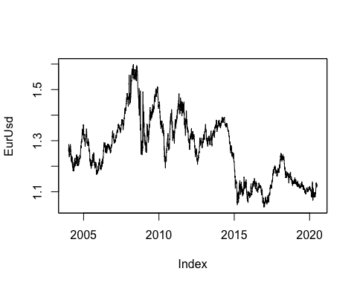

class(EurUsd)

## [1] "zoo"

plotNA.distributionBar(EurUsd, breaks = 20)

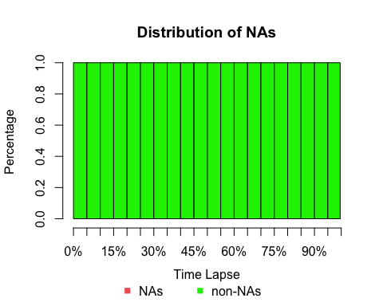

statsNA(EurUsd)

## [1] "Length of time series:"  
## [1] 4304  
## [1] "-------------------------"  
## [1] "Number of Missing Values:"  
## [1] 0  
## [1] "-------------------------"  
## [1] "Percentage of Missing Values:"  
## [1] "0%"  
## [1] "-------------------------"  
## [1] "No NAs in the time Series."

## [1] "No NAs"

autoplot(EurUsd) + facet_free()

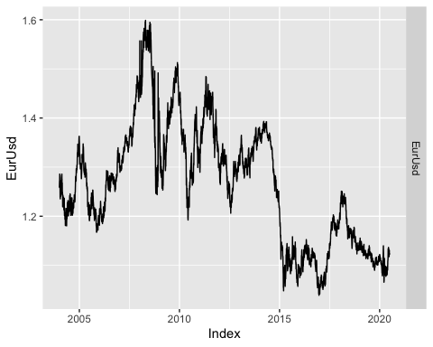

rEurUsd <- 100 * diff(log(EurUsd))  
statsNA(rEurUsd)

## [1] "Length of time series:"  
## [1] 4303  
## [1] "-------------------------"  
## [1] "Number of Missing Values:"  
## [1] 0  
## [1] "-------------------------"  
## [1] "Percentage of Missing Values:"  
## [1] "0%"  
## [1] "-------------------------"  
## [1] "No NAs in the time Series."

## [1] "No NAs"

autoplot(rEurUsd) + facet_free()

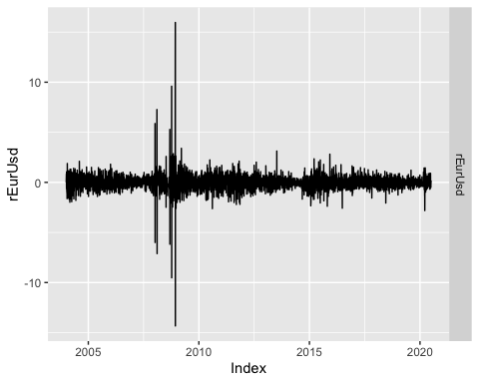

summary(rEurUsd)

## Index rEurUsd   
## Min. :2004-01-02 Min. :-14.332357   
## 1st Qu.:2008-02-16 1st Qu.: -0.336803   
## Median :2012-04-02 Median : 0.000000   
## Mean :2012-04-01 Mean : -0.002606   
## 3rd Qu.:2016-05-16 3rd Qu.: 0.334235   
## Max. :2020-06-30 Max. : 15.963244

#  
rEurUsd_GARCH <- garchFit(~ garch(1,1), data = rEurUsd, cond.dist = "norm", trace = FALSE)

summary(rEurUsd_GARCH)

##   
## Title:  
## GARCH Modelling   
##   
## Call:  
## garchFit(formula = ~garch(1, 1), data = rEurUsd, cond.dist = "norm",   
## trace = FALSE)   
##   
## Mean and Variance Equation:  
## data ~ garch(1, 1)  
## <environment: 0x7f8287b33f78>  
## [data = rEurUsd]  
##   
## Conditional Distribution:  
## norm   
##   
## Coefficient(s):  
## mu omega alpha1 beta1   
## 0.0061244 0.0012245 0.0496229 0.9510491   
##   
## Std. Errors:  
## based on Hessian   
##   
## Error Analysis:  
## Estimate Std. Error t value Pr(>|t|)   
## mu 0.0061244 0.0077203 0.793 0.427612   
## omega 0.0012245 0.0003706 3.304 0.000952 ***  
## alpha1 0.0496229 0.0041871 11.851 < 2e-16 ***  
## beta1 0.9510491 0.0034737 273.784 < 2e-16 ***  
## ---  
## Signif. codes: 0 '***' 0.001 '**' 0.01 '*' 0.05 '.' 0.1 ' ' 1  
##   
## Log Likelihood:  
## -3839.462 normalized: -0.8922757   
##   
## Description:  
## Fri Jul 24 12:34:24 2020 by user:   
##   
##   
## Standardised Residuals Tests:  
## Statistic p-Value   
## Jarque-Bera Test R Chi^2 12658.73 0   
## Shapiro-Wilk Test R W 0.9524602 0   
## Ljung-Box Test R Q(10) 26.87093 0.00272961   
## Ljung-Box Test R Q(15) 28.97918 0.01618422   
## Ljung-Box Test R Q(20) 30.85773 0.0570969   
## Ljung-Box Test R^2 Q(10) 61.58489 1.814584e-09  
## Ljung-Box Test R^2 Q(15) 65.47936 2.815523e-08  
## Ljung-Box Test R^2 Q(20) 67.58693 4.489335e-07  
## LM Arch Test R TR^2 63.72545 4.685898e-09  
##   
## Information Criterion Statistics:  
## AIC BIC SIC HQIC   
## 1.786411 1.792329 1.786409 1.788501

plot(rEurUsd_GARCH, which = 3)

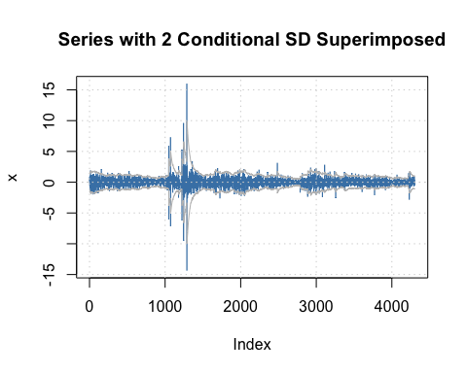

#  
# Plot selection:   
# 1: Time Series 2: Conditional SD   
# 3: Series with 2 Conditional SD Superimposed 4: ACF of Observations   
# 5: ACF of Squared Observations 6: Cross Correlation   
# 7: Residuals 8: Conditional SDs   
# 9: Standardized Residuals 10: ACF of Standardized Residuals   
# 11: ACF of Squared Standardized Residuals 12: Cross Correlation between r^2 and r   
# 13: QQ-Plot of Standardized Residuals   
#  
rEurUsd_ARMA_GARCH <- garchFit(~ arma(1,0) + garch(1,1), data = rEurUsd, trace = FALSE)

summary(rEurUsd_ARMA_GARCH)

##   
## Title:  
## GARCH Modelling   
##   
## Call:  
## garchFit(formula = ~arma(1, 0) + garch(1, 1), data = rEurUsd,   
## trace = FALSE)   
##   
## Mean and Variance Equation:  
## data ~ arma(1, 0) + garch(1, 1)  
## <environment: 0x7f8287af7e50>  
## [data = rEurUsd]  
##   
## Conditional Distribution:  
## norm   
##   
## Coefficient(s):  
## mu ar1 omega alpha1 beta1   
## 0.0062115 -0.0686681 0.0011935 0.0480499 0.9524307   
##   
## Std. Errors:  
## based on Hessian   
##   
## Error Analysis:  
## Estimate Std. Error t value Pr(>|t|)   
## mu 0.0062115 0.0077489 0.802 0.422789   
## ar1 -0.0686681 0.0164586 -4.172 3.02e-05 ***  
## omega 0.0011935 0.0003625 3.293 0.000992 ***  
## alpha1 0.0480499 0.0040879 11.754 < 2e-16 ***  
## beta1 0.9524307 0.0034117 279.163 < 2e-16 ***  
## ---  
## Signif. codes: 0 '***' 0.001 '**' 0.01 '*' 0.05 '.' 0.1 ' ' 1  
##   
## Log Likelihood:  
## -3830.798 normalized: -0.8902622   
##   
## Description:  
## Fri Jul 24 12:34:24 2020 by user:   
##   
##   
## Standardised Residuals Tests:  
## Statistic p-Value   
## Jarque-Bera Test R Chi^2 12128.66 0   
## Shapiro-Wilk Test R W 0.9533347 0   
## Ljung-Box Test R Q(10) 7.230544 0.7035157   
## Ljung-Box Test R Q(15) 9.181668 0.8678285   
## Ljung-Box Test R Q(20) 11.07379 0.9442865   
## Ljung-Box Test R^2 Q(10) 50.23979 2.411272e-07  
## Ljung-Box Test R^2 Q(15) 53.9883 2.638668e-06  
## Ljung-Box Test R^2 Q(20) 56.19766 2.714218e-05  
## LM Arch Test R TR^2 52.14193 5.850808e-07  
##   
## Information Criterion Statistics:  
## AIC BIC SIC HQIC   
## 1.782848 1.790247 1.782846 1.785461

#  
rEurUsd_ARMA_APARCH <- garchFit(~ arma(1,0) + aparch(1,1), data = rEurUsd, trace = FALSE)

summary(rEurUsd_ARMA_APARCH)

##   
## Title:  
## GARCH Modelling   
##   
## Call:  
## garchFit(formula = ~arma(1, 0) + aparch(1, 1), data = rEurUsd,   
## trace = FALSE)   
##   
## Mean and Variance Equation:  
## data ~ arma(1, 0) + aparch(1, 1)  
## <environment: 0x7f828927fb58>  
## [data = rEurUsd]  
##   
## Conditional Distribution:  
## norm   
##   
## Coefficient(s):  
## mu ar1 omega alpha1 gamma1 beta1   
## 0.0028079 -0.0712447 0.0011334 0.0480636 0.0881566 0.9522628   
## delta   
## 2.0000000   
##   
## Std. Errors:  
## based on Hessian   
##   
## Error Analysis:  
## Estimate Std. Error t value Pr(>|t|)   
## mu 0.0028079 0.0078638 0.357 0.72104   
## ar1 -0.0712447 0.0164858 -4.322 1.55e-05 ***  
## omega 0.0011334 0.0003695 3.067 0.00216 **   
## alpha1 0.0480636 0.0048243 9.963 < 2e-16 ***  
## gamma1 0.0881566 0.0361453 2.439 0.01473 *   
## beta1 0.9522628 0.0034130 279.012 < 2e-16 ***  
## delta 2.0000000 0.1270506 15.742 < 2e-16 ***  
## ---  
## Signif. codes: 0 '***' 0.001 '**' 0.01 '*' 0.05 '.' 0.1 ' ' 1  
##   
## Log Likelihood:  
## -3827.82 normalized: -0.8895702   
##   
## Description:  
## Fri Jul 24 12:34:25 2020 by user:   
##   
##   
## Standardised Residuals Tests:  
## Statistic p-Value   
## Jarque-Bera Test R Chi^2 11510.81 0   
## Shapiro-Wilk Test R W 0.9543717 0   
## Ljung-Box Test R Q(10) 7.273812 0.6993672   
## Ljung-Box Test R Q(15) 9.163725 0.8688023   
## Ljung-Box Test R Q(20) 11.10075 0.9435677   
## Ljung-Box Test R^2 Q(10) 64.81227 4.402634e-10  
## Ljung-Box Test R^2 Q(15) 68.95601 6.850062e-09  
## Ljung-Box Test R^2 Q(20) 71.4374 1.059174e-07  
## LM Arch Test R TR^2 67.47906 9.459101e-10  
##   
## Information Criterion Statistics:  
## AIC BIC SIC HQIC   
## 1.782394 1.792752 1.782389 1.786052