Consumo de carburantes en Estados Unidos

J. Ramajo

2020

library(readr)  
library(alr4)

FUEL_CONS <- read_csv("FUEL_CONS.csv")

## Parsed with column specification:  
## cols(  
## id = col_character(),  
## Drivers = col_double(),  
## FuelC = col_double(),  
## Income = col_double(),  
## Miles = col_double(),  
## MPC = col_double(),  
## Pop = col_double(),  
## Tax = col_double(),  
## DLpc = col_double(),  
## FCpc = col_double(),  
## INCpc = col_double()  
## )

summary(FUEL_CONS)

## id Drivers FuelC Income   
## Length:51 Min. : 328094 Min. : 148769 Min. :20993   
## Class :character 1st Qu.: 1087128 1st Qu.: 737361 1st Qu.:25323   
## Mode :character Median : 2718209 Median : 2048664 Median :27871   
## Mean : 3750504 Mean : 2542786 Mean :28404   
## 3rd Qu.: 4424256 3rd Qu.: 3039932 3rd Qu.:31208   
## Max. :21623793 Max. :14691753 Max. :40640   
## Miles MPC Pop Tax   
## Min. : 1534 Min. : 6556 Min. : 381882 Min. : 7.50   
## 1st Qu.: 36586 1st Qu.: 9391 1st Qu.: 1162624 1st Qu.:18.00   
## Median : 78914 Median :10458 Median : 3115130 Median :20.00   
## Mean : 77419 Mean :10448 Mean : 4257046 Mean :20.15   
## 3rd Qu.:112828 3rd Qu.:11311 3rd Qu.: 4845200 3rd Qu.:23.25   
## Max. :300767 Max. :17495 Max. :25599275 Max. :29.00   
## DLpc FCpc INCpc   
## Min. : 700.2 Min. :317.5 Min. :20.99   
## 1st Qu.: 864.1 1st Qu.:575.0 1st Qu.:25.32   
## Median : 909.1 Median :626.0 Median :27.87   
## Mean : 903.7 Mean :613.1 Mean :28.40   
## 3rd Qu.: 943.0 3rd Qu.:666.6 3rd Qu.:31.21   
## Max. :1075.3 Max. :842.8 Max. :40.64

pairs(FCpc ~ Tax + DLpc + INCpc + log(Miles), data=FUEL_CONS)

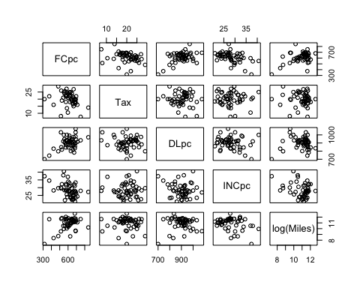

scatterplotMatrix(~ FCpc + Tax + DLpc + INCpc + log(Miles), data=FUEL_CONS, smooth=FALSE, regLine=TRUE)

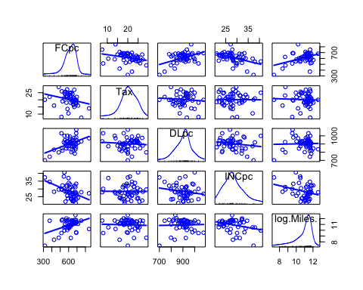

dem.reg <- lm(formula = FCpc ~ Tax + DLpc + INCpc + log(Miles), data=FUEL_CONS)  
S(dem.reg)

## Call: lm(formula = FCpc ~ Tax + DLpc + INCpc + log(Miles), data = FUEL_CONS)  
##   
## Coefficients:  
## Estimate Std. Error t value Pr(>|t|)   
## (Intercept) 154.1928 194.9062 0.791 0.432938   
## Tax -4.2280 2.0301 -2.083 0.042873 *   
## DLpc 0.4719 0.1285 3.672 0.000626 ***  
## INCpc -6.1353 2.1936 -2.797 0.007508 **   
## log(Miles) 26.7552 9.3374 2.865 0.006259 **   
## ---  
## Signif. codes: 0 '***' 0.001 '**' 0.01 '*' 0.05 '.' 0.1 ' ' 1  
##   
## Residual standard deviation: 64.89 on 46 degrees of freedom  
## Multiple R-squared: 0.5105  
## F-statistic: 11.99 on 4 and 46 DF, p-value: 9.331e-07   
## AIC BIC   
## 577.09 588.68

anova(dem.reg) # Type I tests

## Analysis of Variance Table  
##   
## Response: FCpc  
## Df Sum Sq Mean Sq F value Pr(>F)   
## Tax 1 26635 26635 6.3254 0.0154602 *   
## DLpc 1 79378 79378 18.8506 7.692e-05 ***  
## INCpc 1 61408 61408 14.5833 0.0003997 ***  
## log(Miles) 1 34573 34573 8.2104 0.0062592 **   
## Residuals 46 193700 4211   
## ---  
## Signif. codes: 0 '***' 0.001 '**' 0.01 '*' 0.05 '.' 0.1 ' ' 1

Anova(dem.reg) # # Type II tests

## Anova Table (Type II tests)  
##   
## Response: FCpc  
## Sum Sq Df F value Pr(>F)   
## Tax 18264 1 4.3373 0.0428733 *   
## DLpc 56770 1 13.4819 0.0006256 ***  
## INCpc 32940 1 7.8225 0.0075078 **   
## log(Miles) 34573 1 8.2104 0.0062592 **   
## Residuals 193700 46   
## ---  
## Signif. codes: 0 '***' 0.001 '**' 0.01 '*' 0.05 '.' 0.1 ' ' 1

avPlots(dem.reg, id=F)

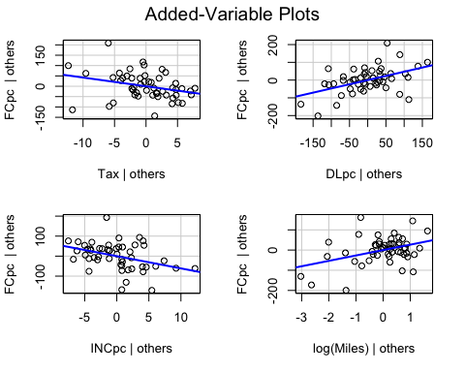

plot(allEffects(dem.reg))

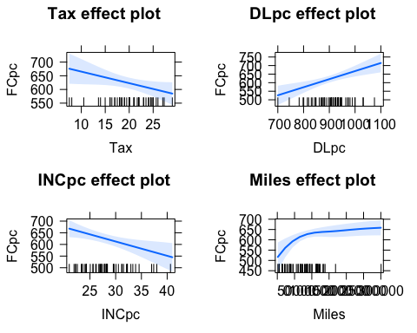

# plot(Effect("Tax", dem.reg), grid=TRUE, rug=TRUE)  
# plot(Effect("Miles", fuel1), grid=TRUE, rug=TRUE)  
effs <- allEffects(dem.reg)  
plot(effs, ask=FALSE, multiline=TRUE, main="", rug=FALSE, grid=TRUE, ci.style="bars")

