Ecuación de salarios en un banco americano

J. Ramajo

2020

library(readr)  
library(car)

## Loading required package: carData

library(MASS)  
library(effects)

## Registered S3 methods overwritten by 'lme4':  
## method from  
## cooks.distance.influence.merMod car   
## influence.merMod car   
## dfbeta.influence.merMod car   
## dfbetas.influence.merMod car

## lattice theme set by effectsTheme()  
## See ?effectsTheme for details.

library(tidyverse)

## ── Attaching packages ──────────────────────────────────────────────────────────────────────────── tidyverse 1.3.0 ──

## ✓ ggplot2 3.3.1 ✓ dplyr 1.0.0  
## ✓ tibble 3.0.1 ✓ stringr 1.4.0  
## ✓ tidyr 1.1.0 ✓ forcats 0.5.0  
## ✓ purrr 0.3.4

## ── Conflicts ─────────────────────────────────────────────────────────────────────────────── tidyverse_conflicts() ──  
## x dplyr::filter() masks stats::filter()  
## x dplyr::lag() masks stats::lag()  
## x dplyr::recode() masks car::recode()  
## x dplyr::select() masks MASS::select()  
## x purrr::some() masks car::some()

library(RcmdrMisc)

## Loading required package: sandwich

library(sfsmisc)

##   
## Attaching package: 'sfsmisc'

## The following object is masked from 'package:dplyr':  
##   
## last

#  
SAL_BANCO <- read_csv("SAL_BANCO.csv")

## Parsed with column specification:  
## cols(  
## EDAD = col_double(),  
## EDUC = col_double(),  
## EXPER = col_double(),  
## RAZA = col_double(),  
## SALARIO = col_double(),  
## SEXO = col_double()  
## )

str(SAL_BANCO)

## tibble [200 × 6] (S3: spec_tbl_df/tbl_df/tbl/data.frame)  
## $ EDAD : num [1:200] 28.5 41.9 41.2 46.2 35.2 ...  
## $ EDUC : num [1:200] 16 19 15 12 16 19 12 12 15 16 ...  
## $ EXPER : num [1:200] 0.25 13 12 20 5.75 ...  
## $ RAZA : num [1:200] 0 0 0 0 0 0 0 0 0 0 ...  
## $ SALARIO: num [1:200] 16079 28351 22800 12301 20500 ...  
## $ SEXO : num [1:200] 0 0 0 0 0 0 0 0 0 0 ...  
## - attr(*, "spec")=  
## .. cols(  
## .. EDAD = col_double(),  
## .. EDUC = col_double(),  
## .. EXPER = col_double(),  
## .. RAZA = col_double(),  
## .. SALARIO = col_double(),  
## .. SEXO = col_double()  
## .. )

head(SAL_BANCO, n=10)

## # A tibble: 10 x 6  
## EDAD EDUC EXPER RAZA SALARIO SEXO  
## <dbl> <dbl> <dbl> <dbl> <dbl> <dbl>  
## 1 28.5 16 0.25 0 16079. 0  
## 2 41.9 19 13 0 28351. 0  
## 3 41.2 15 12 0 22800. 0  
## 4 46.2 12 20 0 12301. 0  
## 5 35.2 16 5.75 0 20500. 0  
## 6 30.1 19 2.92 0 27250. 0  
## 7 44.5 12 18 0 9000. 0  
## 8 27.8 12 3.42 0 10980. 0  
## 9 35.4 15 11.1 0 16020. 0  
## 10 34.3 16 5.67 0 21950. 0

dim(SAL_BANCO)

## [1] 200 6

summary(SAL_BANCO)

## EDAD EDUC EXPER RAZA   
## Min. :23.00 Min. : 8.00 Min. : 0.000 Min. :0.00   
## 1st Qu.:29.75 1st Qu.:12.00 1st Qu.: 2.170 1st Qu.:0.00   
## Median :37.34 Median :12.00 Median : 6.085 Median :0.00   
## Mean :40.54 Mean :13.52 Mean :10.200 Mean :0.29   
## 3rd Qu.:51.50 3rd Qu.:16.00 3rd Qu.:15.940 3rd Qu.:1.00   
## Max. :64.50 Max. :21.00 Max. :38.330 Max. :1.00   
## SALARIO SEXO   
## Min. : 6360 Min. :0.000   
## 1st Qu.: 9645 1st Qu.:0.000   
## Median :12000 Median :0.000   
## Mean :14722 Mean :0.455   
## 3rd Qu.:18817 3rd Qu.:1.000   
## Max. :41498 Max. :1.000

#  
# Matriz 'scatterplot' de los datos  
scatterplotMatrix(~SALARIO + EDUC + EDAD + EXPER, data=SAL_BANCO,   
 var.labels=c("Salario", "Nivel de educación",   
 "Edad", "Experiencia"),  
 smooth=list(smoother=loessLine, var=FALSE, lwd.smooth=3),   
 col="black")

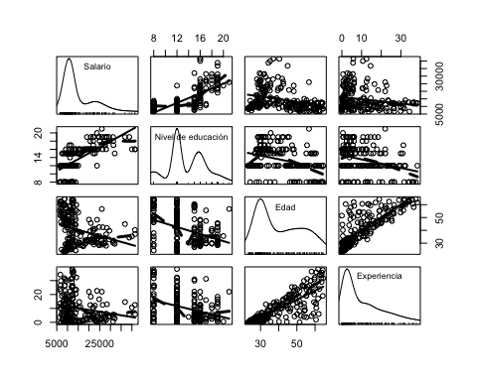

# Análisis univariante de la variable SALARIO  
#  
par(mfrow=c(2, 2))  
Hist(SAL_BANCO$SALARIO, xlab="SALARIO", ylab="Frecuencia",   
 col="gray", main="(a)")  
Boxplot(~SALARIO, data=SAL_BANCO, main="(b)", ylab="SALARIO")

## [1] "30" "32" "82" "101" "131"

densityPlot(SAL_BANCO$SALARIO, from=0, normalize=TRUE,   
 xlab="SALARIO", main="(c)")  
qqPlot(~SALARIO, data=SAL_BANCO, ylab="SALARIO",   
 xlab="Normal Quantiles", main="(d)",  
 id=list(method=c(TRUE, rep(FALSE, 132), TRUE)), col.lines="black")

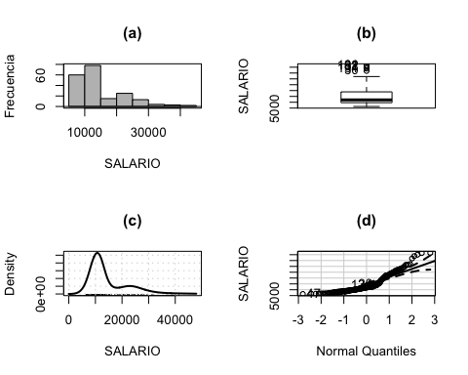

## [1] 47 134 26

#  
with(SAL_BANCO, hist(SALARIO))  
with(SAL_BANCO, hist(log(SALARIO)))  
# Simetría de los boxplots  
symbox(~SALARIO, data=SAL_BANCO, xlab=expression("Potencias,"~lambda), ylab="",   
 powers = c(-1, -0.5, 0, 0.33, 0.5, 1))  
mtext(2, 1, text=expression(t[BC]("SALARIO",~lambda)))  
#  
# Estimación del lambda de la transformación  
#  
S(pt <- powerTransform(SALARIO ~ 1, data=SAL_BANCO))

## bcPower Transformation to Normality   
## Est Power Rounded Pwr Wald Lwr Bnd Wald Upr Bnd  
## Y1 -0.7274 -1 -1.0467 -0.408  
##   
## Likelihood ratio test that transformation parameter is equal to 0  
## (log transformation)  
## LRT df pval  
## LR test, lambda = (0) 20.54316 1 5.8302e-06  
##   
## Likelihood ratio test that no transformation is needed  
## LRT df pval  
## LR test, lambda = (1) 118.5095 1 < 2.22e-16

pt$lambda # estimated lambda

## Y1   
## -0.7273628

sqrt(pt$invHess) # SE

## [,1]  
## [1,] 0.1629263

# Densidad de la variable SALARIO log-transformada  
#  
densityPlot(~log(SALARIO), data=SAL_BANCO, adjust=0.75, xlab="log(SALARIO)")  
basicPowerAxis(0, side="above", at=c(1, 5, 10, 20, 50, 100),   
 axis.title="")

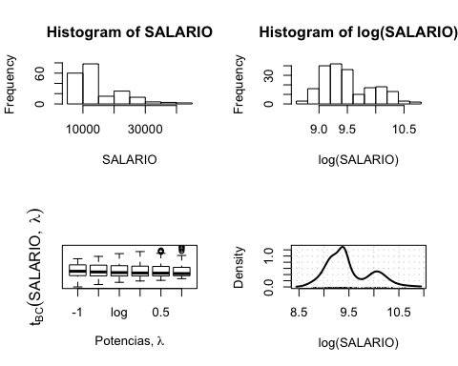

# Análisis bivariante  
#  
# Scatterplots  
#  
scatterplot(log(SALARIO) ~ EDUC, data=SAL_BANCO, smooth=list(smoother=loessLine, var=FALSE,   
 lwd.smooth=3), col="black",  
 regLine=list(lwd=3),  
 xlab="EDUC",   
 ylab="log(SALARIO)")

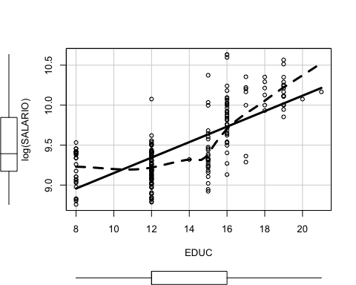

#  
scatterplot(log(SALARIO) ~ EDAD, data=SAL_BANCO, smooth=list(smoother=loessLine, var=FALSE,   
 lwd.smooth=3), col="black",  
 regLine=list(lwd=3),  
 xlab="EDAD",   
 ylab="log(SALARIO)")

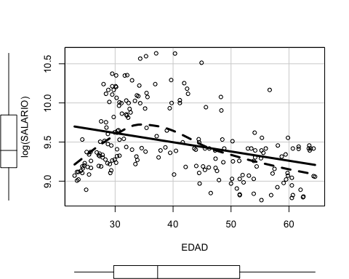

#  
scatterplot(log(SALARIO) ~ EDUC, data=SAL_BANCO, pch=".")

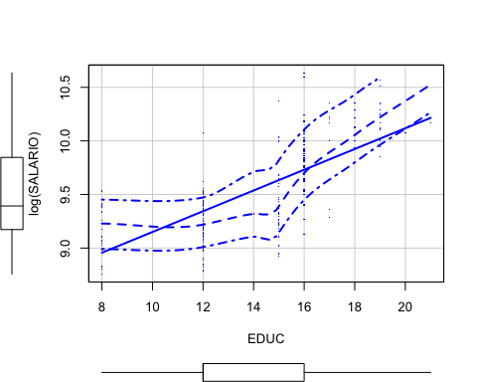

scatterplot(log(SALARIO) ~ EDAD, data=SAL_BANCO, pch=".")

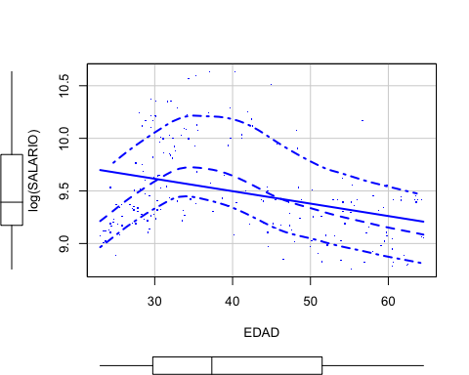

#  
pairs( ~ SALARIO + EDUC + EDAD, data=SAL_BANCO)

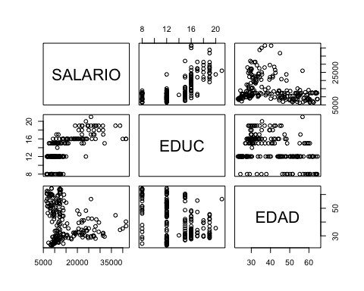

scatterplotMatrix( ~ SALARIO + EDUC + EDAD, data=SAL_BANCO)

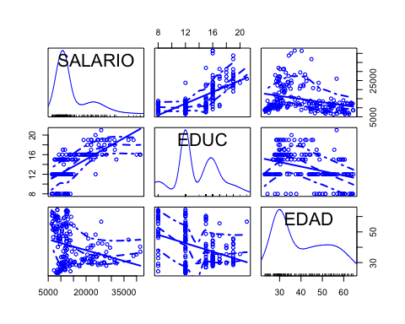

library(PerformanceAnalytics)

## Loading required package: xts

## Loading required package: zoo

##   
## Attaching package: 'zoo'

## The following objects are masked from 'package:base':  
##   
## as.Date, as.Date.numeric

##   
## Attaching package: 'xts'

## The following object is masked from 'package:sfsmisc':  
##   
## last

## The following objects are masked from 'package:dplyr':  
##   
## first, last

##   
## Attaching package: 'PerformanceAnalytics'

## The following object is masked from 'package:graphics':  
##   
## legend

chart.Correlation(SAL_BANCO, method="pearson", histogram=TRUE, pch=16)

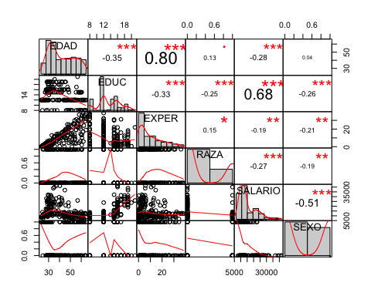

#  
# Gráficos bidimensionales  
#  
ggplot(SAL_BANCO, aes(x=EDUC, y=SALARIO)) + geom_point() + labs(title="Diagrama de puntos", x="Educación", y="Salario")

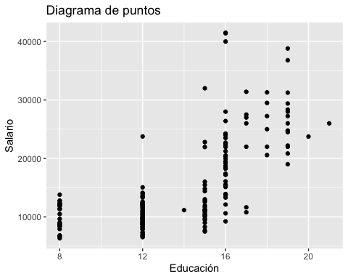

ggplot(SAL_BANCO, aes(x=EDAD, y=SALARIO)) + geom_point() + labs(title="Diagrama de puntos", x="Edad", y="Salario")

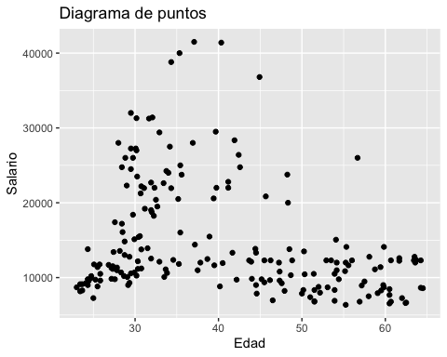

ggplot(SAL_BANCO, aes(x=as.factor(SEXO), y=SALARIO)) + geom_boxplot() + labs(title="Box plot", x="Sexo", y="Salario")

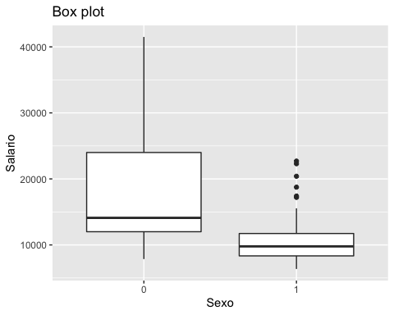

ggplot(SAL_BANCO, aes(x=as.factor(RAZA), y=SALARIO)) + geom_boxplot() + labs(title="Box plot", x="Raza", y="Salario")

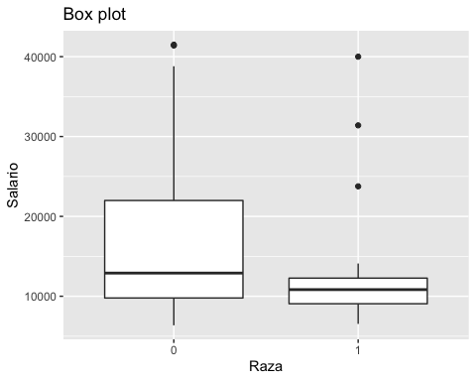

#  
ggplot(SAL_BANCO, aes(x=EDUC, y=SALARIO)) + geom_point() + geom_smooth(method = 'lm')

## `geom_smooth()` using formula 'y ~ x'

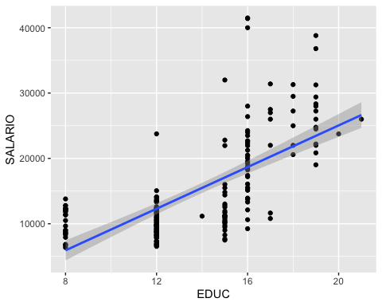

ggplot(SAL_BANCO, aes(x=EDAD, y=SALARIO)) + geom_point() + geom_smooth(method = 'lm')

## `geom_smooth()` using formula 'y ~ x'

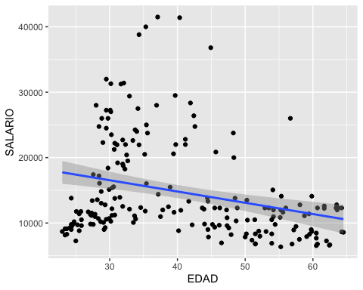

#  
# Variables de control (cambiar SEXO por RAZA para analizar los cambios)  
#  
ggplot(SAL_BANCO, aes(x=EDUC, y=SALARIO, color=as.factor(SEXO), shape=as.factor(SEXO))) + geom_point()

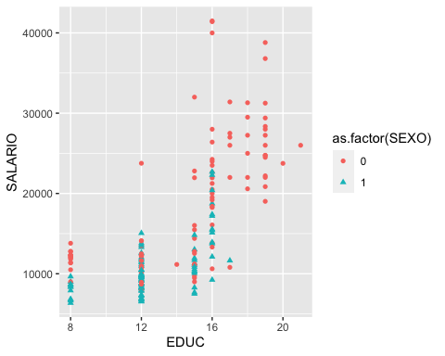

ggplot(SAL_BANCO, aes(x=EDUC, y=SALARIO, color=as.factor(SEXO), shape=as.factor(SEXO))) + geom_point() + geom_smooth(method = 'lm')

## `geom_smooth()` using formula 'y ~ x'

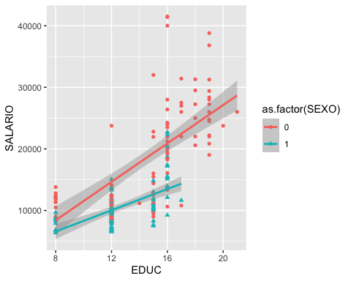

ggplot(SAL_BANCO, aes(x=EDAD, y=SALARIO, color=as.factor(SEXO), shape=as.factor(SEXO))) + geom_point()

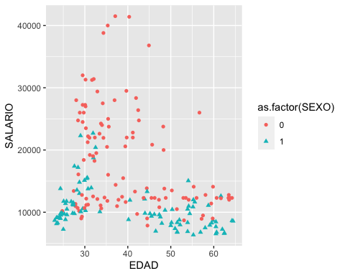

ggplot(SAL_BANCO, aes(x=EDAD, y=SALARIO, color=as.factor(SEXO), shape=as.factor(SEXO))) + geom_point() + geom_smooth(method = 'lm')

## `geom_smooth()` using formula 'y ~ x'

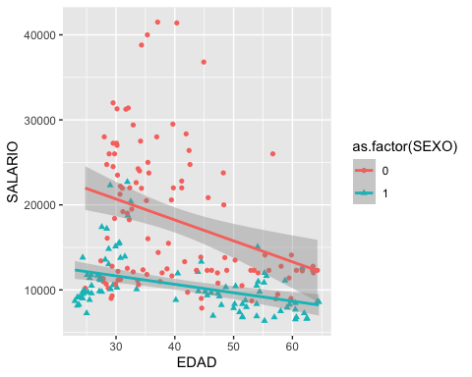

#  
ggplot(SAL_BANCO, aes(x=EDUC, y=SALARIO, color=as.factor(SEXO), size=EDAD)) + geom_point()

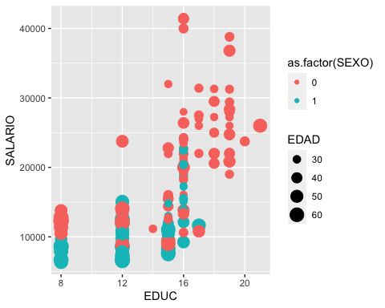

ggplot(SAL_BANCO, aes(x=EDUC, y=SALARIO, color=as.factor(RAZA), size=EDAD)) + geom_point()

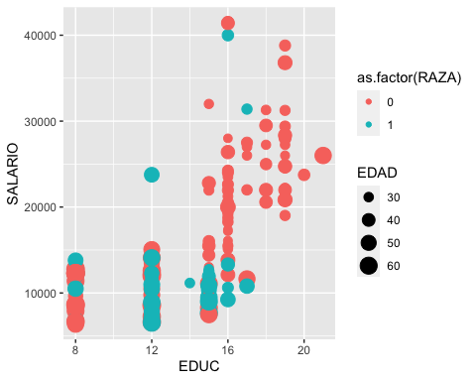

#  
ggplot(SAL_BANCO, aes(x=EDUC, y=SALARIO)) + geom_point() + facet_wrap(~ as.factor(SEXO))

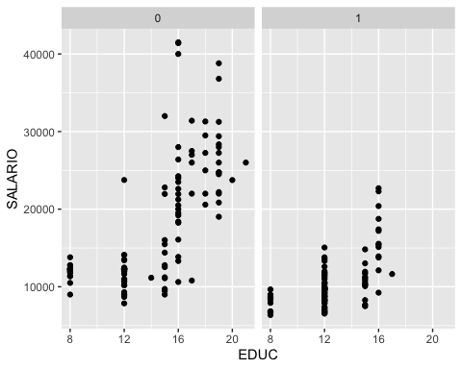

ggplot(SAL_BANCO, aes(x=EDUC, y=SALARIO)) + geom_point() + facet_wrap(~ as.factor(RAZA))

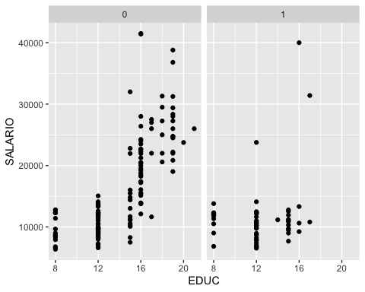

#  
ggplot(SAL_BANCO, aes(x=EDAD, y=SALARIO)) + geom_point() + facet_wrap(~ as.factor(SEXO))

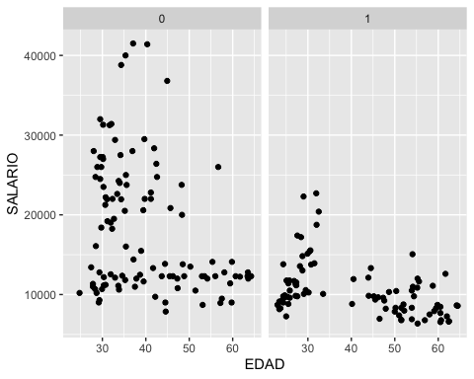

ggplot(SAL_BANCO, aes(x=EDAD, y=SALARIO)) + geom_point() + facet_wrap(~ as.factor(RAZA))

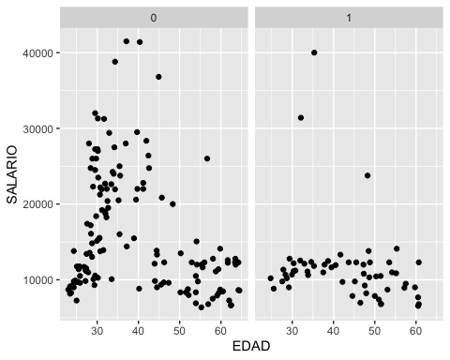

#  
# Modelo de regresión lineal  
# R usa la notación de Wilkinson-Rogers para especificar modelos: variable respuesta ~ variables explicativas  
# El símbolo (~) se lee como “es modelizada como función de” .   
# Otros símbolos utilizados son:  
# + inclusiónn de variable  
# - exclusión de variable (no substracción)  
# ∗ incluir variables y sus interacciones  
# : interaccionar dos variables  
# ∧ interacción de variables hasta un grado especificado (no un exponente)  
# Para obviar un símbolo de modelo, usar la función I().  
# Ejemplos:  
# y ~ x1 + x2 + x3 (regresión múltiple)  
# y ~ . (regress y on all variables in data set)  
# y ~ x1 + x2 - 1 (excluir la constante del modelo)  
# y ~ x1 + x2 + x1:x2 (incluir interacción entre x1 y x2)  
# y ~ x1 * x2 (incluir x1, x2 y su interacción - mismo resultado que el modelo anterior)  
# y ~ x1 + x2 + x3 + x1:x2 + x1:x3 + x2:x3 + x1:x2:x3 (modelo con interacciones de doble y triple vía)  
# y ~ x1 * x2 * x3 (igual que el modelo anterior)  
# y ~ (x1 + x2 + x3)ˆ2 (interacciones de dbole-vía)  
# y ~ x1 + I(x1ˆ2) + x2 (regresión cuadrática en x1 más variables x2)  
# y ~ poly(x1, 2, raw = TRUE) + x2 (igual que el modelo anterior)  
# Modelo lineal  
S(lm_sal_0 <- lm(SALARIO ~ EDUC + EDAD, data = SAL_BANCO))

## Call: lm(formula = SALARIO ~ EDUC + EDAD, data = SAL_BANCO)  
##   
## Coefficients:  
## Estimate Std. Error t value Pr(>|t|)   
## (Intercept) -5039.79 2626.87 -1.919 0.0565 .   
## EDUC 1551.98 131.09 11.839 <2e-16 ***  
## EDAD -30.12 33.83 -0.890 0.3744   
## ---  
## Signif. codes: 0 '***' 0.001 '**' 0.01 '*' 0.05 '.' 0.1 ' ' 1  
##   
## Residual standard deviation: 5524 on 197 degrees of freedom  
## Multiple R-squared: 0.463  
## F-statistic: 84.92 on 2 and 197 DF, p-value: < 2.2e-16   
## AIC BIC   
## 4019.31 4032.51

## Diagnósticos  
# 'residuals' -errores estimados y `rstudent()` - residuos estudentizados  
# `densityPlot()` chequeo de la distribución de los errores (densidades estimadas)  
densityPlot(residuals(lm_sal_0))  
densityPlot(rstudent(lm_sal_0))  
spreadLevelPlot(lm_sal_0)

##   
## Suggested power transformation: 0.8973957

# `qqPlot()` chequeo de errores no-normales (comparación de los residuos estudentizados con una distribution t)  
qqPlot(lm_sal_0)

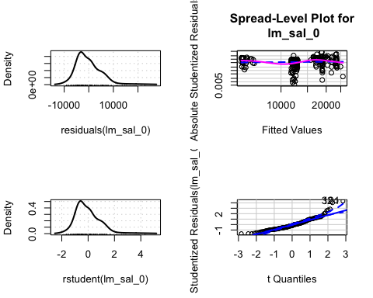

## [1] 32 101

# Chequeo de 'outliers' en la regresión  
#  
max(hatvalues(lm_sal_0))

## [1] 0.05872325

which.max(hatvalues(lm_sal_0))

## 21   
## 21

#  
outlierTest(lm_sal_0)

## rstudent unadjusted p-value Bonferroni p  
## 101 4.331607 2.3616e-05 0.0047231  
## 32 4.331018 2.3673e-05 0.0047347  
## 82 4.011607 8.5743e-05 0.0171490

#  
max(cooks.distance(lm_sal_0))

## [1] 0.05421915

which.max(cooks.distance(lm_sal_0))

## 30   
## 30

#  
max(abs(dffits(lm_sal_0)))

## [1] 0.4088903

which.max(abs(dffits(lm_sal_0)))

## 30   
## 30

#  
# Medidas de influencia  
S(influence.measures(lm_sal_0))

## Potentially influential observations of  
## lm(formula = SALARIO ~ EDUC + EDAD, data = SAL_BANCO) :  
##   
## dfb.1_ dfb.EDUC dfb.EDAD dffit cov.r cook.d hat   
## 14 0.09 0.03 -0.15 0.26 0.92_* 0.02 0.01   
## 21 -0.01 0.01 0.00 0.01 1.08_* 0.00 0.06_*  
## 30 -0.31 0.36 0.19 0.41_* 0.94_* 0.05 0.03   
## 32 -0.10 0.22 0.00 0.39_* 0.78_* 0.05 0.01   
## 51 0.09 -0.07 -0.06 0.09 1.06_* 0.00 0.04   
## 82 -0.06 0.19 -0.04 0.36 0.81_* 0.04 0.01   
## 89 0.08 -0.07 -0.05 0.09 1.05_* 0.00 0.03   
## 101 -0.17 0.25 0.09 0.40_* 0.78_* 0.05 0.01   
## 131 -0.21 0.34 0.02 0.41_* 0.92_* 0.05 0.02

influenceIndexPlot(lm_sal_0, vars=c("Cook", "hat", "Studentized"))

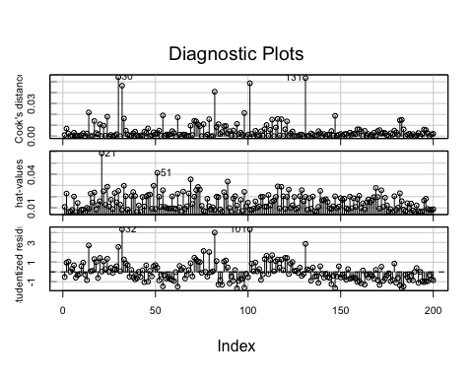

influencePlot(lm_sal_0, xlab="Hat values")

## StudRes Hat CookD  
## 21 0.0291055 0.058723246 1.770638e-05  
## 30 2.5477581 0.025110343 5.421915e-02  
## 32 4.3310179 0.008026966 4.641173e-02  
## 51 0.4348382 0.041240086 2.722295e-03  
## 101 4.3316069 0.008412244 4.867037e-02  
## 131 2.8644299 0.019845816 5.342317e-02

# Gráficos de variable añadida, buscando casos influyentes  
avPlots(lm_sal_0, id=list(cex=0.60, method="mahal"))

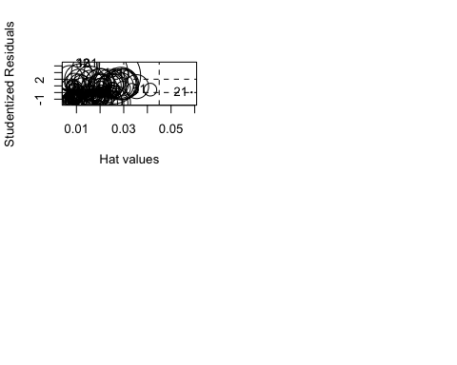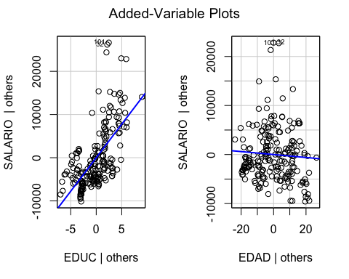

# Chequeo de no linealidad: gráficos de componente+residuo  
crPlots(lm_sal_0, smooth=list(span=0.7))

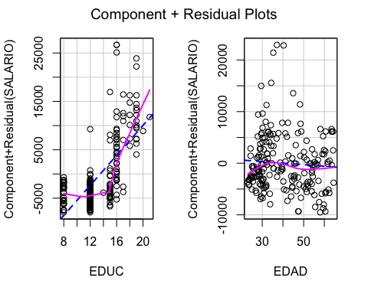

# Chequeo de varianza no constante:  
ncvTest(lm_sal_0)

## Non-constant Variance Score Test   
## Variance formula: ~ fitted.values   
## Chisquare = 14.92596, Df = 1, p = 0.00011181

ncvTest(lm_sal_0, var.formula= ~ EDUC + EDAD)

## Non-constant Variance Score Test   
## Variance formula: ~ EDUC + EDAD   
## Chisquare = 18.27925, Df = 2, p = 0.00010733

#  
# Modelo log-lineal  
#  
S(lm_sal <- lm(log(SALARIO) ~ EDUC + EDAD, data = SAL_BANCO))

## Call: lm(formula = log(SALARIO) ~ EDUC + EDAD, data = SAL_BANCO)  
##   
## Coefficients:  
## Estimate Std. Error t value Pr(>|t|)   
## (Intercept) 8.381805 0.150665 55.632 <2e-16 ***  
## EDUC 0.092165 0.007519 12.258 <2e-16 ***  
## EDAD -0.003374 0.001941 -1.739 0.0837 .   
## ---  
## Signif. codes: 0 '***' 0.001 '**' 0.01 '*' 0.05 '.' 0.1 ' ' 1  
##   
## Residual standard deviation: 0.3168 on 197 degrees of freedom  
## Multiple R-squared: 0.4945  
## F-statistic: 96.35 on 2 and 197 DF, p-value: < 2.2e-16   
## AIC BIC   
## 112.81 126.01

brief(lm_sal)

## (Intercept) EDUC EDAD  
## Estimate 8.382 0.09216 -0.00337  
## Std. Error 0.151 0.00752 0.00194  
##   
## Residual SD = 0.317 on 197 df, R-squared = 0.494

coef(lm_sal)

## (Intercept) EDUC EDAD   
## 8.38180464 0.09216472 -0.00337382

confint(lm_sal)

## 2.5 % 97.5 %  
## (Intercept) 8.084681719 8.6789275586  
## EDUC 0.077337314 0.1069921306  
## EDAD -0.007200724 0.0004530834

#  
# Introducción de factores de control  
# Boxplots  
#  
Boxplot(log(SALARIO) ~ SEXO, data=SAL_BANCO, id=list(location="lr"),   
 ylab="SALARIO", xlab="SEXO")

## [1] "50" "63" "154"

#  
Boxplot(log(SALARIO) ~ SEXO, data=SAL_BANCO, id=list(location="lr"),   
 ylab="SALARIO", xlab="RAZA")

## [1] "50" "63" "154"

#  
lm_sal_factors <- lm(log(SALARIO) ~ SEXO + RAZA + EDUC + EDAD, data = SAL_BANCO)  
S(lm_sal_factors)

## Call: lm(formula = log(SALARIO) ~ SEXO + RAZA + EDUC + EDAD, data = SAL_BANCO)  
##   
## Coefficients:  
## Estimate Std. Error t value Pr(>|t|)   
## (Intercept) 9.027626 0.129264 69.839 < 2e-16 ***  
## SEXO -0.421681 0.037356 -11.288 < 2e-16 ***  
## RAZA -0.239739 0.040782 -5.879 1.77e-08 ***  
## EDUC 0.065614 0.006270 10.465 < 2e-16 ***  
## EDAD -0.004002 0.001500 -2.669 0.00825 **   
## ---  
## Signif. codes: 0 '***' 0.001 '**' 0.01 '*' 0.05 '.' 0.1 ' ' 1  
##   
## Residual standard deviation: 0.2443 on 195 degrees of freedom  
## Multiple R-squared: 0.7025  
## F-statistic: 115.1 on 4 and 195 DF, p-value: < 2.2e-16   
## AIC BIC   
## 10.78 30.57

compareCoefs(lm_sal, lm_sal_factors)

## Calls:  
## 1: lm(formula = log(SALARIO) ~ EDUC + EDAD, data = SAL_BANCO)  
## 2: lm(formula = log(SALARIO) ~ SEXO + RAZA + EDUC + EDAD, data = SAL_BANCO)  
##   
## Model 1 Model 2  
## (Intercept) 8.382 9.028  
## SE 0.151 0.129  
##   
## EDUC 0.09216 0.06561  
## SE 0.00752 0.00627  
##   
## EDAD -0.00337 -0.00400  
## SE 0.00194 0.00150  
##   
## SEXO -0.4217  
## SE 0.0374  
##   
## RAZA -0.2397  
## SE 0.0408  
##

#  
anova(lm_sal_factors)

## Analysis of Variance Table  
##   
## Response: log(SALARIO)  
## Df Sum Sq Mean Sq F value Pr(>F)   
## SEXO 1 12.1696 12.1696 203.8913 < 2.2e-16 ***  
## RAZA 1 6.2225 6.2225 104.2525 < 2.2e-16 ***  
## EDUC 1 8.6657 8.6657 145.1865 < 2.2e-16 ***  
## EDAD 1 0.4251 0.4251 7.1227 0.008252 **   
## Residuals 195 11.6389 0.0597   
## ---  
## Signif. codes: 0 '***' 0.001 '**' 0.01 '*' 0.05 '.' 0.1 ' ' 1

#  
# Modelo cuadrático con factores de control  
#  
S(lm_sal_poly <- lm(log(SALARIO) ~ SEXO + RAZA + poly(EDUC,2, raw=TRUE) + poly(EDAD,2, raw=TRUE), data = SAL_BANCO))

## Call: lm(formula = log(SALARIO) ~ SEXO + RAZA + poly(EDUC, 2, raw = TRUE) +  
## poly(EDAD, 2, raw = TRUE), data = SAL_BANCO)  
##   
## Coefficients:  
## Estimate Std. Error t value Pr(>|t|)   
## (Intercept) 9.5376718 0.3576590 26.667 < 2e-16 ***  
## SEXO -0.3496025 0.0382804 -9.133 < 2e-16 ***  
## RAZA -0.2328608 0.0414828 -5.613 6.83e-08 ***  
## poly(EDUC, 2, raw = TRUE)1 -0.1112075 0.0406899 -2.733 0.00686 **   
## poly(EDUC, 2, raw = TRUE)2 0.0064279 0.0015116 4.252 3.29e-05 ***  
## poly(EDAD, 2, raw = TRUE)1 0.0283828 0.0131379 2.160 0.03198 *   
## poly(EDAD, 2, raw = TRUE)2 -0.0003939 0.0001537 -2.563 0.01115 *   
## ---  
## Signif. codes: 0 '***' 0.001 '**' 0.01 '*' 0.05 '.' 0.1 ' ' 1  
##   
## Residual standard deviation: 0.2313 on 193 degrees of freedom  
## Multiple R-squared: 0.7362  
## F-statistic: 89.76 on 6 and 193 DF, p-value: < 2.2e-16   
## AIC BIC   
## -9.24 17.14

# Comparación con el modelo simple  
anova(lm_sal, lm_sal_poly)

## Analysis of Variance Table  
##   
## Model 1: log(SALARIO) ~ EDUC + EDAD  
## Model 2: log(SALARIO) ~ SEXO + RAZA + poly(EDUC, 2, raw = TRUE) + poly(EDAD,   
## 2, raw = TRUE)  
## Res.Df RSS Df Sum of Sq F Pr(>F)   
## 1 197 19.777   
## 2 193 10.322 4 9.4554 44.202 < 2.2e-16 ***  
## ---  
## Signif. codes: 0 '***' 0.001 '**' 0.01 '*' 0.05 '.' 0.1 ' ' 1

# Chequeo por defecto  
plot(lm_sal_poly)

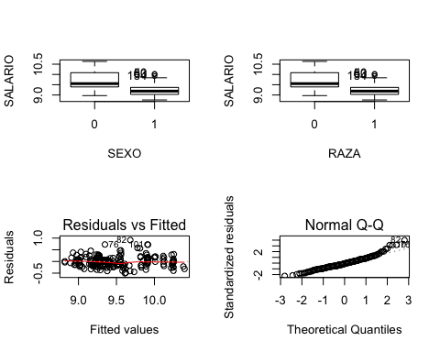

# Chequeo de las hipótesis de linealidad (y varianza constante)  
plot(lm_sal_poly, which = 1)  
# Chequeo de la hipótesis de normalidad  
plot(lm_sal_poly, which = 2)

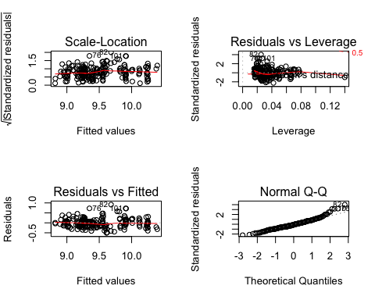

# Chequeo de las hipótesis de varianza constante  
plot(lm_sal_poly, which = 3)  
# Chequeo de observaciones atípicas e influyentes  
plot(lm_sal_poly, which = 5)  
plot(lm_sal_poly, which = 4)  
#  
# Análisis de efectos  
summary(lm_sal_poly)

##   
## Call:  
## lm(formula = log(SALARIO) ~ SEXO + RAZA + poly(EDUC, 2, raw = TRUE) +   
## poly(EDAD, 2, raw = TRUE), data = SAL_BANCO)  
##   
## Residuals:  
## Min 1Q Median 3Q Max   
## -0.50692 -0.14152 -0.02066 0.12946 0.91440   
##   
## Coefficients:  
## Estimate Std. Error t value Pr(>|t|)   
## (Intercept) 9.5376718 0.3576590 26.667 < 2e-16 ***  
## SEXO -0.3496025 0.0382804 -9.133 < 2e-16 ***  
## RAZA -0.2328608 0.0414828 -5.613 6.83e-08 ***  
## poly(EDUC, 2, raw = TRUE)1 -0.1112075 0.0406899 -2.733 0.00686 **   
## poly(EDUC, 2, raw = TRUE)2 0.0064279 0.0015116 4.252 3.29e-05 ***  
## poly(EDAD, 2, raw = TRUE)1 0.0283828 0.0131379 2.160 0.03198 *   
## poly(EDAD, 2, raw = TRUE)2 -0.0003939 0.0001537 -2.563 0.01115 *   
## ---  
## Signif. codes: 0 '***' 0.001 '**' 0.01 '*' 0.05 '.' 0.1 ' ' 1  
##   
## Residual standard error: 0.2313 on 193 degrees of freedom  
## Multiple R-squared: 0.7362, Adjusted R-squared: 0.728   
## F-statistic: 89.76 on 6 and 193 DF, p-value: < 2.2e-16

plot(Effect("EDUC", lm_sal_poly))  
plot(Effect("EDAD", lm_sal_poly))  
#  
# Modelo con efectos de interacción  
#  
lm_sal_poly_int <- lm(log(SALARIO) ~ SEXO + RAZA + poly(EDUC,2, raw=TRUE) + poly(EDAD,2, raw=TRUE) + EDUC:EDAD, data = SAL_BANCO)  
S(lm_sal_poly_int)

## Call: lm(formula = log(SALARIO) ~ SEXO + RAZA + poly(EDUC, 2, raw = TRUE) +  
## poly(EDAD, 2, raw = TRUE) + EDUC:EDAD, data = SAL_BANCO)  
##   
## Coefficients:  
## Estimate Std. Error t value Pr(>|t|)   
## (Intercept) 8.3047154 0.5204150 15.958 < 2e-16 ***  
## SEXO -0.3326206 0.0377729 -8.806 7.61e-16 ***  
## RAZA -0.2029661 0.0415909 -4.880 2.22e-06 ***  
## poly(EDUC, 2, raw = TRUE)1 -0.0053869 0.0517288 -0.104 0.917169   
## poly(EDUC, 2, raw = TRUE)2 0.0050769 0.0015360 3.305 0.001132 **   
## poly(EDAD, 2, raw = TRUE)1 0.0537647 0.0150921 3.562 0.000463 ***  
## poly(EDAD, 2, raw = TRUE)2 -0.0004511 0.0001512 -2.984 0.003219 **   
## EDUC:EDAD -0.0016467 0.0005151 -3.197 0.001625 **   
## ---  
## Signif. codes: 0 '***' 0.001 '**' 0.01 '*' 0.05 '.' 0.1 ' ' 1  
##   
## Residual standard deviation: 0.2259 on 192 degrees of freedom  
## Multiple R-squared: 0.7495  
## F-statistic: 82.07 on 7 and 192 DF, p-value: < 2.2e-16   
## AIC BIC   
## -17.62 12.07

plot(Effect("EDUC", lm_sal_poly_int))  
plot(Effect("EDAD", lm_sal_poly_int))  
plot(Effect(c("EDUC","EDAD"), lm_sal_poly_int))  
#  
# Diagnóstico del modelo  
#  
# Normalidad de los residuos  
# Distribución de los residuos  
library(tseries)

## Registered S3 method overwritten by 'quantmod':  
## method from  
## as.zoo.data.frame zoo

r <- resid(lm_sal_poly_int)  
rbar <- mean(r)  
sdr <- sd(r)  
hist(r, col="grey", freq=FALSE, main="Distribución de los residuos",  
 ylab="Density", xlab="residuos")  
curve(dnorm(x, rbar, sdr), col=2, add=TRUE,  
 ylab="Density", xlab="r")

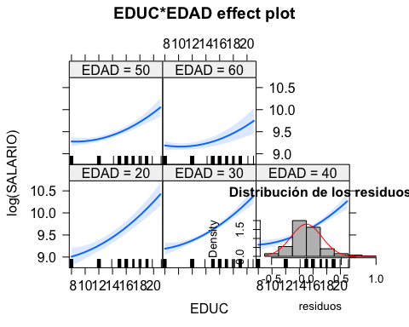

#   
# Residuos estandarizados  
rs<-(r-rbar)/sdr  
hist(rs, freq=FALSE,  
 main="Distribución de los residuos estandarizados")  
#  
qqnorm(rs)   
abline(0,1)   
#  
jarque.bera.test(r) #(package 'tseries')

##   
## Jarque Bera Test  
##   
## data: r  
## X-squared = 46.864, df = 2, p-value = 6.662e-11

shapiro.test(r)

##   
## Shapiro-Wilk normality test  
##   
## data: r  
## W = 0.96165, p-value = 2.993e-05

#  
# Distribución de los residuos estudentizados  
library(MASS)  
rt <- studres(lm_sal_poly_int)  
hist(rt, freq=FALSE,  
 main="Distribución de los residuos estudentizados")  
xfit<-seq(min(rt),max(rt),length=40)  
yfit<-dnorm(xfit)  
lines(xfit, yfit)   
#  
# QQ plot de los residuos estudentizados  
qqPlot(lm_sal_poly_int, main="QQ Plot")

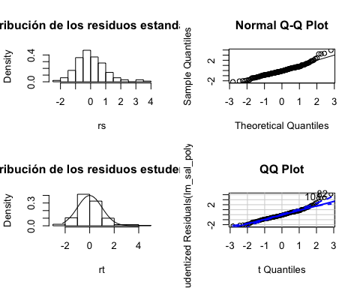

## [1] 82 101

#  
# Multicolinealidad  
# Matriz de correlaciones  
cor(SAL_BANCO)

## EDAD EDUC EXPER RAZA SALARIO SEXO  
## EDAD 1.00000000 -0.3549893 0.8013086 0.1270033 -0.2844342 0.04033283  
## EDUC -0.35498933 1.0000000 -0.3251096 -0.2460025 0.6788401 -0.26246839  
## EXPER 0.80130862 -0.3251096 1.0000000 0.1459087 -0.1915098 -0.21361832  
## RAZA 0.12700328 -0.2460025 0.1459087 1.0000000 -0.2720387 -0.18565209  
## SALARIO -0.28443420 0.6788401 -0.1915098 -0.2720387 1.0000000 -0.50955103  
## SEXO 0.04033283 -0.2624684 -0.2136183 -0.1856521 -0.5095510 1.00000000

# Factores de inflación de la varianza  
vif(lm_sal_poly_int)

## GVIF Df GVIF^(1/(2*Df))  
## SEXO 1.386378 1 1.177445  
## RAZA 1.395619 1 1.181363  
## poly(EDUC, 2, raw = TRUE) 24.863252 2 2.233004  
## poly(EDAD, 2, raw = TRUE) 34.127079 2 2.416990  
## EDUC:EDAD 28.606751 1 5.348528

sqrt(vif(lm_sal_poly_int)) > 2 # problema de multicolinealidad

## GVIF Df GVIF^(1/(2*Df))  
## SEXO FALSE FALSE FALSE  
## RAZA FALSE FALSE FALSE  
## poly(EDUC, 2, raw = TRUE) TRUE FALSE FALSE  
## poly(EDAD, 2, raw = TRUE) TRUE FALSE FALSE  
## EDUC:EDAD TRUE FALSE TRUE