Aplicación 2.4: La apertura de un nuevo negocio en Pekín

J. Ramajo

2020

# Preliminares

Lectura de packages

library(readr)  
library(car)

## Loading required package: carData

library(MASS)  
library(effects)

## Registered S3 methods overwritten by 'lme4':  
## method from  
## cooks.distance.influence.merMod car   
## influence.merMod car   
## dfbeta.influence.merMod car   
## dfbetas.influence.merMod car

## lattice theme set by effectsTheme()  
## See ?effectsTheme for details.

library(tidyverse)

## ── Attaching packages ──────────────────────────────────────────────────────────────────────────── tidyverse 1.3.0 ──

## ✓ ggplot2 3.3.1 ✓ dplyr 1.0.0  
## ✓ tibble 3.0.1 ✓ stringr 1.4.0  
## ✓ tidyr 1.1.0 ✓ forcats 0.5.0  
## ✓ purrr 0.3.4

## ── Conflicts ─────────────────────────────────────────────────────────────────────────────── tidyverse_conflicts() ──  
## x dplyr::filter() masks stats::filter()  
## x dplyr::lag() masks stats::lag()  
## x dplyr::recode() masks car::recode()  
## x dplyr::select() masks MASS::select()  
## x purrr::some() masks car::some()

Lectura de datos

VENT_HAMB <- read_csv("VENT_HAMB.csv")

## Parsed with column specification:  
## cols(  
## A = col_double(),  
## P = col_double(),  
## Q = col_double()  
## )

VENT_HAMB_ts <- ts(VENT_HAMB, start=c(1), end = c(20), frequency = 1)  
Q <- VENT_HAMB_ts[,"Q"]  
P <- VENT_HAMB_ts[,"P"]  
A <- VENT_HAMB_ts[,"A"]  
plot(VENT_HAMB_ts)

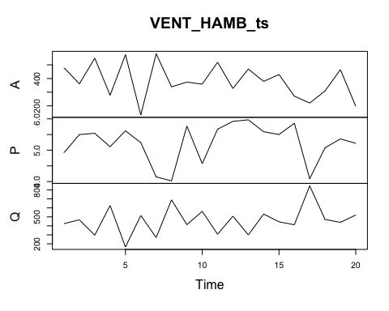

Gráficas

#  
scatterplot(Q ~ P, pch=".")

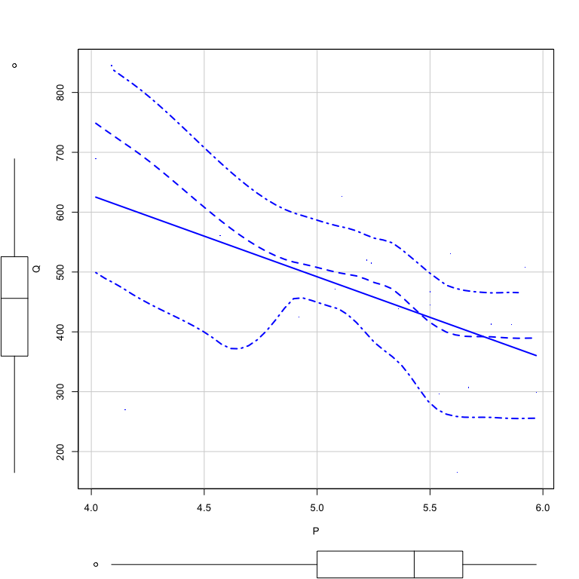

scatterplot(Q ~ A)

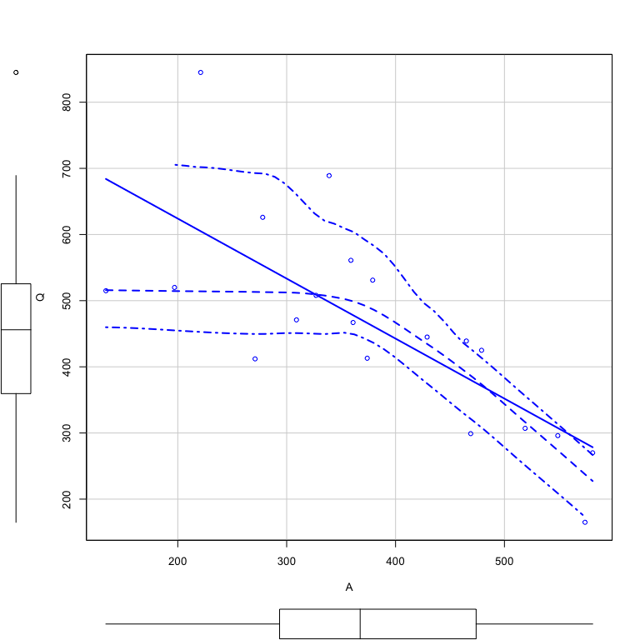

#  
ggplot(VENT_HAMB, aes(x=P, y=Q)) + geom_point() + labs(title="Diagrama de puntos", x="Precio", y="Ventas")

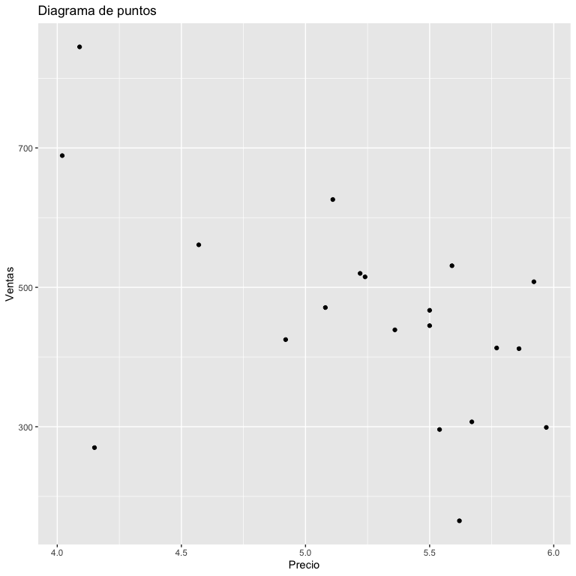

ggplot(VENT_HAMB, aes(x=A, y=Q)) + geom_point() + labs(title="Diagrama de puntos", x="Publicidad", y="Ventas")

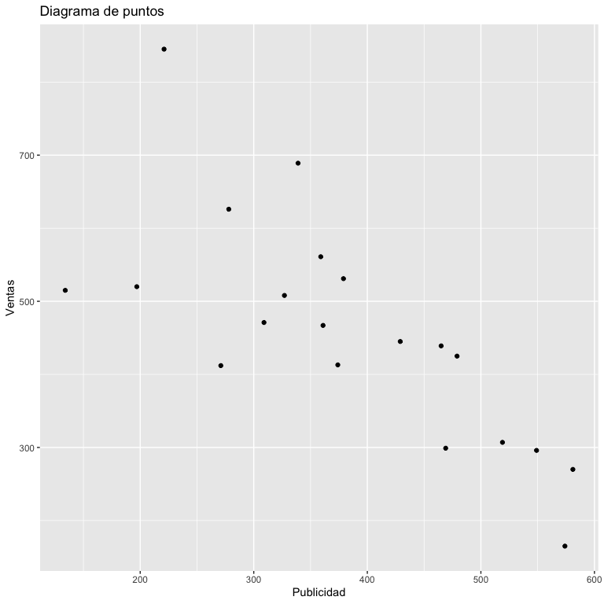

#  
scatterplotMatrix( ~ Q + P + A, id=list(n=3), data=VENT_HAMB)

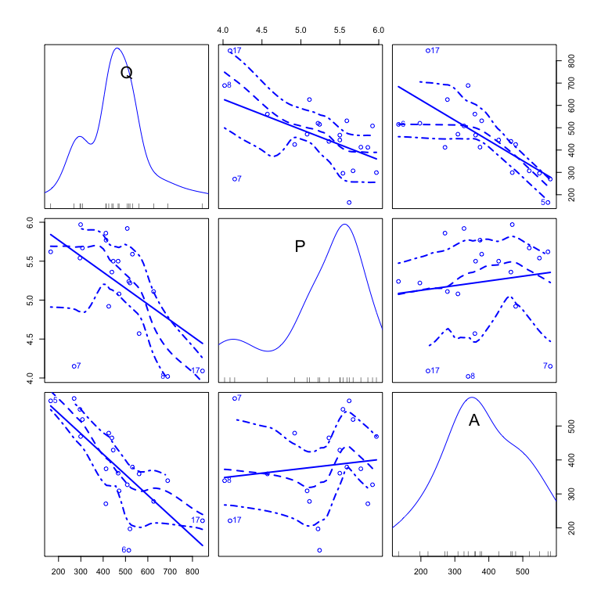

## Análisis econométrico

lm_VENTAS <- lm(Q ~ P + A)  
summary(lm_VENTAS)

##   
## Call:  
## lm(formula = Q ~ P + A)  
##   
## Residuals:  
## Min 1Q Median 3Q Max   
## -151.54 -67.52 11.53 57.94 121.00   
##   
## Coefficients:  
## Estimate Std. Error t value Pr(>|t|)   
## (Intercept) 1373.2393 171.4084 8.012 3.58e-07 ***  
## P -113.4178 32.0321 -3.541 0.00251 **   
## A -0.8387 0.1528 -5.489 3.99e-05 ***  
## ---  
## Signif. codes: 0 '***' 0.001 '**' 0.01 '*' 0.05 '.' 0.1 ' ' 1  
##   
## Residual standard error: 83.73 on 17 degrees of freedom  
## Multiple R-squared: 0.7399, Adjusted R-squared: 0.7093   
## F-statistic: 24.18 on 2 and 17 DF, p-value: 1.067e-05

#  
lm_VENTAS_poly <- lm(Q ~ P + poly(A,2, raw=TRUE))  
# lm_VENTAS_poly <- lm(Q ~ P + A + I(A^2))  
summary(lm_VENTAS_poly)

##   
## Call:  
## lm(formula = Q ~ P + poly(A, 2, raw = TRUE))  
##   
## Residuals:  
## Min 1Q Median 3Q Max   
## -104.131 -35.870 -7.825 42.191 133.654   
##   
## Coefficients:  
## Estimate Std. Error t value Pr(>|t|)   
## (Intercept) 1.035e+03 1.550e+02 6.680 5.28e-06 ***  
## P -1.279e+02 2.413e+01 -5.302 7.16e-05 ***  
## poly(A, 2, raw = TRUE)1 1.624e+00 6.519e-01 2.490 0.02413 *   
## poly(A, 2, raw = TRUE)2 -3.269e-03 8.522e-04 -3.836 0.00146 **   
## ---  
## Signif. codes: 0 '***' 0.001 '**' 0.01 '*' 0.05 '.' 0.1 ' ' 1  
##   
## Residual standard error: 62.3 on 16 degrees of freedom  
## Multiple R-squared: 0.8645, Adjusted R-squared: 0.8391   
## F-statistic: 34.03 on 3 and 16 DF, p-value: 3.554e-07

plot(Effect("P", lm_VENTAS_poly))

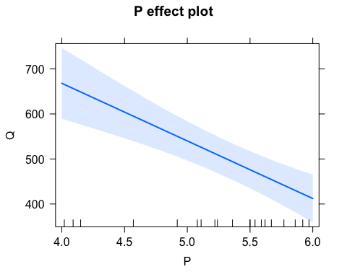

plot(Effect("A", lm_VENTAS_poly))

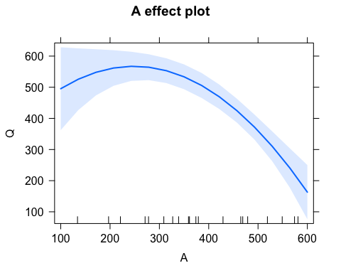

#  
# Efectos marginales  
#  
b <- coef(lm_VENTAS_poly)  
b

## (Intercept) P poly(A, 2, raw = TRUE)1   
## 1.035384e+03 -1.279250e+02 1.623604e+00   
## poly(A, 2, raw = TRUE)2   
## -3.268586e-03

dQdP <- b[2]  
dQdP

## P   
## -127.925

dQdA <- b[3] + 2*b[4]*A  
dQdA

## Time Series:  
## Start = 1   
## End = 20   
## Frequency = 1   
## [1] -1.5077011 -0.7363149 -1.9653031 -0.1937296 -2.1287323 0.7476230  
## [7] -2.1744925 -0.5924971 -0.8212981 -0.7232405 -1.7691879 -0.5140510  
## [13] -1.4423294 -0.8539839 -1.1808425 -0.1479694 0.1788891 -0.3963819  
## [19] -1.4161807 0.3357812

scatterplot(dQdA ~ A)

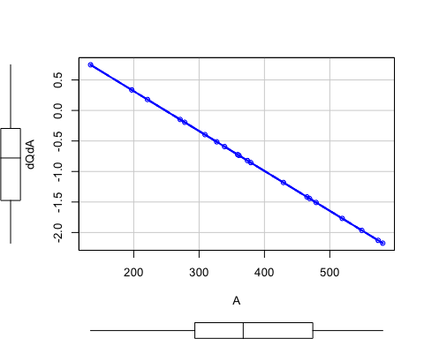

#  
# Predicciones  
new_P_A <- data.frame(P = c(5.25, 5.30, 5.40, 5.50 , 5.60), A = c(200, 210, 220, 230 , 240))  
new_P_A

## P A  
## 1 5.25 200  
## 2 5.30 210  
## 3 5.40 220  
## 4 5.50 230  
## 5 5.60 240

predict(lm_VENTAS_poly, new_P_A, interval = "prediction")

## fit lwr upr  
## 1 557.7550 412.6576 702.8525  
## 2 554.1936 410.7239 697.6633  
## 3 543.5822 401.1395 686.0250  
## 4 532.3172 390.4964 674.1379  
## 5 520.3983 378.8250 661.9717