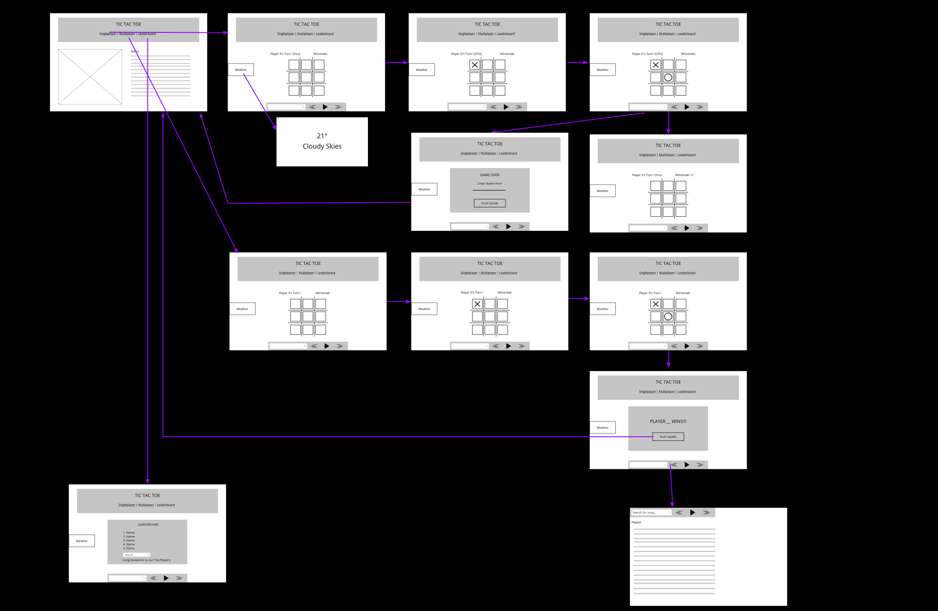

Loss

Win

PopOut

When hovering

over the music

section, this larger

page pops out

revealing a playlist

of songs.