# Tugas 2

Aplikasi SCRUM dalam Pengembangan Perangkat Lunak Tangkas

**Topik :**

“Aplikasi Bantuan Visual Tunanetra”

**Nama Tim :**

EyesUp

**Anggota :**

* Albert Suhargo (211110370)
* Julian Philbert Lee (211110066)
* Stanly Winata (211110222)

## User Story & Product Backlog



## Sprint Planning

* **Sprint 1**

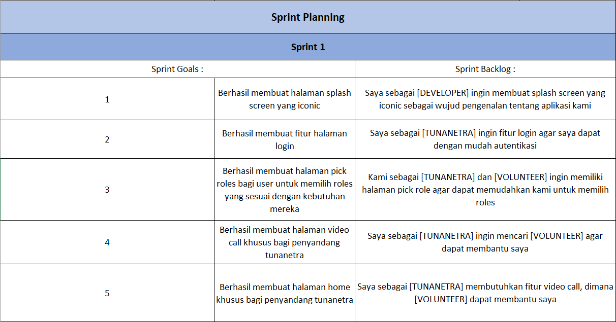

* **Sprint 2**

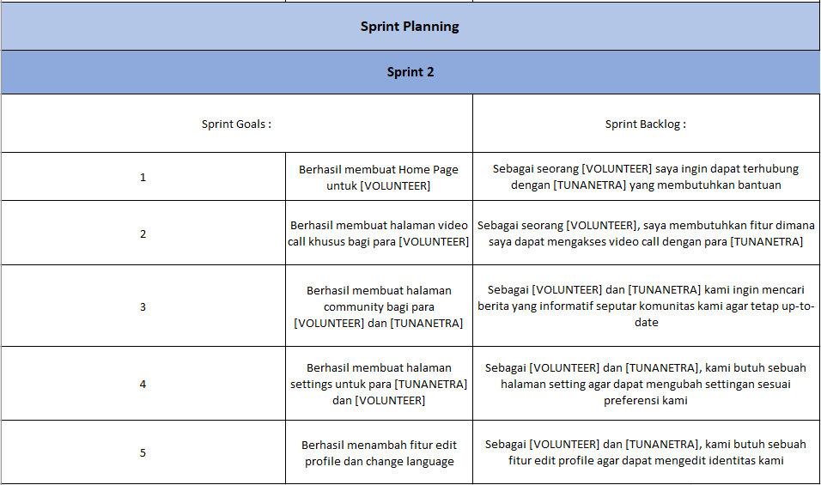

* **Sprint 3**



* **Sprint 4**



## Daily Scrum Meeting

* **Sprint 1**

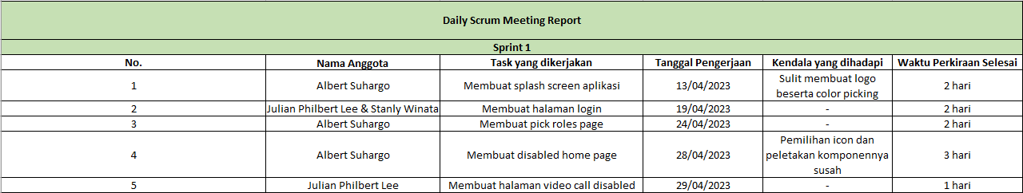

* **Sprint 2**



* **Sprint 3**



* **Sprint 4**



* **Sprint Review 1**

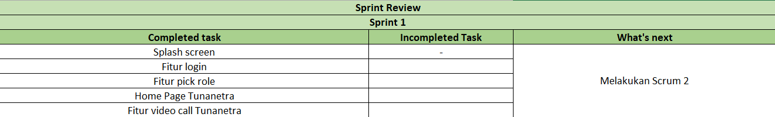

* **Sprint Review 2**

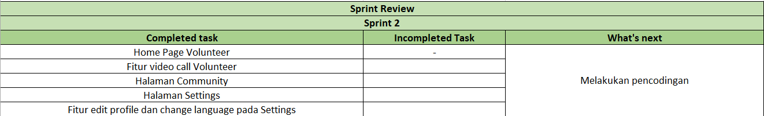

* **Sprint Review 3**

