Mullen TreeFlux Analysis
JM
2026-06-30
Table of Contents

Welcome to the TEMPEST Flood Tree Greenhouse Gas Flux dataset analysis!

TEMPEST flood dates
flood_date <- tribble(~Event, ~Start, ~End,
"T1", "2022-06-22", "2022-06-22",
"T2", "2023-06-06", "2023-06-07",
"T3", "2024-06-11", "2024-06-13")
flood_date$Start <- ymd(flood_date$Start)
flood_date$End <- ymd(flood_date$End)
knitr::kable(flood_date)
Event | Start | End
T1 | 2022-06-22 | 2022-06-22
T2 | 2023-06-06 | 2023-06-07
T3 | 2024-06-11 | 2024-06-13

Read data
# Read in data from Apache Parquet file -----
FLUX_DATA_FILE <- "tempest_tree_ghg_fluxes.parquet"
message("Reading ", FLUX_DATA_FILE)
## Reading tempest_tree_ghg_fluxes.parquet
my_data <- read_parquet(FLUX_DATA_FILE)
code_to_name <- c(ACRU = "Red Maple", FAGR = "Beech", LITU = "Tulip Poplar")
TREE_MAPPING_FILE <- "ancillary_data/sapflow_tree_mapping.csv"
message("Reading ", TREE_MAPPING_FILE)
## Reading ancillary_data/sapflow_tree_mapping.csv
tree_map <- read.csv(TREE_MAPPING_FILE,
stringsAsFactors = FALSE) %>%
mutate(across(where(is.character), trimws)) %>%
transmute(ID = Sapflux_ID,
Species_from_map = unname(code_to_name[Species_Code])) %>%
distinct(ID, .keep_all = TRUE)
my_data <- my_data %>%
left_join(tree_map, by = "ID") %>%
mutate(Species = coalesce(Species, Species_from_map)) %>%
select(-Species_from_map)
message("Trees with NA species: ", sum(is.na(my_data$Species)))
## Trees with NA species: 0

Prep Soil Temp Data
read_L2_variable(variable = "soil-temp-5cm", path = "Sensor_Data/", quiet=TRUE)

Take daily avg
soil_temp_data <- read_L2_variable(variable = "soil-temp-5cm",
path = "Sensor_Data/", quiet = TRUE)
soil_temp_daily <- soil_temp_data %>%
mutate(
# TIMESTAMP = as.POSIXct(TIMESTAMP),
Date = as.Date(TIMESTAMP),
Value = as.numeric(Value) ) %>%
filter(!is.na(Value)) %>%
group_by(Site, Plot, Date) %>%
summarise(
soil_temp_daily_mean = mean(Value),
n = n(),
# TODO: explain this next step (what's 480?)
coverage = n / 480,
.groups = "drop" )
print(soil_temp_daily)
## # A tibble: 6,020 × 6
## Site Plot Date soil_temp_daily_mean n coverage
## <chr> <chr> <date> <dbl> <int> <dbl>
## 1 TMP C 2020-05-05 12.7 37 0.0771
## 2 TMP C 2020-05-06 11.9 96 0.2
## 3 TMP C 2020-05-07 11.4 96 0.2
## 4 TMP C 2020-05-08 11.9 96 0.2
## 5 TMP C 2020-05-09 9.68 96 0.2
## 6 TMP C 2020-05-10 9.76 96 0.2
## 7 TMP C 2020-05-11 11.1 96 0.2
## 8 TMP C 2020-05-12 10.6 96 0.2
## 9 TMP C 2020-05-13 11.3 96 0.2
## 10 TMP C 2020-05-14 12.2 96 0.2
## # ℹ 6,010 more rows

Graphs of Soil Temp Data (Daily averages over time)
ggplot(soil_temp_daily,aes(x = Date, y = soil_temp_daily_mean,
color = Plot, group = Plot)) + geom_line(alpha = 0.7) + facet_wrap(~ Site) +
labs( title = "Daily Mean Soil Temperature by Plot",
x = "Date",
y = "Soil Temperature (°C)" )
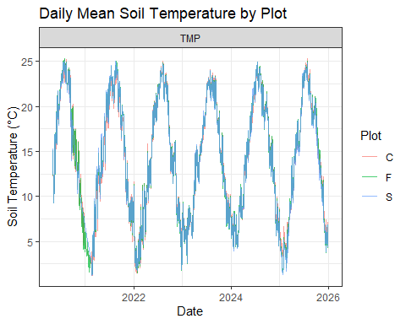

Matching the plot names from tree flux and soil temp
soil_temp_daily <- soil_temp_daily %>%
mutate( Plot = recode(Plot,
"C" = "Control",
"F" = "Freshwater",
"S" = "Seawater" ) )

Joining datasets
my_data <- my_data %>%
left_join(
soil_temp_daily %>%
select(Plot, Date, soil_temp_daily_mean),
by = c("Plot", "Date"))

Numerical summaries —–
print(my_data) # BBL: print summary of fluxes? A table with mean, min, max and date ranges
my_data %>%
ggplot(aes( x = Year, y = CH4_lin_flux.estimate, color = Plot )) +
geom_point(alpha = 0.6) +
facet_wrap(~ Species) +
labs( title = "CH4 Flux by Species (2021–2025)" )
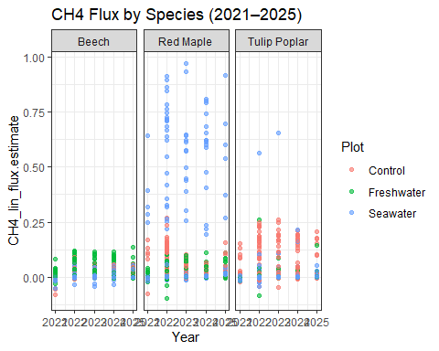
my_data %>%
ggplot(aes( x = Year, y = CO2_lin_flux.estimate, color = Plot )) +
geom_point(alpha = 0.6) +
facet_wrap(~ Species) +
labs( title = "CO2 Flux by Species (2021–2025)", y = "CO2 Flux" )
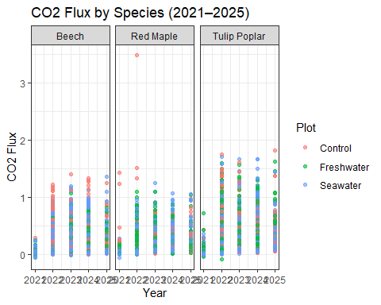

Numerical summaries
print(my_data)
## # A tibble: 3,361 × 13
## # Groups: Year, Date, Plot, Timepoint, Species, ID [3,361]
## Year Date Plot Timepoint Species ID CO2_lin_flux.estimate
## <dbl> <date> <chr> <chr> <chr> <chr> <dbl>
## 1 2021 2021-10-08 Control (none) Tulip Popl… C1 0.425
## 2 2021 2021-10-08 Control (none) Red Maple C10 0.227
## 3 2021 2021-10-08 Control (none) Red Maple C12 0.0817
## 4 2021 2021-10-08 Control (none) Beech C14 0.293
## 5 2021 2021-10-08 Control (none) Beech C16 0.0628
## 6 2021 2021-10-08 Control (none) Beech C17 0.139
## 7 2021 2021-10-08 Control (none) Tulip Popl… C2 0.228
## 8 2021 2021-10-08 Control (none) Tulip Popl… C6 0.181
## 9 2021 2021-10-08 Control (none) Red Maple C8 1.43
## 10 2021 2021-10-08 Freshwater (none) Tulip Popl… F1 0.276
## # ℹ 3,351 more rows
## # ℹ 6 more variables: CO2_lin_r.squared <dbl>, CO2_rob_flux.estimate <dbl>,
## # CH4_lin_flux.estimate <dbl>, CH4_lin_r.squared <dbl>,
## # CH4_rob_flux.estimate <dbl>, soil_temp_daily_mean <dbl>
# BBL: print summary of fluxes? A table with mean, min, max and date ranges

Plots

Initial visualizations of Raw Data

Overall data, by species
my_data %>%
ggplot(aes( x = Year, y = CH4_lin_flux.estimate, color = Plot )) +
geom_point(alpha = 0.6) +
facet_wrap(~ Species) +
labs( title = "CH4 Flux by Species (2021–2025)" )

my_data %>%
ggplot(aes( x = Year, y = CO2_lin_flux.estimate, color = Plot )) +
geom_point(alpha = 0.6) +
facet_wrap(~ Species) +
labs( title = "CO2 Flux by Species (2021–2025)", y = "CO2 Flux" )


Flux ranges by species
# Overall flux range (using boxplot) for each gas, by tree species
ggplot(my_data,aes(x = Species, y = CH4_lin_flux.estimate, fill = Plot)) +
geom_boxplot() +
theme_bw() +
theme(axis.text.x = element_text(angle = 45, hjust = 1))
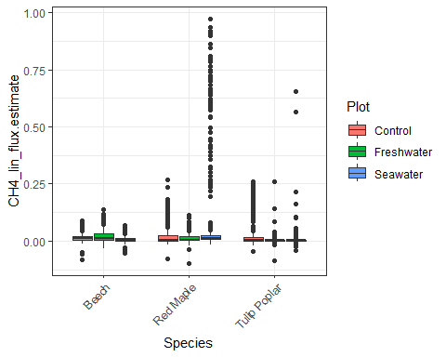
ggplot(my_data, aes(x = Species, y = CO2_lin_flux.estimate, fill = Plot)) +
geom_boxplot() +
theme_bw() +
theme(axis.text.x = element_text(angle = 45, hjust = 1))
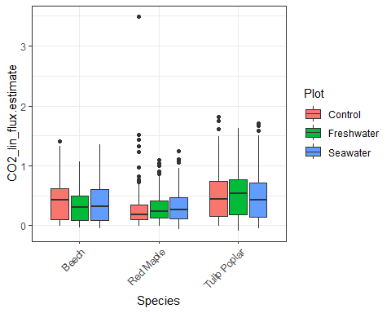

Spaghetti plots of Raw Data
ggplot(my_data, aes(x = Date, y = CH4_lin_flux.estimate,
group = ID, color = Plot)) +
geom_line(alpha = 0.2) +
facet_wrap(~ Species) +
labs(title = "CH4 Flux Over Time by Species and Plot",
x = "Date",
y = "CH4 Flux")
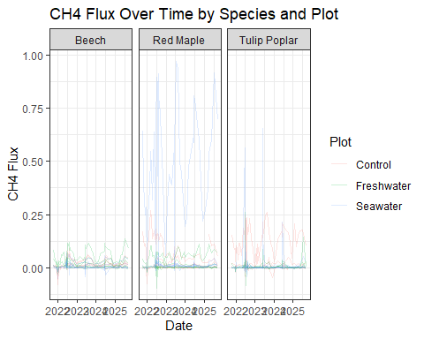
ggplot(my_data, aes(x = Date,
y = CO2_lin_flux.estimate,
group = ID,
color = Plot)) +
geom_line(alpha = 0.2) +
facet_wrap(~ Species) +
labs(
title = "CO2 Flux Over Time by Species and Plot",
x = "Date",
y = "CO2 Flux" )
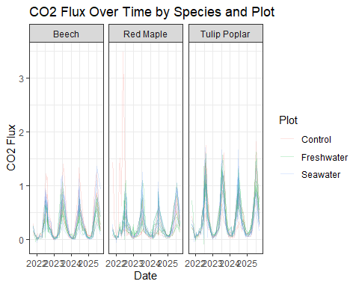

Heat Maps of of Raw Data
heat_data_CH4 <- my_data %>%
group_by(Species, Year) %>%
summarize(
mean_flux = mean(CH4_lin_flux.estimate, na.rm = TRUE),
.groups = "drop" )
ggplot(heat_data_CH4, aes(x = Year, y = Species, fill = mean_flux)) +
geom_tile() +
scale_fill_viridis_c() +
labs( title = "Mean CH4 Flux by Species and Year", x = "Year", y = "Species",
fill = "Mean CH4 Flux") + theme_minimal()
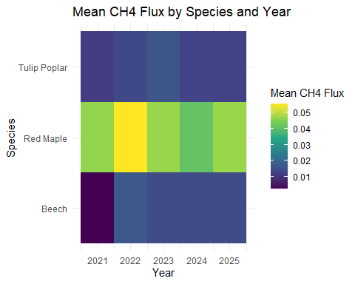
seawater_rows <- my_data %>%
filter(Plot == "Seawater")
heat_data_CO2 <- my_data %>%
group_by(Species, Year) %>%
summarize(mean_flux = mean(CO2_lin_flux.estimate, na.rm = TRUE),.groups = "drop")
ggplot(heat_data_CO2,aes(x = Year, y = Species, fill = mean_flux)) +
geom_tile() +
scale_fill_viridis_c() +
labs(title = "Mean CO2 Flux by Species and Year", x = "Year",y = "Species",
fill = "Mean CO2 Flux" ) +theme_minimal()
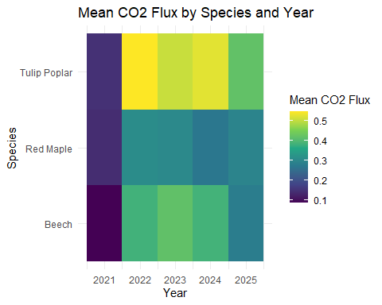

Relationship Between CH₄ and CO₂ Flux by Species
ggplot(my_data, aes(x = CO2_lin_flux.estimate, y = CH4_lin_flux.estimate, color = Species)) +
geom_point(alpha = 0.4) +
geom_smooth(method = "lm", se = FALSE) +
labs(title = "Relationship Between CO2 and CH4 Flux by Species",x = "CO2 Flux",y = "CH4 Flux",
color = "Species") +
theme_minimal()
## `geom_smooth()` using formula = 'y ~ x'
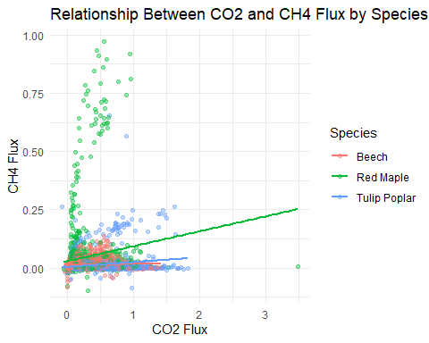

Quarterly Flux for both GHG (raw data)
annual_means_CH4 <- my_data %>%
group_by(Year, Species, Plot) %>%
summarize( mean_flux = mean(CH4_lin_flux.estimate, na.rm = TRUE),
se = sd(CH4_lin_flux.estimate, na.rm = TRUE) / sqrt(n()), .groups = "drop")
ggplot(annual_means_CH4, aes( x = Year, y = mean_flux,color = Plot,group = Plot)) +
geom_line() +
geom_point(size = 2) +
geom_errorbar( aes( ymin = mean_flux - se,ymax = mean_flux + se ),width = 0.1 ) +
facet_wrap(~ Species) +
labs( title = "Mean CH4 Flux by Species and Plot (2021–2025)",
x = "Year", y = "Mean CH4 Flux" )
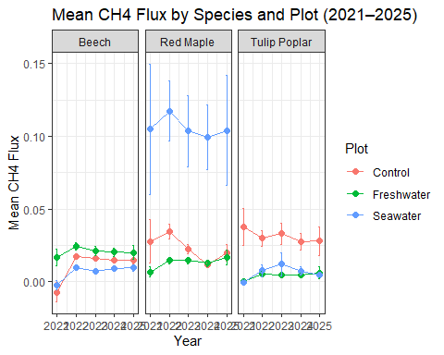
annual_means_CO2 <- my_data %>%
group_by(Year, Species, Plot) %>%
summarize( mean_flux = mean(CO2_lin_flux.estimate, na.rm = TRUE),
se = sd(CO2_lin_flux.estimate, na.rm = TRUE) / sqrt(n()), .groups = "drop")
ggplot(annual_means_CO2,aes( x = Year, y = mean_flux, color = Plot, group = Plot )) +
geom_line() +
geom_point(size = 2) +
geom_errorbar( aes(ymin = mean_flux - se,ymax = mean_flux + se ), width = 0.1) +
facet_wrap(~ Species) +
labs( title = "Mean CO2 Flux by Species and Plot (2021–2025)",
x = "Year",
y = "Mean CO2 Flux" )
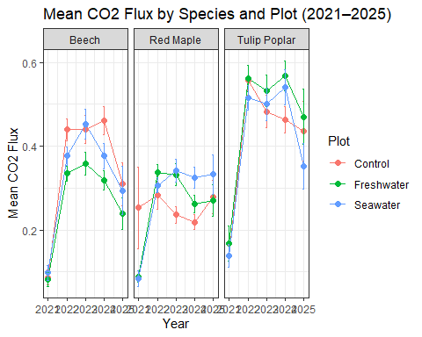

Creation of Quarters
my_data <- my_data %>%
mutate(
Date = as.Date(Date),
Year = year(Date),
Quarter = quarter(Date),
YearQuarter = Year + (Quarter-1)/4)
table(my_data$Quarter)
##
## 1 2 3 4
## 539 1513 717 592
quarterly_CH4 <- my_data %>%
mutate(is_S7 = ID == "S7") %>%
group_by(YearQuarter, Species, Plot, is_S7) %>%
summarize(mean_flux = mean(CH4_lin_flux.estimate, na.rm = TRUE),
se = sd(CH4_lin_flux.estimate, na.rm = TRUE) / sqrt(n()), .groups = "drop")

Flood-week averages for reference
flood_data <- list()
for(i in seq_len(nrow(flood_date))) {
message("Isolating data for ", flood_date$Event[i])
flood_data[[i]] <-
my_data %>%
filter(
Date >= flood_date$Start[i],
Date <= flood_date$End[i] ) %>%
mutate(Event = flood_date$Event[i])}
## Isolating data for T1
## Isolating data for T2
## Isolating data for T3
flood_CH4 <- bind_rows(flood_data) %>%
mutate(is_S7 = ID == "S7") %>%
group_by(Event, YearQuarter, Species, Plot, is_S7) %>%
summarize(
mean_flux = mean(CH4_lin_flux.estimate, na.rm = TRUE),
se = sd(CH4_lin_flux.estimate, na.rm = TRUE) / sqrt(n()),
.groups = "drop" )

Quarterly Methane Flux with flood averages emphasized
ggplot(quarterly_CH4,
aes(x = YearQuarter, y = mean_flux, color = Plot, group = Plot)) +
geom_line() +
geom_point(size = 2) +
geom_errorbar(
aes(ymin = mean_flux - se,
ymax = mean_flux + se),
width = 0.05) +
# Flood overlay (T1, T2, T3 labeled in legend)
geom_point(
data = flood_CH4,
aes(x = YearQuarter,
y = mean_flux,
shape = Event),
color = "black",
size = 1.5,
inherit.aes = FALSE) +
facet_wrap(~ Species) +
labs( title = "Quarterly CH4 Flux with Flood Events Highlighted",
x = "Year-Quarter",
y = "CH4 Flux",
shape = "Flood event") +
scale_shape_manual(values = c(
T1 = 17,
T2 = 17,
T3 = 17)) +
theme(axis.text.x = element_text(angle = 45, hjust = 1))
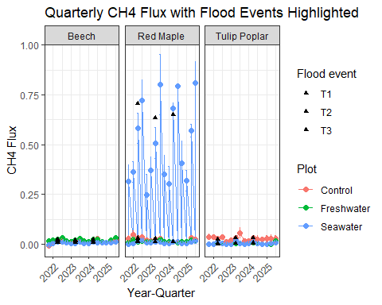

Isolating Red Maple Trees (finding outlier (S7))
my_data %>%
filter(Species == "Red Maple") %>%
ggplot(aes(x = Date, y = CH4_lin_flux.estimate)) +
geom_line(alpha = 0.7) +
facet_wrap(~ ID) +
labs(title = "Red Maple CH4 Flux by Individual Tree")
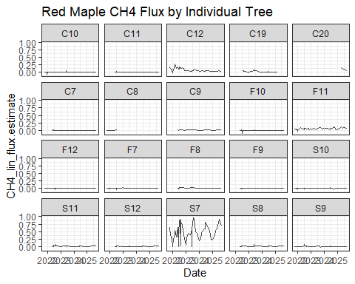
my_data %>%
filter(Species == "Red Maple") %>%
ggplot(aes(x = Date, y = CO2_lin_flux.estimate)) +
geom_line(alpha = 0.7) +
facet_wrap(~ ID)
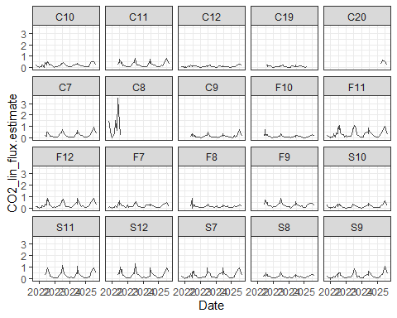

Separate S7 from all other trees
s7_CH4 <- my_data %>%
filter(ID == "S7") %>%
group_by(YearQuarter, Species, Plot) %>%
summarize(mean_flux = mean(CH4_lin_flux.estimate, na.rm = TRUE),
se = sd(CH4_lin_flux.estimate, na.rm = TRUE) / sqrt(n()), .groups = "drop" )
quarterly_CH4_nos7 <- my_data %>%
filter(ID != "S7") %>%
group_by(YearQuarter, Species, Plot) %>%
summarize(mean_flux = mean(CH4_lin_flux.estimate, na.rm = TRUE),
se = sd(CH4_lin_flux.estimate, na.rm = TRUE) / sqrt(n()), .groups = "drop" )
quarterly_CH4_S7 <- s7_CH4
flood_points <- flood_date %>%
mutate(YearQuarter = year(Start) + (quarter(Start)-1)/4) %>%
select(Event, YearQuarter)
flood_S7_CH4 <- s7_CH4 %>%
inner_join(flood_points, by = "YearQuarter")
#Quarterly CH4 Flux (S7 excluded from means, shown separately)
ggplot() +
# OTHER TREES (baseline)
geom_line(
data = quarterly_CH4_nos7,
aes(x = YearQuarter, y = mean_flux, color = Plot, group = Plot)) +
geom_point(
data = quarterly_CH4_nos7,
aes(x = YearQuarter, y = mean_flux, color = Plot)) +
# S7 (highlighted)
geom_line(
data = s7_CH4,
aes(x = YearQuarter, y = mean_flux),
color = "red",
linewidth = 1 ) +
geom_point(data = s7_CH4,
aes(x = YearQuarter, y = mean_flux),
color = "red", size = 2) +
# FLOOD EVENTS ON S7
geom_point(
data = s7_CH4 %>%
inner_join(flood_points, by = "YearQuarter"),
aes(x = YearQuarter, y = mean_flux, shape = Event),
color = "black",
size = 3 ) +
facet_wrap(~ Species) +
labs( title = "Quarterly CH4 Flux (S7 excluded from means, shown separately)",
x = "Year-Quarter",
y = "CH4 Flux",
shape = "Flood event") +
scale_shape_manual(values = c(
T1 = 17,
T2 = 17,
T3 = 17 )) +
theme_minimal() +
theme(axis.text.x = element_text(angle = 45, hjust = 1))
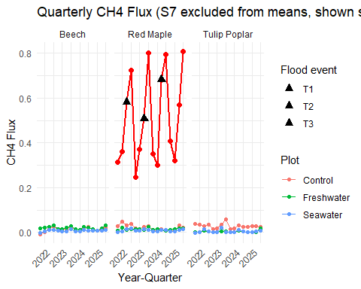
#S7 only
ggplot(quarterly_CH4_S7, aes(x = YearQuarter, y = mean_flux)) +
geom_line(color = "red", linewidth = 1) + geom_point(color = "red", size = 2) +
geom_errorbar(aes(ymin = mean_flux - se, ymax = mean_flux + se),
width = 0.05, color = "red" ) +
geom_point(
data = flood_S7_CH4,
aes(x = YearQuarter, y = mean_flux),
color = "black",
size = 2 ) +
labs( title = "S7 Quarterly CH4 Flux with Flood Periods Highlighted",
x = "Year-Quarter",
y = "CH4 Flux") +
theme_minimal() +
theme(axis.text.x = element_text(angle = 45, hjust = 1))
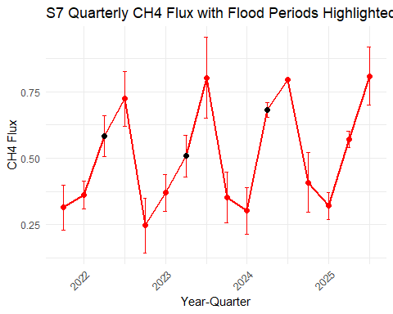
#S7 Excluded from CH4 Flux
flood_plot_data <- quarterly_CH4_nos7 %>%
inner_join(flood_points, by = "YearQuarter")
ggplot() + geom_line(
data = quarterly_CH4_nos7,
aes(x = YearQuarter, y = mean_flux, color = Plot, group = Plot) ) +
geom_point(
data = quarterly_CH4_nos7,aes(x = YearQuarter, y = mean_flux, color = Plot) ) +
geom_point(data = flood_plot_data,
aes(x = YearQuarter, y = mean_flux, shape = Event),
color = "black",
size = 3 ) +
facet_wrap(~ Species) +
labs(title = "Quarterly CH4 Flux with Flood Events Across Treatments",
x = "Year-Quarter",
y = "CH4 Flux",
shape = "Flood event" ) +
scale_shape_manual(values = c(T1 = 17, T2 = 17, T3 = 17)) +
theme_minimal() + theme(axis.text.x = element_text(angle = 45, hjust = 1))
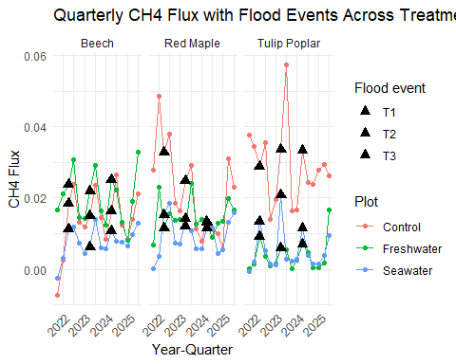

Visualizing Soil Temp Data x GHG Tree Flux

GHG Tree Flux x Soil Temp (colored by species)
ggplot(my_data, aes(x = soil_temp_daily_mean,
y = CH4_lin_flux.estimate,
color = Species)) +
geom_point(alpha = 0.5) +
geom_smooth(method = "lm", se = FALSE) +
labs(
x = "Daily Mean Soil Temperature (°C)",
y = "CH₄ Flux" )
## `geom_smooth()` using formula = 'y ~ x'
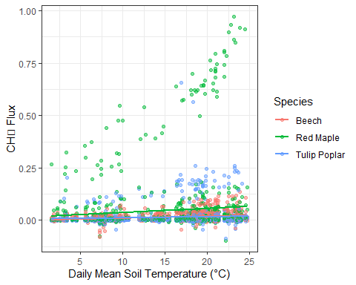
ggplot(my_data,aes(x = soil_temp_daily_mean,
y = CO2_lin_flux.estimate,
color = Species)) +
geom_point(alpha = 0.5) + geom_smooth(method = "lm", se = FALSE)
## `geom_smooth()` using formula = 'y ~ x'
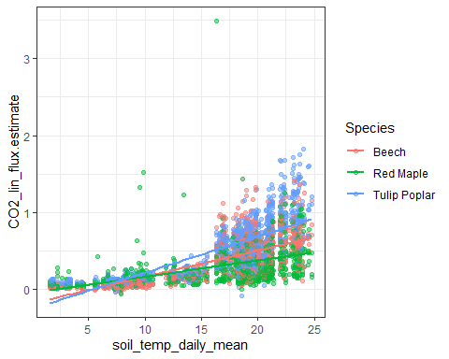

CH4 Tree Flux x Soil Temp (colored by species)
ggplot(my_data, aes(x = soil_temp_daily_mean,
y = CH4_lin_flux.estimate,
color = Species)) +
geom_point(alpha = 0.5) +
geom_smooth(method = "lm", se = FALSE) +
labs(
x = "Daily Mean Soil Temperature (°C)",
y = "CH₄ Flux" )
## `geom_smooth()` using formula = 'y ~ x'


CO2 Tree Flux x Soil Temp (colored by species)
ggplot(my_data,aes(x = soil_temp_daily_mean,
y = CO2_lin_flux.estimate,
color = Species)) +
geom_point(alpha = 0.5) + geom_smooth(method = "lm", se = FALSE)
## `geom_smooth()` using formula = 'y ~ x'


Methane and Soil Temp Over Time
ggplot(my_data, aes(x = Date)) +
geom_line(aes(y = CH4_lin_flux.estimate, color = "CH4"), alpha = 0.5) +
geom_line(aes(y = soil_temp_daily_mean, color = "Soil Temp"), alpha = 0.7) +
facet_wrap(~ Species) +
scale_color_manual(values = c("CH4" = "darkgreen", "Soil Temp" = "red")) +
labs( title = "CH4 Flux and Soil Temperature Over Time",
y = "Value (different scales)",
color = "Variable" )
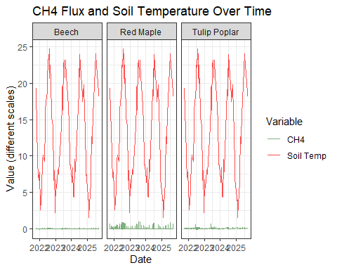

Methane vs Soil Temp (by plot)
ggplot(my_data, aes(x = soil_temp_daily_mean, y = CH4_lin_flux.estimate)) +
geom_point(aes(color = Plot), alpha = 0.5) +
geom_smooth(method = "lm", se = FALSE) +
facet_wrap(~ Species) +
geom_vline(data = flood_date,
aes(xintercept = NA), linetype = "dashed") # placeholder style
## `geom_smooth()` using formula = 'y ~ x'
## Warning: Removed 9 rows containing missing values or values outside the scale range
## (`geom_vline()`).
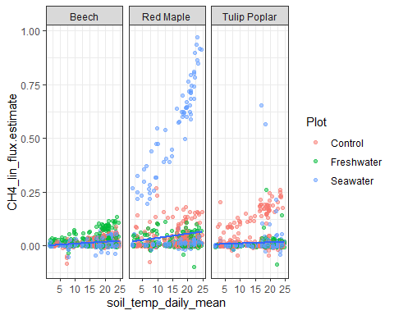

Soil Temperature × Treatment Effects on CH4 Flux
ggplot(my_data, aes(x = soil_temp_daily_mean,
y = CH4_lin_flux.estimate,
color = Plot)) +
geom_point(alpha = 0.4) +
geom_smooth(method = "lm", se = FALSE) +
facet_wrap(~ Species) +
labs(title = "Soil Temperature × Treatment Effects on CH4 Flux")
## `geom_smooth()` using formula = 'y ~ x'
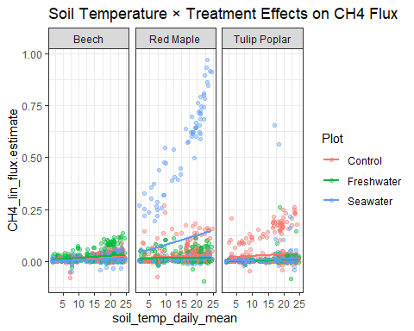

Methane vs Soil Temp (by plot)
ggplot(my_data, aes(x = soil_temp_daily_mean, y = CH4_lin_flux.estimate)) +
geom_point(aes(color = Plot), alpha = 0.5) +
geom_smooth(method = "lm", se = FALSE, color = "black") +
facet_wrap(~ Species) +
labs(
title = "CH4 Flux vs Soil Temperature",
x = "Soil Temperature (°C)",
y = "CH4 Flux" )
## `geom_smooth()` using formula = 'y ~ x'
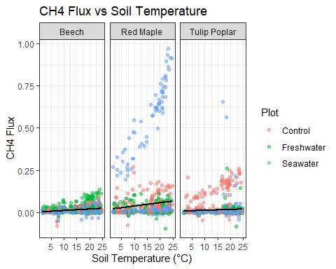

Nonlinear Temperature Response of CH4 (What is the actual shape of the temperature–methane relationship?)

Locally Estimated Scatterplot Smoothing = LOESS
ggplot(my_data, aes(soil_temp_daily_mean, CH4_lin_flux.estimate)) +
geom_point(alpha = 0.4, aes(color = Species)) +
geom_smooth(method = "loess", se = FALSE) +
facet_wrap(~ Plot) +
labs(title = "Nonlinear Temperature Response of CH4")
## `geom_smooth()` using formula = 'y ~ x'
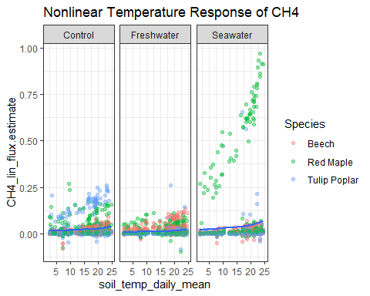

Species Differences in Temperature Sensitivity (Do different species have different average rates of response to temperature?)
ggplot(my_data, aes(soil_temp_daily_mean,
CH4_lin_flux.estimate,
color = Species)) +
geom_point(alpha = 0.4) +
geom_smooth(method = "lm", se = FALSE) +
labs(title = "Species Differences in Temperature Sensitivity")
## `geom_smooth()` using formula = 'y ~ x'
