Milestone2

Julianne; [Julianne.Ammirati@emory.edu](mailto:Julianne.Ammirati@emory.edu)

March 28, 2017

#### The CDC has allowed open access to the NSFG survey results from 1973-2015:

<https://www.cdc.gov/nchs/nsfg/index.htm>.

#### The code used to generate this report is available from my GitHub Account:

<https://github.com/JulianneA/N741_Milestone1>

# Initial Cleaning of Available Data

|  |  |  |  |
| --- | --- | --- | --- |
| Year of NFGS | Number of Respondents | Variables | Notes |
| 2013-2015 | 5699 | 3207 | This was the first file imported as a CSV. |
| 2011-2013 | 5601 | 3094 | Imported as CSV. |
| 2006-2010 | 1.227910^{4} | 3315 | Imported as CSV. |
| 2002 | 7643 | 3087 | Cycle 6, 3 SAS setup files. |
| 1995 | 1.084710^{4} | 5753 | Cycle 5, Imported as CSV. |
| 1988 | 8450 | 1437 | Cycle 4, Imported as CSV. |
| 1982 | 7969 | 742 | Cycle 3, Imported as CSV. |
| 1976 | 8611 | 470 | Cycle 2, Imported as CSV. |
| 1973 | 9797 | 451 | Cycle 1, Imported as CSV. |
| All Respondents | 7.689610^{4} |  |  |
| 1982-2015 | 5.848810^{4} |  |  |

Upon further inspection of code books, it became evident that the 1973 and 1976 files could not be used in analysis. Throughout these cycles, the CDC interviewed only married women or unmarried women who had borne children for the NSFG. From 1982 onward, unmarried and childless women were included in the NSFG, therefore, the initial two cycles of the NSFG were excluded here because the differences in sampling populations introduces too great a threat to data validity and generalizability.

## `stat_bin()` using `bins = 30`. Pick better value with `binwidth`.

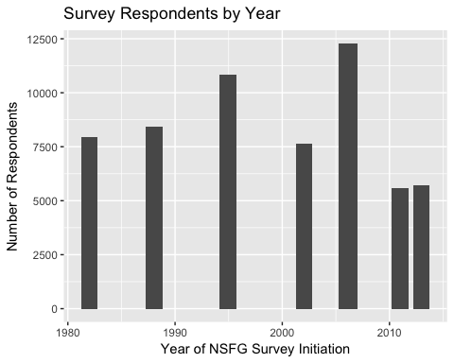

## Data Cleaning Summary

Sixty-three variables were extracted from the NSFG datasets. These variables capture information regarding respondent demographics, contraceptive utilization, sexual education history, and reproductive history. These variables were selected with special consideration for variables present in the most recent three cycles of the NSFG (2006, 2011-2013, and 2013-2015), which are most similar in their data cleaning and accessibility of resources detailing data coding methodology. Two variables were added prior to datamerge: CYCLE and YEAR which both indicate which NSFG survey dataset that respondent had been included.

#### Below is a summary of the sixty-three variables chosen for extraction:

* MAINTENANCE
  + CASEID: Respondent's (R's) Study ID.
  + CMINTVW: Century Month of Interview.
  + INTVWYEAR: Year of Interview.
* DEMOGRAPHICS
  + AGE_R: Age of R
  + MARSTAT: Marital Status of R
  + HIGRADE: R's current grade in school or highest grade/year attended
  + DEGREES: R's highest college or university degree received
  + PARMARR: Whether R's biological parents married at R's birth
  + ACASILANG: Language to be used in ACASI
  + AGER: Recode of R's Age
  + HISPANIC: Whether R identifies as Hispanic
  + RACE: R's Race
  + CURR_INS: Current health insurance status
  + METRO: Metro versus Non-Metro as place of residence
  + RELIGION: R's current religions affiliation
  + LABORFOR: R's employment status
  + POVERTY: R's income as a percentage of poverty level
  + TOTINCR: R's total household income
  + PUBASSIS: Whether R currently receives public assistance
* CONTRACEPTIVE USE
  + PILL- Whether R has ever used birth control pills?
  + NORPLANT- Whether R has ever used hormonal implants?
  + CONDOM- Whether R has ever used condoms?
  + VASECTMY- Whether R has ever depended on partner's vasectomy?
  + DIAFRAGM- Whether R has ever used a diaphragm?
  + DEPOPROV- Whether R has ever used depo-provera or other injectable?
  + WIDRAWAL- Whether R has ever used withdrawal?
  + RHYTHM- Whether R has ever used rhythm method?
  + SDAYCBDS- Whether R has ever used Standard Days or CycleBeads?
  + TEMPSAFE- Whether R has ever used natural family planning (safe temperature)?
  + WOCONDOM- Whether R has ever used a women's condem?
  + FOAMALON- Whether R has ever used contraceptive foam?
  + JELCRMAL- Whether R has ever used spermicide jelly or cream?
  + CERVLCAP- Whether R has ever used a cervical cap?
  + SUPPOSIT- Whether R has ever used suppositories?
  + TODAYSPG- Whether R has ever used the Today Sponge?
  + IUD- Whether R has ever had an IUD?
  + LUNELLE- Whether R has ever used Lunelle injection?
  + PATCH- Whether R has ever used contraceptive patch?
  + RING- Whether R has ever used the contracpetive ring?
  + OTHRMETH01- Has R used another method?
  + ECTIMESX- Number of times R used emergency contraception.
  + FIRSMETH1- What was first method R used?
  + CURRMETH1- What is the current method R uses (1)?
  + CURRMETH2- What is the current method R uses (1)?
  + CURRMETH3- What is the current method R uses (1)?
  + CURRMETH4- What is the current method R uses (1)?
* REPRO HEALTH
  + MAYBPREG- Currently, does R believe she could be pregnant?
  + NPREGS_S- Total number of pregnancies
  + PARITY- Total number of live births
  + ABORTION- Total number of induced abortions
  + HYST- Has R had a hysterectomy?
  + OVAREM- Has R had an ovarectomy?
  + OTHR- Is R surgically sterile due to another operation?
  + PREGNOWQ- Is R currently pregnant?
* SEXUAL HX
  + EVERSEX- Has R ever had hetereosexual intercourse?
  + RHADSEX- Has R ever had hetereosexual intercourse (recoded)?
  + YNOSEX- Main reason R has not had hetereosexual intercourse?
* SEX ED
  + SEDBC- Did R receive formal Sex Ed Before 18: Methods of Birth Control
  + SEDBCG- R's Grade When Received Instruction on Birth Control
  + SEDBCSX- Received Sex Ed on Birth Control Methods Before/After 1st Sex
  + SEDWHBC- Did R receive formal Sex Ed Before 18: Where to Get Birth Control
  + SEDWHBCG- R's Grade When Received Instruction on Where to Get Birth Control
  + SEDWBCSX- Received Sex Ed on Where to get Birth Control Before/After 1st Sex

#### *Challenges:*

This survey has been collected in large cohorts of women over the past 34 years. While providing the user with enormous amounts of data, the CDC has been consistently inconsistent in their variable collection and availability of specific variables. Since its inception in 1973, there has been a seven-fold increase in the number of variables maintained in the dataset, while many of these are recodes and imputed variables, some are useful for further examining reproductive health history or sexual education experiences. Additionally, many contraceptive methods have been developed or fallen out of use in the last 35 years, so the contraceptive use variables have also changed greatly overtime. Many coding schemes have been inconsistent across NSFG datasets, allowing the collapse across sets to be difficult.

Additionally, the SAS setup files provided by the CDC did not generate CSV files with complete column names. Many of these files, for whatever reason, stopped containing variable names after a certain column. This impacted many of the recoded variables, which are of most use here because the recode schemes have remained consistent. For this reason, it became necessary to add column headers within the CSV files to ensure the variables could be imported.

# Preliminary Analyses

### Basic Demographics

Below is a table of Race, Ethnicity, Mean Education, and Mean Age of each cohort the survey was completed with. While some demographics have changed drastically over the years (ie: the increase in hispanic women and the marked decrease of Black women surveyed over the years)

|  |  |  |  |  |  |
| --- | --- | --- | --- | --- | --- |
| Year of NFGS | Age | Highest Grade of Education | % Hispanic | % Black | % White |
| 1982 | 27.26 +/- 8.18 | 12.71 +/- 4.48 | 6.24 | 40.17 | 57.44 |
| 1988 | 29.54 +/- 8.13 | 12.99 +/- 4.14 | 7.59 | 32.79 | 63.36 |
| 1995 | 30.59 +/- 8.31 | 13.03 +/- 2.82 | 14.32 | 23.18 | 71.41 |
| 2002 | 29.5 +/- 8.43 | 13.31 +/- 3.13 | 20.79 | 21.85 | 69.24 |
| 2006-2010 | 28.64 +/- 8.45 | 13.3 +/- 3.25 | 22.18 | 22.17 | 65.82 |
| 2011-2013 | 28.61 +/- 8.38 | 13.46 +/- 3.67 | 26.05 | 23.76 | 63.36 |
| 2013-2015 | 28.88 +/- 8.4 | 13.59 +/- 3.33 | 24.46 | 22.57 | 66.66 |
| All Respondents | 29.08 +/- 8.39 | 13.17 +/- 3.55 | 16.85 | 26.49 | 65.65 |

#### Additional Demographics

|  |  |  |  |  |
| --- | --- | --- | --- | --- |
| Year of NFGS | % Currently Married | % Never Married | % Residing in Metro Areas | % Perfering English/Spanish |
| 1982 | 44.56 | 39.5 | 39.65 | Data Unavailable |
| 1988 | 47.7 | 34.52 | 29.34 | Data Unavailable |
| 1995 | 48.78 | 36.9 | Data Unavailable | 97.09; 2.91 |
| 2002 | 40.3 | 38.55 | 47.23 | 92.59; 7.41 |
| 2006-2010 | 32.34 | 45.58 | Data Unavailable | 92.33; 7.58 |
| 2011-2013 | 30.55 | 45.21 | 41.9 | 94.25; 5.73 |
| 2013-2015 | 29.81 | 46.89 | 41.05 | 93.58; 6.37 |
| All Surveys | 39.9 | 40.72 | 39.06 | 94.03; 5.94 |

#### Participant Financial Indicators

|  |  |  |  |  |  |
| --- | --- | --- | --- | --- | --- |
| Year of NFGS | % Private Insured | % Medicaid Insured | % Uninsured | % Receiving Public Assistance | % Employeed Full Time |
| 1982 | Data Unavailable | Data Unavailable | Data Unavailable | Data Unavailable | 35.1 |
| 1988 | Data Unavailable | Data Unavailable | Data Unavailable | Data Unavailable | 46.47 |
| 1995 | Data Unavailable | Data Unavailable | Data Unavailable | Data Unavailable | 42.09 |
| 2002 | 63.27 | 12.84 | 6.8 | 10.24 | 43.06 |
| 2006-2010 | 55.41 | 20.07 | 3.66 | 0.35 | 39.67 |
| 2011-2013 | 48.49 | 23.62 | 6.09 | 0.67 | 37.14 |
| 2013-2015 | 52.48 | 26.32 | 4 | 87.99 | 38.78 |
| All Surveys | 55.56 | 20.08 | 4.93 | 1.11 | 40.59 |

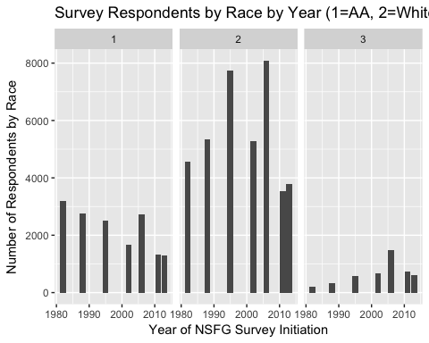

### Contraceptive Utilization Information

Below is a selection of contraception methods and the percentage of women in each survey who *have ever* tried that method.

|  |  |  |  |  |  |  |  |  |
| --- | --- | --- | --- | --- | --- | --- | --- | --- |
| Year of NFGS | Pill | Condom | IUD | Withdrawal | Rhythm | NFP | Patch | Ring |
| 1982 | 76.0702687 | 6774 | 18.7776794 | 20.4015353 | 13.6256274 | 1.8010038 | NaN | NaN |
| 1988 | 77.8439942 | 7551 | 14.4881473 | 11.3759767 | 9.1511058 | 1.4832473 | NaN | NaN |
| 1995 | 76.2883747 | 9906 | 10.2866949 | 39.1177064 | 23.7129013 | 4.108621 | NaN | NaN |
| 2002 | 73.125736 | 6785 | 5.6595431 | 55.4753132 | 16.2859248 | 3.3898305 | 0.7850321 | NaN |
| 2006-2010 | 70.4210441 | 1.060710^{4} | NaN | 59.02876 | 17.1145686 | 3.8943894 | 10.8803649 | 5.9776855 |
| 2011-2013 | 69.4875915 | 4858 | NaN | 64.2033759 | 16.8793742 | 3.1494442 | 11.1408677 | 8.9626852 |
| 2013-2015 | 67.9241972 | 4887 | 13.1777505 | 64.6613464 | 14.3851033 | 2.9261306 | 9.4577996 | 9.4577996 |

# Data Visualizations

These graphs are visualizations of the current contraceptive method utilized by women in this survey.

GGPlot was utilized in the making of all visualizations, but there are clear ways to improve these plots. The addition of animation would alleviate the difficulty of seeing certain variables within the graphs. Due to the amount of time required to recode variables, I was not able to put as much time into visualizations as I would have liked. Ideally, the final stage of the project would allow me to: * Complete Contraceptive*Demographic analysis with remaining variables*  Follow a tutorial on animation and attempt to recreate within this dataset. * Make a widget to allow a viewer to more easily flip between different variables being used in the graphics.

The recoding and reformatting of the datasets was the most time consuming part of this project, thus far. My methods changed with each recode and rearrangement of data, and I've *finally* figured out a quick way to generate relevant counts/percentages using cross_tab and insert as a variable into a dataset (since I was unable to coerce the crosstabbed data into a dataframe).

## Warning: position_stack requires non-overlapping x intervals

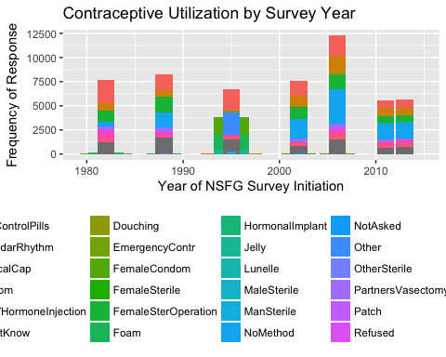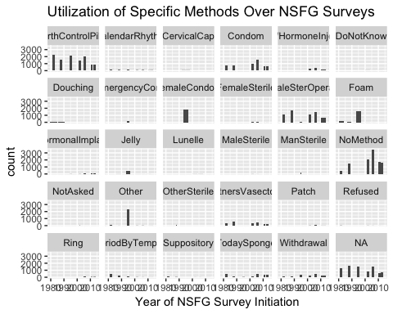

### Basic Year By Contraceptive Method Use Plots

## Warning: Removed 177 rows containing missing values (geom_text).

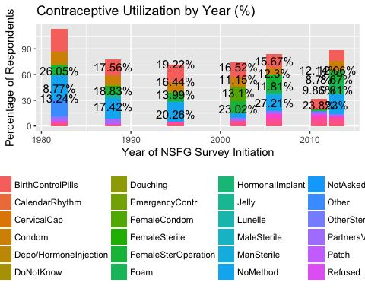

### Basic Year By Contraceptive Method By Race

