Grouped Validation of Machine Learning for Moisture Exposure Stage Estimation in Barley Using NIR Spectra
Julián Coronel Reyes¹ [0000-0002-7883-5388], Vanessa Vergara-Lozano² [0000-0002-0644-5946], Carlota Delgado-Vera² [0000-0002-8527-6078]
¹ Universidad Técnica de Machala, Facultad de Ciencias Agropecuarias, Av. Panamericana, Km. 5 1/2 Vía Machala-Pasaje, Ecuador
{jcoronel1}@utmachala.edu.ec
Corresponding author: Julián Coronel Reyes (jcoronel1@utmachala.edu.ec).
² Universidad Agraria del Ecuador, Facultad de Ciencias Agrarias, Av. 25 de Julio, Guayaquil, Ecuador
{cdelgado,vvergara}@uagraria.edu.ec
Abstract. We benchmark acquisition-stage estimation from public barley NIR spectra while separating repeated kernels and Petri dishes in model evaluation. The dataset contains 13,452 spectra with 204 channels from 2,242 kernels in 90 dishes, spanning a dry reference and five daily post-moisture stages. PLSR, RBF SVR, and Extra Trees are tuned independently with five outer and four inner dish-grouped folds. For the harder post-moisture observations, original SVR out-of-fold predictions give MAE 0.680 stage units and R² 0.618. Including the easily recognized dry reference lowers pooled MAE to 0.577 (conditional 95% dish-cluster interval 0.560–0.594), with R² 0.781. A fixed-configuration audit finds only a 0.021-stage random-row versus dish-grouped MAE difference; this small effect is an informative negative finding rather than evidence of substantial leakage inflation. Training-only PLS profiles show distributed importance rather than a dominant water-band signal; larger-C frozen checks do not improve error. Cultivar exclusions are exploratory at the model-family level. Stage and acquisition session coincide in one sequence: the study cannot exclude session fingerprinting instead of biological exposure progress. The contribution is an auditable within-experiment benchmark, not a validated biological clock, chemical moisture assay, or external-transfer model.
Keywords. Barley, near-infrared spectroscopy, grouped validation, support vector regression, moisture exposure.

1 Introduction
Near-infrared (NIR) spectroscopy supports barley malt-quality modeling [1] and investigation of germination and varietal effects [2]. We ask a narrower question: can a kernel-level spectrum distinguish stages of a public moisture-exposure sequence without processing its images?
The released dataset [3] follows individual kernels through a dry pre-moisture reference and five daily acquisitions. Our target is their acquisition-stage index, not water concentration or seed viability. Moisture uptake could contribute spectral information, but experimental age and acquisition session coincide in this single sequence. Accurate prediction may therefore include session fingerprinting rather than biological exposure progress.
Random-row partitions can share kernels, and kernel grouping can still share dishes. We compare PLSR, RBF SVR and Extra Trees with nested dish-grouped evaluation, then audit a fixed configuration across partition units and exploratory domain exclusions. The small observed row-versus-dish effect is an informative negative finding, not a demonstration of large leakage inflation. The contribution is an auditable benchmark with explicit confounding analysis and training-only spectral interpretation; no new learning algorithm is introduced.

2 Related Work
Ajayi et al. compared PLSR, Bayesian regression, and principal-component-based neural networks for predicting barley malt quality traits from NIR spectra [1]. Their work motivates a chemometric linear baseline alongside nonlinear learning. Their bulk malt traits differ from our kernel-level stage target, so numerical errors are not directly comparable.
Orth et al. investigated germination, time, and varietal effects using short-wave infrared spectral imaging and analysis of variance simultaneous component analysis [2]. We instead evaluate supervised regression of released mean spectra. This does not reproduce their spatial processing or experimental-factor analysis.
The longitudinal release by Engstrøm et al. supplies the observations used in our benchmark [3]. Its repeated-kernel organization allows us to study progressively stricter partition units. The original report also identifies inhibited germination associated with glue residue. We therefore do not treat its germination annotations as evidence of a kernel's viability under normal malting conditions.
PLSR provides a latent-variable model for correlated spectral predictors [4]. SVR offers regularized nonlinear estimation [5], while Extra Trees uses randomized tree ensembles [6]. These families compare distinct assumptions within a small search space, without attempting an exhaustive algorithm leaderboard.
Standard normal variate (SNV) transformation and Savitzky–Golay filtering are established spectral preprocessing operations [7, 8]. Their usefulness must nevertheless be checked with the prediction task. Normalization may remove useful amplitude information, and differentiation can emphasize noise as well as spectral shape. Preprocessing is therefore selected within the same training-only loop as the model hyperparameters.
Two methodological distinctions guide our evaluation. Varma and Simon showed why selecting settings and reporting their performance from the same cross-validation loop can give an optimistic estimate [9]. Roberts et al. discussed validation for temporally, spatially, and hierarchically structured data, emphasizing that the partition should match the intended prediction domain [10]. Nesting addresses direct tuning reuse, while grouping addresses overlap in the chosen experimental unit. Neither procedure creates independent acquisition sessions or an external harvest-year cohort.

3 Dataset and Prediction Target

3.1 Spectral Input and Identifiers
The analysis uses the archive's six mean pseudo-absorbance arrays and their row-order files. We join the files using the compound key consisting of Petri dish and kernel identifier. The released vectors contain 204 channels in an approximate 950–1650 nm range. RGB images, spectral cubes, segmentation masks, and germination labels are not predictors.
Our local audit yields 13,452 spectrum-stage observations from 2,242 kernels in 90 dishes. Each kernel has exactly one observation at each of the six stages. We check compound-key uniqueness, stage coverage, and finite spectral values before model fitting. There are no duplicated kernel-stage keys, no missing stages, and no non-finite predictor values in the analyzed subset. The nominal sample groups are prospect_0, prospect_1, laureate_0, and laureate_1. We distinguish these four groups from the two cultivar names, Prospect and Laureate.
The public annotations contain 381 kernels with an observed germination event. The source report's overall table states 382, whereas its subgroup entries sum to 381 [3]. The discrepancy does not affect the exposure-stage target. We retain the released annotations for audit purposes and do not alter their values or use them as spectral features.

3.2 Meaning of the Output
For each observation, the reference output is its acquisition stage: 0 for pre-moisture and 1–5 for the subsequent daily observations. A regression prediction is continuous, but evaluation occurs only at these six reference values. No intermediate-time samples are available to assess whether, for example, a prediction of 2.4 corresponds to a valid estimate at 2.4 days.
Treating the stages numerically permits errors to reflect the distance between adjacent stages. A one-stage error is penalized less than a four-stage error. The pre-moisture label is a reference condition rather than a sample taken immediately after wetting, so the 0-to-1 transition includes both exposure onset and elapsed time. We report errors by stage and separately summarize the post-moisture observations to show whether the aggregate result depends mainly on recognizing the dry reference.
The model receives one spectrum at prediction time. Kernel identity, dish number, cultivar, sample-group label, current germination status, and a previous spectrum are excluded from the predictors. The analysis therefore does not require a baseline measurement from the same kernel. Metadata are used only for partitioning and reporting.

4 Experimental Method
Fig. 1 summarizes the nested evaluation workflow. Each model family is tuned only within the outer-training dishes; held-out dishes enter only prediction. Training-only PLS interpretation and the exploratory diagnostics remain distinct from the primary out-of-fold assessment.
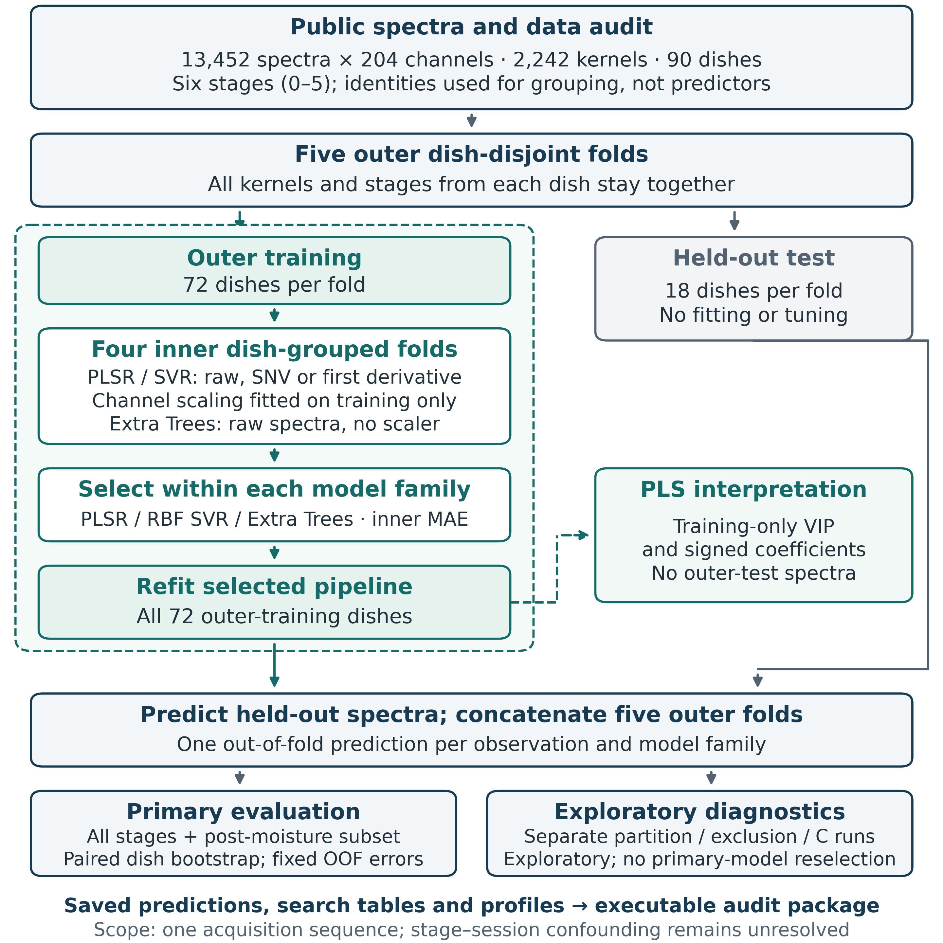
Fig. 1. Dish-grouped nested workflow. Training-only selection and PLS profiles are separated from held-out prediction. Bootstrap intervals use fixed out-of-fold errors; diagnostics do not reselect the primary model.

4.1 Preprocessing
We construct preprocessing variants from float32 copies of the released vectors, considering raw spectra, SNV, and the first Savitzky–Golay derivative. SNV centers each spectrum by its own mean and divides by its own population standard deviation across channels. If a spectrum had zero standard deviation, the denominator would be replaced by one. This guard prevents division by zero without using information from other observations.
The derivative uses an 11-channel window and a second-degree polynomial. Channel spacing is set to one, so the derivative is expressed per channel rather than per nanometer. This choice avoids presenting the approximate wavelength grid as an exact instrument calibration. The default interpolation edge treatment is used. These operations are deterministic and act within each individual spectrum, so they can be cached without estimating population statistics.
PLSR and SVR also use channel-wise standardization. The standard scaler is fitted only on the current training partition and applied to its validation or test partition. It is stored in the estimator pipeline. Extra Trees uses raw spectral inputs without standardization. In particular, we never fit a global scaler, a principal component transformation, or a supervised feature selector before creating the folds.

4.2 Models and Search Space
PLSR uses 10, 20, or 30 latent components and each of the three preprocessing choices, giving nine configurations. We disable the estimator's internal feature scaling because the pipeline performs explicit standardization. The maximum number of algorithm iterations is 1,000.
SVR uses an RBF kernel. We search C values of 10 and 100, epsilon values of 0.05 and 0.10, and SNV or the first derivative, giving eight configurations. Gamma uses the implementation's scale rule, which is calculated from the transformed training data. Epsilon and the target are in stage or day units. Raw-spectrum SVR was examined in the feasibility phase but is not part of the compact nested search.
Extra Trees uses 300 trees. We search feature fractions of 0.5 and 1.0 and minimum leaf sizes of 1, 2, or 5, giving six configurations. The random seed is 2026. Other estimator settings follow the recorded software implementation. The resulting study has 23 candidate configurations rather than a broad algorithm leaderboard.
The compact grids were informed by an earlier feasibility analysis of the same public data. The outer evaluation is isolated from the current inner tuning procedure, but the research process was not prospectively preregistered and has no untouched external test cohort. We disclose this distinction to avoid presenting nested cross-validation as proof that all analysis-level selection bias has been eliminated.

4.3 Nested Dish Grouping
The primary comparison uses five external folds created by GroupKFold on Petri dish. All stages of all kernels from a dish remain together. For each external training partition, four internal GroupKFold partitions are created using the same grouping variable. Dish disjointness is asserted for both levels before fitting.
Each family is tuned independently. For every candidate, we calculate the mean internal-fold mean absolute error (MAE). The candidate with the lowest mean MAE is selected. Ties are resolved by mean root mean squared error (RMSE), then the candidate identifier for deterministic behavior. The selected candidate is refitted on the entire external training partition and predicts its external test partition. This produces one out-of-fold prediction per observation and model family.
No external prediction is used to choose the setting for its fold. Selection frequencies across external folds are reported, because one favorable aggregate number can otherwise conceal unstable choices. The family comparison concerns training and tuning procedures, not three globally fixed fitted models.

4.4 Metrics and Conditional Uncertainty
MAE is the primary criterion. We also report RMSE, the coefficient of determination R², mean signed error, and the fraction of continuous predictions within one stage of the reference. Predictions are not clipped or rounded for the primary regression metrics. R² is allowed to be negative when a model performs poorly outside its training domain.
We show both the mean and standard deviation of the five external-fold metrics and metrics pooled over all out-of-fold predictions. The pooled values provide the point estimates used for confidence intervals. Fold standard deviations are descriptive and are not treated as standard errors from five independent experiments.
For conditional uncertainty, we draw 90 Petri dishes with replacement and concatenate all observations from each drawn dish, retaining repetitions. We repeat this procedure 2,000 times with seed 2026 and take percentile limits at 2.5% and 97.5%. The same dish draws are used for all families, allowing paired bootstrap differences in MAE. This follows the resampling principle [11] while preserving the observed dish clusters.
These intervals quantify variability in the fixed out-of-fold errors when the observed dishes are remixed. Models are not retrained within each bootstrap replication. The procedure therefore does not account fully for variation from model fitting, a new harvest year, or a new acquisition session. It should not be interpreted as a universal deployment confidence interval.

4.5 Partition Sensitivity and Domain Transfer
For partition sensitivity, we hold one configuration of the best-performing family fixed. It is chosen by its frequency of selection in the primary external folds, with a tie resolved by the mean internal MAE. We compare five-fold random-row partitioning, kernel-disjoint grouping, and dish-disjoint grouping. The random-row scheme uses shuffled KFold with seed 2026. This is a descriptive audit of partition sensitivity, not a second independent model-selection experiment or a replacement for the nested estimate.
For transfer, we withhold each cultivar in turn and then each of the four sample groups in turn. In every case, tuning is repeated using only the remaining training observations and dish-grouped internal folds. The held-out cultivar or sample group is used only for the test prediction. Since the best family is chosen using the primary comparison on the full dataset, these transfer checks remain exploratory at the family-selection level.
With only two cultivars and four sample groups, directional errors are more informative than a single pooled transfer score. A successful direction cannot establish transfer to all varieties, and failure in one direction may involve sample composition as well as cultivar identity. We report each withheld group rather than combine these tasks into a broad biological generalization claim.

4.6 Reproducibility
Code, a notebook with an explicit full-recompute switch, out-of-fold predictions, candidate scores and PLS profiles are archived in the project repository at https://github.com/Julians30/barley-nir-stage-benchmark. Dataset SHA-256, folds, seeds and software versions are recorded (scikit-learn [12]). Source data [3]: ERDA DOI 10.17894/ucph.71c22737-8005-4588-bd74-80bf7b5ac6b4. They and covered adaptations retain CC BY-NC 4.0 attribution and non-commercial restrictions; software rights are separate.

4.7 Spectral Interpretation and Frozen Boundary Checks
PLS variable importance in projection (VIP) and regression coefficients are computed separately in the five outer-training partitions, using each partition's internally selected raw-spectrum model [4, 14]. VIP weights squared, unit-normalized component weights by response variation explained by each component; its mean square across channels is one. VIP above one is a descriptive threshold, not a significance test. Coefficients are stage units per training-channel standard deviation. Profiles are summarized by five-fold means and ranges, not independence-based confidence intervals.
An exploratory post-moisture profile refits PLS on training stages 1–5 only, retaining the original all-stage selected component count. It is not a separately tuned post-only predictor. No outer-test observations enter either supervised profile. Mean spectra by stage are descriptive summaries. The source README specifies uniformly spaced channels over approximately 950–1650 nm. Our plotting grid, linspace(950,1650,204), is not an exact instrument calibration. A broad approximate 1400–1500 nm window examines the O–H water region [13], without assigning precise channel peaks.
The original SVR selects C=100, the upper grid boundary, in all five folds. A post-review frozen check evaluates C=300 and 1000 with the same outer partitions and each fold's training-selected preprocessing, epsilon and gamma rule. C=100 uses original saved predictions. All three settings are reported without selecting a replacement primary model from diagnostic errors. This does not establish a global optimum or constitute an untouched confirmatory test.

5 Results

5.1 Primary Nested Comparison
The completed evaluation contains 15 external family-fold fits and one external prediction for every observation and family. Each external partition holds out 18 dishes and retains 72 for training. The number of spectrum-stage observations varies slightly with dish occupancy. Independent recalculation from the saved predictions reproduces all reported metrics and confirms dish disjointness at both levels of the partition.
The harder post-moisture subset is central to interpretation: saved SVR predictions give MAE 0.680, RMSE 0.875 and R² 0.618 on stages 1–5. These are subset metrics of the original all-stage procedure, not a newly fitted post-only model. Across all six stages, RBF SVR has the lowest mean external-fold MAE, 0.577 with fold SD 0.010. Its pooled MAE is 0.577, RMSE 0.800 and R² 0.781 (Table 1). Including the dry reference reduces MAE by about 15% relative to the post-moisture mean.
Table 1. Pooled external regression metrics under nested dish-grouped validation. MAE and RMSE are in stage units; brackets give conditional 95% MAE intervals from 2,000 dish-cluster resamples. Within one stage uses continuous, unclipped predictions.
Family | MAE [95% interval] | RMSE | R² | Within ±1 (%)
RBF SVR | 0.577 [0.560, 0.594] | 0.800 | 0.781 | 80.3
PLSR | 0.722 [0.705, 0.738] | 0.901 | 0.722 | 72.5
Extra Trees | 0.856 [0.838, 0.873] | 1.130 | 0.562 | 61.7
The constant reference predictor gives 1.500 MAE, 1.708 RMSE, and 0.000 R² over the six equally represented stages. Because every complete kernel contributes all six stages, the training-fold mean of the target is also 2.5. The model comparison therefore reflects spectral prediction beyond this uninformative mean-stage baseline rather than a favorable target-frequency imbalance.
The paired MAE difference for Extra Trees minus RBF SVR is 0.279 stages, with a conditional percentile interval of 0.264–0.292. The paired MAE difference for PLSR minus RBF SVR is 0.145 stages, with a conditional percentile interval of 0.130–0.158. These paired comparisons concern the observed out-of-fold errors of the three evaluated procedures. They do not include a new experimental sequence or refitting within each resample, and selection of the best family remains conditional on this benchmark.
Fig. 2 displays the pooled external predictions against the six reference labels. Since the target is discrete while the estimator is continuous, the plot contains six vertical distributions rather than a continuously sampled reference trajectory. The overall fraction within one stage is 80.3%. This fraction is a tolerance measure and must not be described as six-class accuracy.
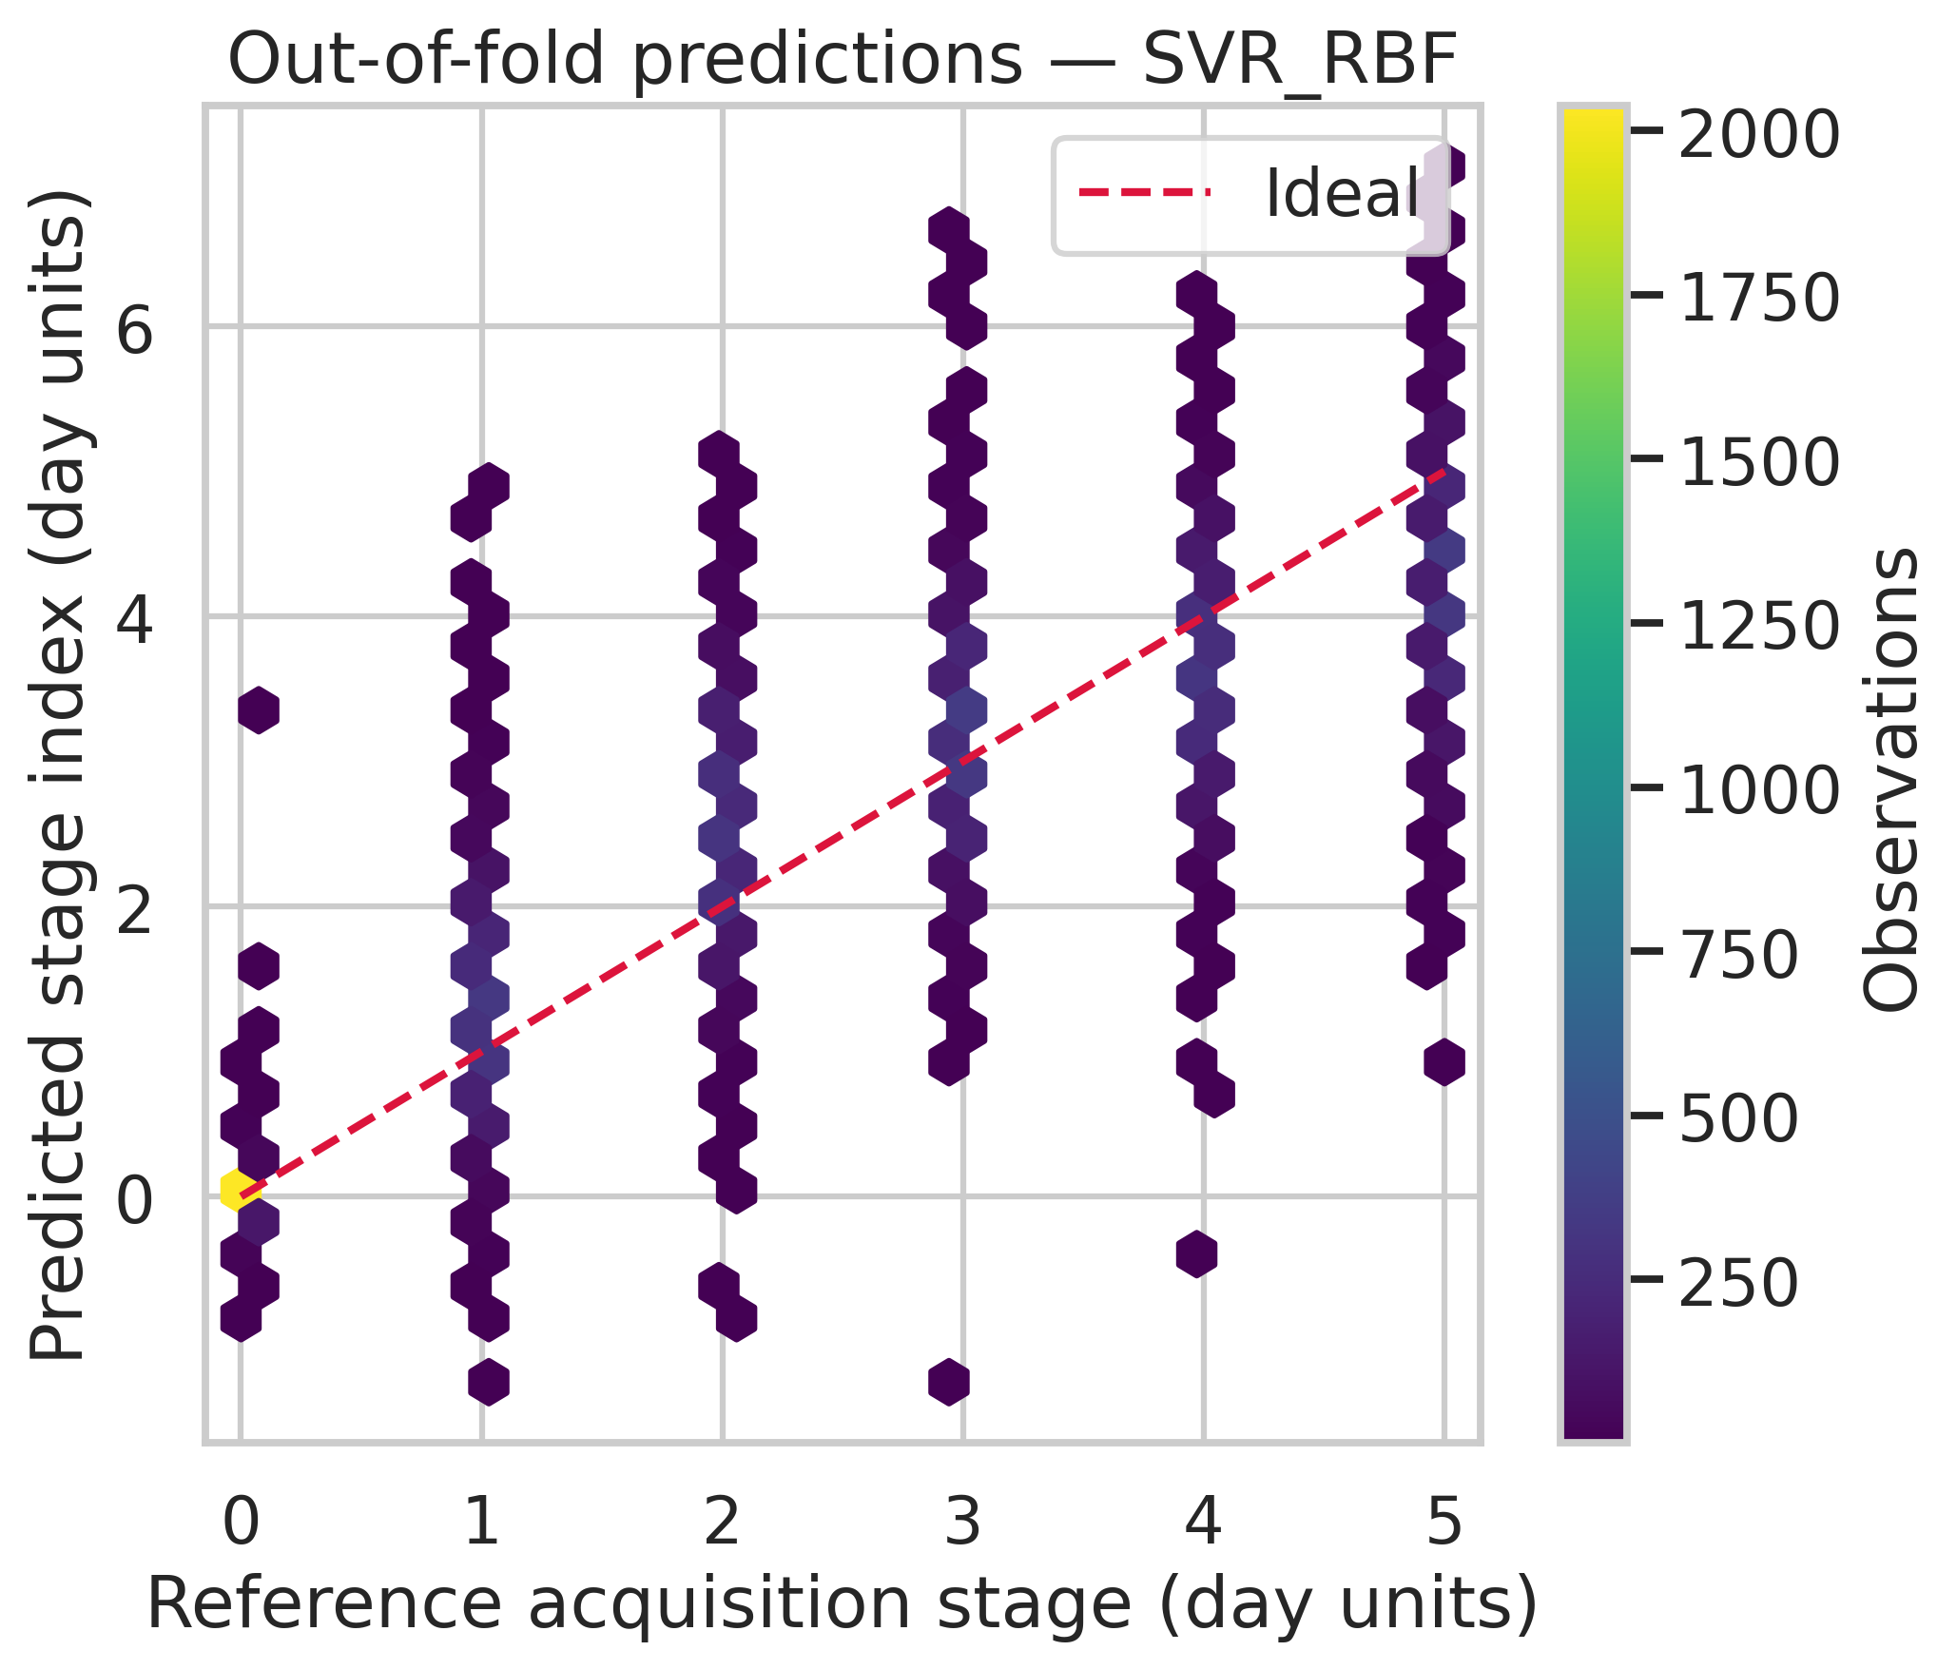
Fig. 2. External predictions of the best-performing family against the six reference acquisition stages. Color indicates the number of observations in each bin; the dashed line denotes exact numerical agreement.

5.2 Selected Configurations and Stage Errors
The first derivative is selected in 4 external folds and SNV in 1. The accompanying fold-selection table retains the exact settings and test errors. The consensus configuration for the fixed-model partition audit is savgol_d1, C=100;epsilon=0.05;gamma=scale. This summarizes the observed selections; it does not replace the fold-specific procedures evaluated in the primary comparison.
Table 2 exposes the error profile by stage. The lowest stage-specific MAE is 0.062 at stage 0, and the highest is 0.935 at stage 5. Signed errors at the endpoints are 0.006 for the dry reference and -0.810 for stage 5. These values indicate the direction of endpoint errors without assuming a linear or biologically calibrated progression.
Table 2. Stage-specific metrics for the saved external predictions of the best-performing family. Bias is predicted minus reference stage. Each stage contains 2,242 observations.
Stage | N | MAE | RMSE | Bias | Within ±1 (%)
0 | 2242 | 0.062 | 0.125 | 0.006 | 99.8
1 | 2242 | 0.568 | 0.748 | 0.319 | 83.6
2 | 2242 | 0.734 | 0.922 | 0.579 | 72.3
3 | 2242 | 0.548 | 0.708 | 0.175 | 85.7
4 | 2242 | 0.614 | 0.772 | -0.362 | 81.1
5 | 2242 | 0.935 | 1.147 | -0.810 | 59.0
Restricting the same saved predictions to the 11,210 post-moisture observations at stages 1–5 gives MAE 0.680, RMSE 0.875, and R² 0.618. The mean-stage reference on this subset gives MAE 1.200 and RMSE 1.414. This descriptive check assesses whether aggregate performance is attributable only to recognizing the dry condition. It does not refit a post-moisture-only estimator or validate predictions at intermediate times.

5.3 Fixed Configuration Partition Sensitivity
Table 3 compares the same consensus configuration under random-row, kernel-grouped, and dish-grouped five-fold partitions. These entries are means of fold metrics, not the pooled estimates in Table 1. Random-row splitting produces a lower MAE than dish grouping for this fixed configuration. The random-row minus dish-grouped MAE difference is -0.021 stages. Its sign and magnitude are reported directly rather than assumed from the existence of repeated observations.
Table 3. Descriptive partition sensitivity with a fixed consensus configuration. Values are mean five-fold metrics, without a fresh hyperparameter search for each partition scheme.
Partition | MAE | RMSE | R² | Within ±1 (%)
Random rows | 0.554 | 0.764 | 0.800 | 81.4
Kernel grouped | 0.563 | 0.778 | 0.793 | 81.4
Dish grouped | 0.575 | 0.796 | 0.782 | 80.4
This audit measures how one fixed setting responds to the observed partitions. Shared kernels and dishes remain an inappropriate match for a claim about new dishes even if the numerical difference is small. The analysis also does not address acquisition-session confounding, since all three schemes operate within the same experimental sequence.

5.4 Directional Domain Transfer
The two cultivar exclusions yield MAEs of 0.667–0.815, compared with the pooled primary MAE of 0.577. Table 4 reports each direction and each sample-group exclusion. The held-out observations do not enter the tuning loop for their own test. Nevertheless, the choice to run these checks on RBF SVR follows its selection in the complete primary comparison, so the tests are exploratory at the family level.
Table 4. Exploratory transfer tests, not confirmatory varietal-robustness evidence. SVR family selection used the full primary benchmark; configuration tuning uses only remaining training dishes. The dish column gives training/test counts. Settings are retuned for each exclusion; all directional predictions and selections are retained in the accompanying results.
Exclusion | Held out | Dishes | MAE | RMSE | R²
Cultivar | Laureate | 41/49 | 0.667 | 0.899 | 0.723
Cultivar | Prospect | 49/41 | 0.815 | 1.152 | 0.545
Sample group | laureate_0 | 65/25 | 0.667 | 0.894 | 0.726
Sample group | laureate_1 | 66/24 | 0.614 | 0.825 | 0.767
Sample group | prospect_0 | 65/25 | 0.789 | 1.056 | 0.618
Sample group | prospect_1 | 74/16 | 0.856 | 1.213 | 0.496
The directional results describe specific shifts in this archive. They should not be combined into a claim of population-wide varietal robustness. Cultivar identity, sample-group composition, and handling may all contribute to the transfer error. Independent acquisition sequences are still needed to establish generalization beyond the conditions shared by the released data.

5.5 Spectral Interpretation
Fig. 3 shows descriptive mean spectra and training-only PLS profiles. In the approximate 1400–1500 nm window, mean VIP across channels and folds is 0.775 for all-stage training (fold means 0.773–0.778), and 0.909 for exploratory post-moisture training (fold means 0.901–0.918). Mean proportions of channels above VIP=1 are 4.1% and 19.3%, respectively. Channel-level VIP, signed coefficients and band summaries for every fold accompany the manuscript.
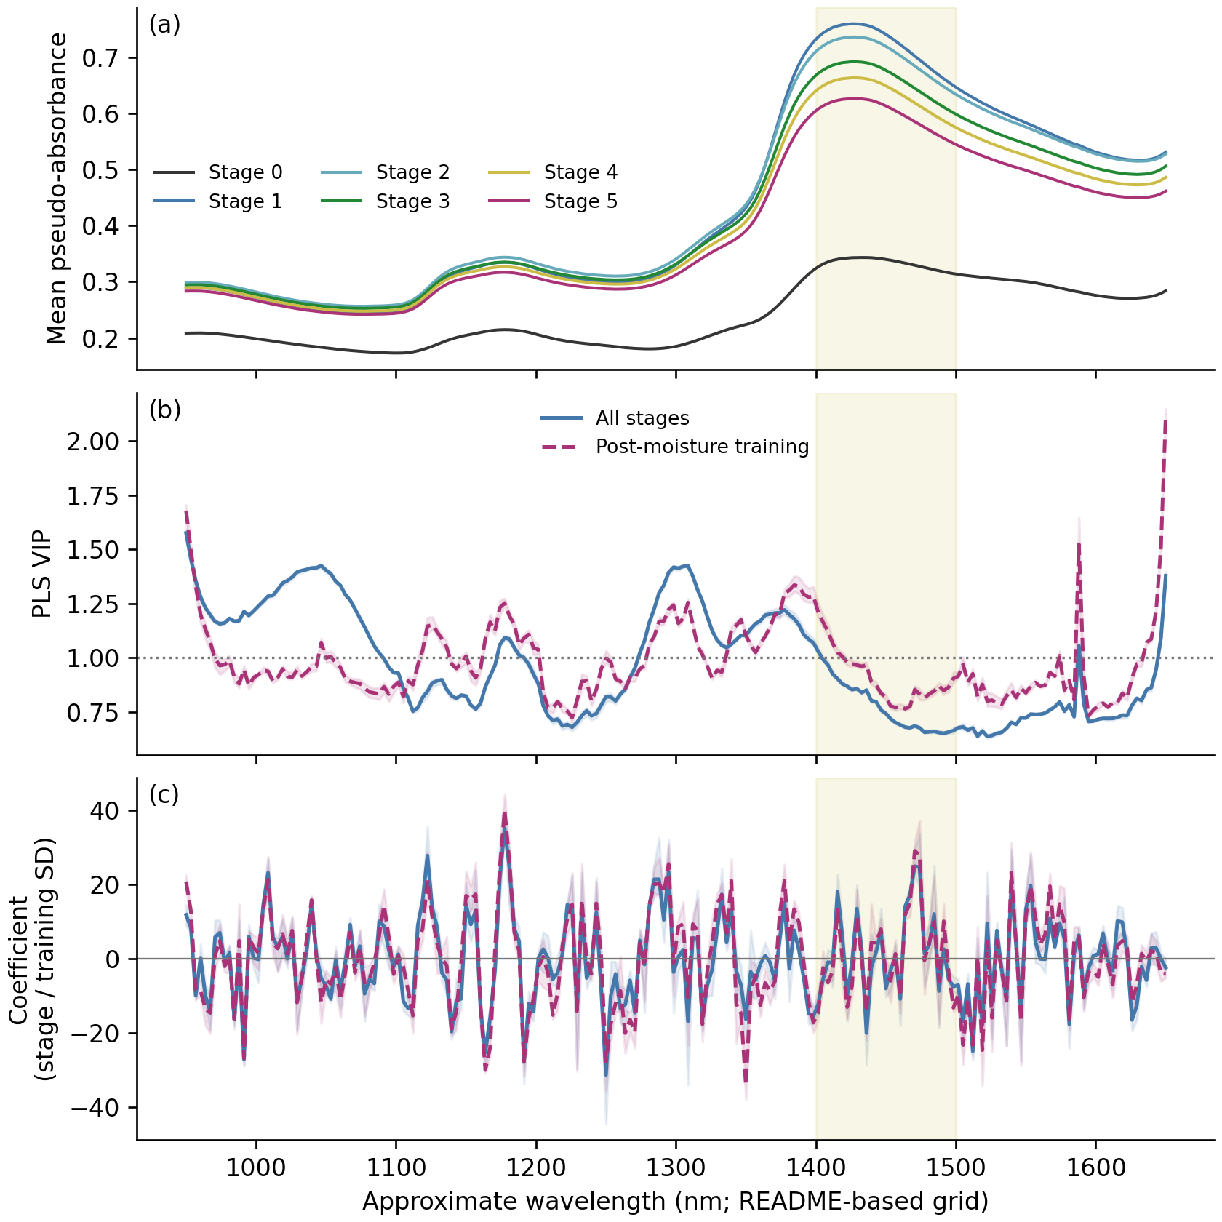
Fig. 3. Spectral diagnostics: (a) descriptive mean pseudo-absorbance by stage; (b) PLS VIP; (c) signed PLS coefficients per training-channel SD. Supervised profiles use outer-training data only. Lines are five-fold means and shading gives fold minima–maxima, not confidence intervals. Dashed post-moisture profiles retain all-stage selected component counts. The highlighted 1400–1500 nm window and wavelength axis are approximate README-based mappings.
This window contains the broad water O–H first-overtone region near 1450 nm [13]. Mean pseudo-absorbance separates the dry reference strongly from exposed stages; its broad peak is highest at stage 1 and declines toward stage 5, rather than increasing monotonically with stage. Both window-average VIPs are below one and most window channels fall below that descriptive threshold. The profiles therefore do not support a dominant water-band explanation of PLS prediction. Water-associated variation remains compatible with the spectra, but there is no specific proof of changing kernel water concentration. Distributed VIP and oscillatory signed coefficients must be interpreted jointly with overlapping, correlated spectral structure. These profiles explain PLS, not the nonlinear SVR directly, and cannot separate hydration from acquisition-session conditions.

5.6 Frozen SVR Grid Boundary Sensitivity
Table 5 reports larger-C checks without replacing the original nested results. Only C changes relative to each fold's original internally selected configuration. All settings predict the same external observations.
Table 5. Post-review frozen C sensitivity, not outer-error-based model selection. Post-moisture scores restrict predictions of the all-stage fitted procedure to stages 1–5.
C | All-stage MAE | All-stage RMSE | Post-moisture MAE | Post-moisture R²
100 | 0.577 | 0.800 | 0.680 | 0.618
300 | 0.590 | 0.823 | 0.692 | 0.597
1000 | 0.619 | 0.887 | 0.721 | 0.533
Relative to C=100, pooled all-stage MAE changes by +0.0128 at C=300 and +0.0424 at C=1000. These observed changes delimit sensitivity to the original boundary; they do not justify selecting C from outer errors or declaring the grid globally optimal.

6 Discussion

6.1 Interpretation of Stage Prediction
The model predicts stages for dishes excluded from their own training and tuning. Post-moisture MAE 0.680 better represents discrimination among exposed stages than aggregate MAE 0.577. Stage 0 has MAE 0.062, whereas stage 5 has MAE 0.935 and negative endpoint bias. Nevertheless, the post-moisture constant-stage reference gives MAE 1.200, so the result is not attributable only to dry-reference recognition. These subset scores reuse original all-stage out-of-fold predictions.
PLS profiles examine the broad O–H water region without converting the stage prediction into a chemical assay or explaining SVR directly. Correlated predictors can distribute importance; opposing coefficients can reflect multivariate compensation rather than isolated molecular effects. No intermediate-time observations validate sub-day resolution or interpolation.

6.2 Partition Effects and Unresolved Session Confounding
Random-row and dish-grouped MAEs differ by only 0.021 for the fixed configuration. This is an informative negative finding about a large partition effect, not evidence that grouping yields a substantial numerical gain. It is neither an equivalence test nor a causal estimate of leakage. Dish grouping remains necessary for the stated new-dish domain, even when dependence has little observed influence on a score.
The principal unresolved limitation is stage–session confounding. Each stage coincides with a measurement occasion in one sequence, and training and test dishes share these occasions. Session fingerprinting cannot be ruled out: instrument, illumination or other session-wide signatures could support prediction instead of biological exposure progress. Excluding identifiers and identifying the O–H region do not remove this dependency.
Domain exclusions retune configurations on remaining training dishes, but the SVR family was selected in the complete primary comparison. They are exploratory at that level, not confirmatory varietal-robustness evidence. Directional differences may reflect composition and handling as well as cultivar. Source glue residue inhibited germination [3], preventing normal-malting or prospective-viability interpretations.

6.3 Reproducibility and Next Validation
Saved predictions, candidate scores, supervised profiles, frozen-C checks and executable code support computational audit. Bootstrap intervals remain conditional on fixed dish-clustered out-of-fold errors; they omit complete refitting, shared-session variation and analysis-level selection. Same-data feasibility and post-review diagnostics are disclosed, and there is no untouched external cohort.
Further validation should prioritize independent exposure sequences with staggered starts or acquisition schedules that separate stage from session. A fixed protocol can then test a new harvest or instrument. Chemical moisture measurements would be needed for a concentration target; a suitable handling regime and independent outcome would be needed for viability. A larger algorithm grid cannot resolve the missing experimental independence.

7 Conclusion
Nested dish-grouped evaluation provides an auditable comparison of three compact NIR regression procedures. Original SVR predictions give post-moisture MAE 0.680 and R² 0.618; including the easy dry reference improves aggregate MAE to 0.577 and R² to 0.781. Training-only PLS profiles examine water-associated O–H information, while frozen larger-C checks qualify the search boundary without selecting a replacement primary model from external errors.
The small partition effect repositions the contribution as a reproducible benchmark and honest dependency analysis, rather than proof of substantial leakage inflation. Because stage and acquisition session coincide, session fingerprinting cannot be excluded. Evidence establishes within-experiment stage prediction, not biological exposure progress, chemical moisture, viable germination or validated continuous time. Independent sequences separating stage and session are the necessary next test.

References
1. Ajayi, O.O., Akinyemi, L., Atanda, S.A., Walling, J.G., Mahalingam, R.: Malt quality profile of barley predicted by near-infrared spectroscopy using partial least squares, Bayesian regression, and artificial neural network models. Journal of Chemometrics 37(12), e3519 (2023). https://doi.org/10.1002/cem.3519
2. Orth, S.H., Marini, F., Fox, G.P., Manley, M., Hayward, S.: Non-invasive exploration of malting barley (Hordeum vulgare) in vitro germination and varietal effects using short wave infrared spectral imaging and ANOVA simultaneous component analysis. Spectrochimica Acta Part A 323, 124869 (2024). https://doi.org/10.1016/j.saa.2024.124869
3. Engstrøm, O.-C.G., Dreier, E.S., Jespersen, B.M., Pedersen, K.S.: A Time Series Dataset of NIR Spectra and RGB and NIR-HSI Images of the Barley Germination Process. arXiv:2504.16658 (2025). https://doi.org/10.48550/arXiv.2504.16658
4. Wold, S., Sjöström, M., Eriksson, L.: PLS-regression: a basic tool of chemometrics. Chemometrics and Intelligent Laboratory Systems 58(2), 109–130 (2001). https://doi.org/10.1016/S0169-7439(01)00155-1
5. Smola, A.J., Schölkopf, B.: A tutorial on support vector regression. Statistics and Computing 14, 199–222 (2004). https://doi.org/10.1023/B:STCO.0000035301.49549.88
6. Geurts, P., Ernst, D., Wehenkel, L.: Extremely randomized trees. Machine Learning 63, 3–42 (2006). https://doi.org/10.1007/s10994-006-6226-1
7. Barnes, R.J., Dhanoa, M.S., Lister, S.J.: Standard Normal Variate Transformation and De-trending of Near-Infrared Diffuse Reflectance Spectra. Applied Spectroscopy 43(5), 772–777 (1989). https://doi.org/10.1366/0003702894202201
8. Savitzky, A., Golay, M.J.E.: Smoothing and Differentiation of Data by Simplified Least Squares Procedures. Analytical Chemistry 36(8), 1627–1639 (1964). https://doi.org/10.1021/ac60214a047
9. Varma, S., Simon, R.: Bias in error estimation when using cross-validation for model selection. BMC Bioinformatics 7, 91 (2006). https://doi.org/10.1186/1471-2105-7-91
10. Roberts, D.R., et al.: Cross-validation strategies for data with temporal, spatial, hierarchical, or phylogenetic structure. Ecography 40, 913–929 (2017). https://doi.org/10.1111/ecog.02881
11. Efron, B.: Bootstrap Methods: Another Look at the Jackknife. The Annals of Statistics 7(1), 1–26 (1979). https://doi.org/10.1214/aos/1176344552
12. Pedregosa, F., et al.: Scikit-learn: Machine Learning in Python. Journal of Machine Learning Research 12, 2825–2830 (2011). https://jmlr.org/papers/v12/pedregosa11a.html
13. Segtnan, V.H., Šašić, Š., Isaksson, T., Ozaki, Y.: Studies on the Structure of Water Using Two-Dimensional Near-Infrared Correlation Spectroscopy and Principal Component Analysis. Analytical Chemistry 73(13), 3153–3161 (2001). https://doi.org/10.1021/ac010102n
14. Farrés, M., Platikanov, S., Tsakovski, S., Tauler, R.: Comparison of the variable importance in projection (VIP) and of the selectivity ratio (SR) methods for variable selection and interpretation. Journal of Chemometrics 29(10), 528–536 (2015). https://doi.org/10.1002/cem.2736

