# **ACRONYMS**

[**CO**](https://www1.nyc.gov/site/buildings/property-or-business-owner/certificate-of-occupancy.page) – Certificate of Occupancy [**DOB ACRONYM LIST**](https://www1.nyc.gov/site/buildings/dob/acronym-glossary.page)

**FCO** – Final Certificate of Occupancy [**DOB GLOSSARY**](https://www1.nyc.gov/site/buildings/dob/dob-glossary1.page)

**SO** – Schedule of Occupancy [**DOB FORM LIST**](https://www1.nyc.gov/site/buildings/dob/forms.page)

**BSO** – BIN Level Schedule of Occupancy [**EFILING USER GUIDE**](https://www1.nyc.gov/assets/buildings/pdf/efiling_user_guide.pdf)

**BIN** – Building Identification Number [**DIRECTIVE 14 OF 1975 ALTERATION**](https://www1.nyc.gov/assets/buildings/pdf/code_notes_directive-14of1975-alterations.pdf)

[**AHV**](https://www1.nyc.gov/site/buildings/industry/after-hour-variances.page) – After Hours Variance

* Permit that allows construction to take place outside of regular schedule

[**TPP**](https://www1.nyc.gov/site/buildings/tenant/tenant-protection-plan.page)– Tenant Protection Plan

* Outlines measures the building owner and contractor will take to protect tenants

[**PAA**](https://www1.nyc.gov/site/buildings/industry/post-approval-amendment-paa.page)– Post Approval Amendment

* Up to date record of job that reflects any changes, makes sure all work is done up to date and compliant, a correction to the initial job application

[**LOC**](https://www1.nyc.gov/site/buildings/property-or-business-owner/letter-of-no-objection-or-completion.page) – Letter of Completion

* Issued for minor alterations that do not necessarily require a new CO

[**BPP**](https://www1.nyc.gov/site/buildings/dob/project-categories-bpp.page)– Builders Pavement Plan

* Sidewalks, curbs, paved roadways
* BPP Pro-Cert application will need tech review. BPP applications are handle by the Tech Team (Chief Plan Examiners).
* For NB/ BPP signoffs please email BPPIR@buildings.nyc.gov

[**LAA**](https://www1.nyc.gov/site/buildings/industry/limited-alteration-application.page)– Limited Alteration Application

* Plumbing, piping, and oil burner installations that require no construction

**CPE** – Chief Plan Examiner

[**PER11**](https://sandmexpediting.com/assets/uploads/forms/per11.pdf)– Chief Plan Examiner appointment request

[**RF1**](https://www1.nyc.gov/assets/buildings/pdf/refund_request_application.pdf)– Refund Request. [Instructions](https://www1.nyc.gov/assets/buildings/pdf/refund_request_appl_instr.pdf)

**EBN** – Elevator Building Notice

**ACPE** – Assistant Chief Plan Examiner

[**L2**](https://www1.nyc.gov/site/buildings/property-or-business-owner/civil-penalty-review-requests.page)– Civil Penalty Review Request. [Instructions](https://www1.nyc.gov/assets/buildings/pdf/l2_instr.pdf)

* Work without a permit, stop work orders

**LL __/__** – Construction Code. [List](https://www1.nyc.gov/site/buildings/codes/2014-construction-codes-updates.page).

**LMP** – Licensed Master Plumber

**SWO** – Stop Work Order [Instructions](https://www1.nyc.gov/site/buildings/property-or-business-owner/stop-work-order.page)

[**LIC 6**](https://www1.nyc.gov/assets/buildings/pdf/lic6.pdf) – General Contractor Registration Form. [Instructions](https://www1.nyc.gov/site/buildings/industry/general-contractor-registration-renewal.page)

**SSM** – Site Safety Manager

[**EN2**](https://www1.nyc.gov/assets/buildings/pdf/en2.pdf)– As Built Energy Analysis

[**AEU2**](https://www1.nyc.gov/assets/buildings/pdf/aeu2.pdf)– Certificate of Correction. [Instructions](https://www1.nyc.gov/site/buildings/safety/swo.page)

[**ELV1**](https://www1.nyc.gov/assets/buildings/pdf/elv1.pdf)– Elevator Application. [Instructions](https://www1.nyc.gov/assets/buildings/pdf/elv1ins.pdf).

**RDP** - Registered Design Professional (Applicant-of-Record)

**EWN** – Emergency Work Notification

**AOR** - Applicant of Record

**V5** – Asbestos

[**AI1**](https://www1.nyc.gov/assets/buildings/pdf/ai1_new0309.pdf)– Additional Information

**DHCR/HCR** – Division of Housing and Community Renewal

[**PA**](https://www1.nyc.gov/assets/buildings/pdf/pa_guide.pdf)– Place of Assembly

**TR FORMS**

[**TR1**](https://www1.nyc.gov/assets/buildings/pdf/tr1_2014.pdf)– Technical Report Statement of Responsibility. [Instructions](https://www1.nyc.gov/assets/buildings/pdf/tr1ins_2014.pdf)

* Waive requests go to borough director

[**TR2**](https://www1.nyc.gov/assets/buildings/pdf/tr2.pdf) – Concrete Pouring, Sampling and Compression Test Cylinders. [Instructions](https://www1.nyc.gov/assets/buildings/pdf/tr2ins.pdf)

[**TR3**](https://www1.nyc.gov/assets/buildings/pdf/tr3.pdf)– Concrete Design Mix. [Instructions](https://www1.nyc.gov/assets/buildings/pdf/tr3ins.pdf)

[**TR4**](https://www1.nyc.gov/assets/buildings/pdf/tr4.pdf)– Soil Inspection. [Instructions](https://www1.nyc.gov/assets/buildings/pdf/tr4ins.pdf)

[**TR5**](https://www1.nyc.gov/assets/buildings/pdf/tr5.pdf)– Pile Driving. [Instructions](https://www1.nyc.gov/assets/buildings/pdf/tr5ins.pdf)

**TR6** – Periodic Inspection of Exterior Walls and Appurtenances. Found in DOBNOW. [Instructions](https://www1.nyc.gov/assets/buildings/pdf/tr6instr.pdf)

[**TR7**](https://www1.nyc.gov/assets/buildings/pdf/tr7.pdf)– Luminous Egress Path Markings Report

[**TR8**](https://www1.nyc.gov/assets/buildings/pdf/tr8.pdf)– Technical Report Statement of Responsibility for Energy Code Progress Inspections. [Instructions](https://www1.nyc.gov/assets/buildings/pdf/tr8ins.pdf)

[**TR15**](https://www1.nyc.gov/assets/buildings/pdf/tr15.pdf)– Potentially Structurally Compromised Buildings. [Instructions](https://www1.nyc.gov/assets/buildings/pdf/tr15_instr.pdf)

**UNITS** [**(Details)**](https://www1.nyc.gov/site/buildings/dob/unit-descriptions.page)

**PEU** – Plan Examiner Unit

**FEU** – Forensic Engineering Unit

* Construction Injuries

**DEAR** - Data Entry and Research Unit

**AEU** – Administrative Enforcement Unit

* Enforces Compliance with NYC construction, zoning, and electric codes

**PW FORMS**

[**PW1**](https://www1.nyc.gov/assets/buildings/pdf/pw1.pdf) - PLAN/WORK APPLICATION, proposal for what job will be done. [Instructions](https://www1.nyc.gov/assets/buildings/pdf/pw1_userguide.pdf)

[**PW1A**](https://www1.nyc.gov/assets/buildings/pdf/pw1a.pdf)– Schedule A: Occupancy/use

[**PW1B**](https://www1.nyc.gov/assets/buildings/pdf/pw1b.pdf)– Schedule B: Plumbing, sprinkler, standpipe

[**PW1C**](https://www1.nyc.gov/assets/buildings/pdf/pw1c.pdf)– Schedule C: Heating & combustion equipment

[**PW2**](https://www1.nyc.gov/assets/buildings/pdf/pw2.pdf) – WORK PERMIT APPLICATION, permit request and contractor information. [Instructions](https://www1.nyc.gov/assets/buildings/pdf/pw2ins.pdf)

[**PW3**](https://www1.nyc.gov/assets/buildings/pdf/pw3.pdf) - COST AFFADAVIT, breaks down the costs of the job. [Instructions](https://www1.nyc.gov/assets/buildings/pdf/pw3ins.pdf)

[**PW4**](https://www1.nyc.gov/assets/buildings/pdf/pw4.pdf) – CERTIFICATE OF COMPLIANCE APPLICATION. verifies job was done in accordance with DOB regulations. [Instructions](https://www1.nyc.gov/assets/buildings/pdf/pw4ins.pdf)

[**PW5**](https://www1.nyc.gov/assets/buildings/pdf/pw5.pdf) – AFTER HOURS WORK PERMIT, allows for construction to take place outside usual hours. [Instructions](https://www1.nyc.gov/assets/buildings/pdf/pw5ins.pdf)

[**PW6**](https://www1.nyc.gov/assets/buildings/pdf/pw6.pdf) – CO INSPECTION REQUEST, initiates required inspections for CO. [Instructions](https://www1.nyc.gov/assets/buildings/pdf/pw6ins.pdf)

[**PW7**](https://www1.nyc.gov/assets/buildings/pdf/pw7.pdf) – LETTER OF COMPLETION REQUEST, requests TCO, TCO Renewal, or FCO. [Instructions](https://www1.nyc.gov/assets/buildings/pdf/pw7ins.pdf)

# BIS Job Status Code

|  |  |  |
| --- | --- | --- |
| **Code** | **Code Online** | **Description (not showing online)** |
| **A** | Pre-Filed | Pre-Filing |
| **B** | A/P Unpaid | Application Processed - Part-No Payment |
| **C** | A/P to D.E.A.R | Application Processed - Payment Only |
| **D** | A/P Entire | Application Processed - Completed |
| **E** | AP-NPE | Application Processed - No Plan Exam |
| **F** | Assigned To P/E | Application Assigned To Plan Examiner |
| **G** | PAA Fee Due | PAA Fee Due |
| **H** | P/E In Process | Plan Exam - In Process |
| **I** | Sign-Off | Sign-Off (ARA) |
| **J** | P/E Disapproved | Plan Exam - Disapproved |
| **K** | P/E Partial APRV | Plan Exam - Partial Approval |
| **L** | P/E PAA $ Pending | P/E PAA - Pending Fee Estimation |
| **M** | P/E PAA $ Resolved | P/E PAA - Fee Resolved |
| **P** | Approved | Plan Exam - Approved |
| **Q** | Permit-Partial | Permit Issued - Partial Job |
| **R** | Permit-Entire | Permit Issued - Entire Job/Work |
| **U** | Completed | Completed |
| **X** | Signed-Off | Signed-Off |
| **3** | Suspended | Suspended |

|  |  |  |  |
| --- | --- | --- | --- |
| ***BIS Permit Types*** | | ***DOB NOW Permit Types*** | |
| **Code** | **Description** | **Code** | **Description** |
| **AL** | Alteration | **AN** | Antenna |
| **DM** | Demolition & Removal | **BE** | Boiler Equipment |
| **EQ** | Construction Equipment | **CC** | Curb Cut |
| **CH** | Chute | **EA** | Earthwork |
| **FN** | Fence | **EL** | Electrical |
| **SH** | Sidewalk Shed | **FN** | Construction Fence |
| **SF** | Scaffold | **FO** | Foundation |
| **OT** | Other-General Construction, Partitions, Marquees, BPP (Builder Pavement Plan), etc. | **GC** | General Construction |
| **GC-CX** | Combined (GC + others) |
| **EW** | Equipment Work | **LA** | Limited Alteration Applications (LAA) |
| **BL** | Boiler | **MS** | Mechanical Systems |
| **FA** | Fire Alarm | **PA** | Place of Assembly |
| **FB** | Fuel Burning | **PL** | Plumbing |
| **FP** | Fire Suppression | **PM** | Protection and Mechanical Methods |
| **FS** | Fuel Storage | **SD** | Standpipe |
| **MH** | Mechanical/HVAC | **SE** | Support of Excavation |
| **SD** | Standpipe | **SF** | Supported Scaffold |
| **SP** | Sprinkler | **SG** | Sign |
| **FO** | Foundation/Earthwork | **SH** | Sidewalk Shed |
| **FO/EA** | Earthwork Only | **SP** | Sprinkler |
| **NB** | New Building | **ST** | Structural |
| **PL** | Plumbing | **TA** | Temporary Place of Assembly |
| **SG** | Sign | **VT** | Elevator |

# Contacts

**For Professional Certification Job Filings:**

|  |  |  |
| --- | --- | --- |
| **Borough** | **Borough Director** | **Service Manager** |
| Manhattan | Rashid Kearns | Felisha Torres  Rondel Scipio |
| Bronx | Ikwumma Daniels | Cecile Lambe |
| Brooklyn | Darnelle Clarke-Mills |  |
| Queens | Jamie Maule | Jacquetta Callender |
| Staten Island | Stacy Lorenzo |  |
| The HUB | Natarsia Joye  **(NJoye@buildings.nyc.gov)**  Carlos Pineiro |  |

**For Standard Plan Examination Job Filings:**

|  |  |  |
| --- | --- | --- |
| **Borough** | **Chief Plan Examiner (CPE)** | **Assistant Chief Plan Examiner (ACPE)** |
| Manhattan | Elizabeth Spirig |  |
| Bronx | William Singer | Blanca Rivera, Janet Suro, Km Iftekher Uddin |
| Brooklyn | Sophia Hairston |  |
| Queens | Gerard McGovern |  |
| Staten Island | Deloor Shenouda |  |
| Development HUB | Rami Bitar |  |
| HUB Full Service | Barry Stein |  |
| FDNY | shaji.mathew@fdny.nyc.gov 718-999-1979. |  |

|  |  |  |
| --- | --- | --- |
| **Borough** | **Commissioner** | **Assistant Commissioner** |
| Manhattan | John Raine | Lisa Amoia and Chintan Desai |
| Bronx | Rodney Gittens | Azmi Zahed-Atkins (Acting) |
| Brooklyn | Kazimir Vilenchik | Reda Shehata and Frank Marchiano |
| Queens | Reda Shehata, (Acting) | Simon Lee and S. Ron Kunateerachadalai, R.A. (Acting) |
| Staten Island | Ira Gluckman | N/A |
| The HUB | Scott Pavan and Elizabeth Skowronek | N/A |

[Clerk's Office - OATH (nyc.gov)](https://www1.nyc.gov/site/oath/clerks-office/clerks-office.page)

[Licensing Applications & Forms - Buildings (nyc.gov)](https://www1.nyc.gov/site/buildings/industry/applications-forms.page)

**Special Enforcement Team (SET):** The Special Enforcement Team (SET) audits selected applications and special inspection/progress inspection/TR1 reports to ensure compliance with the Building Code, the Zoning Resolution, the Rules of the City of New York and Department procedures. Following the audits, SET prosecutes enforcement actions against non-compliant design professionals (architects and engineers).  
**Neil G. Adler** is the **Chief Plan Examiner**   
**Matthew Burdge** is the **Deputy Director**

**Greenroofandsolar@buildings.nyc.gov** - This email is for general solar and green roof tax abatement program inquiries and sign-off requests only.

# Contact Guide

|  |  |  |
| --- | --- | --- |
| **Issue Type** | **Job Filing Type** | **Send to** |
| Approval of job filing or PAA | Standard Plan Job Filing | Chief Plan Examiner and Plan Examiner (if known) |
| Professional Certification Job Filing | Borough Director |
| HUB Full-Service job filing | [HubFSProjectAdvocate@buildings.nyc.gov](mailto:HubFSProjectAdvocate@buildings.nyc.gov) |
| Development HUB job filing | [nycdevelopmenthub@buildings.nyc.gov](mailto:nycdevelopmenthub@buildings.nyc.gov) |
| Did not received approved plans/approved plans do not have a stamp | Standard Plan Job Filing | Chief Plan Examiner and Plan Examiner (if known) |
| Professional Certification Job Filing | Borough Director |
| Status of permit request (PW2 request)/permit issued to wrong contractor | Both | Borough Director |
| Withdrawal request (client has already filed) | Both | Borough Director (For BK include Recaldo Stevens) |
| Status of Letter of Completion (LOC)/Sign off/PW7 | Both | Borough Director |
| Status of TR1/TR8/EN2 | Both | Borough Director |
| Request for fee estimation | Both | Chief Plan Examiner |
| Request to have status change from permit partial to permit entire | Both | Riley Tonge |
| LAA Withdrawal/Administrative Closure | N/A | [DOBNOWLAAWithdrawal@buildings.nyc.gov](mailto:DOBNOWLAAWithdrawal@buildings.nyc.gov) |
| Request for reassignment of the Plan Examiner | Standard Plan Job Filing | Chief Plan Examiner |
| Elevator sign off |  | Reassign to Elevator CO group |
| DOB NOW job filings |  | Reassign to DOB NOW Support |
| Temporary Certificate of Occupancy request (not final) |  | Reassign to Occupancy group |

# The HUB

[**Information**](https://www1.nyc.gov/site/buildings/industry/the-hub.page)

[**FAQ**](https://www1.nyc.gov/site/buildings/industry/hub-frequently-asked-questions.page)

[**Hub Full-Service Withdrawal Instructions**](https://www1.nyc.gov/assets/buildings/pdf/withdrawing_an_application.pdf)

**Hub Full-Service:**  Hubfsprojectadvocate@buildings.nyc.gov

Hubfullservice@buildings.nyc.gov

**Hub Self-Service:**  Hubselfservice@buildings.nyc.gov

Hubselfserviceobj@buildings.nyc.gov

**(HUB SELF SERVICE NO LONGER EXISTS,**

**please send all bis job inquiries to the**

**Borough Directors of that respective Borough)**

**Development Hub:**  [NYCdevelopmenthub@buildings.nyc.gov](mailto:NYCdevelopmenthub@buildings.nyc.gov)

Solar Panels or Green Roof – Tracking to Dev HUB  
  
**HUB FULL SERVICE/SELF SERVICE do not withdraw jobs or process PW1 of any kind. Withdrawals are processed through the borough office operations unit**

**HUB DOES NOT PROCESS LOC’s/PW. SEND THOSE TO THEIR RESPECTIVE BOROUGH DIRECTORS**

# Withdrawals

**Client Asks How to Withdraw Prefiling:**

To request a withdrawal of a job filing in **pre-filing** status, you must drop off the PW1 at the borough office.

All customers submitting withdrawals are required to upload in e-submit.

**Only demos and pre-files can be dropped off at the borough office.**

**Client Asks How to Withdraw Permitted Jobs:**

For job filings that were filed in BIS, you will need to upload a PW1 (<https://www1.nyc.gov/assets/buildings/pdf/pw1.pdf>) in eSubmit (<https://a810-efiling.nyc.gov/eRenewal/loginER.jsp>) and click on the Withdrawal radio button in Select Filing Type to request a withdrawal. In section 24 of the PW1, indicate the reason for the withdrawal. Additionally, if the job was **permitted**, you will need to first request a withdrawal inspection in DOB NOW: Inspection. Once you have obtained the inspection report you will need to also submit it in eSubmit. Both documents will need to be uploaded separately.

**Withdraw/Add Work Type:**

To withdraw a work type, you need to submit a PW1 as a withdrawal and specify which work type you would like removed. Here is a link to the PW1 form:   
<https://www1.nyc.gov/assets/buildings/pdf/pw1.pdf>A work type cannot be added to filling with a PAA, must be filed in DOBNOW.  
  
[2/8/22 12:34pm ID#1074492] **Jody**: *We can't speak to the actual issue of why they want to withdraw the job. That is between the customer and the contractor. But you can tell the contractor how to withdraw a permit.*

# Waive Required Items

You can submit a request to **XXX@buildings.nyc.gov** to request a waiver of required items. Examiners may waive some items during your appointment if the job is not yet approved.

**Insert email corresponding to the client's borough**

[ManhPER11PlanExam@buildings.nyc.gov](mailto:ManhPER11PlanExam@buildings.nyc.gov)

[BronxPER11PlanExam@buildings.nyc.gov](mailto:BronxPER11PlanExam@buildings.nyc.gov)

[BrooklynPER11PlanExam@buildings.nyc.gov](mailto:BrooklynPER11PlanExam@buildings.nyc.gov)

[QueensPER11PlanExam@buildings.nyc.gov](mailto:QueensPER11PlanExam@buildings.nyc.gov)

StatenIslandPER11PlanExam@buildings.nyc.gov

# [**Permits**](https://www1.nyc.gov/site/buildings/property-or-business-owner/permits-by-type.page)

**NB**: construction of new structures

**Alt**: multiple types of work that do not change the use, egress or occupancy of the building

**Alt-CO**: construction of a new structure or major alteration that will change the use, egress or occupancy of a building

[Filing Permit Applications - Buildings (nyc.gov)](https://www1.nyc.gov/site/buildings/industry/filing-permit-applications.page)[Permit Renewal](https://www1.nyc.gov/site/buildings/property-or-business-owner/permit-renewal.page)After job filing is reinstated, customer may need to drop off permit renewal request at the borough office.   
A permit is not allowed to be renewed online if THAT permit has expired for more than one year.

BIS Permit Renewal Application Filing Steps

1. *Submit the PW2 application two weeks before its expiration (two copies)*
2. *Make sure all insurance is updated on your existing tracking number or submit insurance certificates reflecting that policies are currently in effect*
3. *Provide complete information on permit application (PW2)*
4. *Submit $100.00 renewal fee for each work type, except for work that is exempt or fee deferred*

If a customer wants to withdraw an **in-process permit renewal**. How do they do that? – Borough office can do it.

**System not allowing online submission**: If you are renewing the permit with a change, you can't do it online. You have to drop it off at the borough office. You can bring a copy of the screen shot of the error message as proof that it cannot be submitted online.

***Secondary Permit***: The customer will just need to upload a PW2 form and indicate secondary permit in section 3c. Secondary permits must be submitted in the Borough Office for processing.

If the system is not allowing submission, then you must drop it off in the office. I recommend printing out a copy of the error message so that you can show proof that you can't submit online.

TIP: When is a Superseding Letter is Necessary – A superseding letter is required when replacing a contractor on a permit that is currently active. This letter is authorized by the owner and allows the previous contractor to be replaced on record with a newly hired contractor.

**Permit Renewals**

A permit renewal with no changes can be done on efiling. A permit renewal with changes must be dropped off at the borough’s office.

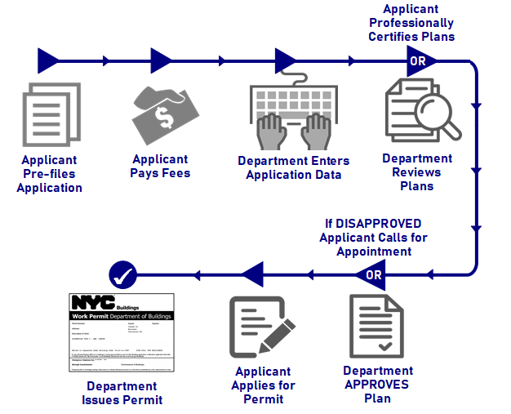

# [**Violations**](https://www1.nyc.gov/site/buildings/property-or-business-owner/violation-issued.page)

The Office of Administrative Trials and Hearings [(OATH)](https://www1.nyc.gov/site/buildings/property-or-business-owner/what-is-an-oath-summons.page) is an administrative tribunal that provides hearings on notices of violation issued by City agencies.

DOB inspectors issue [OATH Summons](https://www1.nyc.gov/site/buildings/safety/oath-summonses.page) when a property or construction does not comply with the Construction Codes.

A [DOB Violation](https://www1.nyc.gov/site/buildings/safety/dob-violations.page) is a notice that a property is not in compliance with some provision of applicable law and includes an order from the Commissioner of the Department of Buildings to correct the violating condition.

* [**Boiler Violations**](https://www1.nyc.gov/site/buildings/safety/resolve-dob-boiler-violations.page)
* [**Elevator Violations**](https://www1.nyc.gov/site/buildings/safety/resolve-dob-elevator-violations.page)
* [**Façade Violations**](https://www1.nyc.gov/site/buildings/safety/resolve-dob-fa%c3%a7ade-violations.page)
* [**Fire Safety Violations**](https://www1.nyc.gov/site/buildings/safety/resolve-dob-fire-safety-violations.page)
* For all other DOB violations, [**contact the issuing unit directly**](https://www1.nyc.gov/site/buildings/dob/unit-descriptions.page).

[Stop Work Order](https://www1.nyc.gov/site/buildings/property-or-business-owner/stop-work-order.page) **(SWO)**

[Certificate of Correction Request User Guide](https://www1.nyc.gov/assets/buildings/pdf/cofc_user_guide.pdf)   
[Certificate of Correction FAQs](https://www1.nyc.gov/site/buildings/property-or-business-owner/certificate-of-correction-frequently-asked-questions.page)

# Superseding

**Request for Construction Superintendent**

All request for Construction superintendents must be sent to [csuper@buildings.nyc.gov](mailto:csuper@buildings.nyc.gov).

**Supersede Construction Superintendent**

For superseding a construction superintendent, permit renewals (PW2) with change must be submitted in the Borough Office for processing. The customer needs a notarized letter from the owner stating that the previous CS was released. The letter along with a check for $100 (renewal fee) must be included with the PW2.

**Supersede the Applicant**

For job filings that were filed in BIS you will need to file a PAA in eFiling to supersede the applicant. On the PW1, select New (Superseding) Applicant in the Filing Status (section 4) section.

**Client Asks to Supersede Contractor**

Superseding a contractor on a BIS job requires a PW2:Work Permit Application and a $100 fee. This is a "Renewal Permit with Changes" (section 1 "reason for filing" of the PW2). The PW2 and the $100 fee must be dropped off at the borough office.

# Record Request

For record requests, please see the instructions on the attached form:

<https://www1.nyc.gov/assets/buildings/pdf/records_requests_sn.pdf>

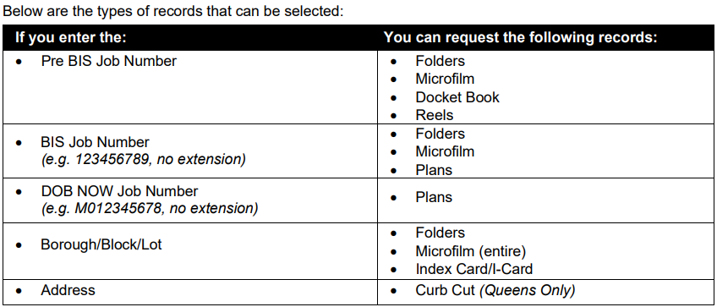

# Refund Request

For a refund request, please complete the following form. Instructions on filling out the form and who to send it to are attached.

FORM: <https://www1.nyc.gov/assets/buildings/pdf/refund_request_application.pdf>

INSTRUCTIONS: <https://www1.nyc.gov/assets/buildings/pdf/refund_request_appl_instr.pdf>

# PW1 Correction - PAA

For making corrections to your PW1, please submit a PAA. Here are instructions on how to fill out a PAA: <https://www1.nyc.gov/site/buildings/industry/post-approval-amendment-paa.page>   
  
When requesting a Post Approval Amendment to be approve, the customer must e-submit a PW1 clearly indicating **“ok to approve”.**  
When the PW1 is uploaded, the AI1 and amended plans will be stamped and copies of approved plans will be uploaded.  
  
Appointments are no longer required for first review of PAA!!

# Copy of the plans

Once the plans are approved the stamped plans are uploaded to eFiling by the plan examiner or the borough staff. It is in eFiling for 30 days. After that they no longer have access to it. They should have download it once they received it. If they need a copy of the plans, they will have to come to the Record Room to request a copy of the plans.

# Reinstatements

[Reinstatement Fees: Expired Plans, Permits + Applications (nyc.gov)](https://www1.nyc.gov/assets/buildings/pdf/reinstatement_fees.pdf)**Reinstate Job**

Reinstatements are reviewed by the Commissioner, not the Director. Regardless of if its pro cert or plan exam.

The first step to reinstate a job is to set up an appointment with the **Borough Commissioner**: Include the property address, job number and job type in the email subject line.

[ManhPER11Appointments@buildings.nyc.gov](mailto:ManhPER11Appointments@buildings.nyc.gov)

[BronxPER11Appointments@buildings.nyc.gov](mailto:BronxPER11Appointments@buildings.nyc.gov)

[BrooklynPER11Appointments@buildings.nyc.gov](mailto:BrooklynPER11Appointments@buildings.nyc.gov).

[QueensPER11Appointments@buildings.nyc.gov](mailto:QueensPER11Appointments@buildings.nyc.gov)

[StatenIslandPER11Appointments@buildings.nyc.gov](mailto:StatenIslandPER11Appointments@buildings.nyc.gov)

**Reinstate Application Items**

You can submit a request to **XXX@buildings.nyc.gov** to reinstate your application.

**Insert email corresponding to the client's borough**

[ManhPER11PlanExam@buildings.nyc.gov](mailto:ManhPER11PlanExam@buildings.nyc.gov)

[BronxPER11PlanExam@buildings.nyc.gov](mailto:BronxPER11PlanExam@buildings.nyc.gov)

[BrooklynPER11PlanExam@buildings.nyc.gov](mailto:BrooklynPER11PlanExam@buildings.nyc.gov)

[QueensPER11PlanExam@buildings.nyc.gov](mailto:QueensPER11PlanExam@buildings.nyc.gov)

StatenIslandPER11PlanExam@buildings.nyc.gov

**NOTE:** After job is reinstated, it must be submitted in the borough office, not esubmit

**Someone related to the filing must do the reinstatement**

# Account Management (Email Change, Name Change, etc.)

Your updated name or address will take effect in eFiling immediately. The applicant will need to log into [**DOB NOW**](http://www.nyc.gov/dobnow) at least once for the new information to populate when the email address is entered in a filing.

Owners and Filing Representatives:

1. Log into [**eFiling**](https://a810-efiling.nyc.gov/eRenewal/loginER.jsp)
2. Click Manage Your Account
3. Click Show
4. Click Manage Account
5. Update your information
6. Click Submit

Licensees and General Contractors:

1. Update your address with the DOB Licensing Unit, following the process for a [**licensee**](https://www1.nyc.gov/site/buildings/industry/business-address-verification.page) or [**general contractor**](https://www1.nyc.gov/site/buildings/industry/general-contractor-registration.page)
2. After you have updated your address with the DOB Licensing unit, login to [**eFiling**](https://a810-efiling.nyc.gov/eRenewal/loginER.jsp)
3. Click Manage Your Account
4. Click Show
5. Click Manage Account
6. Update your mailing address
7. Click Submit

Design Professionals:

1. Log into [**eFiling**](https://a810-efiling.nyc.gov/eRenewal/loginER.jsp)
2. Click Manage Your Account
3. Click Show
4. Click Manage Account
5. Update your information
6. Click Submit
7. Print, sign, date, and seal the Authentication form

# LAA Signoff/Withdrawal

Please submit a letter from the homeowner signed and notarized or from the applicant of record signed and sealed on company letterhead requesting an Administrative Sign off/Withdrawal. The letter should indicate the LAA filing you are requesting to be Administrative Sign off/withdrawn. Also please provide a justification and all documents to substantiate your request. If no work was performed an inspection will be required, please provide contact information, so that an appointment can be scheduled. Requests for supersedes and withdrawals of LAA filings may take up to 3 weeks to be processed. Please submit your letter to the following email address [DOBNOWLAAWithdrawal@buildings.nyc.gov](mailto:DOBNOWLAAWithdrawal@buildings.nyc.gov)*\*The LAA Unit takes at least 3 weeks to process, and they are not going to respond until they are done. During that time the customer may continue to follow up with you for a status update. Therefore, recently, I just tell the customer to submit it the correct way so that they will deal with the LAA unit and not me, since I don't have an answer for them beside that it is with the unit for processing. \**

**~ For customers repeatedly inquiring about the status of their LAA signoff/withdrawal, see below ~**  
  
Please resubmit your request based on the information below so that it is routed to the LAA Unit for processing. Choose the below selections on the DOB Help Form at www.nyc.gov/dobhelp to ensure that the inquiry is directed to the appropriate staff:

LAA Administrative Closures of BIS Jobs

• Module: DOB NOW: Build

• Project/Filing Type: LAA

• Question Category: LAA Administrative Closure

Please see the Service Notice for more information: <https://www1.nyc.gov/assets/buildings/pdf/laa_supersede_withdrawal_sn.pdf>

# BPP (Builders Pavement Plan)

**NP/BPP Signoffs**

For NB/ BPP signoffs please email [BPPIR@buildings.nyc.gov](mailto:BPPIR@buildings.nyc.gov)

**DON’T CONTACT BPPIR FOR WITHDRAWALS OR APPROVALS**

The BPP unit has no dealings with the withdrawal process. The Plan Examiner must submit all documentation into the system once they approve for the application to be withdrawn. They must reach out to Plan Exam for further information.

The applicant must reach out to the Plan Examiner regarding the disapproval status. The BPP unit does not have anything to do with approving a job.

# PAA Fees Due for Fee Exempt Jobs

**Professionally Certified PAA**

For fee exempt Professionally Certified PAA, when the PAA is in PAA FEE DUE status, you will need to upload a PW1 with “ok to approve” written on the PW1 in eSubmit. Select Approval for PAA as the Filing Type.

**Standard Job PAA**

Fee-exempt jobs pay no fees, and they remain in PAA fee due status until it is approved. The Plan Examiner will examine the PAA at this status. There is nothing wrong with the status of the PAA. Submit any documents that is needed for approval for this PAA in eSubmit.

# Project Advocate Program

[Project Advocate Program - Buildings (nyc.gov)](https://www1.nyc.gov/site/buildings/property-or-business-owner/project-advocate-program.page)

* provides customers with a single point of contact (a Project Advocate) within the Department

Note: TR2 and TR3 waiver request are handled by the Project Advocate.

Submit the form and all your essential project information to the borough email address where your project is located:

Bronx projects – BXPAServiceRequest@buildings.nyc.gov

Brooklyn projects – BKPAServiceRequest@buildings.nyc.gov

Manhattan projects – MNPAServiceRequest@buildings.nyc.gov

Queens projects – QNPAServiceRequest@buildings.nyc.gov

Staten Island projects – SIPAServiceRequest@buildings.nyc.gov

**Note:** Can waive TR2 & TR3 forms. TR1 goes to borough director

# Homes and Community Renewal (HCR/DHCR)

The customer should follow the link below to SN regarding the DHCR requirement

<https://www1.nyc.gov/assets/buildings/pdf/bis_update_sn.pdf>

DHCR document: plan examiner to receive this item  
  
HUB Professional Certification Job filing – DHCR processing reach out to [HubSelfServiceObj@buildings.nyc.gov](mailto:HubSelfServiceObj@buildings.nyc.gov)

# ALT Forms

**ALT 1** *(STANDARD PLAN EXAM)*: nycdevelopmenthub@buildings.nyc.gov.

**ALT2 & ALT3** *(STANDARD PLAN OR PRO CERT)*: Hubfullservice@buildings.nyc.gov

**ALT2 & ALT3** *(PRO CERT):* [Hubselfservice@buildings.nyc.gov](mailto:Hubselfservice@buildings.nyc.gov)

This inquiry should be forwarded to the zoning review examiner. Professional Certified Alt 1s are no longer approved by Application Processing.

# How to submit a PW7/LOC Request (BIS)

Sign into eFiling

Click on Other Filings

Scroll down and click on Other Job Applications and Hub Full-Service

Electronically Submit Documents

Enter Job Number and click Next

Scroll down to Filing Documents

Click on the Select Upload Type and click on the drop down. Select Upload Form

Go to Select Form Name and click on the drop-down arrow.

Search for the document name and click on it.

Select PW7 Request Type: Letter of Completion (LOC)

Click on Choose File and search for the file on your computer and upload it.

Click on Submit File.

# Can’t upload PW2

A PW2 can only be submitted after the PW1 has been approved. A PW2 must also be submitted by the general contractor. It cannot be submitted by a filing representative.

# Fee Adjustments (PW3/Affidavit does not match BIS)

You need to send an email to the fee estimator requesting a fee adjustment to **XXXPER11PlanExam@buildings.nyc.gov.**

**Insert email corresponding to the client's borough**

[ManhPER11PlanExam@buildings.nyc.gov](mailto:ManhPER11PlanExam@buildings.nyc.gov)

[BronxPER11PlanExam@buildings.nyc.gov](mailto:BronxPER11PlanExam@buildings.nyc.gov)

[BrooklynPER11PlanExam@buildings.nyc.gov](mailto:BrooklynPER11PlanExam@buildings.nyc.gov)

[QueensPER11PlanExam@buildings.nyc.gov](mailto:QueensPER11PlanExam@buildings.nyc.gov)

StatenIslandPER11PlanExam@buildings.nyc.gov

# Data on BIS is incorrect

* If something was recently uploaded, tell them that we received their doc and it will be processed shortly however if it's something from a PAA that hasn't been reflected on bis, check their PAA status and fee exemption.
* If it says PAA fees due, then tell them they must pay their PAA fees before the changes are reflected.
* if no fees or PAA received but PW1 not updated, then send it to Riley Tonge.

*DO NOT SEND KIRSTIE TICKETS (BIN issues)

# Obsolete BIN

A temporary BIN is required to do work at that address. To request a BIN, contact the topographical bureau at the appropriate [**Borough President’s office**](http://www.nyc.gov/) and request confirmation of the address. As part of that process, have the Borough President stamp and sign a [**PD-1 Plot Diagram**](https://www1.nyc.gov/assets/buildings/pdf/pd1.pdf) form for the work that you plan to do. If you are splitting or merging existing lot numbers, you will need to [**request a lot merger or apportionment**](http://www1.nyc.gov/site/finance/taxes/property-forms/property-forms-dividing-and-merging-lots.page) from the Department of Finance. Then submit your forms in [**DOB NOW: *Build***](http://www.nyc.gov/dobnow) along with a brief explanation of the work that you are planning to do. From the DOB NOW dashboard select **+Requests** and then **Temporary BIN**. For more information see page 81 of this [**Training Presentation**](https://www1.nyc.gov/assets/buildings/pdf/job-types-in-dob-now.pdf).

# PE missed appointment and now the system won’t let them reschedule

If PE misses an appointment and the system is not updated accordingly it causes issues with rescheduling. The PE must go back into their side to make this change themselves, if they do not you have to create a ticket with the help desk to handle.

# FDNY Job Filing

This is a FDNY job filing. The customer should reach out to FDNY to have them review and approve it. When you look up the plan examiner on BIS, it shows Fire Dept next to the name. The contact info for the Plan Examiner for the FDNY is [shaji.mathew@fdny.nyc.gov](mailto:shaji.mathew@fdny.nyc.gov) 718-999-1979.

# Can’t request final inspection because of a revocation notice

The issue is that the customer is trying to request a final inspection in DOB NOW Inspection, but the system won't allow them because there is a notice to revoke the permit. To get more info on the notice to revoke, you can reach out to the borough commissioner's office. The customer must get that “notice to revoke” removed in order to do the inspection to sign off the job.

# Directive 14

**Directive 14 allows the architect/engineer to do the final inspections of the job. Otherwise (non-directive 14) the Department of Buildings will do the inspection**

**How can I change a Directive 14 filing to non-Directive 14?**

This change cannot be made on a submitted filing. The job will need to be withdrawn and refiled.

# Diagrams

**PAA:**  
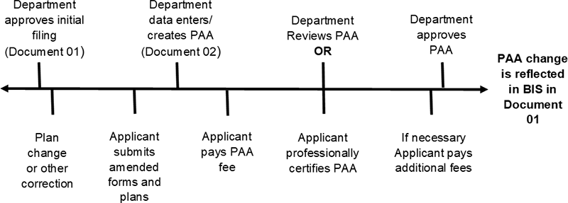

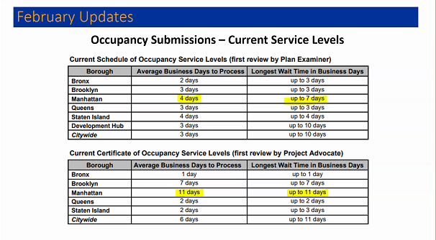

# Creating Tickets

* Click on Contacts



* Click on Contact Search

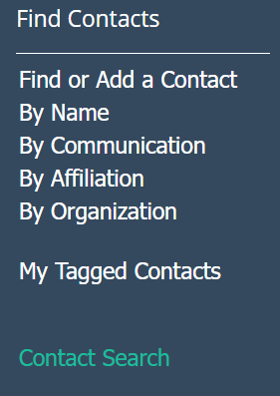

* Fill in First and Last name, or the email
* Select contact with most activity, such as messages, outreach, & services (This is likely the account they use)
* Click on Actions

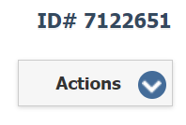

* Select New Default Service

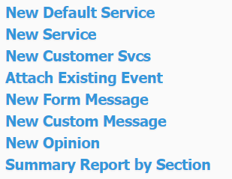

* Copy Question Entry into Customer Inquiry

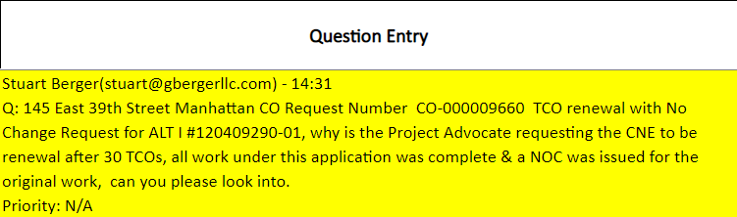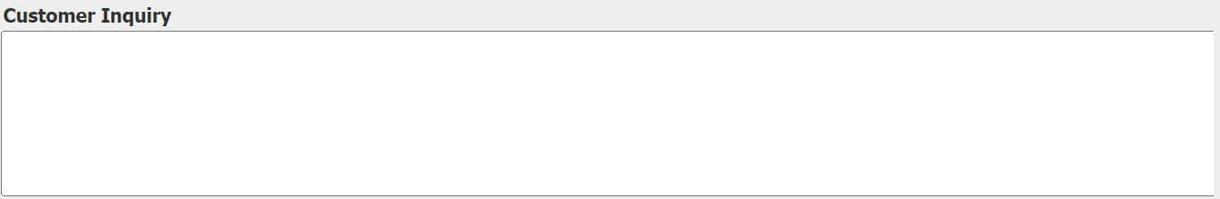

* Insert the intake method, module, work type, and number. Number can be anything from job number to permit number, whatever number they provide. If multiple numbers are provided, insert the job number.

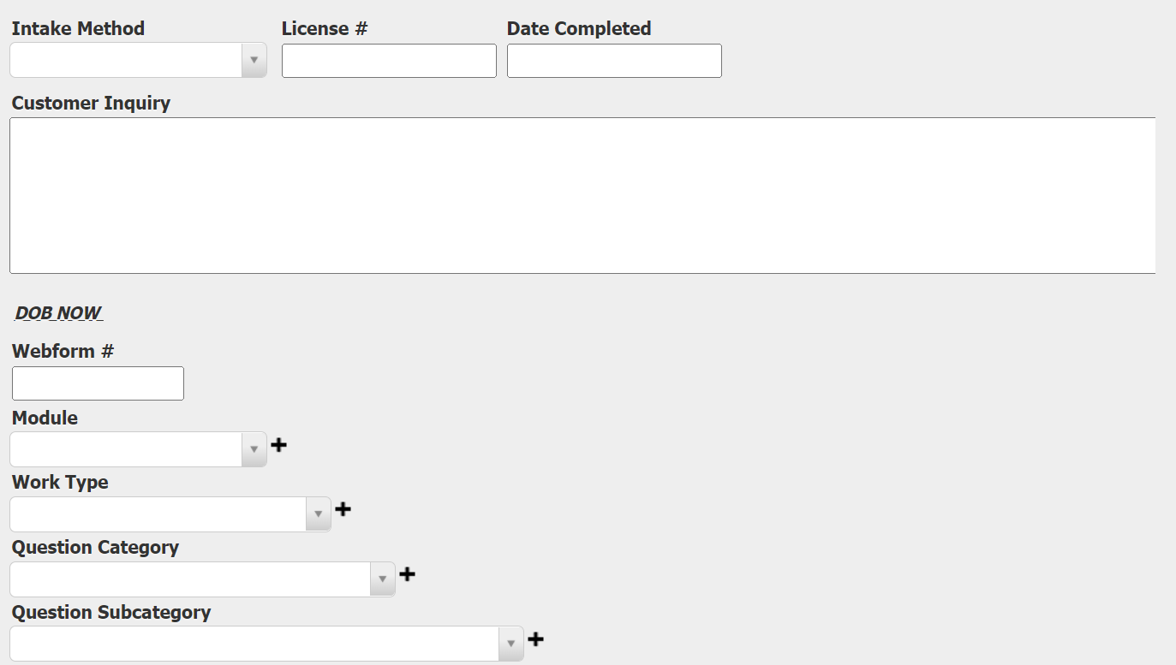

* Click on save



* Make sure it’s assigned to you. If not, assign it to yourself



* Do whatever is mentioned in the response entry. Attach whoever took responsibility for the ticket. In this example, Kirstie took responsibility, so we will attach Kirstie and send her a tracking sheet. Let her know what meeting it was from in the Additional Information section, so she knows it’s important

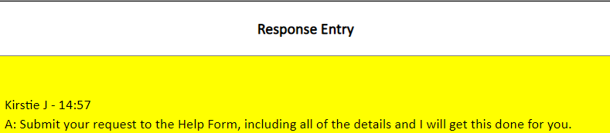

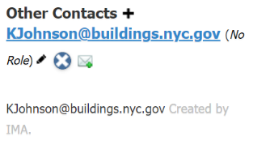



* Copy the ID # (found in the top right of the ticket webpage) and paste it into the Action section. Write down the action taken as well.

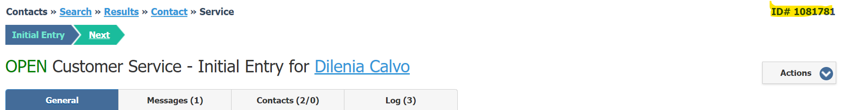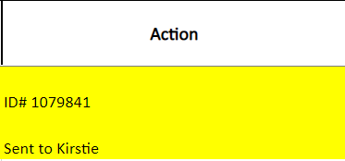

* Click on edit and route it to whatever corresponds with your action. Since we sent a tracking sheet to Kirstie, we will rout it as Unit Action.

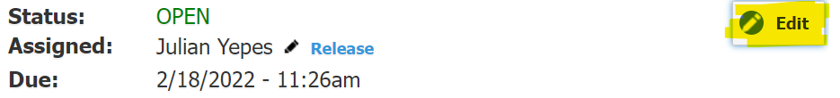

* Write the status of the ticket in the “Done?” Column. In this example, we need to wait for Kirstie to follow up, so we’ll write “follow up with Kirstie”

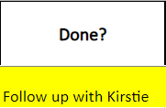

* Keep track of the ticket and make sure it’s complete before the next meeting. Send another tracking sheet if necessary. Done!

# MISC

The OP113 is in DOB NOW: Inspection module – requester must be delegated to the filing to request it in DOB NOW Inspection.

Address changes go to BUILD IT

**Sustainable Roof Zone Form Signoff**

Attach and send a tracking sheet to [greenroofandsolar@buildings.nyc.gov](mailto:greenroofandsolar@buildings.nyc.gov)

**Extensions (TCO, etc.)**

Send tracking sheet to Shumo

**AHV won’t renew because of a stop work order**   
Create a new AHV because the stop order is written for that address

**Audit**  
Contact your applicant of record to schedule an appointment and resolve the audit.

**Cranes**

Diego Cuaratolo

**Elevators**  
  
Periodic Inspections: Diego Cuaratolo

<https://www1.nyc.gov/assets/buildings/pdf/safety_elevator_step_by_step_guide.pdf>