 | SURGICAL PREFERENCE CARDS SYSTEM  Database Design  DRAFT · 22 September 2026

1. Purpose
The system replaces the paper preference cards kept in theatre files. Each card records what one surgeon needs for one operation — packs, sutures, instruments, positioning and special instructions — so the scrub team can set up correctly every time.
It is a web app built with Django on a PostgreSQL database. It holds no patient information and is not a hospital management system: the hospital side is limited to hospitals and the users who log in.

2. How It Works
Step | Table | Example
Specialty | specialties | ENT Surgery
Doctor (personal details) | doctors | Prof Clemence Chidziva, UZ / Parirenyatwa
Surgeon (surgical details) | surgeons | Prof Chidziva, glove size 7
Procedure | procedures | Tonsillectomy
Preference card | preference_cards | Prof Chidziva — Tonsillectomy, supine
Items on the card | preference_card_items | 2 × Drape, 4 × Mosquito forceps
Where each item comes from | sutures / surgical_instruments / surgical_packs | Drape → surgical_packs

Roles
Role | Can do
VIEWER | Search, read and print cards. Cannot change anything (most theatre staff).
EDITOR | Also create and update cards, doctors, surgeons, procedures and item lists.
ADMIN | Also manage user accounts and restore deleted records.

Figure 1 — All tables
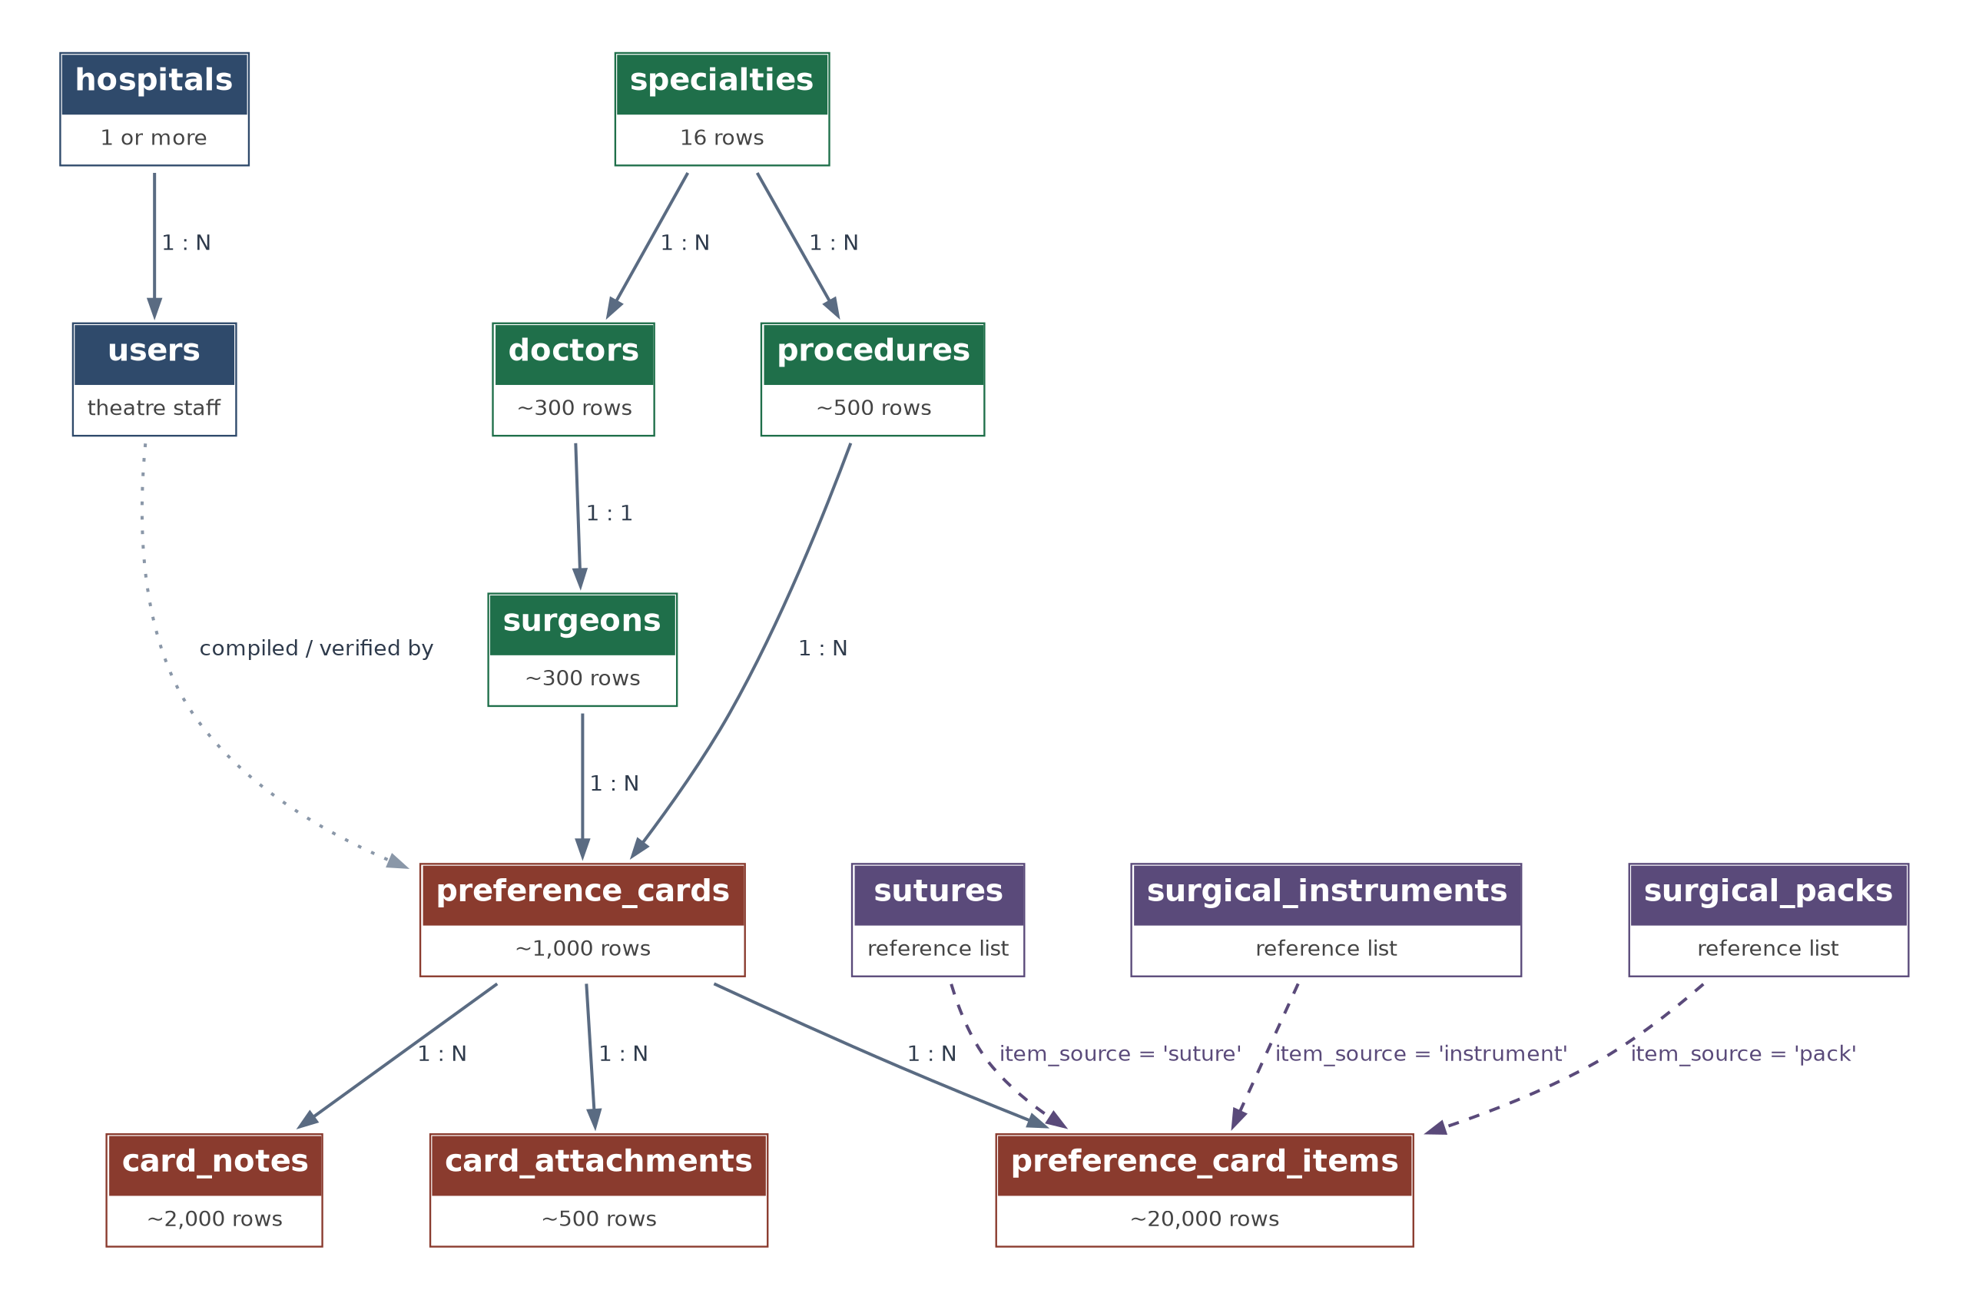
Figure 1. The 13 tables and how they connect. Dashed arrows: card items linked to the item lists.

Figure 2 — The preference card
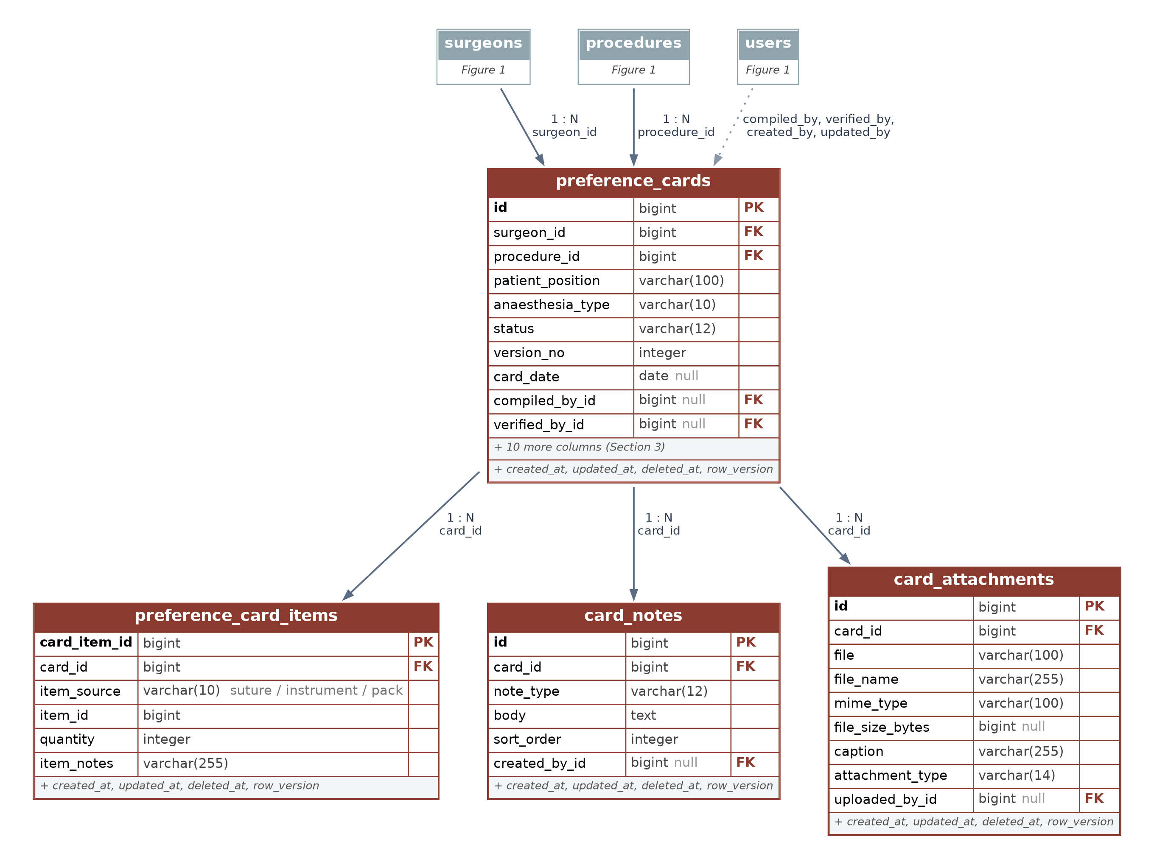
Figure 2. A card belongs to one surgeon and one procedure; its items, notes and photos hang beneath it.

3. The Tables
13 tables in four groups. Every table except users also has created_at, updated_at, deleted_at (soft delete) and row_version.
Group | Table | Holds | Key columns
Clinical directory | specialties | The 16 surgical specialties. | name
 | doctors | Doctors' personal and contact details. | doctor_name, specialty_id, sub_specialty, phones
 | surgeons | Surgical details; one per doctor who operates. | doctor_id, display_name, glove_size
 | procedures | Operations, stored once and shared by surgeons. | specialty_id, name, aliases
Preference card | preference_cards | One surgeon's card for one procedure. | surgeon_id, procedure_id, patient_position, status
 | preference_card_items | Each item on a card. The only table with a quantity. | card_id, item_source, item_id, quantity, item_notes
 | card_notes | Starred instructions, e.g. 'Always prepare for bronchoscope'. | card_id, note_type, body
 | card_attachments | Positioning photos, tray layouts, scans of paper cards. | card_id, file, attachment_type
Item lists | sutures | Sutures and ties cards can call for. | material, size, item_type, needle_type
 | surgical_instruments | Reusable instruments and positioning aids. | name, category, condition_status
 | surgical_packs | Trays, gown packs, bowl packs, drapes. | pack_name, pack_type, contents_description
Access | hospitals | Hospitals using the system. | name, short_code
 | users | Theatre staff who log in (Django user model). | username, hospital_id, job_title, role

4. Key Rules
- One live card per surgeon and procedure. A second active card is refused; archive the old one first.
- Quantity is on the card item only, and must be 1 or more. The item lists hold no stock counts.
- Card items point to one of three lists. item_source says which list (suture, instrument or pack); item_id says which row. The app checks the row exists before saving.
- Directory records in use can't be deleted. A specialty, doctor, surgeon or procedure used by a card is protected.
- Deleting hides rather than destroys. deleted_at is filled in, so records can be restored.

5. Points to Confirm
- Offline use. The requirements form asked for it; a web app needs a connection. Reading cards offline can be added later.
- One specialty per doctor. Fine for the ENT list; earlier sample cards showed a surgeon working across several specialties.
- Items not in any list (e.g. K-Y jelly) — add them to a list first, or add a fourth list for consumables.

Next step: confirm the points above, then build the theatre search and print screens on this database.

