 | SURGICAL PREFERENCE CARDS SYSTEM  System & Database Documentation  Version 2.0 · 22 September 2026

Prepared for | Prepared by | Project
Zamani Sibanda  RGN / Operating Theatre Nurse | Xyten Technologies  Tanaka Machona | Surgical Preference Cards App  Agreement dated 17 Sept 2026

Document history
Version | Date | Change
1.0 | 20 Sept 2026 | First database design, based on the requirements form and the scanned sample cards.
1.1 – 1.3 | 22 Sept 2026 | Item lists (sutures, instruments, packs) and doctors added; quantity kept on card items only; surgeons linked to doctors; hospital side reduced to hospitals and users.
2.0 | 22 Sept 2026 | Built in Django on PostgreSQL. ERDs and table definitions in this document are generated from the working code.

Contents
1. Introduction 2
2. System Overview 2
3. Data Model at a Glance 4
4. Entity Relationship Diagrams 6
5. Table Reference 13
6. Business Rules and Constraints 20
7. Worked Example: A Real Card 21
8. The System in Use 22
9. Django Implementation 26
10. Points to Confirm 27

1. Introduction
The Surgical Preference Cards System replaces the paper and typed preference cards kept in theatre files. Each card records what one surgeon needs for one operation — the trays and packs to open, the sutures, the instruments, how the patient is positioned, and any special instructions — so the scrub team can set up correctly every time.
This document describes the system and its database: what it holds, how the pieces connect, every table and column, the rules the database enforces, and how the Django implementation is organised and run. Sections 1 to 4 are written for anyone presenting or reviewing the system; Sections 5, 6 and 9 carry the technical detail for developers.

1.1 Scope
The system does | The system does not
Keep a directory of specialties, doctors, surgeons and procedures | Manage the hospital (wards, beds, rosters, departments)
Keep reference lists of sutures, instruments and packs | Track stock levels or reorder items
Store a preference card for each surgeon and procedure | Hold any patient information
Let staff search, view and print cards | Schedule operations or theatre lists
Control who can view and who can edit

No patient data
The database records what a surgeon prefers for a type of operation. It never records who was operated on or when. This keeps the system outside medical-records regulation, and a lost device exposes nothing about any patient.

2. System Overview

2.1 How the information fits together
Everything is organised the way theatre staff already think about the cards:
Step | Table | Example
1. Specialty | specialties | ENT Surgery
2. Doctor (personal details) | doctors | Prof Clemence Chidziva, UZ / Parirenyatwa
3. Surgeon (surgical details) | surgeons | Prof Chidziva, glove size 7
4. Procedure | procedures | Tonsillectomy
5. Preference card | preference_cards | Prof Chidziva — Tonsillectomy, supine, sandbag under shoulders
6. Items on the card | preference_card_items | 2 × Drape, 4 × Mosquito forceps, 4 × 3/0 Silk tie
7. Where each item comes from | sutures / surgical_instruments / surgical_packs | Drape → surgical_packs; Mosquito forceps → surgical_instruments

2.2 Who uses it
All theatre personnel — registered general nurses (RGN), operating theatre nurses (OTN), scrub nurses and health care assistants (HCA). The requirements form asked that other theatre staff can view cards but not edit them, so access is split into three roles.

2.3 Roles and permissions
Role | Can do | Typical holder
VIEWER | Search, read and print any card. Cannot change anything. | Most theatre staff — scrub nurses, HCAs
EDITOR | Everything a viewer can do, plus create and update cards, doctors, surgeons, procedures and the item lists. | Senior theatre nurses who maintain the files
ADMIN | Everything an editor can do, plus manage user accounts and restore deleted records. | The system owner and one nominated deputy

2.4 Technology
Part | Choice | Why
Web framework | Django 5.2 (LTS), Python 3.11+ | Built-in login, permissions and an administration interface that gives working data-entry screens from day one.
Database | PostgreSQL 16 | Supports the partial unique index that allows only one live card per surgeon and procedure.
Data entry | Django admin (branded) | Search, filters and full card editing with items, notes and photos on one page.
Card printing | Django templates + WeasyPrint | To be built: prints a card to PDF straight from the stored data.
Files | Django media storage | Positioning photos and scans of the original paper cards.

3. Data Model at a Glance
The database has 13 tables in four groups. The colours match the diagrams in Section 4.
Group | Tables | What it holds
Clinical directory (green) | specialties, doctors, surgeons, procedures | Who operates and what operations exist.
Preference card (red) | preference_cards, preference_card_items, card_notes, card_attachments | Each surgeon's card for each procedure, with its items, starred notes and photos.
Item lists (purple) | sutures, surgical_instruments, surgical_packs | The reference lists a card's items are chosen from. No stock quantities.
Access (blue) | hospitals, users | Who can log in, and which hospital they belong to.

3.1 Design decisions
- Doctors and surgeons are separate. doctors holds personal and contact details; surgeons holds surgical details such as glove size. Each surgeon is linked to exactly one doctor, and the specialty comes through the doctor.
- A procedure is stored once. “Tonsillectomy” exists once under ENT Surgery, and every surgeon who performs it has their own card for it. This keeps names consistent and makes search reliable.
- One live card per surgeon and procedure. The database refuses a second active card for the same surgeon and procedure. Archived cards don't count, so a card can be replaced without losing the old one.
- Items come from three lists. Each line on a card points to a row in sutures, surgical_instruments or surgical_packs, using item_source to say which list and item_id to say which row.
- Quantity lives on the card item only. How many of something a surgeon needs is a property of the card. The item lists hold descriptions, not stock counts.
- Nothing is deleted outright. Deleting a record fills in deleted_at so it disappears from screens but can be restored.
- Whole-number IDs. Every table uses an auto-numbered bigint key, created by the server.

3.2 Relationships
Every link between tables, read from the Django models. “On delete” says what happens to the linked rows if the parent is deleted outright.
Parent | Child | Linked by | Type | On delete
hospitals | users | hospital_id | 1 : N | Blocked while in use
specialties | doctors | specialty_id | 1 : N | Blocked while in use
doctors | surgeons | doctor_id | 1 : 1 | Blocked while in use
specialties | procedures | specialty_id | 1 : N | Blocked while in use
surgeons | preference_cards | surgeon_id | 1 : N | Blocked while in use
procedures | preference_cards | procedure_id | 1 : N | Blocked while in use
users | preference_cards | compiled_by_id | 1 : N | Link cleared
users | preference_cards | verified_by_id | 1 : N | Link cleared
users | preference_cards | created_by_id | 1 : N | Link cleared
users | preference_cards | updated_by_id | 1 : N | Link cleared
preference_cards | preference_card_items | card_id | 1 : N | Deleted with it
preference_cards | card_notes | card_id | 1 : N | Deleted with it
users | card_notes | created_by_id | 1 : N | Link cleared
preference_cards | card_attachments | card_id | 1 : N | Deleted with it
users | card_attachments | uploaded_by_id | 1 : N | Link cleared
sutures | preference_card_items | item_source + item_id | 1 : N | Checked by the application (Section 6)
surgical_instruments | preference_card_items | item_source + item_id | 1 : N | Checked by the application (Section 6)
surgical_packs | preference_card_items | item_source + item_id | 1 : N | Checked by the application (Section 6)

4. Entity Relationship Diagrams
Five diagrams follow. Figure 1 shows all 13 tables and how they connect. Figures 2 to 5 show each group with its columns and types. They are generated directly from the Django models, so they match the working database exactly.

How to read the diagrams
Symbol | Meaning
PK | Primary key — the row's own auto-numbered ID.
FK | Foreign key — a column that points to a row in another table.
UQ | Unique — no two rows can have the same value.
1 : N | One row in the parent table can have many rows in the child table (one surgeon, many cards).
1 : 1 | One row links to at most one row (one doctor, at most one surgeon record).
Solid arrow | A foreign key enforced by the database.
Dashed arrow | The item_source + item_id link from a card item to one of the three item lists.
Dotted arrow | A link to the user who compiled, verified, created or updated a record.
Grey box | A table shown in full in another figure.
null | The column may be left empty.
+ created_at, … | The four record-keeping columns every table carries (Section 5.1).

Colour key
Green clinical directory · Red preference card · Purple item lists · Blue access

Figure 1 — All tables
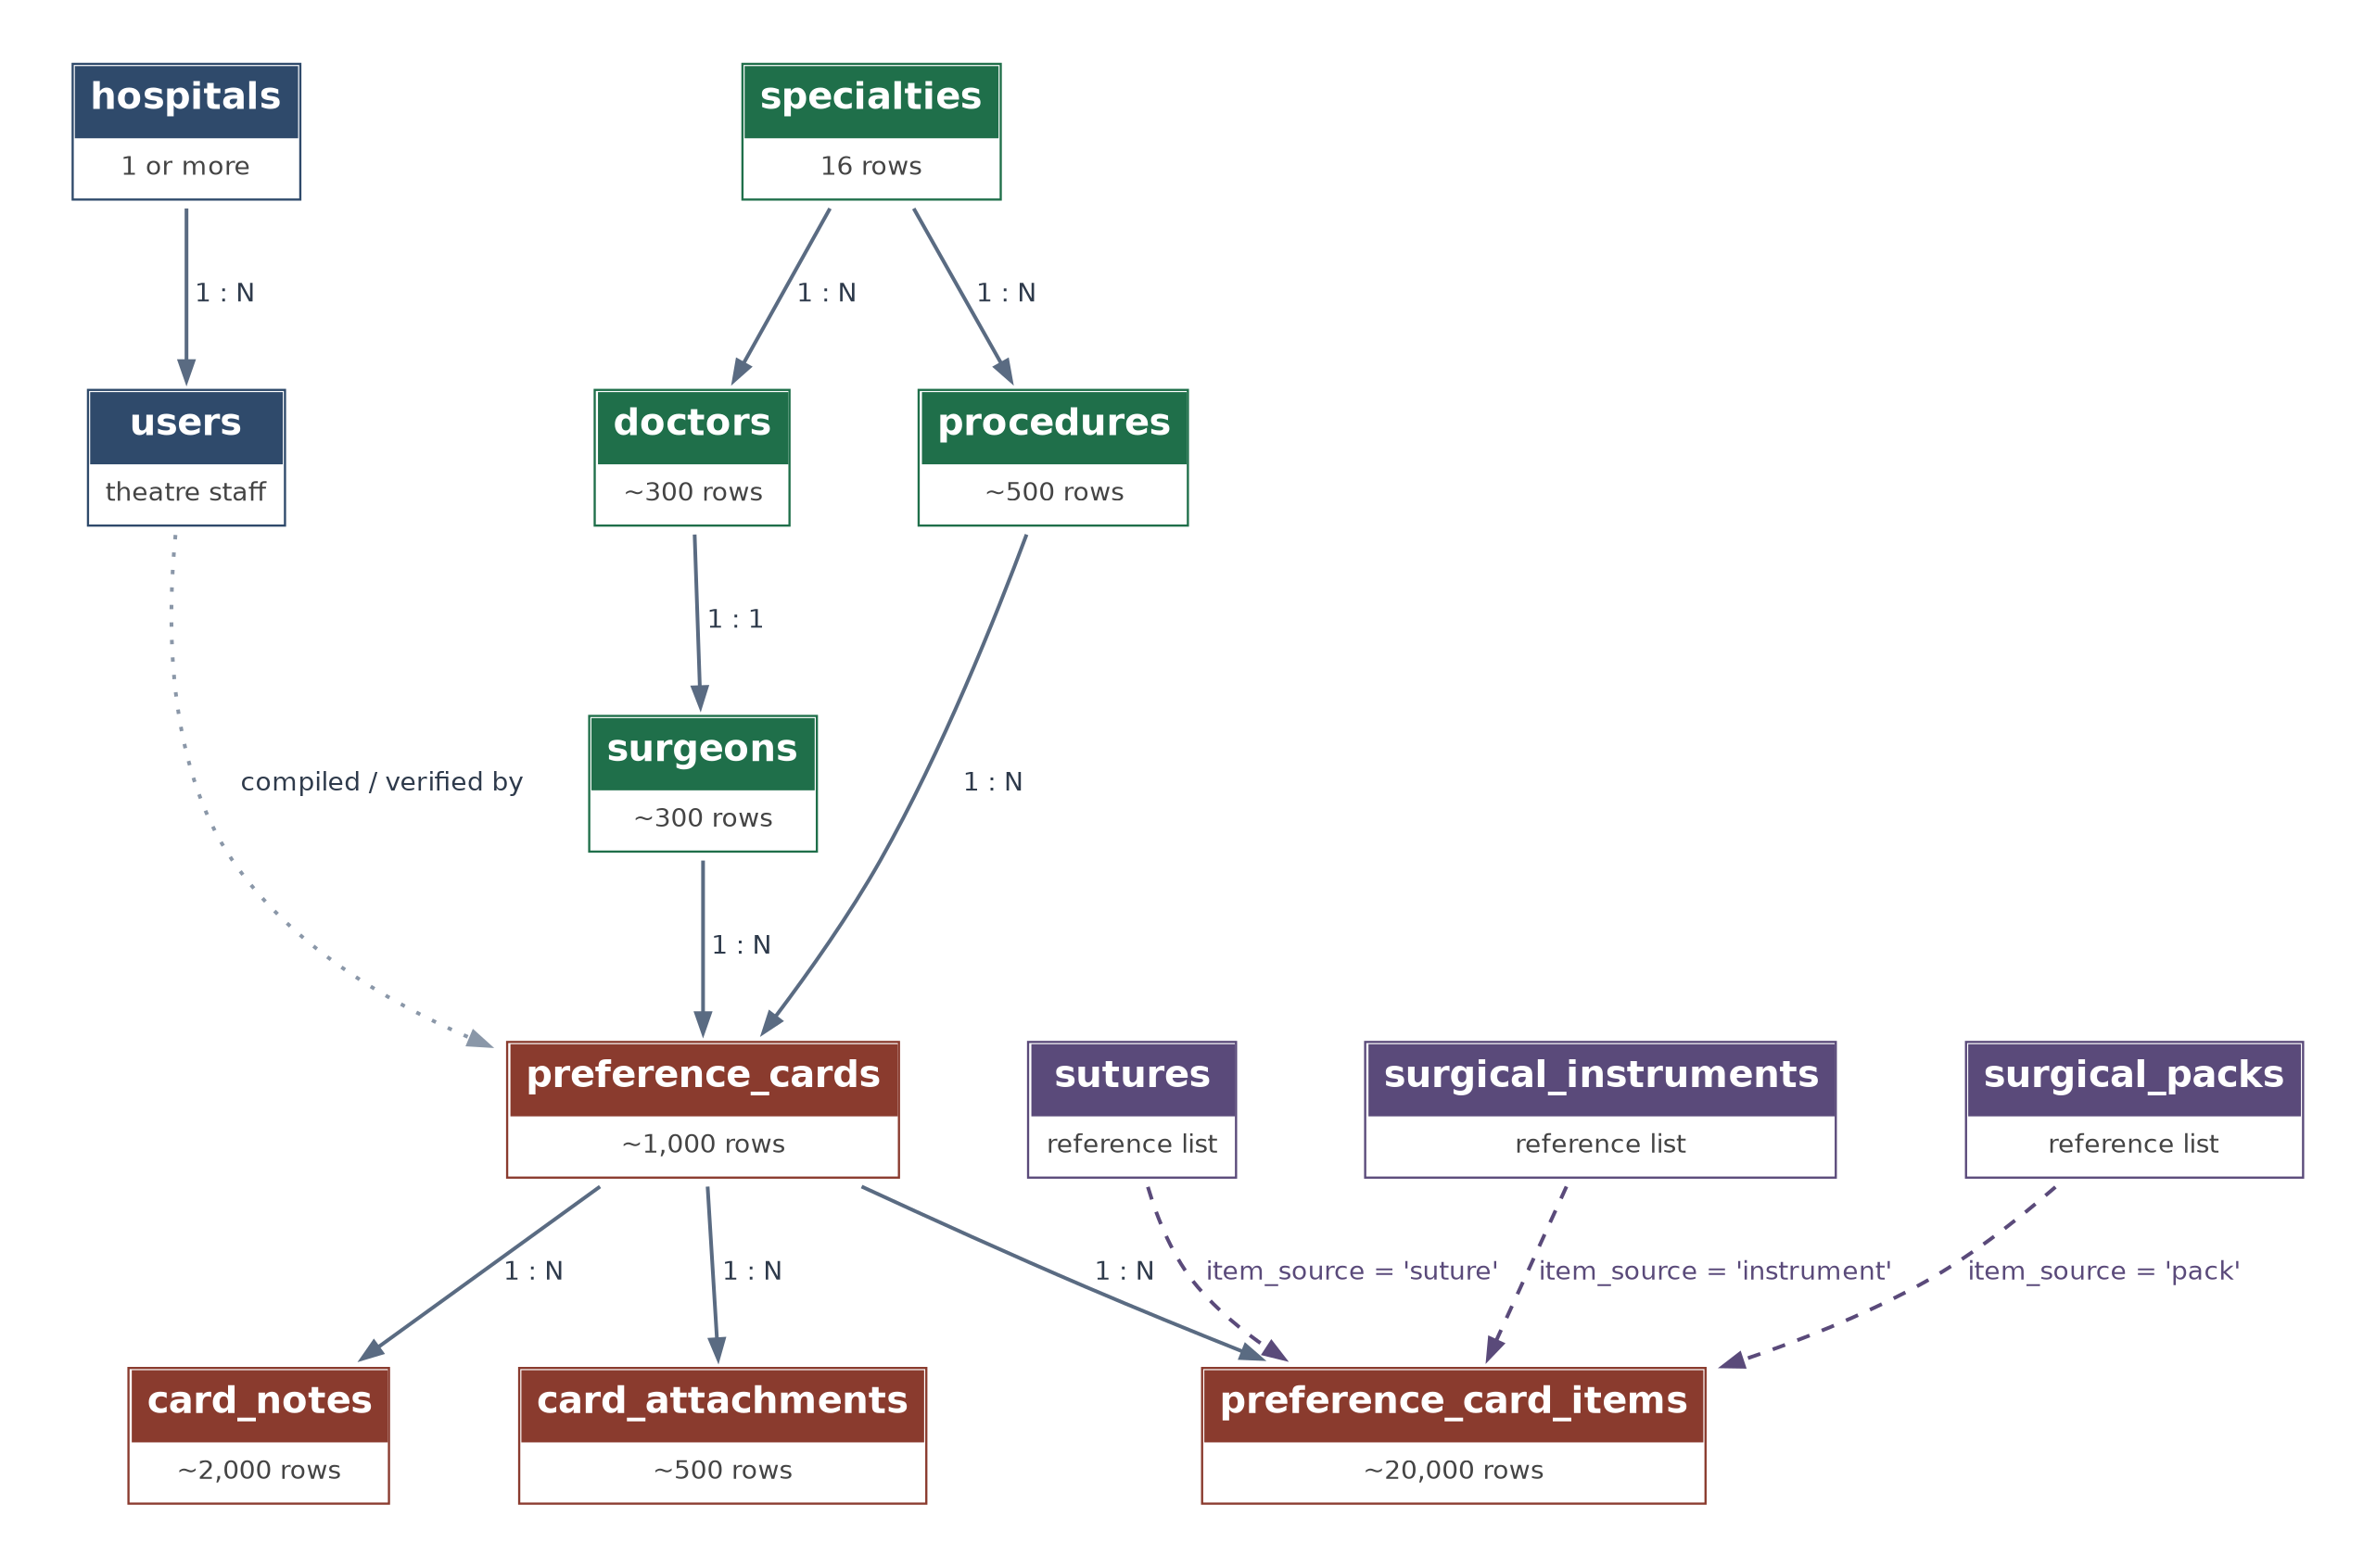
Figure 1. The 13 tables and how they connect. Row counts are the expected sizes from the requirements form.

Figure 2 — Clinical directory
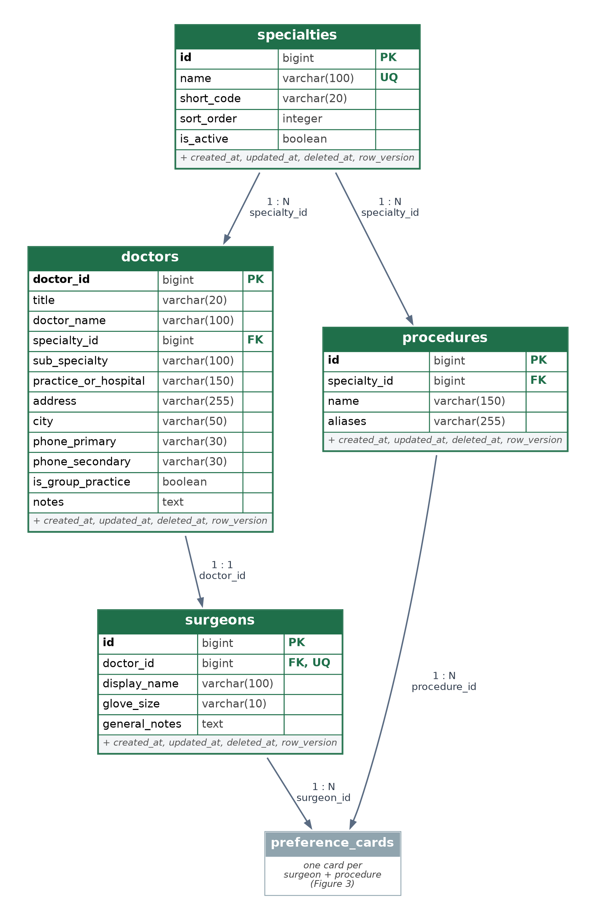
Figure 2. Specialties → doctors → surgeons, and procedures under each specialty. Both lead to preference_cards.

Figure 3 — The preference card
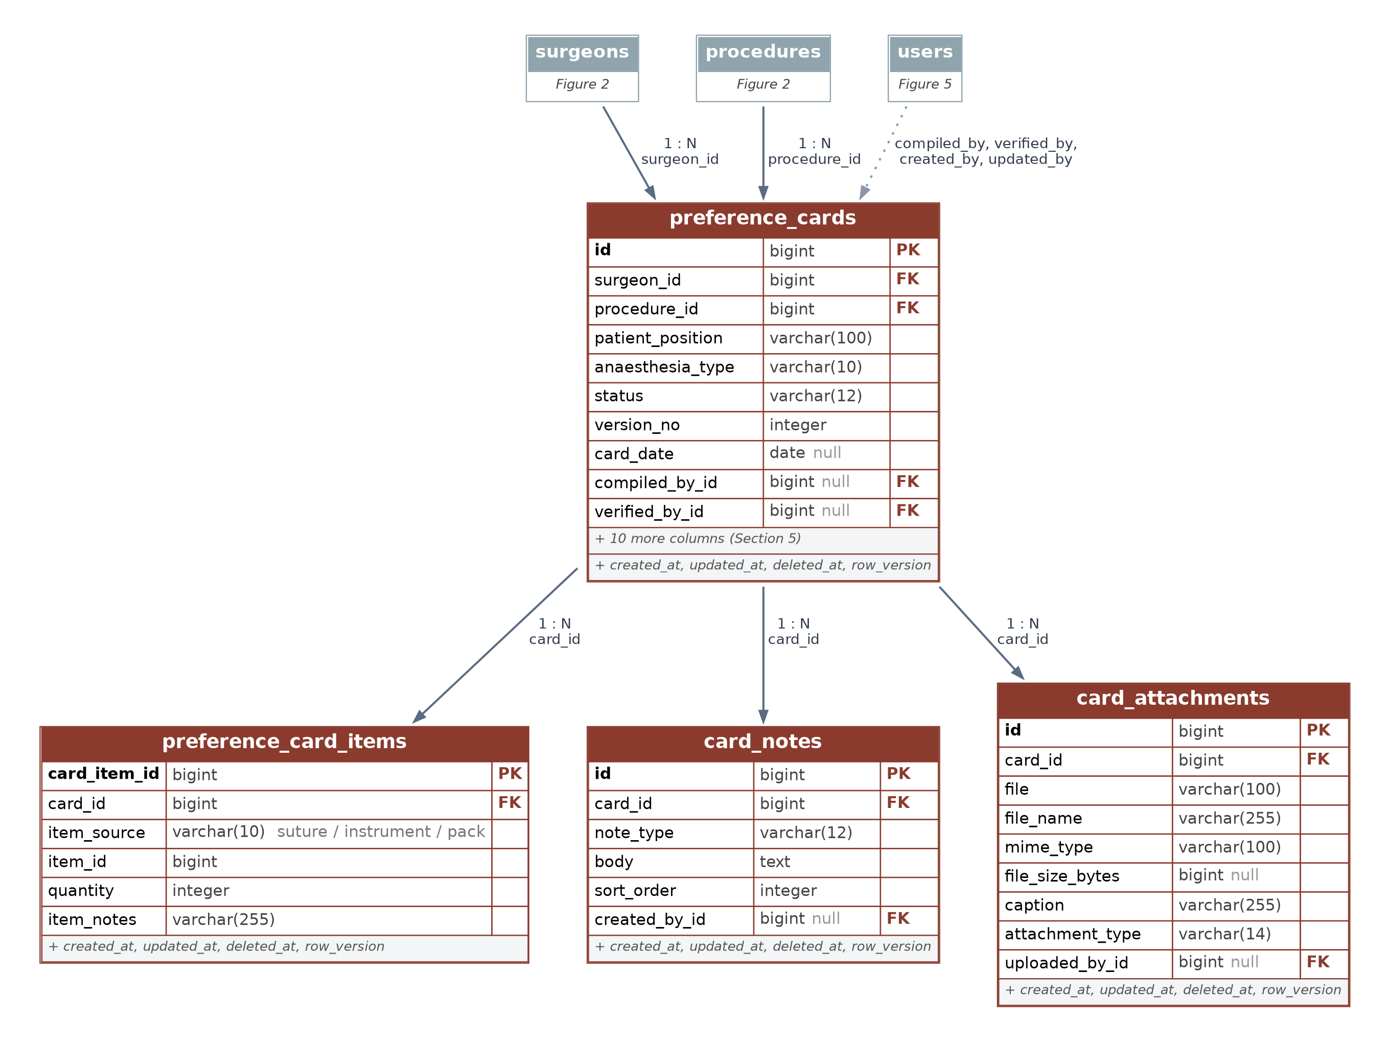
Figure 3. A card belongs to one surgeon and one procedure; its items, notes and photos hang beneath it. How items link to the item lists is shown in Figure 4.

Figure 4 — Item lists
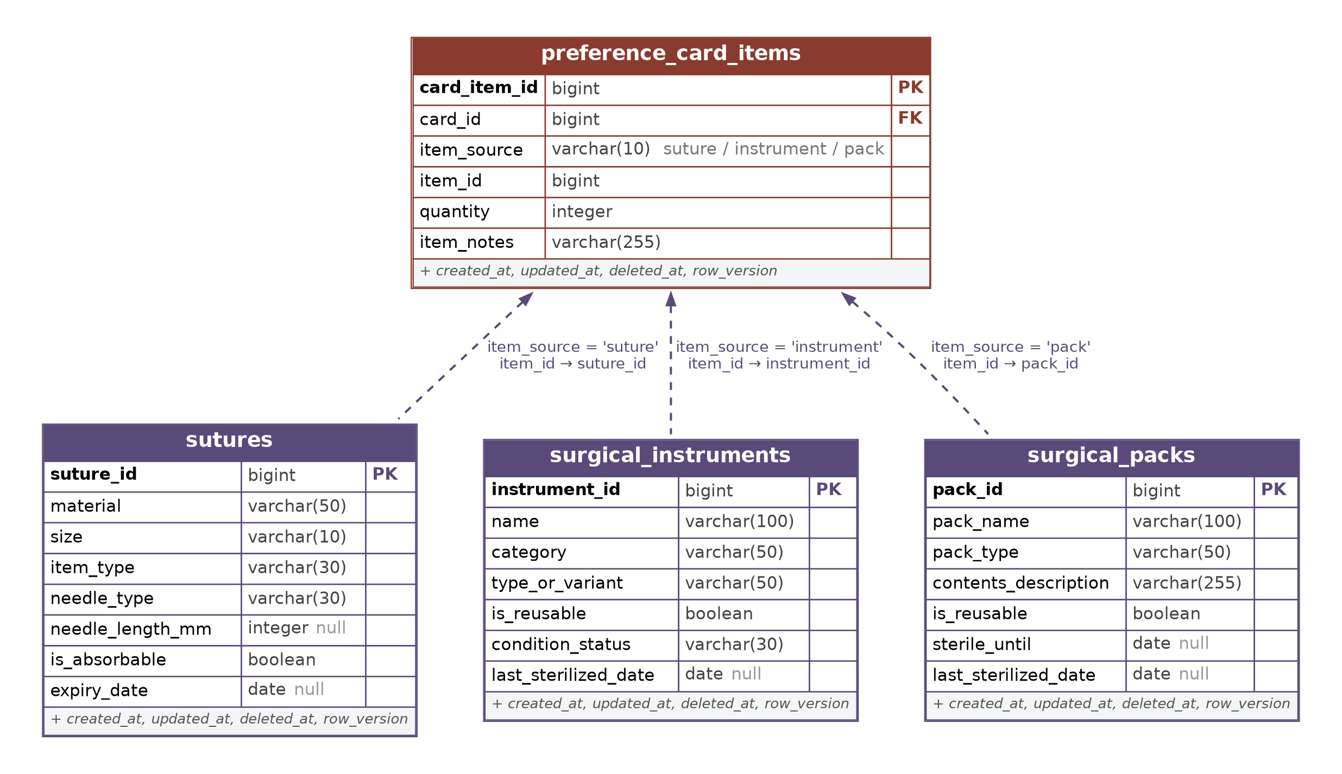
Figure 4. Each card item points to one row in sutures, surgical_instruments or surgical_packs. item_source names the list; item_id is that row's ID.

Figure 5 — Access
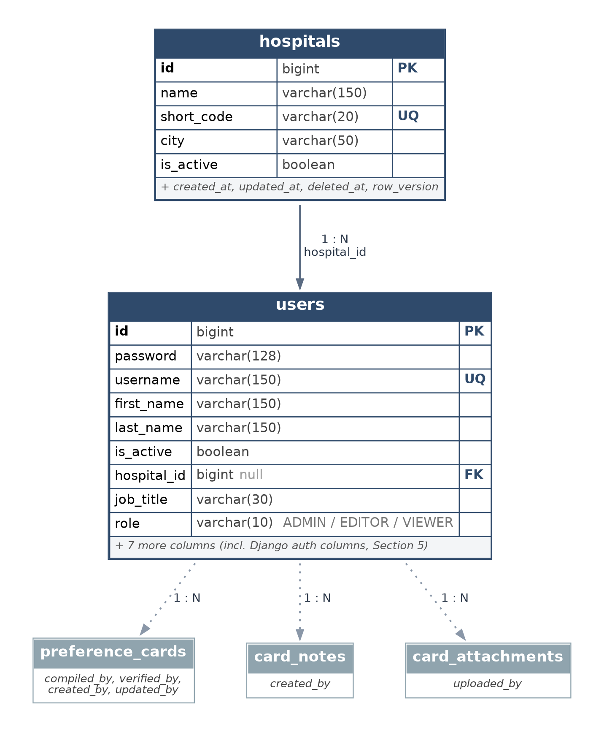
Figure 5. Hospitals and users only. Users are recorded against the cards, notes and photos they compile, verify, create or upload.

5. Table Reference
Every table and column, in the order they appear in the database. Types are PostgreSQL types. “Null” says whether the column may be left empty; “Key” marks primary keys (PK), foreign keys (FK) and unique columns (UQ).

5.1 Columns on every table
All tables except users (which uses Django's standard user model) carry four record-keeping columns:
Column | Type | Description
created_at | timestamptz | When the row was first saved. Set automatically.
updated_at | timestamptz | When the row was last changed. Set automatically on every save.
deleted_at | timestamptz | Empty for live rows. Filled in when the row is soft-deleted, so it is hidden but can be restored.
row_version | integer | Starts at 1 and goes up by one on every save. Used to detect two people editing the same row at once.

5.2 specialties
Django model: cards.Specialty · Group: Clinical directory
The 16 surgical specialties the directory is organised by.
Column | Type | Null | Key | Description
id | bigint | No | PK | Auto-numbered identifier.
name | varchar(100) | No | UQ | Specialty name, e.g. ENT Surgery. Must be unique.
short_code | varchar(20) | No |  | Optional short code, e.g. ENT.
sort_order | integer | No |  | Controls the order specialties appear in lists.
is_active | boolean | No |  | Untick to hide a specialty from new entries.
created_at, updated_at, deleted_at, row_version |  |  |  | Standard record-keeping columns (Section 5.1).

5.3 doctors
Django model: cards.Doctor · Group: Clinical directory
Personal and contact details for each doctor. Surgical details are kept separately in surgeons.
Column | Type | Null | Key | Description
doctor_id | bigint | No | PK | Auto-numbered identifier.
title | varchar(20) | No |  | Prof, Dr, Mr, etc.
doctor_name | varchar(100) | No |  | Full name as it should appear.
specialty_id | bigint | No | FK → specialties | The doctor's specialty. Links to specialties.
sub_specialty | varchar(100) | No |  | Optional sub-specialty, e.g. Paediatric ENT, Otology.
practice_or_hospital | varchar(150) | No |  | Where the doctor practises, e.g. Citimed Hospital.
address | varchar(255) | No |  | Street address.
city | varchar(50) | No |  | City or town.
phone_primary | varchar(30) | No |  | Main phone number. Stored as text so leading zeros are kept.
phone_secondary | varchar(30) | No |  | Second phone number.
is_group_practice | boolean | No |  | Ticked when the entry is a group practice rather than one person.
notes | text | No |  | Free-text notes.
created_at, updated_at, deleted_at, row_version |  |  |  | Standard record-keeping columns (Section 5.1).
Rules: Indexed on doctor_name for fast search.

5.4 surgeons
Django model: cards.Surgeon · Group: Clinical directory
Surgical details for a doctor who operates. Each surgeon is exactly one doctor; the specialty comes through that doctor.
Column | Type | Null | Key | Description
id | bigint | No | PK | Auto-numbered identifier.
doctor_id | bigint | No | FK → doctors, UQ | The doctor this surgeon record belongs to. Links to doctors; one surgeon record per doctor.
display_name | varchar(100) | No |  | Name as written on the cards, e.g. Mr Machawira.
glove_size | varchar(10) | No |  | Glove size, e.g. 7½. Printed at the top of every card.
general_notes | text | No |  | Habits that apply to all of this surgeon's cards.
created_at, updated_at, deleted_at, row_version |  |  |  | Standard record-keeping columns (Section 5.1).
Rules: One surgeon record per doctor (doctor_id is unique).

5.5 procedures
Django model: cards.Procedure · Group: Clinical directory
The operations. Each is stored once under its specialty and shared by every surgeon who performs it.
Column | Type | Null | Key | Description
id | bigint | No | PK | Auto-numbered identifier.
specialty_id | bigint | No | FK → specialties | The specialty the procedure belongs to. Links to specialties.
name | varchar(150) | No |  | Procedure name, e.g. Tonsillectomy. Unique within a specialty.
aliases | varchar(255) | No |  | Other names staff search by, e.g. VV strip.
created_at, updated_at, deleted_at, row_version |  |  |  | Standard record-keeping columns (Section 5.1).
Rules: A procedure name can appear only once within a specialty (uq_procedure_per_specialty).

5.6 preference_cards
Django model: cards.PreferenceCard · Group: Preference card
The card header: one surgeon's preferences for one procedure. The items on the card are in preference_card_items.
Column | Type | Null | Key | Description
id | bigint | No | PK | Auto-numbered identifier.
surgeon_id | bigint | No | FK → surgeons | The surgeon the card belongs to. Links to surgeons.
procedure_id | bigint | No | FK → procedures | The procedure the card is for. Links to procedures.
card_title | varchar(150) | No |  | Optional title; replaces the procedure name on the printed card if filled in.
patient_position | varchar(100) | No |  | How the patient is positioned, e.g. Supine.
position_aids | varchar(255) | No |  | Positioning aids, e.g. Sandbag under shoulders.
anaesthesia_type | varchar(10) | No |  | GA, Spinal, Epidural, Local, Sedation, Regional or Other.
glove_size | varchar(10) | No |  | Only filled in if it differs from the surgeon's usual glove size.
skin_prep | varchar(100) | No |  | Skin preparation, e.g. Chlorhexidine.
diathermy_settings | varchar(100) | No |  | Diathermy settings, e.g. Mono 30/30.
estimated_minutes | integer | Yes |  | Typical length of the operation in minutes.
status | varchar(12) | No |  | DRAFT, ACTIVE, UNDER_REVIEW or ARCHIVED.
version_no | integer | No |  | Goes up by one each time the card is edited in the admin.
card_date | date | Yes |  | Date written on the original paper card.
review_due_on | date | Yes |  | Date the card should next be checked with the surgeon.
compiled_by_id | bigint | Yes | FK → users | The user who compiled the card. Links to users.
verified_by_id | bigint | Yes | FK → users | The user who checked the card is correct. Links to users.
verified_at | timestamptz | Yes |  | When the card was verified.
created_by_id | bigint | Yes | FK → users | The user who created the record. Links to users.
updated_by_id | bigint | Yes | FK → users | The user who last changed the record. Links to users.
created_at, updated_at, deleted_at, row_version |  |  |  | Standard record-keeping columns (Section 5.1).
Rules: Only one live card per surgeon and procedure: archived and deleted cards are ignored (uq_live_card_per_surgeon_procedure, a partial unique index).

5.7 preference_card_items
Django model: cards.PreferenceCardItem · Group: Preference card
Every item on a card. item_source says which list the item comes from and item_id points to the row in that list. This is the only table that holds a quantity.
Column | Type | Null | Key | Description
card_item_id | bigint | No | PK | Auto-numbered identifier.
card_id | bigint | No | FK → preference_cards | The card this item is on. Links to preference_cards.
item_source | varchar(10) | No |  | Which list the item comes from: suture, instrument or pack.
item_id | bigint | No |  | The ID of the item in that list (suture_id, instrument_id or pack_id).
quantity | integer | No |  | How many are needed. Must be 1 or more.
item_notes | varchar(255) | No |  | Optional note, e.g. colts, for chest drain.
created_at, updated_at, deleted_at, row_version |  |  |  | Standard record-keeping columns (Section 5.1).
Rules: item_source must be suture, instrument or pack (ck_item_source_valid). quantity must be 1 or more (ck_quantity_positive). Indexed on (item_source, item_id).

5.8 card_notes
Django model: cards.CardNote · Group: Preference card
The starred instructions on a card, such as 'Always prepare for bronchoscope'. Printed in a box at the top of the card.
Column | Type | Null | Key | Description
id | bigint | No | PK | Auto-numbered identifier.
card_id | bigint | No | FK → preference_cards | The card the note belongs to. Links to preference_cards.
note_type | varchar(12) | No |  | GENERAL, WARNING, PREFERENCE, POSITIONING or POST_OP.
body | text | No |  | The note text.
sort_order | integer | No |  | Order the notes are printed in.
created_by_id | bigint | Yes | FK → users | The user who wrote the note. Links to users.
created_at, updated_at, deleted_at, row_version |  |  |  | Standard record-keeping columns (Section 5.1).

5.9 card_attachments
Django model: cards.CardAttachment · Group: Preference card
Photos attached to a card: positioning diagrams, tray layouts, or a scan of the original paper card.
Column | Type | Null | Key | Description
id | bigint | No | PK | Auto-numbered identifier.
card_id | bigint | No | FK → preference_cards | The card the file belongs to. Links to preference_cards.
file | varchar(100) | No |  | Where the file is stored (path in the media storage).
file_name | varchar(255) | No |  | Original file name. Filled in automatically.
mime_type | varchar(100) | No |  | File type, e.g. image/jpeg.
file_size_bytes | bigint | Yes |  | File size. Filled in automatically.
caption | varchar(255) | No |  | Short caption shown under the picture.
attachment_type | varchar(14) | No |  | POSITIONING, TRAY_LAYOUT, ORIGINAL_CARD or OTHER.
uploaded_by_id | bigint | Yes | FK → users | The user who uploaded the file. Links to users.
created_at, updated_at, deleted_at, row_version |  |  |  | Standard record-keeping columns (Section 5.1).

5.10 sutures
Django model: cards.Suture · Group: Item lists
The reference list of sutures and ties that cards can call for. Holds no stock quantities.
Column | Type | Null | Key | Description
suture_id | bigint | No | PK | Auto-numbered identifier.
material | varchar(50) | No |  | Silk, Nylon, Prolene, Vicryl, PDS, Monocryl, etc.
size | varchar(10) | No |  | Gauge, e.g. 0, 2/0, 3/0, 4/0.
item_type | varchar(30) | No |  | Tie or Needled suture.
needle_type | varchar(30) | No |  | Cutting, Round body, None, etc.
needle_length_mm | integer | Yes |  | Needle length in millimetres, e.g. 25. Empty for ties.
is_absorbable | boolean | No |  | Ticked for absorbable materials.
expiry_date | date | Yes |  | Expiry date of the batch, if tracked.
created_at, updated_at, deleted_at, row_version |  |  |  | Standard record-keeping columns (Section 5.1).

5.11 surgical_instruments
Django model: cards.SurgicalInstrument · Group: Item lists
The reference list of reusable instruments, equipment and positioning aids. Holds no stock quantities.
Column | Type | Null | Key | Description
instrument_id | bigint | No | PK | Auto-numbered identifier.
name | varchar(100) | No |  | Instrument name, e.g. Mosquito forceps.
category | varchar(50) | No |  | Forceps, Retractor, Scissors, Clip, Suction, Equipment, Positioning aid, etc.
type_or_variant | varchar(50) | No |  | Curved, straight, self-retaining, etc.
is_reusable | boolean | No |  | Ticked for reusable instruments.
condition_status | varchar(30) | No |  | Sterile, In use, Needs repair, Clean.
last_sterilized_date | date | Yes |  | Date last sterilised.
created_at, updated_at, deleted_at, row_version |  |  |  | Standard record-keeping columns (Section 5.1).

5.12 surgical_packs
Django model: cards.SurgicalPack · Group: Item lists
The reference list of trays, gown packs, bowl packs and drapes. Holds no stock quantities.
Column | Type | Null | Key | Description
pack_id | bigint | No | PK | Auto-numbered identifier.
pack_name | varchar(100) | No |  | Pack name, e.g. Major general set, Gown pack (3).
pack_type | varchar(50) | No |  | Instrument tray, Gown pack, Bowl pack, Drape, etc.
contents_description | varchar(255) | No |  | What is in the pack, e.g. 3 sterile surgical gowns.
is_reusable | boolean | No |  | Ticked for reusable trays; unticked for disposables.
sterile_until | date | Yes |  | Sterility expiry date.
last_sterilized_date | date | Yes |  | Date last sterilised (mainly reusable trays).
created_at, updated_at, deleted_at, row_version |  |  |  | Standard record-keeping columns (Section 5.1).

5.13 hospitals
Django model: cards.Hospital · Group: Access
The hospitals using the system. Its only job is to show which hospital each user belongs to; this is not a hospital management system.
Column | Type | Null | Key | Description
id | bigint | No | PK | Auto-numbered identifier.
name | varchar(150) | No |  | Hospital name, e.g. Parirenyatwa Group of Hospitals.
short_code | varchar(20) | No | UQ | Short unique code, e.g. PARI.
city | varchar(50) | No |  | City or town.
is_active | boolean | No |  | Untick to stop new users being added to this hospital.
created_at, updated_at, deleted_at, row_version |  |  |  | Standard record-keeping columns (Section 5.1).

5.14 users
Django model: cards.User · Group: Access
Theatre staff who log in. Built on Django's standard user model, so password hashing, login, sessions and permissions come ready-made.
Column | Type | Null | Key | Description
id | bigint | No | PK | Auto-numbered identifier.
password | varchar(128) | No |  | Password stored as a one-way hash (PBKDF2). The real password is never stored.
last_login | timestamptz | Yes |  | Date and time of the user's last login.
is_superuser | boolean | No |  | Has every permission. Reserved for the system administrator.
username | varchar(150) | No | UQ | Login name. Must be unique.
first_name | varchar(150) | No |  | First name or initial.
last_name | varchar(150) | No |  | Surname.
email | varchar(254) | No |  | Email address (optional).
is_staff | boolean | No |  | Can open the administration screens.
is_active | boolean | No |  | Untick to block a user from logging in without deleting them.
date_joined | timestamptz | No |  | When the account was created.
hospital_id | bigint | Yes | FK → hospitals | The hospital the user works at. Links to hospitals.
job_title | varchar(30) | No |  | What the person signs a card as: RGN, OTN, Scrub Nurse, HCA, Anaesthetic Nurse or Other.
role | varchar(10) | No |  | What the system lets them do: ADMIN, EDITOR or VIEWER (see Section 2.3).
phone | varchar(30) | No |  | Contact number (optional).
must_change_password | boolean | No |  | Forces a password change at next login, e.g. after an admin sets a temporary one.
Rules: username is unique. Django also creates two link tables for group and permission assignments (users_groups, users_user_permissions).

6. Business Rules and Constraints
These rules keep the data correct. Most are enforced by PostgreSQL itself, so they hold whichever screen or program writes the data.
Rule | Enforced by | What happens if broken
Only one live card per surgeon and procedure | Database: partial unique index | The save is refused. Archive the old card first.
A card item's quantity is 1 or more | Database: check constraint | The save is refused.
item_source is suture, instrument or pack | Database: check constraint + choice list | The save is refused.
item_id must exist in the list item_source names | Application: PreferenceCardItem.clean() | The admin shows “No suture with ID …” and does not save.
Each doctor has at most one surgeon record | Database: unique doctor_id | The save is refused.
A procedure name is unique within its specialty | Database: unique (specialty_id, name) | The save is refused.
Specialties, doctors, surgeons and procedures in use cannot be deleted | Database: ON DELETE RESTRICT (Django PROTECT) | Deletion is blocked and the admin lists what uses the record.
Deleting a card deletes its items, notes and photos | Database: ON DELETE CASCADE | They are removed together.
Removing a user keeps the cards they worked on | Database: ON DELETE SET NULL | The card stays; the user link is cleared.
Records are soft-deleted | Model: soft_delete() and .alive() | The row is hidden from screens and lists but kept.
Every save bumps row_version | Model: TimeStamped.save() | Used to spot two people editing the same record.
Every card edit in the admin bumps version_no and records who made it | Admin: save_model() | updated_by and version_no always show the latest change.

6.1 Why item_id is checked by the application
A foreign key can only point at one table. A card item can point at any of three, so the database cannot check item_id by itself. The model's clean() method looks the ID up in the right list before anything is saved. The Django admin and all Django forms run clean() automatically. Any future import script or API must call full_clean() before saving card items.

7. Worked Example: A Real Card
Mr Machawira's card for Stripping of Varicose Veins, taken from the scanned paper card and loaded into the system. This is exactly what the database holds.

7.1 The card header
Column | Value | Meaning
id | 1 | The card's own ID.
surgeon_id | 1 | Mr Machawira (doctor_id 10, glove 7½).
procedure_id | 1 | Stripping of Varicose Veins, under Vascular Surgery.
patient_position | Supine
position_aids | Sandbag or pillow for positioning
anaesthesia_type | GA | General anaesthetic.
status | ACTIVE | In use.
card_date | 2024-06-12 | Date on the paper card.
compiled_by_id | → T. Tsikasha | The RGN who compiled it.

7.2 The items on the card
card_item_id | item_source | item_id | Resolves to | quantity | item_notes
1 | pack | 1 | Major general set | 1
2 | pack | 2 | Bowl pack | 1
3 | pack | 3 | Gown pack (3) | 1
4 | pack | 4 | Splash bowl | 1
5 | pack | 5 | Drape | 1
6 | suture | 1 | 0 Silk Tie | 1
7 | suture | 2 | 3/0 Silk Tie | 1
8 | suture | 3 | 2/0 Nylon Needled suture Cutting | 1 | colts
9 | suture | 5 | 4/0 Prolene Needled suture Round body 25mm | 1
10 | instrument | 1 | Mosquito forceps | 10
11 | instrument | 2 | Cat's paw retractor | 1
12 | instrument | 3 | Latex tubing | 1
13 | instrument | 4 | Adson forceps | 1
14 | instrument | 7 | O'Shaughnessy forceps | 1
15 | instrument | 10 | Towel clips | 1 | Mayo towel clips
16 | instrument | 11 | Travers retractor | 1
16 items. Quantity appears only here: the 10 mosquito forceps are a property of this card, not of the instrument list.

7.3 The starred note
note_type | body
POSITIONING | Sandbag or pillow for positioning + saline

8. The System in Use
Screens from the working system running the sample data (Section 9.4). This is the Django administration interface, branded for the system. The theatre-facing search and print screens still to be built will use the same data.

8.1 Home
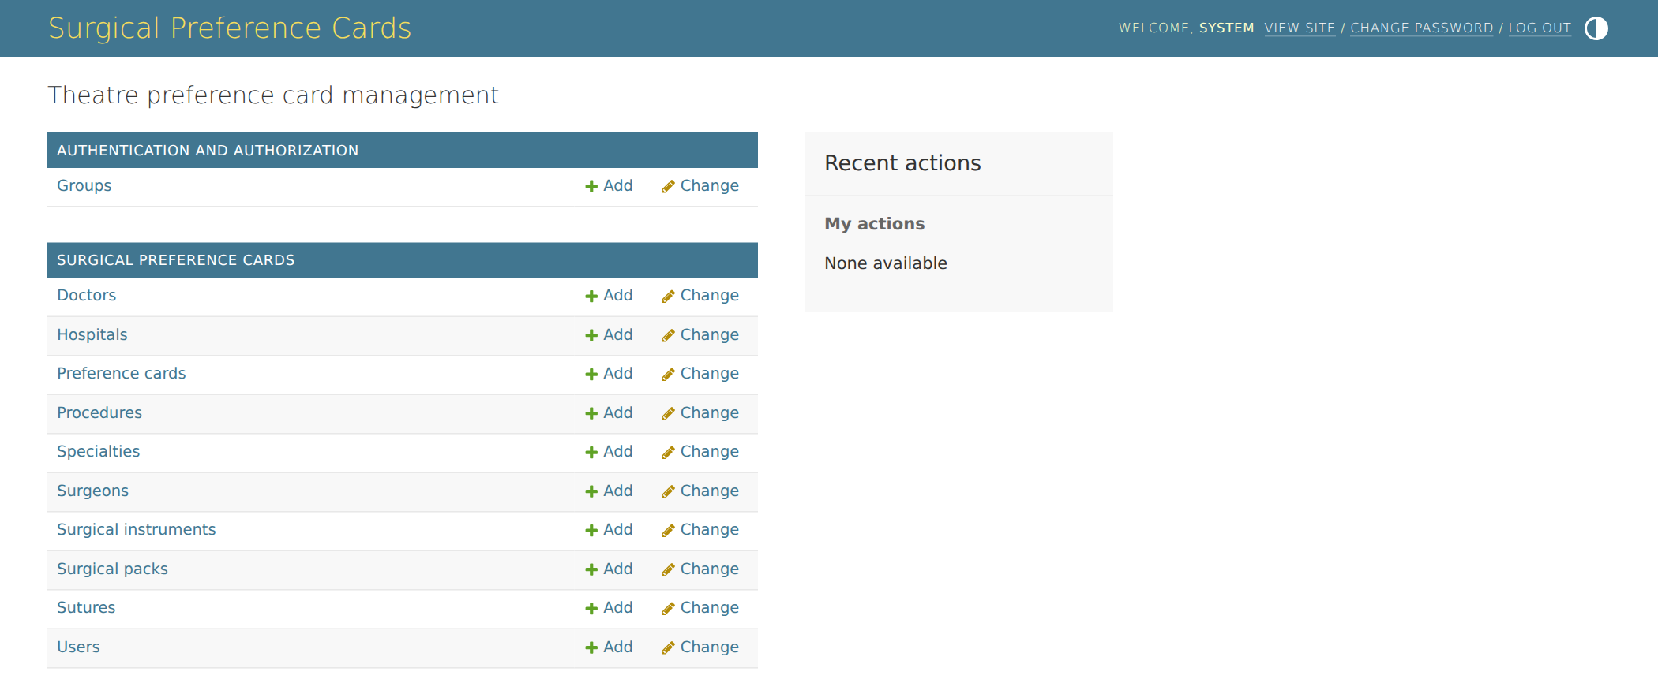
Figure 6. The home screen lists every part of the system an editor can manage.

8.2 Preference cards
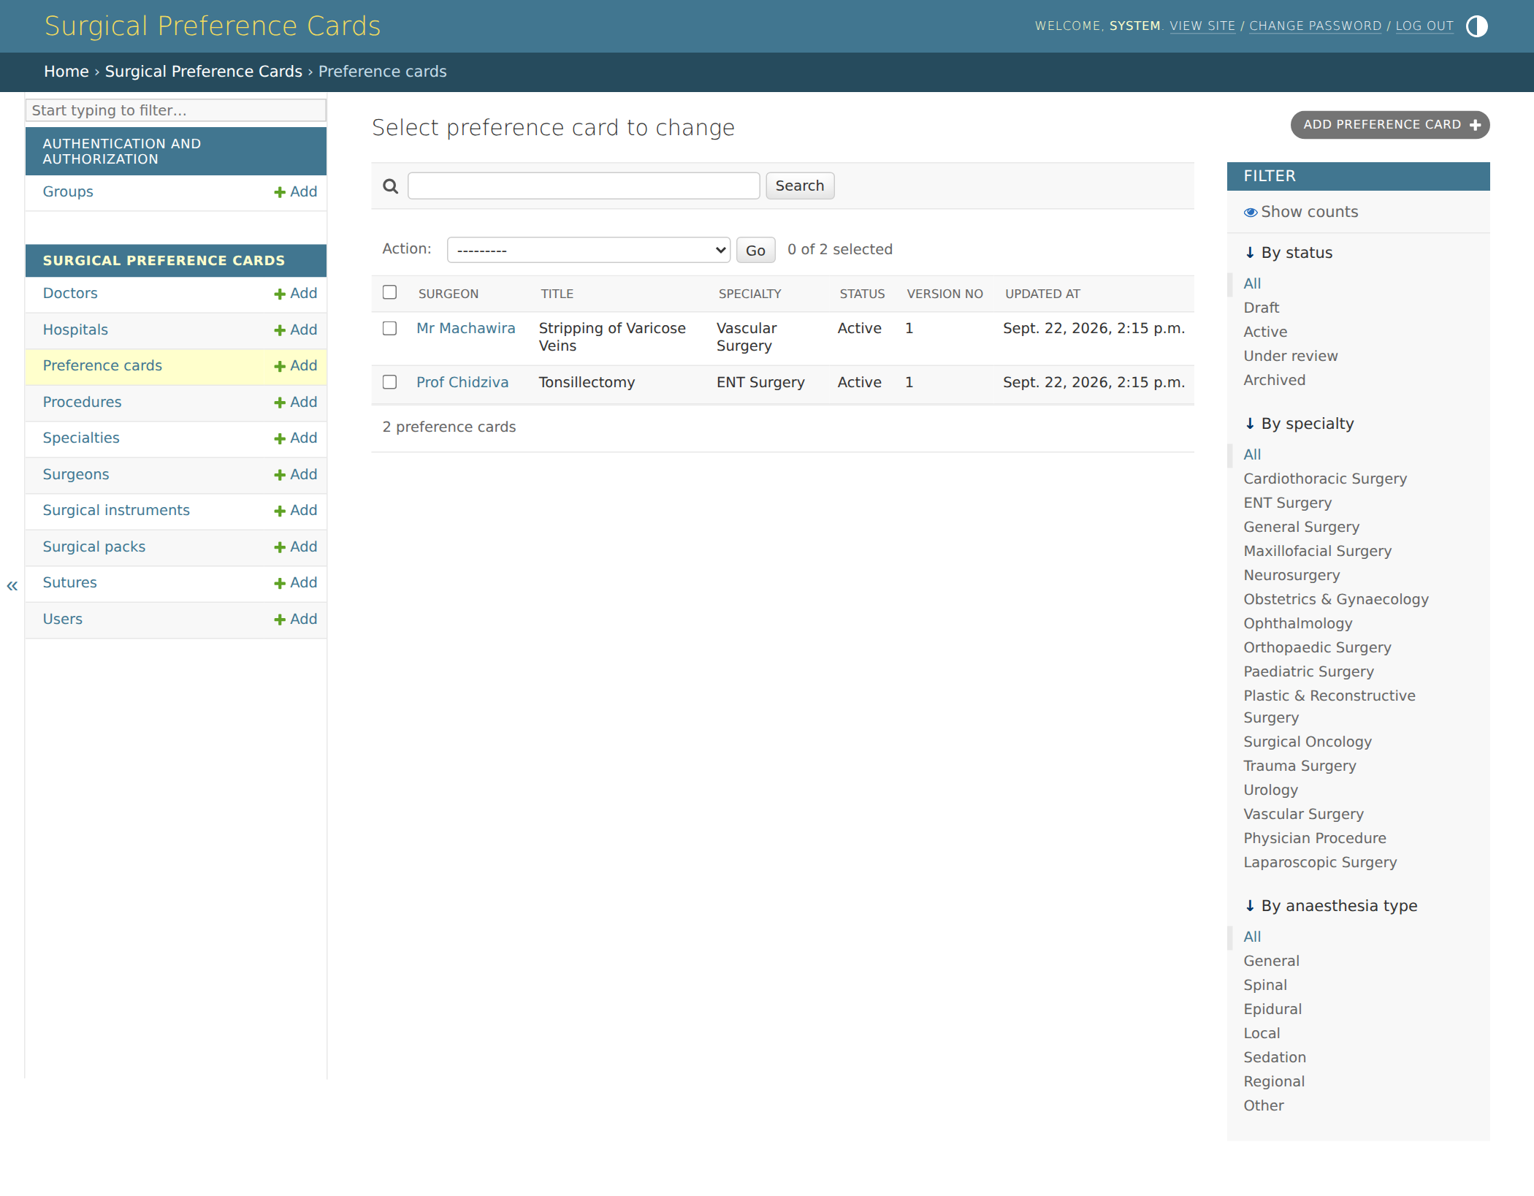
Figure 7. All cards, with filters by status, specialty and anaesthesia type, and search by surgeon or procedure (including aliases such as “VV strip”).

8.3 Editing a card
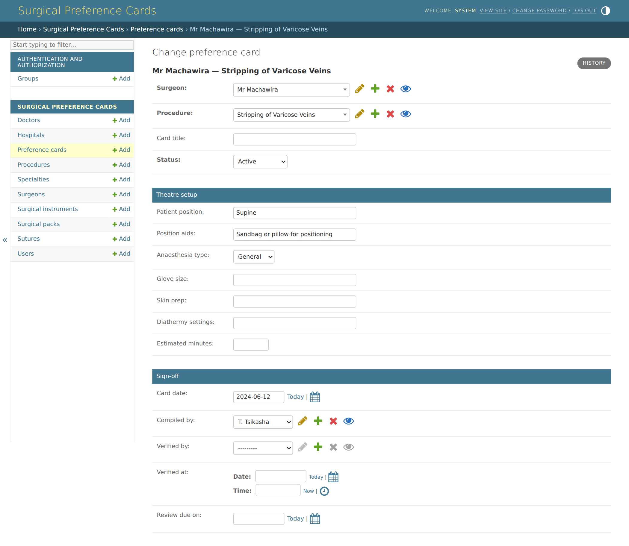
Figure 8. The card header: surgeon, procedure, status, theatre set-up and sign-off.

8.4 Items on a card
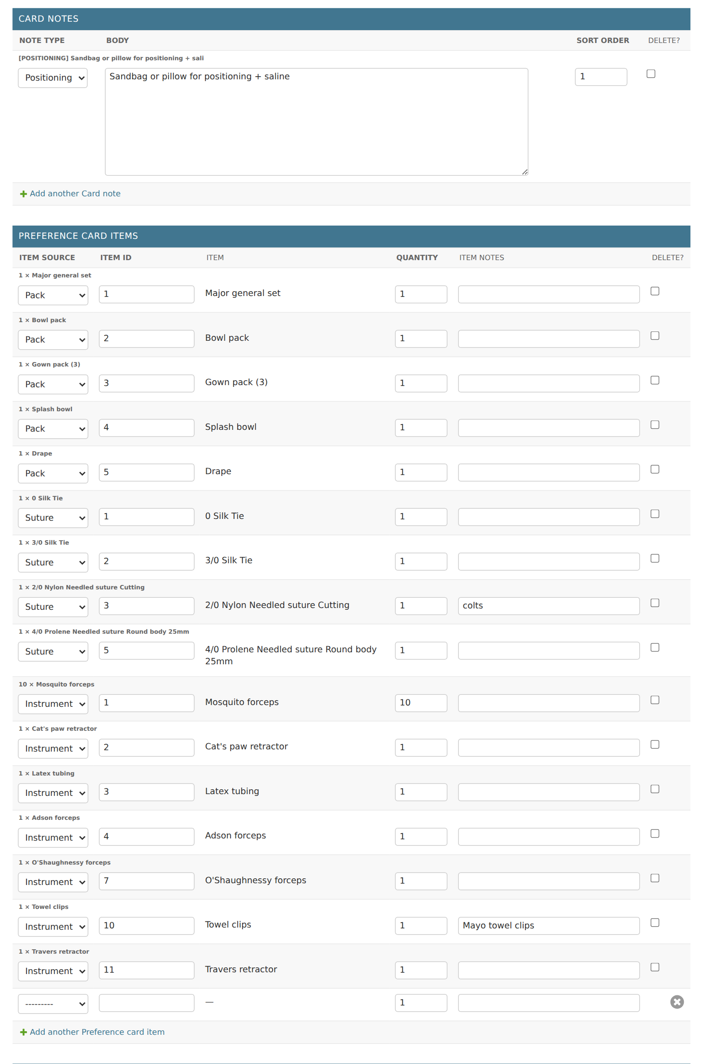
Figure 9. Notes and items are edited on the same page. Each item shows the list it comes from, its ID, the resolved name, quantity and notes.

8.5 Doctors
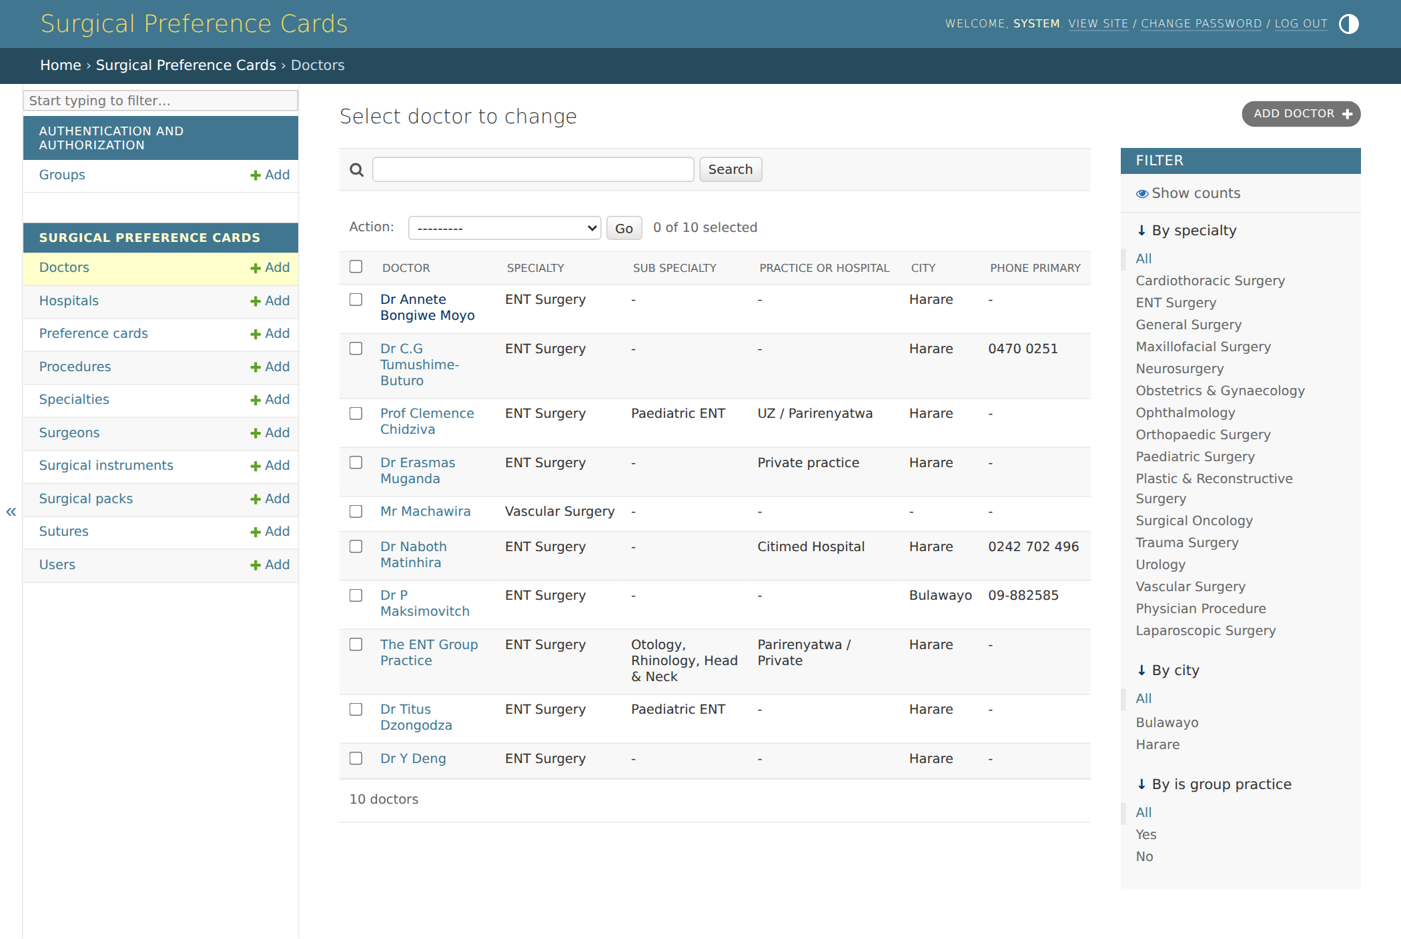
Figure 10. The doctors list, filterable by specialty and city. A doctor's surgeon details are edited on the same page.

8.6 Sutures
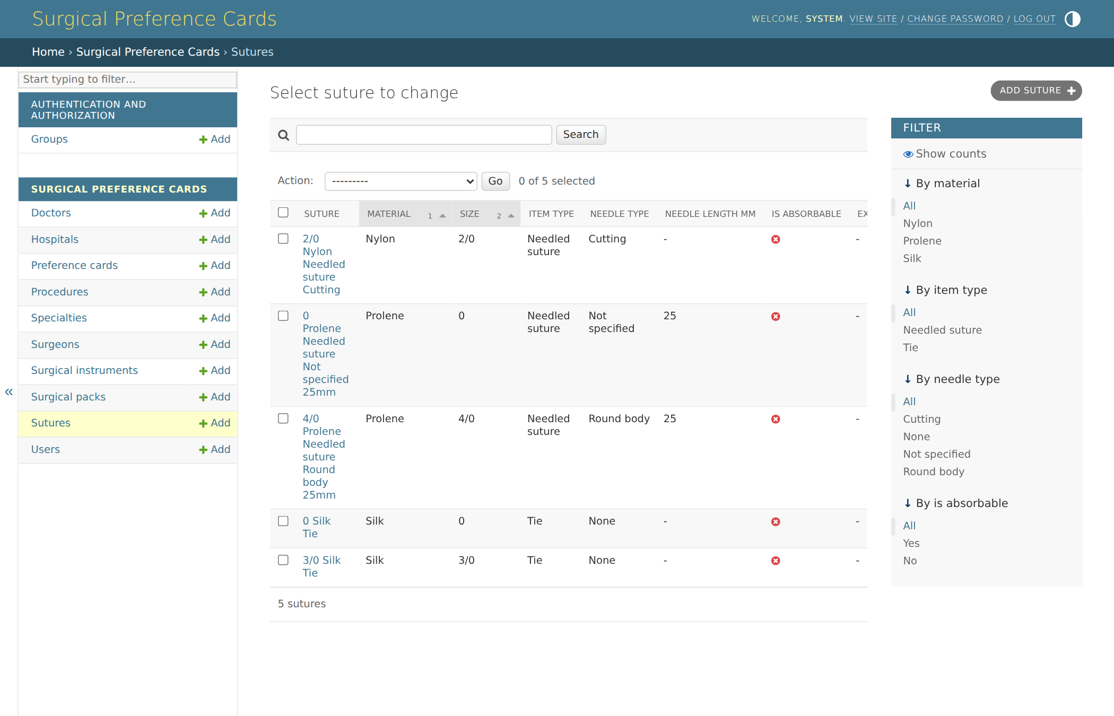
Figure 11. The suture list. Instruments and packs have the same kind of screen.

9. Django Implementation

9.1 Project structure
preference_cards_django/
├── manage.py
├── requirements.txt Django, psycopg, Pillow, WeasyPrint
├── config/
│ ├── settings.py PostgreSQL connection, AUTH_USER_MODEL = cards.User
│ └── urls.py /admin/
└── cards/ the application
├── models.py the 13 tables
├── admin.py data-entry screens and branding
├── tests.py 9 automated tests
├── migrations/
│ └── 0001_initial.py creates all tables, indexes and constraints
└── management/commands/
└── load_sample_data.py demonstration data

9.2 Models and tables
Django model | Table | Admin screen
Hospital | hospitals | Own screen
User | users | Own screen
Specialty | specialties | Own screen
Doctor | doctors | Own screen
Surgeon | surgeons | Own screen, and inside the doctor page
Procedure | procedures | Own screen
Suture | sutures | Own screen
SurgicalInstrument | surgical_instruments | Own screen
SurgicalPack | surgical_packs | Own screen
PreferenceCard | preference_cards | Own screen
PreferenceCardItem | preference_card_items | Inside the card page
CardNote | card_notes | Inside the card page
CardAttachment | card_attachments | Inside the card page
Shared behaviour. Every model except User inherits from TimeStamped, which adds the four record-keeping columns, the .alive() filter for live rows, and soft_delete(). PreferenceCardItem.item returns the actual suture, instrument or pack; Surgeon.specialty returns the doctor's specialty; PreferenceCard.effective_glove_size returns the card's glove size or, if blank, the surgeon's.

9.3 Installing and running
python -m venv .venv && source .venv/bin/activate
pip install -r requirements.txt

# PostgreSQL database (development credentials)
createuser prefcards -P # password: prefcards
createdb prefcards -O prefcards

python manage.py migrate # creates the 13 tables
python manage.py load_sample_data # optional demonstration data
python manage.py runserver # open http://127.0.0.1:8000/admin/

Connection settings come from environment variables DB_NAME, DB_USER, DB_PASSWORD, DB_HOST and DB_PORT. For a quick trial without PostgreSQL, set USE_SQLITE=1.

9.4 Sample data
python manage.py load_sample_data loads the 16 specialties, the ten doctors from the client's lists, the sutures, instruments and packs from the Theatre Preference Card Database document, and two complete cards: Mr Machawira's varicose veins card (Section 7) and Prof Chidziva's tonsillectomy card. It also creates three users: admin (ADMIN), rgn.tsikasha (EDITOR) and hca.viewer (VIEWER), all with the password ChangeMe123!. Running it twice does not create duplicates. Contact and stock details are sample values.

9.5 Automated tests
Run with python manage.py test cards. All 9 pass on PostgreSQL 16 and on SQLite.
Test | Checks that
card_renders_with_resolved_items | Card items show the real suture, instrument and pack names with their quantities.
specialty_reached_through_doctor | A surgeon's specialty comes from their doctor, and the glove size falls back to the surgeon's.
one_live_card_per_surgeon_procedure | A second active card for the same surgeon and procedure is refused.
archived_card_does_not_block_new_one | Archiving a card allows a new one to be created.
item_must_exist_in_its_source_list | An item pointing to a suture that doesn't exist is rejected.
quantity_must_be_positive | A quantity of 0 is refused by the database.
roles | Editors can edit; viewers cannot.
soft_delete_hides_but_keeps | A soft-deleted item disappears from lists but stays in the database.
row_version_bumps_on_save | Each save increases row_version by one.

9.6 Before going live
- Set a new SECRET_KEY, set DEBUG = False and list the site's address in ALLOWED_HOSTS.
- Use a strong database password, supplied through the environment rather than the settings file.
- Serve the site over HTTPS, and store uploaded photos outside the code folder (or in cloud storage).
- Change the sample passwords, or skip load_sample_data on the live server.
- Back up the PostgreSQL database daily.

10. Points to Confirm
# | Point | Current position
1 | Offline use. The requirements form asked for it; this is a web app. | Works on computer, Android and iPhone through the browser with a connection. Reading cards offline can be added later by caching them on the device; editing offline is outside this budget.
2 | One specialty per doctor. | A doctor has one specialty and optional sub-specialty. Earlier sample cards showed one surgeon across several specialties; if that is common, a link table can be added.
3 | Card items that are not in any list (e.g. K-Y jelly). | Add them to the most suitable list (usually instruments) before putting them on a card, or add a fourth list for consumables.
4 | Order and headings on the printed card. | Proposed for the print layout (still to be built): items grouped by list (packs, sutures, instruments), in the order they were entered.

Accompanying files: the Django project (preference_cards_django) and the five ERD figures as high-resolution images for presenting.
Contact: Tanaka Machona, Xyten Technologies — 0775186816 — xytentech.com

