Evaluation of the Effects of Forest Patch Characteristics on Bird Abundance

Aim
The aim of this study was to examine how forest fragmentation due to land development affects bird abundance. Eight forest patch characteristics were evaluated and added to a model to identify the main determinants of forest bird abundance.

Background
The dataset comprised observations from 56 independent forest patches. Further information on variables is provided in the Statistical Methods and Results section.

Findings
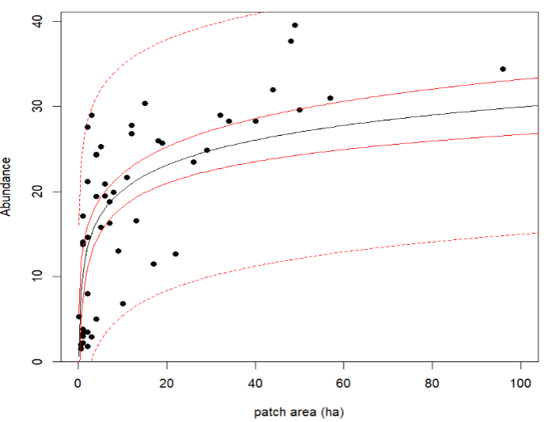
- The analysis showed that the relationship between patch size and bird abundance was positive: larger patches held larger bird numbers.
Figure 1 Fitted Regression Line With Prediction Intervals
The black line represents the relationship between patch size and bird abundance. The prediction intervals (red dotted lines) show the model was more accurate for patches under 5 ha. Note: the patch axis has been magnified to improve visibility.

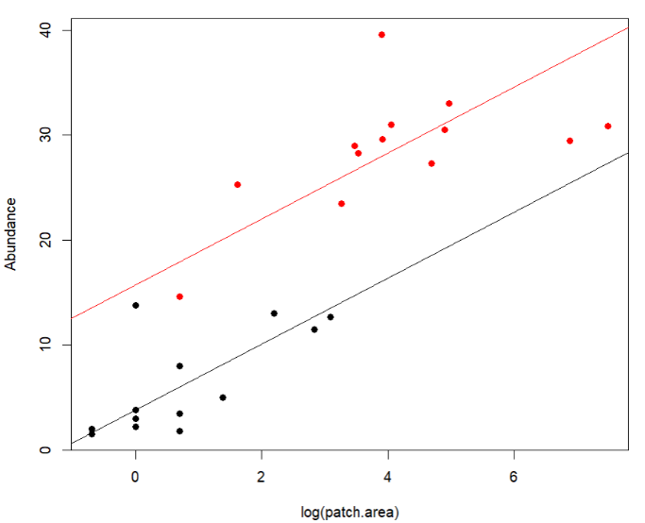
- The relationship between light and heavy grazing practices can be explained by a parallel linear relationship.
Figure 1 Fitted Regression Lines for Grazing Intensities
The red dots represent bird abundance in patches with light grazing and black dots represent bird abundance in heavily grazed patches. The parallel model suggests that lightly grazed patches support more birds than the heavily grazed plots.

Discussion
The final model (Table GG) suggested that patch.area and grazing.intensity explained 70% of the variance in bird abundance. Specifically, if a patch size were to double, there would be an increase of about 2.2 birds (calculated as b X ln(2)). Model 2 also implied that, in this dataset, patches with heavy grazing practices contained an average of 3.8 birds while lightly grazed patches contained about 15.5 birds, holding patch size constant (E[Abundance | log(patch.area), light grazing] = 15.72 + 3.15log(patch.area); E[Abundance | log(patch.area), heavy grazing] = 3.82 + 3.15log(patch.area)).
Residual plots suggested slight non-linearity (Table pp), thus, using Model 2 to predict bird abundance should be interpreted with caution. Considering the linearity concerns, future studies could apply statistical techniques that are more robust to large variability and skewed distributions. It might be important investigate why only light and heavy grazing intensities were significantly different, as this may signal that unidentified predictors mediate the relationship between grazing intensities and bird abundance (supports by the unexplained leftover 30% variance). Lastly, the results may have practical implications land developers: increase patch sizes and reduce grazing practices to boost bird numbers (Figure 1-2).

Statistical Methods and Results

Variables
- Abundance (abundance): the response variable measuring the average number of forest birds observed in a patch (counts from independent 20-minute sessions).
- Patch area (patch.area): signifies size of the patch, measured in hectares (ha).
- Year of isolation (year.of.isolation): year the patch became isolated.
- Distance to the nearest patch (dist.nearest): distance to the next closest patch (km).
- Distance to larger patch (dist.larger): distance to the nearest larger patch (km).
- Altitude (altitude): represents patch elevation.
- Grazing intensity (grazing.intensity): is the study categorical variable suggesting how much the patch was grazed by livestock with five factor levels: light, less than average, average, moderately heavy, heavy.
- Years of isolation (yrs.isolation): number of years a patch has been fragmented.

Computational methods
The analysis was performed in RStudio version (2024.12.0) using R (4.5.1). Functions used were: pairs() to create a scatterplot matrix; lm() to fit linear models; abline() to add fitted regression lines; plot() to inspect residuals plots; boxplot() to visualise categorical data; summary() to inspect model coefficients; influence.measures() provided output to assess influential points; drop1() was used as a stepwise tool; and lastly, anova() was used to compare model contributions to explaining abundance.

Methods and Results
Firstly, grazing levels were arranged from light to heavy. Data analysis commenced with boxplot that provided insight into the relationship between abundance and grazing.intensity (Figure C). A scatterplot matrix was created to visualise the pairwise relationships between abundance and predictor variables, followed by a correlation analysis between yrs.isolation and year.of.isolation (Figures A & B). After this analysis the preliminary model (Model 1) was proposed (Figure C-C). Residual plots were examined to ensure that assumptions of linear regression were met (Figure K), and potential outliers in Model 1 were assessed (Figure L). Model 2 was selected using a manual backward stepwise method (Figure), and then evaluated for its suitability as a linear model for collected data (Figure). Lastly, a polynomial transformation was added to the model and assessed, it was found not to be an appropriate fit.

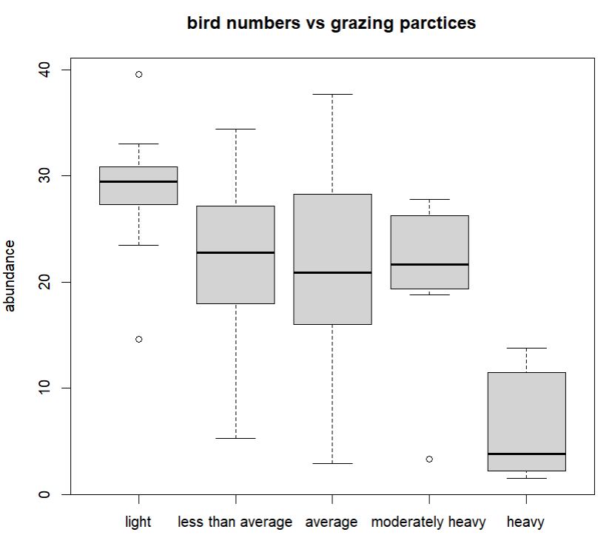
Figure C Relationship Between Abundance of Birds and Five Levels of Grazing
The box plot suggested that heavy grazing practices were associated with fewer bird numbers than the other four grazing intensities. Also, outliers were observed with the moderately heavy and light grazing levels.
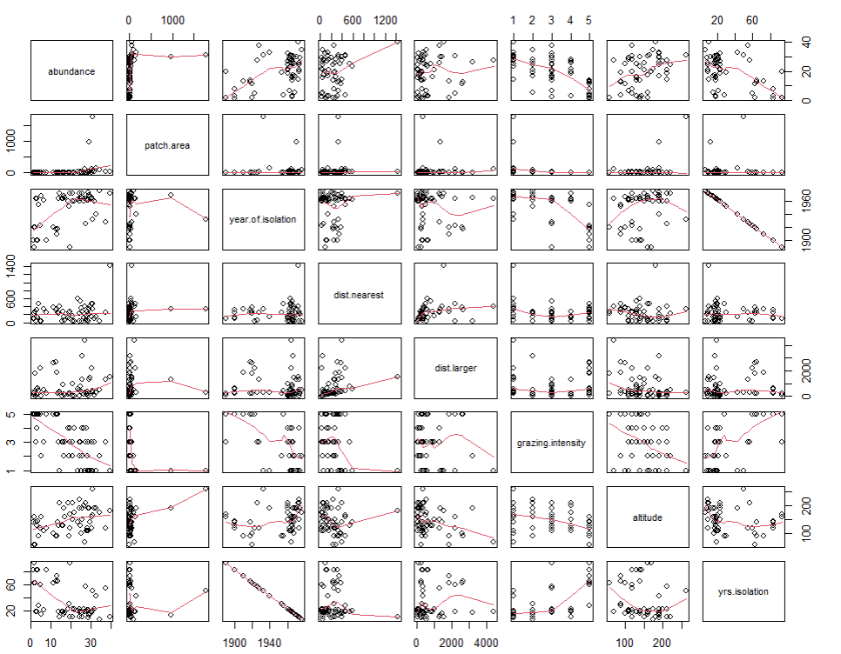
Figure A Scatterplot Matrix for Abundance and Predictor Variables
Based on the inspection it was not clear if there were strong relationships between the abundance of birds and explanatory variables. For instance, the patch.area against abundance plot showed most of the data points concentrated around small patch sizes. Similarly, this pattern appeared between abundance and dist.nearest, dist.larger and yrs.isolation, suggesting a need for log transformations of these predictors. The relationship between the response variable and altitude seemed linear but not overly strong. Contrastingly, yrs.isolation and year.of.isolation seemed strongly correlated, which indicated the need to remove one of these variables from the model to avoid multicollinearity.
A correlation test (r=-1, p < .001) confirmed that yrs.isolation and year.of.isolation were highly corelated. To avoid multicollinearity, year.of.isolation was excluded from the model, while yrs.isolation was kept due to its interpretability. Prompted by the pairwise scatterplot A, four log transformations were applied to patch.area, dist.nearest , dist.larger , yrs.isolation, and the transformed predictors were added to the preliminary linear model. Also, interaction terms were added to evaluate the effect of altitude on abundance across different grazing levels (altitude:grazing.intensity), and whether the effects of patch.size on abundance differed across grazing intensities (log(patch.area):grazing.intensity). As a result, the preliminary model was:
Model 1: abundance ~ log(patch.area) + log(dist.nearest) + log(dist.larger) + altitude + grazing.intensity + log(yrs.isolation)+ log(patch.area):grazing.intensity + altitude:grazing.intensity

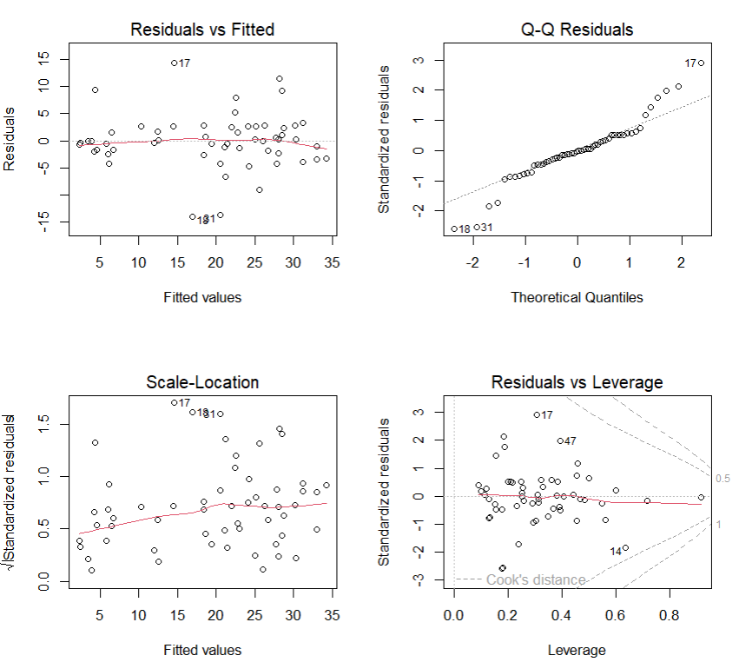
To evaluate the regression line of the new model, an inspection of the diagnostic plot of residuals for Model 1 was preformed (Figure K).
Figure K Residual Diagnostic Plots for the Preliminary Regression Model 2
The Residuals vs. Fitted plot suggested that a linear regression may adequately capture the relationship between the variables. The Scale-Location plot indicated slight non-constant variance (heteroscedasticity), with gentle fanning out. The Q-Q plot showed a S-shape pattern, suggesting a heavy tailed bell curve. The Residuals vs Leverage plot highlighted that three cases (14, 17 and 47) were potential outliers.

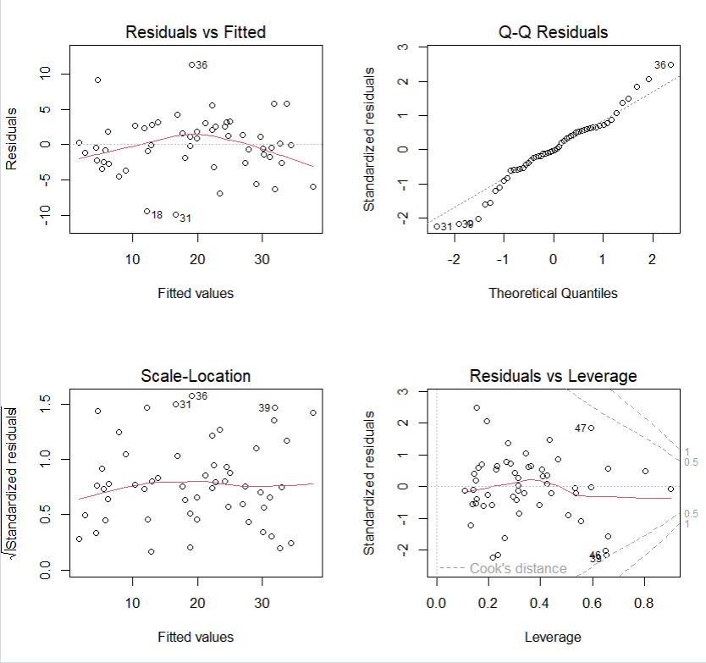
Further checks were done on cases 14, 17, and 47. Case 17 showed high DFBETA values for the intercept and several predictors, indicating a high influence on coefficient if removed. Case 14 also showed similar values while case 47 did not return any noteworthy results. Both cased 14 and 17 demonstrated high DIFFTS values in comparison to all other cases, which suggested their strong effect on fitted values if removed. Residual plots inspection and coefficients of Model 1 without cases 14 and 17.

Figure Z Residual Diagnostic Plots for Model 1 Cases 14 and 17
The Residuals vs. Fitted plot suggested that a linear regression may not capture the relationship between the variables . The Scale-Location plot indicated homoscedasticity. The Q-Q plot showed a S-shape pattern, suggesting a heavy tailed bell curve. The Residuals vs Leverage plot highlighted that three data points (39, 46 and 47) were potential outliers.

Table 1 Summary of Adjusted R² and Signifincat Coefficinets With and Without Cases 14 and 17
 | All cases included | no 17 | no 14 | no 14 and 17
Adjusted R² | 69% | 77% | 72% | 79%
log(patch.area)ª | ns | 2.93** | ns | 2.04*
average | -22.06* | -23.75* | ns | -20.89*
heavy | -20.32* | ns | ns | ns
average:altitudeª | ns | 0.15* | ns | ns
grazing.average:patch.areaª | ns | ns | ns | -0.26*
log(patch.area):moderately heavyª | 6.7* | ns | ns | ns
moderately heavy:patch.areaª | ns | ns | 0.92* | 0.89*
Note. * p < .05, **p < .01, ***p < .001., ns = not significant at α = .05., ª Coefficients that were statisrically significant based on the preliminary model and its case combinations.

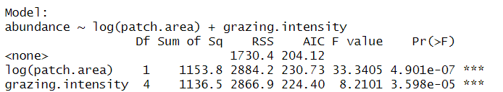
The analysis in Table 1 demonstrated that removal of the two cases increased the explained variation by 10% compared to the all-inclusive model. Also, it showed an increase in number of significant coefficients. While the residual plot (Figure Z) shows improvement in the constant variance, linearity worsened and three new outliers appeared. Given that removing case 14 and 17 did not resolve the initial concerns it was decided to keep all data points. As a result, Model 1 was accepted and stepwise approach was used until all statistically significant predictors were selected.
Figure BB First Step in Model 3 Construction using the Drop Function

Figure ZZ Fina; Step in Model Construction using the Drop Function

The first step in predictor selection is shown in Figure BB. The output indicated that log(dist.larger) was least helpful with a p = 0.94, therefore it was removed from the model. This process was repeated, and predictors were removed in the following order: log(dist.nearest) (p = 0.70), log(yrs.isolation) (p = 0.71), altitude (p = 0.70), grazing.intensity:altitude (p = 0.63), log(patch.area):grazing.intensity (p = 0.11). The resulting model is displayed in Figure ZZ, which demonstrated an AIC decrease for the two remaining predictors.

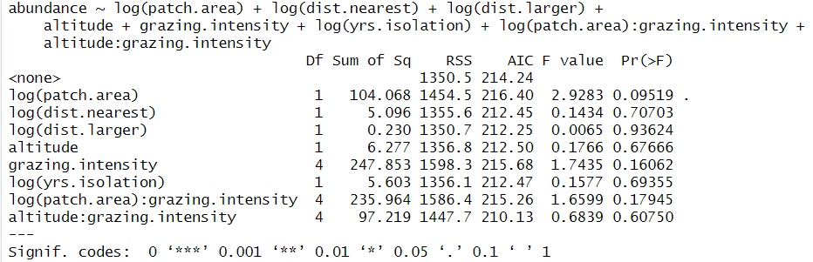

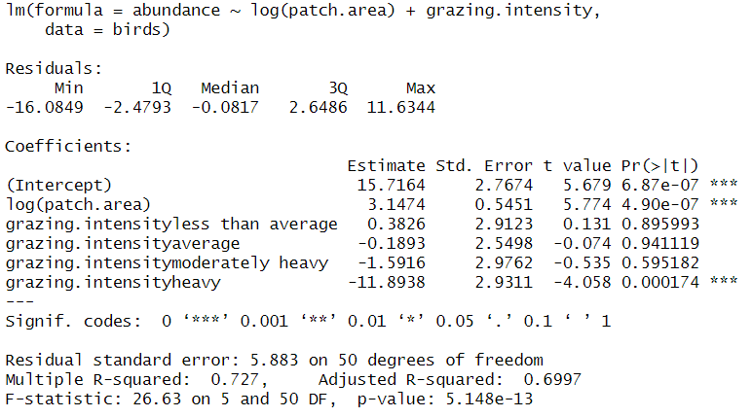
Figure SS Characteristics of Model 2

Model 2 included log(patch.area) and grazing intensity (less than average). The regression summary suggested that the patch area was significant and positive predictor of abundance. This meant a unit increase in log(patch.area) was associated with an increase in 3.1 birds while holding grazing constant. Contrastingly, heavy grazing practices were associated with 11 fewer birds than areas with light grazing practices, controlling for abundance. The model explained 70% of variation in bird abundance (adjusted R²).

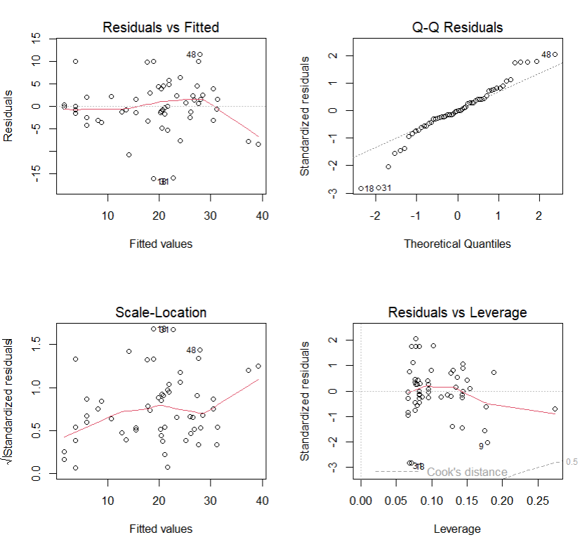
Figure NN Model 2 Residual Diagnostic Plots
The diagnostic plots demonstrated a change for the Residuals vs. Fitted and Scale-Location plot in comparison to Model 2. It suggested a decreased ability of a linear model to capture the relationship between variables, and an increase in heteroskedasticity. Therefore, a polynomial transformation of patch area was tested.

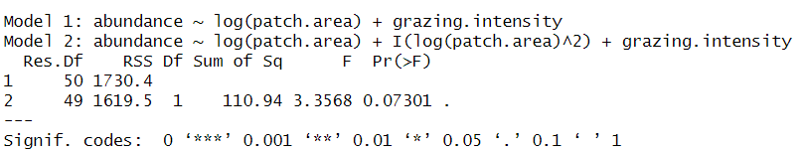
On inspection, Model 3 (labelled Model 2 below) which included a quadratic term did not significantly (p = 0.73) contribute to explaining bird abundance in segmented patches of forest as demonstrated below:

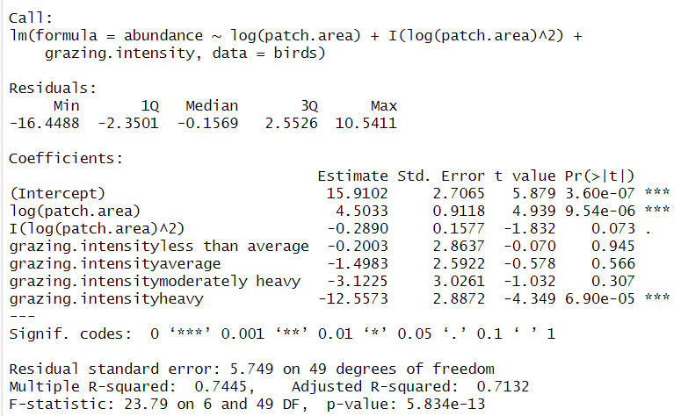
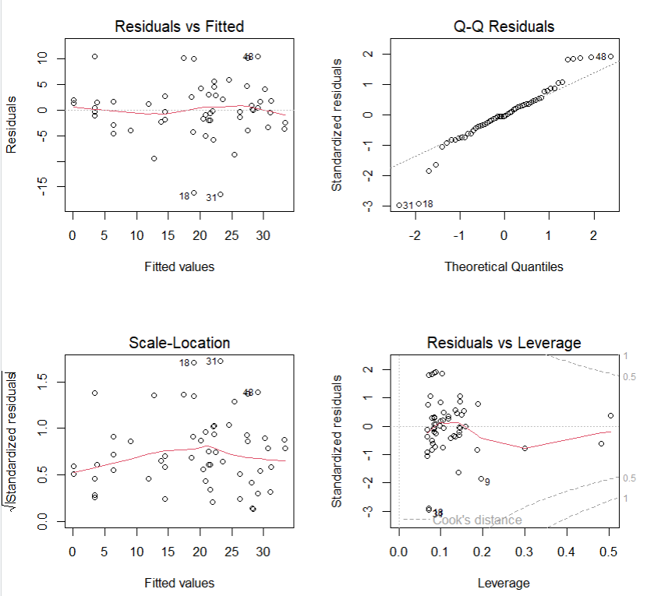
Figure SS Characteristics of Model 3 with quadratic addition

Model 3 included a quadratic term for log(patch.area) and grazing intensity (less than average). The model indicated that log(patch. Area) was a signficant predictor of abundance while the quadratic term wasn’t. In contrast to Model 2, heavy grazing practices were significant and associated with 12.5 fewer birds than areas with light grazing practices, controlling for abundance. The model explained 71% of variation in bird abundance (adjusted R²).
Figure HH Model 3 Residual Diagnostic Plots With a Polynomial Transformation
Adding a polynomial term for log(patch.area) slightly improved the residual plots in comparison to Figure NN. In particular, there was an improvement in the Residuals vs. Fitted plot demonstrated as a reduction curvature.

It seemed that the quadratic term improved the capacity to explain the relationship between variables (Figure HH). However, the quadratic term coefficient in the updated model (Model 3) was not significant. Therefore, to keep the model simple and based on the observations above, the quadratic term was excluded. The final model, and thus, determinants of bird abundance were log(patch.area) and grazing.intensity:
Final Model (Model 2): abundance ~ log(patch.area) + grazing.intensity

