說明：請各位使用此template進行Report撰寫，如果想要用其他排版模式也請註明題號以及題目內容（請勿擅自更改題號），最後上傳前，請務必轉成PDF檔，並且命名為report.pdf，否則將不予計分。

---------------------------------------------------------------------------

學號：R12945060 系級：生醫電資所 姓名：羅佳蓉

1. (0.5%) Please write down the Bellman consistency equation in terms of $V^{π}$

on both sides.



* Vπ(s): The expected cumulative reward starting at state s and following policy π.
* π(s,a): The probability of taking action a in state s under policy π.
* p(s′∣s,a): The probability of transitioning to state s′from state ]s by taking action a.
* R(s,a): The immediate reward for taking action a in state s.
* γ: The discount factor, controlling the weight of future rewards.

1. (0.5%) Please implement the epsilon-greedy algorithm or the UCB algorithm. Paste the code and compare the public leaderboard scores of it and the default greedy algorithm (directly choose the state with maximum value).

* epsilon-greedy algorithm

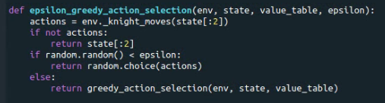

epsilon-greedy score: 85.2

* UCB algorithm

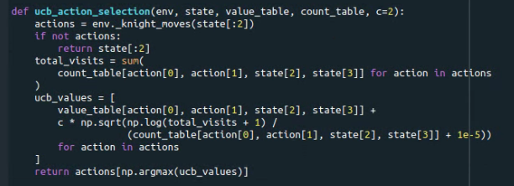

UCB score: 87.8

1. (1%) How to encourage the agent to catch the pawn as soon as possible?

Please make two modifications (for example, change the reward function, discount factor, …)

* 1. What is your first modification? How does it affect your public score?

REWARD_STEP = -0.1

Increase the penalty for each step taken by the agent. This forces the agent

to minimize the number of steps required to catch the pawn.

* 1. What is your second modification? How does it affect your public score?

GAMMA = 0.85

Decrease the discount factor to reduce the weight of long-term rewards. This

encourages the agent to prioritize immediate rewards, which aligns with catching the pawn quickly.

