Part 2: Github provides a web-based graphical interface for Git, a version control for codebases. Github also provides productivity and collaboration tools. Another similar platform that I have used is BitBucket. The founders were Tom Preston-Werner, Chris Wranstrath, and PJ Hyett. Github was created to make it easier to collaborate on coding projects. It also made open-source software easier to contribute to. You can have public repositories, where anyone can see your code, download it, and ask to contribute to it, or you can use their paid or student service to have some private repositories.

Part 3: I accidentally didn’t copy and paste as I was going, but I finished the tutorial. 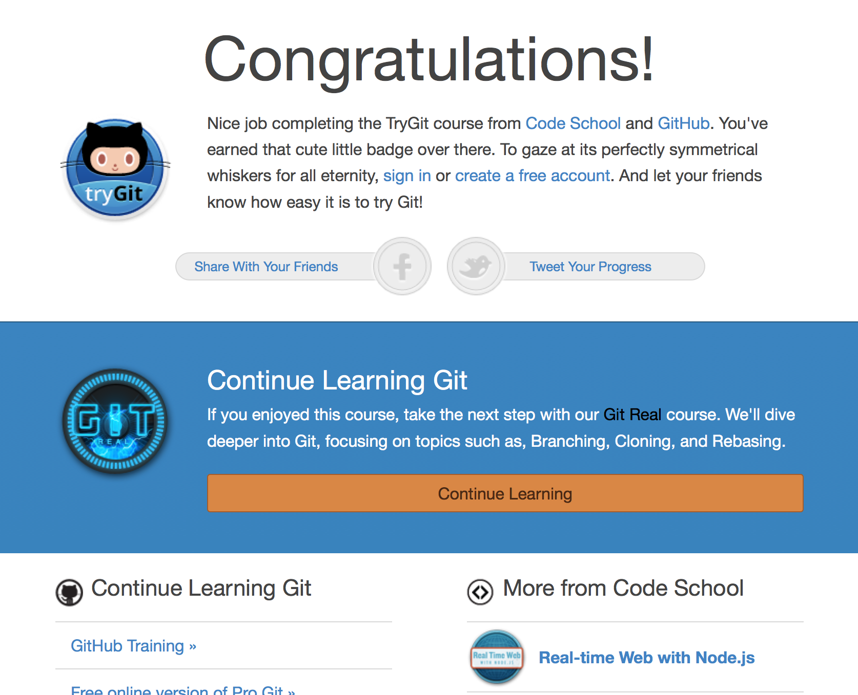

Part 4:

* Repository – A virtual location where the code and data is stored and managed.
* Commit – You do this when you have made changes to the code that you plan to keep and want in the repository, to indicate that you plan on making them “permanent”.
* Push – You do this to make the changes that you have made to the code “permanent” in the repository officially.
* Branch – A copy of the code to work on without affecting the code that everyone in a team is working on.
* Fork – Make a copy of the repository for yourself, and create a new repository for you.
* Merge – Take the changes in one branch and make them a part of the main branch or another branch in the repository.
* Clone – Make a copy of the repository onto your local machine.
* Pull – Apply all of the changes that have been made to the repository.
* Pull request – Shows the changes that will be applied before it has been reviewed and agreed to have them applied to the repository.

Part 5: