Hello everyone,  
Today I’m going to present the first part of my research internship, here at Kyushu University. My project focuses on how **knee pathologies** can affect the way our **muscles behave during walking**.

INTRODUCTION

Walking is a complex movement that requires good coordination between joints and muscles. The knee plays a key role, and when it's injured or affected by a pathology, this balance is disturbed, which can change how muscles work and how we walk.

In this project, I focus on EMG signals, which measure the electrical activity of muscles. My goal is to compare the EMG signals of healthy people with those of people who have knee problems, to find meaningful differences. These differences could help with diagnosis or rehabilitation follow-up.

Right now, I’m working on the basics: understanding what EMG is, the different types, an example of walking signals, and the gait cycle. I will also present the database I’m using. I’ve started learning about signal preprocessing, and later, I plan to use AI to help classify gait profiles.

CONTEXTE

During the first two weeks of my internship, I focused on learning how EMG works and how it can be used to study walking.

I explored the two main types of EMG (surface and intramuscular) and I started to understand the basic signal characteristics.

I also studied the gait cycle and its phases. For now, I’m just starting to look at how to apply preprocessing on the data. This will be my next step, followed by AI applications,

1. EMG signal, what is it?

An electromyographic (EMG) signal reflects the electrical activity produced by skeletal muscles when they contract. This activity results from the propagation of action potentials along muscle fibers, which are initiated by motor neurons. When several motor units are activated simultaneously, the resulting electrical potentials sum up to form a measurable EMG signal. These signals are recorded as voltage differences, typically ranging from 0 to 10 millivolts for surface EMG, and allow us to quantify muscle activation during motion.

EMG is a widely used method in both clinical and research contexts. It helps evaluate muscular function, detect neuromuscular disorders, analyze motor coordination, and assess rehabilitation or performance in sports science.

1. Different types of Electromyography:

There are two main types of EMG: **surface EMG** and **intramuscular EMG**.

* **Surface EMG:**

Surface EMG (sEMG) involves placing flat electrodes directly on the skin, above the muscle of interest. This non-invasive technique allows us to measure the global electrical activity of a muscle group. It is easy to set up and well-suited for dynamic activities such as walking, running, or sports exercises. However, it has some limitations: its signals are influenced by subcutaneous tissue, and it is less precise for deep muscles. It is also sensitive to motion artifacts and electromagnetic noise.

* **Intramuscular EMG:**

Intramuscular EMG, on the other hand, uses very fine needle electrodes that are inserted directly into the muscle. This method is invasive, but it provides high spatial precision and allows for the recording of the activity of specific motor units. It is often used in clinical diagnosis, especially for neuromuscular diseases like muscular dystrophy or neuropathies. Although more accurate, it can be uncomfortable or painful for the subject, and it requires medical supervision.

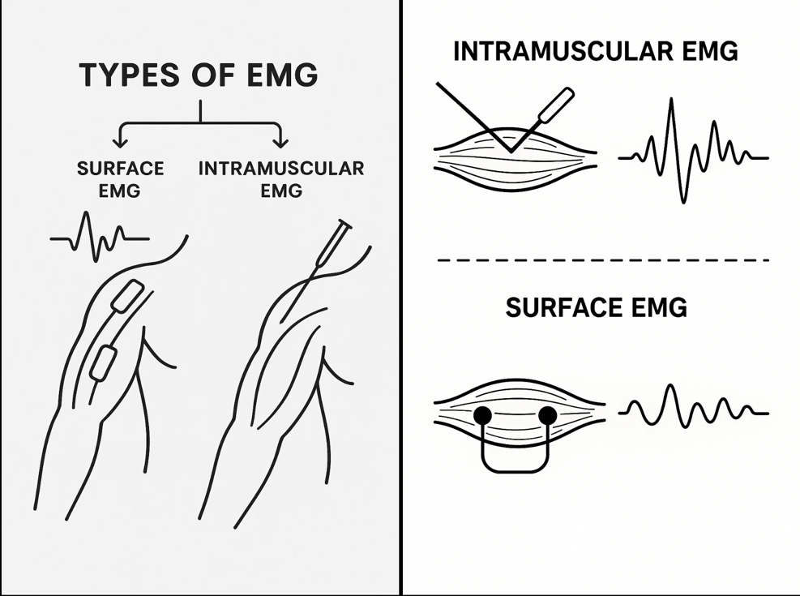

1. Example of an EMG signal:

The adjacent graphs show the EMG signals of a man walking. The probes are placed on 5 different muscles (rectus femoris, semitendinosus, tibalis anterior, gastrocnemius, peroneus) on the 2 legs (red: left leg, blue: right leg).

1. Gait Cycle:

Walking is a rhythmic and coordinated sequence of movements involving both legs. Each full step, known as a **gait cycle,** is typically divided into two main phases: the **stance phase** (= phase d’appui) and the **swing phase (= phase oscillation).** These phases reflect how the foot interacts with the ground and how the leg moves forward.

The **stance phase** represents about 60% of the cycle. It begins when the heel first touches the ground and ends when the same foot pushes off. During this time, the foot is in contact with the ground and supports the body’s weight.

The stance phase includes five key moments:

1. **Heel Strike (Initial Contact)**: the heel touches the ground.
2. **Flat Foot (Loading Response)**: the foot rolls to full contact.
3. **Mid-Stance**: the body weight is fully supported on one leg.
4. **Heel Off (Terminal Stance)**: the heel lifts off the ground.
5. **Toe Off (Pre-Swing)**: the toes push off to initiate swing.

The **swing phase** covers the remaining 40% of the cycle. It starts right after toe-off and ends with the next heel contact. During this phase, the foot is off the ground, and the leg swings forward in preparation for the next step.

The swing phase has three stages:

1. **Initial Swing**: the foot leaves the ground and the leg begins to move.
2. **Mid-Swing**: the leg advances forward.
3. **Late Swing**: the leg slows down in preparation for the next contact.

To better understand how the leg moves throughout these phases, we can look at the **knee flexion angle** over time. This graph provides a visual representation of how the knee bends and extends during a complete gait cycle

The flexion of the knee in relation to time in the gait cycle can be represented in a graph :

### Database Presentation

Now I’ll present the database I’m working with.  
It contains real experimental data from 22 male subjects — 11 healthy, and 11 with a diagnosed knee pathology.

Even though several movements were recorded, in my project I only focus on walking.  
During the data collection, four surface EMG electrodes were placed on key leg muscles: Rectus Femoris, Biceps Femoris, Vastus Medialis, and Semitendinosus.  
At the same time, a goniometer was used to measure the knee flexion angle.

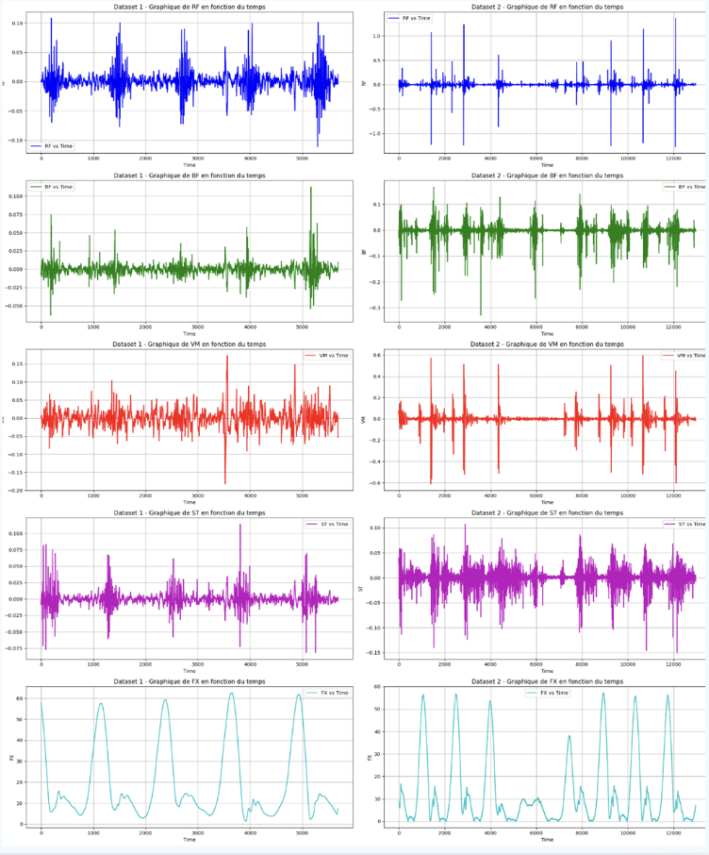The signals were recorded using the Biometrics DataLOG system, with a sampling rate of 1000 Hz.  
Each file is in .txt format and contains five columns: one for each of the four muscles and one for the knee angle.  
The files are stored in two folders — one for healthy subjects, and one for pathological subjects.

To get a first overview of the data, I plotted the EMG signals and the knee flexion for one healthy person and one patient.  
Each signal is color-coded for a specific muscle, and the last signal represents the knee angle.  
In the graph, the left column shows the healthy subject, and the right one shows the pathological subject.

1. Next Steps:

Right now, I’m exploring the structure of the dataset and preparing it for future analysis.

For now, I’m still working on understanding the structure of the data. The next step in my project will be to start applying signal preprocessing techniques, such as filtering, segmentation, and feature extraction.

Once this part is complete, I plan to build a machine learning model to classify walking patterns. The final goal is to develop a tool that can help detect or monitor knee pathologies using EMG signals