# LABELLING EXAMPLES OF TWO SAMPLES

# Sample 22

*Here, crying segments have some non-crying parts and the contrary.*

**Labels for the 3 annotators**

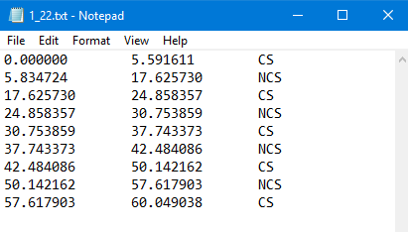 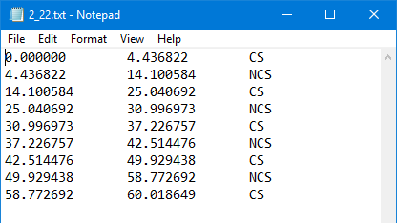

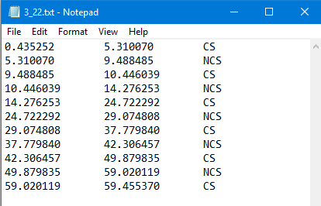

**Results of label with a window=3s and an overlap=25%**

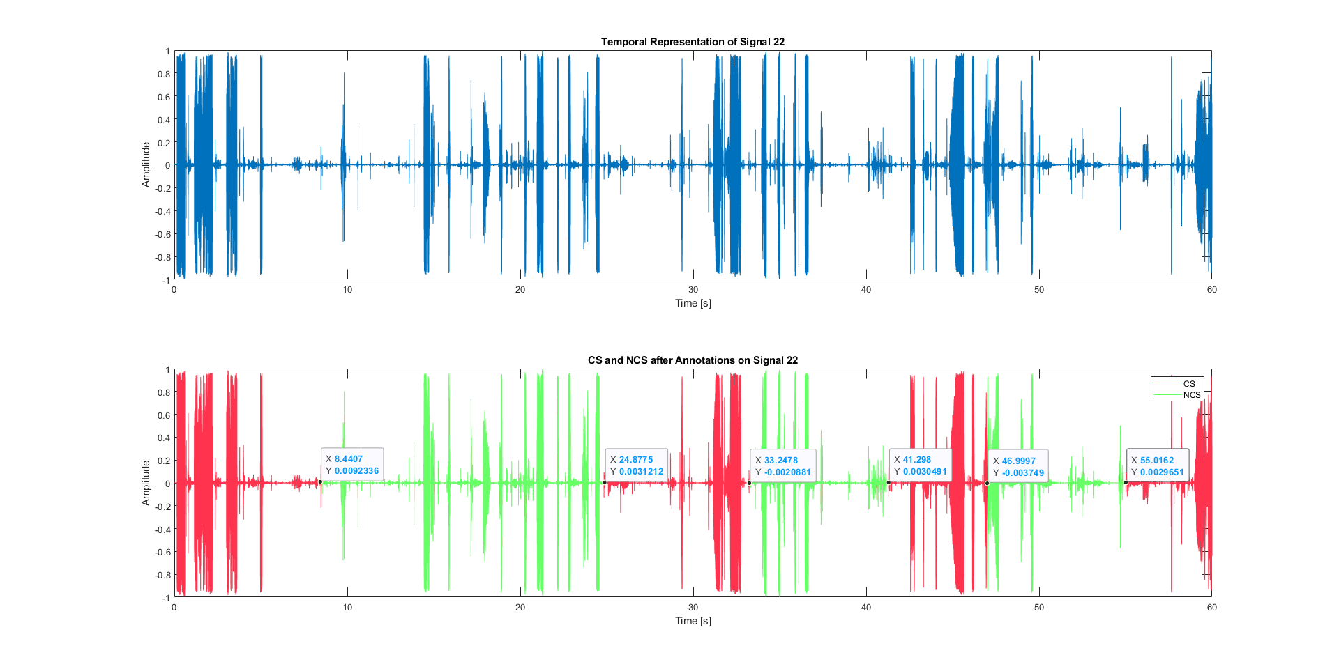

# Sample 7

*Here, the annotations are quite different. One CS fits the 3 annotators around 26-27s, but because of the 3s window, it doesn’t appeared 🡪 Non-crying segments often contain crying parts.*

**Labels for the 3 annotators**

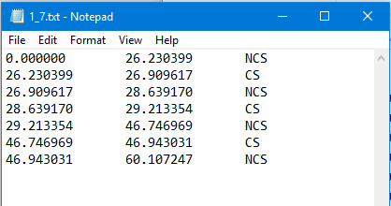 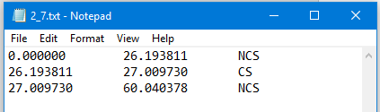

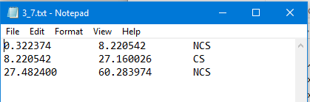

**Results of label with a window=3s and an overlap=25%**

