STATE OF THE ART

# Intro

Every year, an estimated 15 million babies are born preterm, and this number is rising. Complications due to their immaturity are the leading cause of infant mortality[1].

* Une des complications: Deficience respiratoty
* Combien cela touche d’enfants? Quels sont les risques ?
* Plusieurs façons d’aider suivant la gravité, dont injection de surfactant.

But du projet :

* But global : ???
* Identify acoustic differences in the breath sounds of preterm neonates with RDS before and after SRT.
* En particulier en signal processing : trouver des features dont la différence sera la plus importante ?

*That is more than 1 in 10 babies.*

*and many survivors face a lifetime of disability.*

*Preventing deaths and complications from preterm birth starts with*

Slightly fewer than 12 percent of all babies are premature. Overall, the rate of premature births is rising, mainly due to the large numbers of multiple births in recent years.

# Internship context

## Monash University

Lieu

Combien d’étudiants en tout ? (Sur les différents campus)

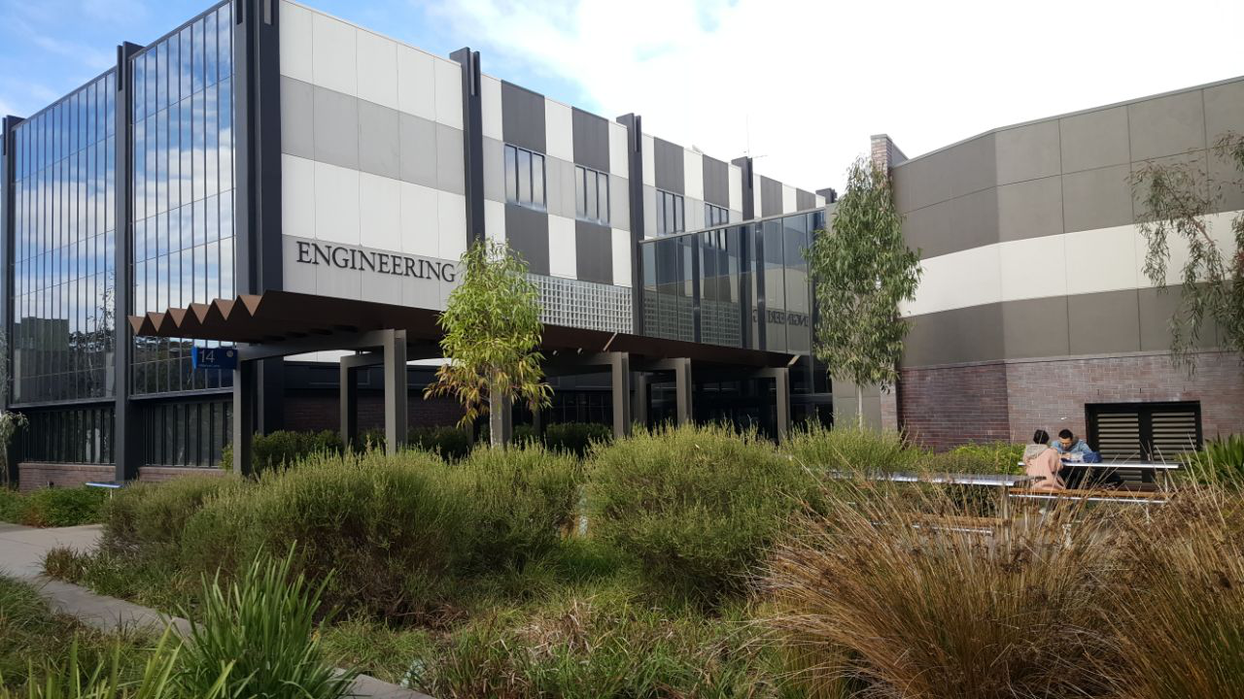 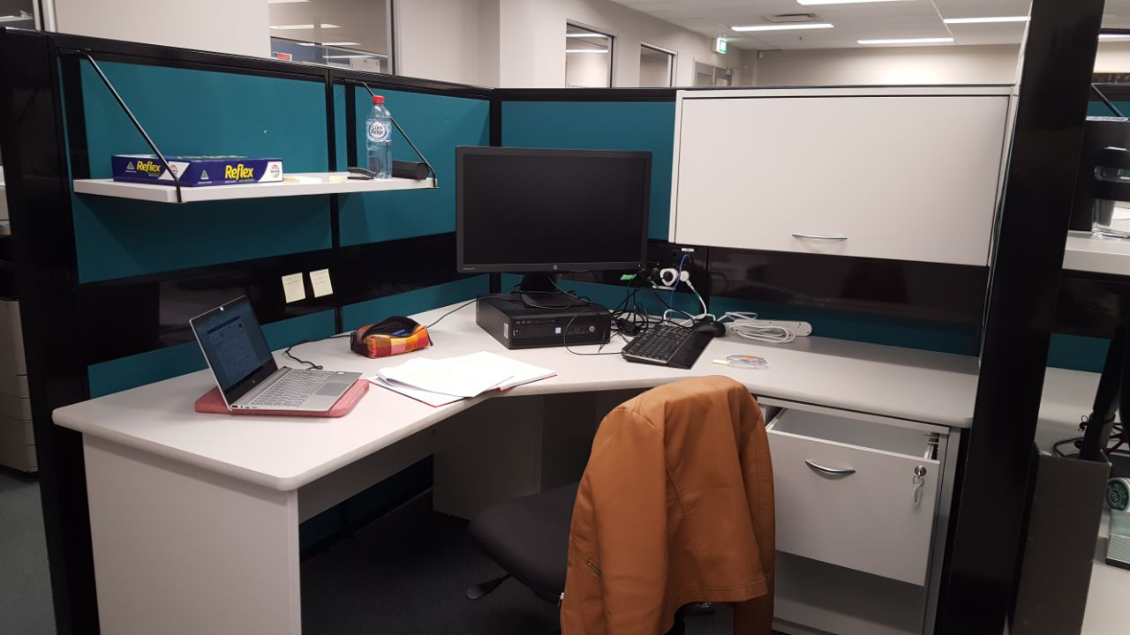

Figure 1: Monash University, with my building and my desk

## ESCE Department

Qu’est-ce qu’on y fait ?

Combien de personnes ?

Combien d’articles publiés ?

## The team

Supervisor : Fae . Maitre de conférence depuis quand ? En congés maternité mais visio toute les semaines et pour de vrai tous les mois.

Belle : Etudiante 5ème année de medicine qui prend 1 an pour faire de la recherche

Lindsay : Docteur qui a fini l’année dernière sa formation. Ca fait 1 an qui en plus de ses activités dans les cas d’urgences pour les bébés prématurés fait de la recherche.

Moi : Stage de 2A d’école d’ingé de l’Enseirb

# Medical background

## Preterm Neonates’ Immaturity

Normally, a pregnancy lasts about 40 weeks. A neonate will be considered as preterm if he is born before 37 weeks of pregnancy have been completed.

When a baby is premature, he is not fully developed, which often causes serious disorders. The newborn’s difficulty degree is usually related to his gestational age: it is greater the earlier he is born.[2]

The neonates’ immaturity affects many areas, including the central nervous system, the cardiovascular system and the respiratory system.[3]

## Respiratory Distress Syndrome

The Respiratory Distress Syndrome (RDS) is a breathing disorder that affects newborns and particularly premature infants as it results from the respiratory system immaturity.

RDS occurs when there is not enough of a substance in the lungs called surfactant. Surfactant is a liquid produced by the lungs that plays a key role by reducing the surface tension between liquid and air in each alveolus. It opposes the surface tension attraction forces to reach a balance, allowing the open and stable alveoli maintenance, the pulmonary compliance reduction (lung ability to open and close), the cells dry upkeep and defenses against infectious agents.[4]

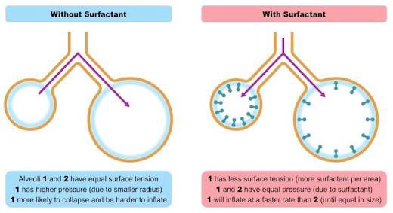

Figure 2: Surfactant role in the respiratory system

REFAIRE le SCHEMA

<https://ib.bioninja.com.au/standard-level/topic-6-human-physiology/64-gas-exchange/pneumocytes.html>

The production of surfactant begins by 24 weeks’ gestation, which is very late in pregnancy. Consequently, the vast majority of babies born under 32 weeks’ gestation need respiratory supports. [5]

## RDS Therapies

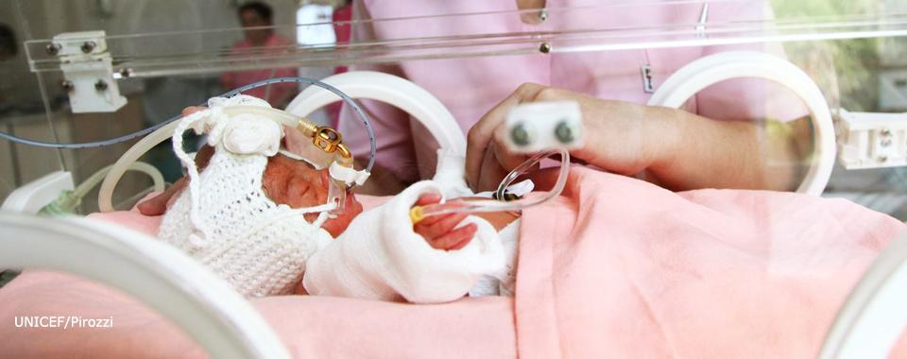The RDS can lead to serious consequences, including death. For this reason, different treatments exit to overcome respiratory dysfunction. They ensure that the infants' organs get enough oxygen to work well. The course of therapy depends on the lung immaturity seriousness, corresponding to the breathing difficulty degree.

<https://extranet.who.int/rhl/topics/newborn-health/care-newborn-infant/who-recommendation-early-administration-surfactant-intubated-preterm-newborns-respiratory-distress>

Figure 3: Preterm neonate receiving surfactant

Infants who have breathing problems may get oxygen therapy. Oxygen is given through a ventilator or nasal continuous positive airway pressure (NCPAP) machine, or through a tube in the nose.

When newborns need a lot of oxygen, it means that their surfactant production is very insufficient, even non-existent. The surfactant replacement therapy (SRT) is then necessary, which aims to give surfactant to the neonate lungs. This treatment is now a well-established therapy in the Neonatal Intensive Care Unit (NICU), but opinions still differ for its use[6]. *When should it be used? What dose to inject?* Indeed, it is not always well seen to put a foreign substance in a very fragile baby. In addition, the surfactant is not always well absorbed, and never in the same way. Today, the Monash Children's Hospital uses it when the baby needs more than 30% oxygen, but research in this area continues to be conducted.

# The Project

## The purpose

In Monash, a large study is in progress on newborns, whether regarding their respiratory or cardiac signals. One research aimed at doing a better assessment in preterm neonates under 32 weeks to improve their respiratory breath. My internship is part of this research topic, especially regarding the Surfactant Replacement Therapy (SRT). Indeed, lung acoustics reflect lung volume and then their analysis is essential to know more about the treatment. The first part of my internship will be to analyze the respiratory signals before and after SRT, in order to determine differences. Et deuxieme partie classification

An experiment aimed at recovering the lung sounds before and after SRT was set up by Isabella, the medical student of my team.

## The experiment

### Available tools

Different tools can be used to record the sound of the lungs, which all has advantages and disadvantages. The tool choice is very important, on the one hand for the smooth running of the experience and the health of the baby, and on the other hand for the quality of sound recorded. Isabella made a state of the art of these various tools summarized in the table in Annex 1.

There is no « gold standard” device to asses lung parameters[7], but the Digital Stethoscope (DS) was finally chosen. It is composed of a diaphragm which functions to capture sounds. Instead of the sound being transmitted via acoustic vibrations, these sounds are converted to electrical signals, which can then be amplified and processed to optimize the information they contain. These electrical signals can be converted back to sound waves for listening.[8]

A stethoscope is normally used by a doctor to listen. But respiratory deficiency diagnoses are very difficult and remain rather subjective dire que depends de l’entrainement des medecins. For this reason, the sound of the stethoscope will be recorded so that it can be analyzed. Enreigstré sur un téléphne portable

### Preterm neonates constraints

Qualité des signaux qui dépend des conditions dans lesquelles le son est recorded. Les enregistrements se feront sur des bébés qui ont besoin de SRT, avant et apres la prise. Le premier enregistrement sera tres bruité car le bébé est en mauvaise posture si ne peux pas respirer et toutes l’équipe médicale s’active.

Un point positif est que ce enfants prématurés ne pleure pas, on aura pas de bruit de se coté la.

Quelques mesures doivent être prise car très fragile et attention aux conditions d’hygiène.

### Les enreisgtrements

Comment les signaux sont enregistrés? Ou ? Quand ?

Combien?

Problème de bruit : machines + docteurs qui parlent + crying (pas souvent)

Limitations (stetoscope avec pas trop de résolution, bruit (A4 p4))

Dire qu’ils faut que les parents est donné leu accord, …

## The sounds analysis

### Signals

Nombre + taille + bruité

### Different methods

Machine Learning + Signal processing (tableau + et -) Différentes méthodes pour traiter les données : IA ou signal processing. Car très peu de données, on ne se tourne pas vers l’IA, qui semble quand même être une techno très prometteuse dans le lung sounds.

# Vocabulary

Preterm births

Babies born prematurely

Preterm neonates

Newborn=neonate

Premature=preterm=premature infants

# Annex 1

|  |  |  |
| --- | --- | --- |
| **Available tools** | **Advantages** | **Disadvantages** |
| **X-ray** | * Cheap * Bedside * Instant results | * Ionizing radiation |
| **Ultrasound** | * Cheap * Bedside * Instant results * Radiation free | * Training * Infection |
| **Electrical impedance tomography** | * Bedside * Radiation free * Dynamic monitoring * Assess regional changes | * Appliance of electrodes * Technical analysis * Cross sectional only |
| **Respiratory inductive plethysmography** | * Bedside * Radiation free * Dynamic monitoring | * Technical analysis * Sensitive to heat and movement * Influenced by blood flow |
| **Gas techniques** | * No sedation | * Doesn't measure trapped gas * Affected by mask leaks * Alter breathing patterns * Costly |
| **Whole body plethysmography** | * Measures trapped gas | * May require sedation * Bulky machine * Unsuitable for unstable or small neonates |
| **Computed tomography** | * High quality image resolution | * Ionizing radiation * Transfer to machine * Unsuitable for unstable neonates * Costly * Time consuming |

<https://www.nhlbi.nih.gov/health-topics/respiratory-distress-syndrome>

# References

1. World Health Organisation, <https://www.who.int/news-room/fact-sheets/detail/preterm-birth>
2. [Olga Basso](https://www.ncbi.nlm.nih.gov/pubmed/?term=Basso%20O%5BAuthor%5D&cauthor=true&cauthor_uid=20407380), [Allen Wilcox](https://www.ncbi.nlm.nih.gov/pubmed/?term=Wilcox%20A%5BAuthor%5D&cauthor=true&cauthor_uid=20407380). Mortality risk among preterm babies: Immaturity vs. underlying pathology. [Epidemiology. 2010 Jul; 21(4): 521–527.](https://www.ncbi.nlm.nih.gov/entrez/eutils/elink.fcgi?dbfrom=pubmed&retmode=ref&cmd=prlinks&id=20407380) <https://www.ncbi.nlm.nih.gov/pmc/articles/PMC2967434/>
3. [Bharti Taneja](https://www.ncbi.nlm.nih.gov/pubmed/?term=Taneja%20B%5BAuthor%5D&cauthor=true&cauthor_uid=26023373),corresponding author [Vinish Srivastava](https://www.ncbi.nlm.nih.gov/pubmed/?term=Srivastava%20V%5BAuthor%5D&cauthor=true&cauthor_uid=26023373), and [Kirti N Saxena](https://www.ncbi.nlm.nih.gov/pubmed/?term=Saxena%20KN%5BAuthor%5D&cauthor=true&cauthor_uid=26023373). Physiological And Anaesthetic Considerations For The Preterm Neonate Undergoing Surgery. [J Neonatal Surg](https://www.ncbi.nlm.nih.gov/pmc/articles/PMC4420318/). 2012 Jan-Mar; 1(1): 14. <https://www.ncbi.nlm.nih.gov/pmc/articles/PMC4420318/>
4. Nkadi PO, Merritt TA, Pillers DA. An overview of pulmonary surfactant in the neonate: genetics, metabolism, and the role of surfactant in health and disease Mol Genet Metab. 2009;97(2):95-101.
5. Chow SSW, Creighton P, Kander V, Haslam R, Lui K. Report of the Australian and New Zealand Neonatal Network 2016. Sydney: ANZNN; 2018.
6. Sweet DG, Carinelli V, Greisen G, Mikko H, Ozek E, Plavka R. European Consensus Guidelines on the Management of Respiratory Distress Syndrome - 2016 Update. Neonatology. 2017;111(2):107-25.
7. Ramanathan A, Zhou L, Marzbanrad F, Roseby R, Tan K, Kevat A, et al. Digital stethoscopes in paediatric medicine. Acta Paediatr. 2018.
8. Arrabella King. Digital stethoscope technology to evaluate breath sounds in preterm neonates with respiratory distress syndrome.