Internship Report

Table des matières

[Intro 4](#_Toc15046467)

[1. Context 5](#_Toc15046468)

[1.1. Internship context 5](#_Toc15046469)

[1.1.1. Monash University 5](#_Toc15046470)

[1.1.2. ESCE Department 5](#_Toc15046471)

[1.1.3. The team 5](#_Toc15046472)

[1.2. Medical background 6](#_Toc15046473)

[1.2.1. Preterm Neonates’ Immaturity 6](#_Toc15046474)

[1.2.2. Respiratory Distress Syndrome 6](#_Toc15046475)

[1.2.3. RDS Therapies 6](#_Toc15046476)

[1.3. The Project 7](#_Toc15046477)

[1.3.1. The Purpose 7](#_Toc15046478)

[1.3.2. The Experiment 7](#_Toc15046479)

[1.3.3. The Sound Analysis 8](#_Toc15046480)

[2. Pre-processing 10](#_Toc15046481)

[2.1. Methods 10](#_Toc15046482)

[2.1.1. Re-sampling 10](#_Toc15046483)

[2.1.2. Noise Filtering 10](#_Toc15046484)

[2.1.3. Crying removing 10](#_Toc15046485)

[2.2. Results 11](#_Toc15046486)

[2.3. Discussion 11](#_Toc15046487)

[3. Features extraction 12](#_Toc15046488)

[3.1. Methods 12](#_Toc15046489)

[3.1.1. Temporal Features 12](#_Toc15046490)

[3.1.2. Spectral Coefficients 12](#_Toc15046491)

[3.1.3. Spectral Fit 13](#_Toc15046492)

[3.1.4. Perceptual Spectral Features 14](#_Toc15046493)

[3.2. Results 14](#_Toc15046494)

[3.3. Discussion 14](#_Toc15046495)

[4. Classification 14](#_Toc15046496)

[4.1. Methods 14](#_Toc15046497)

[4.2. Results 14](#_Toc15046498)

[4.3. Discussion 14](#_Toc15046499)

[5. Conclusion 14](#_Toc15046500)

[7. Vocabulary 15](#_Toc15046501)

[Annex 1 15](#_Toc15046502)

[Annex 2 16](#_Toc15046503)

[8. References 17](#_Toc15046504)

# Intro

Every year, an estimated 15 million babies are born preterm, and this number is rising. Complications due to their immaturity are the leading cause of infant mortality[[1]](#endnote-2).

* Une des complications: Deficience respiratoty
* Combien cela touche d’enfants? Quels sont les risques ?
* Plusieurs façons d’aider suivant la gravité, dont injection de surfactant.

But du projet :

* But global : ???
* Identify acoustic differences in the breath sounds of preterm neonates with RDS before and after SRT.
* En particulier en signal processing : trouver des features dont la différence sera la plus importante ?

*That is more than 1 in 10 babies.*

*and many survivors face a lifetime of disability.*

*Preventing deaths and complications from preterm birth starts with*

Slightly fewer than 12 percent of all babies are premature. Overall, the rate of premature births is rising, mainly due to the large numbers of multiple births in recent years.

Durée du stage

# Context

## Internship context

### Monash University

Monash University is the largest university in Australia and one of the major world universities, especially for its research departments. With approximately 55,000 students, it owns campuses in Australia, Malaysia and South Africa.

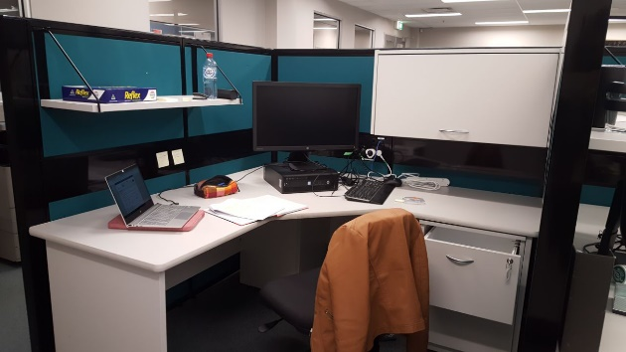I did my internship in Clayton Campus, the main campus of [Monash University](https://en.wikipedia.org/wiki/Monash_University) both in terms of size and student population. Clayton is a suburb of [Melbourne](https://en.wikipedia.org/wiki/Melbourne), in the state of [Victoria](https://en.wikipedia.org/wiki/Victoria_(Australia)), Australia.

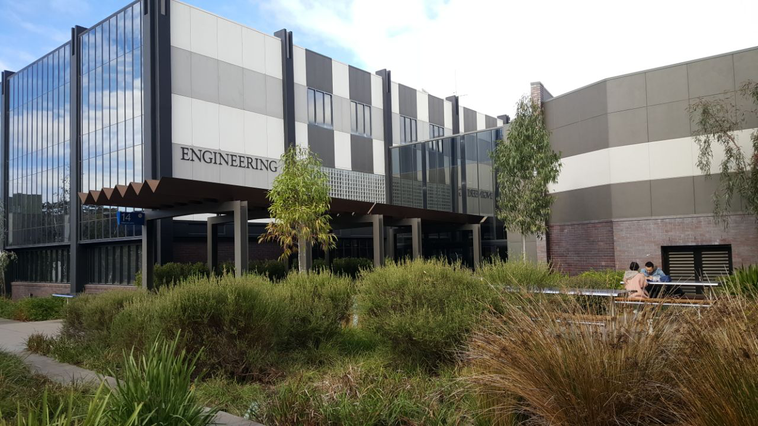

Figure 1: Monash University, with my building and my desk

### ESCE Department

My internship took place in the Electrical and Computer Systems Engineering (ECSE) department. It covers a diverse field that encompasses biomedical, computer systems, electronics, electrical power, robotics and telecommunications.

Like the university, the department is international, with various professors or PhDs from the Middle East and Asia. In total, twenty-two professors and about thirty PhDs and Post-Docs work in the department.

### The team

My supervisor is Faezeh Marzbanrad. She is a lecturer who joined the University of Monash in 2016. Her research interests include biomedical signal processing, machine learning and statistical data analysis, as well as fetal, maternal and neonatal healthcare technologies. On maternity leave during the first two months of my internship, I first met her every week by videoconference. From August, she returned  [partially](https://www.linguee.fr/anglais-francais/traduction/partially.html) to work which allowed me to see her more often.

I also worked in partnership with a medical team composed of Arabella King and Lindsay Zhou. Lindsay Zhou is a doctor of [the Department of Paediatrics, in Monash Children’s Hospital. Specialized in neonatal medicine, he is conducting a study on ..... Arabella, meanwhile, is a 5th year medical student who decided to take a break from her studies to do a year of research. She has Lindsay as supervisor and ….. A finir et revoir les phrases](https://www.researchgate.net/institution/Monash_University_Australia)

Lindsay : Docteur qui a fini l’année dernière sa formation. Ca fait 1 an qui en plus de ses activités dans les cas d’urgences pour les bébés prématurés fait de la recherche.

Moi : Stage de 2A d’école d’ingé de l’Enseirb

## Medical background

### Preterm Neonates’ Immaturity

Normally, a pregnancy lasts about 40 weeks. A neonate will be considered as preterm if he is born before 37 weeks of pregnancy have been completed.

When a baby is premature, he is not fully developed, which often causes serious disorders. The newborn’s difficulty degree is usually related to his gestational age: it is greater the earlier he is born.[[2]](#endnote-3)

The neonates’ immaturity affects many areas, including the central nervous system, the cardiovascular system and the respiratory system.[[3]](#endnote-4)

### Respiratory Distress Syndrome

The Respiratory Distress Syndrome (RDS) is a breathing disorder that affects newborns and particularly premature infants as it results from the respiratory system immaturity.

RDS occurs when there is not enough of a substance in the lungs called surfactant. Surfactant is a liquid produced by the lungs that plays a key role by reducing the surface tension between liquid and air in each alveolus. It opposes the surface tension attraction forces to reach a balance, allowing the open and stable alveoli maintenance, the pulmonary compliance reduction (lung ability to open and close), the cells dry upkeep and defenses against infectious agents.[[4]](#endnote-5)

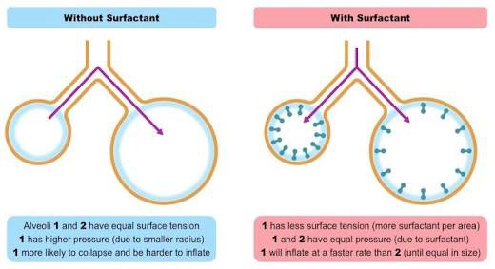

Figure 2: Surfactant role in the respiratory system

REFAIRE le SCHEMA

<https://ib.bioninja.com.au/standard-level/topic-6-human-physiology/64-gas-exchange/pneumocytes.html>

The production of surfactant begins by 24 weeks’ gestation, which is very late in pregnancy. Consequently, the vast majority of babies born under 32 weeks’ gestation need respiratory supports. [[5]](#endnote-6)

### RDS Therapies

The RDS can lead to serious consequences, including death. For this reason, different treatments exit to overcome respiratory dysfunction. They ensure that the infants' organs get enough oxygen to work well. The course of therapy depends on the lung immaturity seriousness, corresponding to the breathing difficulty degree.

Infants who have breathing problems may get oxygen therapy. Oxygen is given through a ventilator or nasal continuous positive airway pressure (NCPAP) machine, or through a tube in the nose.

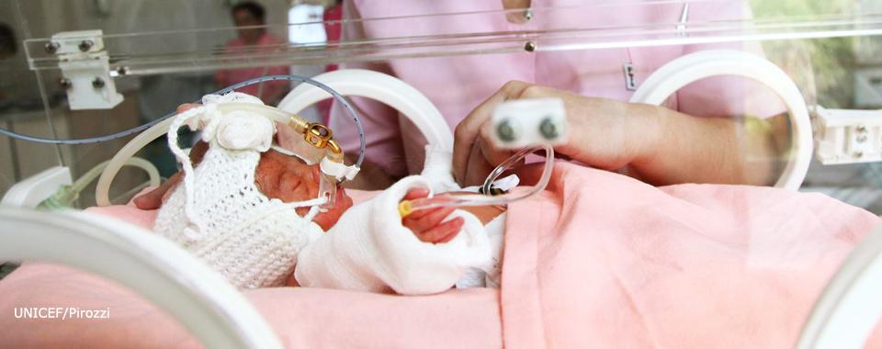

<https://extranet.who.int/rhl/topics/newborn-health/care-newborn-infant/who-recommendation-early-administration-surfactant-intubated-preterm-newborns-respiratory-distress>

Figure 3: Preterm neonate receiving surfactant

When newborns need a lot of oxygen, it means that their surfactant production is very insufficient, even non-existent. The surfactant replacement therapy (SRT) is then necessary, which aims to give surfactant to the neonate lungs. This treatment is now a well-established therapy in the Neonatal Intensive Care Unit (NICU), but opinions still differ for its use[[6]](#endnote-7). *When should it be used? What dose to inject?* Indeed, it is not always well seen to put a foreign substance in a very fragile baby. In addition, the surfactant is not always well absorbed, and never in the same way. Today, the Monash Children's Hospital uses it when the baby needs more than 30% oxygen, but research in this area continues to be conducted.

## The Project

### The Purpose

In Monash, a large study is in progress on newborns, whether regarding their respiratory or cardiac signals. One research aimed at doing a better assessment in preterm neonates under 32 weeks to improve their respiratory breath. My internship is part of this research topic, especially regarding the Surfactant Replacement Therapy (SRT). Indeed, lung acoustics reflect lung volume and then their analysis is essential to know more about the treatment consequences. My internship is based on the analysis of preterm neonates’ respiratory signals before and after SRT. Et deuxieme partie classification

An experiment aimed at recovering the lung sounds before and after SRT was set up by Arrabella King, the medical student of my team.

### The Experiment

#### Available Tools

Different tools can be used to record the sound of the lungs, which all has advantages and disadvantages. The tool choice is very important, on the one hand for the smooth running of the experience and the health of the baby, and on the other hand for the sound recorded quality. Arrabella made a state of the art of these various tools summarized in the table in Annex 1.

There is no « gold standard” device to asses lung parameters[[7]](#endnote-8), but the Digital Stethoscope (DS) known as Clinicloud (Pty Ltd, Melbourne, Australia) was finally chosen. It is composed of a diaphragm which functions to capture sounds. Instead of the sound being transmitted via acoustic vibrations, it is converted to electrical signals, which can then be amplified and processed to optimize the information it contains. These electrical signals can be converted back to sound waves for listening.[[8]](#endnote-9)

A stethoscope is normally used by a doctor to listen. But respiratory deficiency diagnoses are very difficult and remain rather subjective, depending on the doctors’ experience and ability. Even if electronic auscultation have yet to find clinical acceptance, the electrical signals of the stethoscope will be recorded so that they can be analyzed.

#### Preterm Neonates Constraints

The signals quality depends on the conditions in which the sound is recorded. Recording respiratory signals on premature newborns creates a number of constraints, which will then have to be taken into account.

**Sample limitations:** The samples need to be recorded for neonates delivered at Monash Medical Center during the recruitment period (from March to August 2019), with a gestational age between 24 and 32 weeks inclusive whose parents have given informed consent to involvement in the study.

**Safety considerations:** First of all, premature newborns are very fragile beings. To lessen the risk of infection, the medical team need to take all the precautions that are necessary. Indeed, the Digital Stethoscope has the potential to introduce pathogens into the neonates' environment. To limit the risk of contamination and because the experience should not encroach on the health of the baby, only a recording is allowed. The quality of the sound can therefore be very variable.

**Ambient noise**: In addition, a close eye is kept on preterm neonates, especially when they have a respiratory deficiency. Ambient noise including the hustle and bustle of nurses and doctors will be present.

**Respiratory support:** All newborns in the study have a Respiratory Distress Syndrome, and therefore they need respiratory support. Different aids exist (see table ... below). According to their clinical signs, neonates will have one support rather than another. The sound of their breathing depends on the aid they use, which will be taken into account in signal processing (see part ..).

Figure … : The different respiratory supports in Monash Children’s Hospital

### The Sound Analysis

#### Breathing Sounds Generalities, A FAIRE

<https://www.ncbi.nlm.nih.gov/pmc/articles/PMC4518345/>

* Ses caractéritiques avec des nombres
  + Breath sound has three characters; frequency, intensity, and timbre or quality.
* Niveau de la recherche là-dedans

#### Adventitious lung sounds: Wheezes Crackles Squeak Pleural rub Stridor

#### The Recordings

Recordings will be done on babies who need SRT, before and after taking surfactant, exactly on Day 2 and on Day 28 after birth. Day 2 was chosen in spite of Day 1 to allow time to the lungs to remove all their fluids. Day 28 was chosen because it is the day when the baby is in full term. It is at this point that we will determine if the child has a Chronic Lung Desease (CLD).

Figure … : Recording timeline

**Recording**

**Recording**

The bank of signals is composed of twenty recordings, all between 24 and 32 weeks of gestation, who have a Respiratory Distress Syndrome requiring an Surfactant Replacement Therapy.

As explained in section 1.3.2.2, the signals have a variable quality, which depends on the ambient noise and respiratory support. In general, the signals recorded on Day 2 are noisier than the ones on Day 28.

FAIRE UN SCHEMA COMME MATTHIEU AVEC LES RECORDINGS ET LEUR NOMBRE ET D’OU ILS PROVIENNENT. Rq : Je n’ai eu acces à ca qu’a la fin de mon stage car il fallait être blinded.

#### The Stages of Analysis

My goal was to assist the medical team in the analysis of the raw audio recordings. I was blinded to patient clinical data, surfactant administration and the timing of recordings. But label on the respiratory supports? The analysis of the raw recordings involves three stages.

The **preprocessing** part is essential in this study. Depending on the type of baby's respiratory support, on the neonates’ crying and on background noise due to the doctors' discussions, the quality of recordings is very variable, but should not influence the results.

The **features extraction** is then the heart of the project, as that will allow to deduce some properties on the Surfactant Replacement Therapy. A large number of features were extracted and gathered in an Excel file to allow the medical team to do statistical studies.

Finally, a **classification** was done to predict outcomes like CLD or no CLD.

#### Different methods

Machine Learning + Signal processing (tableau + et -) Différentes méthodes pour traiter les données : IA ou signal processing. Car très peu de données, on ne se tourne pas vers l’IA, qui semble quand même être une techno très prometteuse dans le lung sounds.

# Pre-processing

The pre-processing part was essential in this project car la bank of signals contient beaucoup de diversité : différentes qualités, plus ou moins de pleurs, différents supports respiratoires des nouveaux nés, bruit ambient principalement dû aux talks et heartbeat, … a lot of artefact which i think is created by the movement of the diaphragm on the infants chest

Une partie du traitement avait déjà été faite, mais jamais avec cette signals bank, et de nombreux traitements ont dû être modifiés et rajoutés.

## Methods

Le pre-processing s’est divisé en plusieurs étapes, décrites ci-dessous. Tout le code a été effectué en langage MATLAB. La phase de re-sampling and noise filtering has been partly developed before I arrived.

### Re-sampling

La fréquence d’échantillonnage du Digital Stetoscope est de Fs=16000 Hz. Un ré-échantillonnage a été effectuée pour qu’il corresponde à 2 fois le Nyquist Rate.

The Nyquist Theorem spécifie que the sampling rate must be at least 2\*fmax. Or, dans le cas de ces signaux, bande passante a été choisie de manière à limitée les fréquences entre 100 et 1000Hz (voir partie 2.1.2). On a donc : fmax=1000Hz. Le Nyquist Rate vaut alors NR=2\*fmax=2000Hz. Ainsi la fréquence d’échantillonnage qui sera utilisé dans le reste de l’algorithme est fn=2\*NR=4000Hz. Ce nouvel échantillonnage a été effectué grâce à la fonction resample.

### Crying removing

**Labelling the crying sections**

The first step was to label the samples with ‘Crying’ and ‘Non-Crying’ sections. To do so, Arrabella, Lindsay and I made the annotations independently thanks to Audacity software.

Extraction fichier texte (qui correspondent à la date de début et fin de chaque période, avec les labels); Lecture de ces fichiers dans Matlab. J’échantillonne ensuite avec une précision de 10^-2 seconde, pour mettre des labels (1 si CS, 0 si NCS) sur chaque échantillon. Suivant une fenêtre et un overlap choisi (ici window=3s et Overlap=25%), on fait une moyenne glissante du signal pour déterminer de plus grosse fenetre de 0 ou 1. Cela est fait pour chaque signal, pour chaque rater. Cela donne à la fin une matrice 3D comportant (raters, labels, samples). METTRE EN ANNEXE UN FICHIER AUDACITY + AUTRE ?

The level of agreement was then measured using Fleiss’ KAPPA. It is a statistical measure which assesses the [reliability of agreement](https://en.wikipedia.org/wiki/Inter-rater_reliability) between a fixed number of raters when assigning [categorical ratings](https://en.wikipedia.org/wiki/Categorical_rating) to a number of items. In the project, three raters, two categorical ratings and sixty items (60 sections of 1 second) were used to find a Fleiss’ KAPPA coefficient for each sample. A KAPPA coefficient equal to 0 means no agreement, while 1 means perfect agreement. The detailed calculation of this coefficient can be seen in annex … . It was implemented on Matlab using a function in the Matlab File Exchange [[9]](#endnote-10) .

Finally, each crying segments with a 2/3 or 3/3 agreement have been retained.

**Power ratio at various frequency band**

**Wavelet Features**

### Noise Filtering

Une fois le signal re échantillonné, the second task was to denoise the recordings.

The noise can be first due to doctors’ conversation, heartbeat or stethoscope imprecision. Le filtrage de ces bruits has been mainly developed by Fatema (an ancient PhD student of Monash University). According to the paper[[10]](#endnote-11) and to some listening tests and discussions in the team, a frequency band of interest between [100Hz, 1000Hz] was chosen. A Butterworth pass-band filter was then designed with the cut-off frequencies above. Ce filtre a la particularité d’avoir un gain proche de 1 in the passband, which means having a [frequency response](https://en.wikipedia.org/wiki/Frequency_response" \o "Frequency response) as flat as possible, ce qui est très intéressant quand on ne veut pas détériorée le signal. L’ordre du filtre a été choisi à 6 après quelques tests pour avoir une sélectivité suffisante. Concernant les fonctions Matlab, butter pour créer le filtre, puis filtfilt pour filtrer le signal ont été appliquées.

D’autres bruits dû aux différentes machines aidant les enfants prématurés à respirer altèrent les signaux. Ces bruits sont particuliers à mon signals bank, c’est donc moi qui ait implémenté ce qui suit. A FAIRE

## Results

Mettre un signal avant et après pre-processing, entourer les zones de pleurs, mettre différents signaux pour voir les différences.

## Discussion

Attention toujours pas parfait. Nous avons dû enlever quelques recordings et d’autres influencent surement encore négativement les résultats.

# Features extraction

Cette partie est dédiée à l’extraction de caractéristiques. Comme dans le cas du pre-processing, je suis partie d’un code contenant déjà certaines fonctionnalités, résumées dans le tableau en annexe … . Mon travail a été de faire des recherches afin de trouver d’autres caractéristiques judicieuses sur ces signaux, et de les implémenter.

## Methods

La plupart des caractéristiques extraites se trouvent dans le domaine spectral, bien que quelques-unes soient tirées du domaine temporel et spectro-temporel.

### Temporal Features

Le domaine temporel est assez dangereux à utiliser car les enregistrements n’ont pas tous la même durée, ni ….

Tout de même, le Zero Crossing Rate ainsi que le temps entre chaque respiration (inhalation et exhalation) ont été implémenté.

ZRC : qu’est-ce que c’est et pourquoi c’est utile

Autre

ZeroCrossings: the number of time domain zerocrossings of the signal. ZeroCrossings are useful to detect the amount of noise in a signal.

### Spectral Coefficients

MFCC déjà implémenté

Choisi 2 autres, pourquoi judicieux?

#### Linear Predictive Coefficients - LPC

Linear Predictive Coding with its LPCs (Linear Predictive Coefficients) are a tool used mostly in audio signal processing and speech processing for representing the signal spectral envelope with a reduced number of parameters.

Ces coefficients sont intéressants dans le projet car il donne des informations sur le signal, notamment sur les formants et …. C’est pour cette raison qu’il a été choisi de les implémenter.

**Theorical calculations**

They are based on a prediction of the signal value at time t approximated with linear combination of real signal values in previous moments, which can be expressed as follows (eq. 1):

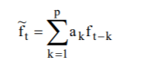

where t is a discrete time moment, ft is the original signal, ftprime an approximation of the original signal, ak the LPCs 1≤k≤p and p the number of LPCs.

They are calculated so that they minimize the error between the real signal and the one calculated using LPCs over the interval of interest to minimize to mean squared error as defined in (1.3 ) .

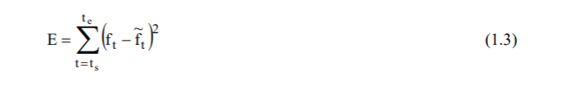

where ts is the starting point in time of the interval for which the error is being calculated, te the ending and E the measured error on the interval t∈[ts; te].

To minimize this error, the ak are calculated in such a way that the derivative of E is equal to 0 (…).

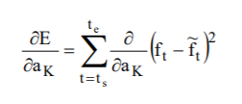avec =0.

Finally, the expression of the LPCs are as follow (…):

METTRE L’EXPRESSION

More details one the calculation of the coefficients can be found on the paper[[11]](#endnote-12).

**Implementation**

L’implémentation se fait simplement avec la fonction lpc sous Matlab. Le choix de 6 coefficients a été retenu car …

#### LSF

IDEM

### Spectral Fit

2 facons diférrentes de ‘représenter’ le periodogramme

#### Gaussian Mixture Model

Qu’est ce que c’est? Pourquoi en avoir choisi 6 ? Qu’est-ce qu’on regarde dessus ? Pourquoi judicieux ?

#### Moving Average F

IDEM

### Perceptual Spectral Features

#### Brightness

The spectral centroid is commonly associated with the measure of the brightness of a sound. It indicates at which frequency the energy of a spectrum is centered upon, by evaluating its center of gravity.

**Theorical calculations**

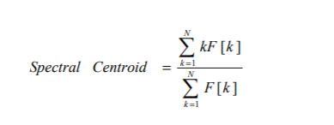It is calculated as the weighted mean of the frequencies present in the signal, with their magnitudes as the weights (eq …).

Attention mettre juste somme sur k (pas de N)

Here, F [k] is the amplitude corresponding to bin k in Discrete Fourier Transform spectrum.

**Implementation**

## Results

Donner les résultats des LPC Et LSF avec le vrai signal et les estimations à l’aide des coeffs.

Donner les résultats avec Belle.

## Discussion

# Classification

## Methods

## Results

## Discussion

# Conclusion

# Vocabulary

Preterm births

Babies born prematurely

Preterm neonates

Newborn=neonate

Premature=preterm=premature infants

# Annex 1

|  |  |  |
| --- | --- | --- |
| **Available tools** | **Advantages** | **Disadvantages** |
| **X-ray** | * Cheap * Bedside * Instant results | * Ionizing radiation |
| **Ultrasound** | * Cheap * Bedside * Instant results * Radiation free | * Training * Infection |
| **Electrical impedance tomography** | * Bedside * Radiation free * Dynamic monitoring * Assess regional changes | * Appliance of electrodes * Technical analysis * Cross sectional only |
| **Respiratory inductive plethysmography** | * Bedside * Radiation free * Dynamic monitoring | * Technical analysis * Sensitive to heat and movement * Influenced by blood flow |
| **Gas techniques** | * No sedation | * Doesn't measure trapped gas * Affected by mask leaks * Alter breathing patterns * Costly |
| **Whole body plethysmography** | * Measures trapped gas | * May require sedation * Bulky machine * Unsuitable for unstable or small neonates |
| **Computed tomography** | * High quality image resolution | * Ionizing radiation * Transfer to machine * Unsuitable for unstable neonates * Costly * Time consuming |

<https://www.nhlbi.nih.gov/health-topics/respiratory-distress-syndrome>

# Annex 2

Faire une timeline avec ce que j’ai effectué durant mon stage.

# References

1. World Health Organisation, <https://www.who.int/news-room/fact-sheets/detail/preterm-birth> [↑](#endnote-ref-2)
2. [Olga Basso](https://www.ncbi.nlm.nih.gov/pubmed/?term=Basso%20O%5BAuthor%5D&cauthor=true&cauthor_uid=20407380), [Allen Wilcox](https://www.ncbi.nlm.nih.gov/pubmed/?term=Wilcox%20A%5BAuthor%5D&cauthor=true&cauthor_uid=20407380). Mortality risk among preterm babies: Immaturity vs. underlying pathology. [Epidemiology. 2010 Jul; 21(4): 521–527.](https://www.ncbi.nlm.nih.gov/entrez/eutils/elink.fcgi?dbfrom=pubmed&retmode=ref&cmd=prlinks&id=20407380" \t "pmc_ext) <https://www.ncbi.nlm.nih.gov/pmc/articles/PMC2967434/> [↑](#endnote-ref-3)
3. [Bharti Taneja](https://www.ncbi.nlm.nih.gov/pubmed/?term=Taneja%20B%5BAuthor%5D&cauthor=true&cauthor_uid=26023373),corresponding author [Vinish Srivastava](https://www.ncbi.nlm.nih.gov/pubmed/?term=Srivastava%20V%5BAuthor%5D&cauthor=true&cauthor_uid=26023373), and [Kirti N Saxena](https://www.ncbi.nlm.nih.gov/pubmed/?term=Saxena%20KN%5BAuthor%5D&cauthor=true&cauthor_uid=26023373). Physiological And Anaesthetic Considerations For The Preterm Neonate Undergoing Surgery. [J Neonatal Surg](https://www.ncbi.nlm.nih.gov/pmc/articles/PMC4420318/). 2012 Jan-Mar; 1(1): 14. <https://www.ncbi.nlm.nih.gov/pmc/articles/PMC4420318/> [↑](#endnote-ref-4)
4. Nkadi PO, Merritt TA, Pillers DA. An overview of pulmonary surfactant in the neonate: genetics, metabolism, and the role of surfactant in health and disease Mol Genet Metab. 2009;97(2):95-101. [↑](#endnote-ref-5)
5. Chow SSW, Creighton P, Kander V, Haslam R, Lui K. Report of the Australian and New Zealand Neonatal Network 2016. Sydney: ANZNN; 2018. [↑](#endnote-ref-6)
6. Sweet DG, Carinelli V, Greisen G, Mikko H, Ozek E, Plavka R. European Consensus Guidelines on the Management of Respiratory Distress Syndrome - 2016 Update. Neonatology. 2017;111(2):107-25. [↑](#endnote-ref-7)
7. Ramanathan A, Zhou L, Marzbanrad F, Roseby R, Tan K, Kevat A, et al. Digital stethoscopes in paediatric medicine. Acta Paediatr. 2018. [↑](#endnote-ref-8)
8. Arrabella King. Digital stethoscope technology to evaluate breath sounds in preterm neonates with respiratory distress syndrome. [↑](#endnote-ref-9)
9. <https://github.com/dgolden1/matlab_fleiss_kappa/blob/master/fleiss_kappa.m> [↑](#endnote-ref-10)
10. Laura E. Ellington, Dimitra Emmanouilidou, Mounya Elhilali, Robert H. Gilman, James M. Tielsch, Miguel A. Chavez, Julio Marin-Concha, Dante Figueroa, James West, William Checkley, "Developing a Reference of Normal Lung Sounds in Healthy Peruvian Children", Springer Science+Business Media New York 2014 [↑](#endnote-ref-11)
11. <http://www.ivoronline.com/Science/Signals/LPC%20-%20Linear%20Predictive%20Coefficients/LPC%20-%20Linear%20Predictive%20Coefficients.pdf> [↑](#endnote-ref-12)